Lesson 19: Comparison Shopping—Unit Price and Related Measurement Conversions

Classwork
Analyze tables, graphs, and equations in order to compare rates.

Examples: Creating Tables from Equations
- The ratio of cups of blue paint to cups of red paint is $1:2$, which means for every cup of blue paint, there are two cups of red paint. In this case, the equation would be red$=2×$blue, or $r=2b$, where $b$ represents the amount of blue paint and $r$ represents the amount of red paint. Make a table of values.

- Ms. Siple is a librarian who really enjoys reading. She can read $\frac{3}{4}$ of a book in one day. This relationship can be represented by the equation days$=\frac{3}{4}$books, which can be written as $d=\frac{3}{4}b$, where $b$ represents the number of books and $d$ represents the number of days.

Exercises
- Bryan and ShaNiece are both training for a bike race and want to compare who rides his or her bike at a faster rate. Both bikers use apps on their phones to record the time and distance of their bike rides. Bryan’s app keeps track of his route on a table, and ShaNiece’s app presents the information on a graph. The information is shown below.
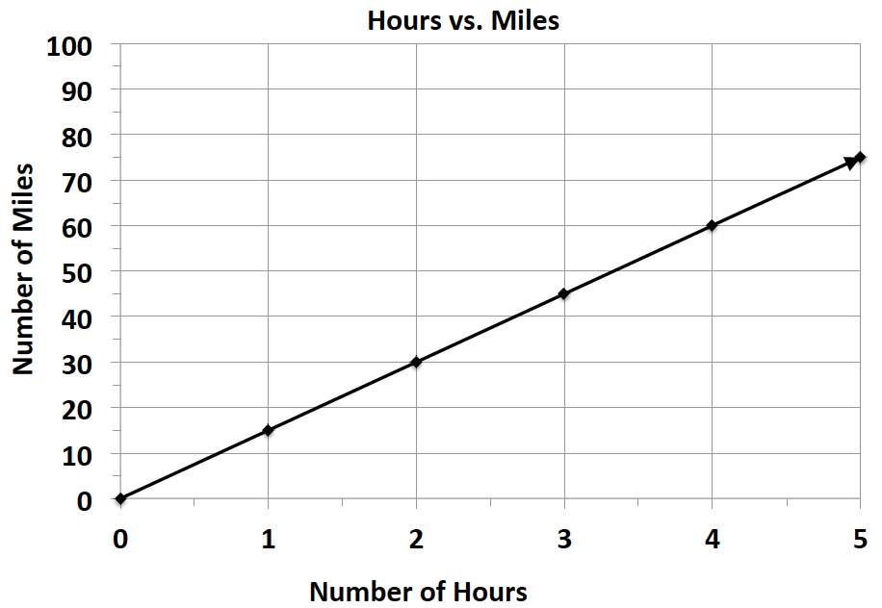
Bryan: ShaNiece:
Number of Hours | $$0$$ | $$3$$ | $$6$$
Number of Miles | $$0$$ | $$75$$ | $$150$$

  - At what rate does each biker travel? Explain how you arrived at your answer.

  - ShaNiece wants to win the bike race. Make a new graph to show the speed ShaNiece would have to ride her bike in order to beat Bryan.

- Braylen and Tyce both work at a department store and are paid by the hour. The manager told the boys they both earn the same amount of money per hour, but Braylen and Tyce did not agree. They each kept track of how much money they earned in order to determine if the manager was correct. Their data is shown below.

Braylen: $m=10.50h$ where $h$ represents the number of hours worked and $m$ represents the amount of money Braylen was paid

Tyce:
Number of Hours | $$0$$ | $$3$$ | $$6$$
Money in Dollars | $$0$$ | $$34.50$$ | $$69$$

  - How much did each person earn in one hour?

  - Was the manager correct? Why or why not?

- Claire and Kate are entering a cup stacking contest. Both girls have the same strategy: stack the cups at a constant rate so that they do not slow down at the end of the race. While practicing, they keep track of their progress, which is shown below.

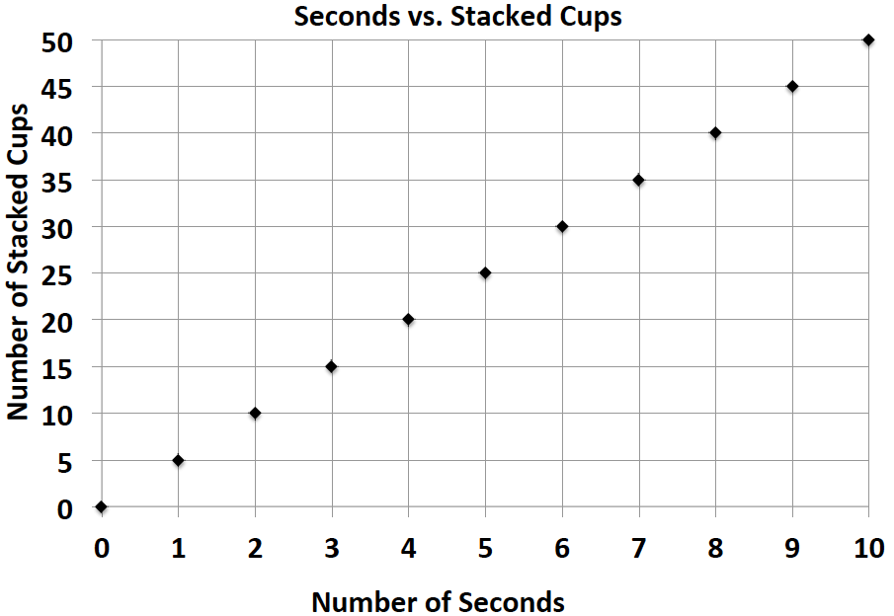
Claire: Kate: $c=4t$, where $t$ represents the amount of time in seconds and $c$ represents the number of stacked cups

  - At what rate does each girl stack her cups during the practice sessions?

  - Kate notices that she is not stacking her cups fast enough. What would Kate’s equation look like if she wanted to stack cups faster than Claire?

Lesson Summary
When comparing rates and ratios, it is best to find the unit rate.
Comparing unit rates can happen across tables, graphs, and equations.

Problem Set

Victor was having a hard time deciding which new vehicle he should buy. He decided to make the final decision based on the gas efficiency of each car. A car that is more gas efficient gets more miles per gallon of gas. When he asked the manager at each car dealership for the gas mileage data, he received two different representations, which are shown below.
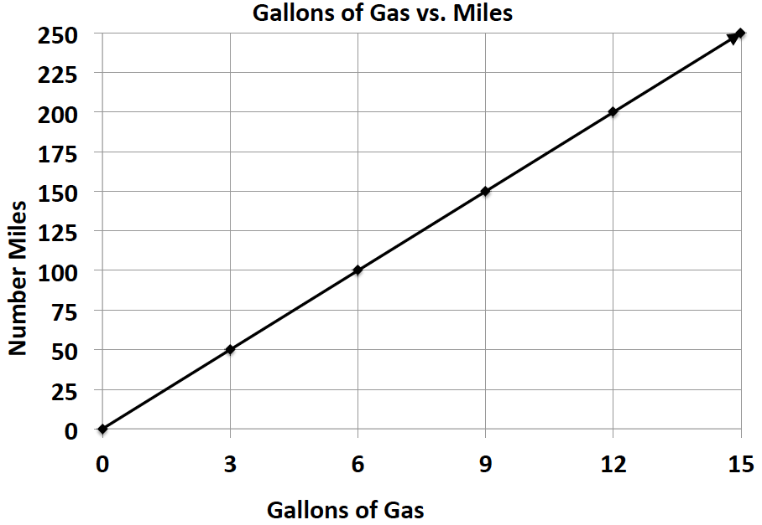
Vehicle 1: Legend Vehicle 2: Supreme
Gallons of Gas | $$4$$ | $$8$$ | $$12$$
Number of Miles | $$72$$ | $$144$$ | $$216$$

      - If Victor based his decision only on gas efficiency, which car should he buy? Provide support for your answer.

      - After comparing the Legend and the Supreme, Victor saw an advertisement for a third vehicle, the Lunar. The manager said that the Lunar can travel about $289$ miles on a tank of gas. If the gas tank can hold $17$ gallons of gas, is the Lunar Victor’s best option? Why or why not?

