Lesson 19: Comparison Shopping—Unit Price and Related Measurement Conversions

Student Outcomes
- Students solve problems by analyzing different unit rates given in tables, equations, and graphs.

Materials
- Matching activity cut and prepared for groups

Classwork
Analyze tables, graphs, and equations in order to compare rates.

Examples (10 minutes): Creating Tables from Equations
- Let’s fill in the labels for each table as shown in the completed table below.
- If we have $1$ cup of blue paint, how many cups of red paint would we have? (Model where these values go on the table.)
- If we have $2$ cups of blue paint, how many cups of red paint would we have? (Model where these values go on the table.)
Examples: Creating Tables from Equations
- The ratio of cups of blue paint to cups of red paint is $1:2$, which means for every cup of blue paint, there are two cups of red paint. In this case, the equation would be red$=2×$blue, or $r=2b$, where $b$ represents the amount of blue paint and $r$ represents the amount of red paint. Make a table of values.
Cups of Blue Paint | $$1$$ | $$2$$ | $$3$$ | $$4$$
Cups of Red Paint | $$2$$ | $$4$$ | $$6$$ | $$8$$

Follow this line of questioning for a few more values.
- Examine the table, and identify the unit rate.
  - $2$
- Where do you see this value in the equation?
  - The unit rate is represented in the equation as the value by which the cups of blue paint are being multiplied.
- Ms. Siple is a librarian who really enjoys reading. She can read $\frac{3}{4}$ of a book in one day. This relationship can be represented by the equation days$=\frac{3}{4}$ books, which can be written as $d=\frac{3}{4}b$, where $b$ is the number of books and $d$ is the number of days.
Number of Days | $$1$$ | $$2$$ | $$3$$ | $$4$$
Number of Books | $$\frac{3}{4}$$ | $$\frac{6}{4}\text{ or }1\frac{1}{2}$$ | $$\frac{9}{4}\text{ or} 2\frac{1}{4}$$ | $$\frac{12}{4}\text{or} 3$$

Encourage students to fill in the table on their own. If students need more assistance, teachers can ask leading questions similar to those above.
Have students recognize the unit rate in the table and the equation, so they can later identify the unit rate in equations without creating a table.
Example 3 (13 minutes): Matching
Match an equation, table, and graph that represent the same unit rate. Students work individually or in pairs.
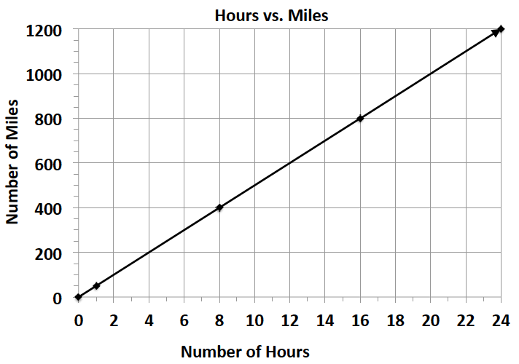
Cut apart the data representations below and supply each student-pair with a set.
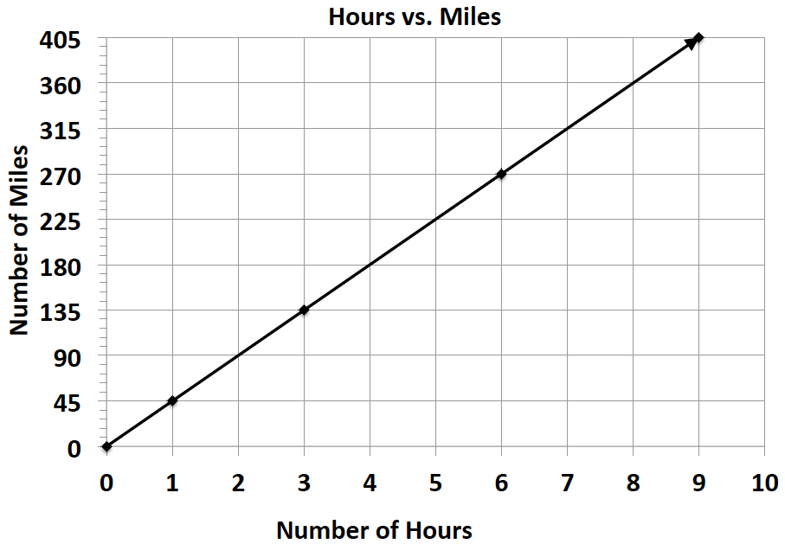
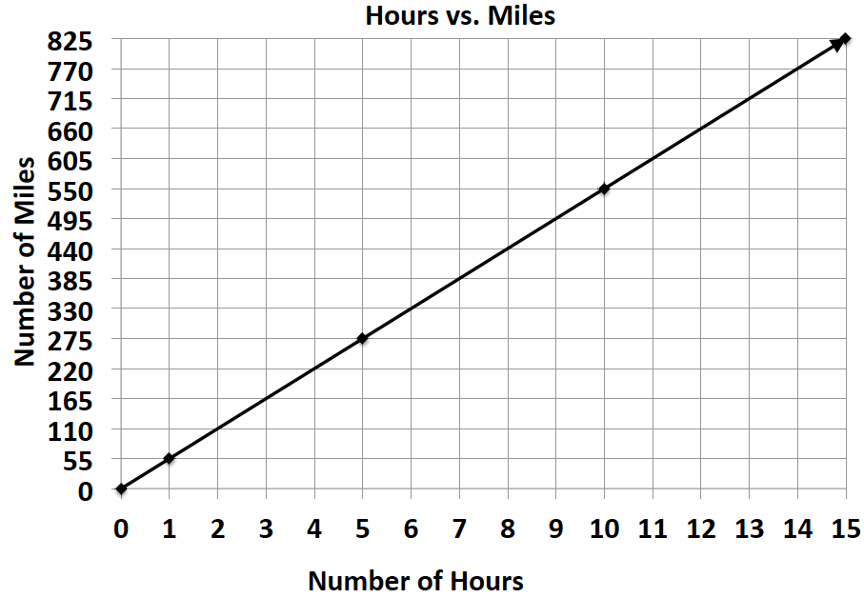
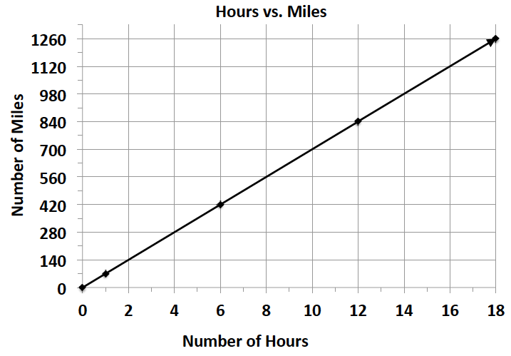
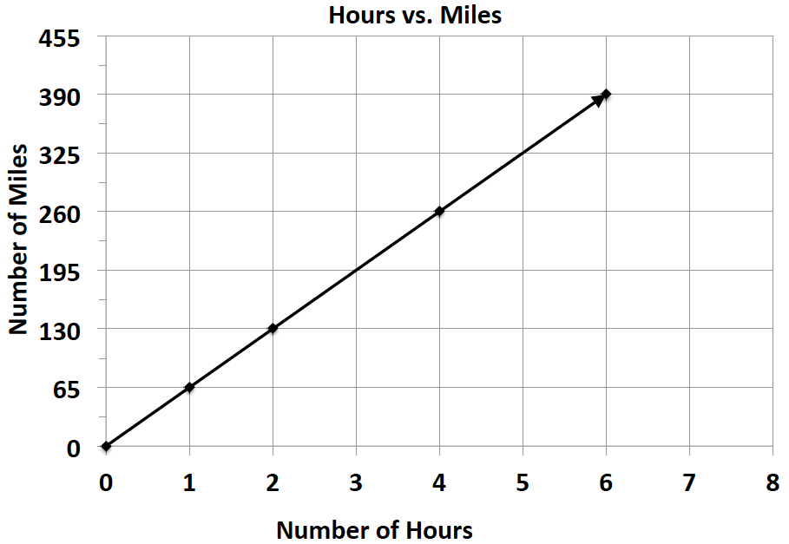
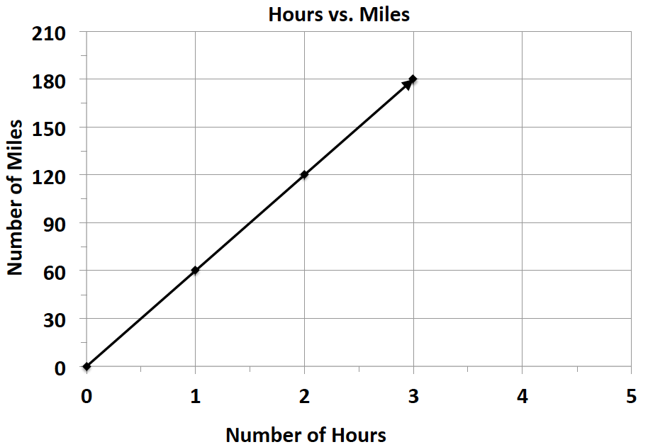

$$m = 65h$$ | $$m = 45h$$ | $$m = 55h$$
$$m = 70h$$ | $$m = 50h$$ | $$m = 60h$$
$$h$$ $$0$$ $$2$$ $$4$$ $$6$$  $$m$$ $$0$$ $$130$$ $$260$$ $$390$$ | $$h$$ $$0$$ $$3$$ $$6$$ $$9$$  $$m$$ $$0$$ $$135$$ $$270$$ $$405$$ | $$h$$ $$0$$ $$5$$ $$10$$ $$15$$  $$m$$ $$0$$ $$275$$ $$550$$ $$825$$
$$h$$ $$0$$ $$1$$ $$2$$ $$3$$  $$m$$ $$0$$ $$60$$ $$120$$ $$180$$ | $$h$$ $$0$$ $$8$$ $$16$$ $$24$$  $$m$$ $$0$$ $$400$$ $$800$$ $$1200$$ | $$h$$ $$0$$ $$6$$ $$12$$ $$18$$  $$m$$ $$0$$ $$420$$ $$840$$ $$1260$$

Exercises (12 minutes)
Students work on problems individually. Encourage students to explain their thinking.

- Bryan and ShaNiece are both training for a bike race and want to compare who rides his or her bike at a faster rate. Both bikers use apps on their phones to record the time and distance of their bike rides. Bryan’s app keeps track of his route on a table, and ShaNiece’s app presents the information on a graph. The information is shown below.
Bryan: ShaNiece:
Number of Hours | $$0$$ | $$3$$ | $$6$$
Number of Miles | $$0$$ | $$75$$ | $$150$$
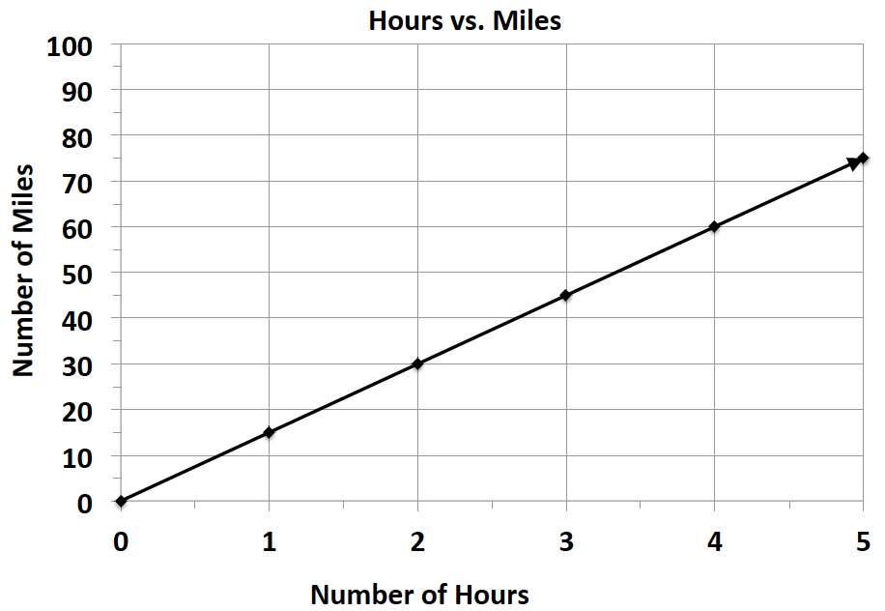

  - At what rate does each biker travel? Explain how you arrived at your answer.
$$1$$
$$2$$
$$3$$
$$25$$
$$50$$
$$75$$

Bryan: Hours

Miles
MP.2

Bryan travels at a rate of $25$ miles per hour. The double number line had to be split in $3$ equal sections. That’s how I got $25$; $\left(25+25+25\right)=75.$
ShaNiece travels at $15$ miles per hour. I know this by looking at the point $\left(1,15\right)$ on the graph.
The $1$ represents the number of hours and the $15$ represents the number of miles.

  - ShaNiece wants to win the bike race. Make a new graph to show the speed ShaNiece would have to ride her bike in order to beat Bryan.
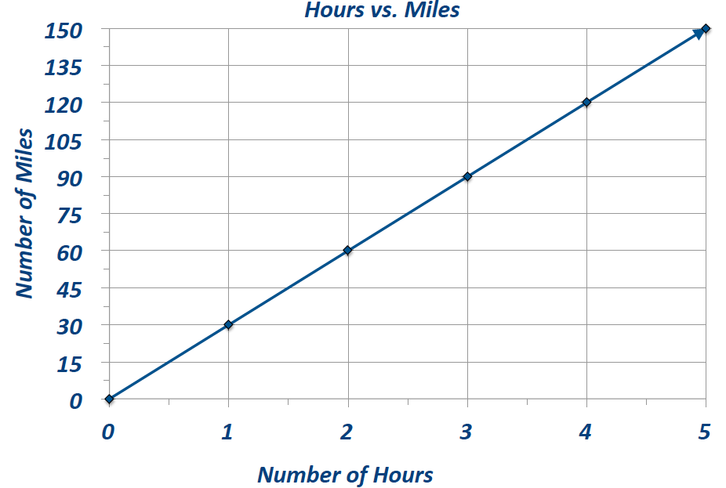

The graph shows ShaNiece traveling at a rate of $30$miles per hour, which is faster than Bryan’s rate.

- Braylen and Tyce both work at a department store and are paid by the hour. The manager told the boys they both earn the same amount of money per hour, but Braylen and Tyce did not agree. They each kept track of how much money they earned in order to determine if the manager was correct. Their data is shown below.
Braylen: $m=10.50h$, where $h$ represents the number of hours worked and $m$ represents the amount of money Braylen was paid
Tyce:
Number of Hours | $$0$$ | $$3$$ | $$6$$
Money in Dollars | $$0$$ | $$34.50$$ | $$69$$

  - How much did each person earn in one hour?
$$1$$
$$2$$
$$3$$
$$11.50$$
$$23.00$$
$$34.50$$

Hours

Dollars
Tyce earned $\$11.50$per hour. Braylen earned $\$10.50$ per hour.

  - Was the manager correct? Why or why not?
The manager was not correct because Tyce earned $\$1$more than Braylen in one hour.
MP.2
- Claire and Kate are entering a cup stacking contest. Both girls have the same strategy: stack the cups at a constant rate so that they do not slow down at the end of the race. While practicing, they keep track of their progress, which is shown below.
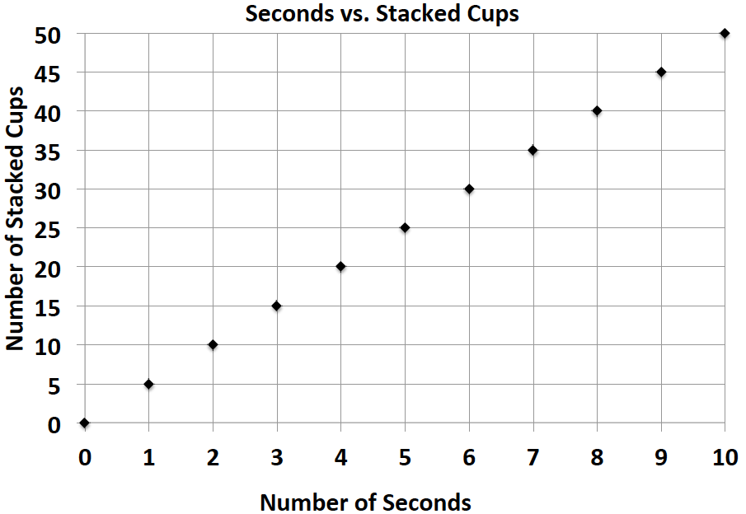
Claire: Kate: $c=4t$, where $t$ represents the amount of
time in seconds and $c$ represents the number of
stacked cups

  - At what rate does each girl stack her cups during the practice sessions?
Claire stacks cups at a rate of $5$ cups per second. Kate stacks cups at a rate of$4$ cups per second.

  - Kate notices that she is not stacking her cups fast enough. What would Kate’s equation look like if she wanted to stack cups faster than Claire?
Answers will vary. $c=6t$, where $t$ represents the time in seconds and $c$ represents the number of cups stacked
Closing (5 minutes)
Students share their answers to the exercises and answer the following questions:
- How do you identify the unit rate in a table, graph, and equation?
- Why was the unit rate instrumental when comparing rates?

Lesson Summary
When comparing rates and ratios, it is best to find the unit rate.
Comparing unit rates can happen across tables, graphs, and equations.

Exit Ticket (5 minutes)

Name ___________________________________________________ Date____________________
Lesson 19: Comparison Shopping—Unit Price and Related Measurement Conversions

Exit Ticket

Kiara, Giovanni, and Ebony are triplets and always argue over who can answer basic math facts the fastest. After completing a few different math fact activities, Kiara, Giovanni, and Ebony recorded their data, which is shown below.

Kiara: $m=5t$, where $t$ represents the time in seconds and Ebony:
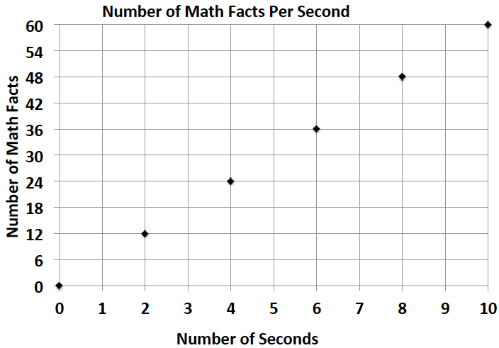
$m$ represents the number of math facts completed

Giovanni:
Seconds | $$5$$ | $$10$$ | $$15$$
Math Facts | $$20$$ | $$40$$ | $$60$$

- What is the math fact completion rate for each student?

- Who would win the argument? How do you know?

Exit Ticket Sample Solutions

Kiara, Giovanni, and Ebony are triplets and always argue over who can answer basic math facts the fastest. After completing a few different math fact activities, Kiara, Giovanni, and Ebony recorded their data, which is shown below.
Kiara: $m=5t$, where $t$ represents the time in seconds and Ebony:
$m$ represents the number of math facts completed

Giovanni:
Seconds | $$5$$ | $$10$$ | $$15$$
Math Facts | $$20$$ | $$40$$ | $$60$$

- What is the math fact completion rate for each student?
Kiara:$5$ math facts/second
Giovanni: $4$ math facts/second
Ebony: $6$ math facts/second

- Who would win the argument? How do you know?
Ebony would win the argument because when comparing the unit rates of the three triplets, Ebony
completes math facts at the fastest rate.

Problem Set Sample Solutions

Victor was having a hard time deciding which new vehicle he should buy. He decided to make the final decision based on the gas efficiency of each car. A car that is more gas efficient gets more miles per gallon of gas. When he asked the manager at each car dealership for the gas mileage data, he received two different representations, which are shown below.
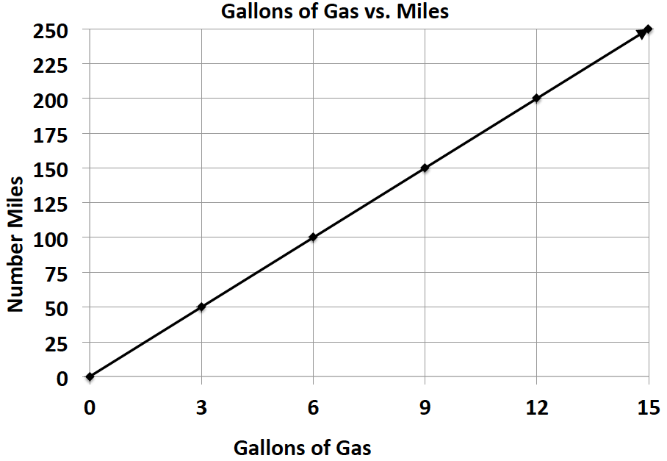
Vehicle 1: Legend Vehicle 2: Supreme
Gallons of Gas | $$4$$ | $$8$$ | $$12$$
Number of Miles | $$72$$ | $$144$$ | $$216$$

      - If Victor based his decision only on gas efficiency, which car should he buy? Provide support for your answer.
Victor should buy the Legend because it gets $18$miles per gallon of gas, and the Supreme only gets $16\frac{2}{3}$ miles per gallon. Therefore, the Legend is more gas efficient.

      - After comparing the Legend and the Supreme, Victor saw an advertisement for a third vehicle, the Lunar. The manager said that the Lunar can travel about $289$ miles on a tank of gas. If the gas tank can hold $17$ gallons of gas, is the Lunar Victor’s best option? Why or why not?
The Lunar is not a better option than the Legend because the Lunar only gets $17$ miles per gallon, and the Legend gets $18$miles per gallon. Therefore, the Legend is still the best option.

