Lesson 17: From Rates to Ratios

Student Outcomes
- Given a rate, students find ratios associated with the rate, including a ratio where the second term is one and a ratio where both terms are whole numbers.
- Students recognize that all ratios associated to a given rate are equivalent because they have the same value.

Classwork
Given a rate, you can calculate the unit rate and associated ratios. Recognize that all ratios associated with a given rate are equivalent because they have the same value.

Example 1 (4 minutes)
Example 1
Write each ratio as a rate.
- The ratio of miles to the number of hours is $434$  to $7$. | - The ratio of the number of laps to the number of minutes is $5$ to $4$.

Miles to hour: $434:7$
Student responses: $\frac{434 \text{miles}}{7 \text{hours}}=$ $62$ miles/hour
Laps to minute: $5:4$
Student responses: $\frac{5 \text{laps}}{4 \text{minutes}}=\frac{5}{4}$ laps/min

Example 2 (15 minutes)
Demonstrate how to change a ratio to a unit rate then to a rate by recalling information students learned the previous day. Use Example 1, part (b).
Example 2
  - Complete the model below using the ratio from Example 1, part (b).
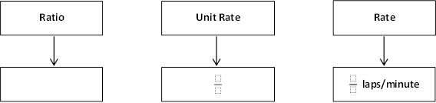

laps/minute
Unit Rate
Rate
Ratio

laps/minute
Unit Rate
Rate
Ratio

laps/minute
Unit Rate
Rate
Ratio

Ratio: $5:4$ Unit Rate: $\frac{5}{4}$ Rate: $\frac{5}{4}$ laps/minute
Rates to Ratios: Guide students to complete the next flow map where the rate is given, and then they move to unit rate and then to different ratios.

  - Complete the model below now using the rate listed below.
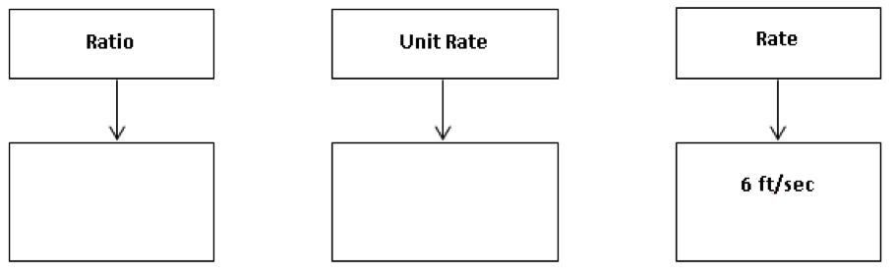

Ratios: Answers may vary Unit Rate: $6$
$6:1$, $60:10$, $12:2$, etc.

Discussion
- Will everyone have the same exact ratio to represent the given rate? Why or why not?
  - Possible Answer: Not everyone’s ratios will be exactly the same because there are many different equivalent ratios that could be used to represent the same rate.
- What are some different examples that could be represented in the ratio box?
  - Answers will vary: All representations represent the same rate:$12:2$, $18:3$, $24:4$.
- Will everyone have the same exact unit rate to represent the given rate? Why or why not?
  - Possible Answer: Everyone will have the same unit rate for two reasons. First, the unit rate is the value of the ratio, and each ratio only has one value. Second, the second quantity of the unit rate is always $1$, so the rate will be the same for everyone.
- Will everyone have the same exact rate when given a unit rate? Why or why not?
  - Possible Answer: No, a unit rate can represent more than one rate. A rate of $\frac{18}{3}$ feet/second has a unit rate of $6$ feet/second.

Examples 3–6 (20 minutes)
Students work on one problem at a time. Have students share their reasoning. Provide opportunities for students to share different methods on how to solve each problem.
Examples 3–6
- Dave can clean pools at a constant rate of $\frac{3}{5}$pools/hour.
  - What is the ratio of the number of pools to the number of hours?
$$3:5$$

  - How many pools can Dave clean in $10$ hours?
Pools $=6$ pools
$$2$$
$$2$$
$$2$$
$$2$$
$$2$$
$$2$$
$$2$$
$$2$$
Hours $=10$ hours
Dave can clean $6$ pools in $10$hours.

  - How long does it take Dave to clean $15$ pools?
Pools $=15$ pools
$$5$$
$$5$$
$$5$$
Hours $=25$ hours
$$5$$
$$5$$
$$5$$
$$5$$
$$5$$
It will take Dave $25$ hours to clean $15$ pools.

- Emeline can type at a constant rate of$\frac{1}{4}$ pages/minute.
  - What is the ratio of the number of pages to the number of minutes?
$$1:4$$

  - Emeline has to type a $5$-page article but only has $18$ minutes until she reaches the deadline. Does Emeline have enough time to type the article? Why or why not?
$5$
$4$
$3$
$2$
$1$

Pages

Minutes
$4$
$12$
$16$
$$20$$
$8$

No, Emeline will not have enough time because it will take her $20$ minutes to type a $5$-page article.

  - Emeline has to type a $7$-page article. How much time will it take her?
$$5$$
$6$
$7$

Pages

Minutes
$$20$$
$24$
$28$

It will take Emeline $28$ minutes to type a $7$-page article.

- Xavier can swim at a constant speed of $\frac{5}{3}$ meters/second.
  - What is the ratio of the number of meters to the number of seconds?
$$5:3$$

  - Xavier is trying to qualify for the National Swim Meet. To qualify, he must complete a $100$ meter race in $55$ seconds. Will Xavier be able to qualify? Why or why not?
Meters | Seconds
$$5$$ | $$3$$
$$10$$ | $$6$$
$$100$$ | $$60$$
Xavier will not qualify for the meet because he would complete the race in $60$ seconds.

  - Xavier is also attempting to qualify for the same meet in the $200$ meter event. To qualify, Xavier would have to complete the race in $130$ seconds. Will Xavier be able to qualify in this race? Why or why not?
Meters | Seconds
$$100$$ | $$60$$
$$200$$ | $$120$$
Xavier will qualify for the meet in the $200$ meter race because he would complete the race in $120$ seconds.

- The corner store sells apples at a rate of $1.25$ dollars per apple.
  - What is the ratio of the amount in dollars to the number of apples?
$$1.25:1$$

  - Akia is only able to spend $\$10$ on apples. How many apples can she buy?
$8$ apples

  - Christian has $\$6$ in his wallet and wants to spend it on apples. How many apples can Christian buy?
Christian can buy $4$ apples and would spend $\$5.00$. Christian cannot buy a $5$^{th} apple because it would cost $\$6.25$ for $5$ apples, and he only has $\$6.00$.

Closing (2 minutes)
- Explain the similarities and differences between rate, unit rate, rate unit, and ratio.
Lesson Summary
A rate of $\frac{2}{3}$gal/min corresponds to the unit rate of $\frac{2}{3}$ and also corresponds to the ratio $2:3$.
All ratios associated with a given rate are equivalent because they have the same value.

Exit Ticket (4 minutes)

Name ___________________________________________________ Date____________________
Lesson 17: From Rates to Ratios

Exit Ticket

Tiffany is filling her daughter’s pool with water from a hose. She can fill the pool at a rate of $\frac{1}{10}$ gallons/second.
Create at least three equivalent ratios that are associated with the rate. Use a double number line to show your work.
Exit Ticket Sample Solutions

Tiffany is filling her daughter’s pool with water from a hose. She can fill the pool at a rate of $\frac{1}{10}$ gallons/second.
Create at least three equivalent ratios that are associated with the rate. Use a double number line to show your work.
Answers will vary.

Problem Set Sample Solutions

- Once a commercial plane reaches the desired altitude, the pilot often travels at a cruising speed. On average, the cruising speed is $570$ miles/hour. If a plane travels at this cruising speed for $7$ hours, how far does the plane travel while cruising at this speed?
$3,990$ miles

- Denver, Colorado often experiences snowstorms resulting in multiple inches of accumulated snow. During the last snow storm, the snow accumulated at $\frac{4}{5}$ inch/hour. If the snow continues at this rate for $10$ hours, how much snow will accumulate?
$8$ inches

