Lesson 37

Objective: Relate subtraction from 9 to corresponding decompositions.

Suggested Lesson Structure
 Fluency Practice (14 minutes)
 Application Problem (6 minutes)
 Concept Development (30 minutes)
 Student Debrief (10 minutes)
Total Time (60 minutes)

Fluency Practice (14 minutes)
- Choral Counting: The Regular and the Say Ten Way 1.NBT.2 (2 minutes)
- 5-Group Flash K.OA.5, 1.OA.6 (2 minutes)
- Sprint: Partners to 10 K.OA.5, 1.OA.6 (10 minutes)

Choral Counting: The Regular and the Say Ten Way (2 minutes)
Note: This activity supports students’ ability to maintain their fluency with the counting sequence while also building the foundational skills for place value.
Tell students to count along, alternating between the regular and the Say Ten way (e.g., 12, ten 3, 14, ten 5, etc.). Start at different numbers within 40. If students are ready, try counting back, too.

5-Group Flash (2 minutes)

NOTES ON
MULTIPLE MEANS
OF ACTION AND EXPRESSION:
Some students would benefit from having a set of ten-frame cards to use as a reference and to have available for practice. This practice should include flipping the cards over to encourage visualization of the numbers and their partners.

Materials: (T) 5-group cards (Lesson 5 Template 1)
Note: This activity addresses the core fluency objective for Grade 1 of adding and subtracting with 10, using visual models to support stronger foundational development.
Flash a 5-group card for 2–3 seconds, and instruct students to identify the number at a signal (or snap). Ask for a number sentence to solve 10 minus the number flashed.

Sprint: Partners to 10 (10 minutes)
Materials: (S) Partners to 10 Sprint
Note: This activity addresses the core fluency objective for Grade 1 of adding and subtracting within 10.

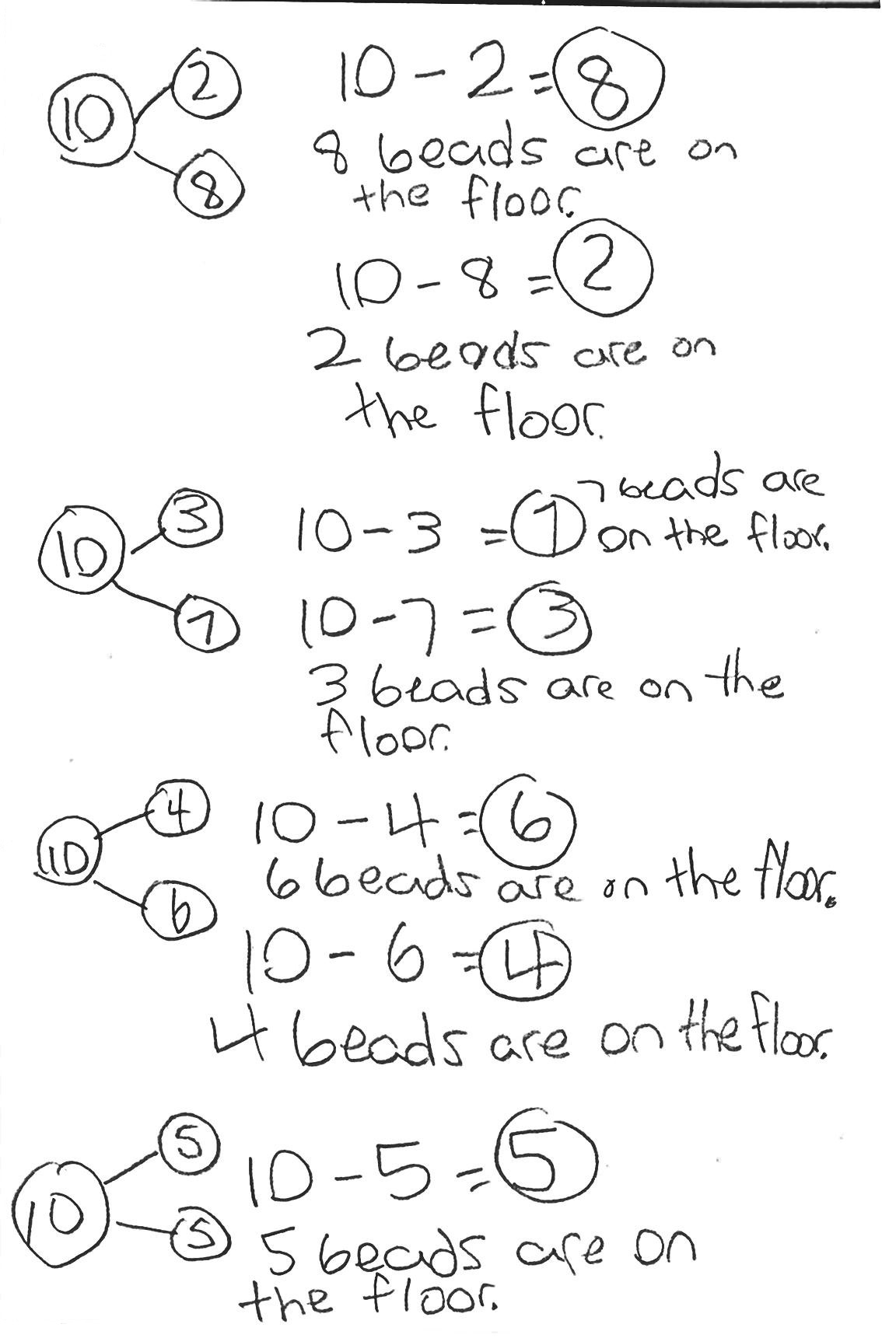
Application Problem (6 minutes)
There are 10 beads on the floor. A student picked up some of the beads but left some on the floor. Write a number bond and a number sentence that would match this story.
Extension: What other number bonds and number sentences could match this story? Try to list all of the possibilities. (Encourage all students to attempt this.)
Note: This problem applies the objective from Lesson 36, decompositions of 10 and their related subtraction facts. This also connects to the current lesson’s Concept Development, which focuses on all of the decompositions of 9 in a similar way.

Concept Development (30 minutes)
Materials: (T) Number bracelet of 10 beads (5 red, 5 white) (see Lesson 8) (S) Number bracelet of 10 beads (5 red, 5 white), personal white board
Have students bring materials to meeting area and sit in a semi-circle.
T: (Assign partners. Project 10 – 5.) Partner A, use your beads to solve, and also show Partner B the number sentence and number bond on your board. Explain as you go.
S: (Complete the task with partner.)
T: (Project 9 – 5.) Partner B, take off 1 bead, and put it behind you to have 9. (Pause.) Use your beads to solve, and also show Partner A a number sentence and number bond on your board. Explain what you did.
S: (Complete the task with partner.)
MP.7
T: Compare your bracelets, your number sentences, and number bonds. How can Partner A’s work help you solve Partner B’s work? (Circulate and listen.)
S: (Discuss with partner.) Partner B starts with 1 less as the whole, but we both took 5 away, and Partner B’s answer is 1 less! Nine is 1 less than 10, so when we take 5 away, our answer will be 1 less. It’s just like on the addition chart! We take away a five group, so it’s 4 left not 5.
T: Good! Now, Partner A, please remove 1 bead, and place it behind you to make sure you have 9. (Pause.) Our 10 is now…
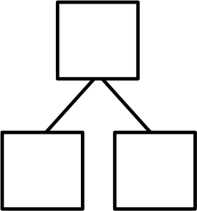
S: 9!
9

1
9 – 1 =
T: (Project 9 – 1.) Use your beads to solve and also show the number sentence and number bond on your personal board.
S: (Push 1 bead away from the set, finish the number bond, and write 9 – 1 = 8.)
T: What is the other number sentence you can write to describe this number bond?

NOTES ON
MULTIPLE MEANS
OF REPRESENTATION:
During this lesson, it is important for students to articulate how using strategies helps to solve problems so that other students can hear how they are thinking. This should help guide them towards a better understanding of the patterns and structures.

S: 9 – 8 = 1!
T: Yes. Now, please write it below your first number sentence.
S: (Write 9 – 8 = 1.)
T: Now, you’re going to write all of the other number bonds with 9 as the total or the whole and the subtraction sentences that describe each number bond. You can move around the room to do this. Hmmm, what tools can you use to help you do this?
S: Our bracelets! Our hands. Our 5-group cards. Our math drawings. Our addition chart. Visualizing. Our brains. The charts in the room!
T: Talk with your partner!
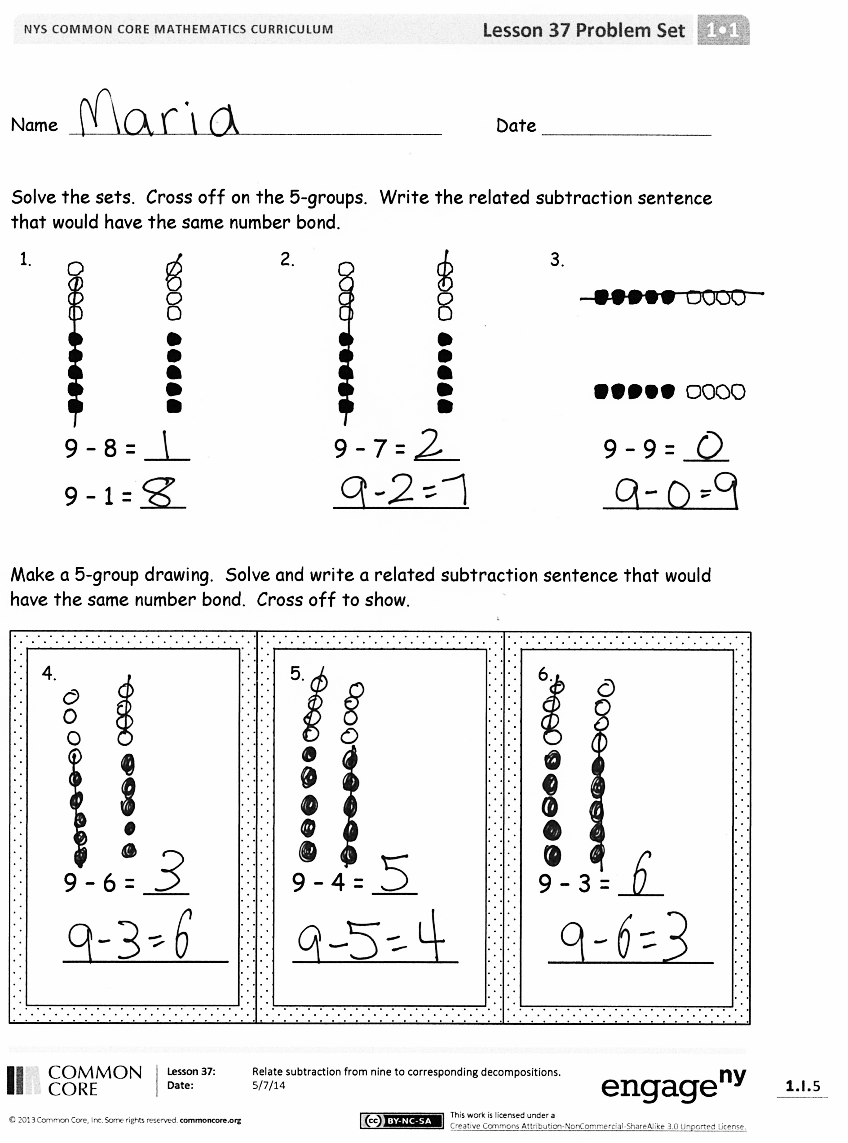
As students work, circulate, and support them as appropriate. When most students have finished, have them return to the meeting area.
T: What strategies did you use to be sure that you got every way to make 9?
S: I used my bracelet and showed 1 less each time! I checked mine over a couple of times and showed it with my bracelet.
T: What strategies did you use to be sure that you showed the subtraction sentences that described the number bonds?
S: I actually took the beads away on my bracelet! I flipped my bracelet after I made the first subtraction sentence.

Problem Set (10 minutes)
Students should do their personal best to complete the Problem Set within the allotted 10 minutes. For some classes, it may be appropriate to modify the assignment by specifying which problems they work on first.
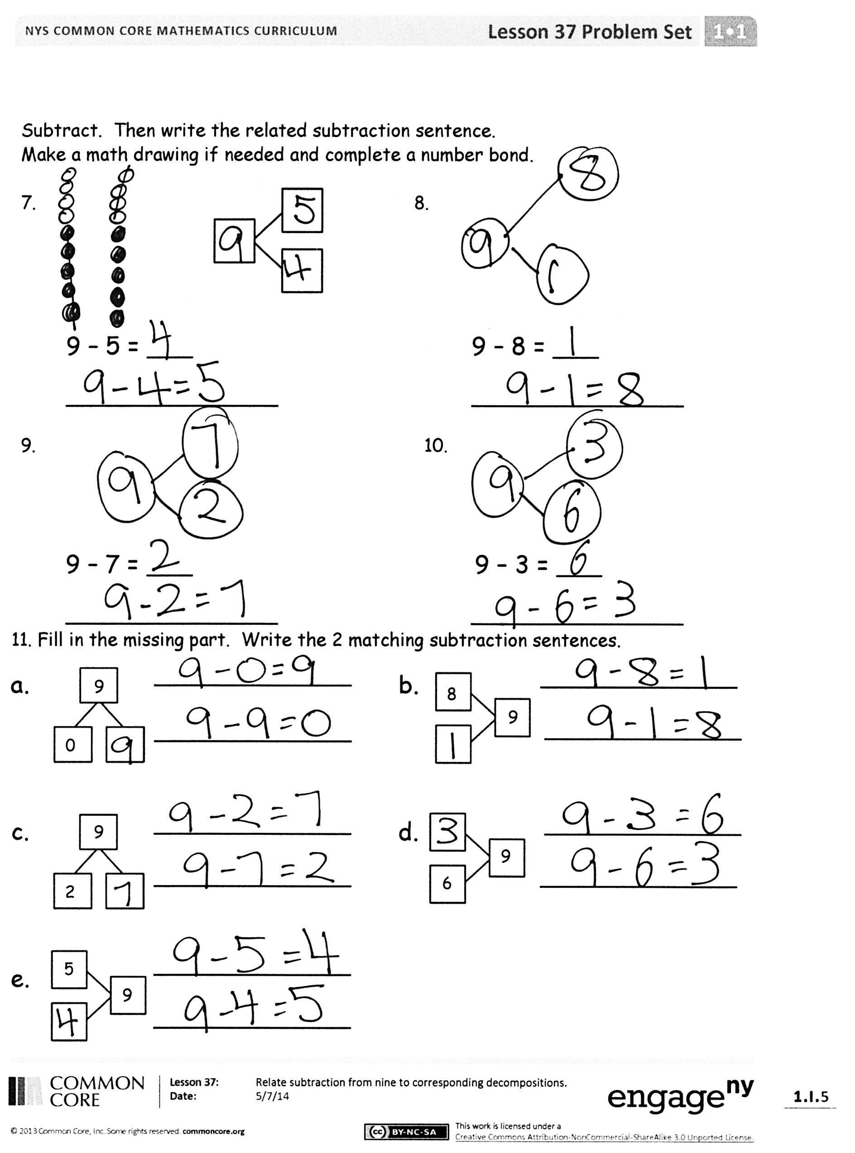
Some problems do not specify a method for solving. Students solve these problems using the RDW approach used for Application Problems.

Student Debrief (10 minutes)
Lesson Objective: Relate subtraction from 9 to corresponding decompositions.
The Student Debrief is intended to invite reflection and active processing of the total lesson experience.
Invite students to review their solutions for the Problem Set. They should check work by comparing answers with a partner before going over answers as a class. Look for misconceptions or misunderstandings that can be addressed in the Debrief. Guide students in a conversation to debrief the Problem Set and process the lesson.
You may choose to use any combination of the questions below to lead the discussion.
- Look at Problem 2 and Problem 6. What is similar and different about them? How did you use Problem 2 to help you solve Problem 6?
- Look at Problems 7–10. What strategy or strategies did you use to solve these? How was your strategy different from or similar to your partner’s?
- Which strategy is the most efficient for solving Problems 7 –10? Why?
- How did the Application Problem connect to today’s lesson?
- How can you visualize 9? What do you see in your brain? Does that help you to subtract from 9?

Exit Ticket (3 minutes)
After the Student Debrief, instruct students to complete the Exit Ticket. A review of their work will help you assess the students’ understanding of the concepts that were presented in the lesson today and plan more effectively for future lessons. You may read the questions aloud to the students.

Name Date
Number correct:
A

*Write the missing number for each subtraction sentence. Pay attention to the + and – signs.
1 | 9 + 1 = ☐ |  | 16 | 10 – 7 = ☐
2 | 1 + 9 = ☐ |  | 17 | 10 = 7 + ☐
3 | 10 – 1 = ☐ |  | 18 | 10 = 3 + ☐
4 | 10 – 9 = ☐ |  | 19 | 10 = 6 + ☐
5 | 10 + 0 = ☐ |  | 20 | 10 = 4 + ☐
6 | 0 + 10 = ☐ |  | 21 | 10 = 5 + ☐
7 | 10 – 0 = ☐ |  | 22 | 10 – ☐ = 5
8 | 10 – 10 = ☐ |  | 23 | 5 = 10 – ☐
9 | 8 + 2 = ☐ |  | 24 | 6 = 10 – ☐
10 | 2 + 8 = ☐ |  | 25 | 7 = 10 – ☐
11 | 10 – 2 = ☐ |  | 26 | 7 = ☐ – 3
12 | 10 – 8 = ☐ |  | 27 | 4 = 10 – ☐
13 | 7 + 3 = ☐ |  | 28 | 5 = ☐ – 5
14 | 3 + 7 = ☐ |  | 29 | 6 = 10 – ☐
15 | 10 – 3 = ☐ |  | 30 | 7 = ☐ – 3
Name Date
Number correct:
B

1 | 8 + 2 = ☐ |  | 16 | 10 – 6 = ☐
2 | 2 + 8 = ☐ |  | 17 | 10 = 8 + ☐
3 | 10 – 2 = ☐ |  | 18 | 10 = 7 + ☐
4 | 10 – 8 = ☐ |  | 19 | 10 = 3 + ☐
5 | 9 + 1 = ☐ |  | 20 | 10 = 4 + ☐
6 | 1 + 9 = ☐ |  | 21 | 10 = 5 + ☐
7 | 10 – 1 = ☐ |  | 22 | 10 – ☐ = 5
8 | 10 – 9 = ☐ |  | 23 | 6 = 10 – ☐
9 | 10 + 0 = ☐ |  | 24 | 7 = 10 – ☐
10 | 0 + 10 = ☐ |  | 25 | 8 = 10 – ☐
11 | 10 – 0 = ☐ |  | 26 | 7 = ☐ – 3
12 | 10 – 10 = ☐ |  | 27 | 2 = 10 – ☐
13 | 6 + 4 = ☐ |  | 28 | 4 = ☐ – 6
14 | 4 + 6 = ☐ |  | 29 | 3 = 10 – ☐
15 | 10 – 4 = ☐ |  | 30 | 7 = ☐ – 3
*Write the missing number for each number sentence. Pay attention to the + and – signs.

Name Date

Solve the sets. Cross off on the 5-groups. Write the related subtraction sentence that would have the same number bond.
1. 2. 3.

9 – 8 = ___ 9 – 7 = ___ 9 – 9 = ___

9 – 1 = ___ _________ _________

Make a 5-group drawing. Solve, and write a related subtraction sentence that would have the same number bond. Cross off to show.

4. 5. 6.

9 – 4 = ___

9 – 6 = ___ 9 – 3 = ___

___________ ___________ ___________
Subtract. Then, write the related subtraction sentence.
Make a math drawing if needed, and complete a number bond.
7. 8.

9 – 5 = ___ 9 – 8 = ___

______________ ______________

9. 10.

9 – 7 = ___ 9 – 3 = ___

______________ ______________

- Fill in the missing part. Write the 2 matching subtraction sentences.
_____________
9
8
_____________
_____________
a. b.
_____________
_____________
9

0

_____________
_____________
9
6
c. d.
9

2
_____________

9
5
_____________
e.
_____________

Name Date

Fill in the missing part. Draw a math picture if needed. Write the 2 matching subtraction sentences.
1. 2. 3.
9

3
9

4
9

7

_________________ _________________ _______________
_________________ _________________ _______________

Name Date

Make 5-group drawings and solve. Use the first number sentence to help you write a related number sentence that matches your picture.
1. 2. 3.
9–6=___
9–3= __

9 – 2 = ____ 9 – 8 = ___ 9 – 4 = ___
__ – __ = __ __ – __ = __ __ – __ = __
Subtract. Then, write the related subtraction sentence. Make a math drawing if needed, and complete a number bond for each.
4. 5. 6.

9 – 7 = ___ 9 – __ = 9 9 – ___ = 6
_________ ________ _________
7. 8.
9 – ___ = 1 ___ = 9 – 5
____________
____________
9. Use 5-group drawings to help you complete the number bond. Match the number bond to the related subtraction sentence. Write the other related subtraction number sentence.
9 – 5 = ___ ___ – ___ = ___
a.
9

8

b.
9

7
9 – 1 = ____ ___ – ___ = ___

c.
9

3
9 – 2 = ____ ___ – ___ = ___

d.
9

5
9 – 6= ___ ___ – ___ = ___

e.
9

9
9 – ___ = 0 ___ – ___ = ___

