Lesson 36
Objective: Relate subtraction from 10 to corresponding decompositions.

Suggested Lesson Structure
 Fluency Practice (13 minutes)
 Application Problem (5 minutes)
 Concept Development (32 minutes)
 Student Debrief (10 minutes)
Total Time (60 minutes)
Fluency Practice (13 minutes)
- Counting the Say Ten Way K.NBT.1 (2 minutes)
- 5-Group Flash K.OA.5, 1.OA.6 (3 minutes)
- Number Bonds of Ten K.OA.5, 1.OA.6 (8 minutes)
Counting the Say Ten Way (2 minutes)
Note: Say Ten counting reinforces place value and prepares students to decompose teen numbers.
Count in the teens, alternating between saying numbers the regular way and the Say Ten way: 2 ten, 19, ten 8, 17, ten 6, 15, ten 4, 13, ten 2, 11, etc.
5-Group Flash (3 minutes)
Materials: (T) 5-group cards (Lesson 5 Template 1)
Note: This activity prepares students for Module 2, where they will learn how to make ten to facilitate adding (e.g., 9 + 4 can be thought of as 9 + 1 + 3 or 10 + 3).
Take out the 7 dot 5-group card, and ask students to compare and contrast it with the 7 dot ten-frame card.
Flash a 5-group card for two to three seconds, and instruct students to identify the number at a signal (or snap). Flash the cards a second time, and ask for the partner to 10. Begin with numbers closest to 10 first, because it is easier to identify the partner to 10.

Number Bonds of 10 (8 minutes)
Materials: (S) Numeral cards 1–10 (single-sided numerals from 5-group cards Lesson 5 Template 1), 10 two-sided beans or counters, a personal board with ten-frame (Fluency Template)

NOTES ON
MULTIPLE MEANS
OF ENGAGEMENT:
- Provide challenging extensions for students who are ready by connecting partners to 10 with numbers up to 100. For example, some pairs could have double-digit numbers. Their goal would be to find the partner to make the next ten and complete a number bond (46, 4, 50).

Note: This activity addresses the core fluency objective for Grade 1 of adding and subtracting within 10.
Assign students partners of equal ability. Students put numeral cards face down in front of them. One partner flips a card and adds counters to the ten-frame (e.g., a partner flips 9 and adds 9 red counters to the ten-frame). The other partner fills up the empty cells, using the other side of the counters (e.g., 1 white counter). The partners then work together to fill in a number bond and write two number sentences to match.
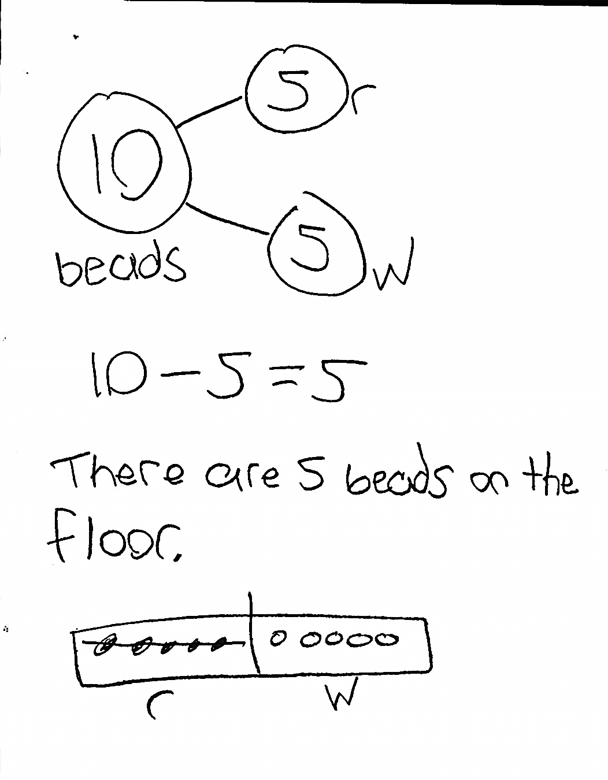
Application Problem (5 minutes)
There are 10 beads on the floor. There is the same number of red beads as white beads. A student picks up the white beads. How many beads are still on the floor? Write a number bond, number sentence, and a statement to share your solution. Make a math drawing to show how you know.
MP.1
Note: This problem enables students to apply their learning from the previous lesson, using doubles facts and 5-groups to solve subtraction. Additionally, the problem bridges to the current lesson, which will focus on decompositions of 10.
Concept Development (32 minutes)

NOTES ON
MULTIPLE MEANS
OF ACTION AND EXPRESSIONS:
Partner share time provides a good opportunity to facilitate student analysis of work, allowing students to evaluate the process and analyze errors. Careful choice of partners is important when students are developing these skills.

Materials: (T) Number bracelet of 10 beads (5 red, 5 white) (from Lesson 8), white board or easel
(S) Number bracelet, personal white boards
Before students come to the meeting area, slip 4 white beads off of the demonstration pipe cleaner and place them in a pocket, out of view of the students. Have students bring materials to the meeting area and sit in a semi-circle.

T: Oh, no! My bracelet broke and is missing some of its beads. (Show pipe cleaner to class, holding it far enough away so that students cannot touch each bead to count.)
T: How many beads are on my bracelet?
S: 6 beads.
T: Wait, how many beads do you have on your bracelet?
S: 10.
T: Use one movement of beads to find out how many fell off my bracelet.
S: (Push 6 away in one movement from the set to find 4.) Four of your beads fell off.
MP.7
T: Write a number sentence and number bond to show what just happened to my bracelet.
S: (Write 10 – 4 = 6, and then write the corresponding number bond.)
T: (Assign partners. Project 10 – 1.) Partner A, use your beads to show Partner B the answer to this problem. Write the number sentence and number bond on your board.
S: (Partner A pushes 1 bead away from the set, writes 10 – 1 = 9, and writes the number bond.)
T: How many beads are left?
S: 9 beads.
T: (Project 10 – 9.) Partner B, use your beads to show Partner A the answer to this problem. Write the number sentence and number bond on your board.
S: (Partner B pushes 9 beads away from the set, writes 10 – 9 = 1, and writes the number bond.)
T: Look at your stretched out bracelets. Talk with your partner: What’s the same or different about them? (Circulate and listen.)
S: (Discuss with partner.) They’re the same; mine is just facing the other way. When I flip my bracelet over, it’s exactly the same as my partner’s.
T: Look at your number bonds and equations. Talk with your partner: What’s the same or different about them? (Circulate and listen.)
S: (Discuss with partner.) Our number bonds are the same. Our number sentences use the same numbers and always start with 10 as the whole.
T: (Project 10 – 7.) Partner A, use your beads to show Partner B the answer to this problem. Write the number sentence and number bond on your board.
S: (Partner A pushes 7 beads away from the set, writes 10 – 7 = 3, and writes the number bond.)
T: Partner B, use your bracelet to show Partner A the other subtraction sentence, which matches your number bond. Write the number sentence.
S: (Partner B pushes 3 beads away from the set and writes 10 – 3 = 7.)
Repeat this process using 10 – 6, starting with Partner B so that Partner A has a hand at coming up with the other subtraction equation. If it seems necessary, continue the process two more times, using 10 – 8 and
10 – 3.

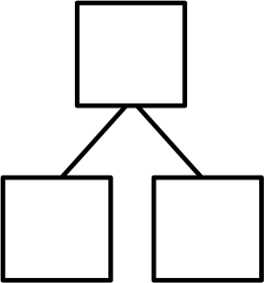
T: You’ve been writing some wonderful number bonds, taking apart 10. Now, I’m going to show you a number bond that’s not quite finished. (Show number bond with 10 in the total box, 4 in a part box, and the other part blank.) What part goes with 4 to make 10?
10

4
Unfinished number bond
S: 6.
T: Good. Now, write both subtraction sentences all by yourself.
S: (Write 10 – 4 = 6 and 10 – 6 = 4.)
Repeat this process with the following number bonds:
10
2
10
7

Problem Set (10 minutes)
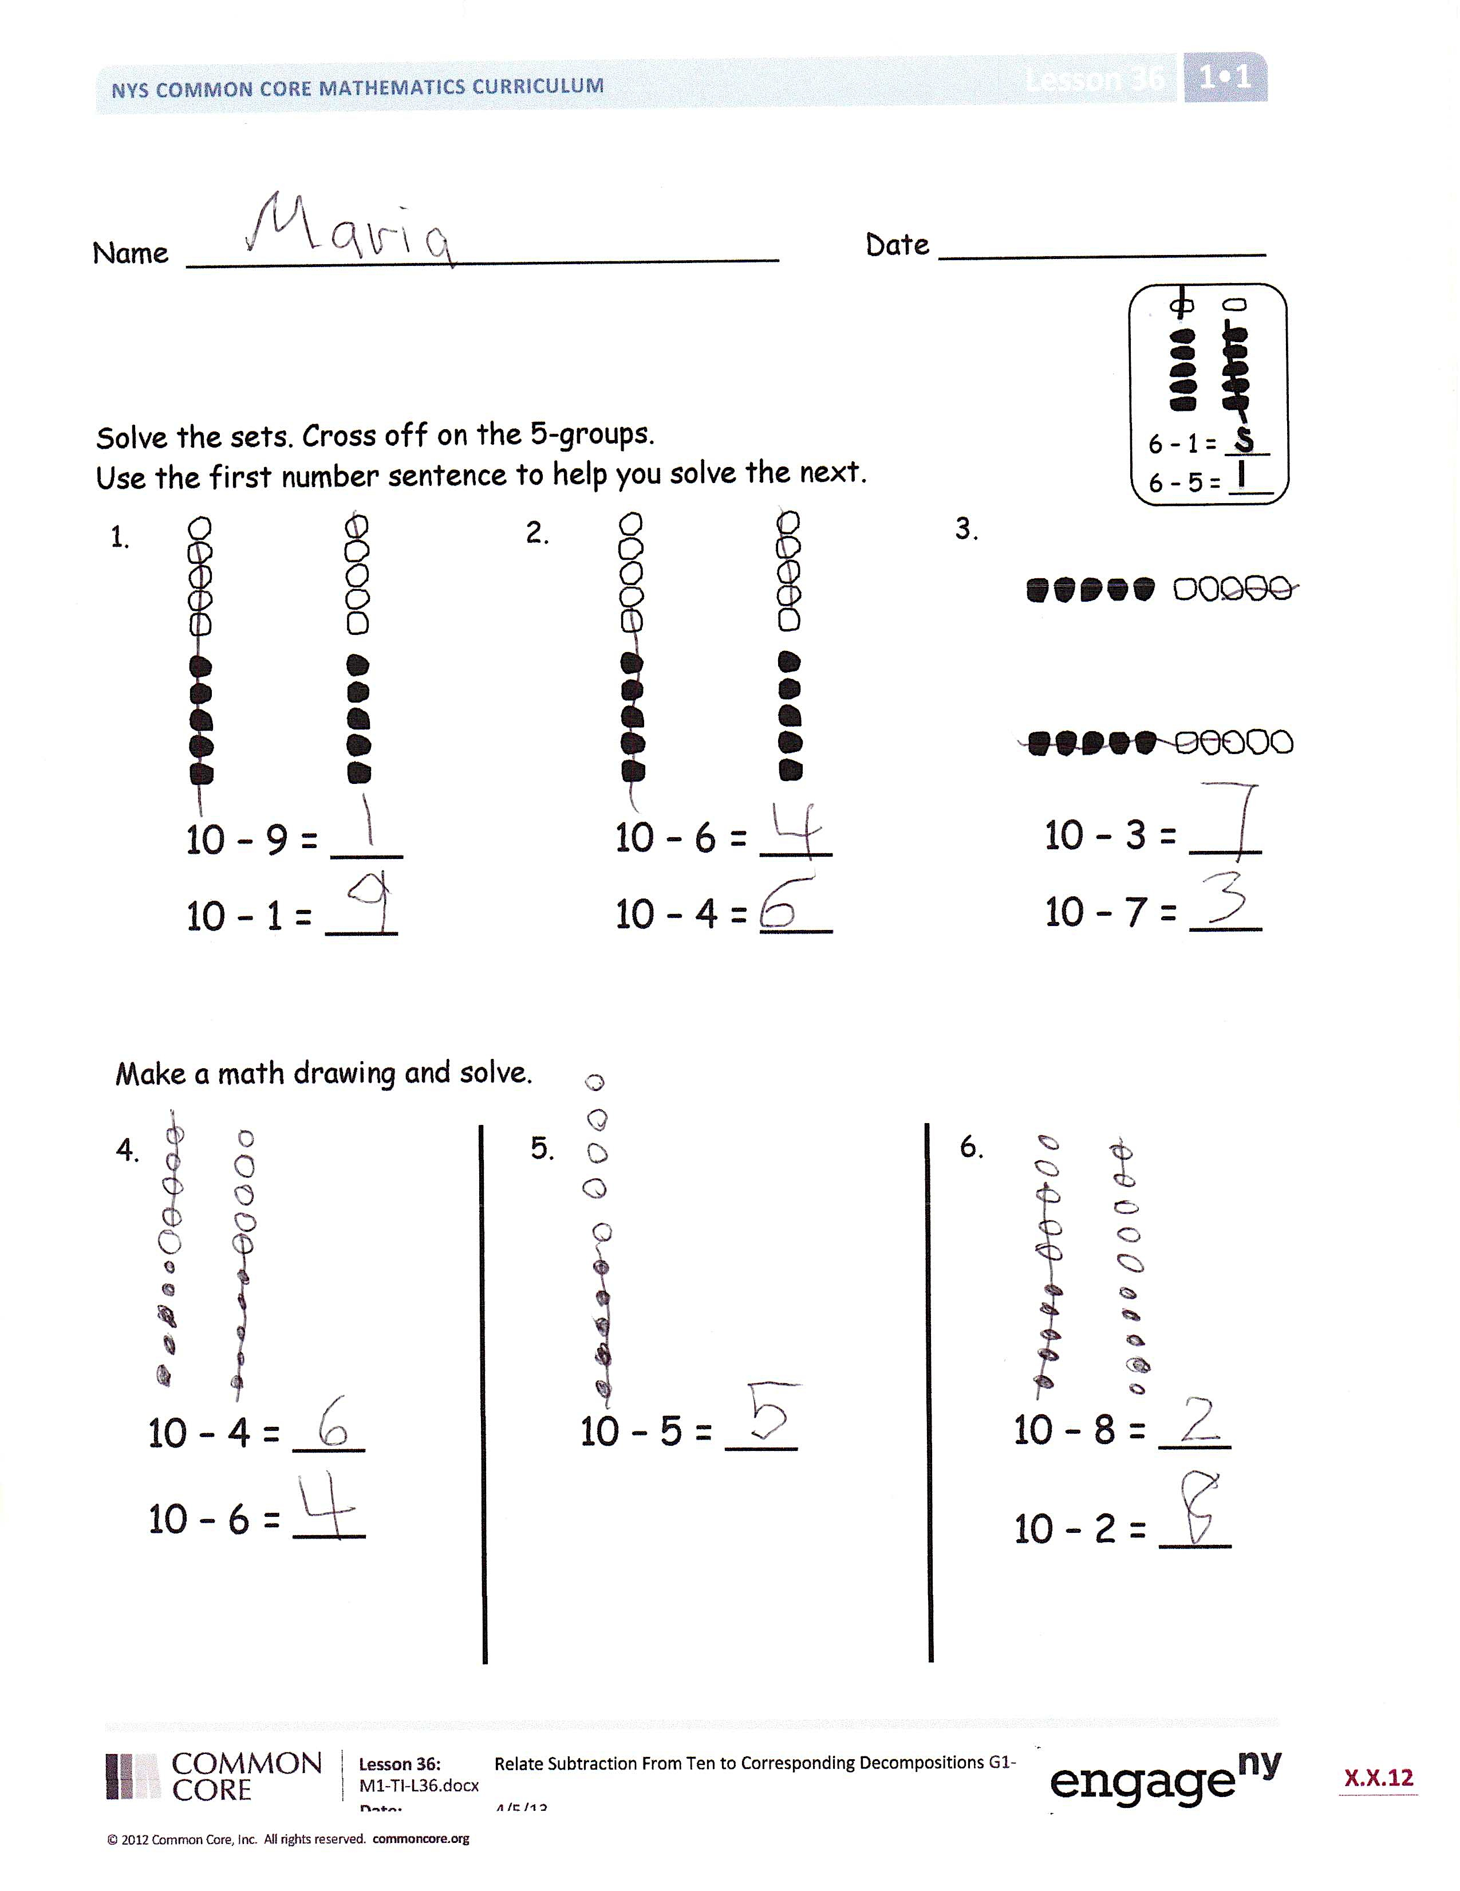
Students should do their personal best to complete the Problem Set within the allotted 10 minutes. For some classes, it may be appropriate to modify the assignment by specifying which problems they work on first. Some problems do not specify a method for solving. Students solve these problems using the RDW approach used for Application Problems.
Student Debrief (10 minutes)
Lesson Objective: Relate subtraction from 10 to corresponding decompositions.
The Student Debrief is intended to invite reflection and active processing of the total lesson experience.
Invite students to review their solutions for the Problem Set. They should check work by comparing answers with a partner before going over answers as a class. Look for misconceptions or misunderstandings that can be addressed in the Debrief.
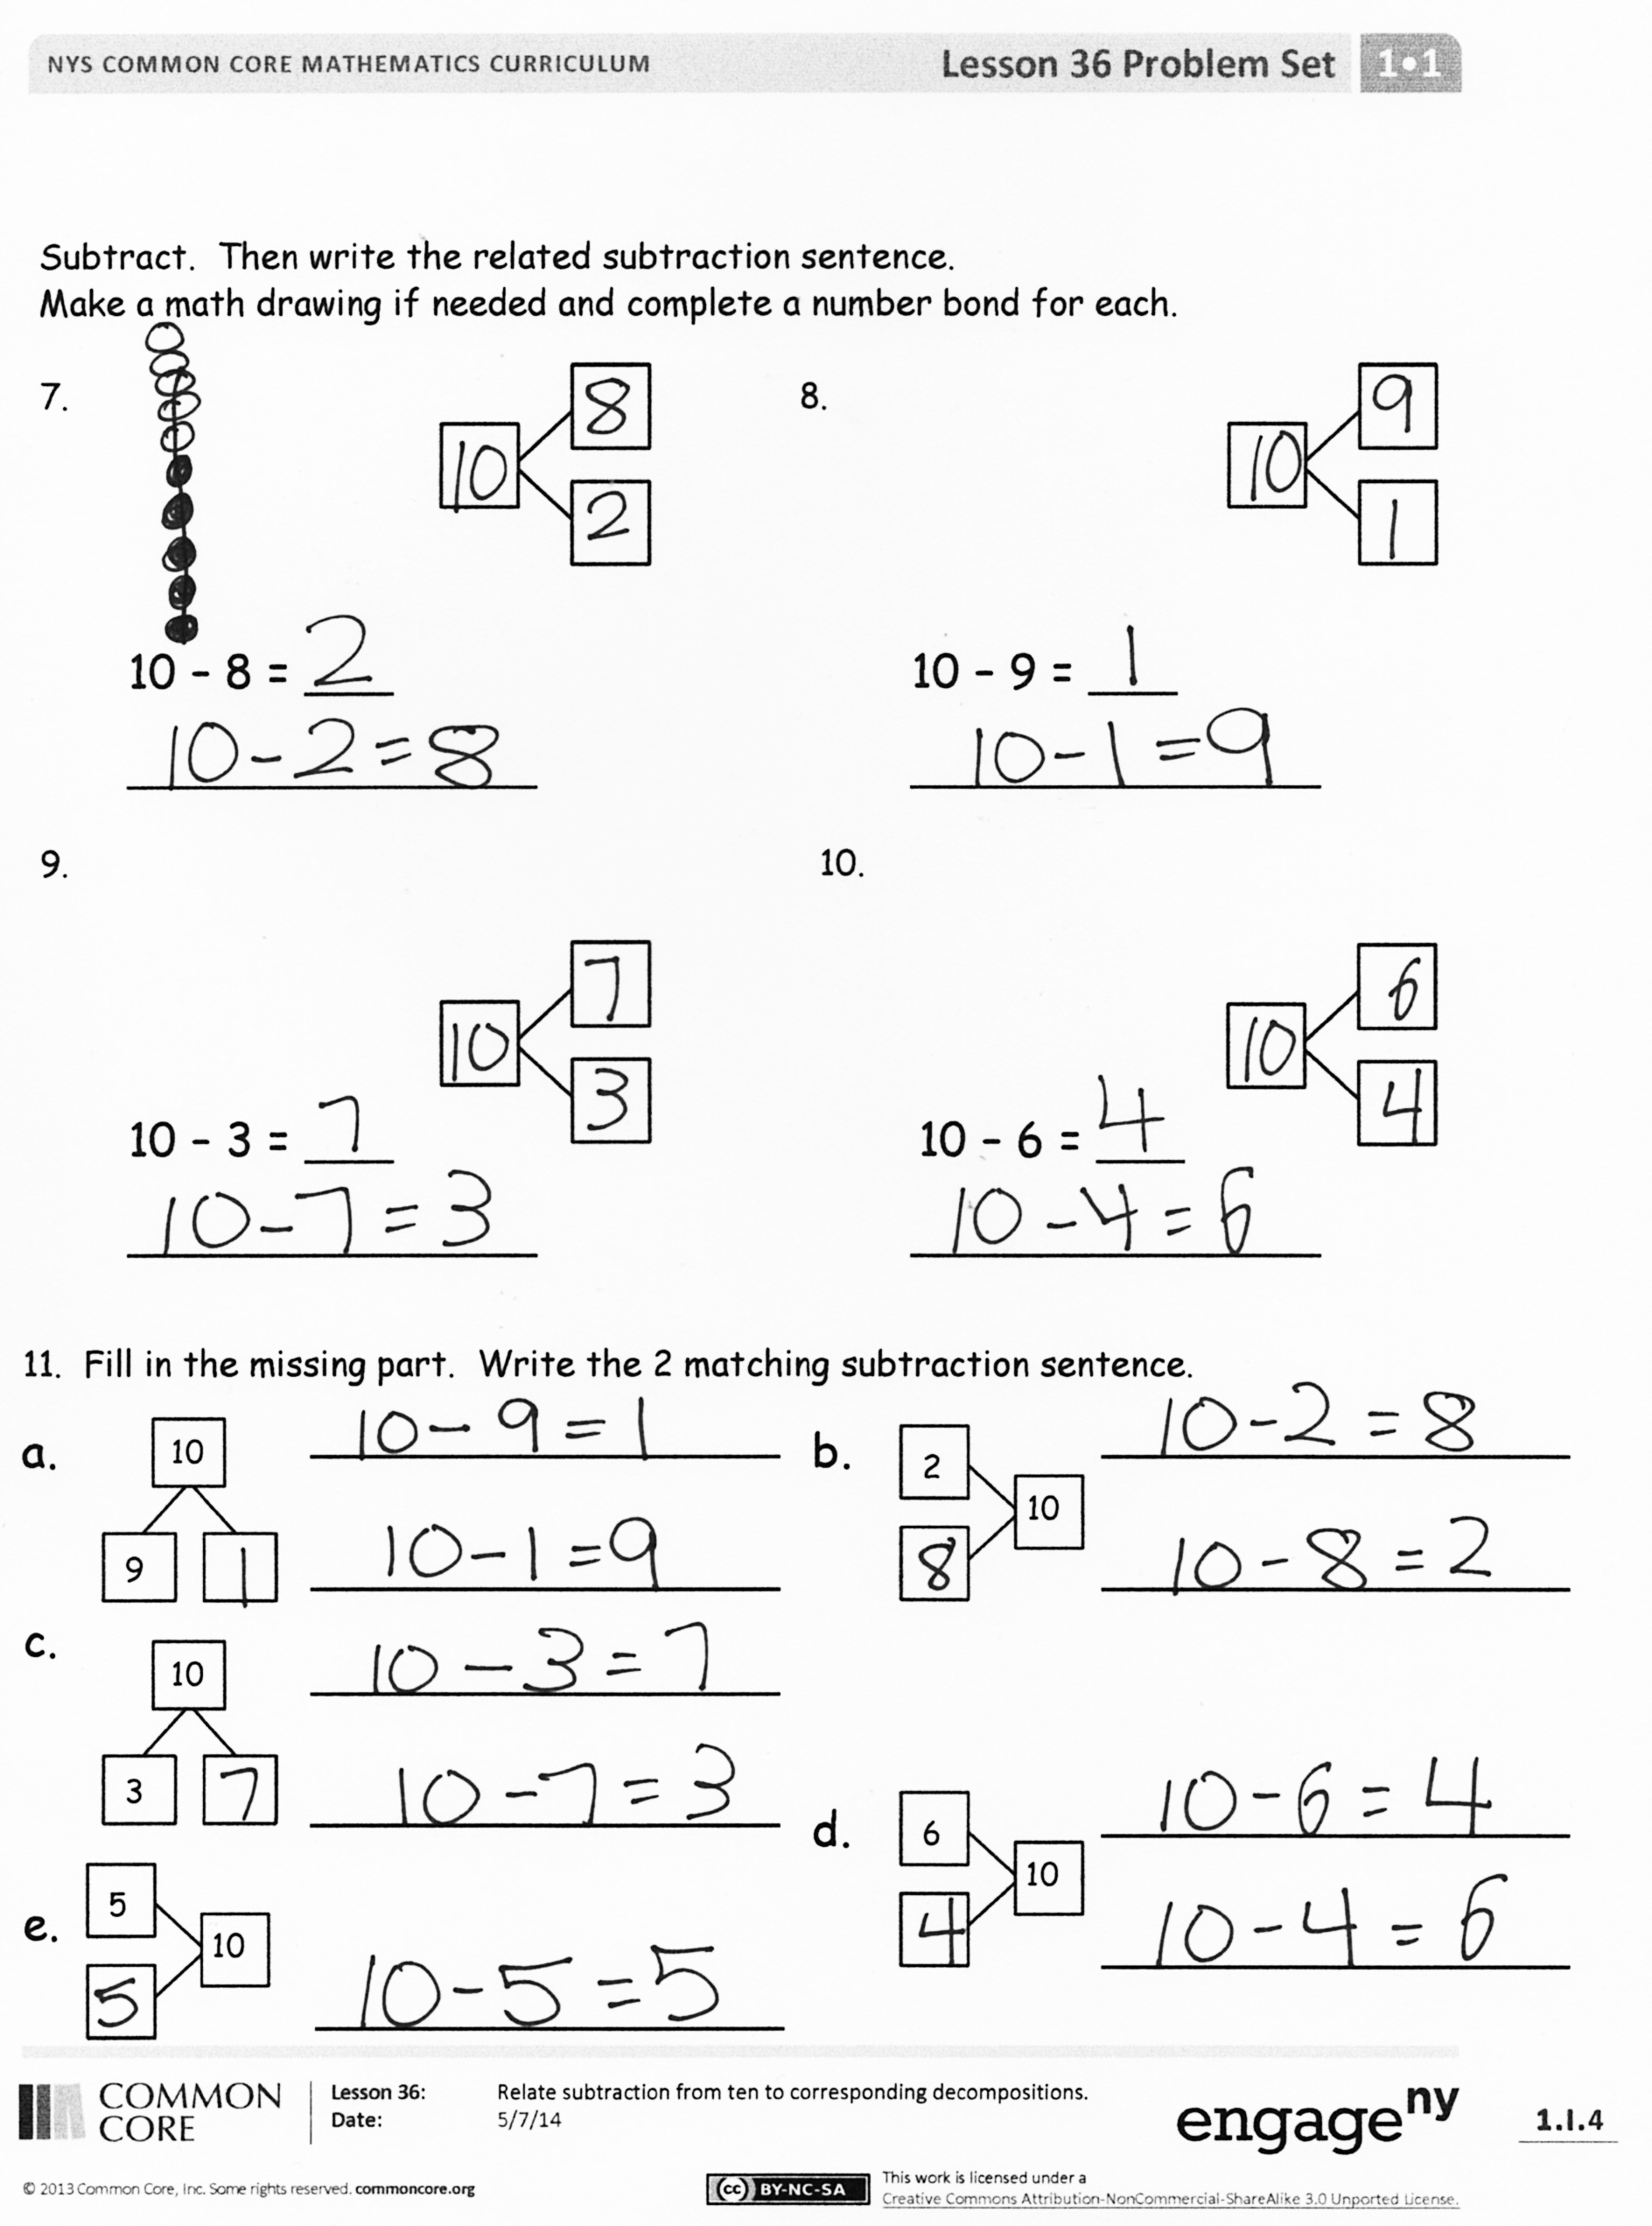
Guide students in a conversation to debrief the Problem Set and process the lesson.
You may choose to use any combination of the questions below to lead the discussion.
- How are 5-groups and our bracelets the same in appearance? What can they help us do? How are they different?
- Which Problem Set problem(s) are similar to the Application Problem? How do you know? How did you solve them similarly or differently?
- Look at Problem 4 and Problem 6. How could Problem 4 help you solve Problem 6? What’s different about them?
- Why is there only one number sentence for Problem 5?
- Explain to your partner how you decided to solve Problem 7, Problem 8, Problem 9, and Problem 10. What helped you? How did you solve them differently or similarly?
- Can we visualize rather than holding our bracelets or 5-groups?
Exit Ticket (3 minutes)
After the Student Debrief, instruct students to complete the Exit Ticket. A review of their work will help you assess the students’ understanding of the concepts that were presented in the lesson today and plan more effectively for future lessons. You may read the questions aloud to the students.

Name Date
Solve the sets. Cross off on the 5-groups.
Use the first number sentence to help you solve the next.
6 – 1 = ___
6 – 5 = ___
1. 2. 3.

10 – 9 = ___ 10 – 6 = ___ 10 – 3 = ___

10 – 1 = ___ 10 – 4 = ___ 10 – 7 = ___

Make a math drawing and solve.

4. 5. 6.

10 – 5 = ___

10 – 8 = ___

10 – 2 = ___

10 – 4 = ___

10 – 6 = ___

Subtract. Then, write the related subtraction sentence.
Make a math drawing if needed, and complete a number bond for each.
7. 8.

10 – 8 = ___ 10 – 9 = ___

______________ ______________

9. 10.

10 – 3 = ___ 10 – 6 = ___

______________ ______________

11. Fill in the missing part. Write the 2 matching subtraction sentences.
________________
________________
a. b.
10
2
10

9
________________
________________
c. d.
________________
10
6
________________
10

3
________________
________________
10
5
________________
e.
________________

Name Date

Fill in the missing part. Draw a math picture if needed. Write the 2 matching subtraction sentences.
1. 2. 3.
10

4
10

7
10

2

_________________ _________________ _______________
_________________ _________________ _______________

Name Date
Make a math drawing, and solve. Use the first number sentence to help you write a related number sentence that matches your picture.

1. 2. 3.
10-6=___
10-4= __

10 – 2 = ____ 10 – 1 = ___ 10 – 7 = ___
__ - __ = ___ __ - __ = ___ __ - __ = __
Subtract. Then, write the related subtraction sentence. Make a math drawing if needed, and complete a number bond for each.
4. 5. 6.

10 – 2 = ___ 10 – __ = 9 10 - ___ = 6
_________ ________ _________

7. 8.
10 – ___ = 1 ___ = 10 - 5
____________ ____________

9. Complete the number bond. Match the number bond to the related subtraction sentence. Write the other related subtraction number sentence.

10 – 5 = ___ ___ - ___ = ___
a.
10

6
10

9
10

7
10

8

b.
10 – 1 = ___ ___ - ___ = ___

c.
10 - 2 = ___ ___ - ___ = ___
d.
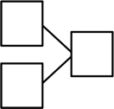
10
5
10 – 4 = ___ ___ - ___ = ___

e.
10 - 3 =___ ___ - ___ = ___

ten-frame

