Lesson 34
Objective: Model n – n and n – (n – 1) pictorially and as subtraction sentences.

Suggested Lesson Structure
 Fluency Practice (12 minutes)
 Application Problem (5 minutes)
 Concept Development (33 minutes)
 Student Debrief (10 minutes)
Total Time (60 minutes)
Fluency Practice (12 minutes)
- 1 Less, 2 Less 1.OA.6 (2 minutes)
- Sprint: n – 0 and n – 1 1.OA.6 (10 minutes)
1 Less, 2 Less (2 minutes)
Note: This activity builds on the previous day’s lesson and prepares students to solve today’s Application Problem. It builds on the counting sequence within 120.
T: I’ll say a number. You say 1 less at the signal.
Use the following suggested sequence: 4, 14, 24, 9, 19, 20, 10, 20, 30, 25, 35, 45, 63, 73, 83, 81, 91, and 101. When ready, change to 2 less.
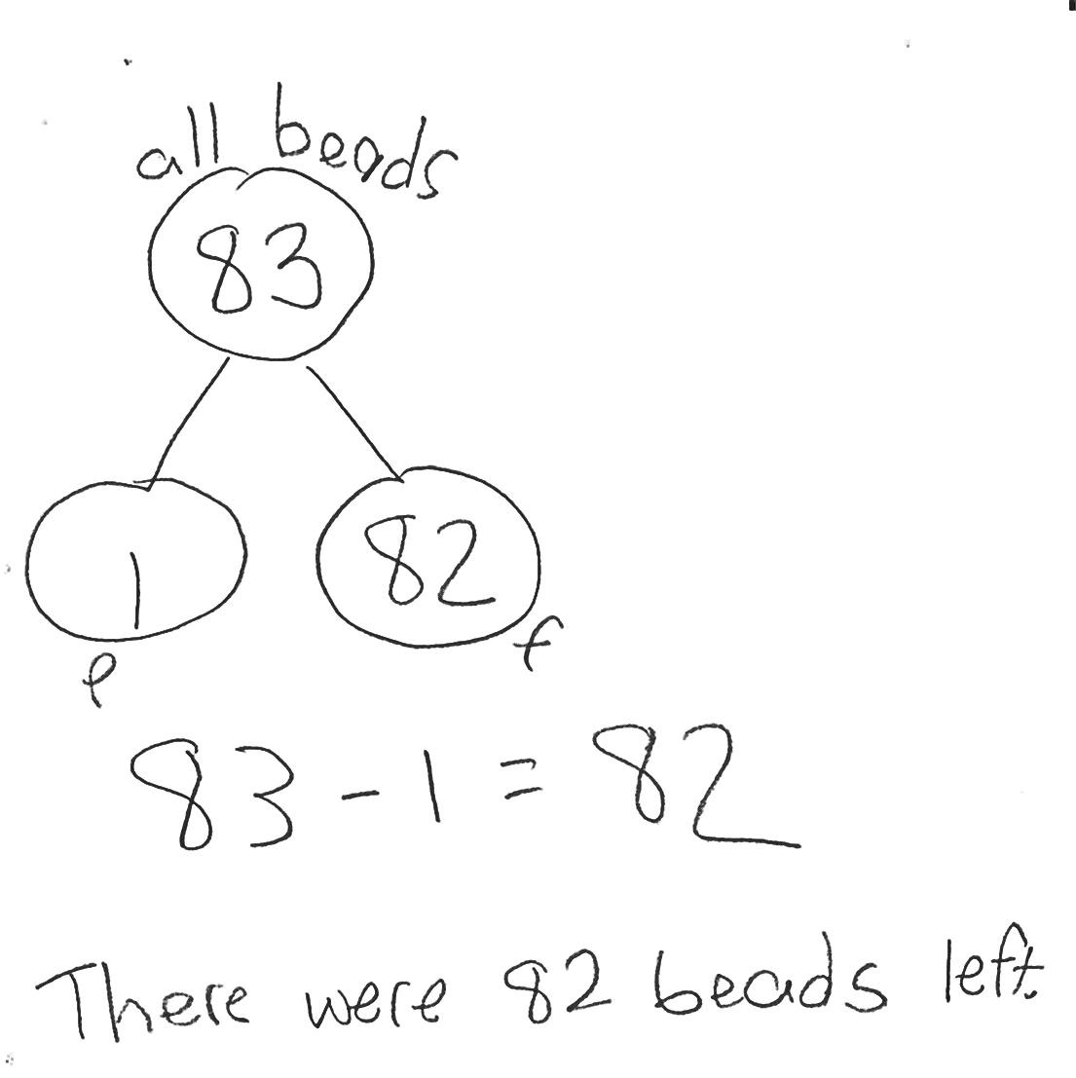
Sprint: n – 0 and n – 1 (10 minutes)
Materials: (S) n – 0 and n – 1 Sprint
Note: This activity addresses the core fluency objective for Grade 1 of adding and subtracting within 10.
Application Problem (5 minutes)
Eighty-three beads spill on the floor. A student picks up 1 bead. How many beads are still on the floor? Write a number bond, number sentence, and a statement to share your solution.
Extension: If a second child picks up 10 more beads, how many beads will remain on the floor? Use number bonds to show how you know.
Note: This problem enables students to apply their learning from the previous lesson to a quantity they cannot visualize easily. Instead, students will use their understanding of subtracting 1 along with their knowledge of the counting sequence within 120.
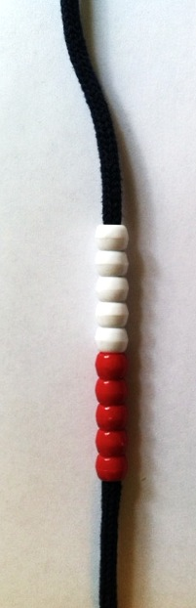
Concept Development (33 minutes)
Materials: (T) Number bracelet of 10, white board or easel (S) Number bracelet of 10 beads (5 red, 5 white) (see Lesson 8), personal white board
Have students bring materials to meeting area and sit in a semi-circle.
T: Stretch out your bracelet into a long line of beads like we did in our last lesson.

NOTES ON
MULTIPLE MEANS
OF REPRESENTATION:
Providing opportunities for all students to work at the concrete level facilitates student discovery of patterns and structures in their math work. Allow time for students to explore with the number bracelets throughout the week to help solidify 5-groups and to discourage counting all.

T/S: (Adjust pipe cleaner into a straight line.)
T: How many beads do we have in this set?
S: 10 beads!
T: Take 10 beads away.
T/S: (Push 10 beads to the other side of the pipe cleaner.)
T: How many beads do we have now?
S: Zero!
T: Write the number sentence to show what you did. Write the number bond also.
T/S: (Write 10 – 10 = 0 and number bond.)
T: Start with 8 beads now.
T/S: (Push 8 beads back to main section of the pipe cleaner.)
Repeat the process using the following suggested sequence:
8 – 8, 7 – 7, and 6 – 6.

NOTES ON
MULTIPLE MEANS
OF ACTION AND EXPRESSION:
Provide students with a variety of ways to respond. Some students will need concrete models to show their understanding, while others would benefit from a partner share.

T: How are these problems similar to each other?
S: We are taking away the total amount.
T: When we have a number and then subtract that exact number, what part are we left with?
S: Zero!
T: Let’s try something different. Start with 10 beads again.
T/S: (Reset pipe cleaner to show all 10 beads as a set.)
T: Take away 9 beads.
T/S: (Push 9 beads slightly farther down the pipe cleaner.)
T: How many beads do we have left?
S: 1 bead!
T: Write the number sentence to show what you did. Write the number bond also.
T/S: (Write 10 – 9 = 1.)
T: Start with 9 beads now.
Repeat the process using the following suggested sequence: 9 – 8, 8 – 7, and 7 – 6. Be sure to keep these number sentences on the board for discussion.
T: How are these problems similar to each other? Turn and talk to your partner. (Circulate and listen.)
S: (Discuss.)
T: How are these problems similar?
MP.8
S: The answer is 1 every time!
T: Let’s try a few more. This time, try to complete the number sentence and number bond without using the beads. Then, check your answer using your beads.
Repeat the process again using expressions that vary between subtracting all and subtracting all but one through the following suggested sequence: 6 – 6, 6 – 5, 8 – 8, 8 – 7, 9 – 9, and 9 – 8.
T: When you are working today, see if you can figure out how to tell quickly that the answer to a subtraction problem will be 1 or that the answer will be 0.
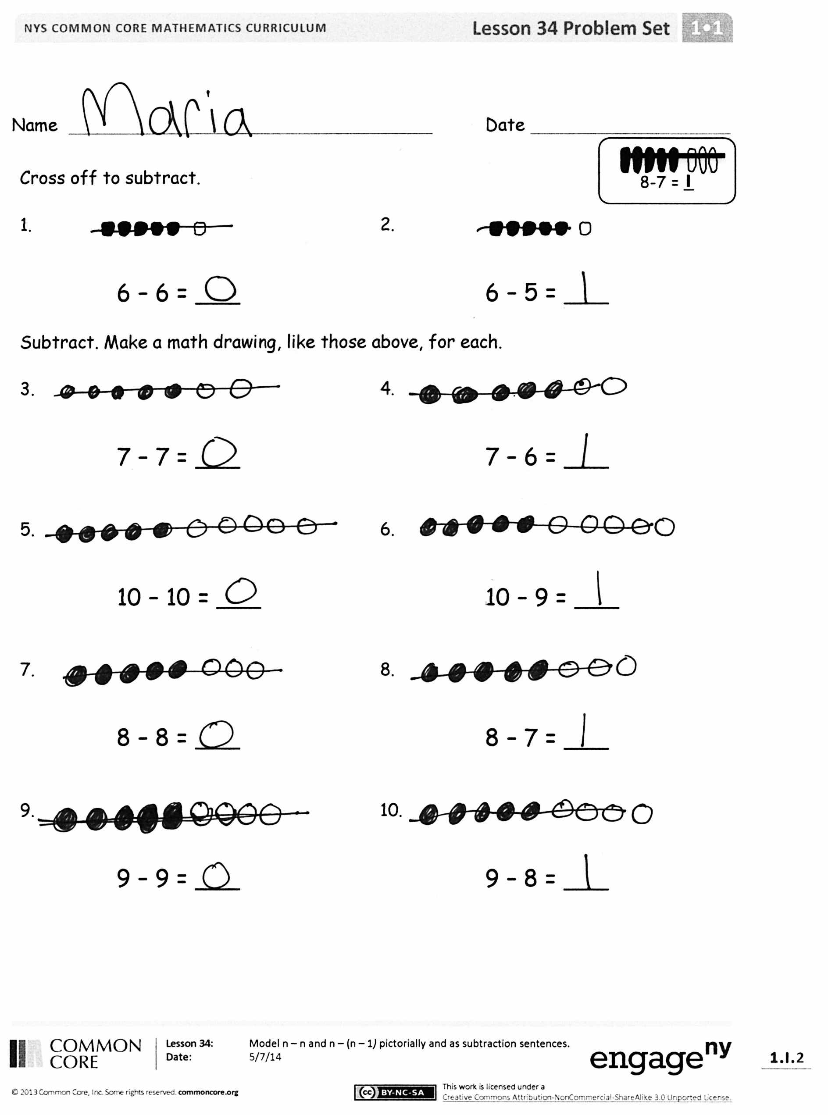
Problem Set (10 minutes)
Students should do their personal best to complete the Problem Set within the allotted 10 minutes. For some classes, it may be appropriate to modify the assignment by specifying which problems they work on first. Some problems do not specify a method for solving. Students solve these problems using the RDW approach used for Application Problems.
Student Debrief (10 minutes)
Lesson Objective: Model n – n and n – (n – 1) pictorially and as subtraction sentences.
The Student Debrief is intended to invite reflection and active processing of the total lesson experience.
Invite students to review their solutions for the Problem Set. They should check work by comparing answers with a partner before going over answers as a class. Look for misconceptions or misunderstandings that can be addressed in the Debrief.
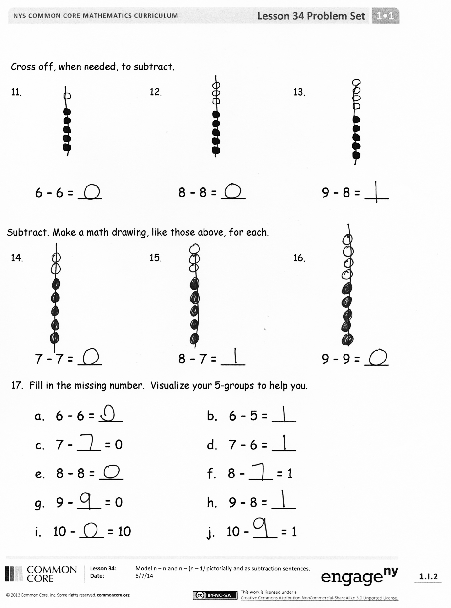
Guide students in a conversation to debrief the Problem Set and process the lesson.
You may choose to use any combination of the questions below to lead the discussion.
- What pattern did you notice between Problems 3 and 10?
- How were your drawings different in Problems 5 and 6?
- How did the Application Problem connect to today’s lesson?
- How can solving 10 – 10 help you solve
1,272 – 1,272, 10,629 – 10,629, or
1,000,000 – 1,000,000?
- How can solving 9 – 8 help you solve
759 – 758…2,478 – 2,477 and
1,000,001 – 1,000,000?
Exit Ticket (3 minutes)
After the Student Debrief, instruct students to complete the Exit Ticket. A review of their work will help you assess the students’ understanding of the concepts that were presented in the lesson today and plan more effectively for future lessons. You may read the questions aloud to the students.

Name Date
Number correct:
A
*Write the missing number from each subtraction sentence. Pay attention to the = sign.
1 | 2 – 1 = ☐ |  | 16 | ☐ = 10 - 0
2 | 1 – 1 = ☐ |  | 17 | ☐ = 10 - 1
3 | 1 – 0 = ☐ |  | 18 | ☐ = 9 - 1
4 | 3 – 1 = ☐ |  | 19 | ☐ = 7 - 1
5 | 3 – 0 = ☐ |  | 20 | ☐ = 6 - 1
6 | 4 – 0 = ☐ |  | 21 | ☐ = 6 - 0
7 | 4 – 1 = ☐ |  | 22 | ☐ = 8 - 0
8 | 5 – 1 = ☐ |  | 23 | 8 - ☐ = 8
9 | 6 – 1 = ☐ |  | 24 | ☐ - 0 = 8
10 | 6 – 0 = ☐ |  | 25 | 7 - ☐ = 6
11 | 8 – 0 = ☐ |  | 26 | 7 = 7 - ☐
12 | 10 – 0 = ☐ |  | 27 | 9 = 9 - ☐
13 | 9 – 0 = ☐ |  | 28 | ☐ - 1 = 7
14 | 9 – 1 = ☐ |  | 29 | ☐ - 0 = 8
15 | 10 – 1 = ☐ |  | 30 | 9 = ☐ - 1
Name Date
Number correct:
B
*Write the missing number from each subtraction sentence. Pay attention to the = sign.
1 | 3 – 1 = ☐ |  | 16 | ☐ = 10 - 1
2 | 2 – 1 = ☐ |  | 17 | ☐ = 9 - 1
3 | 1 – 1 = ☐ |  | 18 | ☐ = 7 - 1
4 | 1 – 0 = ☐ |  | 19 | ☐ = 7 - 0
5 | 2 – 0 = ☐ |  | 20 | ☐ = 8 - 0
6 | 4 – 0 = ☐ |  | 21 | ☐ = 10 - 0
7 | 5 – 1 = ☐ |  | 22 | ☐ = 9 - 1
8 | 7 – 1 = ☐ |  | 23 | 9 - ☐ = 8
9 | 8 – 1 = ☐ |  | 24 | ☐ - 1 = 8
10 | 9 – 0 = ☐ |  | 25 | 7 - ☐ = 6
11 | 10 – 0 = ☐ |  | 26 | 6 = 7 - ☐
12 | 7 – 0 = ☐ |  | 27 | 9 = 9 - ☐
13 | 8 – 0 = ☐ |  | 28 | ☐ - 0 = 9
14 | 10 – 1 = ☐ |  | 29 | ☐ - 0 = 10
15 | 9 – 1 = ☐ |  | 30 | 8 = ☐ - 1

Name Date
8-7 = _

Cross off to subtract.

1. 2.

6 – 6 = ___ 6 – 5 = ___

Subtract. Make a math drawing, like those above, for each.

3. 4.

7 – 7 = ___ 7 – 6 = ___

5. 6.

10 – 10 = ___ 10 – 9 = ___

7. 8.

8 – 8 = ___ 8 – 7 = ___

9. 10.

9 – 9 = ___ 9 – 8 = ___

Cross off, when needed, to subtract.

11. 12. 13.

6 – 6 = ___ 8 – 8 = ___ 9 – 8 = ___

Subtract. Make a math drawing, like those above, for each.

14. 15. 16.

7 – 7 = ___ 8 – 7 = ___ 9 – 9 = ___

17. Fill in the missing number. Visualize your 5-groups to help you.

a. 6 – 6 = ___ b. 6 – 5 = ___
c. 7 – ___ = 0 d. 7 – 6 = ___
e. 8 – 8 = ___ f. 8 – ___ = 1
g. 9 – ___ = 0 h. 9 – 8 = ___

i. 10 – ___ = 10 j. 10 – ___ = 1

Name Date
Make 5-group drawings to show the subtraction.
1. 2.

9 – ___ = 1 0 = 10 – ___

3. 4.

1 = ___ – 7 0 = ___ – 9

Name Date
7-6 = _
Cross off to subtract.
- 2.

10 – 10 = ____ 9 – 8 = ____

Make a 5-group drawing like those above. Show the subtraction.

3. 4.
1 = ___ – 7 8 – ___ = 0

5. 6.
0 = ___ – 7 6 – ___ = 1

Make a 5-group drawing like the model for each problem. Show the subtraction.
9 – 9 = __
7. 8.

9 – ___ = 1 0 = 8 – ___
Write the subtraction number sentence to match the 5-group drawing.
9. 10. 11.

___ - ___ = ___ ___ - ___ = ___ ___ - ___ = ___

12. 13.

___ – ___ = ___ ___ – ___ = ___

14. Fill in the missing number. Visualize your 5-groups to help you.

a. 7 – ___ = 0 b. 1 = 7 – ___

c. 8 – ___ = 1 d. 6 – ___ = 0

e. 0 = 9 – ___ f. 1 = 10 – ___

g. 10 - ___ = 0 h. 9 – ___ = 1

