|  |
| --- |
|  |

Lesson 15: A Synthesis of Representations of Equivalent Ratio Collections

Student Outcomes

* Students associate with each ratio the ordered pair and plot it in the – coordinate plane.
* Given a ratio table, students plot the ratios in the plane and observe that they lie on a line through the origin. Students conclude that the coordinates in the line satisfy , where is the value of an associated ratio.

Classwork

Exploratory Challenge

Based on their previous knowledge from earlier lessons in this module, and working in predetermined groups, students complete Exercises 1–7 independently with ample time to share their collaboration with the entire class.

Exploratory Challenge

At the end of this morning’s news segment, the local television station highlighted area pets that need to be adopted. The station posted a specific website on the screen for viewers to find more information on the pets shown and the adoption process. The station producer checked the website two hours after the end of the broadcast and saw that the website had views. One hour after that, the website had views.

Exercise 1 (3 minutes)

Exercise 1

Create a table to determine how many views the website probably had one hour after the end of the broadcast based on how many views it had two and three hours after the end of the broadcast. Using this relationship, predict how many views the website will have , , and hours after the end of the broadcast.

|  |  |
| --- | --- |
| Hours | Views |
|  |  |
|  |  |
|  |  |
|  |  |
|  |  |
|  |  |

Exercise 2 (2 minutes)

Exercise 2

What is the constant number, , that makes these ratios equivalent?

Using an equation, represent the relationship between the number of views, , the website received and the number of hours, , after this morning's news broadcast.

Exercise 3 (2 minutes)

Exercise 3

Use the table created in Exercise 1 to identify sets of ordered pairs that can be graphed.

, ,,, ,

Exercise 4 (5 minutes)

Exercise 4

Use the ordered pairs you created to depict the relationship between hours and number of views on a coordinate plane. Label your axes and create a title for the graph. Do the points you plotted lie on a line? If so, draw the line through the points.

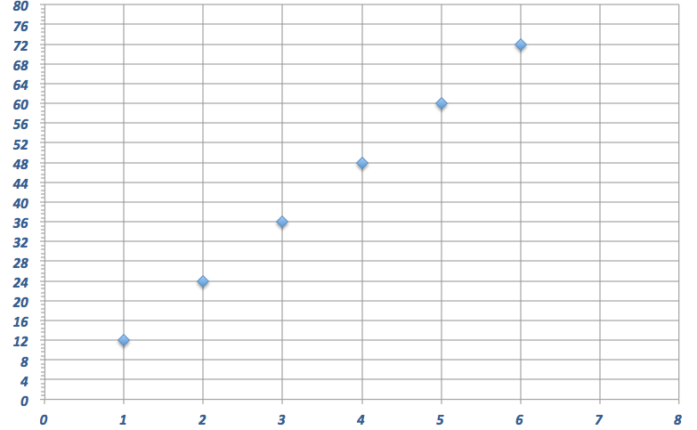

***Views per Hour***

***Number of Hours***

***Number of Views***

Exercise 5 (8 minutes)

Exercise 5

Predict how many views the website will have after twelve hours. Use at least two representations (e.g., tape diagram, table, double number line diagram) to justify your answer.

***Views***

***Hours***

|  |  |
| --- | --- |
| Hours | Views |
|  |  |
|  |  |
|  |  |
|  |  |
|  |  |
|  |  |
|  |  |
|  |  |
|  |  |
|  |  |
|  |  |
|  |  |

***Hours***

***Views***

Exercise 6 (10 minutes)

Exercise 6

Also on the news broadcast, a chef from a local Italian restaurant demonstrated how he makes fresh pasta daily for his restaurant. The recipe for his pasta is below:

eggs, beaten

teaspoon salt

cups all-purpose flour

tablespoons water

tablespoons vegetable oil

Determine the ratio of the number of tablespoons of water to the number of eggs.

Provided the information in the table below, complete the table to determine ordered pairs. Use the ordered pairs to graph the relationship of the number of tablespoons of water to the number of eggs.

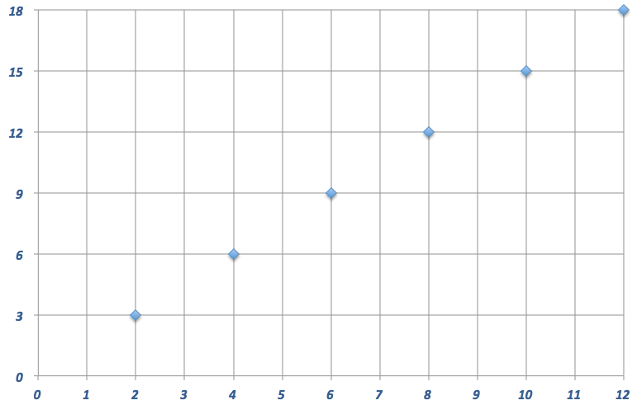

***Pasta Recipe***

***Tablespoons of Water***

***Number of Eggs***

|  |  |  |
| --- | --- | --- |
| Tablespoons of Water | Number of Eggs |  |
|  |  |  |
|  |  |  |
|  |  |  |
|  |  |  |
|  |  |  |
|  |  |  |

What would you have to do to the graph in order to find how many eggs would be needed if the recipe was larger and called for tablespoons of water?

Extend the graph.

Demonstrate on your graph.

How many eggs would be needed if the recipe called for tablespoons of water?

Exercise 7 (5 minutes)

Exercise 7

Determine how many tablespoons of water will be needed if the chef is making a large batch of pasta and the recipe increases to eggs. Support your reasoning using at least one diagram you find applies best to the situation, and   
explain why that tool is the best to use.

Answers may vary but should include reasoning for each tool. For example, extending the table/double number line diagram because values were already given to find the pattern or using a tape diagram to determine the equivalent ratios.

***Eggs***

***Water***

|  |  |
| --- | --- |
| Tablespoons of Water | Number of Eggs |
|  |  |
|  |  |
|  |  |
|  |  |
|  |  |
|  |  |
|  |  |
|  |  |
|  |  |
|  |  |
|  |  |
|  |  |

***Water***

***Eggs***

Closing (5 minutes)

Finish any leftover student discussion and presentation.

* Describe the advantages and disadvantages of using each of the representations of equivalent ratios: table, double number line diagram, equation, and graph.
  + *Answers will vary but should include the following: tables allow for organization and prediction of unknown values; double number line diagrams help make visible that there are many, even infinitely many, pairs of numbers in the same ratio; an equation is an efficient way to understand the relationship between the first value and the second value and allows us to simply multiply or divide to find any equivalent ratio; a graph is a visual way to immediately see the relationship between two values.*

Lesson Summary

**There are several ways that we can represent the same collection of equivalent ratios. These include ratio tables, tape diagrams, double number line diagrams, equations, and graphs on coordinate planes.**

Exit Ticket (5 minutes)

Name ___________________________________________________ Date____________________

Lesson 15: A Synthesis of Representations of Equivalent Ratio Collections

Exit Ticket

Jen and Nikki are making bracelets to sell at the local market. They determined that each bracelet would have eight beads and two charms.

Complete the table below to show the ratio of the number of charms to the number of beads.

|  |  |  |  |  |  |
| --- | --- | --- | --- | --- | --- |
| Charms |  |  |  |  |  |
| Beads |  |  |  |  |  |

Create ordered pairs from the table and plot the pairs on the graph below. Label the axes of the graph and provide a title.



Exit Ticket Sample Solutions

Jen and Nikki are making bracelets to sell at the local market. They determined that each bracelet would have eight beads and two charms.

Complete the table below to show the ratio of the number of charms to the number of beads.

|  |  |  |  |  |  |
| --- | --- | --- | --- | --- | --- |
| Charms |  |  |  |  |  |
| Beads |  |  |  |  |  |

Create ordered pairs from the table and plot the pairs on the graph below. Label the axes of the graph and provide a title.

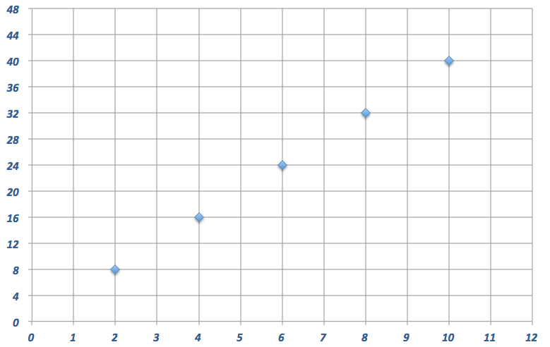

***Number of Charms to Number of Beads***

***Number of Charms***

***Number of Beads***

Problem Set Sample Solutions

1. The producer of the news station posted an article about the high school’s football championship ceremony on a new website. The website had views after four hours. Create a table to show how many views the website would have had after the first, second, and third hours after posting, if the website receives views at the same rate. How many views would the website receive after hours?

|  |  |
| --- | --- |
| Hours | Views |
|  |  |
|  |  |
|  |  |
|  |  |
|  |  |

1. Write an equation that represents the relationship from Problem 1. Do you see any connections between the equations you wrote and the ratio of the number of views to the number of hours?
2. Use the table in Problem 1 to make a list of ordered pairs that you could plot on a coordinate plane.

, ,,,

1. Graph the ordered pairs on a coordinate plane. Label your axes and create a title for the graph.

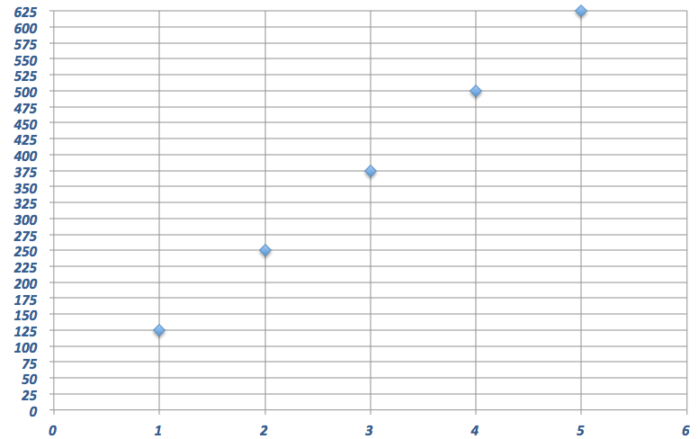

***Website Hours and Views***

***Number of Hours***

***Number of Views***

1. Use multiple tools to predict how many views the website would have after hours.

Answers may vary but could include all representations from the module. The correct answer is views.

Graph Reproducible

