Lesson 14: From Ratio Tables, Equations, and Double Number Line Diagrams to Plots on the Coordinate Plane

Student Outcomes
- Students associate with each ratio $A:B$ the ordered pair $(A, B)$ and plot it in the $x$–$y$ coordinate plane.
- Students represent ratios in ratio tables, equations, and double number line diagrams and then represent those ratios in the coordinate plane.

Lesson Notes
This lesson serves as a means for students to associate ratios with ordered pairs and plot the ordered pairs in the $x$–$y$ coordinate plane. Students will graph collected data on the coordinate plane. Collected data falls within two categories: discrete data and continuous data. Discrete data is a set of data values with unconnected data points and often represents data that is countable and often finite. In this lesson, students will represent non-integer data on the coordinate plane using points that are not connected with a ray. Continuous data can represent an unlimited selection of data and include integers. The lesson starts with an example that uses data that is continuous, allowing students to connect the data points with a ray. Students are able to navigate through the graph in order to analyze data, predict values and find missing values based on the ratio relationship. A student is not required to know the vocabulary of collected data, nor is collected data part of the outcomes of the lesson. The information provided is for reference.

Classwork
Representing Ratios: Using knowledge from previous lessons in this module, students work together in predetermined groups to complete the table to satisfy the missing values, create a double number line diagram to support the values, and develop an equation to support the values. Pose the following scenario:
Kelli is traveling by train with her soccer team from Yonkers, NY to Morgantown, WV for a tournament. The distance between Yonkers and Morgantown is $400$ miles. The total trip will take $8$ hours. The train schedule is provided below:
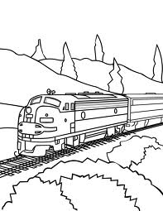
Leaving Yonkers, NY
Destination | Distance
Allentown, PA | $100$ miles
Carlisle, PA | $200$ miles
Berkeley Springs, WV | $300$ miles
Morgantown, WV | $400$ miles
Leaving Morgantown, WV
Destination | Distance
Berkeley Springs, WV | $100$ miles
Carlisle, PA | $200$ miles
Allentown, PA | $300$ miles
Yonkers, NY | $400$ miles

Exercises (10 minutes)
Exercises
- Create a table to show the time it will take Kelli and her team to travel from Yonkers to each town listed in the schedule assuming that the ratio of the amount of time traveled to the distance traveled is the same for each city. Then, extend the table to include the cumulative time it will take to reach each destination on the ride home.
Hours | Miles
$$2$$ | $$100$$
$$4$$ | $$200$$
$$6$$ | $$300$$
$$8$$ | $$400$$
$$10$$ | $$500$$
$$12$$ | $$600$$
$$14$$ | $$700$$
$$16$$ | $$800$$

- Create a double number line diagram to show the time it will take Kelli and her team to travel from Yonkers to each town listed in the schedule. Then, extend the double number line diagram to include the cumulative time it will take to reach each destination on the ride home. Represent the ratio of the distance traveled on the round trip to the amount of time taken with an equation.
Hours
Miles
$$2$$
$$4$$
$$6$$
$$8$$
$$10$$
$$12$$
$$14$$
$$16$$
$$0$$
Using the information from the double number line diagram, how many miles would be traveled in one hour?
$$0$$
$$100$$
$$200$$
$$300$$
$$500$$
$$400$$
$$600$$
$$700$$
$$800$$
$50$
How do you know?
If the train is moving at a constant speed, half of $2$ hours is $1$ hour, and half of $100$ miles is $50$ miles.

Example 1 (25 minutes)
Example 1
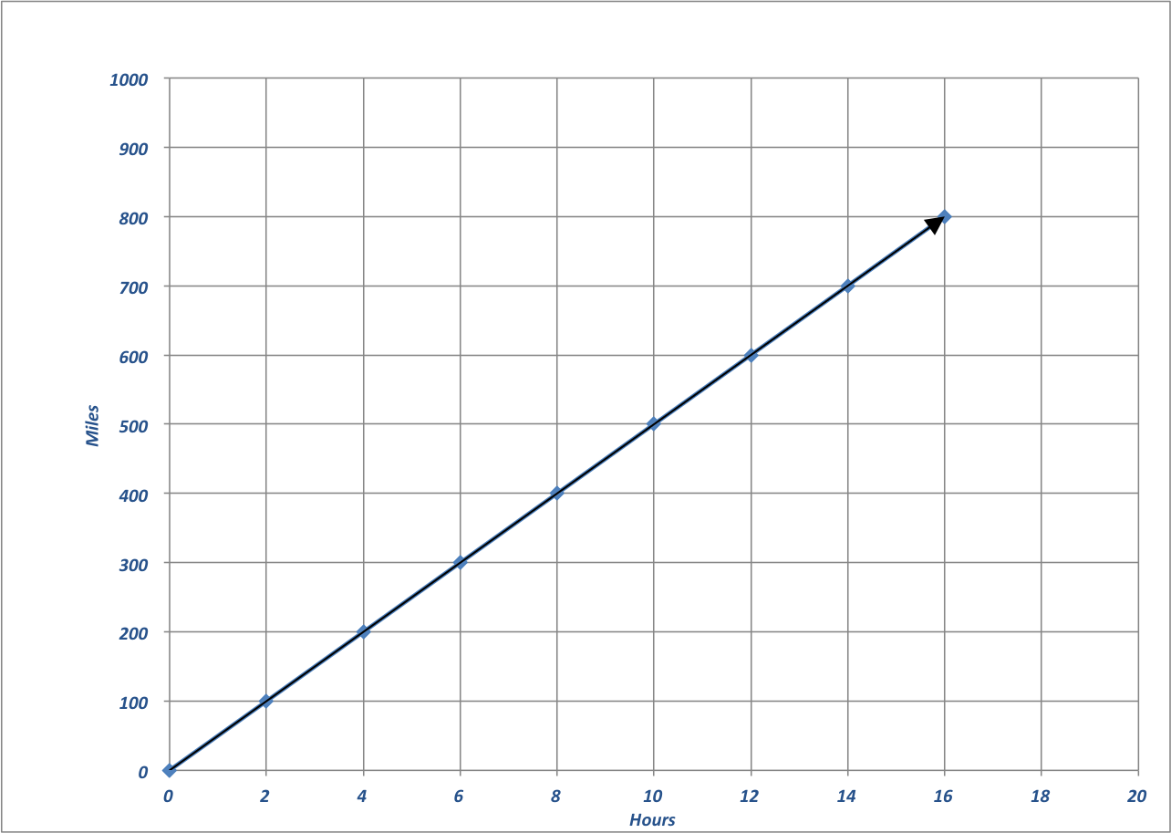
Dinner service starts once the train is $250$ miles away from Yonkers. What is the minimum time the players will have to wait before they can have their meal?
Hours
Time and Distance of Travel
Miles

Hours | Miles | Ordered Pairs
$$2$$ | $$100$$ | $$(2, 100)$$
$$4$$ | $$200$$ | $$(4, 200)$$
$$6$$ | $$300$$ | $$(6, 300)$$
$$8$$ | $$400$$ | $$(8, 400)$$
$$10$$ | $$500$$ | $$(10, 500)$$
$$12$$ | $$600$$ | $$(12, 600)$$
$$14$$ | $$700$$ | $$(14, 700)$$
$$16$$ | $$800$$ | $$(16, 800)$$

The minimum time is $5$ hours.

Discussion
Elicit prior knowledge of the coordinate plane from fifth grade, where students plotted points using order pairs of numbers identified as coordinates, identified $x$- and $y$-axes, and determined how to travel along the axes based upon the ordered pairs.
Display the completed table and coordinate plane below. Should materials be available, students can use sticky dots to aid in plotting points on large gridded chart paper.
Have students determine the following through questioning and discussion:
- We use the horizontal and vertical axes to measure quantities.
- In most cases, time is what is placed on the horizontal axis.
- How should we label this axis?
  - Hours. (Label.)
- Which quantity will we measure using the vertical axis, time or distance?
  - Distance
- How should we label this axis?
  - Miles. (Label.)
- Let’s create the intervals for the $x$-axis. The data is increasing by two each time, but there is enough room to count by $1$ for each interval.

Create the intervals on the $x$-axis.
- Now let’s look at the intervals for the $y$-axis. The data is increasing by $100$, so we will use $100$ as the interval on the $y$-axis.
Create the intervals on the $y$-axis.
- How can I show the relationship between hours and distance on the coordinate plane?
  - Travel first from the origin using the $x$-coordinate (the hours). Next, travel from the $x$-coordinate up the $y$-axis the value of the $y$-coordinate (miles).
Guide students through the following activity to ensure students understand that an ordered pair can be graphed on a plane. Students should also understand how far the train traveled during a given time period and how long it took for the train to travel a given distance.
Have students locate the ordered pair $(4, 600)$ on the coordinate plane.
- What does this point represent in the context of distance and time?
  - The train traveled $600$ miles in $4$ hours.
Have students locate the ordered pair $(7, 500)$ on the coordinate plane.
- How far did the train travel in $7$ hours?
  - The train traveled $500$ miles in $7$ hours.
Have students locate the ordered pair $(15, 750)$ on the coordinate plane.
- How many hours does it take the train to travel $750$ miles?
  - The train has traveled $750$ miles in $15$ hours.
Elicit student responses to create and then place the ordered pairs from the table on the coordinate plane. Allow students to individually model placement of ordered pairs on the coordinate plane, coming to the instructional area and explaining in detail the reasoning behind their placement of the point.
- What do you notice about the arrangement of the points on the coordinate plane?
  - They appear to be in a line.
Model how to connect the ordered pairs to the origin with a line and arrow.
- What do you think having an ordered pair of $(0,0)$ means since we drew the line to the origin?
  - Zero hours after the trip began the train has traveled zero miles.
- Using this graph, we can determine how many hours the team will have to wait before being served dinner.
- What information do we know?
  - Dinner is served at mile $250$.
- Where can we find $250$ miles on our graph?
Students take time to think and share their thoughts with a partner. One pair of students will come to the instructional area and share their thoughts with the class.
- Model how to draw a horizontal line from $100$ miles on the $y$-axis to the line representing the relationship between hours and miles.
- If I draw a vertical line down, at what hour will I intersect the $x$-axis?
  - $2$ hours
- What do you notice? It takes $2$ hours to travel $100$ miles.
- What would happen if I drew a horizontal line from $200$ miles on the $y$-axis to the line representing the relationship between hours and miles and then drew a vertical line down to the $x$-axis?
  - We will intersect the $x$-axis at $4$ hours.
Draw a horizontal line from $250$miles on the $y$-axis to the line representing the relationship between hours and miles.
Draw a vertical line down to the $x$-axis.
- What do you notice?
  - We intersect the $x$-axis halfway between$4$ hours and $6$ hours.
- What is the midpoint of the intervals between $4$ hours and $6$ hours?
  - $5$ hours
- How many hours will the team have to wait to be served dinner?
  - $5$ hours
- Check with the table and the following equation:
$$\text{Miles}=50×\text{hours} \\ \text{Miles}=50×5 \\ 250=250$$

Closing (5 minutes)
- Why would you choose to use a graph to represent a ratio?
  - Answers will vary but should include consideration that reading a graph can be more efficient than creating a table to determine missing values.
Lesson Summary
A ratio table, equation, or double number line diagram can be used to create ordered pairs. These ordered pairs can then be graphed on a coordinate plane as a representation of the ratio.
Example:
Equation: $y=3x$
$$x$$ | $$y$$
$$0$$ | $$0$$
$$1$$ | $$3$$
$$2$$ | $$6$$
$$3$$ | $$9$$

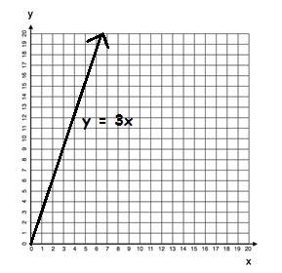

Ordered Pairs
($x$,$y$)
($0, 0$)
($1, 3$)
($2, 6$)
($3, 9$)

Exit Ticket (5 minutes)
Name ___________________________________________________ Date____________________
Lesson 14: From Ratio Tables, Equations, and Double Number Line Diagrams to Plots on the Coordinate Plane

Exit Ticket

Dominic works on the weekends and on vacations from school mowing lawns in his neighborhood. For every lawn he mows, he charges $\$12$. Complete the table. Then determine ordered pairs, and create a labeled graph.
Lawns | Charge  (in dollars) | Ordered Pairs
$$2$$
$$4$$
$$6$$
$$8$$
$$10$$

- How many lawns will Dominic need to mow in order to make $\$240$?

- How much money will Dominic make if he mows $9$ lawns?

Exit Ticket Sample Solutions

Dominic works on the weekends and on vacations from school mowing lawns in his neighborhood. For every lawn he mows, he charges $\$12$.
Complete the table. Then determine ordered pairs, and create a labeled graph.
Lawns | Charge  (in dollars) | Ordered Pairs
$$2$$ | $$24$$ | $$(2, 24)$$
$$4$$ | $$48$$ | $$(4, 48)$$
$$6$$ | $$72$$ | $$(6, 72)$$
$$8$$ | $$96$$ | $$(8, 96)$$
$$10$$ | $$120$$ | $$(10, 120)$$
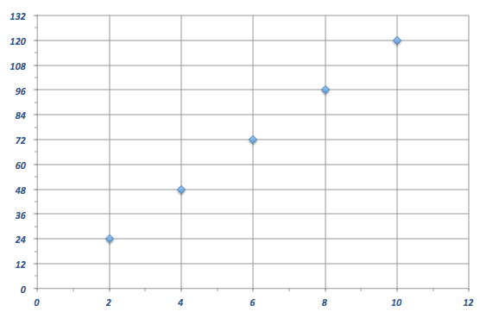
Charges for Lawns Cut
Number of Lawns
Dollars Charged

- How many lawns will Dominic need to mow in order to make $\$240$?
$20$ lawns

- How much money will Dominic make if he mowed $9$ lawns?
$$\$108$$

Problem Set Sample Solutions

- Complete the table of values to find the following:
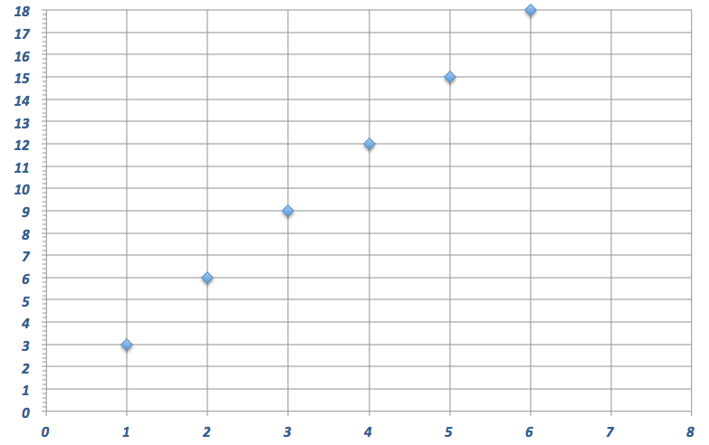
Find the number of cups of sugar needed if for each pie Karrie makes, she has to use $3$ cups of sugar.
Cups of Sugar in Pies
Number of Pies
Cups of Sugar

Pies | Cups of Sugar
$$1$$ | $$3$$
$$2$$ | $$6$$
$$3$$ | $$9$$
$$4$$ | $$12$$
$$5$$ | $$15$$
$$6$$ | $$18$$

Use a graph to represent the relationship.

Create a double number line diagram to show the relationship:
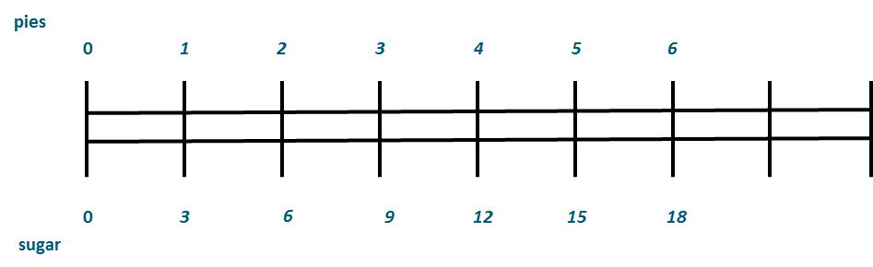

- Write a story context that would be represented by the ratio $1:4$.
Answers will vary. Example: Kendra’s mom pays her four dollars for every load of laundry she washes and dries.
Complete a table of values for this equation and graph.
Loads of Laundry | Amount of Money She Earned in Dollars
$$1$$ | $$4$$
$$2$$ | $$8$$
$$3$$ | $$12$$
$$4$$ | $$16$$
$$5$$ | $$20$$
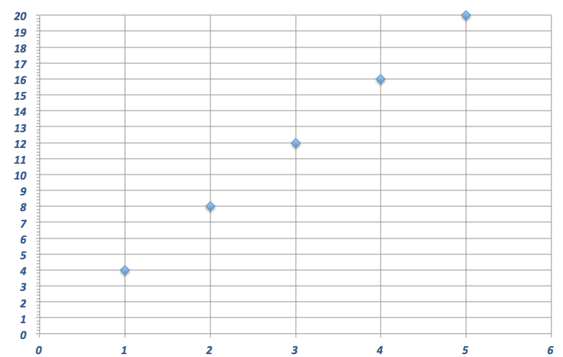
Pay for Laundry
Number of Loads of Laundry
Amount of Money in Dollars

