Lesson 32
Objective: Solve put together/take apart with addend unknown math stories.

Suggested Lesson Structure
 Fluency Practice (15 minutes)
 Application Problem (5 minutes)
 Concept Development (30 minutes)
 Student Debrief (10 minutes)
Total Time (60 minutes)
Fluency Practice (15 minutes)
- Happy Counting the Say Ten Way 1.OA.5 (3 minutes)
- 5-Group Match: Partners to 10 1.OA.6 (10 minutes)
- Number Sentence Swap 1.OA.4 (2 minutes)
Happy Counting the Say Ten Way (3 minutes)
Note: This activity helps students maintain their ability to count by tens, which is foundational to later Grade 1 work with adding and subtracting tens. Remember, the Rekenrek can be used on the first count to help students visualize the numbers as they count forward and backward.
Have students count up and down between 20 and 120 the Say Ten way, depending on their skill level (see Lesson 3). If they are very proficient up to 40, start at 40 and quickly go up to 80. If they are proficient between 40 and 80, Happy Count between 80 and 120. Alternate at times between regular and Say Ten counting, too.
5-Group Match: Partners to 10 (10 minutes)
Materials: (S) 5-group cards (0─10) with 1 extra 5 card per pair (Lesson 5 Template 1)
Note: Strong fluency with partners to 10 will be critical in Module 2 so that students can avoid using up too many of their attention resources on lower-level skills when they are addressing higher-level problems.
Assign students partners. Partner 1 closes his eyes. Partner 2 quickly lays out the 5-group cards, numeral side up. Partner 1 opens his eyes and tries to match all partners to ten as quickly as possible. Each player tries twice in a row to see if they can increase their speed.
Number Sentence Swap (2 minutes)
Note: This activity supports students in developing a strong foundation in the relationship between addition and subtraction.
Give a subtraction sentence aloud, saying “the mystery number” for the unknown answer (e.g., “5 – 3 = the mystery number”). Call on a student to rephrase the sentence as an addition sentence (e.g., “3 + blank = 5”). Ask students to count on to solve the problem, for example, “threeeeee (touch head or hold up fist), 4 (raise thumb), 5 (raise index finger).” Ask students how many fingers they counted on. (2.)
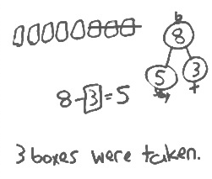
Application Problem (5 minutes)
There are 8 juice boxes in the cubbies. Some children drink their juice. Now, there are only 5 juice boxes. How many juice boxes were taken from the cubbies?
Make a number bond. Write a subtraction sentence and a statement to match the story. Make a box around the solution in your number sentence. Make a math drawing to show how you know.
Note: This problem applies learning from Lesson 31, where students use strategies to solve take from with change unknown problems. The continued use of the number bond supports students’ growing understanding of the relationship between addition and subtraction as they solve various problem types.
Concept Development (30 minutes)
Materials: (T) 10 white linking cubes (S) Personal white board
Invite students to come to the meeting area with their personal white boards and sit in a semi-circle.

NOTES ON
MULTIPLE MEANS
OF REPRESENTATION:
Facilitate student discussions to provide opportunities for English language learners to use math language. This will also provide an opportunity to check for understanding of vocabulary and concepts.

T: There are 8 apples. (In a line, lay out 8 individual white linking cubes.) Put on your magic glasses that will show different colors. (Pretend to put on glasses.)
S: (Pretend to put on glasses.)
T: Ooooh, I see two parts. There are five red apples, here on this side. (Gesture.) That’s one part. Thumbs up if you can see the red apples.
S: (Show thumbs up.)
T: The other part of the apples is green. Can you see the two parts?
S: Yes!
T: Make a number bond to find out how many apples are green. Be sure to label each box, even the mystery box.
S: (Make a number bond with labels.)
T: Make a math drawing to show how you can solve the mystery number. Remember to line up your pictures in a straight row.
S: (Drawings may vary.)
T: Write the number sentence to solve. Be sure to circle the solution.
S: (Number sentences may vary.)
T: (Circulate and observe. Choose two students to share different strategies and number sentences. Possibilities include counting up, counting back, and writing addition or subtraction sentences.)

NOTES ON
MULTIPLE MEANS
OF REPRESENTATION:
Never underestimate the use of manipulatives when students are learning a new skill. Students should use 5-group cards, number path, or other manipulatives such as counting bears when they need extra support. Allow students to use the extra support as long as they need it.

T: James wrote 5 + ___ = 8, and Lily wrote 8 – 5 = ___. Even though they used different number sentences and drawings, did they get the same answer?
S: Yes!
T: Hmmm, which was a faster or more efficient way to solve? Counting up or counting back? Turn and talk to your partner and explain why.
S: Counting up! You only need to count on 3 times to get to 8. Taking away 5 takes longer.
T: (While guiding students to notice that counting on 3 is more efficient, accept all explanations. Some students may know their –5 facts and find 8 – 5 a better strategy.)
Repeat the process with math stories using the following suggested sequence: 7 + ___ = 9, 3 + ___ = 7,
4 + ___ = 8, and 6 + ___ = 9. After each story, ask students to identify which number sentence, addition or subtraction, they used to solve. Guide students to make a generalization about when it would be a better shortcut to use counting on or counting back, along with just knowing the decompositions.
T: Look at this number bond. (Write 8 as the total and 6 as a part.)
T: Think of a math story with a missing part where nothing goes away that could go with this number bond. Tell it to your partner.
T: Make a math drawing, write an addition and subtraction number sentence, and solve. Circle each of your solutions.
S: (Solve.)
Repeat the process by asking students to create their own number bond with 9 as the total.

Problem Set (10 minutes)
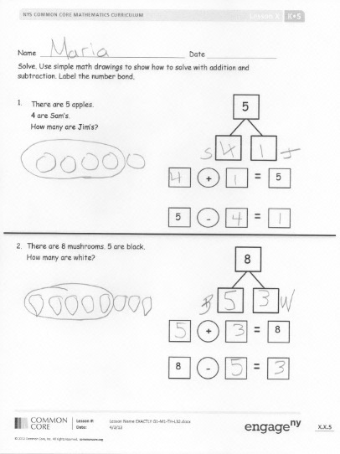
Students should do their personal best to complete the Problem Set within the allotted 10 minutes. For some classes, it may be appropriate to modify the assignment by specifying which problems they work on first. Some problems do not specify a method for solving. Students solve these problems using the RDW approach used for Application Problems.
Student Debrief (10 minutes)
Lesson Objective: Solve put together/take apart with addend unknown math stories.
The Student Debrief is intended to invite reflection and active processing of the total lesson experience.
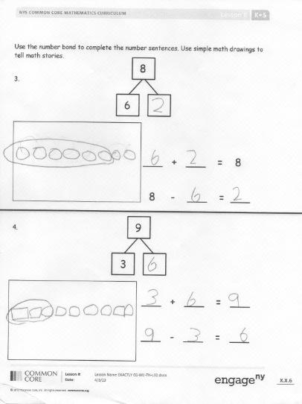
Invite students to review their solutions for the Problem Set. They should check work by comparing answers with a partner before going over answers as a class. Look for misconceptions or misunderstandings that can be addressed in the Debrief. Guide students in a conversation to debrief the Problem Set and process the lesson.
You may choose to use any combination of the questions below to lead the discussion.
- Choose one of your stories for Problem 3 or Problem 4. Tell it to your partner and have him solve and explain what he did.
- How can solving Problem 2 help you solve Problem 3?
- When you use different strategies, do you always find the unknown number in the same place in your number sentence? Give an example to explain your thinking.
- Was it easier for you to use an addition sentence or a subtraction sentence to solve today’s math stories? Why do you think that is?
- When is it wiser for you to use an addition sentence to solve the problem? Give an example from the Problem Set. What about using a subtraction sentence?
- Remember when we were thinking about if it was better to count on or count back? I’m thinking of a subtraction sentence where counting on or counting back would take the same amount of time. What number sentence could I be thinking of? (10 – 5 = 5, 8 – 4 = 4, etc.)
- How did the Application Problem connect to today’s lesson?
Exit Ticket (3 minutes)
After the Student Debrief, instruct students to complete the Exit Ticket. A review of their work will help you assess the students’ understanding of the concepts that were presented in the lesson today and plan more effectively for future lessons. You may read the questions aloud to the students.

Name Date

Solve. Use simple math drawings to show how to solve with addition and subtraction. Label the number bond.
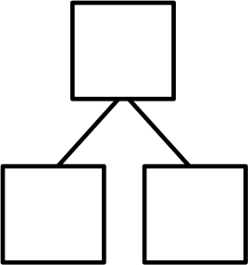
There are 5 apples.
Four are Sam’s.
The rest are Jim's.
How many apples does Jim have?
5
1.
+

5
-

5

There are 8 mushrooms. Five are black. The rest are white.
How many mushrooms are white?

2.
8
+

8
-

8

Use the number bond to complete the number sentences. Use simple math drawings to tell math stories.
8
6
3. ___ + ___ = 8

8 - ___ = ___
9
3
4. ___ + ___ = ___

___ - ___ = ___

Name Date

Read the math story. Make a math drawing and solve.
Glenn has 9 pens. Five are black. The rest are blue. How many pens are blue?

____ pens are blue.

_____ + _____ = _____
_____ - _____ = _____

Name Date

Match the math stories to the number sentences that tell the story. Make a math drawing to solve.
1.
a.
c.
b.
Kate has her fingernails painted. 3 have designs.
The rest are plain.
How many fingernails are plain?
There are 9 apples in a basket.
6 are red.
The rest are green.
How many apples are green?

+

10
-

10
6
6
+

10
-

10

3
+

9
-

9

There are 10 flowers in a vase.
6 are red.
The rest are yellow.
How many flowers are yellow?

Use the number bond to tell an addition and subtraction math story with pictures. Write an addition and subtraction number sentence.
2.
_____ + _____ = _____
_____ - _____ = _____
7
4

3.

_____ + _____ = _____
8
5

_____ - _____ = _____

