Lesson 30
Objective: Solve add to with change unknown math stories with drawings, relating addition and subtraction.

Suggested Lesson Structure
 Fluency Practice (12 minutes)
 Application Problem (5 minutes)
 Concept Development (33 minutes)
 Student Debrief (10 minutes)
Total Time (60 minutes)
Fluency Practice (12 minutes)
- Happy Counting by Tens 1.NBT.1, 1.NBT.5 (2 minutes)
- Math Hands Flash: Partners to 10 1.OA.4, 1.OA.6 (5 minutes)
- Number Bond Dash: 10 K.OA.3, 1.OA.6 (5 minutes)
Happy Counting by Tens (2 minutes)
Note: Practice counting forward and back by tens helps promote automaticity with 10 more and 10 less addition and subtraction problems.
Repeat the Happy Counting activity from Lesson 3, counting by tens. First, count from 0 to 120 and back, and then from 9 to 119 and back.
Math Hands Flash: Partners of 10 (5 minutes)
Note: This activity provides an opportunity for students to maintain their fluency with partners of 10 and strengthen their visualization of 5-groups by using their hands to see the math. The activity also continues to support students in seeing the connection between addition and subtraction.
Guide students to relate addition and subtraction problems while building fluency with partners of 10.
T: (Hold up 9 fingers.) Show me how many fingers I need to make 10.
S: (Hold up 1 finger.)
T: 9 plus what number equals 10?
S: 1.
T: Good! 9 + 1 = 10, so 10 – 9 = ? Look at your hands.
S: 1.
Continue playing, eliciting all partners of 10. If students are highly successful, switch to other totals within 10, such as 9, 8, or 7.
Number Bond Dash: 10 (5 minutes)
Materials: (T) Stopwatch or timer (S) Number Bond Dash 10 (Lesson 9 Fluency Template), marker to correct work
Note: By using the same system repeatedly, students can focus on the mathematics alone. This activity addresses the core fluency for Grade 1 of adding and subtracting within 10.
Follow the procedure for the Number Bond Dash in Lesson 5 Fluency Practice. Tell students to remember how many problems they get correct so they can try to improve their scores tomorrow.
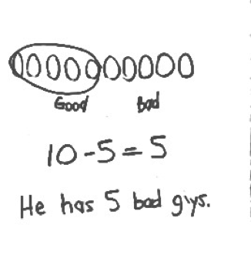Application Problem (5 minutes)
Freddie has 10 action figures in his pocket. Five of them are good guys. How many of his action figures are bad guys? Box the solution in your number sentence, and include a statement to answer the question. Make a math drawing. Circle the part that is good guys to show you have the correct number of bad guys.
Note: This problem applies learning from the previous lesson on solving take apart story problems by circling the known part to find the unknown part. During the Debrief, students will connect this with their new learning as they create a picture number bond to go with the problem.
Concept Development (33 minutes)

Materials: (T) Books of different sizes (S) Personal white board, number path (Lesson 26 Template), yellow colored pencil or highlighter

NOTES ON
MULTIPLE MEANS
OF ACTION AND EXPRESSION:
Provide sentence frames to support verbal responses for English language learners and other students who may require language support.

Display 5 books (either on the ledge of the board or on a shelf). Invite students to sit in the meeting area in a semi-circle with their personal white boards.
T: How many books do I have on this shelf? (Gesture to books.)
S: 5 books.
T: A student came and put some more books on the shelf. Close your eyes. (Add 2 more books.) Open your eyes.
How many books are there now?
S: 7 books.
T: Let’s make a number bond to figure out how many more books the student brought. (Ask students to identify what they already know from the story and decide if it is a part or the total as they fill in the boxes. Have students identify the referents for each number and label the boxes accordingly.)
T: Turn and talk to your partner about what you can do to solve how many more books the student put on the shelf. Write the number sentence, but leave the mystery number blank.
S: (Discuss and write 5 + = 7 or 7 – 5 = .)
T: (Circulate and listen. Ask a student who used addition to share.)
S: (Show the number sentence.) I counted on. Fiiive, 6, 7. I added 2 more. → I said 5 plus what equals 7 and just knew it was 2.
T: Great strategies! (Choose a student who used subtraction to share.)
S: I knew there were 7 books total, so I took away 5 books that we already had and got 2 books.
T: Nice work! Did we all get the same answer even though some used an addition sentence and others used a subtraction sentence?
S: Yes!
Have students fill in the missing part of the number bond and label it.
T: Let’s draw a picture number bond to show the story.
T: Draw circles in a row to represent the total of 7 books. Put a box around it just like the number has a box around it in the number bond. (Model and emphasize the importance of making circles the same size. Each circle represents 1 book, not the size of each book.)
S: (Draw.)
T: Draw circles in a row to represent the number of books we began with. Put a box around it. (Model and draw a diagonal line to connect the part and total box.)
S: (Draw.)
T: Draw a box to show the part that will contain the number of books the student brought. (Model and draw another diagonal line.) Fill in the box with circles that represent how many more books were put on the shelf.
S: (Draw 2 more circles.)
T: Write the labels to show what each box and its circles stand for. (Guide the students if necessary.)
S: (Write labels.)
Repeat the process by telling more add to with change unknown stories. Use the following suggested sequence: 4 + = 7, 6 + = 8, and 6 + = 9. At times, rotate the picture number bond so that the parts are above the total as shown on the Problem Set. This will help students focus on recognizing which is the total and which sections are the parts based on the lines, or arms, of the bond.
T: How did you use your math drawing to show how you can use addition to solve the problem?
S: I started with the 6 books and used my fingers to count on 3 (or add 3) to get to the total.
T: How did you use your math drawing to show how you can use subtraction to solve the problem?
S: I started with the total, which is 9, and separated the 6 and saw that 3 were left.
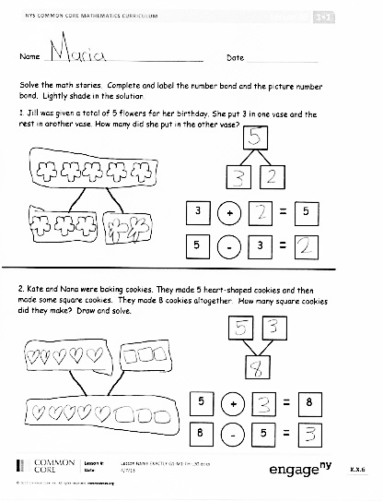
Problem Set (10 minutes)
Students should do their personal best to complete the Problem Set within the allotted 10 minutes. For some classes, it may be appropriate to modify the assignment by specifying which problems they work on first. Some problems do not specify a method for solving. Students solve these problems using the RDW approach used for Application Problems.
In this Problem Set, students should begin with Problem 1, possibly leaving Problem 4 to the end if there is still time.
Student Debrief (10 minutes)
Lesson Objective: Solve add to with change unknown math stories with drawings, relating addition and subtraction.
The Student Debrief is intended to invite reflection and active processing of the total lesson experience.
Invite students to review their solutions for the Problem Set. They should check work by comparing answers with a partner before going over answers as a class. Look for misconceptions or misunderstandings that can be addressed in the Debrief. Guide students in a conversation to debrief the Problem Set and process the lesson.
You may choose to use any combination of the questions below to lead the discussion.
- How did the addition sentences help you solve today’s problems? How did subtraction sentences help you solve today’s problems?
- Which problem do you think would be solved most efficiently using subtraction? Why?
- What new math strategy did we use today to communicate precisely? Explain how it is helpful.
- How is drawing a picture number bond similar to and different from your past math drawings?
- How did the Application Problem connect to today’s lesson? Draw a picture number bond to match the story.
- Let’s compare our problems using subtraction again.
T: When we used subtraction yesterday, we didn’t cross off any parts of our drawings. What does it mean when we cross things off in our drawings? (Give an example.)
S: Something is going away.
T: Why didn’t we cross things off today? (Give an example.)
S: Something was being added but we didn’t know what. We added on the mystery number. We just subtracted because it was a missing part, but it didn’t sound like subtraction. I didn’t even write a subtraction sentence at first! I didn’t need to, because I saw the number bond in my mind. A part was missing.
Exit Ticket (3 minutes)
After the Student Debrief, instruct students to complete the Exit Ticket. A review of their work will help you assess the students’ understanding of the concepts that were presented in the lesson today and plan more effectively for future lessons. You may read the questions aloud to the students.

Name Date

Solve the math stories. Complete and label the number bond and the picture number bond. Lightly shade in the solution.
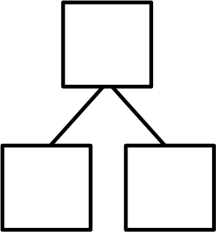
- Jill was given a total of 5 flowers for her birthday. She put 3 in one vase and the rest in another vase. How many flowers did she put in the other vase?

+

3
5

-

5
3

- Kate and Nana were baking cookies. They made 5 heart-shaped cookies and then made some square cookies. They made 8 cookies altogether. How many square cookies did they make? Draw and solve.

-

8
5
+

5
8
Solve. Complete and label the number bond and the picture number bond. Circle the unknown number.

A
K
C
7
5
2

2 + 5 = 7
7 – 2 = 5
- Bill has 2 trucks. His friend James came over with some more.
Together, they have 6 trucks.
How many trucks did James bring over?
James brought over ______ trucks.
____ + ____ = 6
6 - ____ = ____
.

- Jane caught 5 fish before she stopped to eat lunch.
After lunch, she caught some more.
At the end of the day, she had 9 fish.
How many fish did she catch after lunch?

____ + ____ = 9
9 - ____ = ____

Jane caught ______ fish after lunch.

Name Date
Draw and label a picture number bond to solve.

Toby collects shells. On Monday, he finds 6 shells. On Tuesday, he finds some more. Toby finds a total of 9 shells. How many shells does Toby find on Tuesday?
____ + ____ = ___
____ - ____ = ____

Toby finds ________ shells on Tuesday.

Name Date
Solve the math stories. Draw and label a picture number bond to solve. Circle the unknown number.
- Grace has a total of 7 dolls. She puts 2 in the toy box and takes the rest to her friend’s house. How many dolls does she take to her friend’s house?
toy box
friend’s house
dolls
Grace takes ______ dolls to her friend’s house.
____ + ____ = 7
7 - ____ = ____

- Jack can invite 8 friends to his birthday party. He makes 3 invitations. How many invitations does he still need to make?
____ + ____ = 8
8 - ____ = ____
Jack still needs to make _______ invitations.
- There are 9 dogs at the park. Five dogs play with balls. The rest are eating bones. How many dogs are eating bones?

____ + ____ = 9
___ - ____ = ____

_____ dogs are eating bones.

- There are 10 students in Jim’s class. Seven bought lunch at school. The rest brought lunch from home. How many students brought lunch from home?
____ + ____ = ____
____ - ____ = ____

_____ students brought lunch from home.

