Lesson 29
Objective: Solve take apart with addend unknown math stories with math drawings, equations, and statements, circling the known part to find the unknown.

Suggested Lesson Structure
 Fluency Practice (12 minutes)
 Application Problem (8 minutes)
 Concept Development (30 minutes)
 Student Debrief (10 minutes)
Total Time (60 minutes)
Fluency Practice (12 minutes)
- Stand on Even Numbers 1.OA.5 (3 minutes)
- Cold Call: 2 Less 1.OA.5, 1.OA.6 (2 minutes)
- Subtraction with Cards 1.OA.6 (7 minutes)
Stand on Even Numbers (3 minutes)
Note: Practice counting forward by twos helps promote automaticity with adding 2 and counting with automaticity up to 40.
Students sit in a circle and count by ones, each student saying one number to count up. When a student says an even number, she stands: 1, 2 (student stands), 3, 4 (student stands)…. Continue counting until all students are standing. The last one sitting is the winner. Play again starting at a different point in the circle. This leads nicely into Cold Call wherein all students start out standing.
Cold Call: 2 Less (2 minutes)
Note: This activity supports students’ ability to relate counting back 2 to subtracting 2.
Tell students you are going to say a number aloud, and instruct them to think about the number that is 2 less. Let them know you will cold call students to say the answer as quickly as possible. Alternate between calling on individual students, the whole class, and groups of students (e.g., only girls, only boys, etc.). Begin with numbers within 10, and then expand to numbers within 20. Students stand with hands behind their backs to help them resist raising their hand when they hear the teacher’s call.
A suggested sequence type is 3, 2, 8, 6, 9, 7, 10, 8, 18, 8, ten 8, 3, 13, etc.
Subtraction With Cards (7 minutes)
Materials: (S) 1 set numeral side only 5-group cards (Lesson 5 Template 1) per pair, counters (if needed)
Note: This activity addresses the core fluency objective for Grade 1 of adding and subtracting within 10.
Students place cards face down between them. Each partner flips over two cards and subtracts the smaller number from the larger number. The partner with the smallest difference keeps the cards played by both players that round. The player with the most cards at the end of the game wins.
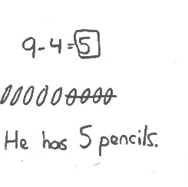
Application Problem (8 minutes)
Lucas has 9 pencils for school. He lends 4 of them to his friends. How many pencils does Lucas have left? Box the solution in your number sentence, and include a statement to answer the question. Be sure to draw your simple shapes in a straight line.
Note: This problem applies the objective from Lesson 28 and moves from crossing off a part that is taken away to circling a known part to identify an unknown part embedded within the total. In the Debrief, students will be able to compare and contrast the two strategies.
Concept Development (30 minutes)
Materials: (S) Personal white board
Invite students to sit in the circle area in a semi-circle with their personal white boards.
T: Welcome to another edition of Math Stories Theater! Six children are at a sleepover. (Call 6 children to the front, lining them up in a straight row.)
T: Four children are wearing black shoes. The rest are wearing white shoes.

NOTES ON
MULTIPLE MEANS
OF REPRESENTATION:
Frequent checks for understanding benefit English language learners and other students who may shy away from asking questions. Ask questions for comprehension and encourage students to retell the story to ensure the vocabulary and concept is being understood.

T: How many children are wearing white shoes at the sleepover?
T: Write a subtraction sentence to answer the question.
S: (Write 6 – 4 = 2.)
T: By lining up our actors in a straight row, we can easily see the sets of students. Let’s try another one.
T: It’s bedtime! Three children are in their sleeping bags. The rest are underneath their blankets. How many children are using blankets? Turn and decide with a partner.
S: (Discuss with partner.)
S: Three children are using blankets!
T: Let’s use the actors to see. These 3 have sleeping bags. (Gesture to students.) That means these children have blankets. Three children are using blankets!

NOTES ON
MULTIPLE MEANS
OF ENGAGEMENT:
Adjust the lesson structure to suit the specific needs of the class. Some students may need to continue with concrete representations throughout the lesson. Other students may be ready for more challenging numbers or the opportunity to develop their own math stories.

T: Let’s draw a simple math drawing to match this situation. (On personal board, draw 6 circles in a row.)
T: These circles represent our 6 children in the story. We know that 3 of them are using sleeping bags. I’m going to circle the first 3 of these (circle the first 3 shapes), and then we should be able to see how many children are left using blankets. How many circles are left?
S: 3 circles.
T: Draw a simple math drawing like mine to match the story. Write the subtraction sentence that goes with it.
S: (Create similar math drawing and write 6 – 3 = 3.)
Repeat the process with more take apart math stories. Listed below is a suggested sequence of story lines:
- 8 cupcakes in all: 6 with chocolate icing, the rest with vanilla
- 7 sneakers in all: 3 with Velcro, the rest with shoe laces
- 10 coats: 7 with buttons, the rest with zippers
- 9 balls: 3 basketballs, the rest soccer balls
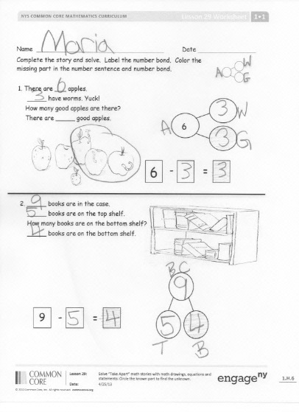
Each time, ask the students to draw a simple math story to check their solution to the story problem before having the actors portray the two parts. Focus on circling the part that is known to help solve the unknown part.
Problem Set (10 minutes)
Students should do their personal best to complete the Problem Set within the allotted 10 minutes. For some classes, it may be appropriate to modify the assignment by specifying which problems they work on first. Some problems do not specify a method for solving. Students solve these problems using the RDW approach used for Application Problems.
For this Problem Set, it is suggested that all students begin with Problem 1, possibly leaving Problem 4 to the end if there is still time.

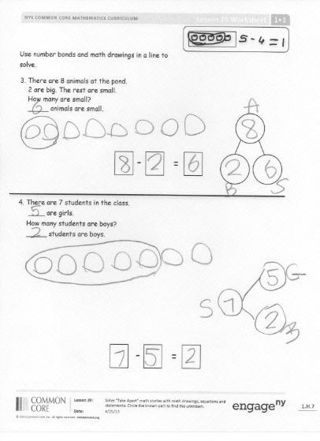
Student Debrief (10 minutes)
Lesson Objective: Solve take apart with addend unknown math stories with math drawings, equations, and statements, circling the known part to find the unknown.
The Student Debrief is intended to invite reflection and active processing of the total lesson experience.
Invite students to review their solutions for the Problem Set. They should check work by comparing answers with a partner before going over answers as a class. Look for misconceptions or misunderstandings that can be addressed in the Debrief. Guide students in a conversation to debrief the Problem Set and process the lesson.
You may choose to use any combination of the questions below to lead the discussion.
- In what way does making your drawing in a straight line help you solve the math problems? Use Problem 3 to help you explain your thinking.
- Explain your choices for Problem 4 to a partner. Did you and your partner complete Problem 4 in the same way or in different ways? Can you both be right even if you have different numbers for the parts? Why?
- With your partner, come up with different ways to make Problem 4 true.
- How did the Application Problem connect to today’s lesson? How is the strategy of crossing out in our math drawing similar to the strategy we used today? Why might we choose one strategy instead of another when solving story problems?
- Help students make a distinction between the take apart and take from stories, the two problem types using subtraction they have encountered thus far in the module.
T: When we used subtraction today, we didn’t cross off any parts of our drawings. What does it mean when we cross things off in our drawings? (Give an example.)
S: Something is going away.
T: Why didn’t we cross things off today? (Give an example.)
S: Because nothing went away. It was just that one part was different from the other. We were looking for the other part.
- Another strategy for problems like the ones we had today is to draw the parts into a picture number bond. This number bond math drawing represents one of the problems in the Problem Set. (Draw the picture to the right on the board.) Which problem do you think this drawing represents? (Problem 2.) How can you tell? Describe each part. (Label as each part is described. The top row represents all of the books. The bottom row has 2 parts, with 1 part representing books on the top shelf and the other part representing the books on the bottom shelf.)
Exit Ticket (3 minutes)
After the Student Debrief, instruct students to complete the Exit Ticket. A review of their work will help you assess the students’ understanding of the concepts that were presented in the lesson today and plan more effectively for future lessons. You may read the questions aloud to the students.

Name Date
Complete the story, and solve. Label the number bond.
Color the missing part in the number sentence and number bond.
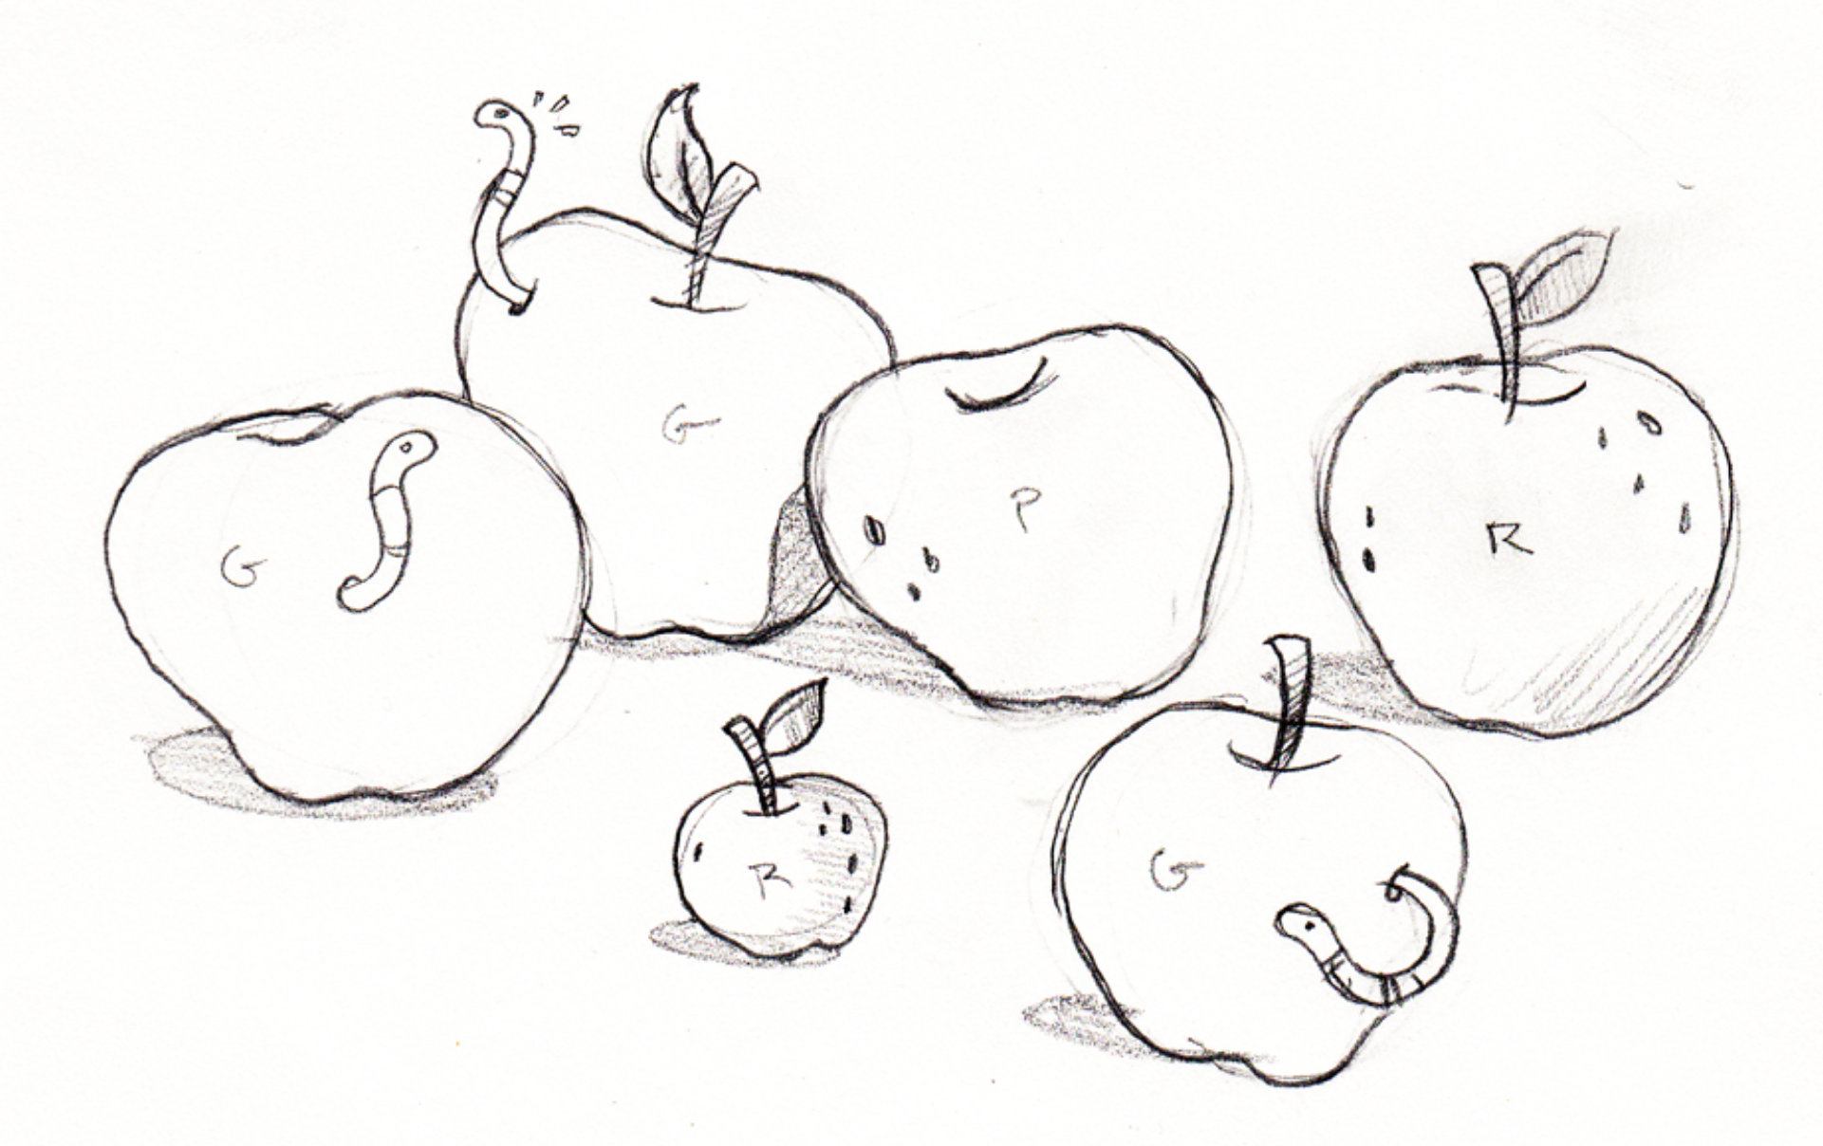
1. There are _____ apples.
_____ have worms. Yuck!
How many good apples are there?
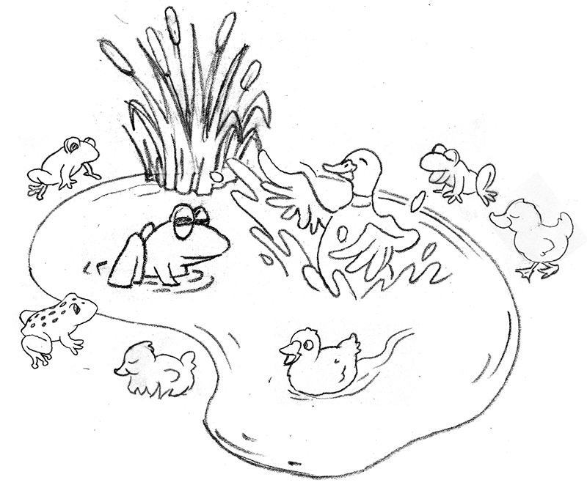
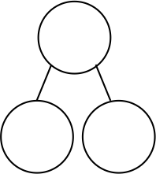
6
-

=

6

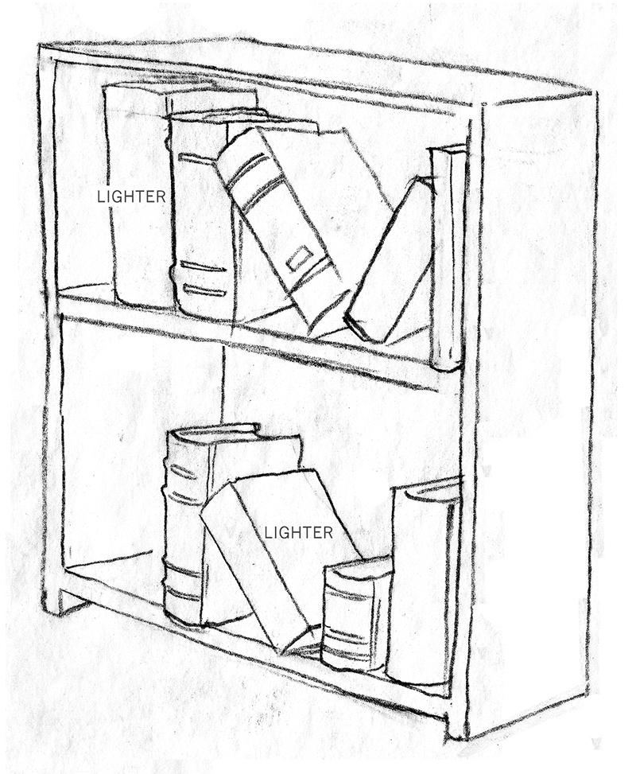
There are _____ good apples.
2. _____ books are in the case.
_____ books are on the top shelf.
How many books are on the bottom shelf?
9
-

=

_____ books are on the bottom shelf.
Use number bonds and math drawings in a line to solve.
Example of math drawing and number sentence

-

=

3. There are 8 animals at the pond.
Two are big. The rest are small.
How many are small?
_____ animals are small.

4. There are 7 students in the class.
____ students are girls.
How many students are boys?

-

=

_____ students are boys.
Name Date
Read the story. Make a math drawing to solve.
There are 9 baseball players on the team. Seven are on the bench. How many are not on the bench?

___ - ___ = ___

_____ players are not on the bench.

Name Date
Read the math stories. Make math drawings to solve.

1. Tom has a box of 7 crayons. Five crayons are red. How many crayons are not red?

___ - ___ = ___

___ crayons are not red.

2. Mary picks 8 flowers. Two are daisies. The rest are tulips. How many tulips does she pick?

___ - ___ = ___

Mary picks ___ tulips.
3. There are 9 pieces of fruit in the bowl. Four are apples. The rest are oranges. How many pieces of fruit are oranges?
___ - ___ = ___

The bowl has ___ oranges.

4. Mom and Ben make 10 cookies. Six are stars. The rest are round. How many cookies are round?

___ - ___ = ___

There are ___ round cookies.

5. The parking lot has 7 spaces. Two cars are parked in the lot. How many more cars can park in the lot?
___ - ___ = ___

___ more cars can park in the lot.

6. Liz has 2 fingers with Band Aids. How many fingers are not hurt?

___ - ___ = ___

Write a statement for your answer:

