Lesson 28
Objective: Solve take from with result unknown math stories with math drawings, true number sentences, and statements, using horizontal marks to cross off what is taken away.

Suggested Lesson Structure
 Fluency Practice (14 minutes)
 Application Problem (6 minutes)
 Concept Development (25 minutes)
 Student Debrief (15 minutes)
Total Time (60 minutes)
Fluency Practice (14 minutes)
- Beep Counting by Ones (1.NBT.1) (2 minutes)
- Cold Call: 1 Less (1.OA.5, 1.OA.6) (2 minutes)
- Sprint: 1 Less (1.OA.5, 1.OA.6) (10 minutes)

NOTES ON
MULTIPLE MEANS
OF ACTION AND EXPRESSION:
Some students would benefit from having a visual model of the number sequence. Allow students to use personal white boards to record the sequence, or provide a visual representation.

Beep Counting by Ones (2 minutes)
Note: This activity focuses on practicing the counting sequence to 120 starting at any given number. Students remain attentive to small sets of consecutive numbers, considering the order of the numbers without relying on the typical predictability of rote counting.
Say a series of three numbers, but replace one of the numbers with the word beep (e.g., “5, 6, beep”). When signaled, students say the beep number. Scaffold number sequences from simple to complex. Include forward and backward number sentences.
Use the following suggested sequence: 5, 6, beep; 17, 18, beep; 28, 29, beep; 2, 1, beep; 42, 41, beep; 62, 61, beep; 8, beep, 10; 58, beep, 60; beep, 55, 56; beep, 71, 72; 88, 87, beep; 91, beep, 89; 99, beep, 101; and 109, beep, 111.
Cold Call: 1 Less (2 minutes)
Note: This activity continues to strengthen students’ development of counting backwards within the counting sequences up to 120.
Tell students you are going to say a number aloud, and instruct them to think about the number that is 1 less. They do not need to raise their hands, as you will cold call students to say an answer. Alternate between calling on individual students, the whole class, and groups of students (e.g., only girls, only boys, etc.). Begin with numbers within 10, and then expand to numbers within 40, then 80, and then 120.
Use the following suggested sequence: 2, 1, 8, 6, 9, 7, 10, 8, 18, 28, 38, 3, 13, 23, 33, etc.
Sprint: 1 Less (10 minutes)
Materials: (S) 1 Less Sprint
Note: This activity continues to strengthen students’ development of counting backwards within the counting sequences up to 32.
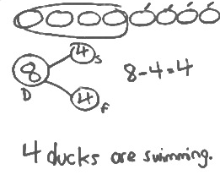
Application Problem (6 minutes)
Eight ducks are swimming in the pond. Four ducks fly away. How many ducks are still swimming in the pond? Write a number bond, number sentence, and statement. Draw a number path to prove your answer.
Note: This problem is a bridge from Lesson 27, and a lead-up to the Concept Development for the current lesson. Bringing students back to the number path from Lesson 27 provides a strong lead-in for using horizontal marks to show the part that is “taken away” in the current concept.
Concept Development (25 minutes)

NOTES ON
MULTIPLE MEANS
OF ACTION AND EXPRESSION:
Using personal white boards for student responses is a great way to involve all learners. Some students might not feel comfortable participating orally, while others may not be able to respond orally. This way, both groups can can show what they know on their personal white boards so that the teacher can check for understanding.

Materials: (S) Personal white board
Invite students to sit in the circle area in a semi-circle with their personal white boards.
T: Welcome to another edition of Math Stories Theater! You will be watching math stories and having a hand at solving them.
T: There were 6 children at the sleepover. (Call on 6 students to come to the front of the room and act out being at a sleepover). Two children got picked up. (Draw an imaginary horizontal line in front of 2 students.)
S: (Two students leave the group of 6 and sit down.)
T: How many children stayed?
S: 4!
T: Put that into a sentence.
S: Four children stayed.
T: Now, use simple math drawings to show how you know 4 children stayed. (Ask all actors to return to the circle.)
S: (Draw simple math drawings such as circles, and use their own strategies to show that 2 children left the sleepover.)
T: (Ask students to share their strategies.)
If a student shares the crossing off using horizontal marks strategy, have her share with the group, being sure to include key points from the script below. If no one uses horizontal marks, lead students into a dialogue similar to the one below.
T: What did we start with?
S: Six children at the sleepover.
T: (Model drawing 6 circles in a linear configuration.) What is the whole in this story?
S: 6!
T: Yes. So, our drawing shows how we started with the whole. Then, what happened?
S: Two children had to leave.
T: When they were leaving I drew an imaginary line in front of them to show that they were leaving. Let’s show that with our drawing. I’m going to cross 2 off with a line. (Model crossing off 2 of the circles and ask students to trace it in the air.) What does that line crossing out those 2 remind you of?
S: Taking away! The subtraction symbol!
T: Good! Write a number bond and number sentence that tells the sleepover story. Don’t forget to label your number bond.

NOTES ON
MULTIPLE MEANS
OF ACTION AND EXPRESSION:
Having students act out number stories is a great way to provide math-they-can-see. This will help your students with hearing impairments. It will also provide visual and kinesthetic learners an opportunity to engage in the lesson using their preferred style of learning.

T: (Circulate and listen. Then, ask a student or two to share with the class.)
S: For my number sentence, I wrote 6 – 2 = 4. For my number bond, I wrote 6 as the total children at the sleepover, and then one of the parts was 2, because those were the children who got picked up. The other part was 4, because those children stayed.
Have students erase their personal white boards. Continue to tell stories without actors, using the following suggested sequence and scenarios: 7 – 3 (frogs on a log), 8 – 6 (apples getting eaten), and 9 – 5 (flowers getting picked). Focus students on the referents, starting with the whole and crossing off to show the action of taking away.
MP.7

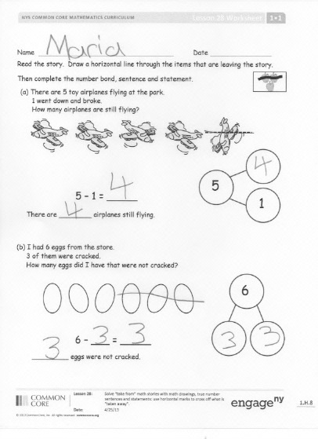
Problem Set (10 minutes)
Distribute the Problem Set, and have students complete their work in partnerships or in small groups. When setting up partners, be sure that students who are unable to read the problems are paired with a student who can read the problems. This Problem Set may be best completed with you reading each problem aloud.
Students should do their personal best to complete the Problem Set within the allotted 10 minutes. For some classes, it may be appropriate to modify the assignment by specifying which problems they work on first. Some problems do not specify a method for solving. Students solve these problems using the RDW approach used for Application Problems.
On this Problem Set, all students should begin with Problem 1 and possibly leave Problem 4 to the end if there is still time.
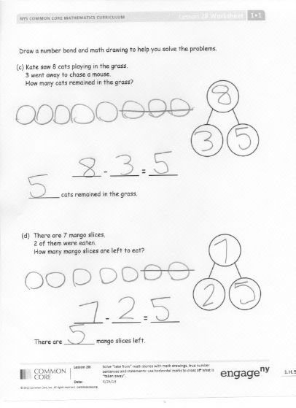
Student Debrief (15 minutes)
Lesson Objective: Solve take from with result unknown math stories with math drawings, true number sentences, and statements, using horizontal marks to cross off what is taken away.
The Student Debrief is intended to invite reflection and active processing of the total lesson experience.
Invite students to review their solutions for the Problem Set. They should check work by comparing answers with a partner before going over answers as a class. Look for misconceptions or misunderstandings that can be addressed in the Debrief. Guide students in a conversation to debrief the Problem Set and process the lesson.
You may choose to use any combination of the questions below to lead the discussion.
- Look at the drawings from your Application Problem and Problem 4 from your Problem Set. How are these two drawing strategies the same? How are they different? Does one seem more efficient than the other? Why?
- What do our drawings in a row remind us of? (A number path! 5-group cards!) Why would you draw our stories this way?
- Today, we all used drawings and number bonds to solve problems. Let’s look at Problem 3 together.
T: How many total cats did Kate see playing in the grass?
S: 8 cats.
T: How did you draw those 8 cats? (Invite students who have drawn in a linear configuration to share.)
S: I drew 8 circles in a line.
T: (Draw 8 circles in a line, and enclose them with a rectangle. Label the total.) How many cats went to chase a mouse?
S: 3 cats.
total cats
chased a mouse
remained
T: I see your number bonds show that. I’m going to make this into a picture number bond and show that 3 cats chased a mouse. (Draw a diagonal line to 3 circles enclosed with a rectangle. Label the part.)
T: How many cats remained?
S: 5 cats.
T: Who can help me draw the other part of our picture number bond to show that 5 cats remained? (Call on one student.)
S: (Draw another diagonal line to 5 circles enclosed with a rectangle.)
T: These are the cats that…
S: Remained! Stayed!
T: (Label the part. Ask the following questions to close the lesson.)
- How is this number bond different from your number bond? How is it the same?
- How is this number bond different from your math drawing? How is it the same?
- Can we always show a math story using a picture number bond? Does it only work for this story? (Try it out with Problem 4!)
Exit Ticket (3 minutes)
After the Student Debrief, instruct students to complete the Exit Ticket. A review of their work will help you assess the students’ understanding of the concepts that were presented in the lesson today and plan more effectively for future lessons. You may read the questions aloud to the students.

Name Date
Number correct:
A
*Write the number that is 1 less.
1 | 5 |  | 16 | 10
2 | 4 |  | 17 | 8
3 | 3 |  | 18 | 11
4 | 5 |  | 19 | 10
5 | 3 |  | 20 | 9
6 | 1 |  | 21 | 1
7 | 4 |  | 22 | 11
8 | 5 |  | 23 | 21
9 | 7 |  | 24 | 4
10 | 6 |  | 25 | 14
11 | 7 |  | 26 | 24
12 | 9 |  | 27 | 10
13 | 8 |  | 28 | 20
14 | 9 |  | 29 | 21
15 | 10 |  | 30 | 31
Name Date
Number correct:
B
*Write the number that is 1 less.
1 | 3 |  | 16 | 10
2 | 2 |  | 17 | 9
3 | 1 |  | 18 | 11
4 | 6 |  | 19 | 9
5 | 4 |  | 20 | 13
6 | 2 |  | 21 | 11
7 | 1 |  | 22 | 1
8 | 3 |  | 23 | 11
9 | 5 |  | 24 | 21
10 | 7 |  | 25 | 5
11 | 10 |  | 26 | 15
12 | 9 |  | 27 | 25
13 | 8 |  | 28 | 20
14 | 6 |  | 29 | 10
15 | 17 |  | 30 | 21

Name Date
Read the story. Draw a horizontal line through the items that are leaving the story.
Example: 3 – 2 = 1
Then, complete the number bond, sentence, and statement.
- There are 5 toy airplanes flying at the park.
One went down and broke.
How many airplanes are still flying?

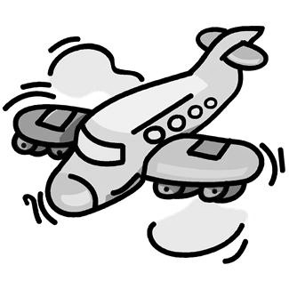

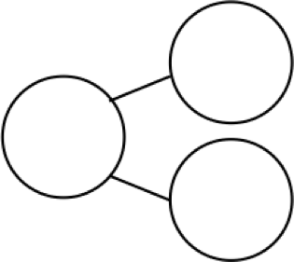
5
1

5 – 1 = _____

There are ________ airplanes still flying.

2. I had 6 eggs from the store.
Three of them were cracked.
How many eggs did I have that were not cracked?

6

6 – ___ = _____
_________ eggs were not cracked.
Draw a number bond and math drawing to help you solve the problems.

3. Kate saw 8 cats playing in the grass.
Three went away to chase a mouse.
How many cats remained in the grass?

_____ – _____ = _____

________ cats remained in the grass.

4. There were 7 mango slices.

Two of them were eaten.
How many mango slices are left to eat?

_____ – _____ = _____

There are ________ mango slices left.
Name Date
Read the problem. Make a math drawing to solve.
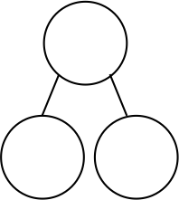
There were 9 kites flying in the park. Three kites got caught in trees. How many kites were still flying?

___ - ___ = ___
____ kites were still flying.

Name Date
Read the story. Make a math drawing to solve.

Sample: 3-2=1
  - There were 6 hot dogs on the grill. Two finish cooking and are removed. How many hot dogs remain on the grill?
6 - ___ = ___

6

There are ____ hot dogs remaining on the grill.
  - Bob buys 8 new toy cars. He takes 3 out of the bag.
___ - ___ = ___

How many cars are still in the bag?
____ cars are still in the bag.

- Kira sees 7 birds in the tree. Three birds fly away. How many birds are still in the tree?
____ birds are still in the tree.
___ - ___ = ___

- Brad has 9 friends over for a party. Six friends get picked up. How many friends are still at the party?
___ - ___ = ___

____ friends are still at the party.

- Jordan was playing with 10 cars. He gave 7 to Kate.
___ = ___ - ___
How many cars is Jordan playing with now?
Jordan is playing with ____ cars now.

- Tony takes 4 books from the bookshelf. There were 10 books on the shelf to start. How many books are on the shelf now?
___ = ___ - ___
____ books are on the shelf now.

