Lesson 26
Objective: Count on using the number path to find an unknown part.

Suggested Lesson Structure
 Fluency Practice (13 minutes)
 Application Problem (7 minutes)
 Concept Development (30 minutes)
 Student Debrief (10 minutes)
Total Time (60 minutes)
Fluency Practice (13 minutes)
- Number Path Hop 1.OA.5 (3 minutes)
- Partners to 9 1.OA.3, 1.OA.6 (5 minutes)
- Number Bond Dash: 9 1.OA.6 (5 minutes)
Number Path Hop (3 minutes)
Materials: (S) 5-group cards (Lesson 5 Template 1), 1 counter
Note: This activity connects fluency work of addition and subtraction within 10 with the number path as a tool for modeling addition and subtraction.
Students make a number path by ordering their 5-group cards from 0 to 10. Instruct the students to place their counters on 0 and give a series of directions. “Hop forward 2. Where are you?” “Hop back 1 space. What number are you on?” “Hop from 1 to 5. How many hops did you make?” “What number do you add to 5 to make 9?”
Partners to 9 (5 minutes)
Materials: (T/S) 5-group cards (0–9) (Lesson 5 Template 1)
Note: Reviewing partners to 9 allows students to gain and maintain fluency with addition and subtraction facts within 10, a grade level objective. Students also apply the commutative property.
T: (Hold up 5-group card with 5 dots.) How many dots do you see?
S: 5.
T: Hold up your 5-group card that shows how many more dots I need to make 9.
S: (Hold up the card with 4 dots).
T: Say an addition sentence for 9, beginning with the number you see on my card.
S: 5 + 4 = 9.
T: Good. Now say another addition sentence for 9. Begin with your card.
S: 4 + 5 = 9.
Continue playing, eliciting all partners to 9.
Number Bond Dash: 9 (5 minutes)
Materials: (T) Stopwatch or timer (S) Number Bond Dash 9 (Lesson 8 Fluency Template), marker to correct work
Note: This activity addresses the core fluency objective for Grade 1 of adding and subtracting within 10.
Follow the procedure for the Number Bond Dash in Lesson 5 Fluency Practice, remembering today is the second day with making 9. Students should recall their scores from Lesson 25 to see and celebrate improvement.
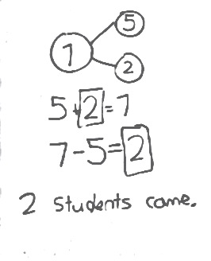
Application Problem (7 minutes)
There were 5 students in the cafeteria. Some more students came in late. Now, there are 7 students in the cafeteria. How many students came in late? Write a number bond to match the story. Write an addition sentence and a subtraction sentence to show two ways to solve the problem. Draw a rectangle around the unknown number that you found.
Note: This problem serves as a bridge from the previous change unknown lesson that allowed students to connect addition and subtraction, preparing the students to do the same in a different context within today’s lesson.
Concept Development (30 minutes)
Materials: (T) Giant number path (S) Personal white board, number path (Template)
Place a giant number path on the floor. Have students bring their personal white boards and sit in a semi-circle facing the number path.
T: (Write 6 – 4 = ___ on the board.) Fill in your number bond using this number sentence. One of the boxes should be left empty.
S: (Write 6 in the total box and 4 in the part box.)
T: Let’s solve 6 – 4 by using this giant number path. What is the whole?
S: 6.
T: (Select and direct a student to stand above 6.) If we are using the number path to show how to take 4 away from 6, should we count on or count back on the number path? By how many?
S: We count down by 4.
T: As Paul hops down, let’s keep track of our counts until we reach 4.
S: (Paul hops 1 square at a time as the rest of the class counts.) 1, 2, 3, 4. (He ends up on 2.)
T: What is 6 – 4?
S: 2.
S/T: (Write 2 in the number sentence. Complete the number bond.)
T: Is there another way to solve 6 – 4? Turn and talk to your partner.
S: We can also count on from 4 to 6. → We can use an addition sentence. → We can think,
“4 + ___ = 6.”
T: (Write 4 + ___ = 6.) We can count on using the number path! How many hops are needed to get to 6? Let’s count on and keep track of the hops on our fingers.

NOTES ON
MULTIPLE MEANS
OF REPRESENTATION:
Present math concretely with familiar objects. Students may prefer using their fingers while others might prefer using something to count such as bears or disks. Allow students to use the manipulative that helps them solve problems in the most effective way.

T/S: Foouuur, 5, 6. (Put up a finger for each hop.)
T: How many does 4 need to get to 6?
S: 2.
T: What is the number sentence to show what we just did?
S: 4 + 2 = 6.
T: (Fill in the blank with 2.) Again, 2 was the number we were looking for. It’s the same answer as the answer from the subtraction sentence.
T: Which was easier, counting back or counting on?
S: Counting on was easier.
T: (Write 8 – 5 = ___ on the board.) When you see a subtraction problem, you can always add instead. How can I turn this into an addition sentence?
S: 5 + ___ = 8. (Read as “five plus an unknown part equals eight.”)
T: Write the number sentence on your board.
T: On your number path, circle the 5. That’s the part we already know. Let’s find the unknown part by hopping to each number until we get to 8. Watch me as you help me count on.
T/S: (Circle 5 and draw to show hopping to each consecutive number.) Fiiiive, 6, 7, 8!
T: How many did 5 need to get to 8?
S: 3.
T: Fill in the unknown number, and put a circle around it to show that it was what we were solving for.
T: If 5 + 3 = 8, then 8 – 5 must be…?
S: 3.
T: Let’s check our work by using the number path to solve 8 – 5. Erase the marks on your number path. Start at 8. Which way should we hop to show taking away 5? How many times?
S: Hop backwards 5 times.
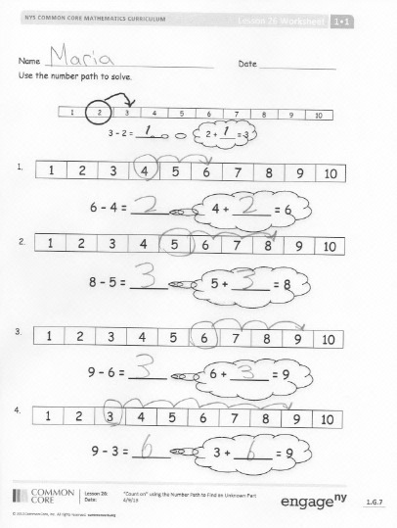
T: Let’s count as we draw our hopping marks.
T/S: 1, 2, 3, 4, 5.
T: What number did you land on?
S: 3.
T: Write the number sentence and put a circle around what we were solving for.
S: (Write 8 – 5 = 3, and circle 3.)
Repeat this process. Consider using the suggested sequence 9 – 2, 7 – 5, and 7 – 3. Some students may begin to see when counting on is more efficient and when counting back is more efficient. It’s okay if they don’t see this yet, as they will do more work with selecting an efficient strategy in Lesson 27.
Problem Set (10 minutes)
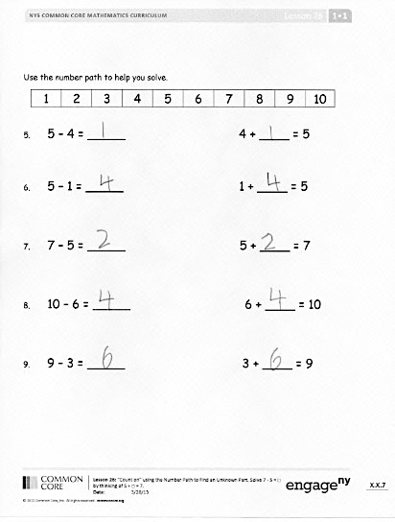
Students should do their personal best to complete the Problem Set within the allotted 10 minutes. For some classes, it may be appropriate to modify the assignment by specifying which problems they work on first. Some problems do not specify a method for solving. Students solve these problems using the RDW approach used for Application Problems.
On this Problem Set, all students should begin with Problems 1–6, possibly leaving Problems 7, 8, and 9 to the end if they still have time.
Student Debrief (10 minutes)
Lesson Objective: Count on using the number path to find an unknown part.
The Student Debrief is intended to invite reflection and active processing of the total lesson experience.
Invite students to review their solutions for the Problem Set. They should check work by comparing answers with a partner before going over answers as a class. Look for misconceptions or misunderstandings that can be addressed in the Debrief. Guide students in a conversation to debrief the Problem Set and process the lesson.

You may choose to use any combination of the questions below to lead the discussion.
- Look at Problem 3 and Problem 4. How are these problems related? Which strategy would be easier to solve Problem 3? Which strategy would be wiser to use to solve Problem 4?
- Look at Problem 5 and Problem 6. What do you notice about these problems? What did you do differently or similarly to solve these problems?
- Look at your Application Problem and Problem Set Problem 7. Describe the connections between the two.
Exit Ticket (3 minutes)
After the Student Debrief, instruct students to complete the Exit Ticket. A review of their work will help you assess the students’ understanding of the concepts that were presented in the lesson today and plan more effectively for future lessons. You may read the questions aloud to the students.

Name Date
Use the number path to solve.

1 | 2 | 3 | 4 | 5 | 6 | 7 | 8 | 9 | 10
3 – 2 = _____ 2 + ___ = 3
1
1

1 | 2 | 3 | 4 | 5 | 6 | 7 | 8 | 9 | 10

1.

6 – 4 = _____ 4 + _____ = 6

1 | 2 | 3 | 4 | 5 | 6 | 7 | 8 | 9 | 10
2.

8 – 5 = _____ 5 + _____ = 8
1 | 2 | 3 | 4 | 5 | 6 | 7 | 8 | 9 | 10

3.

9 – 6 = _____ 6 + _____ = 9

1 | 2 | 3 | 4 | 5 | 6 | 7 | 8 | 9 | 10
4.

9 – 3 = _____ 3 + _____ = 9
1 | 2 | 3 | 4 | 5 | 6 | 7 | 8 | 9 | 10
Use the number path to help you solve.

5. 5 – 4 = _____ 4 + ____ = 5

6. 5 – 1 = _____ 1 + ____ = 5

7. 7 – 5 = _____ 5 + ____ = 7

8. 10 – 6 = _____ 6 + ____ = 10

9. 9 – 3 = _____ 3 + ____ = 9

Name Date
Use the number path to solve. Write the addition sentence you used to help you solve.
1 | 2 | 3 | 4 | 5 | 6 | 7 | 8 | 9 | 10

a. 7 – 5 = _____ ____________
b. 9 – 2 = _____ ____________
c. ____ = 10 – 3 ____________

Name Date
Use the number path to solve.

1 | 2 | 3 | 4 | 5 | 6 | 7 | 8 | 9 | 10
1
1

3 – 2 = _____ 2 + ___ = 3
1 | 2 | 3 | 4 | 5 | 6 | 7 | 8 | 9 | 10

1.
3 + ___ = 5
5 - 3 = _____
1 | 2 | 3 | 4 | 5 | 6 | 7 | 8 | 9 | 10

2.

a. 8 – 6 = ____ 6 + ____ = 8

b. 7 – 4 = ____ 4 + ____ = 7

c. 8 – 2 = ____ ____________

d. 9 – 6 = ____ ____________

Use the number path to solve. Match the addition sentence that can help you.
1 | 2 | 3 | 4 | 5 | 6 | 7 | 8 | 9 | 10

3. a. 6 – 4 = _____ 6 + 4 = 10

b. 9 – 5 = _____ 10 = 7 + 3

c. 10 – 6 = _____ 4 + 5 = 9

d. 10 – 7 = _____ 6 = 4 + 2

- Write an addition and subtraction number sentence for the number bond. You may use the number path to solve.
1 | 2 | 3 | 4 | 5 | 6 | 7 | 8 | 9 | 10

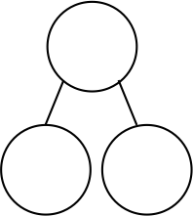
8

3
9

3
b.
a.

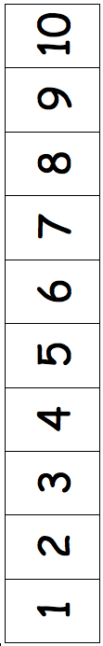

number path

