Lesson 24
Objective: Practice to build fluency with facts to 10.

Suggested Lesson Structure
 Fluency Practice (15 minutes)
 Application Problem (7 minutes)
 Concept Development (30 minutes)
 Student Debrief (8 minutes)
Total Time (60 minutes)
Fluency Practice (15 minutes)
- Partner Counting by Twos 1.OA.5 (2 minutes)
- Cold Call: 2 More and 2 Less 1.OA.5 (3 minutes)
- Friendly Fact Go Around 1.OA.6 (10 minutes)
Partner Counting by Twos (2 minutes)
Note: Counting on and back allows students to build and maintain fluency with this strategy as they solve addition and subtraction problems.
Partners alternate saying numbers aloud to count by twos from 0 to 20 and back.
Cold Call: 2 More and 2 Less (3 minutes)
Note: This activity addresses the core fluency objective for Grade 1 of adding and subtracting within 10.
Tell students you are going to say a number aloud and instruct them to think about the number that is 2 more. Let them know you will cold call students to say the number as quickly as possible. Alternate between calling on individual students, the whole class, and groups of students (e.g., only girls, only boys, etc.). Play again, cold calling students to say the number that is 2 less.
Friendly Fact Go Around (10 minutes)
Materials: (T) Friendly Fact Go Around: Addition Strategies Review (Fluency Template)
Note: This activity addresses the core fluency objective for Grade 1 of adding and subtracting within 10.
Project the Friendly Fact Go Around: Addition Strategies Review sheet (or make a poster). Point to a problem and call on a student to answer (e.g., 8 + 0 = ). The student answers “8!” then the class says the number sentence aloud, completed with the answer (8 + 0 = 8). If the student gives an incorrect answer, he or she then repeats the correct equation that the class gave. The teacher can adapt the problem to individual students, pointing to easier problems for students who are less fluent.
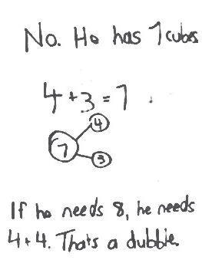
Application Problem (7 minutes)
The teacher told Henry to get 8 linking cubes. Henry took 4 blue cubes and 3 red cubes. Does Henry have the correct amount of linking cubes? Use pictures or words to explain your thinking.
Note: This problem is designed as a bridge from the previous lesson’s focus on common totals on the addition chart. Students will also discuss the related facts embedded in the problem during the Debrief.
Concept Development (30 minutes)
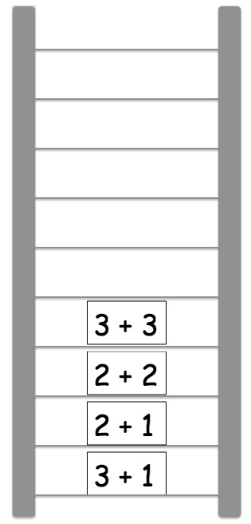
Materials: (T) Friendly Fact Go Around (Fluency Template), Related Fact Ladder (Template 1), 10 expression cards (Template 2) (S) 5–12 expression cards per pair
Materials note: Friendly Fact Go Around and Related Fact Ladder are both to be posted or projected. The suggested set for the expression cards is 3 + 1, 2 + 1, 2 + 2, 3 + 3, 3 + 2, 2 + 3, 4 + 3, 4 + 4, 4 + 5, 5 + 5.
T: (Hold up the expression cards 3 + 1 and 2 + 1. Project ladder picture on the board.) We just found the total of each of the expressions when we played Friendly Fact Go Around. (Tape 3 + 1 on bottom center of board and 2 + 1 directly above it.) How are
3 + 1 and 2 + 1 alike? How are they related to each other?
S: They both are adding 1 to a number.
T: What happens when you add 1 to a number? Use 3 + 1 and 2 + 1 as your examples to explain.

NOTES ON
MULTIPLE MEANS
OF REPRESENTATION:
The Related Fact Ladder provides students an opportunity to demonstrate their level of comprehension. This activity facilitates student discovery of patterns and structures in their math work. Encourage students to discover these connections whenever possible.
S: You get the next counting number. When you add 1 to 3, you get 4, the next counting number. When you add 1 to 2, you get 3, which is the next counting number after 2. Twooo, 3!
T: We’re going to make a Related Fact Ladder. Let’s look for an expression that might be related to 2 + 1 in some way. How about 2 + 2? How is 2 + 2 related to
2 + 1?
S: 2 + 2 is one more than 2 + 1.
T: (Place 2 + 2 card on the next ladder rung, above 2 + 1.) Find a card that is related to 2 + 2. Explain how it is related.
S: 3 + 3. It’s the next doubles fact.
T: (Add card on the next rung of the ladder.)
Repeat the process, having students explain how the expressions are related as you add the cards to the ladder rungs in successive order.
Note: There will always be more than one expression that could be an appropriate choice. (For example, appropriate choices to follow 3 + 2 could be 2 + 2 or 3 + 3 as the double that helps you solve the expression, or 4 + 1 as an expression with the same total, where you add 1 to the first addend and take 1 away from the second addend.) As long as students are able to discuss the mathematical relationship between the two expressions (i.e., it is the next double, a double plus 1 fact is 1 more than the double fact, or the expression is 1 more than the previous expression), the expression can be used.
Problem Set (10 minutes)

NOTES ON
MULTIPLE MEANS
FOR ACTION AND EXPRESSION:
Allow students to use their 5-group cards if they need them. The focus should be on students articulating the relationship between one expression and another as they solve for the totals.

Distribute Problem Sets and expression cards to students. Allow them to play as partners or small groups. Students should do their personal best to complete the Problem Set within the allotted 10 minutes. For some classes, it may be appropriate to modify the assignment by specifying which problems they work on first. Some problems do not specify a method for solving. Students solve these problems using the RDW approach used for Application Problems.
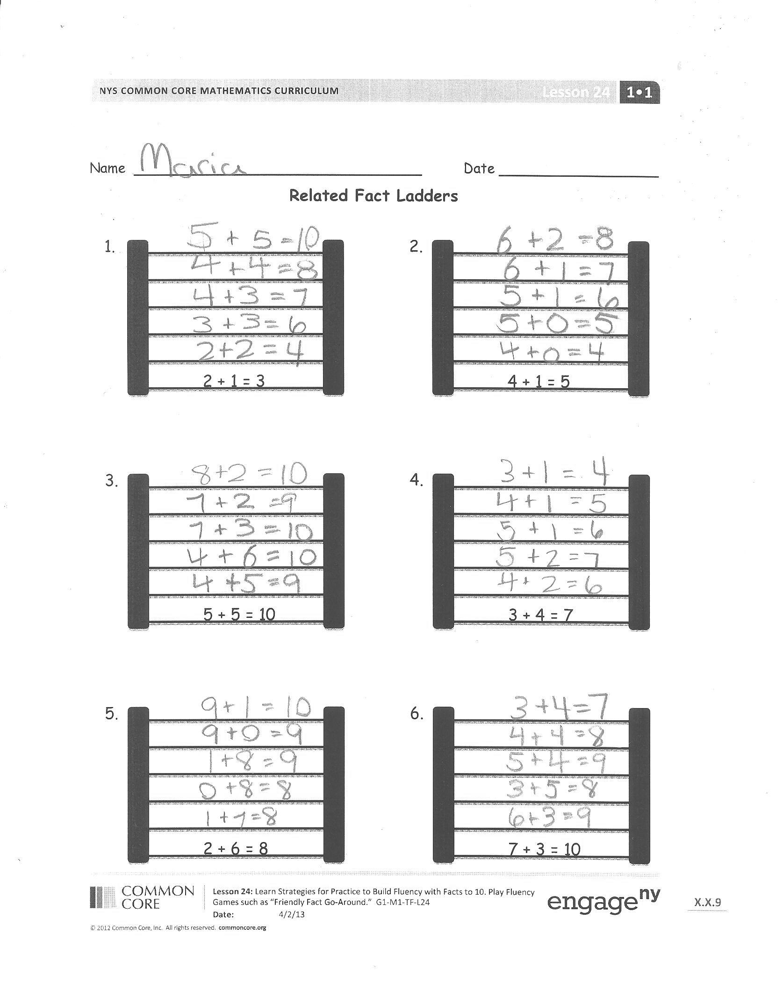
To complete the Problem Set, partners begin with the first ladder. They work together to find an expression card that could be the next related fact on the ladder. Partners discuss how the fact is related, and write the number sentence on the next rung. When players complete the ladder, they begin the next ladder.
MP.7
MP.6
Note: As students play, circulate and ask them to articulate the strategies they used to find the total. This information can be used during the Debrief.
Student Debrief (8 minutes)
Lesson Objective: Practice to build fluency with facts to 10.
The Student Debrief is intended to invite reflection and active processing of the total lesson experience.
Invite students to review their solutions for the Problem Set. They should check work by comparing answers with a partner before going over answers as a class. Look for misconceptions or misunderstandings that can be addressed in the Debrief. Guide students in a conversation to debrief the Problem Set and process the lesson.
You may choose to use any combination of the questions below to lead the discussion.
- Share one of your Related Fact Ladders with a partner. Explain how each number sentence is related. What types of relationships did you both use? What was the easiest relationship for you to think of? Why?
- For which facts did you have the hardest time thinking of a related fact? Explain what made it difficult, and what you decided to do.
- Let’s look at the addition chart together. How does the chart help us see how facts are related? Use examples to explain your thinking.
- Look at your Application Problem. How could Henry change his number of linking cubes from 4 blue cubes and 3 red cubes so that he has 8 cubes using a related number sentence? Explain how your suggestion is related to 4 + 3 = 7.
Exit Ticket (3 minutes)
After the Student Debrief, instruct students to complete the Exit Ticket. A review of their work will help you assess the students’ understanding of the concepts that were presented in the lesson today and plan more effectively for future lessons. You may read the questions aloud to the students.

Name Date
Related Fact Ladders
5 + 5 = 10
3.
2 + 6 = 8
5.

Name Date
3 + 4 = 7
4.
7 + 3 = 10
6.
4 + 1 = 5
2.
2 + 1 = 3
1.

Solve the number sentences. Use the key to color. Once the box is colored, you do not need to color it again.
a.
c.
b.
5 + 2= ____
3 + 3 = ____
2 + 3 = ____
7 + 2 = ____
2 = 1 + ____
7 = 1 + ____
10 = 5 + ___
3 + 4 = ____
8 + 2 = ____
10 = 1 + ____
____ = 5 + 4
____ = 4 + 4

g.
i.
h.
e.
d.
f.
j.
l.
k.

Color doubles red.
Color +1 blue.
Color +2 green.
Color doubles +1 brown.

Challenge:
List the number sentences that can be colored more than 1 way.

__________________________ __________________________

Name Date
Solve and sort the number sentences. One number sentence can go in more than one place when you sort.
5 + 1 = ___
3 + 3 = ____
2 + 3 = ____
6 + 2 = ____
2 + 2 = ____
7 + 1 = ____
____ = 5 + 2
3 + 4 = ____
8 + 2 = ____
10 = 1 + ____
____ = 5 + 4
____ = 4 + 4

Doubles | Doubles +1 | +1 | +2 | Mentally visualized  5-groups
Write your own number sentences, and add them to the chart.

1 + 0 | 1 + 1 | 1 + 2 | 1 + 3 | 1 + 4 | 1 + 5 | 1 + 6 | 1 + 7 | 1 + 8 | 1 + 9
2 + 0 | 2 + 1 | 2 + 2 | 2 + 3 | 2 + 4 | 2 + 5 | 2 + 6 | 2 + 7 | 2 + 8
3 + 0 | 3 + 1 | 3 + 2 | 3 + 3 | 3 + 4 | 3 + 5 | 3 + 6 | 3 + 7
4 + 0 | 4 + 1 | 4 + 2 | 4 + 3 | 4+ 4 | 4 + 5 | 4 + 6
5 + 0 | 5 + 1 | 5 + 2 | 5 + 3 | 5 + 4 | 5 + 5
6 + 0 | 6 + 1 | 6 + 2 | 6 + 3 | 6 + 4
7 + 0 | 7 + 1 | 7 + 2 | 7 + 3
8 + 0 | 8 + 1 | 8 + 2
9 + 0 | 9 + 1
10 + 0
Solve and practice math facts.

2 + 1 = ☐ 3 + 1 = ☐ 5 + 1 = ☐

4 + 1 = ☐ 6 + 1 = ☐ 9 + 1 = ☐

2 + 2 = ☐ 2 + 3 = ☐ 5 + 5 = ☐

3 + 3 = ☐ 4 + 4 = ☐ 4 + 5 = ☐

0 + 1 = ☐ 1 + 3 = ☐ 1 + 1 = ☐

2 + 2 = ☐ 7 + 1 = ☐ 3 + 3 = ☐

1 + 5 = ☐ 5 + 5 = ☐ 3 + 4 = ☐

8 + 1 = ☐ 4 + 4 = ☐ 5 + 4 = ☐

7 + 3 | 0 + 7
0 + 2 | 8 + 2
9 + 0 | 0 + 3
9 + 1 | 1 + 8
6 + 3 | 4 + 6
7 + 2 | 1 + 7
6 + 2 | 4 + 5
6 + 1 | 0 + 6
4 + 3 | 4 + 4
5 + 2 | 5 + 5
5 + 1 | 3 + 5
4 + 2 | 4 + 4
0 + 8 | 4 + 1
2 + 3 | 3 + 3
4 + 0 | 5 + 0
3 + 1 | 3 + 4
5 + 4 | 2 + 2

friendly fact go around
related fact ladder
expression cards
expression cards
expression cards

