Lesson 23
Objective: Look for and make use of structure on the addition chart by looking for and coloring problems with the same total.

Suggested Lesson Structure
 Fluency Practice (12 minutes)
 Application Problem (8 minutes)
 Concept Development (30 minutes)
 Student Debrief (10 minutes)
Total Time (60 minutes)
Fluency Practice (12 minutes)
- Happy Counting by Twos 1.OA.5 (2 minutes)
- Missing Part: 8 1.OA.6 (5 minutes)
- Number Bond Dash: 8 1.OA.6 (5 minutes)
Happy Counting by Twos (2 minutes)
Note: This activity supports the connection between counting on by 2 and adding 2.
Repeat the Happy Counting activity from Lesson 3, counting by twos from 0 to 20 and back.
Missing Part: 8 (5 minutes)
Materials: (S) 5-group cards (0–8 only) (Lesson 5 Template 1)
Note: This activity addresses the core fluency objective for Grade 1 of mastery of sums to 10.
Students work with partners, using 5-group cards. Each student puts a card on his or her forehead. The partner tells how many more to make 8. Students must guess the cards on their foreheads. Partners can play simultaneously.
Number Bond Dash: 8 (5 minutes)
Materials: (T) Stopwatch or timer (S) Number bond dash 8 (Lesson 7 Fluency Template 2), marker to correct work
Note: This activity addresses the core fluency objective for Grade 1 of adding and subtracting within 10.
Follow the procedure for the Number Bond Dash in Lesson 5 Fluency Practice, remembering today is the second day with making 8. Students should recall their scores from Lesson 22 to see and celebrate improvement.
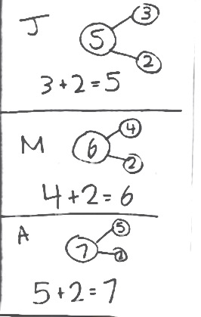
Application Problem (8 minutes)
John has 3 stickers. Mark has 4 stickers. Anna has 5 stickers. They each get two more stickers. How many do they each have now? Write a number bond and number sentence for each student.
Extension: How many stickers do John, Mark, and Anna have together?
Note: This problem is designed as an application of the previous lesson, which focused on common addends on the addition chart. Students will continue to explore the addition chart in today’s lesson, focusing on expressions with the same total.
Concept Development (30 minutes)
Materials: (T) Addition chart with sums to 10 to project or post (Lesson 21 Template), cover paper, markers (three different colors) (S) Addition chart with sums to 10 (Lesson 21 Template), pencils (three different colors)
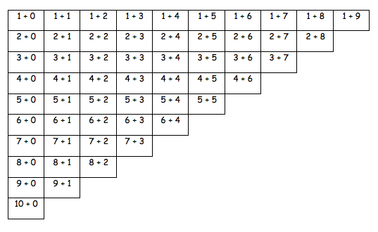
Distribute an addition chart to each student. Have students fold their papers to match the chart below.
Addition Chart with 1 + 5 through 1 + 9 Revealed
T: (Point to 5 + 5.) What is 5 + 5?
S: 10!
T: (Point to 4 + 6.) What is 4 + 6?
S: 10!
T: (Repeat through 1 + 9.) Talk to your partner. What do you notice about the totals?
T: (Circulate and listen. Then, choose students to share with the class.)
S: They are all the same! The totals are all 10! They look like they’re moving up like stairs!

NOTES ON
MULTIPLE MEANS
OF ENGAGEMENT:
Offer opportunities for student leadership as “teacher.” Have students demonstrate for the class how the staircase works for each total. Listen for the use of math vocabulary in their descriptions.

MP.7
T: You said all of the totals are 10. Help me color in the expressions that equal 10. (Prompt students to say which to color.)
S: (Lightly color in charts.)
T: What is 4 + 5?
S: 9.
T: Talk with your partner. Find the other expressions that equal 9.
S: (Share with partners to find totals of 9.)
T: Let’s color them in. (Using a different color, prompt students to say which to color as they color in their own charts.)
T: Talk with your partner: What do you notice about these problems? (Circulate and listen, and then choose students to share with class.)
S: They all equal 9! The totals are all 1 less than the ones we colored in for 10! They make another staircase!
T: With your partner, look for expressions that equal 8. When you both agree, color them in with your last colored pencil.
S: (Circulate and observe.)
T: Which expressions equal 8? (As students share, color them in on the class chart.)
T: What patterns are you noticing?
S: All the totals of 8 make a slanted line, like a staircase.
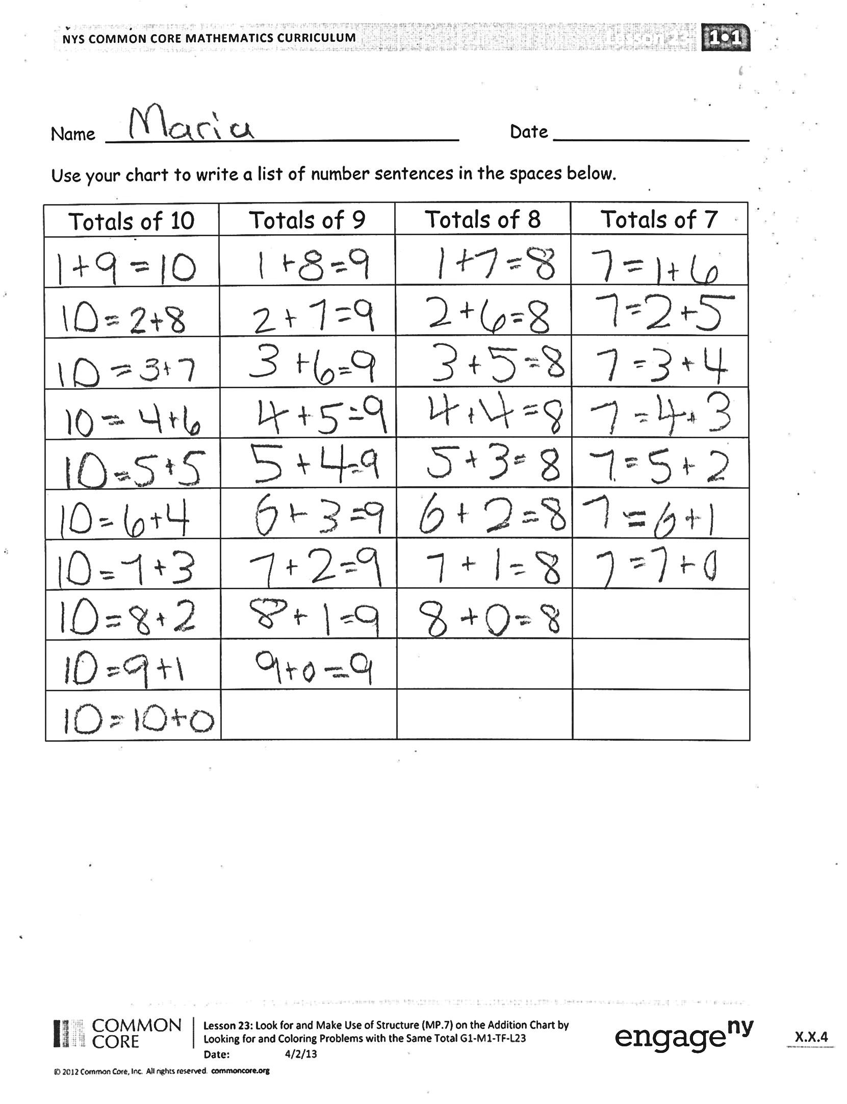
Problem Set (15 minutes)
Students should do their personal best to complete the Problem Set within the allotted 15 minutes. For some classes, it may be appropriate to modify the assignment by specifying which problems they work on first. Some problems do not specify a method for solving. Students solve these problems using the RDW approach used for Application Problems.
Student Debrief (10 minutes)
Lesson Objective: Look for and make use of structure on the addition chart by looking for and coloring problems with the same total.
The Student Debrief is intended to invite reflection and active processing of the total lesson experience.
Invite students to review their solutions for the Problem Set. They should check work by comparing answers with a partner before going over answers as a class. Look for misconceptions or misunderstandings that can be addressed in the Debrief. Guide students in a conversation to debrief the Problem Set and process the lesson.
You may choose to use any combination of the questions below to lead the discussion.
- Look at your Application Problem. What is similar in each of your number bonds? What is different? Could one number bond or number sentence help you solve another one?
- What did you notice about the number of boxes of each color? How many boxes will be colored for the total of 4? 3?
- Why do you think we have more totals for 10 compared to totals for 5?
- Which totals are the easiest for you to solve? Why?
- Which totals do you think you need to practice the most? What can you do to get better at these expressions?
- (Point to the addition chart from yesterday’s work.) How is today’s work similar to what we did yesterday? How is it different?
Exit Ticket (3 minutes)
After the Student Debrief, instruct students to complete the Exit Ticket. A review of their work will help you assess the students’ understanding of the concepts that were presented in the lesson today and plan more effectively for future lessons. You may read the questions aloud to the students.

Name Date

Use your chart to write a list of number sentences in the spaces below.
Totals of 10 | Totals of 9 | Totals of 8 | Totals of 7

Name Date
1 + 0 | 1 + 1 | 1 + 2 | 1 + 3 | 1 + 4 | 1 + 5 | 1 + 6 | 1 + 7 | 1 + 8 | 1 + 9
2 + 0 | 2 + 1 | 2 + 2 | 2 + 3 | 2 + 4 | 2 + 5 | 2 + 6 | 2 + 7 | 2 + 8
3 + 0 | 3 + 1 | 3 + 2 | 3 + 3 | 3 + 4 | 3 + 5 | 3 + 6 | 3 + 7
4 + 0 | 4 + 1 | 4 + 2 | 4 + 3 | 4 + 4 | 4 + 5 | 4 + 6
5 + 0 | 5 + 1 | 5 + 2 | 5 + 3 | 5 + 4 | 5 + 5
6 + 0 | 6 + 1 | 6 + 2 | 6 + 3 | 6 + 4
7 + 0 | 7 + 1 | 7 + 2 | 7 + 3
8 + 0 | 8 + 1 | 8 + 2
9 + 0 | 9 + 1

1. Circle all the boxes that total 10.
2. Draw an X through all the boxes that total 8.
Name Date
Fill in the missing box, and find the totals for all expressions. Use your completed addition chart to help you.
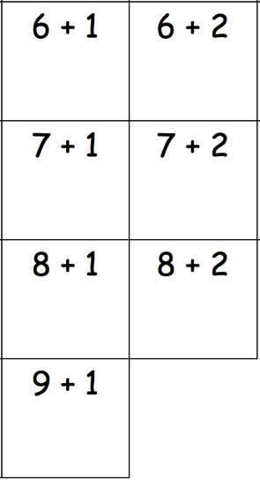
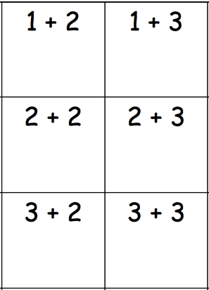
1. 2.

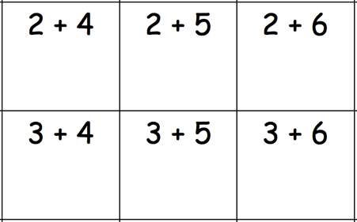
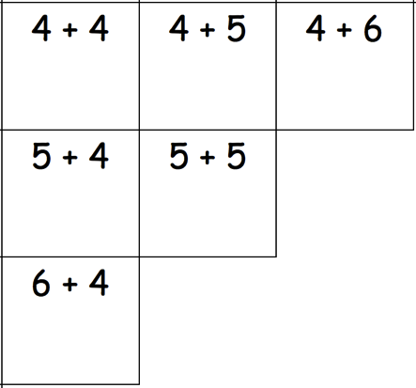
3. 4.

