Lesson 22
Objective: Look for and make use of repeated reasoning on the addition chart by solving and analyzing problems with common addends.

Suggested Lesson Structure
 Fluency Practice (13 minutes)
 Application Problem (5 minutes)
 Concept Development (32 minutes)
 Student Debrief (10 minutes)
Total Time (60 minutes)
Fluency Practice (13 minutes)
- Sparkle: Counting by Twos 1.OA.5 (5 minutes)
- Penny Drop: 8 1.OA.5, 1.OA.6 (3 minutes)
- Number Bond Dash: 8 1.OA.6 (5 minutes)
Sparkle: Counting by Twos (5 minutes)
Note: Practicing counting up allows students to maintain fluency with the strategy as it relates to addition.
Play Sparkle, counting by twos from 0 to 20. (Refer to game directions in Lesson 7.) As you practice the counting sequence before the game, model the say–think–say skip-counting strategy: say 0, think 1, say 2, think 3….
Penny Drop: 8 (3 minutes)

NOTES ON
MULTIPLE MEANS
OF ACTION AND EXPRESSION:
Not all students are comfortable being timed while completing Fluency Practice activities. Allow these students extra time for completion so that they feel successful and strive to do their best during these exercises.

Materials: (T) 8 pennies, 1 can
Note: This activity addresses the core fluency objective for Grade 1 of adding and subtracting within 10.
Show students 8 pennies. Have students close their eyes and listen. Drop some of the pennies in a can, one at a time. To prepare students for the upcoming subtraction lessons, instruct them to count back from 8 in their heads as they hear each penny drop. Ask students to open their eyes and say how many pennies you still have in your hand.
Number Bond Dash: 8 (5 minutes)
Materials: (T) Stopwatch or timer (S) Number bond dash 8 (Lesson 7 Fluency Template 2), marker to correct work
Note: By using the same system repeatedly, students can focus on the mathematics alone. This activity addresses the core fluency objective for Grade 1 of adding and subtracting within 10. Teachers may want to take note of students who are using finger counting. This may help identify students who require additional time or support to solve partners of 8.
Follow the procedure for the Number Bond Dash in Lesson 5 Fluency Practice. Tell students to remember how many problems they get correct so they can try to improve their scores tomorrow.
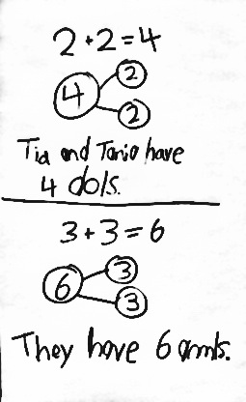
Application Problem (5 minutes)

May and Kay are twins. Whatever May has, Kay has it, too. May has 2 dolls. How many dolls do May and Kay have together? May has 3 stuffed animals. How many stuffed animals do they have together? Write a number bond, number sentence, and statement to show your solution.
Extension: If all the dolls and all the stuffed animals were put together for an imaginary tea party, how many toys would there be? Draw or write to explain your thinking.
Note: This problem is designed as a bridge from the previous lesson, which focused on doubles. Students will also have the opportunity to locate the expressions within their number sentences on the chart and begin to recognize other ways to use repeated reasoning as they explore the addition chart. Teachers may want to take note of students who are using finger counting for doubles. This may help identify students who require additional time or support to utilize doubles as a strategy.
Concept Development (32 minutes)
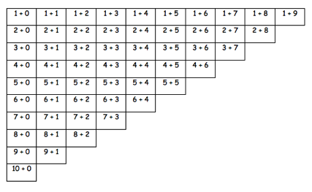
Materials: (T) Addition chart with sums to 10 (Lesson 21 Template), cover paper
Addition Chart with +0 Revealed

T: (Post or project addition chart, reveal only the +0 column.) Mathematicians, today you need to especially put on your noticing ears and eyes! Read the expressions aloud with me.
S/T: 1 + 0, 2 + 0, 3 + 0, 4 + 0, 5 + 0, 6 + 0, 7 + 0,
8 + 0, 9 + 0, 10 + 0.
T: What did you notice was the same as you read each of these expressions?

S: We said “plus zero” every time!
T: What did you notice was different as you read each of these expressions?

NOTES ON
MULTIPLE MEANS
OF REPRESENTATION:
Some students will benefit from an addition chart colored based on the addend. For example, color all the +0 blue, +1 yellow, +3 green, etc. Using the addition chart in this way will especially help visually impaired students who may find the chart hard to read.

S: The first number went up by 1 each time!
T: Good. Now, let’s solve each problem together.
As students solve the problems, transform the expressions into equations as you or student volunteers write the solutions. Be sure to have students read the equations aloud. Next, reveal the +1 column, and go through the same process of having students read, notice the similarities and differences, and then solve.
T: (Point to 1 + 0 and 2 + 0.) You said that all of these problems add zero each time. How does adding zero change this first addend, or part? (Point.)
S: The first addend doesn’t change, because we’re just adding zero!
T: So, it’s zero more than the first number? Is this true of all of the facts in this area? (Gesture to the +0 column.)
S: Yes!
T: (Point to 8 + 1 and 9 + 1.) You said that all of these problems add 1 each time. How does adding 1 change this first addend?
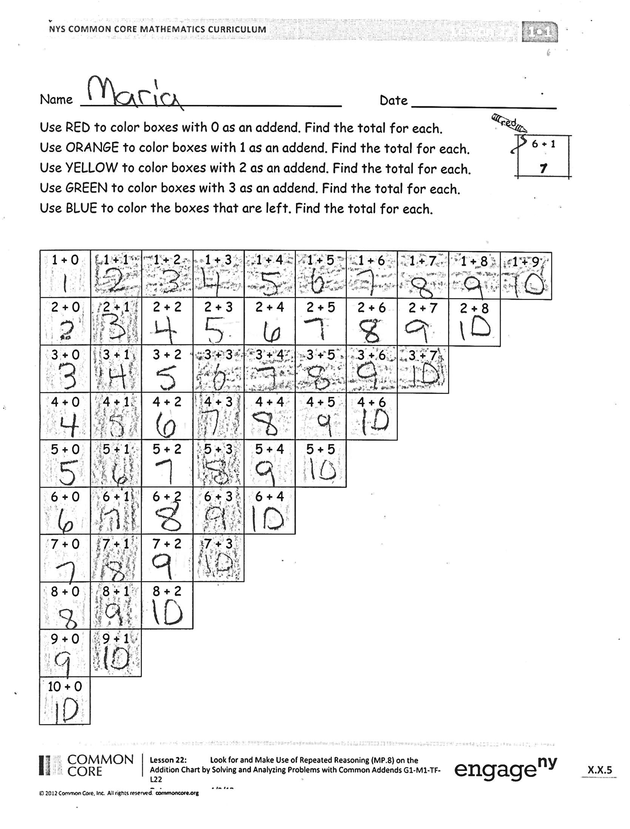
S: The total goes up by 1, because we’re adding on! It’s just the next counting number!
Continue this process with the +2 column, focusing on the common addends.
Problem Set (15 minutes)
Note: Explain to students to complete one color at a time. Students do not need to overlap colors. For examples, 1 + 2 will already be colored red. Students do not need to color it orange.
Students should do their personal best to complete the Problem Set within the allotted 10 minutes. For some classes, it may be appropriate to modify the assignment by specifying which problems they work on first. Some problems do not specify a method for solving. Students solve these problems using the RDW approach used for Application Problems.
Student Debrief (10 minutes)
Lesson Objective: Look for and make use of repeated reasoning on the addition chart by solving and analyzing problems with common addends.
The Student Debrief is intended to invite reflection and active processing of the total lesson experience.
Invite students to review their solutions for the Problem Set. They should check work by comparing answers with a partner before going over answers as a class. Look for misconceptions or misunderstandings that can be addressed in the Debrief. Guide students in a conversation to debrief the Problem Set and process the lesson.
You may choose to use any combination of the questions below to lead the discussion.
- Look at your Problem Set. We talked about how all the problems add 1 each time in this column. (Gesture going up and down on +1 column.) Is that the only place that had problems adding 1 each time?
- How are the second column (n + 1) and the first row (1 + n) related? Does this remind you of another math lesson?
- Which row is the third column related to? What addend, or part, do they have in common?
- Look at your Application Problem. Can you find the expressions from your number sentences on the chart? What do you notice about their locations?
- Which colored boxes have the easiest facts for you to solve? Why?
- Which colored boxes have the facts you need the most practice with? Why?
- How can this chart help you learn your facts better?
Exit Ticket (3 minutes)
After the Student Debrief, instruct students to complete the Exit Ticket. A review of their work will help you assess the students’ understanding of the concepts that were presented in the lesson today and plan more effectively for future lessons. You may read the questions aloud to the students.

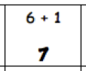
Name Date
orange
1. Use RED to color boxes with 0 as an addend. Find the total for each.
2. Use ORANGE to color boxes with 1 as an addend. Find the total for each.
3. Use YELLOW to color boxes with 2 as an addend. Find the total for each.
4. Use GREEN to color boxes with 3 as an addend. Find the total for each.
5. Use BLUE to color the boxes that are left. Find the total for each.
1 + 0 | 1 + 1 | 1 + 2 | 1 + 3 | 1 + 4 | 1 + 5 | 1 + 6 | 1 + 7 | 1 + 8 | 1 + 9
2 + 0 | 2 + 1 | 2 + 2 | 2 + 3 | 2 + 4 | 2 + 5 | 2 + 6 | 2 + 7 | 2 + 8
3 + 0 | 3 + 1 | 3 + 2 | 3 + 3 | 3 + 4 | 3 + 5 | 3 + 6 | 3 + 7
4 + 0 | 4 + 1 | 4 + 2 | 4 + 3 | 4 + 4 | 4 + 5 | 4 + 6
5 + 0 | 5 + 1 | 5 + 2 | 5 + 3 | 5 + 4 | 5 + 5
6 + 0 | 6 + 1 | 6 + 2 | 6 + 3 | 6 + 4
7 + 0 | 7 + 1 | 7 + 2 | 7 + 3
8 + 0 | 8 + 1 | 8 + 2
9 + 0 | 9 + 1

Name Date
Some of the addends in this chart are missing! Fill in the missing numbers.
1 + 0 | 1 + 1 | 1 + 2 | 1 + 3 | 1 + 4 | 1 + 5 | 1 + 6 | 1 + 7 | 1 + 8 | 1 + 9
2 + 0 | 2 + 1 | 2 + 2 | 2 + __ | 2 + 4 | 2 + 5 | 2 + 6 | 2 + 7 | 2 + 8
3 + 0 | 3 + 1 | 3 + 2 | 3 + __ | 3 + 4 | 3 + 5 | 3 + 6 | 3 + 7
4 + 0 | 4 + __ | 4 + 2 | 4 + 3 | __ + 4 | __ + 5 | __ + 6
5 + 0 | 5 + __ | 5 + 2 | 5 + 3 | 5 + 4 | 5 + 5
6 + 0 | 6 + __ | 6 + 2 | 6 + 3 | 6 + 4
7 + __ | 7 + 1 | 7 + 2 | 7 + 3
8 + __ | 8 + 1 | 8 + 2
9 + __ | 9 + 1
10 + 0

Name Date
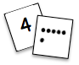
Solve the problems without counting all. Color the boxes using the key.
Step 1: Color problems with “+ 1” or “1 +” blue.
Step 2: Color remaining problems with “+ 2” or “2 +” green.
Step 3: Color remaining problems with “+ 3” or “3 +” yellow.
a.  7 + 1 = ___ | b.  8 + ___ = 9 | c.  3 + 1 = ___ | d.  5 + 3 = ___
e.  5 + ___ = 7 | f.  4 + ___ = 7 | g.  6 + 3 = ___ | h.  8 + ___ = 10
i.  2 + 1 = ___ | j.  1 + ___ = 2 | k.  1 + ___ = 4 | l.  6 + 2 = ___
m.  3 + ___ = 6 | n.  6 + ___ = 7 | o.  3 + 2 = ___ | p.  5 + 1 = ___
q.  2 + 2 = ___ | r.  4 + ___ = 6 | s.  4 + 1 = ___ | t.  7 + 2 = ___
u.  2 + ___ = 3 | v.  9 + 1 = ___ | w.  7 + 3 = ___ | x.  1 + ___ = 3

