Lesson 21
Objective: Visualize and solve doubles and doubles plus 1 with
5-group cards.

Suggested Lesson Structure
 Fluency Practice (12 minutes)
 Application Problem (5 minutes)
 Concept Development (28 minutes)
 Student Debrief (15 minutes)
Total Time (60 minutes)
Fluency Practice (12 minutes)
- Stand on Even Numbers 1.OA.5 (3 minutes)
- Target Practice: 8 1.OA.6 (9 minutes)
Stand on Even Numbers (3 minutes)
Note: Counting on allows students to maintain fluency with this strategy as they solve addition problems.
Students sit in a circle and count by ones, each student saying one number to count up. When a student says an even number, she stands: 1, 2 (student stands), 3, 4 (student stands)…. Continue around the circle until all students are standing. Those who are standing do not continue counting. Then, continuing in the same direction around the circle, students count backwards, beginning with the last number said and sitting on even numbers.
Play the game a second time, instructing students who stay still to whisper their numbers and students who stand or sit to use a normal voice.
Target Practice: 8 (9 minutes)
Materials: (S) Per set of partners: personal white board, target practice (Lesson 10 Fluency Template), 8 counters, 1 die
Note: This activity addresses the core fluency objective for Grade 1 of adding and subtracting within 10.
Follow the directions on the Target Practice template. Use 8 as the target number.

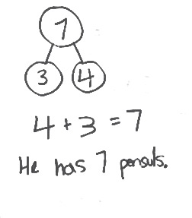
Application Problem (5 minutes)
Jordan is holding a container with 3 pencils. His teacher gives him 4 more pencils for the container. How many pencils will be in the container? Write a number bond, number sentence, and statement to show the solution.
Note: This problem is an application of the commutative property to count on from the larger addend from Lesson 20. It is also relevant to the Concept Development of the current lesson as a doubles plus 1 problem.
Concept Development (28 minutes)
Materials: (T) 5-group cards (1–6) (Lesson 5 Template 1), addition chart (Template), colored pencils (yellow, orange) (S) Personal white board
Have students sit next to their math partners in the meeting area or at their tables.
T: Let’s count by twos using our fingers. Watch me first.
T/S: (Show fingers.) 2, 4, 6, 8, 10, 10, 8, 6, 4, 2.
T: Show me 1 and 1 with your pinkies like me. (See image below.) How many fingers are you holding up?

NOTES ON
MULTIPLE MEANS
OF ENGAGEMENT:
To help students recognize the doubles they are creating, encourage them to wiggle their fingers as they hold up doubles. For instance, to solve 3 + 3, have students wiggle pinkies and say “two,” wiggle pinkies and ring fingers and say “four,” and finally wiggle pinky, ring, and middle fingers and say “six.”
S: 2.
T: What is the number sentence?
S: 1 + 1 = 2.
T: Show me 2 and 2 fingers, your pinkies and ring fingers. Say the number sentence to tell how many fingers you’re holding up.
S: 2 + 2 = 4.
Continue with 3 + 3, 4 + 4, 5 + 5, and back down to 1 + 1.
T: What did you notice about the numbers we added each time?
S: We added the same number two times.
T: We call those doubles.
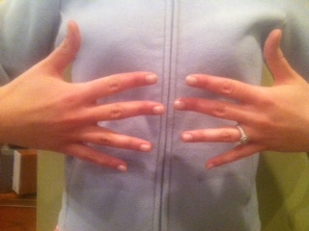
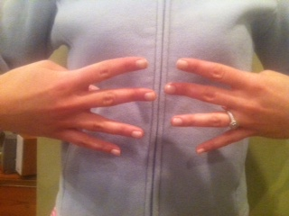
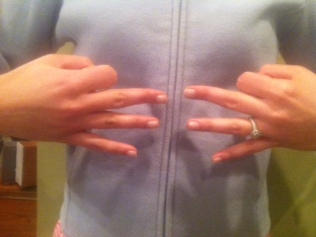
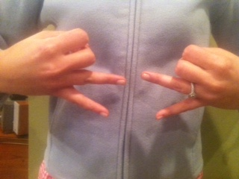
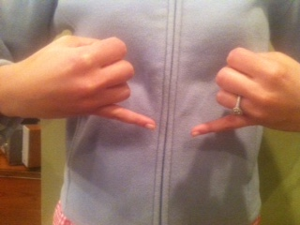

Give 2 minutes for students to work with a partner and practice making doubles number sentences. Partner A flashes doubles fingers; Partner B says the number sentence. They switch roles after 1 minute.
T: (Show two 5-group cards showing 3 dots.) Without counting all, tell how many dots there are.
S: 6.
T: How did you know?
S: I saw doubles. Three and 3. That makes 6.
Continue with 2 + 2, 4 + 4, and 5 + 5, ensuring students use the term doubles to explain what they see and eventually naming it as a strategy. Congratulate them on getting better at mastering their doubles facts.
T: (Show 3 dots card and 4 dots card.) Without counting all, tell how many dots there are.
S: 7.
T: How did you know so quickly? Turn and talk to your partner. (Circulate and listen.)
T: Bobbie said she saw 3 and 3 plus another dot! Give thumbs up if you see 3 dots hiding inside these 4 dots.
S: (Show thumbs.)
T: She used her doubles fact to help. Three plus 3 (circle 3 dots and 3 dots), that’s…
S: 6.
T: Plus another dot?
S: 7.
T: How is 3 + 4 related to 3 + 3?
S: It’s making doubles and adding 1 more.
T: This is called doubles plus 1. Let’s see if we can find more doubles facts hiding inside another expression.
Continue with 1 + 2, 3 + 2, and 4 + 5.
T: (Project the numerals 4 and 5.) How would you solve 4 + 5 using what you learned in today’s lesson? Turn and talk to your partner, and solve on your board.
MP.8
S: (Write 4 + 5 = 9.) Use our doubles facts. 4 + 4 = 8. Add 1 more, and you get 9.
T: (Project 3 + __ = 6.) What number is missing here? Talk with your partner to decide. Tell each other how you know.
S: (Discuss with partner.)

NOTES ON
MULTIPLE MEANS
OF ENGAGEMENT:
For students who have reached mastery with larger doubles, consider using other doubles facts within their repertoire. This will help motivate those students and keep them actively engaged in the objective.

T: What is the missing number in 3 + __ = 6?
S: 3!
T: How do you know?
S: I know that 3 + 3 = 6. I thought of the doubles. If I have 3 (holds up 3 fingers on one hand), I need 3 more to make 6.
T: (Project 3 + __ = 7.) What number is missing here? Discuss with your partner. Remember to use words or your boards to explain your thinking.
S: (Discuss with partner.)
T: What is the missing number in 3 + __ = 7?
S: 4!
T: How could the last problem, 3 + 3 = 6, help you with this one?
S: If you know 3 + 3 is 6 and you need to have 7, you know you need 1 more than last time, so now it’s 3 + 4.
Continue with 4 + 4 and 4 + 5.
Problem Set (10 minutes)
Students should do their personal best to complete the Problem Set within the allotted 10 minutes. For some classes, it may be appropriate to modify the assignment by specifying which problems they work on first. Some problems do not specify a method for solving. Students solve these problems using the RDW approach used for Application Problems.
In this Problem Set, students should begin with Problem 1, Problem 2, Problem 5, Problem 6, and possibly leave Problem 7(d) and 7(e), Problem 8, and Problem 9 to the end if there is still time.
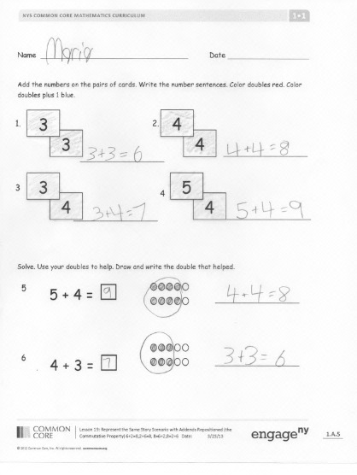
Student Debrief (15 minutes)
Lesson Objective: Visualize and solve doubles and doubles plus 1 with 5-group cards.
The Student Debrief is intended to invite reflection and active processing of the total lesson experience.
Invite students to review their solutions for the Problem Set. They should check work by comparing answers with a partner before going over answers as a class. Look for misconceptions or misunderstandings that can be addressed in the Debrief. Guide students in a conversation to debrief the Problem Set and process the lesson.
You may choose to use any combination of the questions below to lead the discussion.
- (Post the addition chart.) Can you find all the doubles facts? (Color them red.) What do you notice about these numbers?
- Can you find all the doubles plus 1 facts? (Color them using blue.) What do you notice about the two parts in doubles plus 1 facts? (They are the numbers next to each other when we count.)

- Is 4 + 3 a doubles plus 1? Why? How is this related to another math lesson from before? Can you find any more doubles plus 1 facts like this one? (Color them blue if you find any more.)
- Look at Problem 7 in your Problem Set. What do you notice about all the answers to the doubles facts? (They are all even numbers.) What do you notice about all the answers to the doubles plus 1 facts? (They are all odd numbers.) Is this always true? Explain your thinking.
- Look at Problem 7(e) and (f) in your Problem Set. How could you use the pictures in your mind or your knowledge of doubles facts to help you solve these problems?
- Look at your Application Problem. If you used counting on to solve this, which number did you start with in your number sentence? Can you use the strategy from today’s lesson to solve this? How?
Exit Ticket (3 minutes)
After the Student Debrief, instruct students to complete the Exit Ticket. A review of their work will help you assess the students’ understanding of the concepts that were presented in the lesson today and plan more effectively for future lessons. You may read the questions aloud to the students.

Name Date

Add the numbers on the pairs of cards. Write the number sentences. Color doubles red. Color doubles plus 1 blue.
1.
2.1.
3
3
3.
44
4
__________________________
__________________________
4.
4
5
4
3

__________________________
__________________________

Solve. Use your doubles to help. Draw and write the double that helped.
5 + 4 = ☐
5.
__________________________

6.
- + 3 = ☐
__________________________
- Solve the doubles and the doubles plus 1 number sentences.
a. 0 + 0 = ☐ 0 + 1 = ☐
b. 2 + 2 = ☐ 2 + 3 = ☐
c. 3 + 3 = ☐ 3 + 4 = ☐
d. 4 + 4 = ☐ 4 + 5 = ☐
e. 3 +☐ = 6 3 +☐ = 7
f. 5 +☐ = 10 4 + ☐ = 9
- Show how this strategy can help you solve 5 + 6 = ☐

- Write a set of 4 related addition facts for the number sentences of Problem 7(d).

Name Date

Write the double and double plus 1 number sentence for each 5-group card.
4
5

Name Date
23

1. Draw the 5-group card to show a double. Write the number sentence to match the cards.
c.
b.
a.
5

3
4

2. Fill in the 5-group cards in order from least to greatest, double the number, and write the number sentences.
b.
a.
c.
d.
e.
1

1

2

4

3. Solve the number sentences.
b.
a.
c.
3 + 3 = ___
5 + ___ = 10
1 + ___ = 2

d.
e.
8 = 4 + ____
4 = ___ + 2

4. Match the top cards to the bottom cards to show doubles plus 1.
a.
b.
d.
c.
2
4
3
3
4
2
1
5

5. Solve the number sentences. Write the double fact that helped you solve the double plus 1.
a.
b.
c.
4 + ___ = 9
3 + ___ = 7

2 + 3 = ___

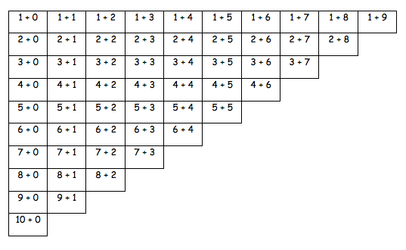

addition chart

