Lesson 10: The Structure of Ratio Tables—Additive and Multiplicative

Classwork
Exploratory Challenge
Imagine that you are making a fruit salad. For every quart of blueberries you add, you would like to put in $3$ quarts of strawberries. Create three ratio tables that show the amounts of blueberries and strawberries you would use if you needed to make fruit salad for greater numbers of people.
Table 1 should contain amounts where you have added fewer than $10$ quarts of blueberries to the salad.
Table 2 should contain amounts of blueberries between $10$ and $50$ quarts.
Table 3 should contain amounts of blueberries greater than $100$ quarts.
Table 2
Quarts of Blueberries | Quarts of Strawberries

Table 1
Quarts of Blueberries | Quarts of Strawberries

Table 3
Quarts of Blueberries | Quarts of Strawberries

  - Describe any patterns you see in the tables. Be specific in your descriptions.

  - How are the amounts of blueberries and strawberries related to each other?

  - How are the values in the blueberries column related to each other?

  - How are the values in the strawberries column related to each other?

  - If we know we want to add $7$ quarts of blueberries to the fruit salad in Table 1, how can we use the table to help us determine how many strawberries to add?

  - If we know we used $70$ quarts of blueberries to make our salad, how can we use a ratio table to find out how many quarts of strawberries were used?

Exercise 1
The following tables were made incorrectly. Find the mistakes that were made, create the correct ratio table, and state the ratio that was used to make the correct ratio table.
Hours | Pay in Dollars

Hours | Pay in Dollars
$$3$$ | $$24$$
$$5$$ | $$40$$
$$7$$ | $$52$$
$$9$$ | $$72$$

Ratio _________________________

Blue | Yellow

Blue | Yellow
$$1$$ | $$5$$
$$4$$ | $$8$$
$$7$$ | $$13$$
$$10$$ | $$16$$

Ratio _________________________
Lesson Summary
Ratio tables are constructed in a special way.
Each pair of values in the table will be equivalent to the same ratio.
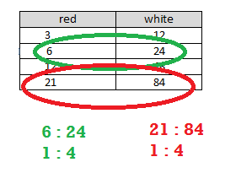
You can use repeated addition or multiplication to create a ratio table.
There is a constant value that we can multiply the values in the first column by to get the values in the second column.
red | white
$$3 ×4$$ | $$12$$
$$6 ×4$$ | $$24$$
$$12 ×4$$ | $$48$$
$$21 ×4$$ | $$84$$
If you add a certain number to each entry in one column, you may not be able to add that same number to the entries in the other column and keep the same ratio. Instead, the numbers you add to the entries must be related to the ratio used to make the table. However, if you multiply the entries in one column by a certain number, you can multiply the entries in the other column by the same number to create equivalent ratios.
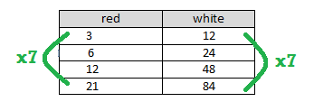

Problem Set

- a. Create a ratio table for making lemonade with a lemon juice-to-water ratio of $1:3$. Show how much lemon
juice would be needed if you use $36$ cups of water to make lemonade.
  - How is the value of the ratio used to create the table?

- Ryan made a table to show how much blue and red paint he mixed to get the shade of purple he will use to paint the room. He wants to use the table to help him make larger and smaller batches of purple paint.
Blue | Red
$$12$$ | $$3$$
$$20$$ | $$5$$
$$28$$ | $$7$$
$$36$$ | $$9$$
  - What ratio was used to create this table? Support your answer.
  - How are the values in each row related to each other?
  - How are the values in each column related to each other?

