Lesson 18
Objective: Practice and solidify Grade 4 vocabulary.

Suggested Lesson Structure
 Fluency Practice (8 minutes)
 Concept Development (42 minutes)
 Student Debrief (10 minutes)
Total Time (60 minutes)
Fluency Practice (8 minutes)
- Grade 4 Core Fluency Differentiated Practice Sets 4.NBT.4 (4 minutes)
- Draw and Identify Geometric Terms 4.G.1 (4 minutes)
Grade 4 Core Fluency Differentiated Practice Sets (4 minutes)
Materials: (S) Core Fluency Practice Sets from G4–M7–Lesson 2
Note: During G4–Module 7, each day’s Fluency Practice may include an opportunity for mastery of the addition and subtraction algorithm by means of the Core Fluency Practice Sets. The process is detailed and materials are provided in G4–M7–Lesson 2. It is recommended these sets be sent home in the Summer Folder.
Draw and Identify Geometric Terms (4 minutes)
Materials: (S) Personal white boards, protractor, ruler
Note: This fluency activity reviews G4–Module 4 and prepares students for using geometric terms in today’s lesson.
A
C
B
T: Use your protractor and ruler to draw a right, isosceles triangle.
S: (Draw as shown to the right, though student pictures may vary.)
T: Label vertices to identify the right angle as $∠ABC$.
S: (Label as shown to the right.)
T: $\overline{AB}$ and $\overline{BC}$ are what types of lines?
D
G
F
E
S: Perpendicular lines.
T: Use your protractor and ruler to draw a rectangle $DEFG.$
S: (Draw as shown to the right, though student pictures may vary.)
T: What type of lines are $\overline{DE}$ and $\overline{FG}$?
S: Parallel lines.

NOTES ON
MULTIPLE MEANS OF ENGAGEMENT:
Like yesterday’s fluency activities, these are games that students can play with family members to maintain skills over the summer. It may be appropriate to invite parents and siblings to learn and participate. This might be done at a math or parents’ night. Students may consider their game partner and make adjustments accordingly. For example, if played with a younger or older sibling, games may include math appropriate for siblings. Discuss with students how to best adapt the games for their personal summer experiences.

T: Identify another pair of parallel lines.
S: $\overline{EF}$ and $\overline{DG}$.
Concept Development (42 minutes)
Materials: (S) 2 small envelopes containing vocabulary definitions and terms (cardstock cutouts), bingo template, game descriptions, summer folder
For the rest of today’s lesson, students play vocabulary games reviewing the major work of Grade 4. Consider opening the lesson with a game of bingo with the whole class and then having them play either bingo or one of the other games in pairs or groups of four, alternating the role of caller, using the cards provided. As yesterday, students might periodically move around the room selecting different partners and playing one of the four games, or they might stay in the same grouping for the duration of this practice.
After the session, store the instructions for the games and all materials in the summer folders for home use.

NOTES ON
MULTIPLE MEANS OF REPRESENTATION:
To accommodate English language learners, rather than using all 24 words, they might omit one or two rows just to reduce the amount of reading.

Problem Set
Please note that the Problem Set for G4–M7–Lesson 18 is the math bingo and other games they will be playing in class.

Student Debrief (10 minutes)
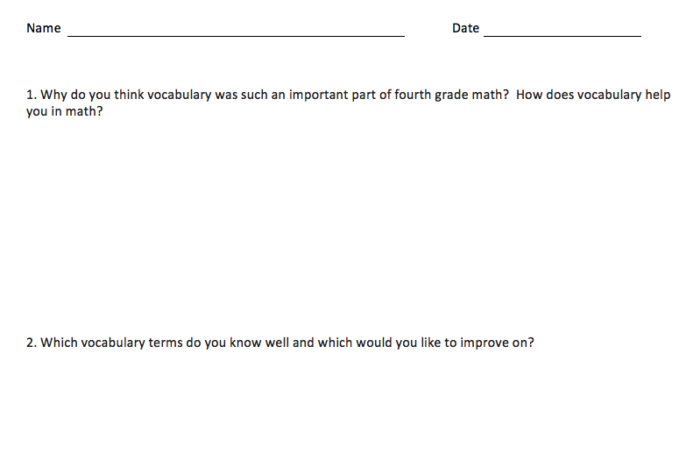
Reflection (3 minutes)
Before the Student Debrief, instruct students to complete the Reflection pictured to the right. Reflections are replacing the Exit Tickets in G4–M7–Topic D in order for students to have four days to think back on their learning and growth in Grade 4.
Lesson Objective: Practice and solidify Grade 4 vocabulary.
The Student Debrief is intended to invite reflection and active processing of the total lesson experience.
Invite students to review their reflections before going over their solutions for the Problem Set. They should check work by comparing answers with a partner before going over answers as a class. Look for misconceptions or misunderstandings that can be addressed in the Debrief. Guide students in a conversation to debrief the Problem Set and process the lesson.
You may choose to use any combination of the questions below to lead the discussion.
- Share your Reflection with a partner. After you have both shared, talk more about ways you might practice this summer and how to overcome difficulties with practicing.
- Which games did you most enjoy? Who might you play those games with during the summer?
- Which games were the most challenging? Did you enjoy the challenge?
- How might you modify the games to play with family and friends?
- How does vocabulary help you to communicate to the people who care about you, about your education, and about what happens in school?

Math Jeopardy:
Structure: Teams or partnerships. Callers should prepare the game in advance.
- The definitions are sorted into labeled columns by a caller: units, lines and angles, the four operations, and geometric shapes.
- The first term directly below the heading has a value of $100, the next $200, and so on. The caller should make an effort to order the questions from easiest to hardest.
- Player 1 chooses a column and a dollar value, for example, “I choose geometry terms for $100.” The caller reads, “The answer is….”
- The players write the matching question, for example, “What is a quadrilateral?”
- The first person to correctly state the question wins the dollar value for that card.
- Play continues until all cards are used.
- The player with the most dollar value wins.
Math Pictionary:
Structure: Teams or partnerships.
- A timer is set for 1 minute.
- A vocabulary term is chosen from a bag by a player from Team 1, who draws an example as quickly as possible.
- The player’s teammate(s) try to guess the vocabulary term. When the term is guessed, a new term is chosen by the same player. The process is repeated as many times as possible within the minute. Terms not guessed when the timer sounds go back in the bag.
- A player from Team 2 repeats the process.
- Teams count the number of words guessed. The team with the most words is the winner.
Bingo:
- Players write a vocabulary term in each box of the math bingo game template. Each term should be used only once. The box that says Math Bingo is a free space.
- Players place the filled-in math bingo template in their mini- boards.
- One person is the caller and reads the definition on a vocabulary card.
- Players cross off (or cover) the term that matches the definition.
- Bingo! is called when 5 vocabulary terms in a row are crossed off diagonally, vertically, or horizontally. The free space counts as 1 box towards the needed 5 vocabulary terms.
- The first player to have 5 in a row reads each crossed off word, states the definition, and gives a description or an example of each word. If all words are reasonably explained as determined by the caller, the player is declared the winner.
Concentration:
Structure: Teams or partnerships.
- Create an array of all the cards face down.
- Players take turns flipping over pairs of cards to find a match. A match is a vocabulary term and its definition. Cards keep their precise location in the array if not matched. Remaining cards are not reconfigured into a new array.
- After all cards are matched, the player with the most pairs is the winner.
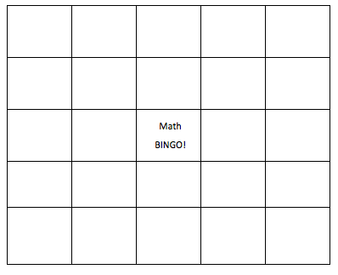
A metric unit of measure equivalent to 1,000 grams. | A whole number greater than 1 whose only factors are 1 and itself. | An angle measuring less than 90 degrees. | Lines that intersect at 90-degree angles.
A whole number plus a fraction. | An angle that turns through $\frac{1}{360}$ of a circle. | The bottom number in a fraction that tells the number of equal parts in the whole. | A customary unit of measurement for liquid volume equivalent to 4 quarts.
A customary unit of measurement for liquid volume equivalent to 2 pints. | The answer to a multiplication problem. | The answer to a division problem. | A line through a figure such that when the figure is folded along an imaginary line, two halves are created that match up exactly.
Two lines in a plane that never intersect. | A triangle with at least two equal sides. | A whole number having three or more distinct factors. | A closed figure with 4 straight sides and 4 angles.
An angle measuring 90 degrees. | An angle with a measure greater than 90 degrees but less than 180 degrees. | Lines that contain at least 1 point in common. | A tool used to measure and draw angles.
The top number in a fraction that tells how many parts of the whole are selected. | A triangle that contains one 90-degree angle. | This special angle measures 180 degrees. | A closed figure with 3 straight sides of equal length and 3 equal angles.

Kilogram | Prime Number | Acute Angle | Perpendicular Lines
Mixed Number | One-Degree Angle | Denominator | Gallon
Quart | Product | Quotient and Remainder | Line of Symmetry
Parallel Lines | Isosceles Triangle | Composite Number | Quadrilateral
Right Angle | Obtuse Angle | Intersecting Lines | Protractor
Numerator | Right Triangle | Straight Angle | Equilateral Triangle

Name Date
- Why do you think vocabulary was such an important part of fourth-grade math? How does vocabulary help you in math?

- Which vocabulary terms do you know well, and which would you like to improve upon?

