Lesson 17
Objective: Practice and solidify Grade 4 fluency.

Suggested Lesson Structure
 Fluency Practice (50 minutes)
 Student Debrief (10 minutes)
Total Time (60 minutes)
Fluency Practice (50 minutes)
- Count by Equivalent Fractions (5 minutes)
- Mixed Review Fluency (45 minutes)
Count by Equivalent Fractions (5 minutes)
Note: Students have practiced this fluency activity throughout the year.
T: Count by threes to 30 starting at 0.
S: 0, 3, 6, 9, 12, 15, 18, 21, 24, 27, 30.
$\frac{0}{10}$ $\frac{3}{10}$ $\frac{6}{10}$ $\frac{9}{10}$ $\frac{12}{10}$ $\frac{15}{10}$ $\frac{18}{10}$ $\frac{21}{10}$ $\frac{24}{10}$ $\frac{27}{10}$ $\frac{30}{10}$
$0$ $\frac{3}{10}$ $\frac{6}{10}$ $\frac{9}{10}$ $\frac{12}{10}$ $\frac{15}{10}$ $\frac{18}{10}$ $\frac{21}{10}$ $\frac{24}{10}$ $\frac{27}{10}$ 3
$0$ $\frac{3}{10}$ $\frac{6}{10}$ $\frac{9}{10}$ $\text{1}\frac{2}{10}$ $\text{1}\frac{5}{10}$ $\text{1}\frac{8}{10}$ $\text{2}\frac{1}{10}$ $\text{2}\frac{4}{10}$ $\text{2}\frac{7}{10}$ 3

T: Count by 3 tenths to 30 tenths starting at 0 tenths. (Write as students count.)
S: $\frac{0}{10}$, $\frac{3}{10}$, $\frac{6}{10}$, $\frac{9}{10}$, $\frac{12}{10}$, $\frac{15}{10}$, $\frac{18}{10}$, $\frac{21}{10 }$, $\frac{24}{10}$, $\frac{27}{10}$, $\frac{30}{10}$.
T: Which of these fractions is equal to a whole number?
S: 30 tenths.
T: (Point to $\frac{30}{10}$.) 30 tenths is how many ones?
S: 3 ones.
T: (Beneath $\frac{20}{10}$$\frac{30}{10}$, write 3 ones.) Count by 3 tenths again. This time, when you come to a whole number, say the whole number. (Write as students count.)
S: $0$, $\frac{3}{10}$, $\frac{6}{10}$, $\frac{9}{10}$, $\frac{12}{10}$, $\frac{15}{10}$, $\frac{18}{10}$, $\frac{21}{10 }$, $\frac{24}{10}$, $\frac{27}{10 }$, 3.
T: (Point to $\frac{12}{10}$$\frac{12}{10}$.) Say $\frac{12}{10}$ as a mixed number.
S: $\text{1}\frac{2}{10}$.
Continue the process for $\text{1}\frac{8}{10}$, $\text{2}\frac{1}{10}$, $\text{2}\frac{4}{10}$, and $\text{2}\frac{7}{10}$.
T: Count by 3 tenths again. This time, convert to mixed numbers or whole numbers. (Write as students count.)
S: $\text{0}$, $\frac{3}{10 }$, $\frac{6}{10 }$, $\frac{9}{10 }$, $\text{1}\frac{2}{10 }$, $\text{1}\frac{5}{10 }$, $\text{1}\frac{8}{10 }$, $\text{2}\frac{1}{10}$,$\text{ 2}\frac{4}{10 }$, $\text{2}\frac{7}{10 }$, 3.
Mixed Review of Fluency (45 minutes)

NOTES ON
MULTIPLE MEANS OF ENGAGEMENT:
These are games that students can play with family members to maintain skills over the summer. It may be appropriate to invite parents and siblings to learn and participate. This might be done at a math or parents’ night. Students may consider game partners and make adjustments accordingly. For example, if played with a younger or older sibling, games may include math appropriate for siblings. Discuss with students how to best adapt the games for their personal summer experiences.

Materials: (T) List of module titles for G4–Modules 1–7 for the Debrief (S) Problem Set of Fluency Cards, mini-personal board, protractor
For the rest of today’s lesson students are engaged in fluency activities reviewing the major work of Grade 4. They work and play in pairs, alternating the role of teacher, using the cards provided. Students might periodically move around the room selecting different partners, or they may stay in the same grouping for the duration of this practice. Also consider letting students select other fluency favorites based on their needs and interests.
The New Problem component of each card may be best completed after practice using the Teacher Card. The practice will help students better understand all the blanks and the movement of the teacher–student talk. They will then be empowered to extend each activity. Use the mini-personal board so that the New Problem remains usable for the summer months.
After the session, the Fluency Cards are placed in the student folders for use during the summer.

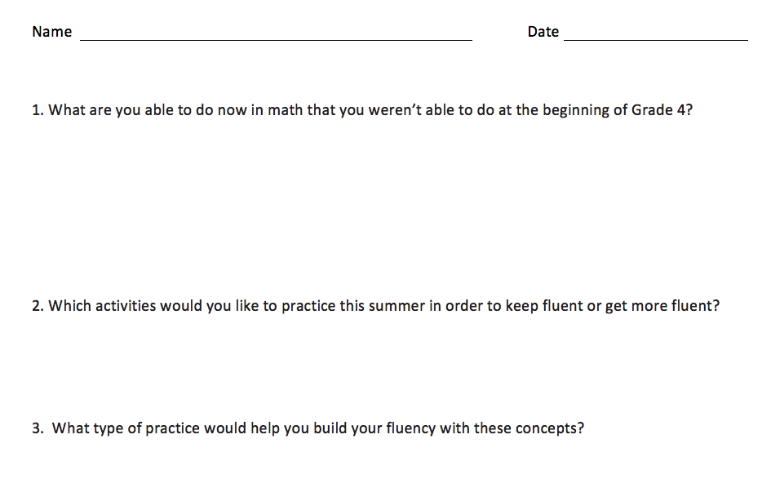
Student Debrief (10 minutes)
Reflection (3 minutes)
Before the Student Debrief, instruct students to complete the Reflection pictured to the right. Reflections are replacing Exit Tickets in G4–M7–Topic D in order for students to have four days to think back on their learning and growth in Grade 4.
Lesson Objective: Practice and solidify Grade 4 fluency.
The Student Debrief is intended to invite reflection and active processing of the total lesson experience.
Invite students to review their reflections before going over their solutions for the Problem Set. They should check work by comparing answers with a partner before going over answers as a class. Look for misconceptions or misunderstandings that can be addressed in the Debrief. Guide students in a conversation to debrief the Problem Set and process the lesson.
You may choose to use any combination of the questions below to lead the discussion.
- Share your Reflection with a partner. After you have both shared, talk more about ways you would like to practice this summer. What problems might you have when you try to practice?
- Do you think that, without practice, fluency can be lost? Why or why not?
- (Display a list of module titles for G4–Modules 1–7.) We have worked hard this year and have learned many things in math. Let’s brainstorm a list of things we have learned this year.
- Which of these concepts were challenging to you at first, but as you worked at them, you understood better?

Name Date
Convert Units: Teacher Card  Materials: (S) Mini-personal boards  T: (Write 1 m 20 cm = ____ cm.)  1 m 20 cm is how many centimeters?  S: 120 centimeters.  Repeat the process with this sequence:  1 m 80 cm = 180 cm  3 km 249 m = 3,249 m  4 L 71 mL = 4,071 mL  2 kg 5 g = 2,005 g | New Problem  T: (Write ________________ = ___________.)  _____________is how many ___________?  S: _________________.

Add Large Numbers: Teacher Card  Materials: (S) Mini-personal boards  T: (Write 747 thousands 585 ones.)  On your boards, write this number in standard form.  S: (Write 747,585.)  T: (Write 242 thousands 819 ones.)  Add this number to 747,585 using the standard algorithm.  S: (Write 747,585 + 242,819 = 990,404  using the standard algorithm.)  Continue the process with this sequence:  528,649 + 247,922 = 776,571  348,587 + 629,357 = 977,944  426,099 + 397,183 = 823,282. | New Problem  T: (Write _______thousands _______ones.) On your boards, write this number in standard form.  S: (Write ________________________.)  T: (Write _______ thousands _______ ones.) Add this number to ___________________ using the standard algorithm.  S: (__________ + __________ = __________ using the standard algorithm.)

Subtract Large Numbers: Teacher Card  Materials: (S) Mini-personal boards  T: (Write 600 thousands.) On your boards, write this number in standard form.  S: (Write 600,000.)  T: (Write 545 thousands 543 ones.) Subtract this number from 600,000 using the standard algorithm.  S: (Write 600,000 – 545,543 = 54,457 using the standard algorithm.)  Continue the process with this sequence:  400,000 – 251,559 = 148,441  700,000 – 385,476 = 314,524  600,024 – 197,088 = 402,936. | New Problem  T: (Write _________ thousands .) On your boards, write this number in standard form.  S: (Write __________________.)  T: (Write _______ thousands ________ones.) Subtract this number from ____________ using the standard algorithm.  S: (___________–___________=__________ using the standard algorithm.)

Multiply Mentally: Teacher Card  Materials: (S) Mini-personal boards  T: (Write 32 × 3 = .)  Say the multiplication sentence.  S: 32 × 3 = 96.  T: (Write 32 × 3 = 96. Below it,  write 32 × 20 = __ .)  Say the multiplication sentence.  S: 32 × 20 = 640.  T: (Write 32 × 20 = 640. Below it,  write 32 × 23 = ___ .)  On your board, solve 32 × 23.  S: (Write 32 × 23 = 736.)  Repeat the process with this sequence:  42 × 2 = 84, 42 × 20 = 840, 42 × 22 = 924  31 × 4 =124, 31 × 40= 1,240, 31 × 44 = 1,364. | New Problem  T: (Write _____ × _____ = _____.)  Say the multiplication sentence.  S: _____ × _____ = _____  T: (Write _____ × _____ = _____. Below it,  write _____ × _____ =_____.)  Say the multiplication sentence.  S: _____ × _____ = _____.  T: (Write _____ × _____ = _____. Below it,  write _____ × _____ = _____.)  On your board, solve _____ × _____.  S: (Write _____ × _____ = _____.)
Divide Mentally: Teacher Card  Materials: (S) Mini-personal boards  T: (Write 40 ÷ 2.) Write the division sentence in unit form.  S: 4 tens ÷ 2 = 2 tens.  T: (To the right, write 8 ÷ 2.) Write the division sentence in unit form.  S: 8 ones ÷ 2 = 4 ones.  T: (Write 48 ÷ 2.) Write the complete division sentence in unit form.  S: 4 tens 8 ones ÷ 2 = 2 tens 4 ones.  T: Say the division sentence.  S: 48 ÷ 2 = 24.  Continue the process with this sequence:  93 ÷ 3 = 31  88 ÷ 4 = 22.  186 ÷ 6 = 24. | New Problem  T: (Write _______________.) Write the division sentence in unit form.  S: ____ tens ÷ ____ = ____ tens.  T: (To the right, write _____ ÷ _____.) Write the division sentence in unit form.  S: ____ ones ÷ ____ = ____ ones.  T: (Write _____________.) Write the complete division sentence in unit form.  S: ____ tens ____ ones ÷ ____ = ____ tens ____ ones.  T: Say the division sentence.  S: ____ ÷ ____ = ____.

State the Value of a Set of Coins: Teacher Card  Materials: (S) Mini-personal board  T: (Draw 2 quarters and 4 dimes as number disks labeled 25¢ and 10¢.) What’s the value of 2 quarters and 4 dimes?  S: 90¢.  T: Write 90 cents as a fraction of a dollar.  S: (Write $\frac{90}{100}$dollar.)  T: Write 90 cents in decimal form using the dollar sign.  S: (Write $0.90.)  Continue the process with this sequence:  1 quarter 9 dimes 12 pennies = 127¢, $\frac{127}{100}$dollar, $1.27  3 quarters 5 dimes 20 pennies = 145¢, $\frac{145}{100}$dollar, $1.45 | New Problems  T: (Draw______ quarters and ______ dimes as number disks.) What’s the value of _________________________________?  S: _____________.  T: Write _______ cents as a fraction of a dollar.  S: (Write _______ dollar.)  T: Write _______ cents in decimal form using the dollar sign.  S: (Write $__________.)

Break Apart 180°: Teacher Card  Materials: (S) Mini-personal boards, protractors, straightedge  T: (Project a number bond with a whole of 180°. Fill in 80° for one of the parts.) On your boards, complete the number bond, filling in the unknown part.  S: (Draw a number bond with a whole of 180°, and 80° and 100° as parts.)  T: Use your protractor to draw the pair of angles.  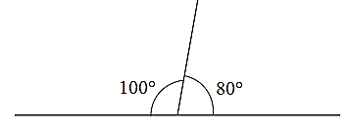  S: (Draw and label the two angles that make 180$°$.)  Continue the process for  120° + 60° = 180°  35° + 145° = 180°  _____ + ________ = 180° | New Problems  T: (Project a number bond with a whole of 180°. Fill in _______° for one of the parts.) On your boards, complete the number bond, filling in the unknown part.  S: (Draw a number bond with a whole of 180°, and _______° and _______° as parts.)  T: Use your protractor to draw the pair of angles.  S: (Draw and label the two angles that make 180$°$.)

Name Date
- What are you able to do now in math that you were not able to do at the beginning of Grade 4?

- Which activities would you like to practice this summer in order to keep fluent or become more fluent?

- What type of practice would help you build your fluency with these concepts?

Name Date
Decimal Fraction Review: Plot each point on the number line below and complete the chart. Only solve the portion above the dotted line.

Point | Unit Form | Decimal Form | Mixed Number (ones and fraction form) | How much more to get to the next whole number?
A | 2 ones and 9 tenths
B |  | 4.4 | $$\text{4}\frac{4}{10}$$
C |  |  |  | $\frac{2}{10}$ or 0.2

Complete the chart. Create your own problem for B and plot the point.

Point | Unit Form | Decimal Form | Mixed Number (ones and fraction form) | How much more to get to the next whole number?
A | 2 ones and 9 tenths
B

Complete the chart. The first one has been done for you. Only solve the top portion above the dotted line.
Decimal | Mixed Number | Tenths | Hundredths
3.2 | $$3\frac{2}{10}$$ | 32 tenths or $\frac{\text{32}}{\text{10}}$ | 320 hundredths or $\frac{320}{100}$
8.6
11.7
4.8

Complete the chart. Create your own problem in the last row.
Decimal | Mixed Number | Tenths | Hundredths
3.2
8.6
11.7

