Lesson 16

Objective: Create and determine the area of composite figures.

Suggested Lesson Structure

 Fluency Practice (9 minutes)

 Concept Development (38 minutes)

 Student Debrief (13 minutes)

**Total Time (60 minutes)**

Fluency Practice (9 minutes)

* Grade 4 Core Fluency Differentiated Practice Sets **4.NBT.4** (4 minutes)
* Find the Area **4.MD.3** (5 minutes)

**Grade 4 Core Fluency Differentiated Practice Sets (4 minutes)**

Materials: (S) Core Fluency Practice Sets from G4–M7–Lesson 2

Note: During G4–Module 7, each day’s Fluency Practice may include an opportunity for mastery of the addition and subtraction algorithm by means of the Core Fluency Practice Sets. The process is detailed and materials are provided in G4–M7–Lesson 2.

Find the Area (5 minutes)

Materials: (S) Personal white boards

Note: This fluency activity reviews area and solving two-digit by two-digit multiplication using the area model from G4-Module 3 and reviews solving for composite areas in G4–M7–Lesson 15.

T: (Project a rectangle with a width of 23 cm and a length of 46 cm.) Decompose the width into tens and ones.

S: 20 centimeters and 3 centimeters.

T: (Draw a horizontal line decomposing the width into 20 centimeters and 3 centimeters.) Decompose the length into tens and ones.

S: (Draw a vertical line decomposing the width into 40 centimeters and 6 centimeters.) 40 centimeters and 6 centimeters.

T: Solve for each smaller area. Then, solve for the total area of the rectangle.

S: 1,058 square centimeters.

Repeat the process for a rectangle with a width of 36 cm and length of 25 cm.

Concept Development (38 minutes)

|  |  |
| --- | --- |
|  | NOTES ON  MULTIPLE MEANS FOR ACTION AND EXPRESSION: |
| Scaffold Problem 1 for students working below grade level and others who may need support managing information. Provide a graphic organizer, such as the chart below, for data collection.   |  |  |  | | --- | --- | --- | | **Item** | **Width** | **Length** | | bedroom |  |  | | bed |  |  | | dresser |  |  | | dresser |  |  | | |

Materials: (S) Problem Set, protractor or copy of protractor template, centimeter ruler or copy of centimeter ruler template, large construction paper

For this lesson, students will work in small groups. They will use protractors and rulers to create rectangular floor plans according to the specifications given in the Problem Set. They will then calculate the area of the open floor space in the floor plan.

Problem 1: Use a protractor and ruler to create a composite figure to given specifications and determine the area of parts of the figure.

The bedroom in Samantha’s dollhouse is a rectangle 26 centimeters long and 15 centimeters wide. It has a rectangular bed that is 9 centimeters long and 6 centimeters wide. The two dressers in the room are each 2 centimeters wide. One measures 7 centimeters long, and the other measures 4 centimeters long. Create a floor plan of the bedroom containing the bed and dressers using your ruler and protractor. Find the area of the open floor space in the bedroom after the furniture is in place.

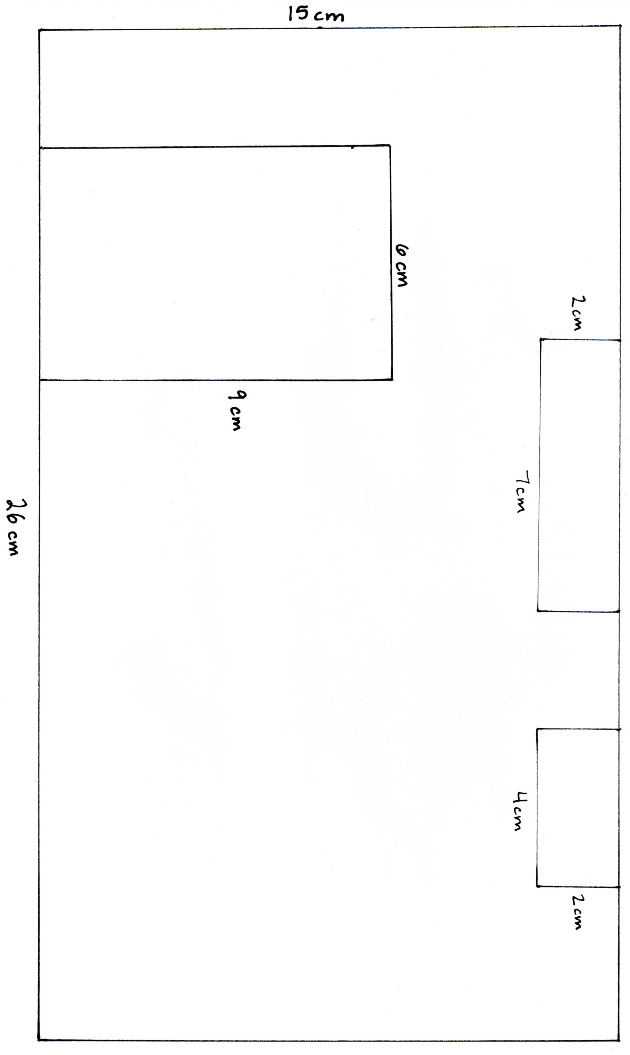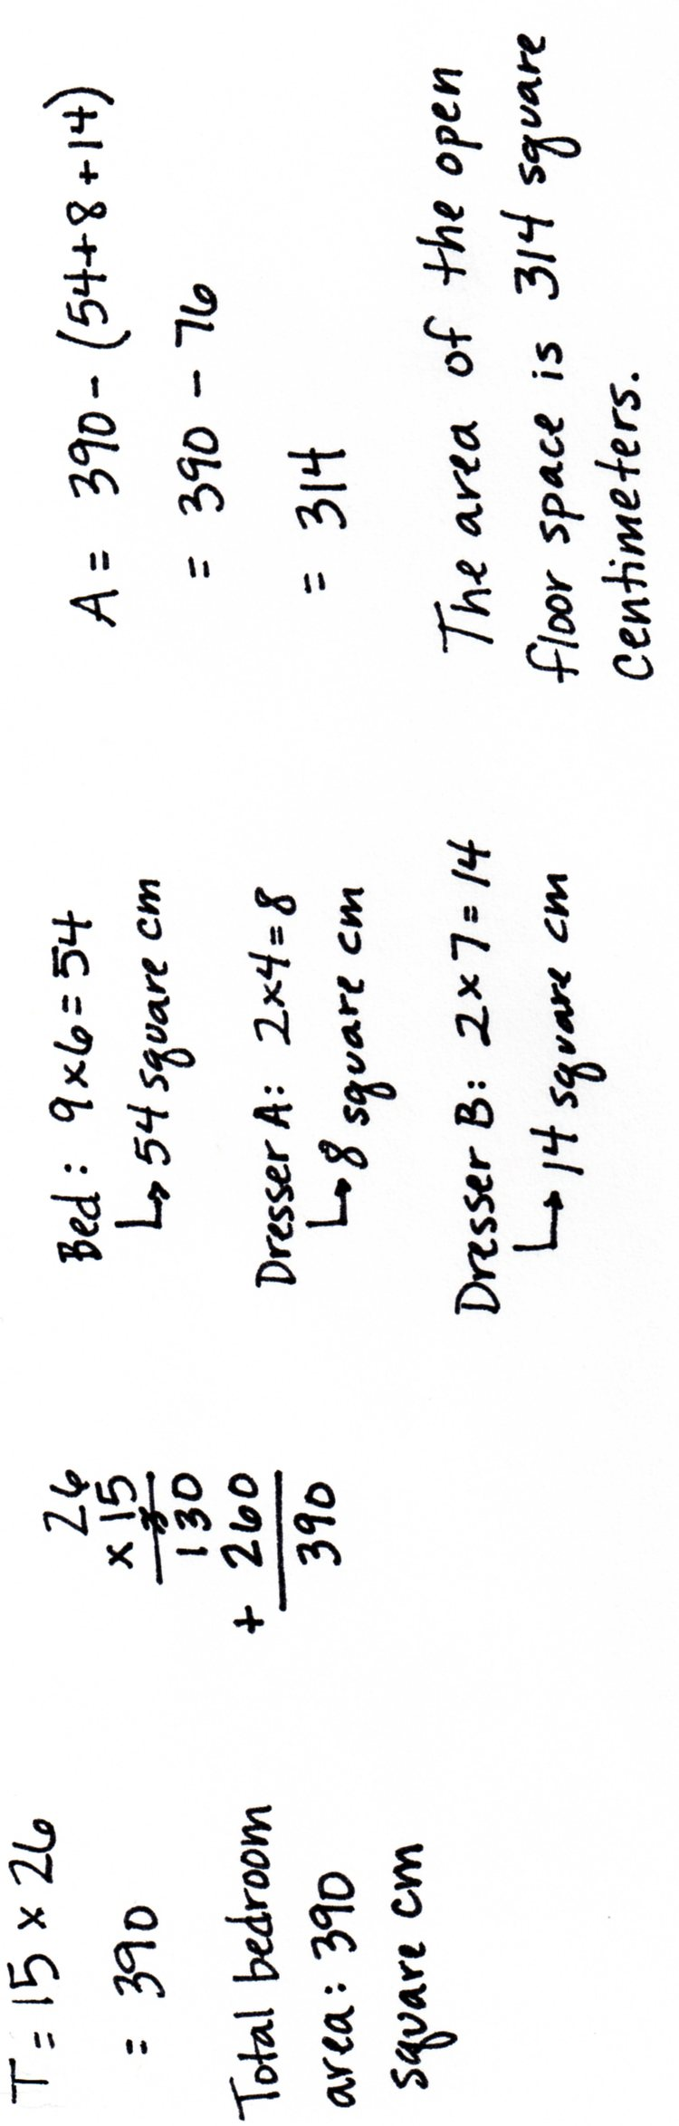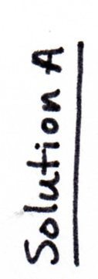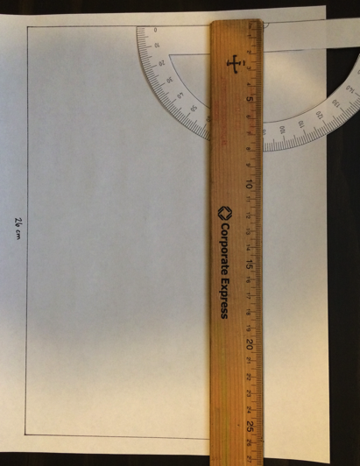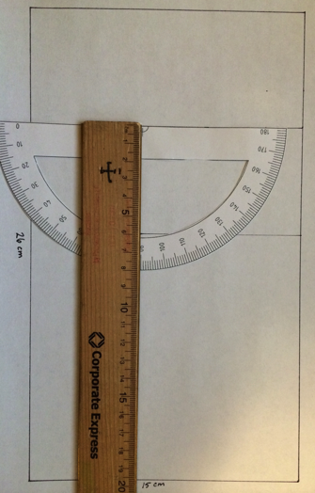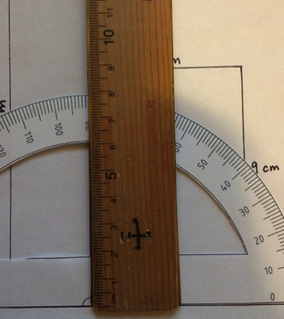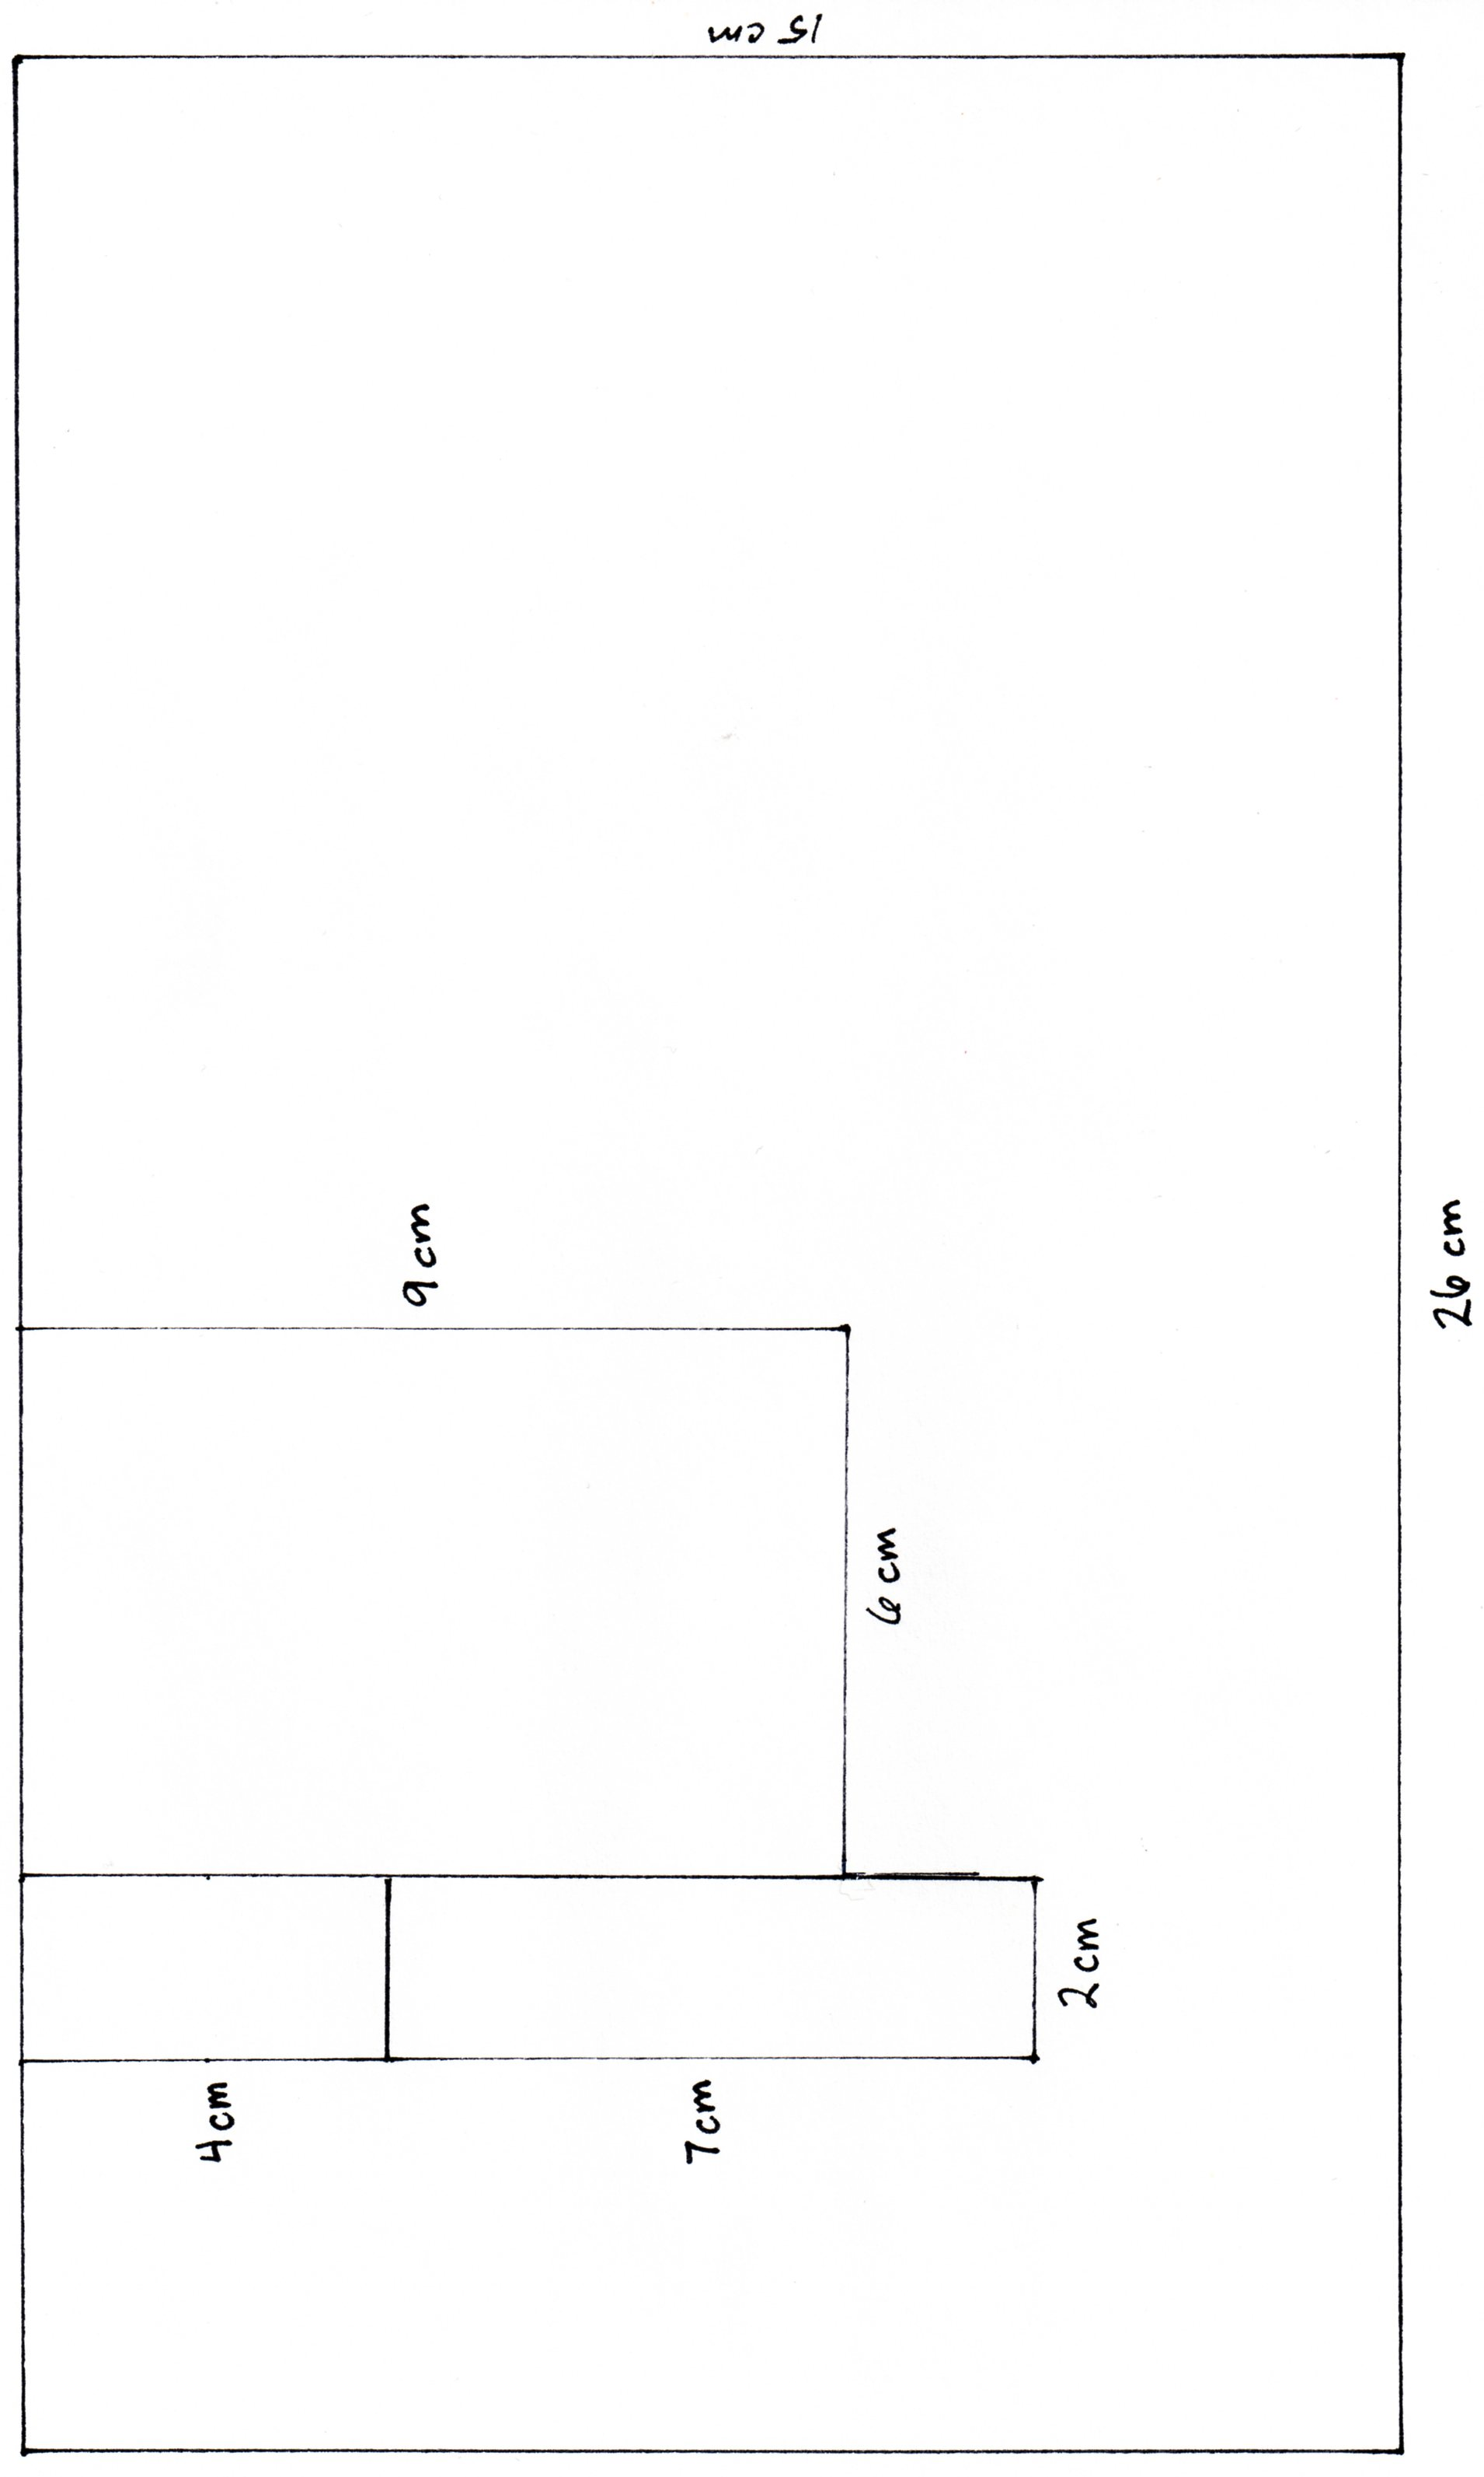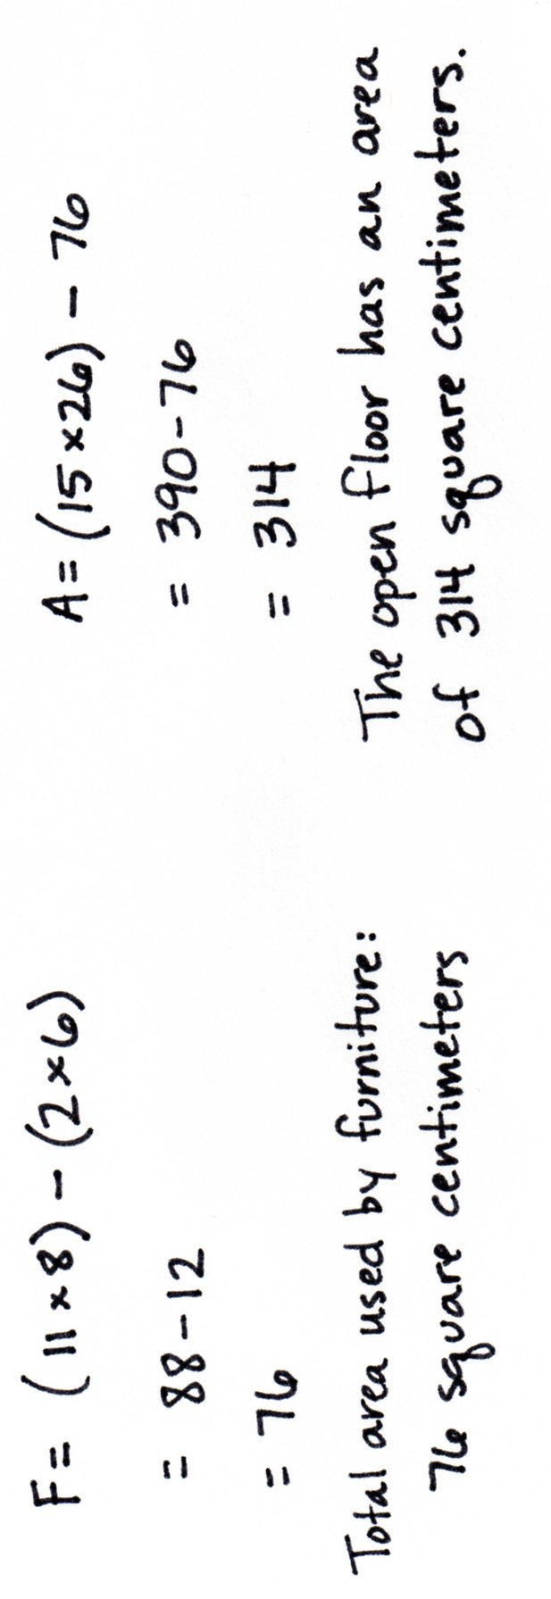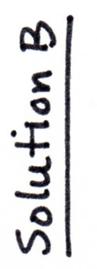

The sample images on the right side of the page are examples of how a ruler and a protractor can be used during the lesson to create right angles, perpendicular lines, and parallel lines to ensure students are accurately drawing rectangles. Various configurations of the furniture are acceptable. Discuss with students the real possibilities of setting up a room such as in this problem. Consider missing features like the placement of a door, window, or desk. Solution A shows a sample where the area of each piece of furniture is found, added together, and then subtracted from the total area of the room. Solution B is found by grouping the furniture. In doing so, an inner larger rectangle with the dimensions of 11 centimeters by 8 centimeters is found and the void area subtracted to find the area the furniture takes up. The area used by the furniture is then subtracted from the total area of the room. Accept reasonable solutions for solving for the amount of available floor space in the room.

Problem 2: Use a protractor and a ruler to create a composite figure by first using given information to determine unknown side lengths and then determining the area of part of the figure.

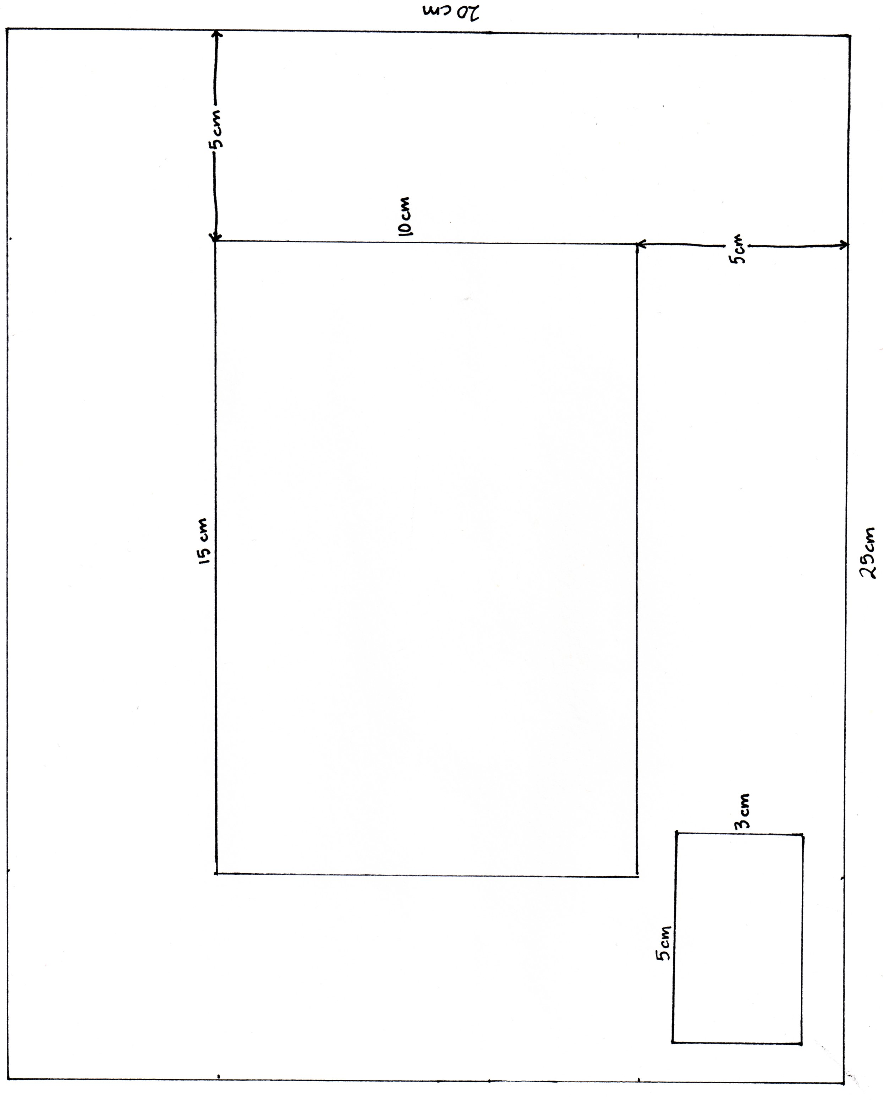A model of a rectangular pool is 15 centimeters long and 10 centimeters wide. The walkway around the pool is 5 centimeters wider than the pool on each of the four sides. In one section of the walkway, there is a flowerbed that is 3 centimeters by 5 centimeters. Create a diagram of the pool area with the surrounding walkway and flowerbed. Find the area of the open walkway around the pool.

|  |  |
| --- | --- |
|  | NOTES ON  MULTIPLE MEANS OF ACTION AND EXPRESSION: |

Provide protractor alternatives for students, if necessary. Some students may work more efficiently with large-print protractors that include a clear, moveable wand. Others may find using an angle ruler easier. Provide an appropriate adaptive ruler, such as a tactile or large-print ruler, if available and helpful.

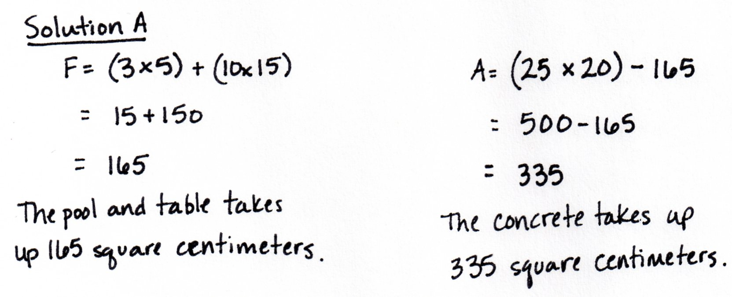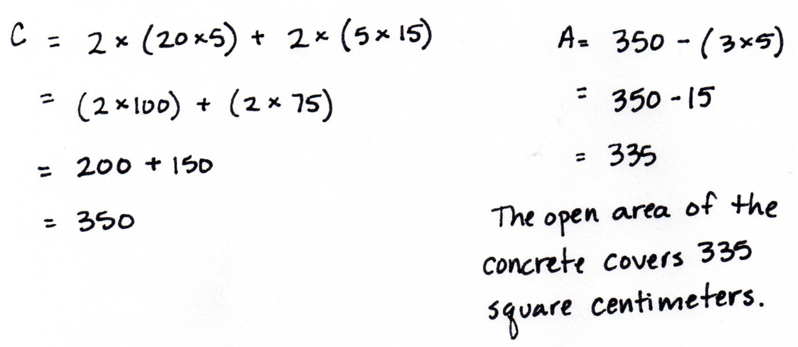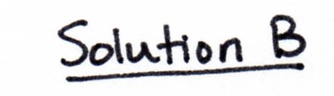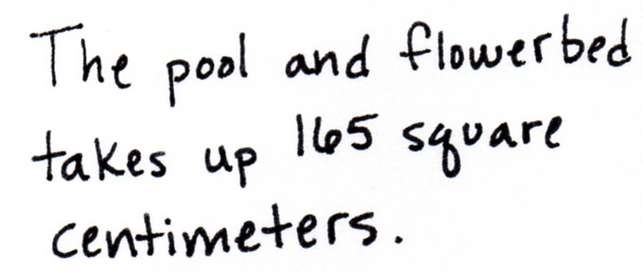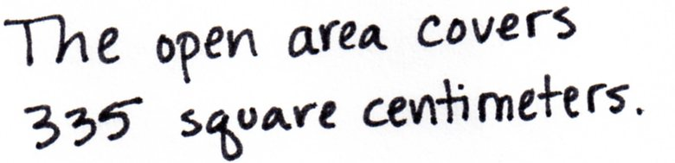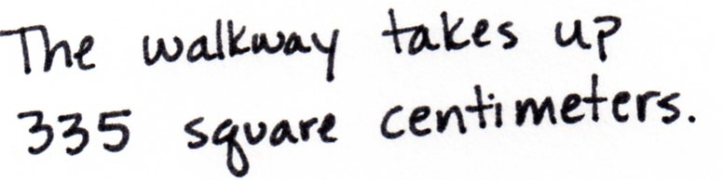

The challenge in drawing this figure is determining the outer edges of the walkway if the pool is drawn first, or determining the border of the pool if the walkway is drawn first. Although the image will fit on standard paper, consider offering students large pieces of paper as to not feel restricted with the paper size. Suggest to students to sketch the figure before drawing with a ruler and protractor. Solution A determined the area of the largest rectangle and subtracted the area of the two inner, smaller rectangles. Solution B found the area of the walkway by creating four smaller rectangles around the pool and then subtracting the area for the flowerbed.

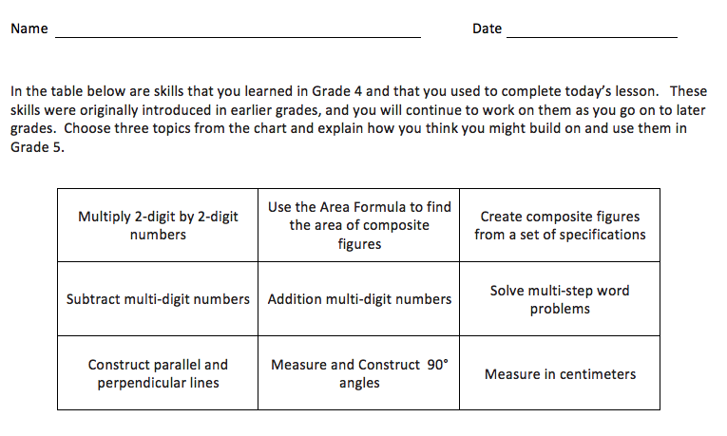Student Debrief (13 minutes)

Reflection (3 minutes)

Before the Student Debrief, instruct students to complete the Reflection pictured to the right. Reflections are replacing the Exit Tickets in Topic D in order for students to have four days to think back on their learning and growth in Grade 4.

**Lesson Objective:** Create and determine the area of composite figures.

The Student Debrief is intended to invite reflection and active processing of the total lesson experience.

Invite students to review their reflections before going over their solutions for the Problem Set. They should check work by comparing answers with a partner before going over answers as a class. Look for misconceptions or misunderstandings that can be addressed in the Debrief. Guide students in a conversation to debrief the Problem Set and process the lesson.

You may choose to use any combination of the questions below to lead the discussion.

* Share your Reflection with a partner. After you have both shared, choose one more skill from the set you both notice you used today and share your experience and progress with using that skill.
* What skills from your previous work with angles and lines did you need to use today to complete the problems?
* What occupations do you think might use these ideas on a regular basis?

Name Date

Work with your partner to create each floor plan as described below on a separate piece of paper.

You should use a protractor and a ruler to create each floor plan and be sure each rectangle you create has two sets of parallel lines and four right angles.

Be sure to label each part of your model with the correct measurement.

1. The bedroom in Samantha’s dollhouse is a rectangle 26 centimeters long and 15 centimeters wide. It has a rectangular bed that is 9 centimeters long and 6 centimeters wide. The two dressers in the room are each 2 centimeters wide. One measures 7 centimeters long, and the other measures 4 centimeters long. Create a floor plan of the bedroom containing the bed and dressers. Find the area of the open floor space in the bedroom after the furniture is in place.
2. A model of a rectangular pool is 15 centimeters long and 10 centimeters wide. The walkway around the pool is 5 centimeters wider than the pool on each of the four sides. In one section of the walkway, there is a flowerbed that is 3 centimeters by 5 centimeters. Create a diagram of the pool area with the surrounding walkway and flowerbed. Find the area of the open walkway around the pool.

Name Date

In the table below are skills that you learned in Grade 4 and that you used to complete today’s lesson. These skills were originally introduced in earlier grades, and you will continue to work on them as you go on to later grades. Choose three topics from the chart and explain how you think you might build on and use them in Grade 5.

|  |  |  |
| --- | --- | --- |
| Multiply 2-digit by 2-digit numbers | Use the Area Formula to find the area of composite figures | Create composite figures from a set of specifications |
| Subtract multi-digit numbers | Add multi-digit numbers | Solve multi-step word problems |
| Construct parallel and perpendicular lines | Measure and Construct 90° angles | Measure in centimeters |

Name Date

For homework, complete the top portion of each page. This will become an answer key for you to refer to when completing the bottom portion as a mini-personal board activity during the summer.

Use a ruler and protractor to create and shade a figure according to the directions. Then find the area of the unshaded part of the figure.

1. Draw a rectangle that is 18 cm long and 6 cm wide. Inside the rectangle, draw a smaller rectangle that is 8 cm long and 4 cm wide. Inside the smaller rectangle, draw a square that has a side length of 3 cm. Shade in the smaller rectangle, but leave the square unshaded. Find the area of the shaded space.

1. Draw a rectangle that is 18 cm long and 6 cm wide. Inside the rectangle, draw a smaller rectangle that is 8 cm long and 4 cm wide. Inside the smaller rectangle, draw a square that has a side length of 3 cm. Shade in the smaller rectangle, but leave the square unshaded. Find the area of the shaded space.

1. Emanuel’s science project display board is 42 inches long and 48 inches wide. He put a 6-inch border around the edge inside the board and placed a title in the center of the board that is 22 inches long and 6 inches wide. How many square inches of open space does Emanuel have left on his board?

1. Emanuel’s science project display board is 42 inches long and 48 inches wide. He put a 6-inch border around the edge inside the board, and placed a title near the top that is 22 inches long and 6 inches wide. How many square inches of open space does Emanuel have left on his board?

Challenge: Replace the given dimensions with different measurements and solve again.

