Lesson 15
Objective: Create and determine the area of composite figures.

Suggested Lesson Structure
 Fluency Practice (9 minutes)
 Application Problem (5 minutes)
 Concept Development (36 minutes)
 Student Debrief (10 minutes)
Total Time (60 minutes)
Fluency Practice (9 minutes)
- Mini-Personal Board Set-Up (5 minutes)
- Find the Area 4.MD.3 (4 minutes)
Mini-Personal Board Set-Up (5 minutes)
Materials: (S) Plastic page protector, manila folder, tape
Note: In G4–M7–Topic D, all homework pages are designed to become part of the take-home summer folder, created in this lesson. Therefore, students will only complete the top portion of each homework page and use the bottom portion as extra practice during the summer, inserting it into their mini-personal boards. Although the homework does not directly reflect the work on each lesson’s Problem Set, the work is directly related to the lesson and Grade 4 standards.
Today’s lesson is the first of four in the Fourth Grade Project. Each lesson involves the creation of an activity page that is later placed in a take-home summer folder. (See Debrief for further explanation.) The folder will contain materials, games, and activities for student reference and practice over the summer. Students create the mini-personal board to use during lessons, and continue to use it over the summer to complete activity pages.
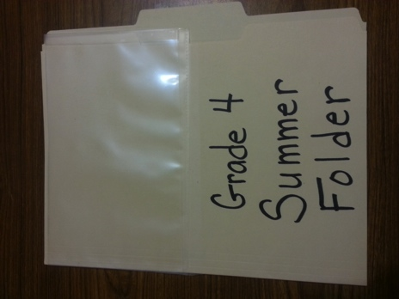
Step 1: Model for students how to fold and cut a plastic page protector in half horizontally. Discard the top piece, keeping the bottom half that is closed like a pocket.
Step 2: The pocket of the page protector becomes the mini-personal board. It should be attached to the top of a manila folder as shown by taping the three closed sides of the page protector to the folder.

Find the Area (4 minutes)
Materials: (S) Mini-personal boards
Note: This fluency activity reviews area from G4–Module 3 and prepares students for solving for the area of composite shapes in this lesson.
T: (Project a rectangle with a width of 3 cm and a length of 10 cm.) Solve for the area of this rectangle.
S: 30 square centimeters.
T: (Project a rectangle with a width of 3 cm and a length of 6 cm.) Solve for the area of this rectangle.
S: 18 square centimeters.
T: (Project a rectangle with a width of 3 cm and a length of 16 cm.) Solve for the area of this rectangle.
S: 48 square centimeters.
Repeat with the following suggested sequence:
- Rectangle with a width of 6 cm and length of 20 cm; width of 6 cm and length of 8 cm; width of 6 cm and length of 28 cm.
- Rectangle with a width of 4 cm and length of 40 cm; width of 4 cm and length of 7 cm; width of 4 cm and length of 47 cm.
Application Problem (5 minutes)

NOTES ON
MULTIPLE MEANS
OF ENGAGEMENT:
Give everyone a fair chance to be successful by providing appropriate scaffolds. Students may use translators, interpreters, or sentence frames to present and respond to feedback. Models shared may include concrete manipulatives.
If the pace of the lesson is a consideration, prepare presenters beforehand. The first problem may be most approachable for students working below grade level.

Emma’s rectangular bedroom is 11 ft long and 12 ft wide. Draw and label a diagram of Emma’s bedroom. How many square feet of carpet does Emma need to cover her bedroom floor?
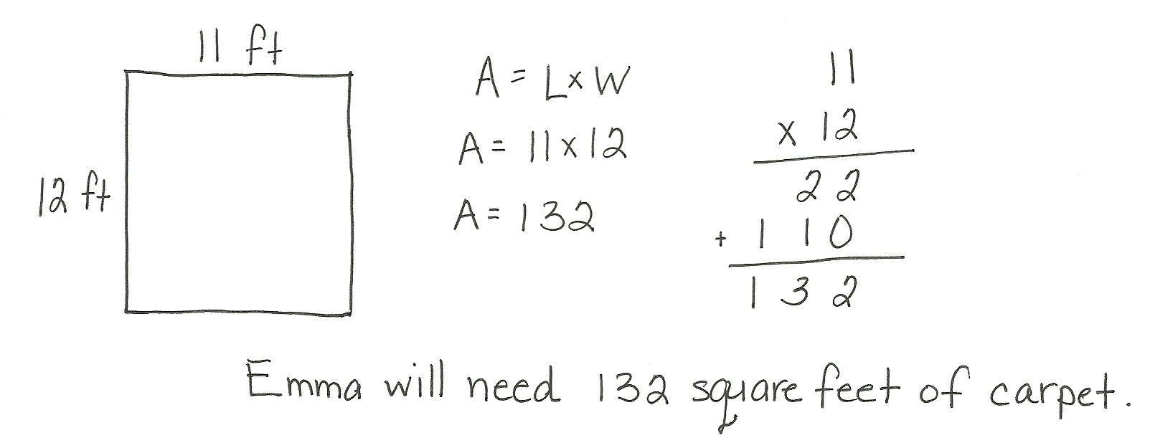

Note: This Application Problem reviews Grade 4’s work with the area formula and two-digit by two-digit multiplication. It also serves as the lead-in to today’s Concept Development. Be sure students draw models with appropriate length sides to represent the dimensions given in the problem. Have students use their mini-personal boards to complete this problem.
Concept Development (36 minutes)
Materials: (S) Problem Set
Suggested Delivery of Instruction for Solving Lesson 15’s Problems
1. Model the problem.
Select two pairs of students who can successfully model the problem to work at the board while the other students work independently or in pairs at their seats. Review the following questions before beginning the first problem.
- Can you draw something?
- What can you draw?
- What conclusions can you make from your drawing?
As students work, circulate and reiterate the questions above. After two minutes, have the two pairs of students share only their labeled diagrams. For about one minute, have the demonstrating students receive and respond to feedback and questions from their peers.
2. Calculate to solve and write a statement.
Allow students two minutes to complete work on the problem, sharing their work and thinking with a peer. Have the students write their equations and statements of the answer.
3. Assess the solution.
Give students one to two minutes to assess the solutions presented by their peers on the board, comparing the solutions to their own work. Highlight alternative methods to reach the correct solution.

Problem 1
Emma’s rectangular bedroom is 11 ft long and 12 ft wide with an attached closet that is 4 ft by 5 ft. How many square feet of carpet does Emma need to cover both the bedroom and closet?
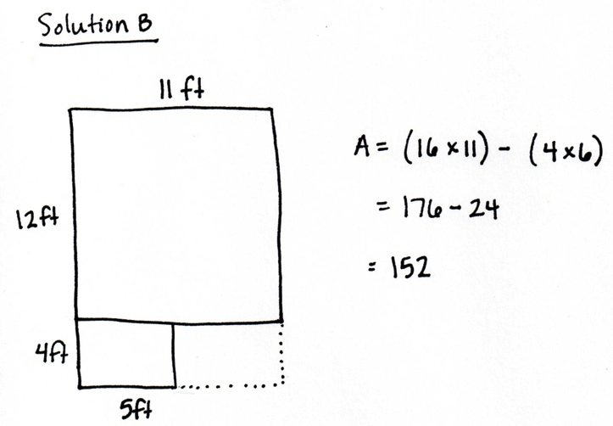
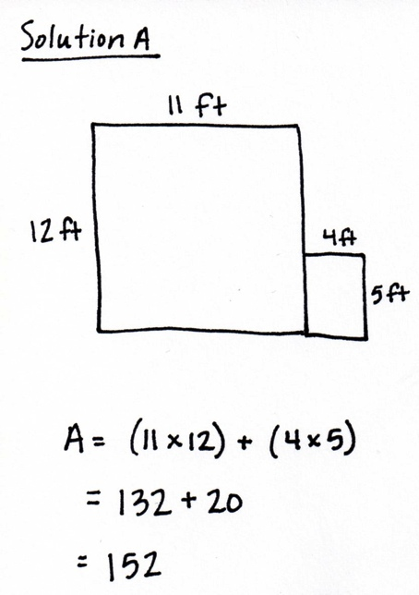

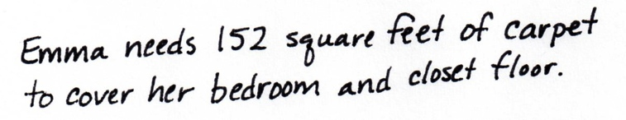

Drawing on their knowledge of solving for composite shapes in Grade 3, students may choose to solve as shown above. Solution A models solving for the two distinct areas and adding those areas together. Solution B models solving for a larger rectangle and subtracting the area not included in the floor space of the bedroom or closet.
Problem 2
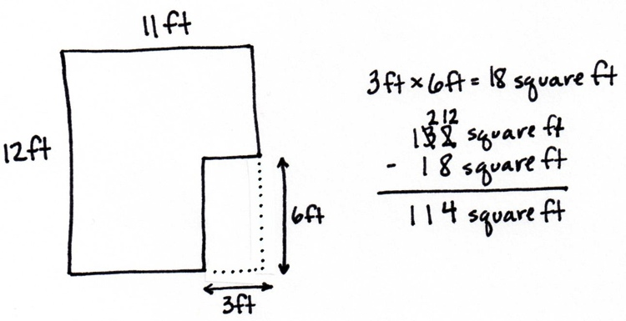
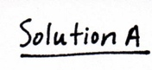
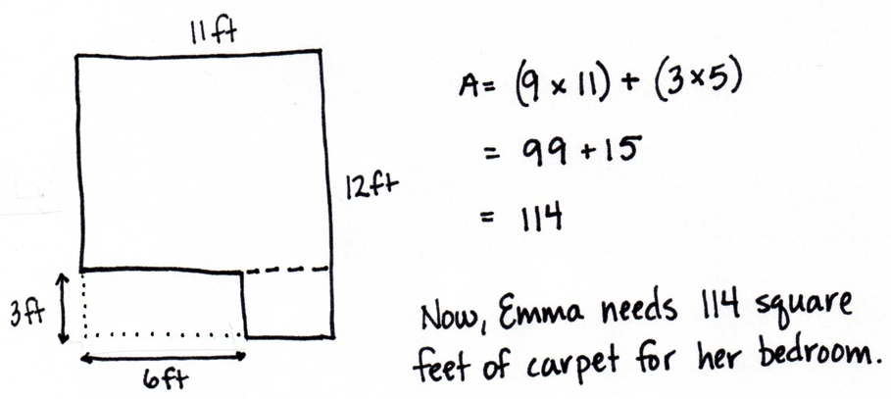
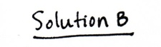
To save money, Emma is no longer going to carpet her closet. In addition, she wants one 3 ft by 6 ft corner of the bedroom to be wood floor. How many square feet of carpet will she need for the bedroom now?

Solution A subtracts the area of the wood floor from the entire area of the bedroom. Solution B solves using just the carpeted space, dividing it into two smaller rectangles to solve. Allow students to analyze that both solution strategies are correct and the placement of the wood floor in their diagram has no contingency on the answer.
Problem 3
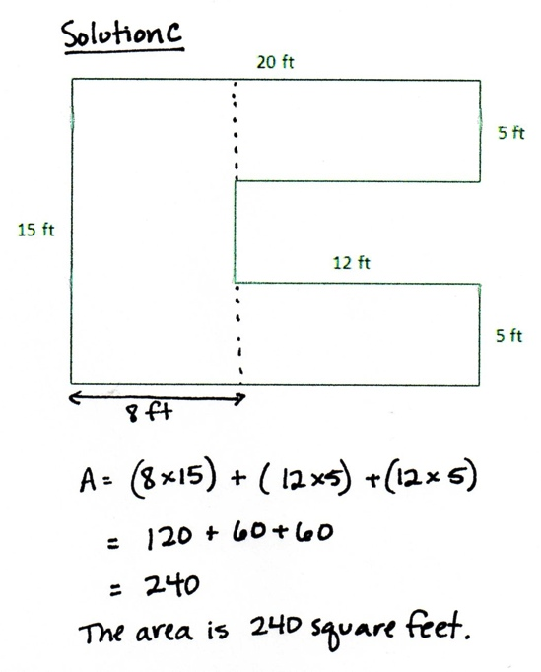
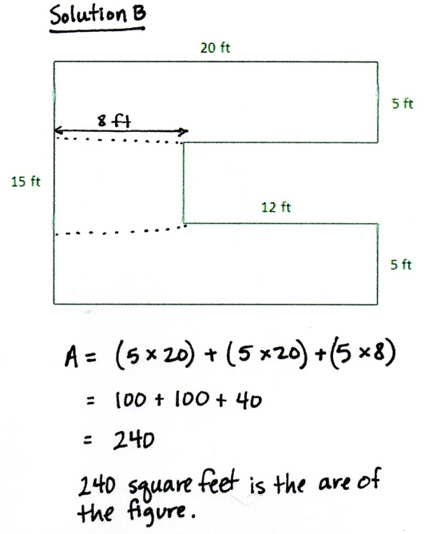
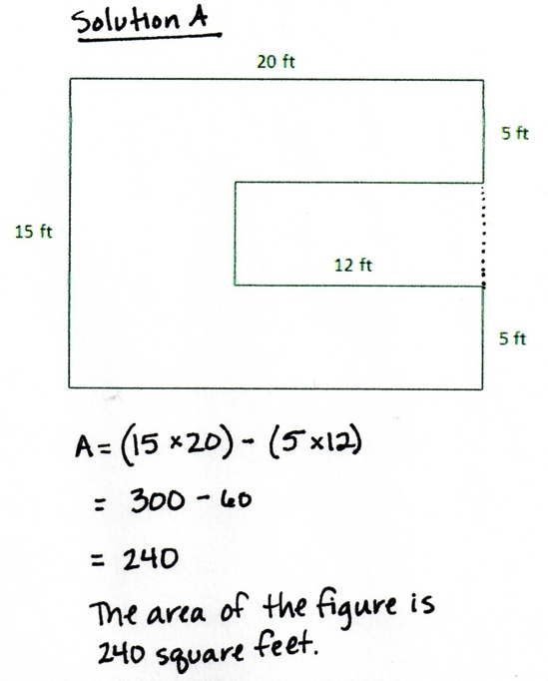
Find the area of the figure.

Allow students to solve using a solution that is comfortable for them. Solution A solves for the entire area of a larger rectangle and subtracts the void area. Solutions B and C partition the figure into three different smaller rectangles and find the area of the entire figure by adding the areas of the three smaller rectangles.
Problem 4
Label the sides of the figure with measurements that make sense. Find the area of the figure.
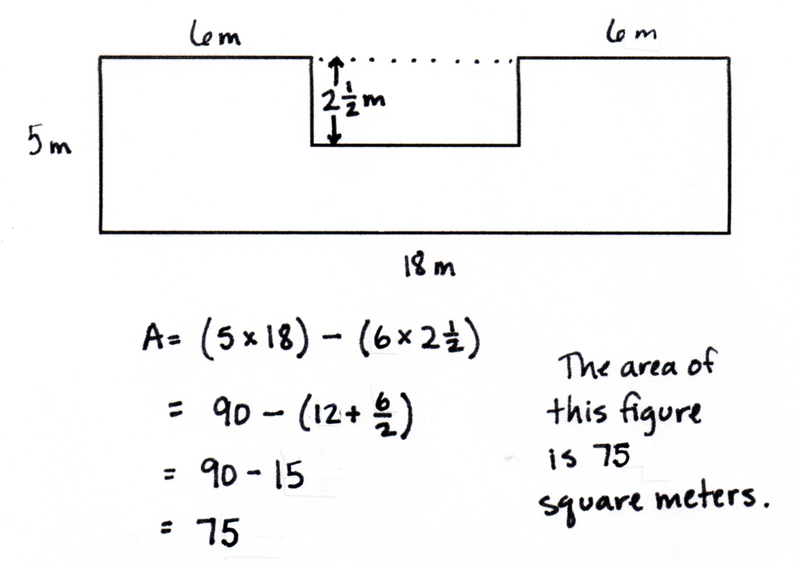
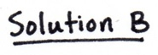
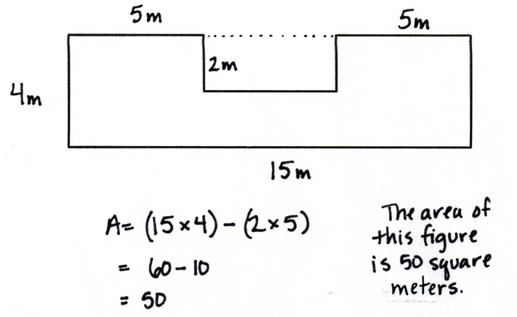
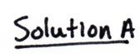

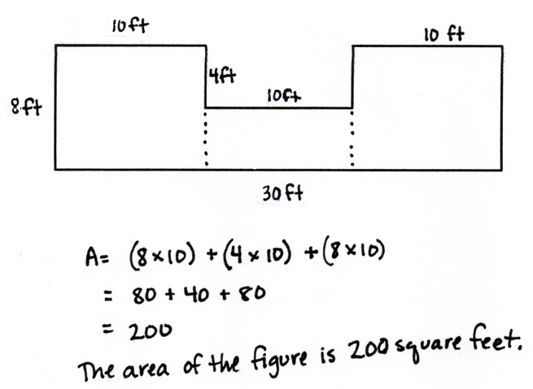
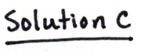
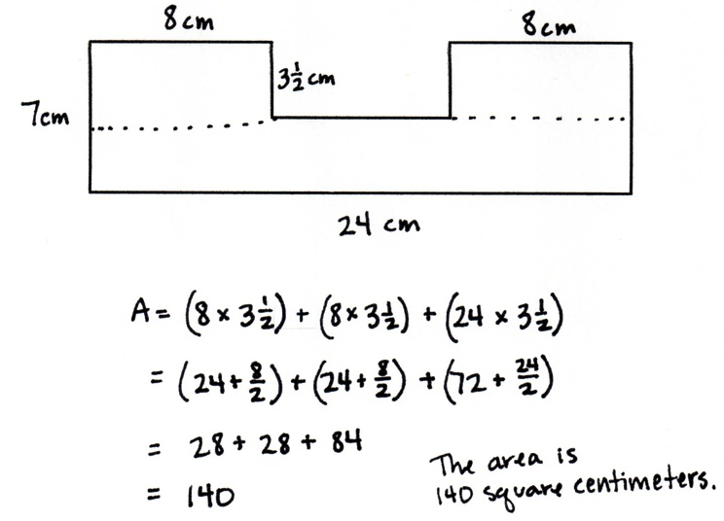
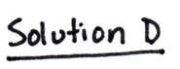

Note: As students build and solve this problem, they may choose the strategy most comfortable for them. Some students will choose to find the area of the whole rectangle and then subtract the part they do not need. Others will break the figure into three separate rectangles, find the separate areas, and add them together. In either case, careful attention should be paid to ensuring that students recognize that the length of the single long side of the figure must be equal to the sum of the shorter opposite sides. This must be true from top to bottom as well as from left to right. A complexity may arise, as shown in Solutions B and D, where the length of an interior side may be a fractional length. Using what students already know about multiplication of fractions, students can solve using various strategies.
Problem 5
Peterkin Park has a square fountain with a walkway around it. The fountain measures 12 feet on each side. The walkway is $\text{3}\frac{1}{2}$ feet wide. Find the area of the walkway.
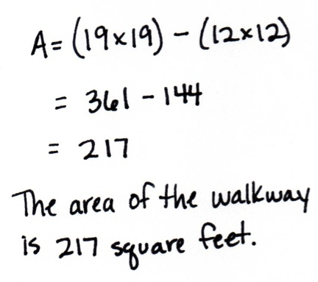
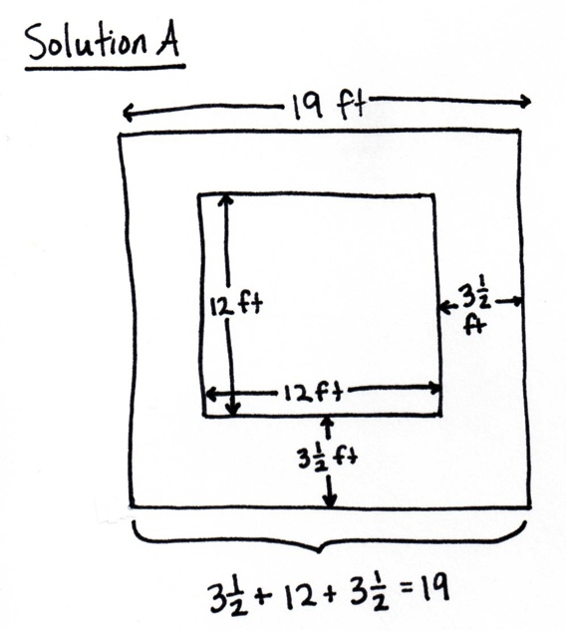

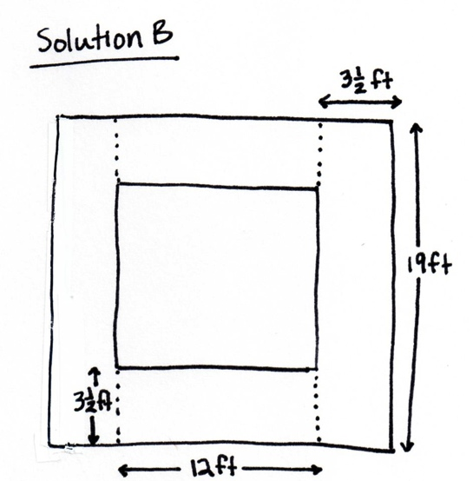
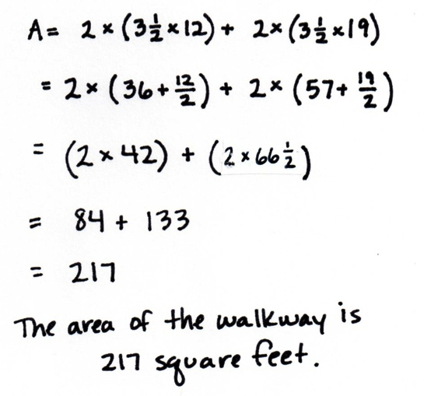

Drawing this diagram may prove difficult for some, as there are many dimensions that could be labeled. Encourage students to think about the diagram as a whole in order find a solution strategy. Solution A found the area of the largest rectangle minus the area of the inner rectangle to find the area of the walkway. Solution B decomposed the walkway into 4 parts, 2 that are the same area and another 2 parts that are the same area. Encouraging students to draw diagrams that are to scale is important for verifying if their answer is reasonable.
Problem 6
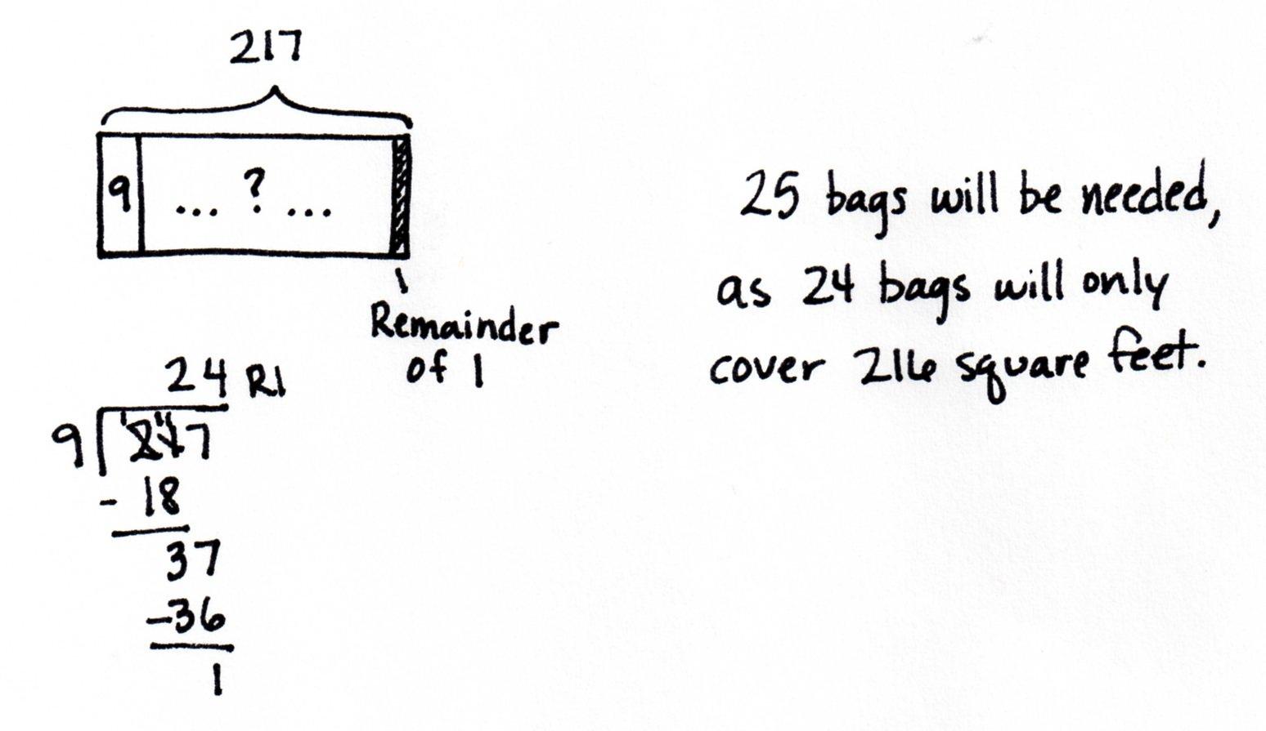
If 1 bag of gravel covers 9 square feet, how many bags of gravel will be needed to cover the entire walkway around the fountain in Peterkin Park?

Students are called upon to use division to solve this final word problem. A tape diagram will allow them to see that the solution will find the number of groups, not the number in each group. Students can solve using any division strategy learned in Grade 4 and must also interpret the remainder to solve correctly.

Student Debrief (10 minutes)
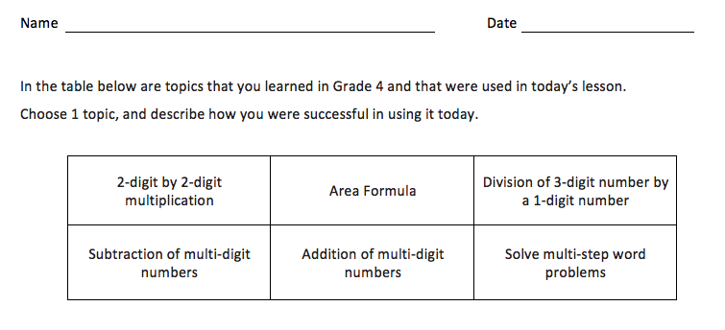
Reflection (3 minutes)
Note: The Reflection replaces the Exit Ticket in Topic D.
Before the Student Debrief, instruct students to complete the Reflection pictured to the right. Reflections are replacing Exit Tickets in G4–M7–Topic D in order for students to have four days to think back on their learning and growth in Grade 4.
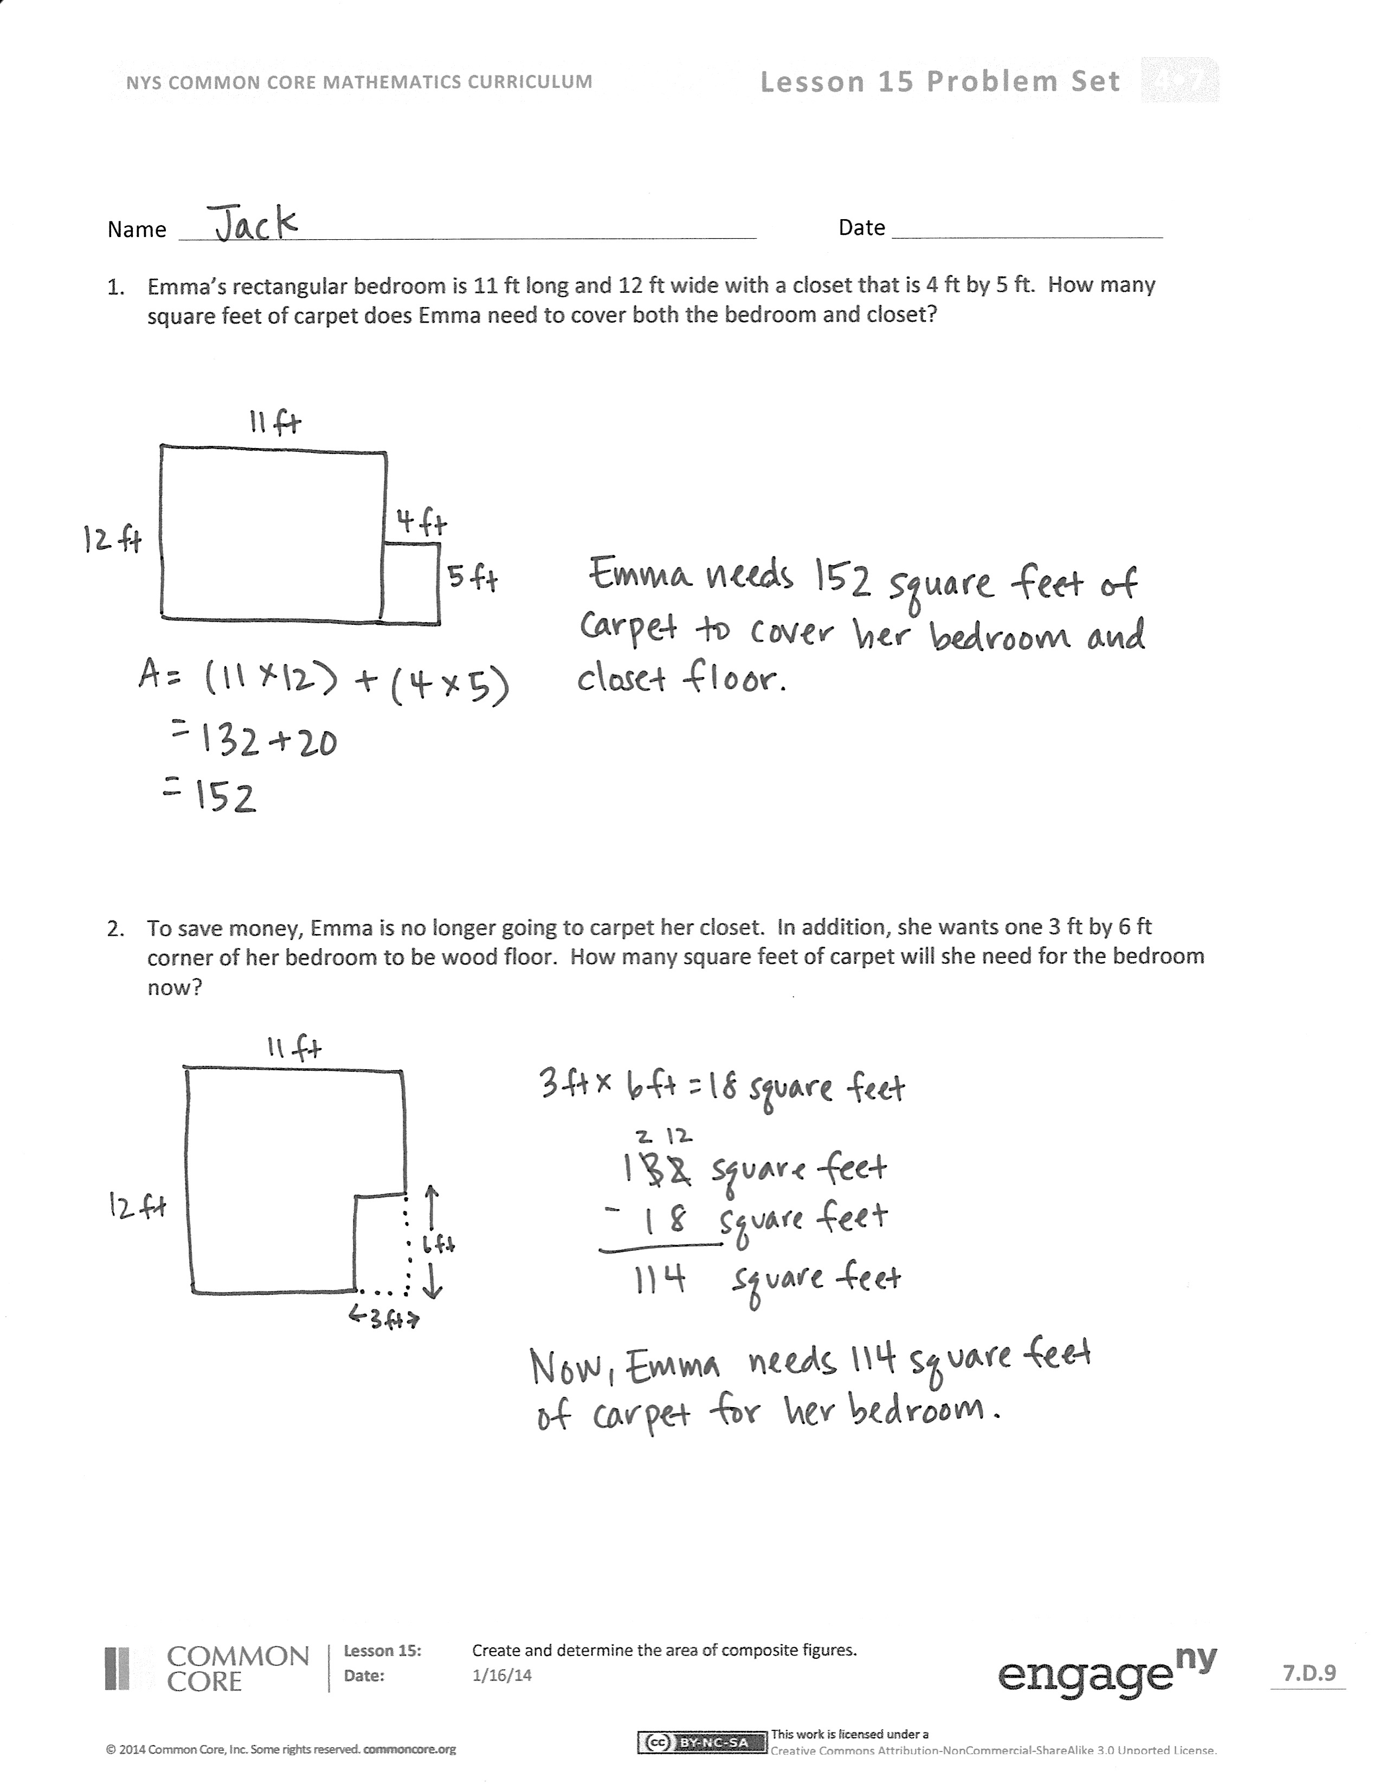
Lesson Objective: Create and determine the area of composite figures.
The Student Debrief is intended to invite reflection and active processing of the total lesson experience.
Invite students to review their reflections before going over their solutions for the Problem Set. They should check work by comparing answers with a partner before going over answers as a class. Look for misconceptions or misunderstandings that can be addressed in the Debrief. Guide students in a conversation to debrief the Problem Set and process the lesson.
You may choose to use any combination of the questions below to lead the discussion.
- Share your Reflection with a partner. After you have both shared, choose one more skill from the set you both notice you used today and share your experience and progress with using that skill.
- For many word problems in Grade 4, we drew tape diagrams to model the problems. What advantage does the area model have over tape diagrams for these types of problems? How can being able to draw various models be helpful as you move into the next grades?
- In which other questions did you see each of the strategies that were used in Problem 4?
- Did you prefer using one strategy over the other? Why?
- How did Problem 3 relate to Problem 2?
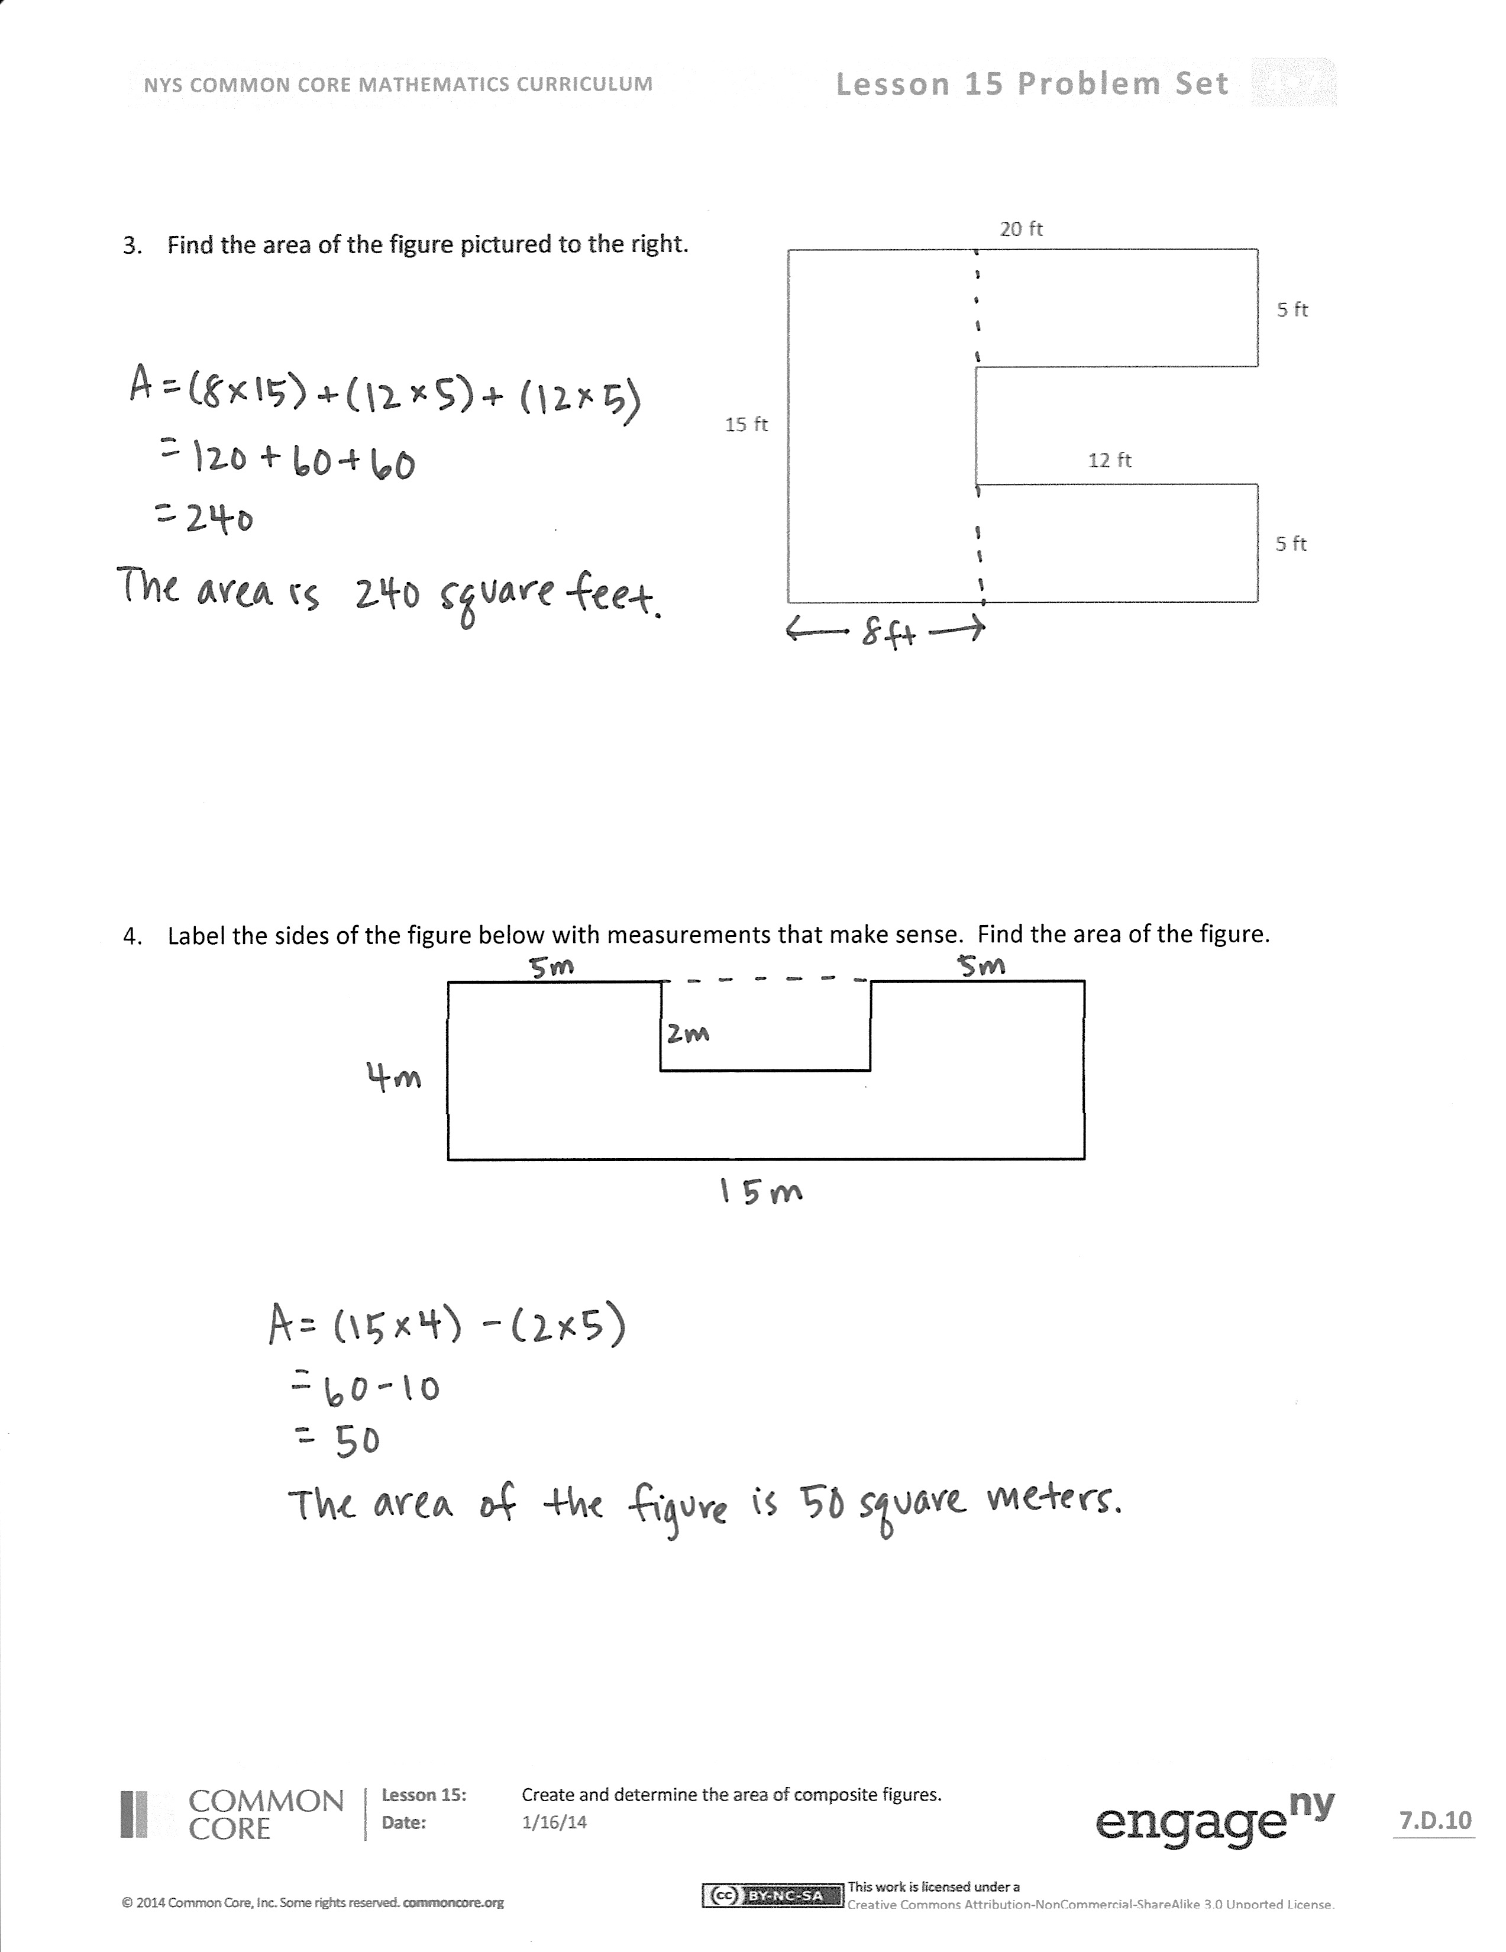
Model for students how their homework assignment only requires them to complete the top half of the sheet. The bottom half of each page is a duplicate of the top. By completing the top half as homework, they are creating an answer key for themselves for the summer when they can then fold the sheet in half, insert the clean problem into the mini-personal board, and fold back the top part containing the answer. Students can then solve the problems and refer back to the answers to check their work.
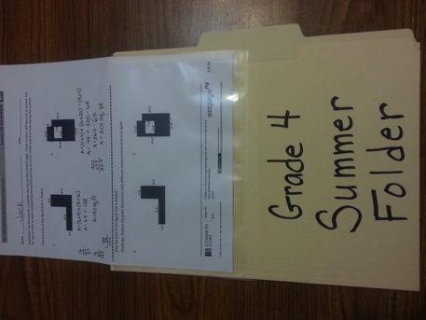
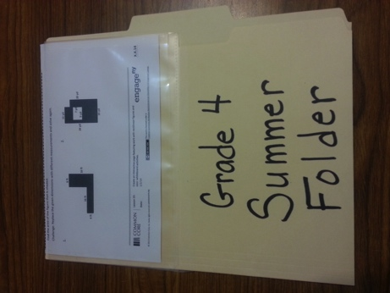
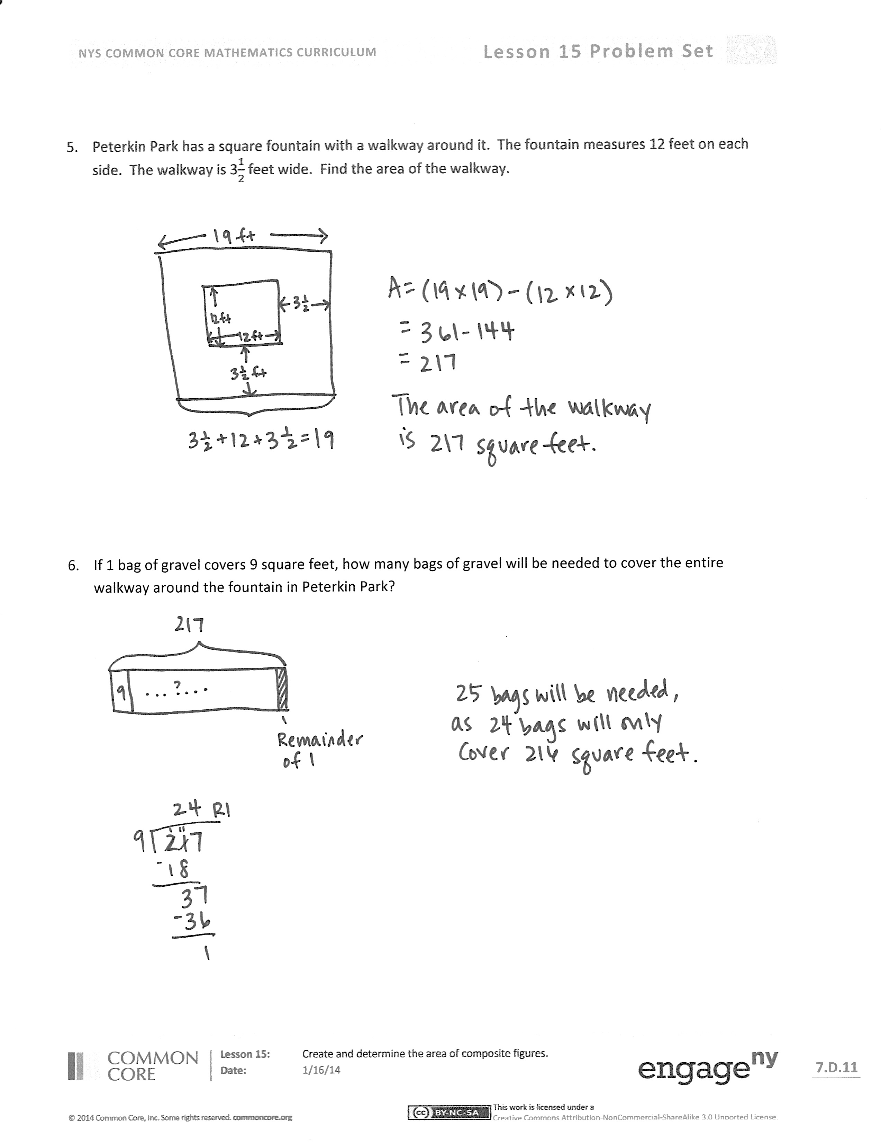

Name Date
- Emma’s rectangular bedroom is 11 ft long and 12 ft wide with an attached closet that is 4 ft by 5 ft. How many square feet of carpet does Emma need to cover both the bedroom and closet?

- To save money, Emma is no longer going to carpet her closet. In addition, she wants one 3 ft by 6 ft corner of her bedroom to be wood floor. How many square feet of carpet will she need for the bedroom now?

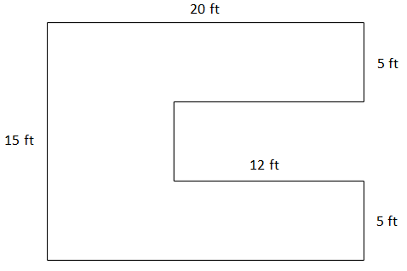
- Find the area of the figure pictured to the right.

- Label the sides of the figure below with measurements that make sense. Find the area of the figure.

- Peterkin Park has a square fountain with a walkway around it. The fountain measures 12 feet on each side. The walkway is $\text{3}\frac{1}{2}$ feet wide. Find the area of the walkway.

- If 1 bag of gravel covers 9 square feet, how many bags of gravel will be needed to cover the entire walkway around the fountain in Peterkin Park?

Name Date
In the table below are topics that you learned in Grade 4 and that were used in today’s lesson.
Choose 1 topic, and describe how you were successful in using it today.

2-digit by 2-digit multiplication | Area Formula | Division of 3-digit number by a 1-digit number
Subtraction of multi-digit numbers | Addition of multi-digit numbers | Solving multi-step word problems

Name Date
For homework, complete the top portion of each page. This will become an answer key for you to refer to when completing the bottom portion as a mini-board activity during the summer.

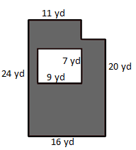
Find the area of the figure that is shaded.
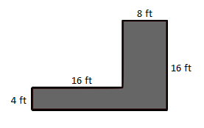
1. 2.

Find the area of the figure that is shaded.

1. 2.

Challenge: Replace the given dimensions with different measurements and solve again.

- A wall is 8 feet tall and 19 feet wide. An opening 7 feet tall and 8 feet wide was cut into the wall for a doorway. Find the area of the remaining portion of the wall.

3. A wall is 8 feet tall and 19 feet wide. An opening 7 feet tall and 8 feet wide was cut into the wall for a doorway. Find the area of the remaining portion of the wall.

