Lesson 14
Objective: Solve multi-step word problems involving converting mixed number measurements to a single unit.

Suggested Lesson Structure
 Fluency Practice (9 minutes)
 Concept Development (41 minutes)
 Student Debrief (10 minutes)
Total Time (60 minutes)
Fluency Practice (9 minutes)
- Complete Length Units 4.MD.1 (3 minutes)
- Complete Weight Units 4.MD.1 (3 minutes)
- Complete Capacity Units 4.MD.1 (3 minutes)
Complete Length Units (3 minutes)
Materials: (S) Personal white boards
Note: This fluency activity reviews measurement conversions and the important notion of completing the unit.
T: (Write 90 centimeters.) How many more centimeters complete 1 meter?
S: (Write 10 centimeters.)
Continue the complete-the-unit work possibly using the following suggested sequence:
- Meters: 50 centimeters, 25 centimeters, 36 centimeters
- Yards: 1 foot
- Kilometers: 500 meters, 650 meters, 350 meters, 479 meters
- Feet: 10 inches, 6 inches, 7 inches
Complete Weight Units (3 minutes)
Materials: (S) Personal white boards
Note: This fluency activity reviews measurement conversions and the important concept of completing the unit.
T: (Write 10 ounces.) How many more ounces complete 1 pound?
S: (Write 6 ounces.)
Continue the complete-the-unit work possibly using the following suggested sequence:
- Pounds: 8 ounces
- Kilograms: 900 grams, 750 grams, 250 grams, 378 grams
Complete Capacity Units (3 minutes)
Materials: (S) Personal white boards
Note: This fluency activity reviews measurement conversions and the important concept of completing the unit.
T: (Write 3 quarts.) How many more quarts complete 1 gallon?
S: (Write 1 quart.)
Continue the complete-the-unit work possibly using the following suggested sequence:
- Gallons: 1 quart
- Liters: 500 milliliters, 200 milliliters, 850 milliliters, 647 milliliters
- Quarts: 2 cups, 1 cup
Concept Development (41 minutes)
Materials: (S) Problem Set
Suggested Delivery of Instruction for Solving Lesson 14’s Word Problems
For Problems 1─4, students may work in pairs to solve each of the problems using the RDW approach to problem solving.

1. Model the problem.
Select two pairs of students who can successfully model the problem to work at the board while the other students work independently or in pairs at their seats. Review the following questions before beginning the first problem.
- Can you draw something?
- What can you draw?
- What conclusions can you make from your drawing?
As students work, circulate and reiterate the questions above. After two minutes, have the two pairs of students share only their labeled diagrams. For about one minute, have the demonstrating students receive and respond to feedback and questions from their peers.

2. Calculate to solve and write a statement.
Allow students two minutes to complete work on the problem, sharing their work and thinking with a peer. Have the students write their equations and statements of the answer.

3. Assess the solution.

NOTES ON
MULTIPLE MEANS OF ENGAGEMENT:
Instead of solving Problem 1, allow students working above grade level to solve the remainder of the problems, and then offer an open-ended challenge. Ask students to complete one of the following alternatives:
- Use the model from one of the problems to write a word problem of your own. Be sure to include measurement unit conversions.
- Write a script to explain your strategy for solving one problem. Share your script with your partner during the Debrief.

Give students one to two minutes to assess the solutions presented by their peers on the board, comparing the solutions to their own work. Highlight alternative methods to reach the correct solution.

Problem 1
A cartoon lasts $\frac{1}{2}$ hour. A movie is 6 times as long as the cartoon. How many minutes does it take to watch both the cartoon and the movie?

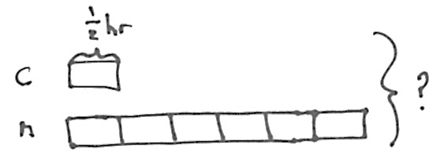
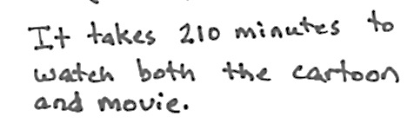
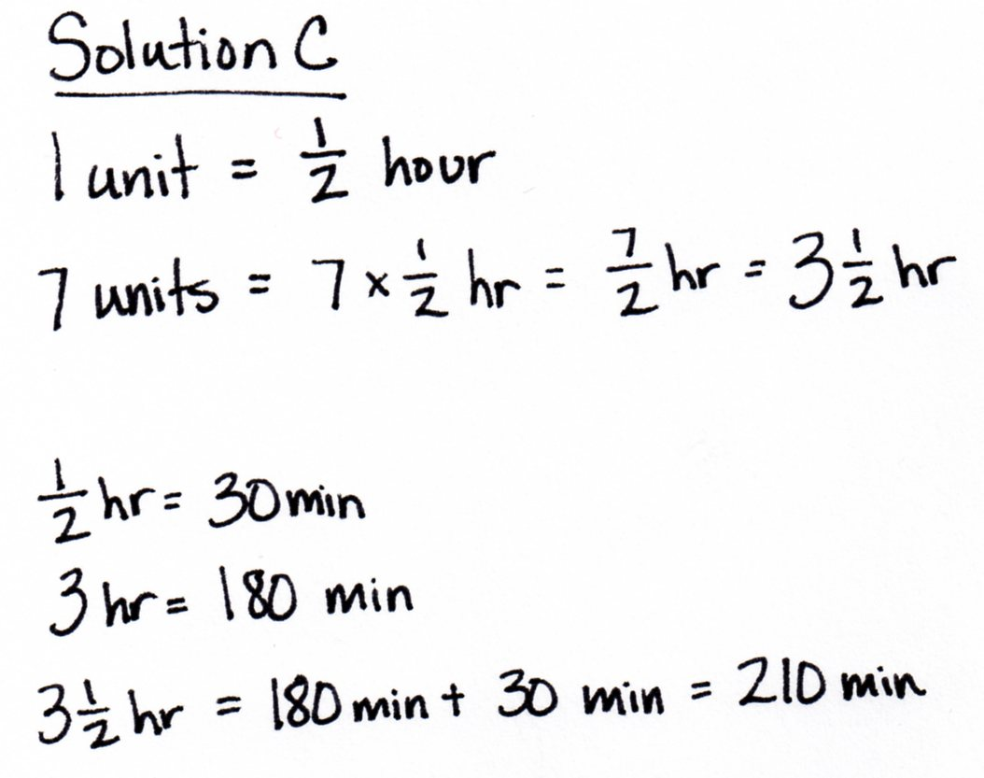

MP.7

In Solution A, the student determines that one unit was 30 minutes using equivalent fractions and multiplied by 7 to find the total number of minutes. In both Solutions B and C, the student multiplies $\frac{1}{2}$ by 7 to get $\text{3}\frac{1}{2}$hours and then determines the total number of minutes. Solution B shows numerical work without noting the measurement units, re-contextualizing the 210 by writing the statement. Solution C keeps the measurement units throughout the process, figuring out the number of minutes in a half hour and adding them to the number of minutes in 3 hours.

Problem 2
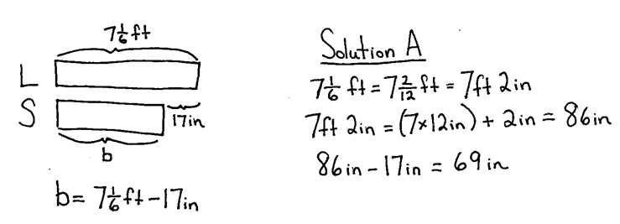
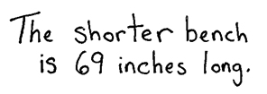
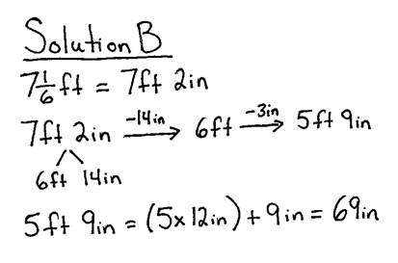
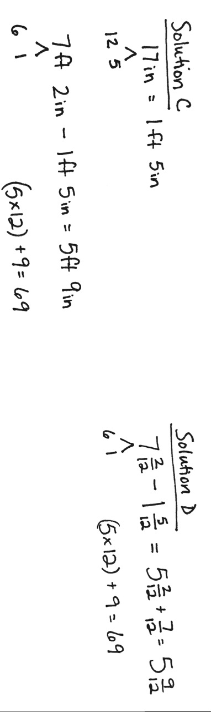
A large bench is $\text{7}\frac{1}{6}$ feet long. It is 17 inches longer than a shorter bench. How many inches long is the shorter bench?

Equivalent fractions are used to determine that $\frac{1}{6}$ foot equals 2 inches in Solution A. The length of the longer bench is converted from feet into inches. To find the length of the shorter bench, 17 inches is subtracted from the length of the longer bench. In Solution B, the student decomposes 7 feet 2 inches into 6 feet 14 inches and subtracts. First, 14 inches are subtracted to get to 6 feet. Next, the student subtracts the remaining 3 inches to get 5 feet 9 inches. This mixed unit measurement was then converted into 69 inches to find the length of the shorter bench in inches. Solution C shows converting the difference in length into a mixed unit to subtract. Solution D shows converting both to mixed numbers to subtract. Each is then converted to inches.

Problem 3
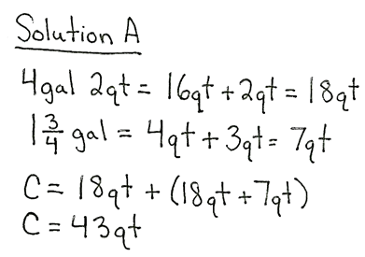
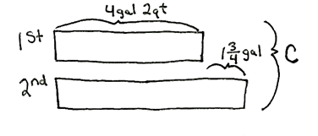
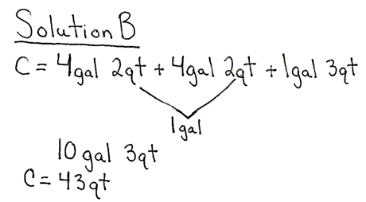
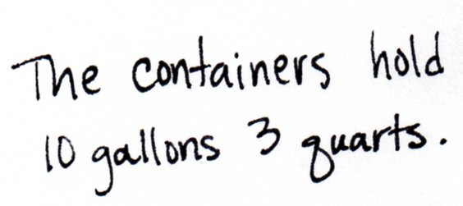
The first container holds 4 gallons, 2 quarts of juice. The second container can hold $\text{1}\frac{3}{4}$ gallons more than the first container. Altogether, how much juice can the two containers hold?
Solution A is solved by converting the mixed unit and the mixed number measurement into quarts, converting to a smaller unit. Remembering 4 quarts equal 1 gallon, students solve for $\text{1}\frac{3}{4}$ gallon as 7 quarts. The total number of quarts in the two containers can then be found by adding the number of quarts held by the first and second containers together. In Solution B, the units are kept as mixed measurements. The tape diagram makes it easy to see the total is made up of two equal parts of 4 gallons 2 quarts plus 1 gallon 3 quarts because the second container is $\text{1}\frac{3}{4}$ gallons more than the first. This results in a total of 10 gallons, 3 quarts that is then converted into 43 quarts.

Problem 4
A girl’s height is $\text{3}\frac{1}{3}$ feet. A giraffe’s height is 3 times that of the girl. How many inches taller is the giraffe than the girl?
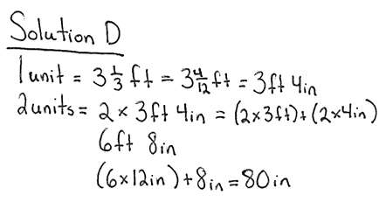

Solution A converts the height of the girl into inches. Then, the height of the giraffe is found by solving for 3 units, as 1 unit equals 40 inches. The heights are subtracted to find the difference of 80 inches. Once the model is drawn, students may see that they don’t need to find the giraffe’s height to solve this problem. Both Solutions B and C recognize that the two units in the model represent how much taller the giraffe is than the girl. Solution C uses the distributive property to multiply the mixed number by 2. Solution C converts the feet into inches.
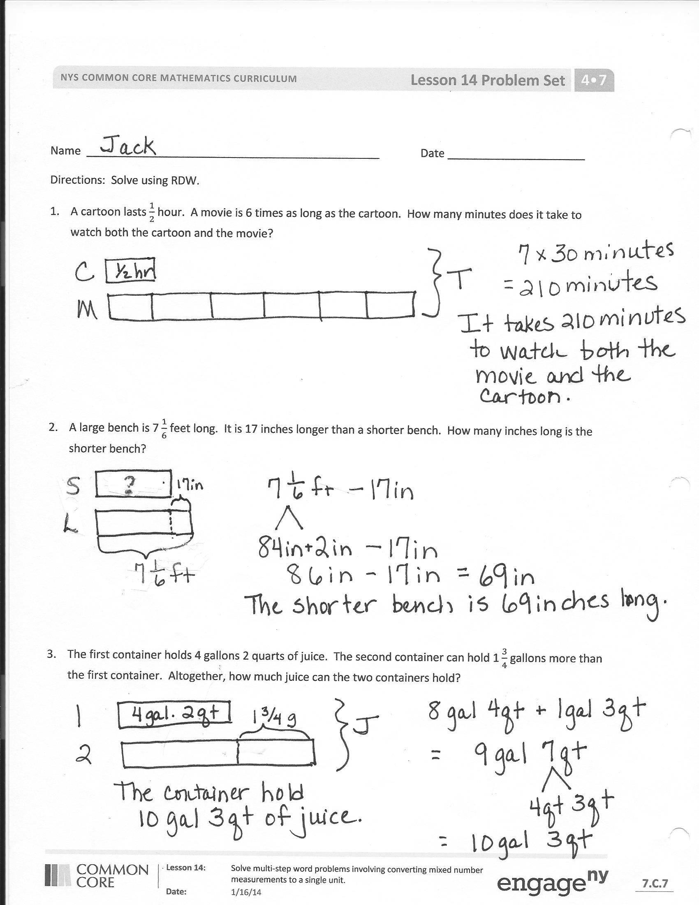
Problem Set
Please note that Problems 1─4 on the Problem Set are completed during instruction. As students present themselves ready to solve independently, release some students or the entire class to work independently or in partnerships. Problems 5─6 can be completed individually, with a partner, or via whole-class instruction.
Student Debrief (10 minutes)
Lesson Objective: Solve multi-step word problems involving converting mixed number measurements to a single unit.
The Student Debrief is intended to invite reflection and active processing of the total lesson experience.
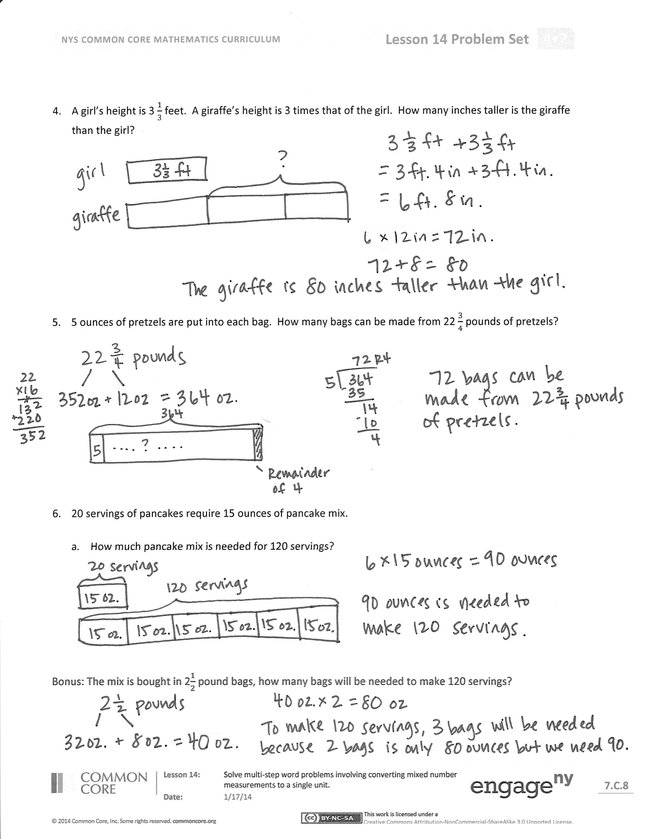
Invite students to review their solutions for the Problem Set. They should check work by comparing answers with a partner before going over answers as a class. Look for misconceptions or misunderstandings that can be addressed in the Debrief. Guide students in a conversation to debrief the Problem Set and process the lesson.
You may choose to use any combination of the questions below to lead the discussion.
- In Problem 1 how many different ways were 7 halves represented? (30 min $\text{×}$ 7, as $\frac{7}{2}$ and as $\frac{6}{2}$ + $\frac{1}{2}.$ ) What advantage is there to knowing all of these representations when it comes to solving a problem like this one?
- Explain to your partner how you solved Problem 2. If you used different strategies, discuss how you arrived at the same answer.
- What shortcuts or efficiencies did you use today when solving your problems? How do you decide whether to start by converting to a smaller unit or to work with the mixed number measurements?
- How is the remainder in Problem 5 interpreted?
- Did you have trouble persevering at times? When? What can you do to stay focused?
Exit Ticket (3 minutes)
After the Student Debrief, instruct students to complete the Exit Ticket. A review of their work will help you assess the students’ understanding of the concepts that were presented in the lesson today and plan more effectively for future lessons. You may read the questions aloud to the students.

Name Date
Use RDW to solve the following problems.
- A cartoon lasts $\frac{1}{2}$ hour. A movie is 6 times as long as the cartoon. How many minutes does it take to watch both the cartoon and the movie?

- A large bench is $\text{7}\frac{1}{6}$ feet long. It is 17 inches longer than a shorter bench. How many inches long is the shorter bench?

- The first container holds 4 gallons, 2 quarts of juice. The second container can hold 1 $\frac{3}{4}$ gallons more than the first container. Altogether, how much juice can the two containers hold?

- A girl’s height is $\text{3}\frac{1}{3}$ feet. A giraffe’s height is 3 times that of the girl. How many inches taller is the giraffe than the girl?

- Five ounces of pretzels are put into each bag. How many bags can be made from $\text{22}\frac{3}{4}$ pounds of pretzels?

- Twenty servings of pancakes require 15 ounces of pancake mix.

    - How much pancake mix is needed for 120 servings?

Bonus: The mix is bought in $\text{2}\frac{1}{2}$ pound bags. How many bags will be needed to make 120 servings?

Name Date
Use RDW to solve the following problems.
- It took Gigi 1 hour and 20 minutes to complete a bicycle race. It took Johnny twice as long because he got a flat tire. How many minutes did it take Johnny to finish the race?

Name Date
Use RDW to solve the following problems.
- Molly baked a pie for 1 hour and 45 minutes. Then, she baked banana bread for 35 minutes less than the pie. How many minutes did it take to bake the pie and the bread?

- A slide on the playground is $\text{12}\frac{1}{2}$ feet long. It is 3 feet 7 inches longer than the small slide. How long is the small slide?

- The fish tank holds 8 gallons 2 quarts of water. Jeffrey poured $\text{1}\frac{3}{4}$ gallons into the empty tank. How much more water does he still need to pour into the tank to fill it?

- The candy shop puts 10 ounces of gummy bears in each box. How many boxes do they need to fill if there are $\text{21}\frac{1}{4}$ pounds of gummy bears?

- Mom can make 10 brownies from a 12 ounce package.

  - How many ounces of brownie mix would be needed to make 50 brownies?

Bonus: The brownie mix is also sold in $\text{1}\frac{1}{2}$ pound bags. How many bags would be needed to make 120 brownies?

