Lesson 13
Objective: Use measurement tools to convert mixed number measurements to smaller units.

Suggested Lesson Structure
 Fluency Practice (10 minutes)
 Application Problem (5 minutes)
 Concept Development (35 minutes)
 Student Debrief (10 minutes)
Total Time (60 minutes)
Fluency Practice (10 minutes)
- Grade 4 Core Fluency Differentiated Practice Sets 4.NBT.4 (4 minutes)
- Complete Time Units 4.MD.1 (3 minutes)
- Complete Weight Units 4.MD.1 (3 minutes)
Grade 4 Core Fluency Differentiated Practice Sets (4 minutes)
Materials: (S) Core Fluency Practice Sets from G4–M7–Lesson 2
Note: During G4–Module 7, each day’s Fluency Practice may include an opportunity for mastery of the addition and subtraction algorithm by means of the Core Fluency Practice Sets. The process is detailed and Practice Sets are provided in G4–M7–Lesson 2.

NOTES ON
MULTIPLE MEANS FOR ACTION AND EXPRESSION:
Depending on the needs of English language learners and others, couple writing (e.g., 4 days) with speaking, “four days” during the Complete Time Units fluency activity.
Also, to support students working below grade level, present equivalencies, such as 24 hours = 1 day, that students may refer to as they solve.

Complete Time Units (3 minutes)
Materials: (S) Personal white boards
Note: This fluency activity reviews G4─M7─Lesson 3. Depending on the class, students might write responses on their personal boards or respond orally.
T: (Write 4 days.) How many more days complete the week?
S: 3 days.
T: (Write 40 min.) How many more minutes complete the hour?
S: 20 minutes.
T: (Write 25 min.) How many more minutes complete the hour?
S: 35 minutes.
T: (Write 18 min.) How many more minutes complete the hour?
S: 42 minutes.
T: (Write 18 hours.) How many more hours complete the day?
S: 6 hours.
T: (Write 10 hours.) How many more hours complete the day?
S: 14 hours.
T: (Write 20 seconds.) How many more seconds complete the minute?
S: 40 seconds.
T: (Write 34 seconds.) How many more seconds complete the minute?
S: 26 seconds.
Complete Weight Units (3 minutes)
Materials: (S) Personal white boards
Note: This fluency activity reviews measurement conversions from G4─M7─Lesson 1 and the important concept of completing the unit.
T: (Write 15 ounces.) How many more ounces complete the pound?
S: (Write 1 ounce.)
Continue the complete-the-unit work possibly using the following suggested sequence: 8 ounces, 12 ounces, 4 ounces, and 7 ounces.
Application Problem (5 minutes)
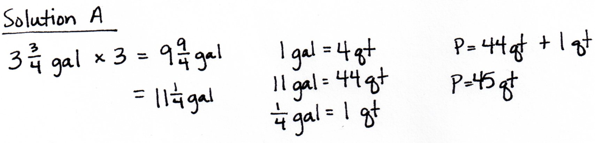
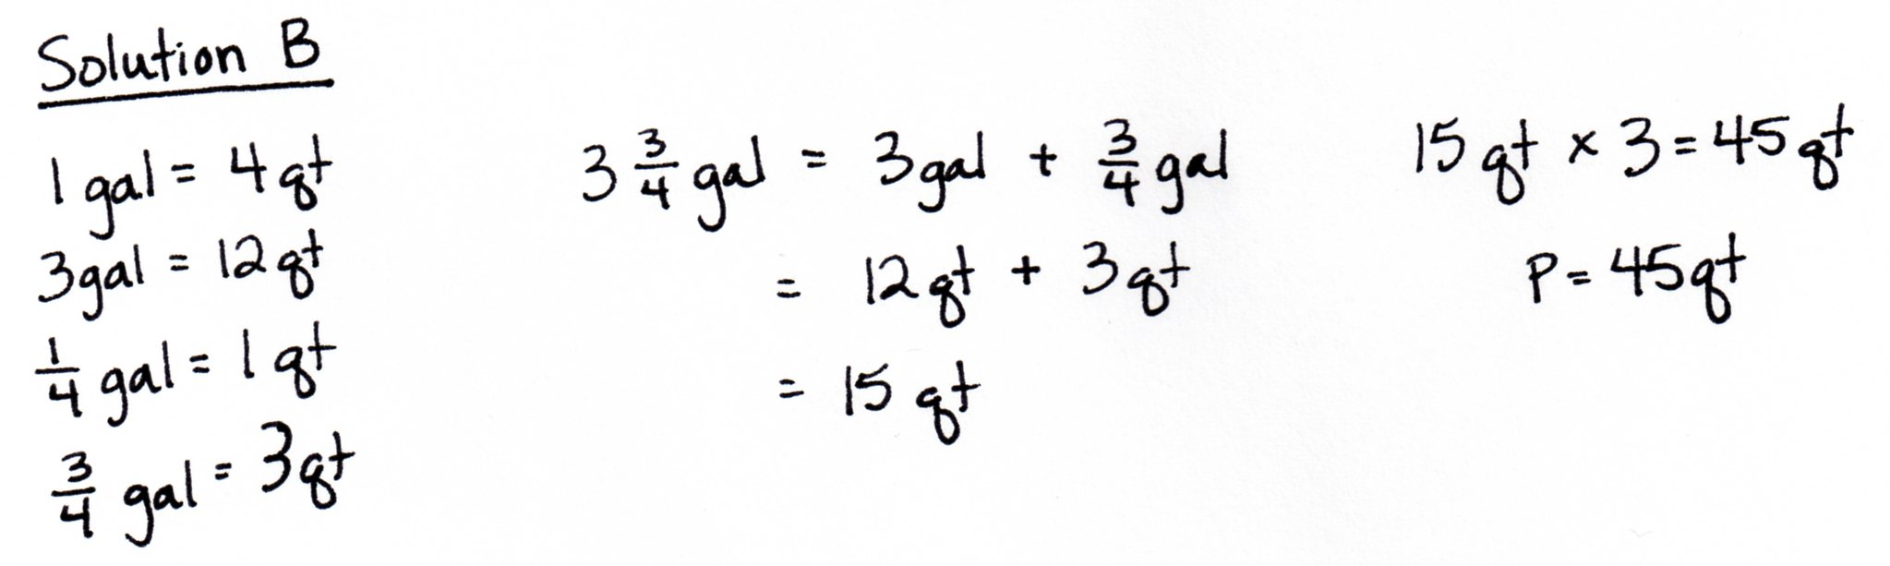
Micah used $\text{3}\frac{3}{4}$ gallons of paint to paint his bathroom. He used 3 times as much paint to paint his bedroom. How many quarts of paint did it take to paint his bedroom?

Note: Reviewing G4─M7─Lesson 12, students use multiplicative reasoning and the conversion of mixed number measurements to solve this problem. Solution A solves for the total number of gallons and then converts to quarts. Solution B finds how many quarts equal 1 unit and then multiplies to find how many quarts are in 3 units.
Concept Development (35 minutes)
Materials: (S) Problem Set

Problem 1: Identify $\frac{1}{16}$ pound as 1 ounce.
T: 1 pound is equal to how many ounces?
S: 16 ounces.
T: Draw a tape diagram to represent 1 pound. You said that 16 ounces equals 1 pound. Show this on your tape diagram.
S: (Draw the tape diagram for 1 pound.)
T: $\frac{1}{16}$ pound equals how many ounces? Tell me the complete number sentence.
S: $\frac{1}{16}$ pound = 1 ounce.
T: $\frac{2}{16}$ pound equals how many ounces?
S: 2 ounces.
T: Find the number of ounces equal to $\frac{1}{2}$ pound. Explain your thinking to your partner.
S: $\frac{1}{2}$ is equal to $\frac{8}{16}$, so $\frac{1}{2}$ pound must be 8 ounces. I shaded half the tape diagram and saw it was equal to 8 units. A unit is an ounce, so $\frac{1}{2}$ pound = 8 ounces. We used equivalent fractions: $\frac{1 × 8}{2 × 8}\text{=}\frac{8}{16}$.
T: How does the number line next to Problem 1 on your Problem Set illustrate this fact?
S: After shading, it’s easy to see the halfway point on the tape diagram lines up with 8 ounces on the number line. You can see that a half is 8 ounces, or 8 of the small length units. It might be even clearer if we labeled 0 and 16 as 0 pounds and 1 pound, not just 0 ounces and 16 ounces.
T: With a partner complete Problems 1 and 2 on your Problem Set.
Ask early finishers to find the number of ounces in $\text{8}\frac{3}{4}$ pounds and $\text{11}\frac{1}{2}$ pounds. Circulate and provide support as necessary.
ounces

Problem 2: Identify $\frac{1}{60}$ hour as 1 minute.
T: 1 hour equals 60 minutes. $\frac{1}{60}$ hour equals how many minutes?
S: 1 minute.
T: Discuss with your partner. How many minutes are in $\frac{1}{2}$ hour?
S: 30 minutes. I know that when the minute hand has gone halfway around the clock, it’s 30 minutes.
T: (Write $\frac{1}{2}$ hour = $\frac{}{60}$ hour.) What equivalent fraction could we write to show how many sixtieths of an hour equal $\frac{1}{2}$ hour? Use multiplication to show the equivalence.
S: $\frac{1}{2}$ = $\frac{1 × 30}{2 × 30}$ = $\frac{30}{60}$.
T: (Write $\frac{1}{4}$ hour = $\frac{}{60}$ hour.) Determine with your partner how to find the number of minutes in a quarter of an hour.
S: I could take the number of minutes in a half an hour and divide them in half to get 15 minutes. I know that when the minute hand has gone a quarter of the way around the clock, 15 minutes have passed. $\frac{1}{4}$ hour = $\frac{1 × 15}{4 × 15}$ =$\frac{15}{60}$ hour.

NOTES ON
MULTIPLE MEANS OF ENGAGEMENT:
Students working above grade level, and others who convert $3\frac{1}{2}$ hours to minutes rapidly and mentally, may enjoy an autonomous partner activity in which they choose their own mixed number amounts of hours their partner will convert to minutes, or more challenging, seconds.

T: How many minutes would there be in $\text{3}\frac{1}{2}$ hours? Use whatever strategy helps you.
MP.3
S: 210 minutes.
If time allows, ask students to find the number of minutes in $\text{8}\frac{1}{4}$ hours and the number of hours in $\text{8}\frac{1}{4}$ days. Have students start the remainder of the Problem Set as soon as they show they can apply their learning to solve the number of smaller units involving a mixed number such as $\text{8}\frac{1}{4}$ hours.
Problem Set (10 minutes)
Students should do their personal best to complete the remainder of the Problem Set within the allotted 10 minutes. For some classes, it may be appropriate to modify the assignment by specifying which problems they work on first. Some problems do not specify a method for solving. Students solve these problems using the RDW approach used for Application Problems.

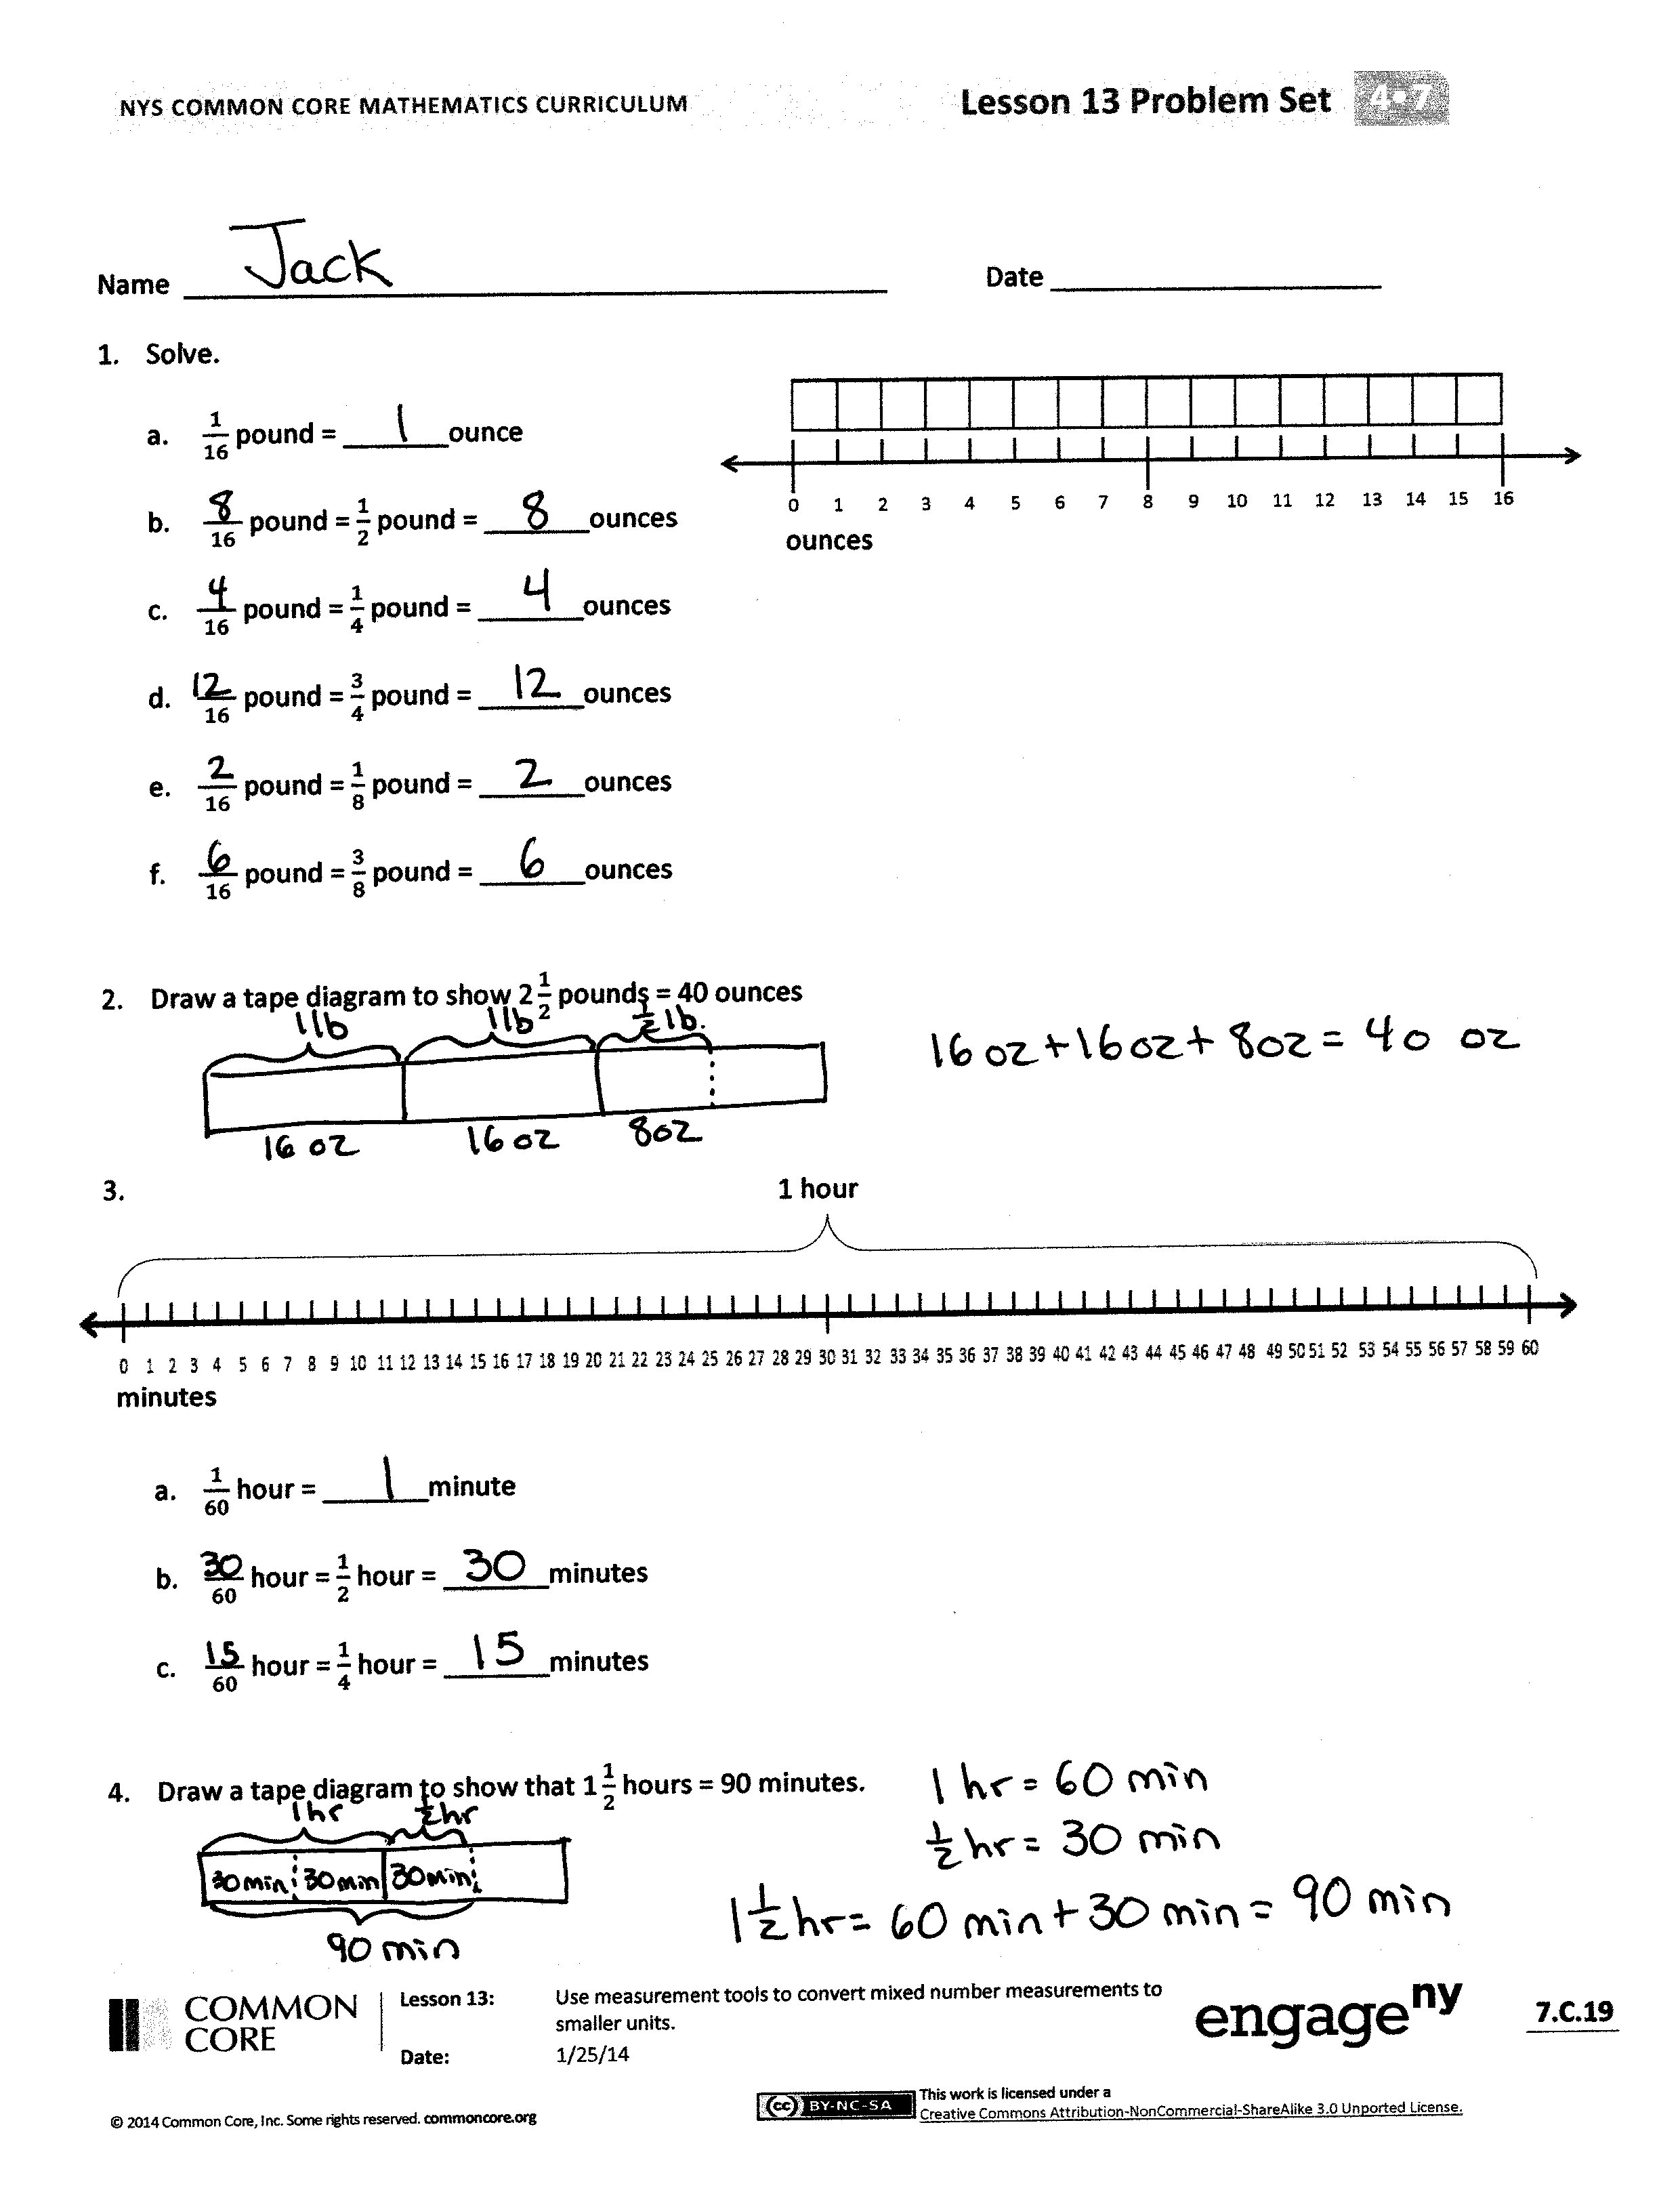
Student Debrief (10 minutes)
Lesson Objective: Use measurement tools to convert mixed number measurements to smaller units.
The Student Debrief is intended to invite reflection and active processing of the total lesson experience.
Invite students to review their solutions for the Problem Set. They should check work by comparing answers with a partner before going over answers as a class. Look for misconceptions or misunderstandings that can be addressed in the Debrief. Guide students in a conversation to debrief the Problem Set and process the lesson.
You may choose to use any combination of the questions below to lead the discussion.
- How could your answer to Problem 5(a) help you solve 5(b)?
- Explain to your partner how to solve Problem 5(i). How do you know that your answer is reasonable?
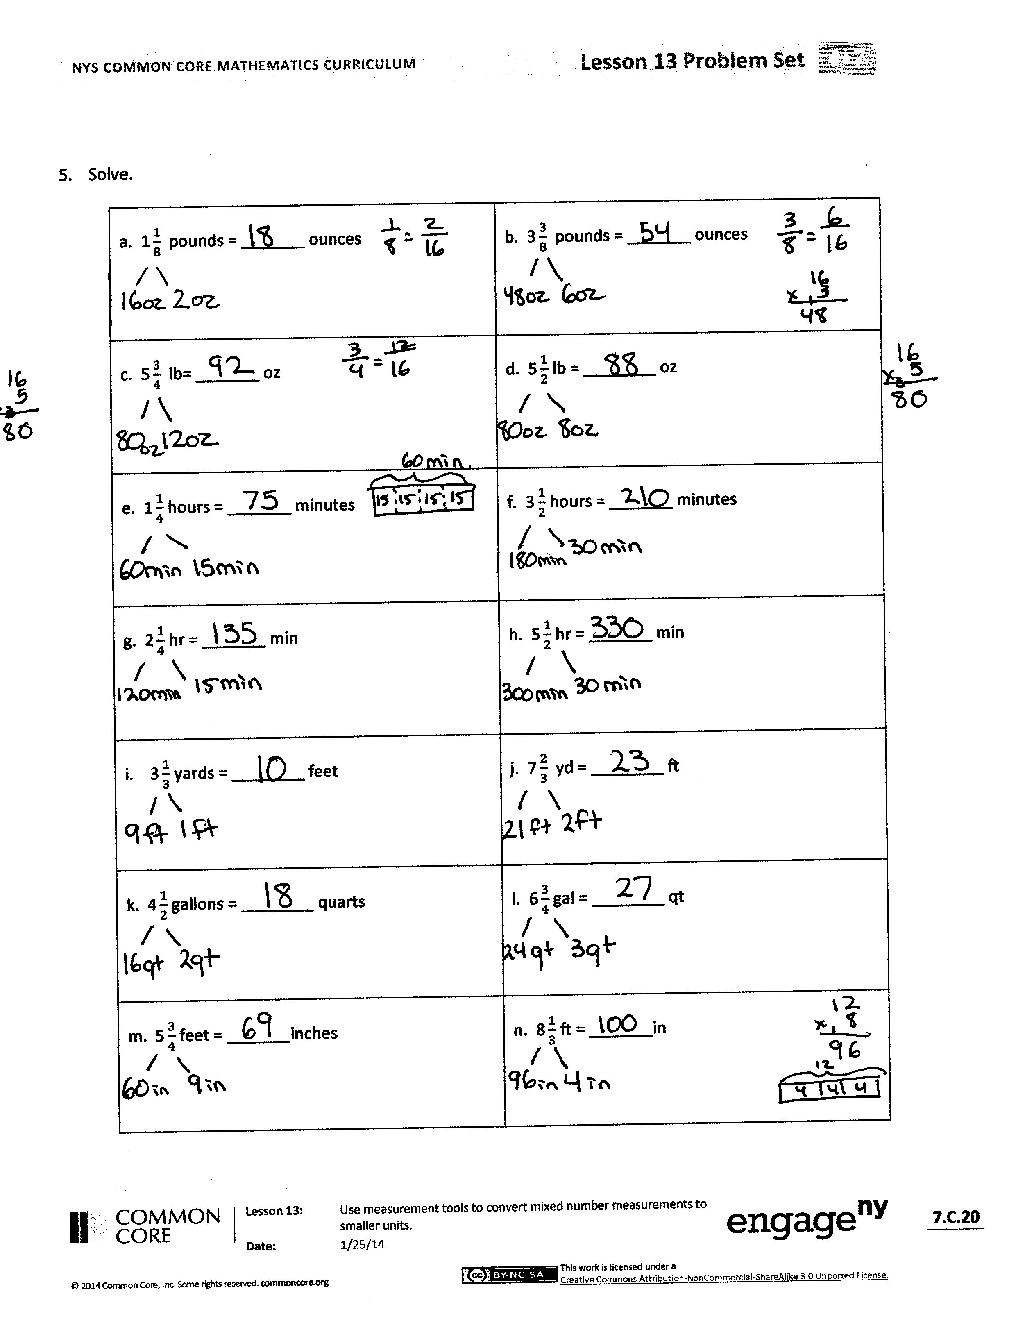
- How does knowing that 5 × 12 equals 60 and
6 × 12 equals 72 help you see that your answer to Problem 5(m) is reasonable?
- What is the advantage of saying $\text{3}\frac{9}{12}$ feet rather than $\text{3}\frac{3}{4}$ feet?
- When have you heard someone talk about a fraction of a unit before? Think of examples using the units we have worked with today along with other units of measurement.
Exit Ticket (3 minutes)
After the Student Debrief, instruct students to complete the Exit Ticket. A review of their work will help you assess the students’ understanding of the concepts that were presented in the lesson today and plan more effectively for future lessons. You may read the questions aloud to the students.

Name Date
- Solve.
- $\frac{1}{16}$ pound = _______ounce

- $\frac{ }{16}$ pound = $\frac{1}{2}$ pound = _______ounces
ounces

- $\frac{ }{16}$ pound = $\frac{1}{4}$ pound = _______ounces

- $\frac{ }{16}$ pound = $\frac{3}{4}$ pound = _______ounces

- $\frac{ }{16}$ pound = $\frac{1}{8}$ pound = _______ounces

- $\frac{ }{16}$ pound = $\frac{3}{8}$ pound = _______ounces

- Draw a tape diagram to show $\text{2}\frac{1}{2}$ pounds = 40 ounces

1 hour

minutes

- $\frac{1}{60}$ hour = _______minute

- $\frac{ }{60}$ hour = $\frac{1}{2}$ hour = _______minutes

- $\frac{ }{60}$ hour = $\frac{1}{4}$ hour = _______minutes

- Draw a tape diagram to show that $\text{1}\frac{1}{2}$hours = 90 minutes.

- Solve.

a. $\text{1}\frac{1}{8}$ pounds = _______ ounces | b. $\text{3}\frac{3}{8}$ pounds = _______ ounces
c. $\text{5}\frac{3}{4}$ lb= _______ oz | d. $\text{5}\frac{1}{2}$ lb = ________ oz
e. $\text{1}\frac{1}{4}$ hours = _______ minutes | f. $\text{3}\frac{1}{2}$ hours = _______ minutes
g. $\text{2}\frac{1}{4}$ hr = _______ min | h. $\text{5}\frac{1}{2}$ hr = _______ min
i. $\text{3}\frac{1}{3}$ yards = ________ feet | j. $\text{7}\frac{2}{3}$ yd = ________ ft
k. $\text{4}\frac{1}{2}$ gallons = ________ quarts | l. $\text{6}\frac{3}{4}$ gal = ________ qt
m. $\text{5}\frac{3}{4}$ feet = _______inches | n. $\text{8}\frac{1}{3}$ ft = _______in

Name Date
- Draw a tape diagram to show that $\text{4}\frac{3}{4}$gallons = 19 quarts.

- Solve.

a. $\text{1}\frac{1}{4}$ pounds = _______ ounces | b. $\text{2}\frac{3}{4}$ hr = _______ min
c. $\text{5}\frac{1}{2}$ feet = _______inches | d. $\text{3}\frac{5}{6}$ ft = _______in

Name Date
  - Solve.
- $\frac{1}{16}$ pound = _______ounce

- $\frac{ }{16}$ pound = $\frac{1}{2}$ pound = _______ounces
ounces

- $\frac{ }{16}$ pound = $\frac{1}{4}$ pound = _______ounces

- $\frac{ }{16}$ pound = $\frac{3}{4}$ pound = _______ounces

- $\frac{ }{16}$ pound = $\frac{1}{8}$ pound = _______ounces

- $\frac{ }{16}$ pound = $\frac{5}{8}$ pound = _______ounces

  - Draw a tape diagram to show $\text{1}\frac{1}{4}$ pounds = 20 ounces

  - Solve.
1 hour

minutes

$a. \frac{1}{60}$ hour = _______minute

$b. \frac{ }{60}$ hour = $\frac{1}{2}$ hour = _______minutes

$c. \frac{ }{60}$ hour = $\frac{1}{4}$ hour = _______minutes

- $\frac{ }{60}$ hour = $\frac{1}{3}$ hour = _______minutes

- Draw a tape diagram to show that $\text{2}\frac{1}{4}$hours = 135 minutes.

- Solve.
a. $\text{2}\frac{1}{4}$ pounds = _______ ounces | b. $\text{4}\frac{7}{8}$ pounds = _______ ounces
c. $\text{6}\frac{3}{4}$ lb= _______ oz | d. $\text{4}\frac{1}{8}$ lb = ________ oz
e. $\text{1}\frac{3}{4}$ hours = _______ minutes | f. $\text{4}\frac{1}{2}$ hours = _______ minutes
g. $\text{3}\frac{3}{4}$ hr = _______ min | h. $\text{5}\frac{1}{3}$ hr = _______ min
i. $\text{4}\frac{2}{3}$ yards = ________ feet | j. $\text{6}\frac{1}{3}$ yd = ________ ft
k. $\text{4}\frac{1}{4}$ gallons = ________ quarts | l. $\text{2}\frac{3}{4}$ gal = ________ qt
m. $\text{6}\frac{1}{4}$ feet = _______inches | n. $\text{9}\frac{5}{6}$ ft = _______in

