Lesson 12
Objective: Use measurement tools to convert mixed number measurements to smaller units.

Suggested Lesson Structure
 Fluency Practice (12 minutes)
 Application Problem (5 minutes)
 Concept Development (33 minutes)
 Student Debrief (10 minutes)
Total Time (60 minutes)
Fluency Practice (12 minutes)
- Grade 4 Core Fluency Differentiated Practice Sets 4.NBT.4 (4 minutes)
- Complete Length Units 4.MD.1 (4 minutes)
- Complete One with Fractional Units 4.NF.3a (4 minutes)
Grade 4 Core Fluency Differentiated Practice Sets (4 minutes)
Materials: (S) Core Fluency Practice Sets from G4–M7–Lesson 2
Note: During G4–Module 7, each day’s Fluency Practice may include an opportunity for mastery of the addition and subtraction algorithm by means of the Core Fluency Practice Sets. The process is detailed and Practice Sets are provided in G4–M7–Lesson 2.
Complete Length Units (4 minutes)
Materials: (S) Personal white boards
Note: This fluency activity reviews measurement conversions and the important notion of completing the unit.
T: (Write 2 feet.) How many more feet are needed to make a yard?
S: (Write 1 foot.)
Continue the complete-the-unit work possibly using the following suggested sequence:
- Yards: 1 foot.
- Meters: 50 centimeters, 75 centimeters, 27 centimeters.
- Kilometers: 900 meters, 750 meters, 250 meters, 168 meters.
- Feet: 11 inches, 5 inches, 8 inches.
Complete One with Fractional Units (4 minutes)
Materials: (S) Personal white boards
Note: This fluency activity reviews fraction work from G4─Module 5 and allows students to see the relationship between measurement and fractional units in anticipation of today’s lesson.
T: (Write $\frac{2.}{3}.$) How many more thirds complete 1?
S: (Write $\frac{1}{3}.$)
T: (Write $\frac{1}{3}.$) How many more thirds complete 1?
S: (Write $\frac{2}{3}.$)
Continue the complete-the-unit work possibly using the following suggested sequence:
$\frac{1}{4},\frac{2}{4},\frac{3}{4},\frac{2}{10},\frac{5}{10},\frac{9}{10},\frac{9}{12},\frac{10}{12}, \frac{7}{12}, \frac{8}{12},\frac{8}{16},\frac{15}{16},\frac{10}{16},\frac{10}{100},\frac{99}{100},\frac{75}{100},\frac{75}{1000},\frac{750}{1000},\frac{999}{1000},\frac{1}{1000}$
Application Problem (5 minutes)
A rectangular tile has a width of 1 foot 6 inches and length of 2 feet. What is the perimeter of the tile?
Solution A

Solution B

Note: This problem reviews the mixed unit work from G4–M7–Topic B. In the Debrief, the students can revisit this problem and see that $\text{1}\frac{1}{2}$feet is another way of saying 1 foot 6 inches.
Concept Development (33 minutes)
Materials: (T) 1 gallon container marked to show 4 quarts, 1 gallon container marked to show fourths of a gallon, 1 quart container, colored water (S) 12-inch ruler (1 per student), yardstick (1 per group of 3 students), Problem Set
Note: Students can work in groups of three so that only 1 yardstick is needed for every three students. Cash register tape can be used for the foot-long strips of paper.
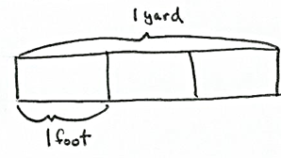
Problem 1: Identify $\frac{1}{3}$ yard as 1 foot, and use this equivalence to solve problems.
T: 1 yard is how many feet? Use your ruler and yardstick to measure to verify your answer.
S: 3 feet. 1 yard equals the length of three 1-foot rulers.
T: Look at Problem 1 on your Problem Set. Draw a tape diagram to represent 1 yard decomposed into 3 feet.
S: (Draw tape diagrams.)
T: (Point to 1 unit of the tape diagram.) 1 unit is $\frac{1}{3}$ yard. Why is that?
S: 3 units is 1. $\frac{1}{3} \text{+} \frac{1}{3} \text{+} \frac{1}{3} \text{=} \text{1}$. 1 is partitioned into 3 units so 1 unit represents $\frac{1}{3}.$
T: In your group, use your rulers to show $\frac{1}{3}$ yard.
S: (Hold up one ruler against the yardstick.)
T: $\frac{1}{3}$ yard is how many feet?
S: 1 foot.
T: As a group, use your rulers to show $\frac{2}{3}$ yard. $\frac{2}{3}$ yard is how many feet?
S: 2 feet.
T: As a group, use your rulers to show $\frac{3}{3}$ yard. $\frac{3}{3}$ yard is how many feet?

NOTES ON
MULTIPLE MEANS OF ENGAGEMENT:
Students working above grade level, and others who convert $\text{1}\frac{2}{3}$ yard to feet rapidly and mentally, may model $\text{2}\frac{2}{3}$ yard = 8 feet without delay. After doing so, or alternatively, they may like an autonomous partner activity in which they choose their own mixed number amounts of yards their partner will convert and model.

S: 3 feet.
T: Record your responses for Problem 1 on the Problem Set.
T: Talk and work with your partner. How many feet are in 1 $\frac{2}{3}$ yard? (Allow students time to work.)
S: 5 feet.
T: Explain your thinking.
S: We used our rulers and yardstick and modeled it. We drew another tape diagram and saw that 2 yards was 6 feet so 1 third less is 1 foot less, or 5 feet. We know that 1 yard is 3 feet and $\frac{2}{3}$ yard is 2 feet. 3 and 2 is 5.
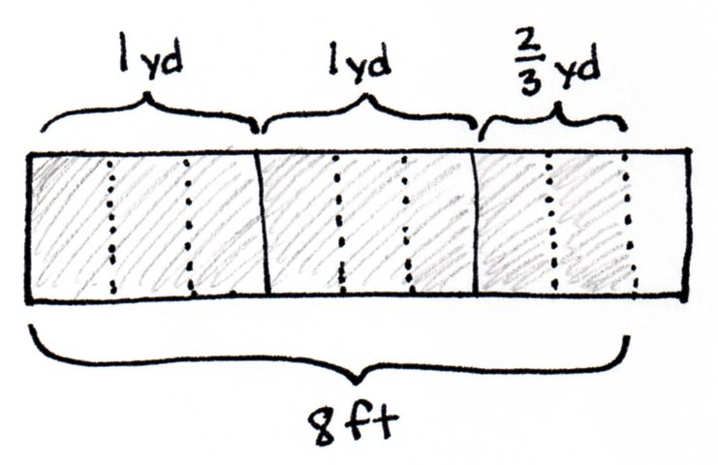
T: Draw a tape diagram for Problem 2 on the Problem Set to show that $\text{2}\frac{2}{3}$ yards is equal to 8 feet. If you finish early, figure out how many feet are equal to $\text{7}\frac{1}{3}$ yards and $\text{35}\frac{2}{3}$ yards.
Circulate to check for understanding.
Problem 2: Identify $\frac{1}{4}$ gallon as 1 quart, and use this equivalence to solve problems.
T: How many quarts equal a gallon?
S: 4 quarts.
T: Yes, this gallon container is marked to show the four quarts. (Measure out 1 quart from the full gallon and pour into the gallon marked to show fourths.) This gallon container is marked to show fourths. One quart of water is in this gallon container. What fraction of a gallon is filled?
S: 1 fourth gallon.
T: $\frac{1}{4}$ gallon is equal to 1 quart. Why?
S: It takes 4 quarts to make 1 gallon. 1 out of 4 parts is $\frac{1}{4}$. A gallon can be divided many different ways. This one is divided into fourths. We can say the 4 units, or 4 quarts, equal 1 gallon, so $\frac{1}{4}$ gallon is 1 unit or 1 quart.
Repeat by pouring additional units of 1 quart of water into the gallon container, asking for the fraction of a gallon being represented after each addition. Be sure to elicit the equivalence of $\frac{2}{4}$ gallon and $\frac{1}{2}$ gallon.
T: Draw a tape diagram to show 4 quarts equals 1 gallon.
S: (Draw as shown to the right.)
T: We have divided the gallon into 4 equal parts. What fraction represents 1 quart?
S: 1 fourth.
T: Draw the tape diagrams for Problems 3 and 4 of your Problem Set.
Circulate to check for student understanding.
Problem 3: Identify $\frac{1}{12}$ foot as 1 inch, and use this equivalence to solve problems.
T: Look at your rulers. 1 foot equals how many inches?
S: 12 inches.
T: Draw a tape diagram where the tape represents 1 foot and each unit represents 1 inch.
S: (Draw a tape diagram with 12 units as shown to the right.)
Note: If time management is not a concern, invite students to mark inches on a foot-long strip and to fold the paper before drawing the tape diagram.
T: 1 unit represents 1 inch. $\frac{1}{12}$ foot equals how many inches? Tell me the complete number sentence.
S: $\frac{1}{12}$ foot = 1 inch.
T: $\frac{2}{12}$ foot?
S: 2 inches.
Have partners quickly proceed with the pattern up to 12 twelfths for 1 foot.
T: Some of these fractions can be expressed in larger units. Shade 1 half foot of your tape diagram.
S: (Shade the tape diagram.)
T: How many inches is $\frac{1}{2}$ foot?
S: 6 inches!
T: (Write $\frac{1}{2}$ ft = $\frac{}{12}$ ft.) Talk to your partner. Instead of just using the tape diagram, how can we use what we know about finding equivalent fractions to find the number of twelfths equal to $\frac{1}{2}$ foot?
S: I know 2 times 6 is 12, so I can multiply the numerator by the same factor: $\frac{1 × 6}{2 × 6}$ = $\frac{6}{12}.$ It’s like a number line. A half is decomposed into 6 smaller parts: $\frac{1}{2}$ foot = $\frac{6}{12}$ foot. We are making larger units. Six inches is now a unit so we have 1 out of 2 units, one-half.
T: Again, how many inches are equal to $\frac{1}{2}$ or $\frac{6}{12}$ foot?
MP.3
S: 6 inches.
T: Work with your partner to find how many inches are equal to $\frac{1}{4}$ foot. (Allow students time to work.)
T: How did you figure it out?
S: To find one fourth we just cut the half in half on the tape diagram to see 1 fourth is equal to 3 inches. We also set it up as an equivalent fraction $\frac{1}{4}\text{=} \frac{}{12}$. Four times 3 is 12, so that meant the numerator would be 3, too.
If students need more guidance, repeat the same process with $\frac{1}{3}$ foot.
T: Talk to your partner. How many inches are equal to $\text{4}\frac{1}{2}$feet?
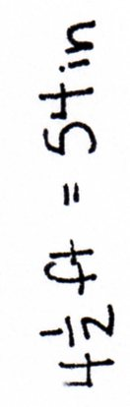
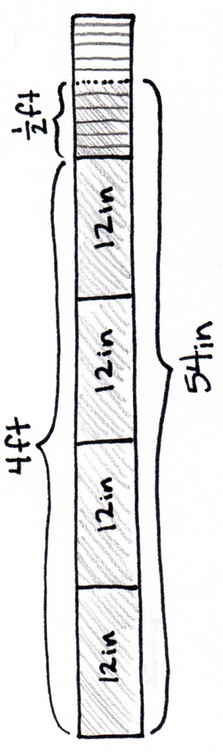
S: Easy. 4 $\text{×}$ 12 is 48. I know $\frac{1}{2}$ foot is 6 inches so 48 + 6 = 54. There are 54 inches. We drew a tape diagram with 5 equal units but partitioned the last unit in half.
Repeat, using multiplication to find the equivalent number of twelfths in $\frac{3}{4}$ foot, the number of inches in $\frac{3}{4}$ foot, and the number of inches in $\text{2}\frac{3}{4}$ foot.
T: Solve Problem 5 (a─f) and Problem 6 on your Problem Set using equivalent fractions or a tape diagram.
Circulate to check for student understanding.

Problem Set (10 minutes)
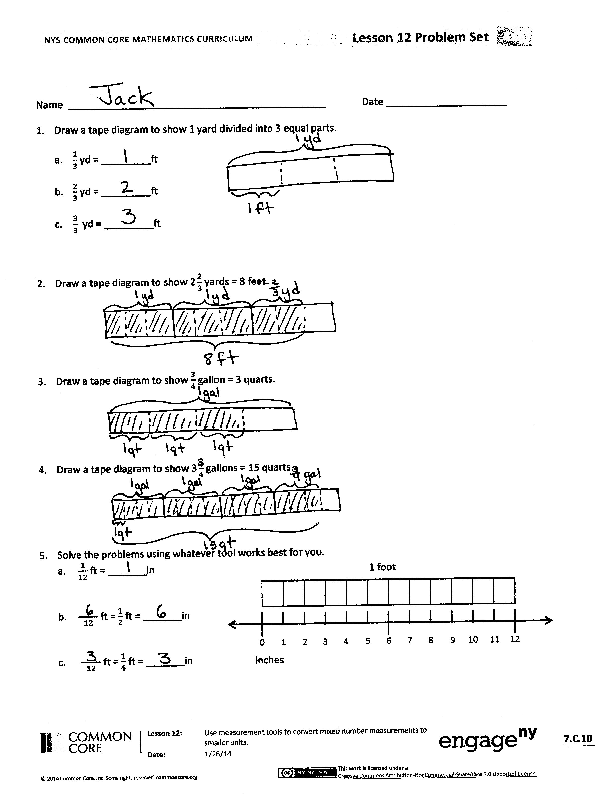
Students should do their personal best to complete the remainder of the Problem Set within the allotted 10 minutes. For some classes, it may be appropriate to modify the assignment by specifying which problems they work on first. Some problems do not specify a method for solving. Students solve these problems using the RDW approach used for Application Problems.
Student Debrief (10 minutes)
Lesson Objective: Use measurement tools to convert mixed number measurements to smaller units.
The Student Debrief is intended to invite reflection and active processing of the total lesson experience.
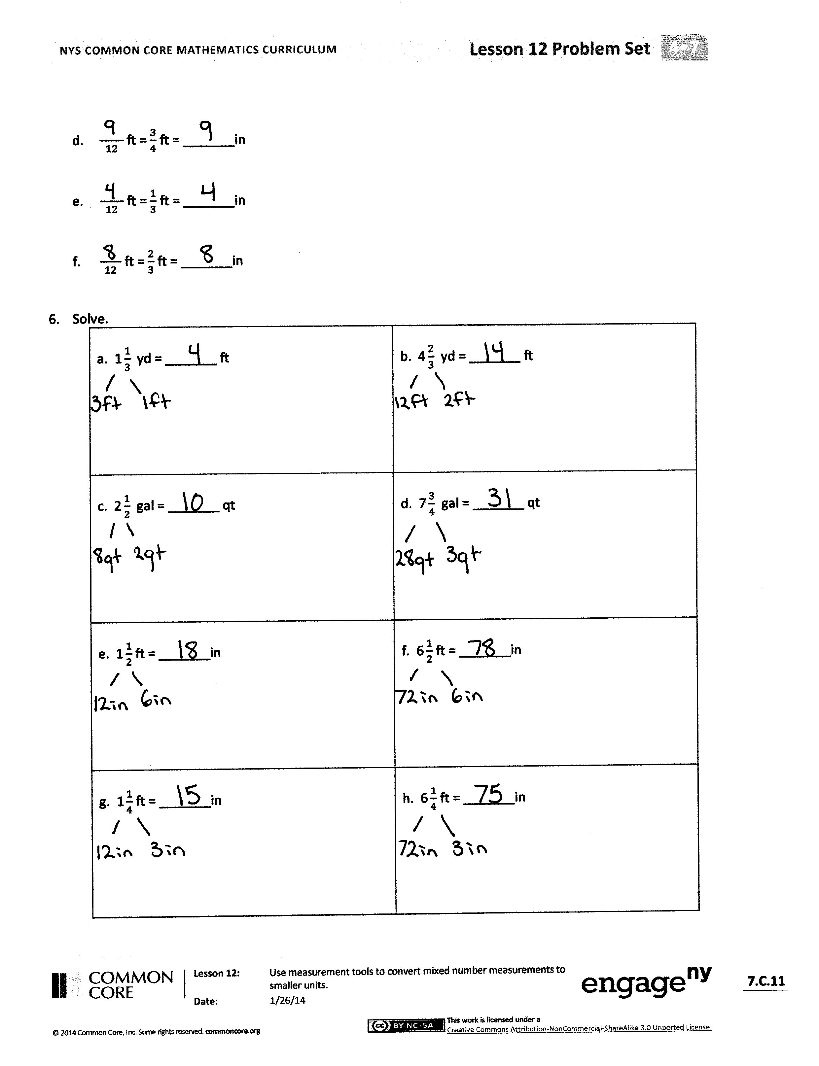
Invite students to review their solutions for the Problem Set. They should check work by comparing answers with a partner before going over answers as a class. Look for misconceptions or misunderstandings that can be addressed in the Debrief. Guide students in a conversation to debrief the Problem Set and process the lesson.
You may choose to use any combination of the questions below to lead the discussion.
- How is Problem 1(a), $\frac{1}{3}$ yard = 1 foot, a similar statement to Problem 5(a), $\frac{1}{12}$ foot = 1 inch?
- Explain to your partner how to solve Problem 6(b).
- How can knowing that 8 gallons equal 32 quarts help you check to make sure your answer to Problem 6(d) is reasonable?
- How could your answer to Problem 6(g) help you figure out Problem 6(h)?
- How could we rewrite the dimensions of the tile from the Application Problem using a mixed number instead of mixed units of feet and inches?

Exit Ticket (3 minutes)
After the Student Debrief, instruct students to complete the Exit Ticket. A review of their work will help you assess the students’ understanding of the concepts that were presented in the lesson today and plan more effectively for future lessons. You may read the questions aloud to the students.

Name Date
- Draw a tape diagram to show 1 yard divided into 3 equal parts.
- $\frac{1}{3}$ yd = _________ft
- $\frac{2}{3}$ yd = _________ft
- $\frac{3}{3}$ yd = _________ft

- Draw a tape diagram to show $\text{2}\frac{2}{3}$ yards = 8 feet.

- Draw a tape diagram to show $\frac{3}{4}$ gallon = 3 quarts.

- Draw a tape diagram to show $\text{3}\frac{3}{4}$ gallons = 15 quarts.

- Solve the problems using whatever tool works best for you.
1 foot

  - $\frac{1}{12}$ ft = _______in
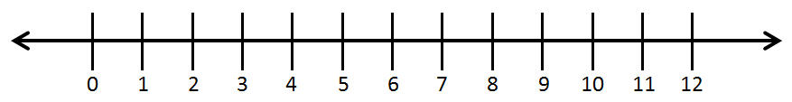
inches

  - $\frac{ }{12}$ ft = $\frac{1}{2}$ ft = _______in

  - $\frac{ }{12}$ ft = $\frac{1}{4}$ ft = _______in

  - $\frac{ }{12}$ ft = $\frac{3}{4}$ ft = _______in

  - $\frac{ }{12}$ ft = $\frac{1}{3}$ ft = _______in

  - $\frac{ }{12}$ ft = $\frac{2}{3}$ ft = _______in

- Solve.
a. $\text{1}\frac{1}{3}$ yd = _______ ft | b. $\text{4}\frac{2}{3}$ yd = _______ ft
c. $\text{2}\frac{1}{2}$ gal = _______ qt | d. $\text{7}\frac{3}{4}$ gal = _______ qt
e. $\text{1}\frac{1}{2}$ ft = _______in | f. $\text{6}\frac{1}{2}$ ft = _______in
g. $\text{1}\frac{1}{4}$ ft = _______in | h. $\text{6}\frac{1}{4}$ ft = _______in

Name Date
- Solve the problems using whatever tool works best for you.
1 foot

inches

  - $\frac{ }{12}$ ft = $\frac{1}{2}$ ft = _______in

  - $\frac{ }{12}$ ft = $\frac{3}{4}$ ft = _______in

- Solve.
- $\text{1}\frac{1}{3}$ yd = _______ ft | - $\text{5}\frac{3}{4}$ gal = _______ qt

Name Date
- Draw a tape diagram to show $\text{1}\frac{1}{3}$ yards = 4 feet.

- Draw a tape diagram to show $\frac{1}{2}$ gallon = 2 quarts.

- Draw a tape diagram to show $\text{1}\frac{3}{4}$ gallons = 7 quarts.

- Solve the problems using whatever tool works best for you.
1 foot

- $\frac{1}{2}$ foot = _______inches
inches

- $\frac{ }{12}$ foot = $\frac{1}{4}$ foot = _______inches

- $\frac{ }{12}$ foot = $\frac{1}{6}$ foot = _______inches

- $\frac{ }{12}$ foot = $\frac{1}{3}$ foot = _______inches

- $\frac{ }{12}$ foot = $\frac{2}{3}$ foot = _______inches

- $\frac{ }{12}$ foot = $\frac{5}{6}$ foot = _______inches

- Solve.
a. $\text{2}\frac{2}{3}$ yd = _______ ft | b. $\text{3}\frac{1}{3}$ yd = _______ ft
c. $\text{3}\frac{1}{2}$ gal = _______ qt | d. $\text{5}\frac{1}{4}$ gal = _______ qt
e. $\text{6}\frac{1}{4}$ ft = _______in | f. $\text{7}\frac{1}{3}$ ft = _______in
g. $\text{2}\frac{1}{2}$ ft = _______in | h. $\text{5}\frac{3}{4}$ ft = _______in
i. $\text{9}\frac{2}{3}$ ft = _______in | j. $\text{7}\frac{5}{6}$ ft = _______in

