Lesson 11
Objective: Solve multi-step measurement word problems.

Suggested Lesson Structure
 Fluency Practice (12 minutes)
 Concept Development (38 minutes)
 Student Debrief (10 minutes)
Total Time (60 minutes)
Fluency Practice (12 minutes)
- Grade 4 Core Fluency Differentiated Practice Sets 4.NBT.4 (4 minutes)
- Add Mixed Numbers 4.MD.2 (4 minutes)
- Convert Weight and Time Units 4.MD.1 (4 minutes)
Grade 4 Core Fluency Differentiated Practice Sets (4 minutes)
Materials: (S) Core Fluency Practice Sets from G4–M7–Lesson 2
Note: During G4–Module 7, each day’s Fluency Practice may include an opportunity for mastery of the addition and subtraction algorithm by means of the Core Fluency Practice Sets. The process is detailed and Practice Sets are provided in G4–M7–Lesson 2.
Add Mixed Numbers (4 minutes)
Materials: (S) Personal white boards
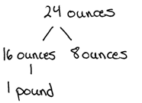
Note: This fluency activity reviews G4─Module 5’s fraction work and anticipates today’s lesson of adding mixed measurement units. Direct students to respond chorally to the questions or to use written responses on their personal boards, depending on what is most effective for them.
T: 9 sixteenths + 15 sixteenths is how many sixteenths?
S: 24 sixteenths.
T: Express 24 sixteenths as ones and sixteenths.
S: 1 one and 8 sixteenths.
T: 9 ounces + 15 ounces is how many ounces?
S: 24 ounces.
T: Express 24 ounces as pounds and ounces. Draw a number bond to pull out 16 ounces.
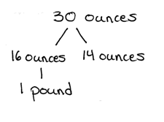
S: 1 pound 8 ounces.
T: 13 sixteenths + 17 sixteenths is how many sixteenths?
S: 30 sixteenths.
T: Express 30 sixteenths as ones and sixteenths.
S: 1 one and 14 sixteenths.
T: 13 ounces + 17 ounces is how many ounces?
S: 30 ounces.
T: Express 30 ounces as pounds and ounces. Draw a number bond to pull out 16 ounces.
S: 1 pound 14 ounces.
Repeat the process using the following possible sequence: 15 sixteenths + 15 sixteenths related to the same amount of ounces.
Convert Weight and Time Units (4 minutes)
Materials: (S) Personal white boards
Note: This fluency activity reviews G4─M7─Lessons 1 and 3 and anticipates today’s work with weight and time units.
T: Express each number of pounds and ounces as ounces, or days and hours as hours.
T: 1 pound.
S: 16 ounces.
T: 1 pound 10 ounces.
S: 26 ounces.
T: 1 day 2 hours.
S: 26 hours.
T: 2 days 3 hours.
S: 51 hours.
Repeat the same process moving between pounds and ounces, then days and hours.

Concept Development (38 minutes)
Materials: (S) Problem Set
Suggested Delivery of Instruction for Solving Lesson 11’s Word Problems
For Problems 1─4, students may work in pairs to solve each of the problems using the RDW approach to problem solving.

1. Model the problem.
Select two pairs of students who can successfully model the problem to work at the board while the other students work independently or in pairs at their seats. Review the following questions before beginning the first problem.
- Can you draw something?
- What can you draw?
- What conclusions can you make from your drawing?
As students work, circulate and reiterate the questions above. After two minutes, have the two pairs of students share only their labeled diagrams. For about one minute, have the demonstrating students receive and respond to feedback and questions from their peers.

NOTES ON
MULTIPLE MEANS OF ENGAGEMENT:
Depending on the needs of English language learners, allow students to discuss their math work in their first language, or provide sentence frames and starters such the ones given below:
- I didn’t understand….
- Can you explain how….
- I thought was a more efficient way of solving because….

2. Calculate to solve and write a statement.
Allow students two minutes to complete work on the problem, sharing their work and thinking with a peer. Have the students write their equations and statements of the answer.

3. Assess the solution.
Give students one to two minutes to assess the solutions presented by their peers on the board, comparing the solutions to their own work. Highlight alternative methods to reach the correct solution.

Problem 1
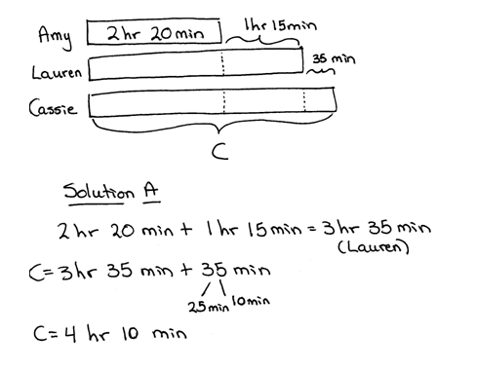
Lauren ran a marathon and finished 1 hour 15 minutes after Amy, who had a time of 2 hours and 20 minutes. Cassie finished 35 minutes after Lauren. How long did it take Cassie to run the marathon?

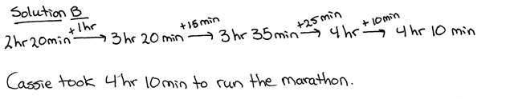

Solution A models solving for Lauren’s time and then adding 35 minutes to Lauren’s time to solve for Cassie’s time. Solution B uses the arrow way to add up starting with Amy’s time of 2 hours 20 minutes and then adding the additional hours and minutes needed to reach Cassie’s time. Encourage students to work with the mixed units. However, it should be noted that an answer resulting in 250 minutes is a correct response because it is equivalent to 4 hours 10 minutes. Early finishers can be encouraged to find the sum of their times. The tape diagram shows clearly that we have (3 $\text{×}$ 2 hr 20 min) + (2 $\text{×} \text{1}$ hr 15 min + 35 min).

Problem 2
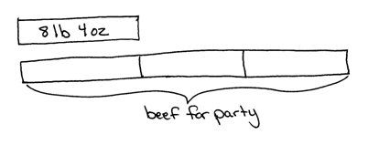
Chef Joe has 8 lb 4 oz of ground beef in his freezer. This is $\frac{1}{3}$ of the amount needed to make the number of burgers he planned for a party. If he uses 4 oz of beef for each burger, how many burgers is he planning to make?

MP.7
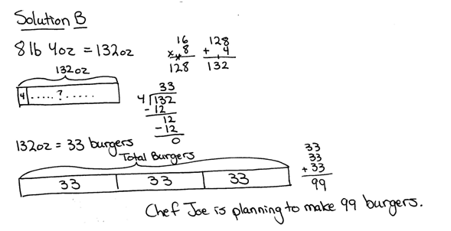

Students use their understanding of fractions when they draw a model showing that the total beef needed is made up of three units of 8 pounds 4 ounces (132 ounces) of beef. Addition or multiplication can be used to find the total amount of beef needed. Solution A models solving for the number of burgers made in the total pounds and in the total ounces separately and then adding the number of burgers together. Alternatively, Solution B shows finding the number of burgers that can be made with one-third of the ground beef. Multiplying by three solves for how many burgers can be made with the whole amount of ground beef.

Problem 3
Sarah read for 1 hour, 17 minutes each day for 6 days. If she took 3 minutes to read each page, how many pages did she read in 6 days?
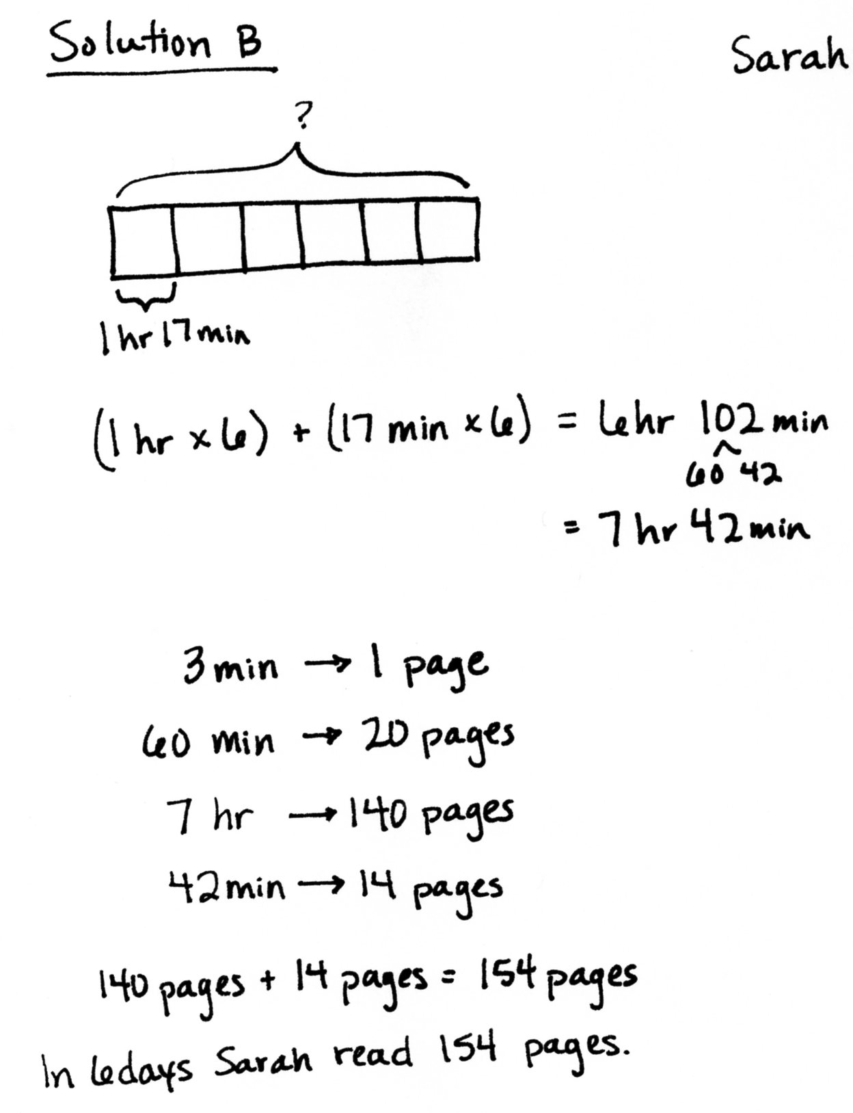

Students may start by converting the mixed units into the minutes read each day. They may then decide to use the minutes read each day to find the pages read each day and then the pages read in six days. Quickly, some may find that solving for the pages read each day results in a remainder which they may not understand how to interpret. Therefore, encourage them to solve with the whole 6 days in mind. Solution A divides the total number of minutes in 6 days by 3 pages to find 154 pages are read in 6 days. Solution B finds the mixed units of hours and minutes and solves part to whole, solving for the number of pages in 7 hours and the number of pages in 42 minutes.

Problem 4
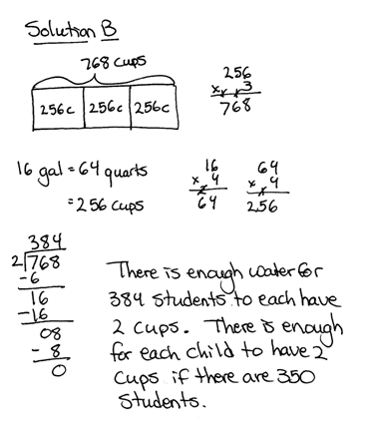
Grades 3, 4, and 5 have their annual field day together. Each grade level is given 16 gallons of water. If there are a total of 350 students, will there be enough water for each student to have 2 cups?
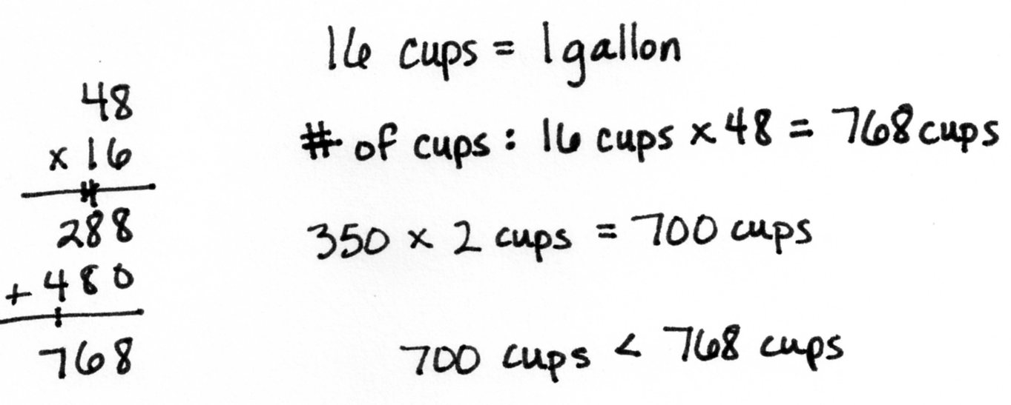

In order to solve this problem, students must see that each grade level is given 16 gallons of water or a total of 48 gallons for field day. Students may choose to convert across two, or even three, units going from gallons to quarts and quarts to cups as shown in Solution B. Sharing multiple solution strategies can show students the efficiency of using the rules learned in G4–M7–Topic A for converting. Solution A shows use of the rules by multiplying the number of gallons by 16 to find the number of cups. Comparing the number of cups needed (700 cups) to the number of cups they have for field day (768 cups) allows students to see that they do have enough water for each student to have 2 cups. Alternatively, Solution B divided to find the total number of students who could drink 2 cups of water from 16 gallons of water, proving there is enough water.

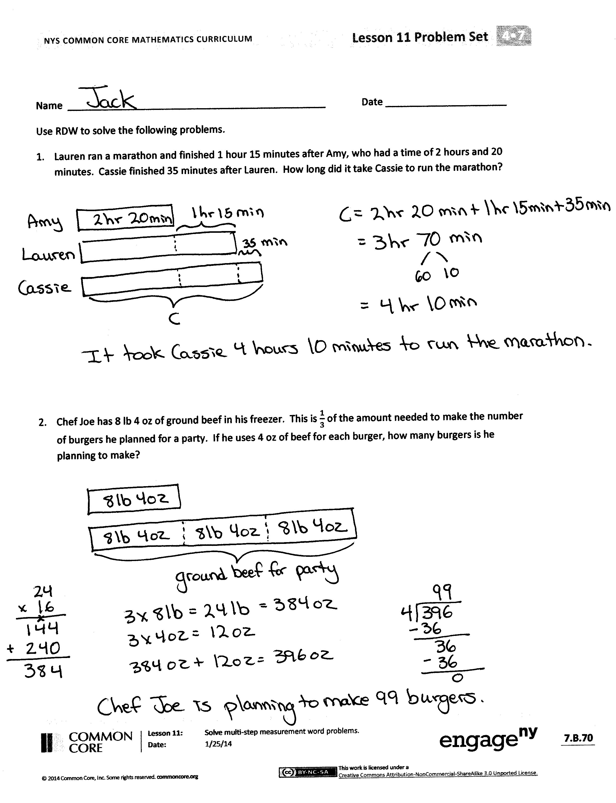
Student Debrief (13 minutes)
Lesson Objective: Solve multi-step measurement word problems.
The Student Debrief is intended to invite reflection and active processing of the total lesson experience.
Invite students to review their solutions for the Problem Set. They should check work by comparing answers with a partner before going over answers as a class. Look for misconceptions or misunderstandings that can be addressed in the Debrief. Guide students in a conversation to debrief the Problem Set and process the lesson.
You may choose to use any combination of the questions below to lead the discussion.
- Why might you want to keep the mixed units in Problem 1? Why might you want to start by converting the mixed units to minutes in Problem 3?
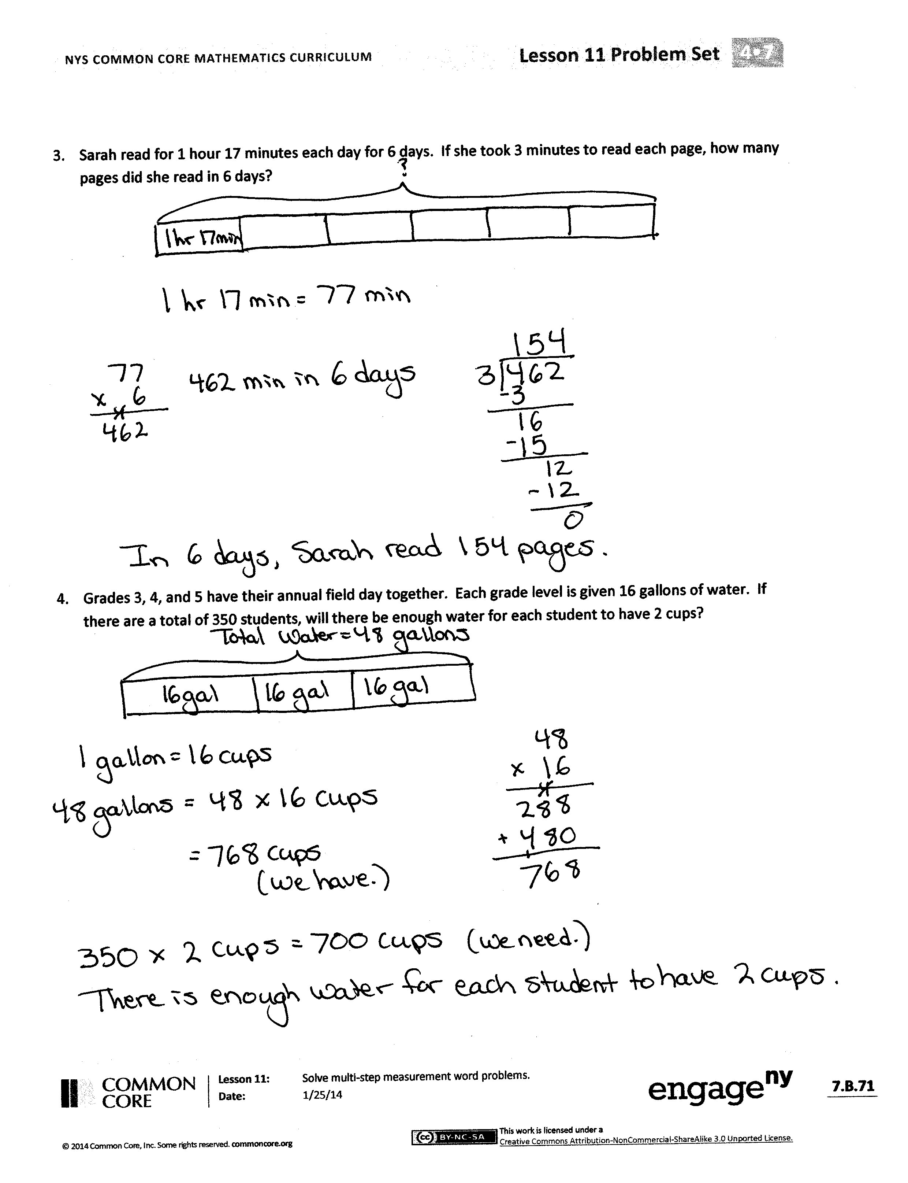
- What challenge might you have faced when solving Problem 3? Why couldn’t you first determine the number of pages she read each day?
- If it took Sarah 4 minutes instead of 3 minutes to read a page in Problem 3, would she read more or fewer pages in a week? Explain.
- Some students use strategies that are creative and much different compared to the majority of the class. How can a student be sure their strategy works?
Exit Ticket (3 minutes)
After the Student Debrief, instruct students to complete the Exit Ticket. A review of their work will help you assess the students’ understanding of the concepts that were presented in the lesson today and plan more effectively for future lessons. You may read the questions aloud to the students.
Name Date
Use RDW to solve the following problems.
- Lauren ran a marathon and finished 1 hour 15 minutes after Amy, who had a time of 2 hours and 20 minutes. Cassie finished 35 minutes after Lauren. How long did it take Cassie to run the marathon?

- Chef Joe has 8 lb 4 oz of ground beef in his freezer. This is $\frac{1}{3}$ of the amount needed to make the number of burgers he planned for a party. If he uses 4 oz of beef for each burger, how many burgers is he planning to make?

- Sarah read for 1 hour, 17 minutes each day for 6 days. If she took 3 minutes to read each page, how many pages did she read in 6 days?

- Grades 3, 4, and 5 have their annual field day together. Each grade level is given 16 gallons of water. If there are a total of 350 students, will there be enough water for each student to have 2 cups?

Name Date
Use RDW to solve the following problems.
- Judy spent 1 hour and 15 minutes less than Sandy exercising last week. Sandy spent 50 minutes less than Mary, who spent 3 hours at the gym. How long did Judy spend exercising?

Name Date
Use RDW to solve the following problems.
- Ashley ran a marathon and finished 1 hour, 40 minutes after P.J., who had a time of 2 hours and 15 minutes. Kerry finished 12 minutes before Ashley. How long did it take Kerry to run the marathon?

- Mr. Foote’s deck is 12 ft 6 in wide. Its length is twice the width plus 3 more inches. How long is the deck?

- Mrs. Lorentz bought 12 pounds 8 ounces of flour. This is $\frac{1}{4}$ of the flour she will use to make sugar cookies in her bakery this week. If she uses 5 ounces of flour for each batch of sugar cookies, how many batches of sugar cookies will she make in a week?

- Beth Ann practiced piano for 1 hour, 5 minutes each day for 1 week. She had 5 songs to practice and spent the same amount of time practicing each song. How long did she practice each song during the week?

- The concession stand has 18 gallons of punch. If there are a total of 240 students who want to purchase 1 cup of punch each, will there be enough punch for everyone?

