Lesson 10
Objective: Solve multi-step measurement word problems.

Suggested Lesson Structure
 Fluency Practice (12 minutes)
 Concept Development (35 minutes)
 Student Debrief (13 minutes)
Total Time (60 minutes)
Fluency Practice (12 minutes)
- Grade 4 Core Fluency Differentiated Practice Sets 4.NBT.4 (4 minutes)
- Add Mixed Numbers 4.MD.2 (4 minutes)
- Convert Capacity and Length Units 4.MD.1 (4 minutes)
Grade 4 Core Fluency Differentiated Practice Sets (4 minutes)
Materials: (S) Core Fluency Practice Sets from G4–M7–Lesson 2
Note: During G4–Module 7, each day’s Fluency Practice may include an opportunity for mastery of the addition and subtraction algorithm by means of the Core Fluency Practice Sets. The process is detailed and Practice Sets are provided in G4–M7–Lesson 2.
Add Mixed Numbers (4 minutes)
Materials: (S) Personal white boards
Note: This fluency activity reviews G4─Module 5’s fraction work and anticipates today’s lesson of adding mixed measurement units. Direct students to respond chorally to the questions or use a written response on their personal boards, depending on what is most effective for them.
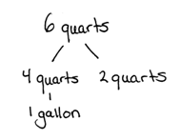
T: 3 fourths + 3 fourths is how many fourths?
S: 6 fourths.
T: Express 6 fourths as ones and fourths.
S: 1 one and 2 fourths.
T: 3 quarts + 3 quarts is how many quarts?
S: 6 quarts.
T: Express 6 quarts as gallons and quarts. Draw a number bond to pull out 4 quarts.
S: 1 gallon 2 quarts.
T: 7 twelfths + 7 twelfths is how many twelfths?
S: 14 twelfths.
T: Express 14 twelfths as ones and twelfths.
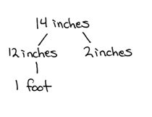
S: 1 one and 2 twelfths.
T: 7 inches + 7 inches is how many inches?
S: 14 inches.
T: Express 14 inches as feet and inches. Draw a number bond to pull out 12 inches.
S: 1 foot 2 inches.
Repeat the process using the following possible sequence: 6 eighths + 6 eighths related to 6 pints + 6 pints, and 11 sixteenths + 11 sixteenths related to 11 ounces + 11 ounces.
Convert Capacity and Length Units (4 minutes)
Materials: (S) Personal white boards
Note: This fluency activity reviews G4─M7─Lessons 1─2 and anticipates today’s work with capacity and length units. Direct students to respond chorally to the questions at a signal or to use written responses on their personal boards, depending on what is most effective for them.
T: Express each number of quarts and cups as cups..

NOTES ON
MULTIPLE MEANS OF REPRESENTATION:
To clarify the Convert Capacity and Length Units fluency activity directions for English language learners and others, give an example demonstrating the anticipated response.

T: 1 quart.
S: 4 cups.
T: 1 quart 2 cups.
S: 6 cups.
T: Express each number of feet and inches as inches.
T: 1 foot 1 inch.
S: 13 inches.
T: 2 quarts 3 cups.
S: 11 cups.
T: 3 feet 7 inches.
S: 43 inches.
Repeat the same process with gallons and pints, then yards and feet.
Concept Development (35 minutes)
Materials: (S) Problem Set
Note: The sample solutions for each problem are examples of the type of thinking that students might use in solving each problem. The solutions are not inclusive of all possible strategies. Encourage and challenge students to explain the strategies that they use.
Suggested Delivery of Instruction for Solving Lesson 10’s Word Problems
For Problems 1─4 below, students may work in pairs to solve each of the problems using the RDW approach to problem solving.

1. Model the problem.

NOTES ON
MULTIPLE MEANS OF ENGAGEMENT:
Communicate clear expectations for modeling that will allow all students to understand what it takes to become a demonstrating student. Offering a rubric and scaffolds by which students can set and achieve goals may give everyone a fair chance to succeed. Demonstrating students may use translators, interpreters, or sentence frames to present and respond to feedback.

Select two pairs of students who can successfully model the problem to work at the board while the other students work independently or in pairs at their seats. Review the following questions before beginning the first problem.
- Can you draw something?
- What can you draw?
- What conclusions can you make from your drawing?
As students work, circulate. Reiterate the questions above. After two minutes, have the two pairs of students share only their labeled diagrams. For about one minute, have the demonstrating students receive and respond to feedback and questions from their peers.
2. Calculate to solve and write a statement.
Allow students two minutes to complete work on the problem, sharing their work and thinking with a peer. Have the students write their equations and statements of the answer.
3. Assess the solution.
Give students one to two minutes to assess the solutions presented by their peers on the board, comparing the solutions to their own work. Highlight alternative methods to reach the correct solution.

Problem 1
Paula’s time swimming in the Ironman Triathlon was 1 hour 25 minutes. Her time biking was 5 hours longer than her swimming time. She ran for 4 hours 50 minutes. How long did it take her to complete all three parts of the race?
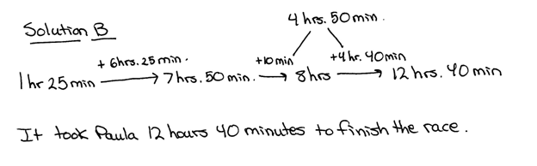
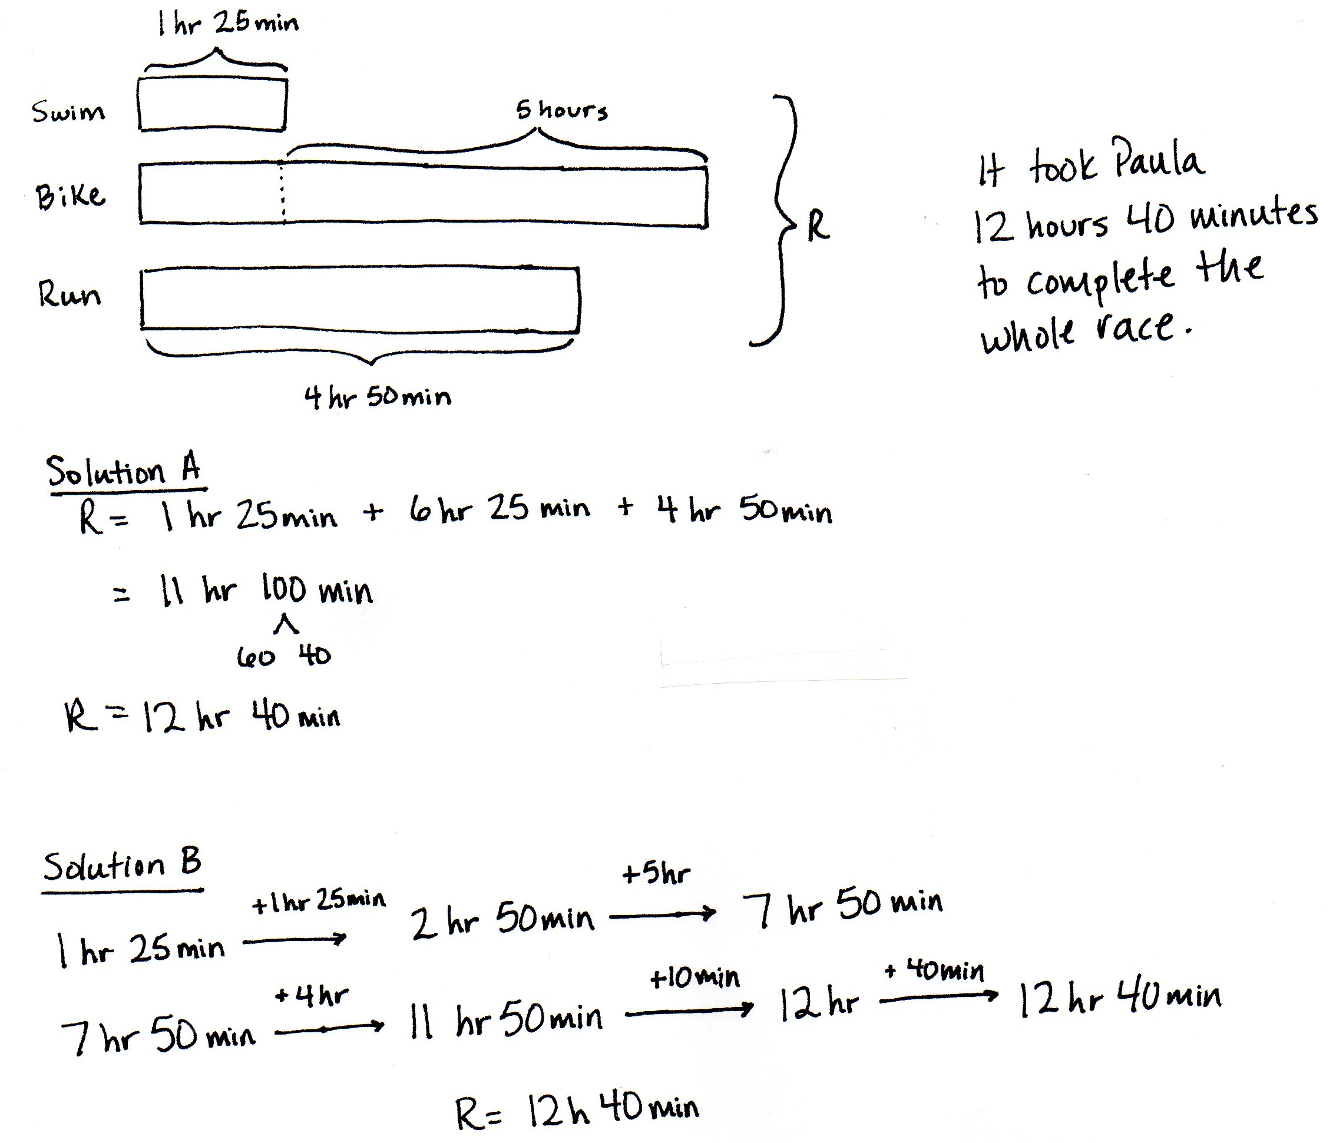
This problem could be solved, as in Solution A, by adding like units. Students may also, as in Solution B, solve by adding up. First, the student adds the 2 equal units of 1 hour 25 minutes and then adds the additional 5 hours. Then, the student adds the remaining 4 hours and 50 minutes, decomposing 50 minutes into 10 minutes and 40 minutes as to complete the whole, the next hour.

Problem 2
Nolan put 7 gallons 3 quarts of gas into his car on Monday and twice as much on Saturday. What was the total amount of gas put into the car on both days?

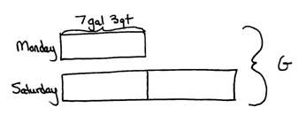

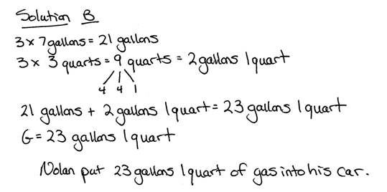
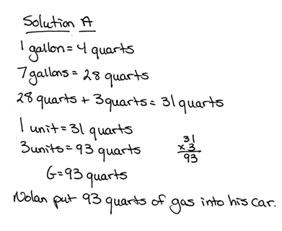

MP.2

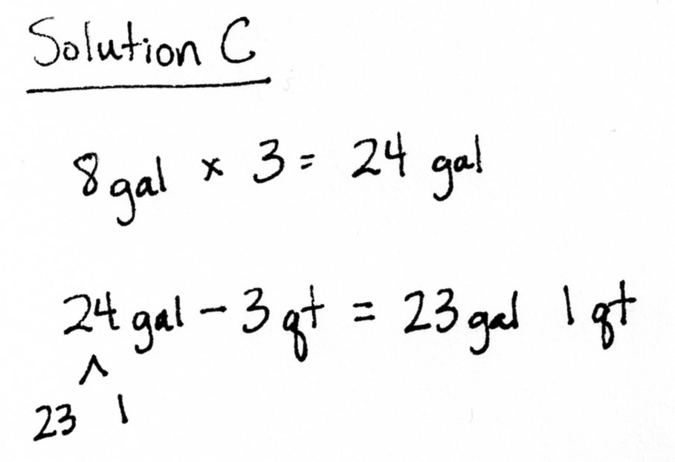

Once students see the relationship between the amount of gas added on Monday and Saturday, they can use different strategies to figure out how much gas was put in the car. The amount of gas can be converted into quarts, as modeled in Solution A, or the student may work with the mixed units to get 23 gallons 1 quart of gas as shown in Solution B. Solution C shows an alternative method of rounding the gas for each unit to 8 gallons, finding about 24 gallons of gas was put into Nolan’s car. Each unit was rounded up by 1 quart, so then 3 quarts, 1 quart for each unit, is subtracted for 24 gallons.

Problem 3
One pumpkin weighs 7 pounds 12 ounces. A second pumpkin weighs 10 pounds 4 ounces. A third pumpkin weighs 2 pounds 9 ounces more than the second pumpkin. What is the total weight of all three pumpkins?
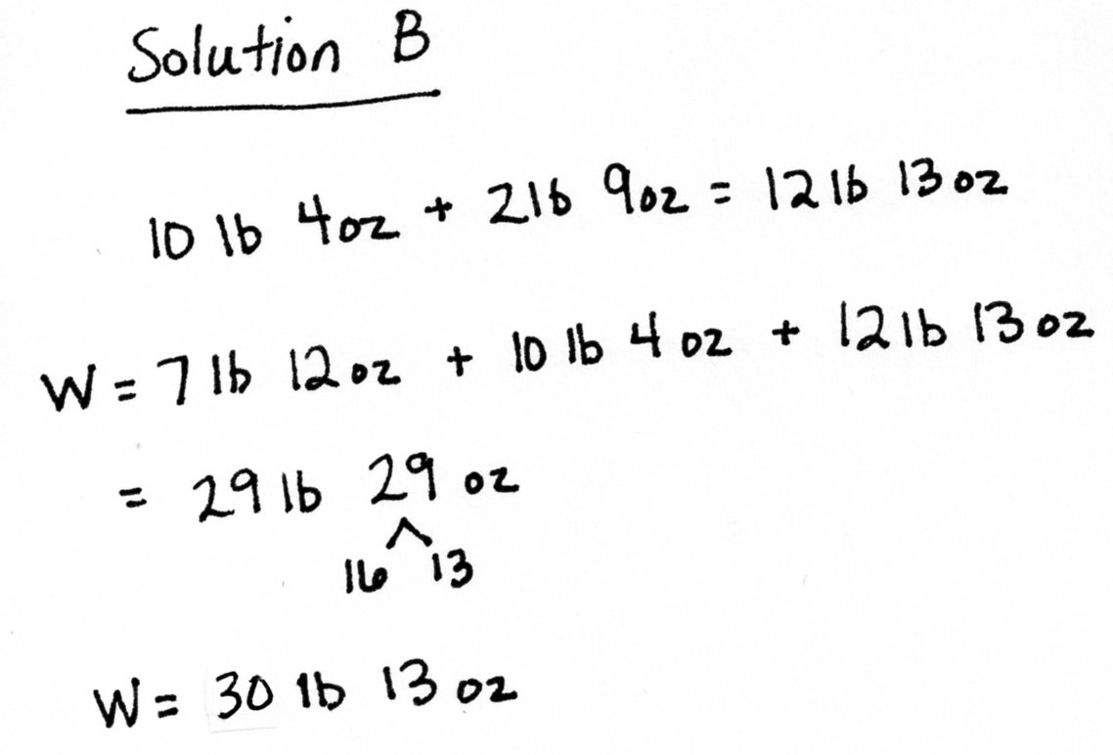
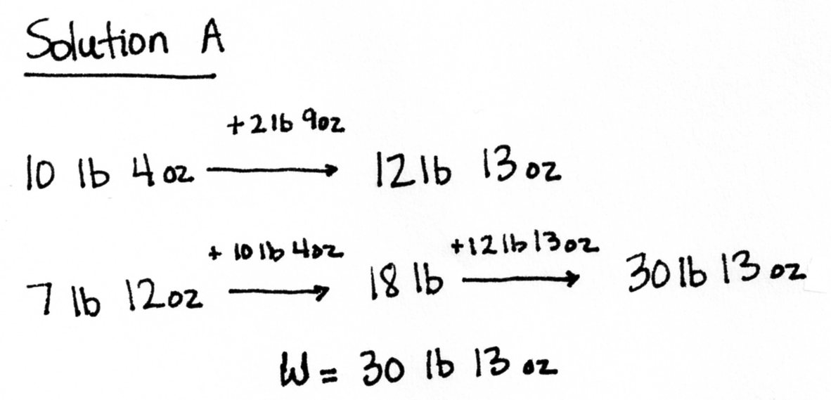
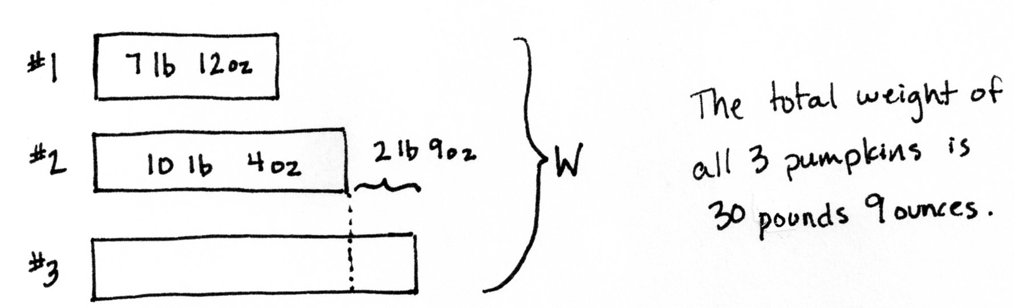
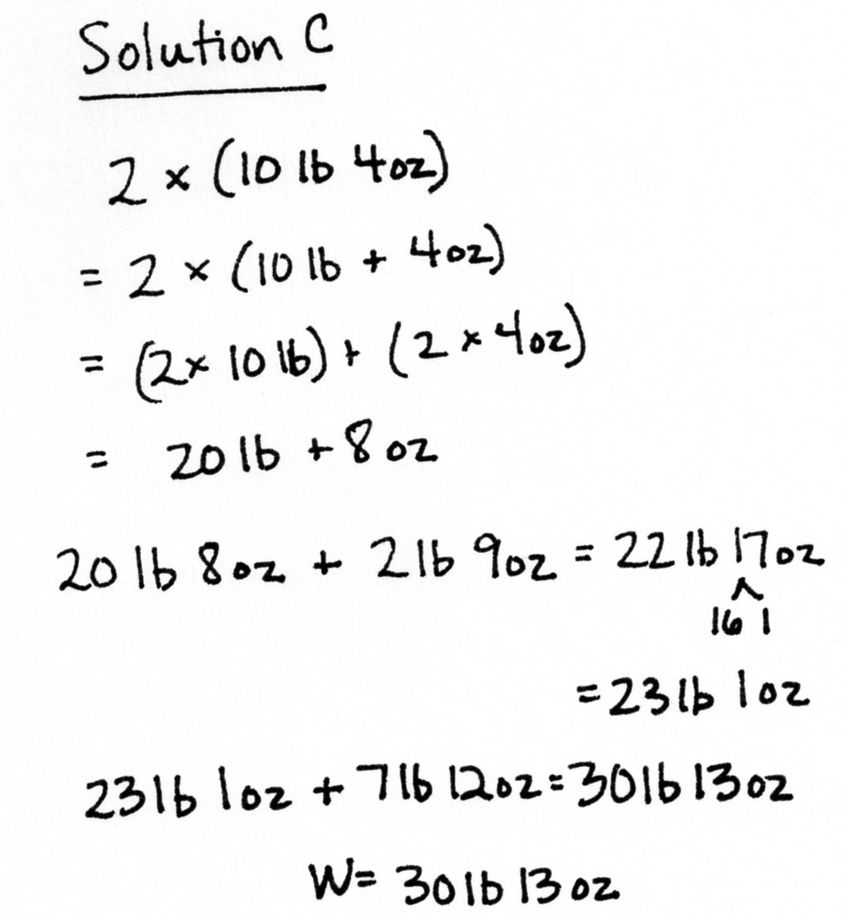
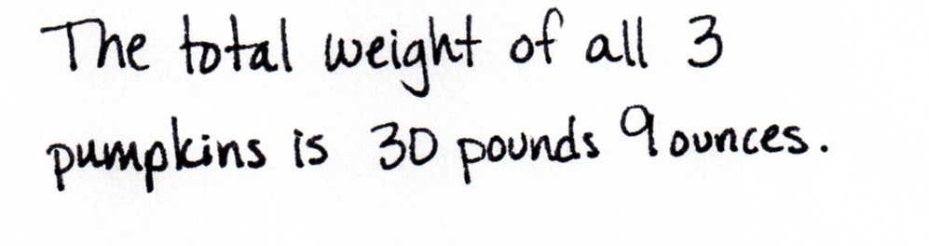

Solution A models the arrow way of adding up. First, the weight of the third pumpkin is determined. Next, the three weights are added together to find their total weight. Solution B uses mixed unit addition, first finding the weight of the third pumpkin and then adding all three weights together. A number bond shows how 1 pound can be taken out of 29 ounces, just as 1 whole can be taken out of 5 fourths. Solution C models using multiplication to find the weight of the full unit of the second pumpkin and the partial unit of the third pumpkin. Then, the additional weight of the third pumpkin and the weight of the first pumpkin are added on. All three solutions shown are computed in mixed units, as converting all weights to ounces and then finding their sum would be inefficient, but a possible strategy.

Problem 4
Mr. Lane is 6 feet 4 inches tall. His daughter, Mary, is 3 feet 8 inches shorter than her father. His son is 9 inches taller than Mary. How many inches taller is Mr. Lane than his son?
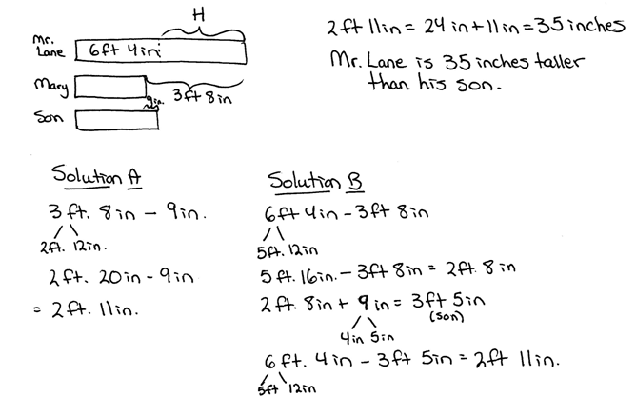

As in Solution A, students may notice from the tape diagrams that they don’t need to find Mary’s height or the son’s heights to solve this problem. They can subtract the 9 inches from the 3 feet 8 inches to see how much taller Mr. Lane is than his son. As shown in Solution B, students can use the given information to find Mary’s height and then add 9 inches to find the son’s height. The son’s height can be subtracted from Mr. Lane’s height to find the difference, and then the difference can be converted to inches to find the solution. Breaking out a foot to subtract the inches makes the subtraction process easier.
Student Debrief (13 minutes)
Lesson Objective: Solve multi-step measurement word problems.
The Student Debrief is intended to invite reflection and active processing of the total lesson experience.
Invite students to review their solutions for the Problem Set. They should check work by comparing answers with a partner before going over answers as a class. Look for misconceptions or misunderstandings that can be addressed in the Debrief. Guide students in a conversation to debrief the Problem Set and process the lesson.
You may choose to use any combination of the questions below to lead the discussion.
- Look at Problem 2. Discuss with your partner which of your solutions is more efficient.
- Is it more efficient to add or multiply for Problem 2? How does that choice affect the units of the solution?
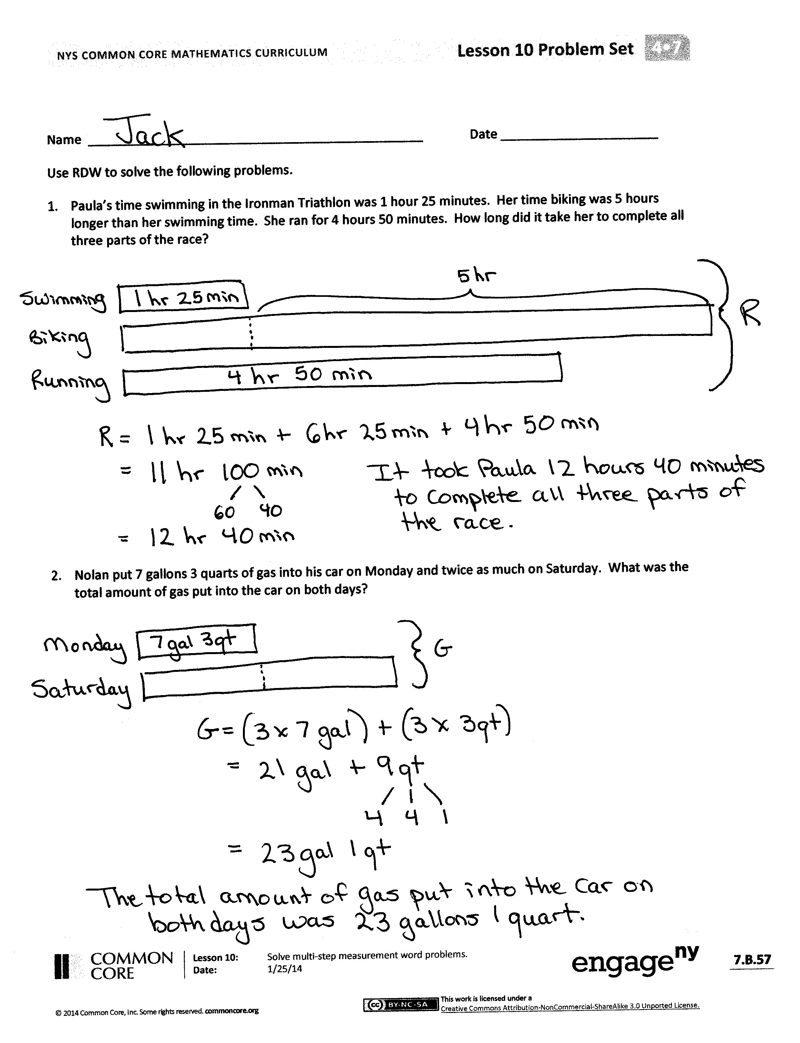
- Explain to your partner how you solved Problem 3. If you used different strategies, discuss how you arrived at the same answer.
- For Problem 3, is 29 pounds 29 ounces a correct answer? Explain.
- Let’s look at how two different students modeled Problem 4. How are they similar? How are they different?
- For Problem 4, how did the drawing of the tape diagram help to find the more efficient way to solve? Why didn’t you have to determine Mary’s height or the son’s height to solve?
- When might it be better to work with the mixed units rather than converting to the smaller unit?
- What are the advantages to knowing several methods for working with units of measurement?
Exit Ticket (3 minutes)
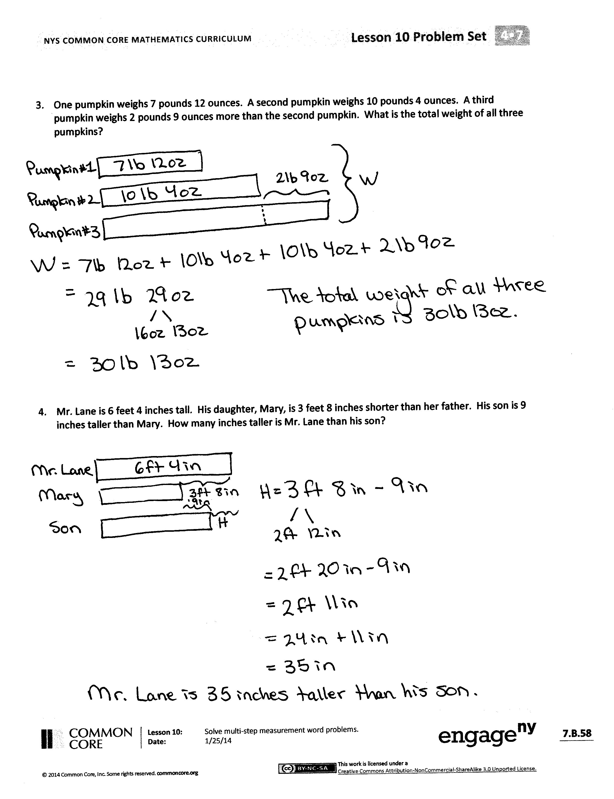
After the Student Debrief, instruct students to complete the Exit Ticket. A review of their work will help you assess the students’ understanding of the concepts that were presented in the lesson today and plan more effectively for future lessons. You may read the questions aloud to the students.
Name Date
Use RDW to solve the following problems.
- Paula’s time swimming in the Ironman Triathlon was 1 hour 25 minutes. Her time biking was 5 hours longer than her swimming time. She ran for 4 hours 50 minutes. How long did it take her to complete all three parts of the race?

- Nolan put 7 gallons 3 quarts of gas into his car on Monday and twice as much on Saturday. What was the total amount of gas put into the car on both days?

- One pumpkin weighs 7 pounds 12 ounces. A second pumpkin weighs 10 pounds 4 ounces. A third pumpkin weighs 2 pounds 9 ounces more than the second pumpkin. What is the total weight of all three pumpkins?

- Mr. Lane is 6 feet 4 inches tall. His daughter, Mary, is 3 feet 8 inches shorter than her father. His son is 9 inches taller than Mary. How many inches taller is Mr. Lane than his son?

Name Date
Use RDW to solve the following problem.
- Hadley spent 1 hour and 20 minutes completing her math homework, 45 minutes completing her social studies homework, and 30 minutes studying her spelling words. How much time did Hadley spend on homework and studying?

Name Date
Use RDW to solve the following problems.
- On Saturday, Jeff used 2 quarts 1 cup of water from a full gallon to replace some water that leaked from his fish tank. On Sunday, he used 3 pints of water from the same gallon. How much water was left in the gallon after Sunday?

- To make punch, Julia poured 1 quart 8 ounces of ginger ale into a bowl and then added twice as much fruit juice. How much punch did she make in all?

- Patti went swimming for 1 hour 15 minutes on Monday. On Tuesday, she swam twice as long as she swam on Monday. On Wednesday, she swam 50 minutes less than the time she swam on Tuesday. How much time did she spend swimming during that three day period?

- Myah is 4 feet 2 inches tall. Her sister, Ally, is 10 inches taller. Their little brother is half as tall as Ally. How tall is their little brother in feet and inches?

- Rick and Laurie have three dogs. Diesel weighs 89 pounds 12 ounces. Ebony weighs 33 pounds 14 ounces less than Diesel. Luna is the smallest at 10 pounds 2 ounces. What is the combined weight of the three dogs in pounds and ounces?

