Lesson 9
Objective: Solve problems involving mixed units of time.

Suggested Lesson Structure
 Fluency Practice (12 minutes)
 Concept Development (38 minutes)
 Student Debrief (10 minutes)
Total Time (60 minutes)
Fluency Practice (12 minutes)
- Grade 4 Core Fluency Differentiated Practice Sets 4.NBT.4 (4 minutes)
- Add Mixed Numbers 4.NF.4 (4 minutes)
- Convert Time Units 4.MD.1 (4 minutes)
Grade 4 Core Fluency Differentiated Practice Sets (4 minutes)
Materials: (S) Core Fluency Practice Sets from G4–M7–Lesson 2
Note: During G4–Module 7, each day’s fluency activity may include an opportunity for mastery of the addition and subtraction algorithm by means of the Core Fluency Practice Sets. The process is detailed and Practice Sets are provided in G4–M7–Lesson 2.
Add Mixed Numbers (4 minutes)
Materials: (S) Personal white boards
Note: This fluency activity reviews G4─Module 5’s fraction work and anticipates today’s lesson of adding mixed measurement units, specifically twenty-fourths and sixtieths, to prepare for work with the hours in a day, the seconds in a minute, and the minutes in an hour.
T: 10 twenty-fourths + 17 twenty-fourths is how many twenty-fourths?
S: 27 twenty-fourths.
T: Express 27 twenty-fourths as ones and twenty-fourths.
S: 1 one and 3 twenty-fourths.
T: 20 twenty-fourths + 20 twenty-fourths is how many twenty-fourths?
S: 40 twenty-fourths.
T: Express 40 twenty-fourths as ones and twenty-fourths.
S: 1 one and 16 twenty-fourths.
Repeat the process using the following possible sequence: $\frac{50}{60} \text{+} \frac{20}{60}, \frac{15}{60} \text{+} \frac{45}{60}, \frac{30}{60} \text{+} \frac{45}{60}, \frac{45}{60} \text{+} \frac{45}{60}.$
Convert Time Units (4 minutes)
Materials: (S) Personal white boards
Note: This fluency activity reviews G4─M7─Lesson 3 and anticipates the lesson’s work with time units.
T: Express each number of days and hours as hours.
T: One day.
S: 24 hours.
T: 1 day 3 hours.
S: 27 hours.
T: 1 day 1 hour.
S: 25 hours.
T: 2 days.
S: 48 hours.
T: Express each number of hours as days and hours if possible.
T: 24 hours is…?
S: 1 day.
T: 48 hours is…?
S: 2 days.
T: 72 hours is…?
S: 3 days.
Repeat the same process with hours and minutes.

NOTES ON
MULTIPLE MEANS FOR ACTION AND EXPRESSION:
In keeping with the previous lessons of exploration, analysis, and autonomy, today’s lesson may be a welcome experience of independence and critical thinking for students working above grade level. Students working below grade level may benefit from more support through scaffolded questioning, visual models, and explicit instruction as to how to add and subtract mixed units of measure.

Concept Development (38 minutes)
Materials: (S) Personal white boards
Problem 1: Add mixed units of time and share alternate strategies.
Note: The same lesson format may be followed as in G4─M7─Lessons 6─7 if so desired. This lesson invites students to share solution strategies on the assumption that they are ready to apply what they have learned in the previous two lessons to time units.
T: (Display 2 hr 45 min + 50 min.) Solve this problem and be prepared to share your solution strategy.
S: I completed an hour and added on the extra minutes. (Solution A.)
S: I added an hour first and subtracted 10 minutes from my answer. (Solution B.)
S: I added the minutes and then took out 60 minutes from the total number of minutes. (Solution C.)
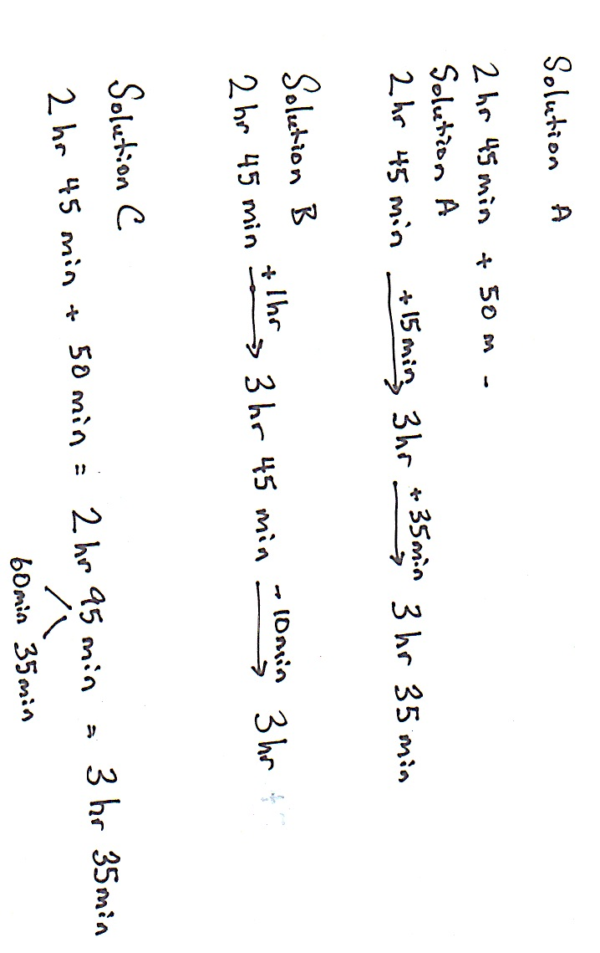
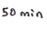

Invite students to direct questions to their peers in order to understand their solution strategies. If you see students are ready to move on to the addition of a mixed unit, continue forward into the next set. If not, give additional practice with problems such as 4 days 16 hours + 8 hours, 8 minutes 47 seconds + 36 seconds.

NOTES ON
MULTIPLE MEANS FOR ACTION AND EXPRESSION:
Some learners may benefit from a modeling of Solution C as a think aloud. It may be beneficial for learners to understand the circumstances in which this strategy is beneficial to use and when it is not.

T: (Display 3 days 12 hours + 9 days 20 hours.) Find the sum. Use the strategy you feel is most efficient.
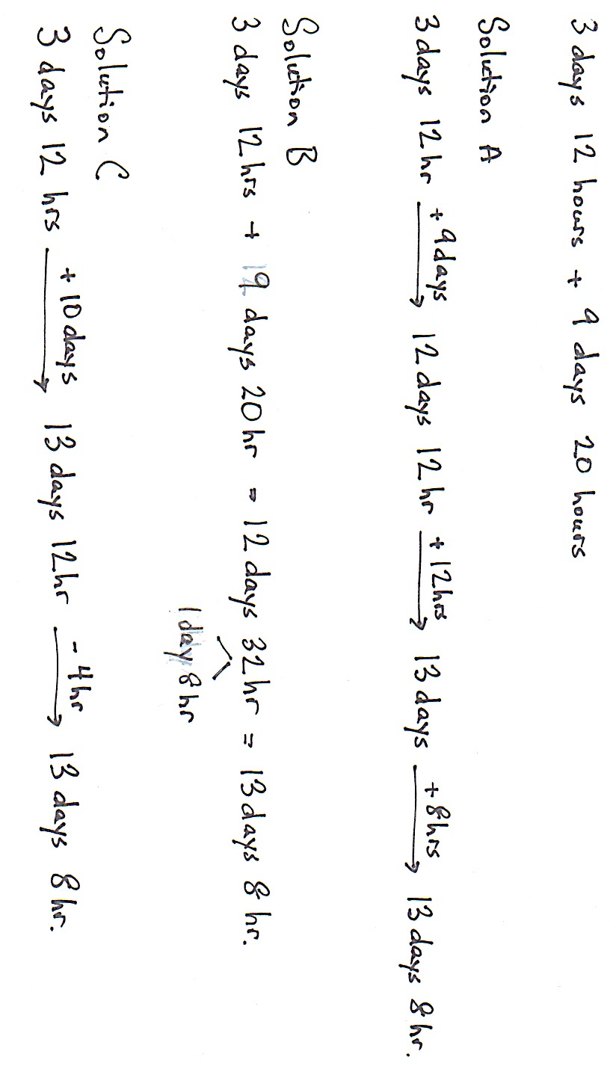
S: I added the days first. Next, I completed a day by adding on 12 hours. Finally, I knew there were 8 more hours to add on. (Solution A.)
S: I added like units then took out a day from the total number of hours. (Solution B.)
S: I added 10 days because I realized that 9 days 20 hours was almost 10 days. Then, I subtracted 4 hours to make up for the 4 hours I added on. (Solution C.)

Let students continue to practice adding mixed units of time using the following: 12 hr 45 min + 3 hr 45 min, 19 min 15 sec + 6 min 58 sec, 2 days 19 hours + 6 days 13 hours, and 24 min 10 sec + 9 min 53 sec.
Problem 2: Subtract units of time when there are not enough smaller units.
T: (Display 7 hr 15 min – 38 min.) What is different about this problem? Use what you know to solve.
S: There are not enough minutes to subtract. I subtracted 15 minutes to get to 7 hours and then subtracted 23 more minutes to get to 6 hours and 37 minutes. (Solution A.)
S: I renamed an hour as 60 minutes to get 6 hours and 75 minutes and then just subtracted 38 minutes from 75 minutes. (Solution B.)
S: I renamed 7 hr 15 min to 6 hr 15 min + 60 min. Next, I subtracted 38 min from 60 min and got 22 min. Finally, I added the remaining hours and minutes to make 6 hr 37 min. (Solution C.)
S: I added 22 minutes to both the total and the part being subtracted to make it easy. Just subtract an hour. (Solution D.)
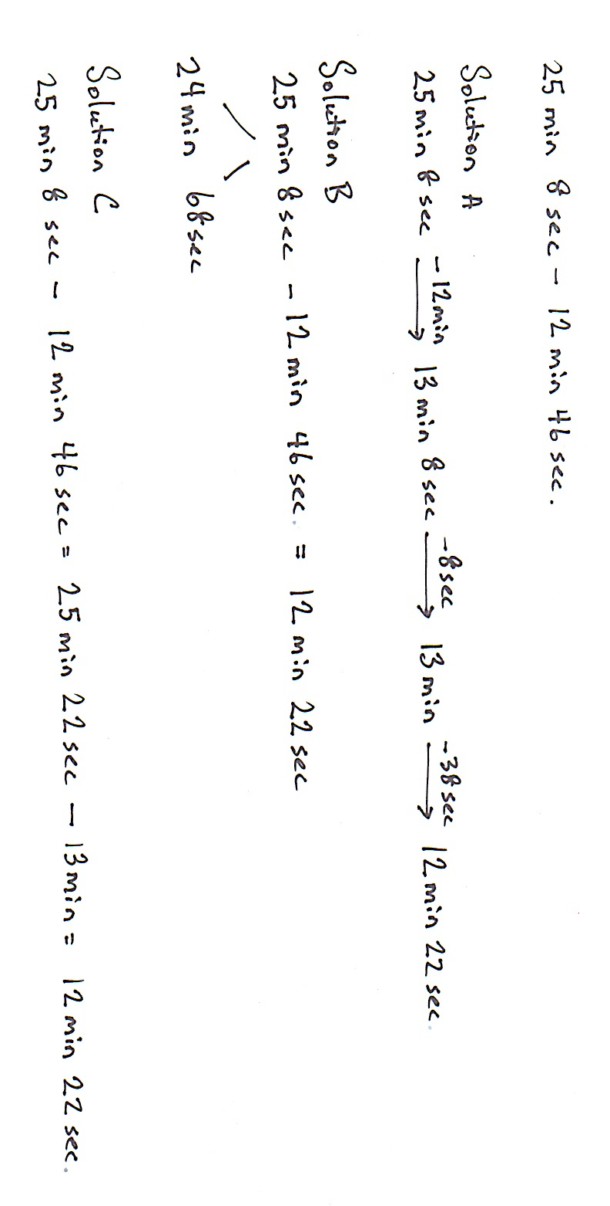
Invite students to direct questions to their peers in order to understand their solution strategies. If you see students are ready to move on to the subtraction of a mixed unit, continue forward into the next set. If not, give additional practice with problems such as 11 days 10 hours ─ 16 hours, 8 minutes 12 seconds ─ 36 seconds, etc.
T: (Display 25 min 8 sec – 12 min 46 sec.) Use the strategy you feel is most efficient. Find the difference.

S: I subtracted 12 minutes first. Next, I subtracted 8 seconds to get to 13 minutes and then took away the rest of the seconds. (Solution A.)
MP.8
S: I renamed 25 minutes 8 seconds as 24 minutes 68 seconds and then just subtracted minutes from minutes and seconds from seconds. (Solution B.)
S: I added 14 seconds to both numbers, so it meant just subtracting 13 minutes. (Solution C.)
Let students practice finding the difference between mixed units of time using the following: 60 min 2 sec – 12 minutes 4 sec, 16 hr 10 min – 15 hr 15 min, and 17 days 3 hours – 10 days 14 hours.
Problem Set (10 minutes)
Students should do their personal best to complete the Problem Set within the allotted 10 minutes. For some classes, it may be appropriate to modify the assignment by specifying which problems they work on first. Some problems do not specify a method for solving. Students solve these problems using the RDW approach used for Application Problems.
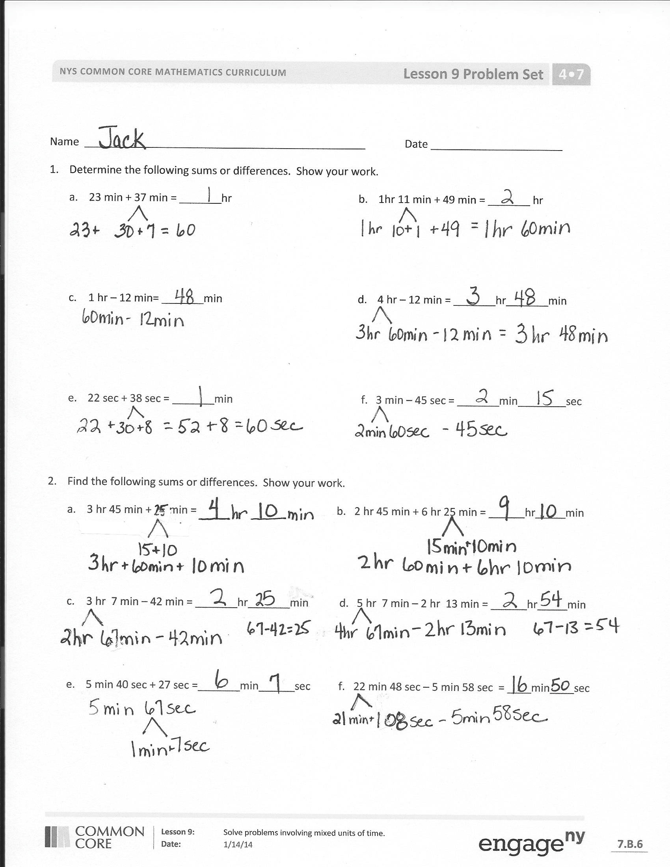
Student Debrief (10 minutes)
Lesson Objective: Solve problems involving mixed units of time.
The Student Debrief is intended to invite reflection and active processing of the total lesson experience.
Invite students to review their solutions for the Problem Set. They should check work by comparing answers with a partner before going over answers as a class. Look for misconceptions or misunderstandings that can be addressed in the Debrief. Guide students in a conversation to debrief the Problem Set and process the lesson.
You may choose to use any combination of the questions below to lead the discussion.
- How was solving Problem 2(a) similar to solving 2(b)? How was it different?
- Many of you solved Problem 4(b) by adding the two movie times together with the 30 extra minutes and then subtracting that time from 5 hours. Talk with your partner about how to use your answer from Problem 4(a) to help solve 4(b).
- How is solving 3 days 12 hours + 9 days 20 hours like solving $\text{3}\frac{12}{24} \text{+} 9\frac{20}{24}?$
- How is subtracting 25 min 8 sec – 12 min 46 sec like solving $\text{25}\frac{8}{60} \text{─} \text{12}\frac{46}{60}?$
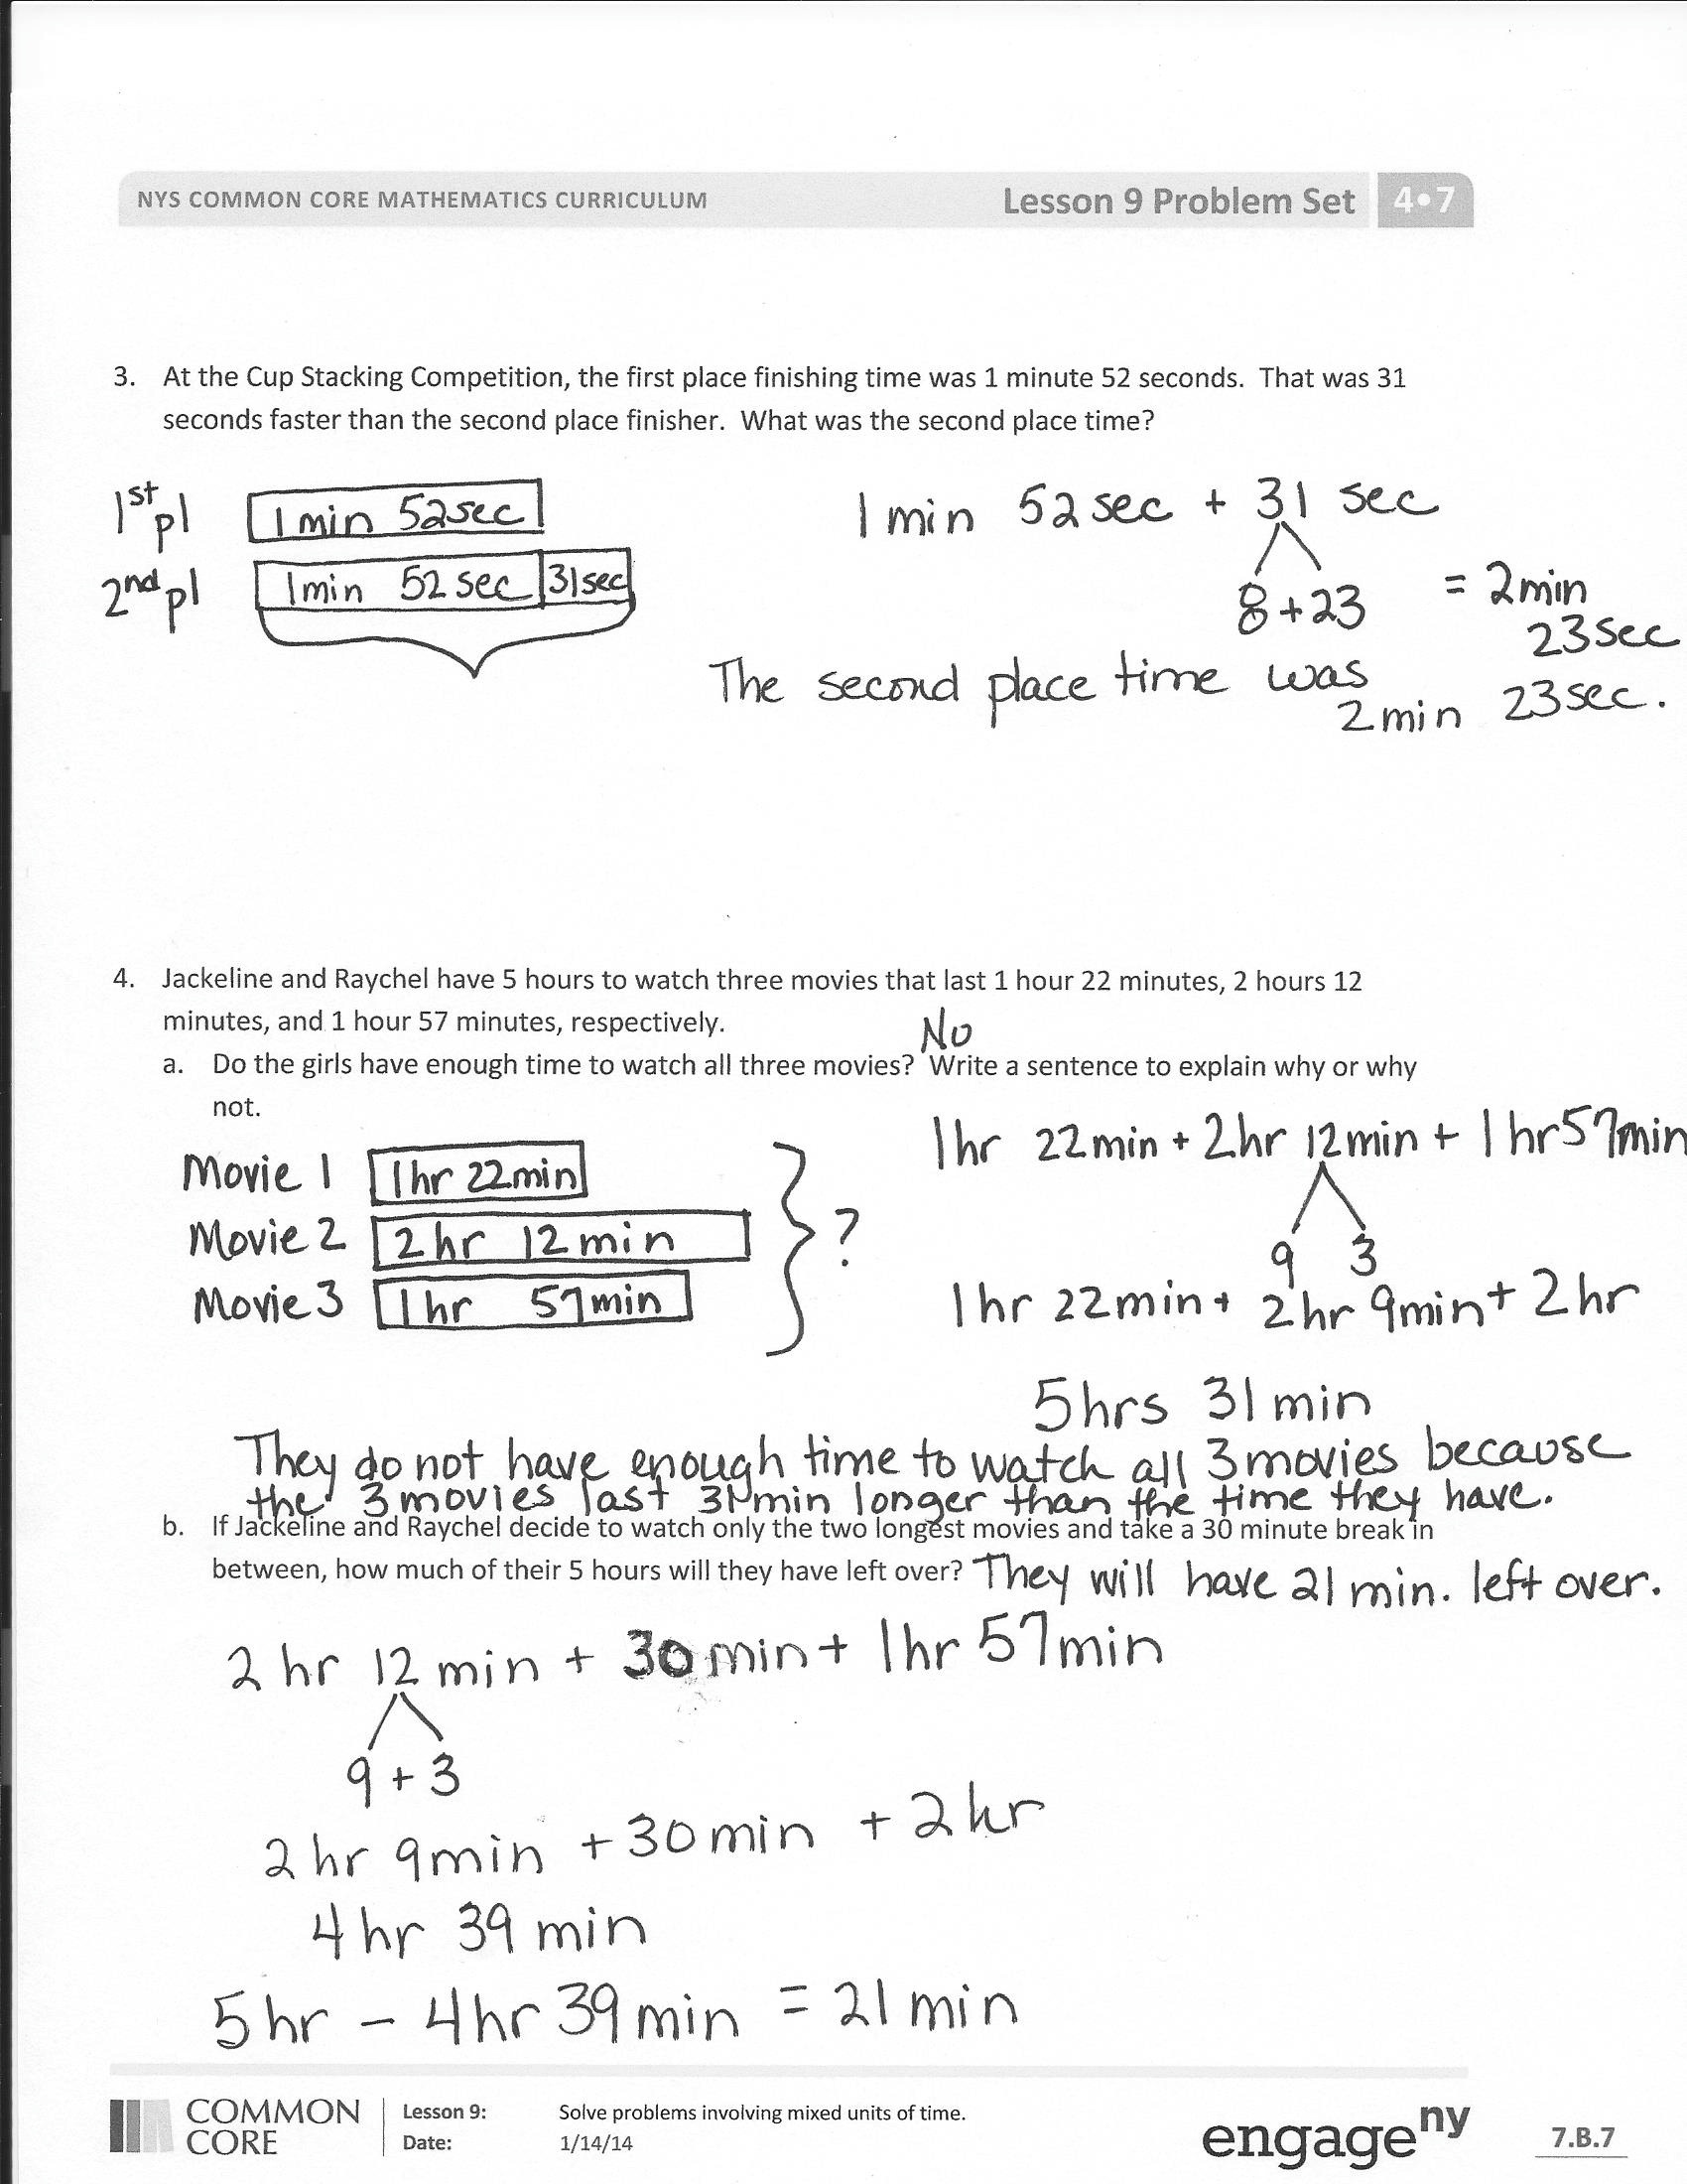
- How is solving 3 days 12 hours + 9 days 20 hours like solving 3 pounds 12 ounces + 9 pounds 8 ounces? How is it different?
- How did our fluency activities prepare us for our lesson?
Exit Ticket (3 minutes)
After the Student Debrief, instruct students to complete the Exit Ticket. A review of their work will help you assess the students’ understanding of the concepts that were presented in the lesson today and plan more effectively for future lessons. You may read the questions aloud to the students.

Name Date
      - Determine the following sums and differences. Show your work.

- 23 min + 37 min = _______hr
- 1hr 11 min + 49 min = _______ hr

- 1 hr – 12 min= _______min
- 4 hr – 12 min = _______hr_______min

- 22 sec + 38 sec = _______min f. 3 min – 45 sec = _______min________sec

- Find the following sums and differences. Show your work.

- 3 hr 45 min + 25 min = ______hr_____min
b. 2 hr 45 min + 6 hr 25 min = ______hr_____min

- 3 hr 7 min – 42 min = _______hr_______min d. 5 hr 7 min – 2 hr 13 min = ______hr_____min

- 5 min 40 sec + 27 sec =_______min______sec
f. 22 min 48 sec – 5 min 58 sec = ____min____sec

- At the cup stacking competition, the first place finishing time was 1 minute 52 seconds. That was 31 seconds faster than the second place finisher. What was the second place time?

- Jackeline and Raychel have 5 hours to watch three movies that last 1 hour, 22 minutes; 2 hours, 12 minutes; and 1 hour, 57 minutes, respectively.
- Do the girls have enough time to watch all three movies? Explain why or why not.

- If Jackeline and Raychel decide to watch only the two longest movies and take a 30 minute break in between, how much of their 5 hours will they have left over?

Name Date
- Find the following sums and differences. Show your work.

- 2 hr 25 min + 25 min = ______hr______min
- 4 hr 45 min + 2 hr 35 min = ______hr_____min

- 11 hr 6 min – 32 min = _______hr_______min d. 8 hr 9 min – 6 hr 42 min = ______hr_____min
Name Date
      - Determine the following sums and differences. Show your work.

- 41 min + 19 min = _______hr
- 2hr 21 min + 39 min = _______ hr

- 1 hr – 33 min= _______min
- 3 hr – 33 min = _______hr_______min

e. 31 sec + 29 sec = _______min f. 5 min – 15 sec = _______min________sec

- Find the following sums and differences. Show your work.

- 5 hr 30 min + 35 min = ______hr______min
- 3 hr 15 min + 5 hr 55 min = ______hr_____min

- 4 hr 4 min – 38 min = _______hr_______min d. 7 hr 3 min – 4 hr 25 min = ______hr_____min

- 3 min 20 sec + 49 sec = _______min______sec f. 22 min 37 sec – 5 min 58 sec = ____min____sec

- It took 5 minutes 34 seconds for Melissa’s oven to preheat to 350 degrees. That was 27 seconds slower than it took Ryan’s oven to preheat to the same temperature. How long did it take Ryan’s oven to preheat?

- Joanna read three books. Her goal was to finish all three books in a total of 7 hours. She completed them, respectively, in 2 hours, 37 minutes; 3 hours, 9 minutes; and 1 hour, 51 minutes.
- Did Joanna meet her goal? Write a statement to explain why or why not.

- Joanna completed the two shortest books in one evening. How long did she spend reading that evening? How long, with her goal in mind, did that leave her to read the third book?

