Lesson 7
Objective: Solve problems involving mixed units of length.

Suggested Lesson Structure
 Fluency Practice (12 minutes)
 Application Problem (6 minutes)
 Concept Development (32 minutes)
 Student Debrief (10 minutes)
Total Time (60 minutes)
Fluency Practice (12 minutes)
- Grade 4 Core Fluency Differentiated Practice Sets 4.NBT.4 (4 minutes)
- Add Mixed Numbers 4.NF.3c (4 minutes)
- Convert Length Units 4.MD.2 (4 minutes)
Grade 4 Core Fluency Differentiated Practice Sets (4 minutes)
Materials: (S) Core Fluency Practice Sets from G4–M7–Lesson 2
Note: During G4–Module 7, each day’s Fluency Practice may include an opportunity for mastery of the addition and subtraction algorithm by means of the Core Fluency Practice Sets. The process is detailed and Practice Sets are provided in G4–M7–Lesson 2.
Add Mixed Numbers (4 minutes)

NOTES ON
MULTIPLE MEANS OF ACTION AND EXPRESSION:
Enhance the learning experience by scaffolding the Add Mixed Numbers and Convert Length Units fluency activities for students working below grade level. Present a visual, such as written form, or a model, such as a number bond, along with the questioning strategy. For example, “Express 8 thirds as ones and thirds.”

Materials: (S) Personal white boards
Note: This fluency activity reviews G4–Module 5’s fraction work and anticipates today’s lesson of adding mixed measurement units. Use choral or written response as necessary.
T: 3 thirds + 5 thirds is how many thirds?
S: 8 thirds.
T: Express 8 thirds as ones and thirds.
S: 2 ones and 2 thirds.
T: 4 thirds + 9 thirds is how many thirds?
S: 13 thirds.
T: Express 13 thirds as ones and thirds.
S: 4 ones and 1 third.
Repeat the process using the following possible sequence: $\frac{7}{12} \text{+} \frac{8}{12}, \frac{5}{12} \text{+} \frac{9}{12}, \frac{14}{12} \text{+} \frac{3}{12}, \frac{9}{12} \text{+} \frac{9}{12}.$
Convert Length Units (4 minutes)
Materials: (S) Personal white boards
Note: This fluency activity reviews G4–M7–Lesson 1 and anticipates today’s work with length units. Use a choral or written response during the activity.
T: Express each number of yards and feet as feet.
T: 1 yard.
S: 3 feet.
T: 1 yard 2 feet.
S: 5 feet.
T: 4 yards 1 foot.
S: 13 feet.
T: 3 yards 2 feet.
S: 11 feet.
T: Express each number of feet as yards.
T: 3 feet is…?
S: 1 yard.
T: 6 feet is…?
S: 2 yards.
T: 9 feet is…?
S: 3 yards.
Repeat the process with feet and inches.
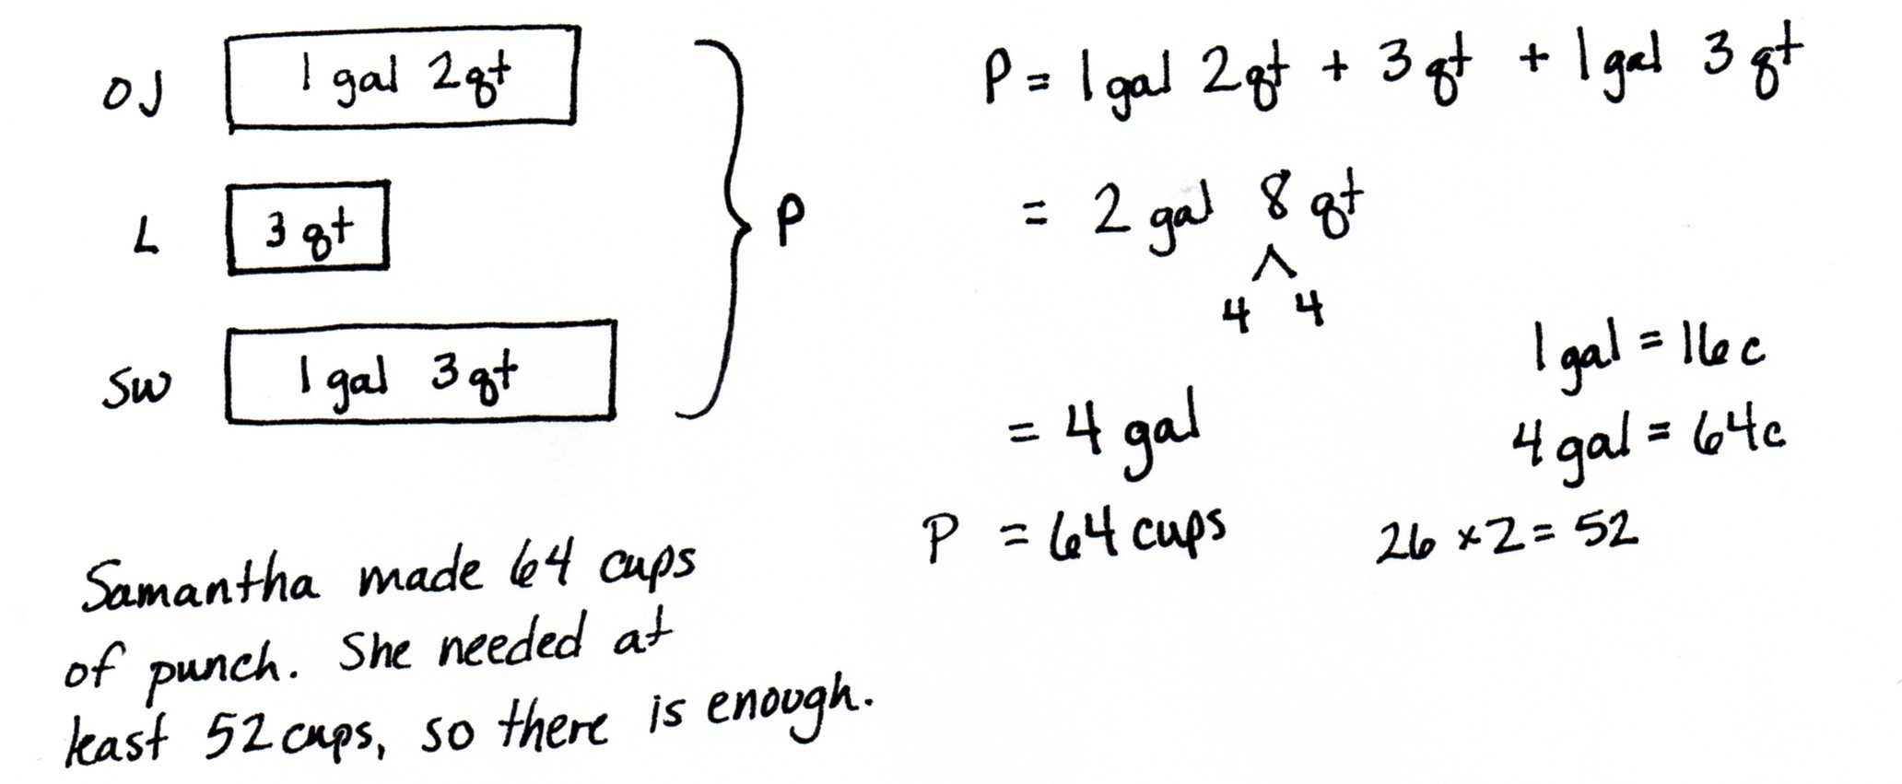
Application Problem (6 minutes)
Samantha is making punch for a class picnic. There are 26 students in her class. Samantha uses 1 gallon 2 quarts of orange juice, 3 quarts of lemonade, and 1 gallon 3 quarts of sparkling water. How much punch did Samantha make? Will there be enough for each student to have two 1-cup servings of punch?

Note: This Application Problem links the prior work students have done with mixed units to today’s work. Students review the skills of working with mixed units of capacity as a lead-in to today’s Concept Development where they will work with mixed units of length.
Concept Development (32 minutes)
Materials: (S) Personal white boards

NOTES ON
MULTIPLE MEANS OF ACTION AND EXPRESSION:
Today’s lesson of partner analysis may be a welcome experience of autonomy and critical thinking for students working above grade level. Students working below grade level may benefit from more support through scaffolded questioning, visual models, and explicit instruction in adding and subtracting mixed units of measure.

Problem 1: Add mixed units of length.
T: 8 months plus 7 months is how many months?
S: 15 months.
T: Express 15 months as years and months.
S: 1 year 3 months.
T: 8 twelfths plus 7 twelfths is how many twelfths?
S: 15 twelfths.
T: Express 15 twelfths as ones and twelfths.
S: 1 one and 3 twelfths.
T: 8 inches + 7 inches is how many inches?
S: 15 inches.
T: Express 15 inches as feet and inches.
S: 1 foot 3 inches.
MP.8
T: Here are two different ways of adding 8 inches and 7 inches. Analyze them with your partner.

S: Solution A makes 1 foot first by adding on 4 of the 7 inches and then adding on the other 3 inches. Solution B adds the inches together to get 15 inches and then breaks the total into a foot and 3 inches. Solution A is like adding 8 twelfths and 7 twelfths. You make one and then add on the extra 3 twelfths, the leftovers. Solution B is like when we found the total number of months and then found the number of years and extra months.
T: Yes, we can either complete a foot and add on or we can add all inches first and then break the total into feet and inches.
Allow students to choose a method to solve and express the following sums with mixed units of feet and inches or yards and feet:
- 11 inches + 9 inches
- 4 feet + 4 feet
T: Here are two different ways of adding 9 feet 8 inches + 7 inches. Analyze them with a partner. How are these problems like those we just solved?

S: Solution A breaks apart 7 inches as 4 inches and 3 inches and adds 4 inches first to make a foot. Solution B adds like units. There aren’t any more feet, but the solution combines the inches to get 15 inches and then adds a foot to the 9 feet.

NOTES ON
MULTIPLE MEANS OF REPRESENTATION:
If needed, allow English language learners to express their analysis in their native language. Provide sentence frames or starters to guide partner discussion, such as,
“Adding feet and inches is like adding cups, quarts, and gallons because…?”
“Adding mixed units is like adding mixed numbers because…?”

Allow students to choose a method to solve and express the following sums with mixed units:
- 4 feet 9 inches + 10 inches
- 6 yards 2 feet + 5 feet
T: Here are two different ways of adding 9 feet 8 inches + 6 feet 7 inches. Analyze them with a partner.

S: Both addends are mixed numbers, so Solution B just adds the like units right way. That seems easy to me. In Solution A, we add each unit one at a time. First, we add feet to the first addend. Then, we add inches. The solution doesn’t write out the breaking down of 7 inches as 4 inches and 3 inches. It’s fair because we can do that with mental math now instead of writing everything out. Adding mixed units is like adding two mixed numbers: add the feet with the feet like we added the ones with the ones and add the inches with the inches like we added the twelfths with the twelfths.
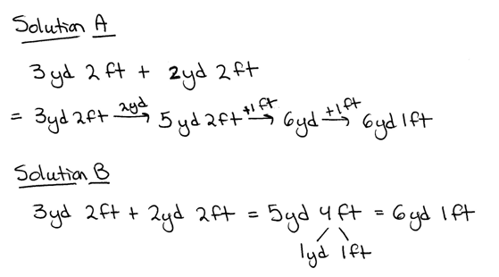
T: Solve for 3 yards 2 feet + 2 yards 2 feet. Work with a partner. Try to solve it using a different solution method if you finish early.

S: We used the arrow way. First, we added the yards. Second, we broke apart the 2 feet to complete one more yard. Finally, we added the 1 foot that was left. Our answer is 6 yards 1 foot.
S: We added like units. Then, we broke 4 feet into 3 feet and 1 foot since 3 feet makes 1 more yard. Our answer is 6 yards 1 foot.
Allow students to choose a method to solve and express the following sums with mixed units: 4 feet 6 inches + 3 feet 11 inches and 6 yards 1 foot + 3 yards 2 feet.
Problem 2: Subtract mixed units of length.
T: 1 – $\frac{9}{12}$ is?
S: 3 twelfths.
T: 7 – $\frac{9}{12}$ is…?
S: 6 and 3 twelfths.
T: 1 year – 9 months is how many months?
S: 3 months.
T: 7 years – 9 months is how many years and months?
S: 6 years 3 months.
T: (Write 1 foot – 9 inches and 7 feet – 9 inches.) Here are two different subtraction problems. Solve them with your partner and compare how they are similar to each other and to the problems you just solved.
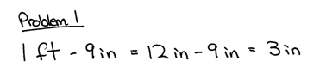
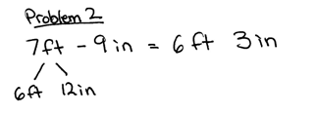

S: Feet and inches are like years and months. 1 year = 12 months just like 1 foot = 12 inches. We have to convert to inches to solve. In the first problem, there is only one foot. We convert it to inches. In the second problem, there are seven feet. We only need to convert one of the feet before subtracting.
T: (Write 7 feet 4 inches – 9 inches and 7 feet 4 inches – 5 feet 9 inches.) Solve with your partner by decomposing 1 foot into inches. How are these problems similar?
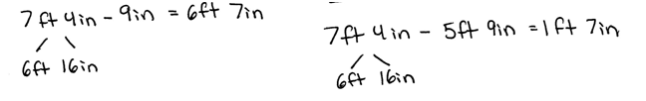

S: Both problems decompose a foot into 12 inches so that we are able to subtract inches. The difference is that in the second problem you have both feet and inches being subtracted. You decompose 1 foot and then subtract feet from feet and inches from inches. It’s like when we subtract $\text{7}\frac{4}{12}$ – $\text{5}\frac{9}{12}$.
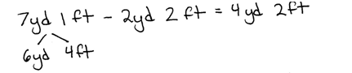
T: Now try 7 yards 1 foot – 2 yards 2 feet.
S: We had to decompose 1 yard into 3 feet. That gave us 6 yards and 4 feet, and then we were able to subtract.
6 yards – 2 yards = 4 yards and 4 feet – 2 feet = 2 feet. The difference is 4 yards 2 feet.
Have students solve 9 feet 2 inches – 4 feet 7 inches and 10 yards 1 feet – 7 yards 2 feet.
Depending on student progress with the addition and subtraction of mixed length units, possibly introduce compensation and counting up strategies as exemplified below in the context of solving 7 feet 4 inches – 5 feet 9 inches. Solution A shows simplification of the problem by adding 3 inches to both subtrahend and minuend. Solution B demonstrates counting up from the part being subtracted to the total.

Problem Set (10 minutes)
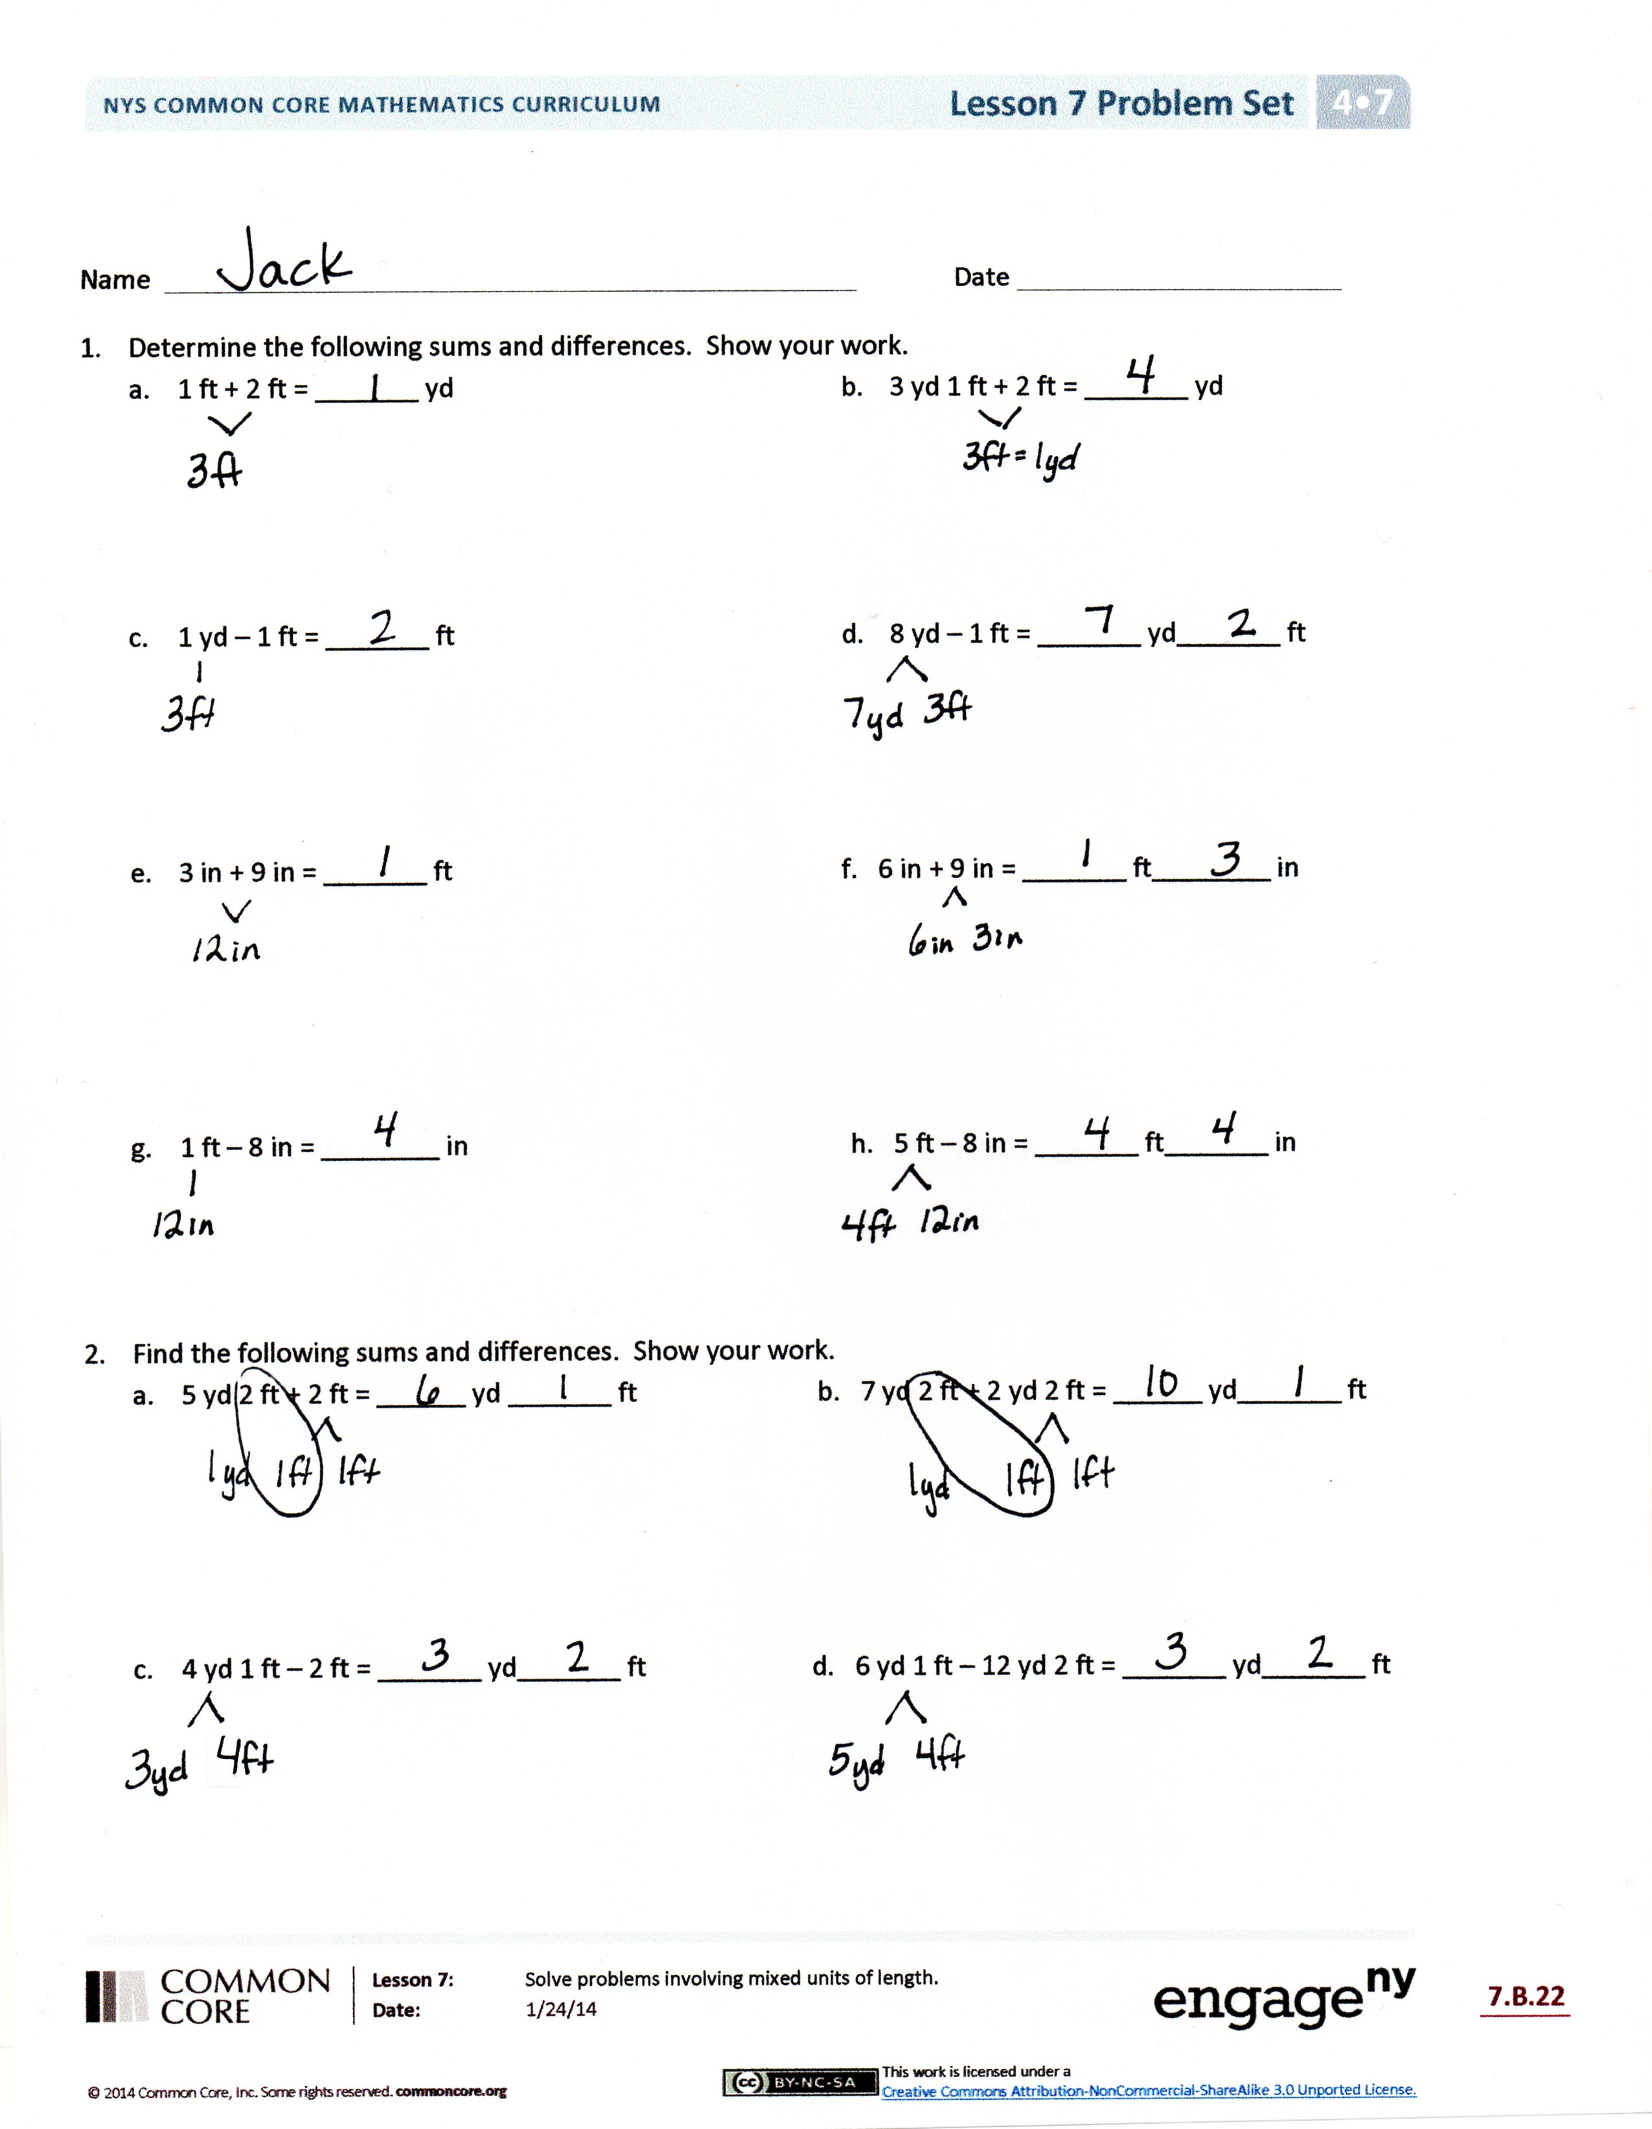
Students should do their personal best to complete the Problem Set within the allotted 10 minutes. For some classes, it may be appropriate to modify the assignment by specifying which problems they work on first. Some problems do not specify a method for solving. Students solve these problems using the RDW approach used for Application Problems.
Student Debrief (10 minutes)
Lesson Objective: Solve problems involving mixed units of length.
The Student Debrief is intended to invite reflection and active processing of the total lesson experience.
Invite students to review their solutions for the Problem Set. They should check work by comparing answers with a partner before going over answers as a class. Look for misconceptions or misunderstandings that can be addressed in the Debrief. Guide students in a conversation to debrief the Problem Set and process the lesson.

You may choose to use any combination of the questions below to lead the discussion.
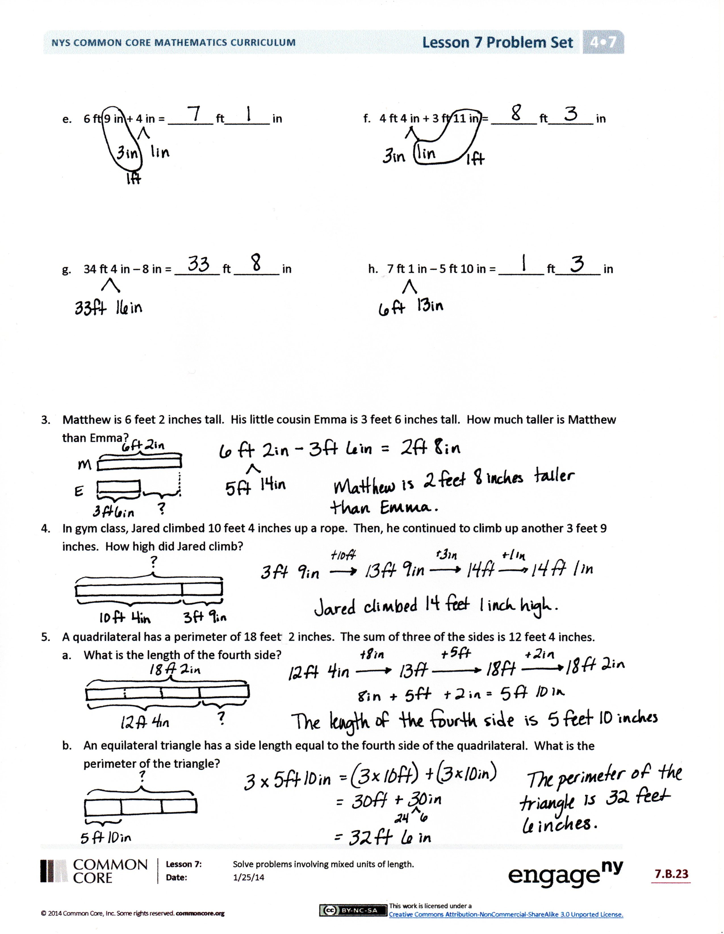
- How does Problem 2(a) relate to Problem 2(b)?
- Problems 3, 4, and 5 all seem to be very different problems. Explain how Problem 3 relates to Problem 5(a) and Problem 4 to Problem 5(b).
- Discuss with your partner how the strategies used today compare to the strategies used yesterday.
- Explain which strategy you like using best and why.
- How is solving 7 feet 4 inches – 5 feet 9 inches similar to solving $\text{7}\frac{4}{12}-\text{5}\frac{9}{12}?$
Exit Ticket (3 minutes)
After the Student Debrief, instruct students to complete the Exit Ticket. A review of their work will help you assess the students’ understanding of the concepts that were presented in the lesson today and plan more effectively for future lessons. You may read the questions aloud to the students.

Name Date

- Determine the following sums and differences. Show your work.

- 1 ft + 2 ft = _______ yd
- 3 yd 1 ft + 2 ft = _______ yd

- 1 yd – 1 ft = _______ ft

- 8 yd – 1 ft = _______ yd_______ ft

- 3 in + 9 in = _______ ft f. 6 in + 9 in = _______ ft________ in

- 1 ft – 8 in = ________ in h. 5 ft – 8 in = _______ ft_______ in

- Find the following sums and differences. Show your work.
- 5 yd 2 ft + 2 ft = ______ yd _______ ft b. 7 yd 2 ft + 2 yd 2 ft = ______ yd_______ ft

- 4 yd 1 ft – 2 ft = _______ yd_______ ft d. 6 yd 1 ft – 2 yd 2 ft = _______ yd_______ ft

- 6 ft 9 in + 4 in = _______ ft_______ in f. 4 ft 4 in + 3 ft 11 in = _______ ft_______ in

- 34 ft 4 in – 8 in = _______ ft _______ in h. 7 ft 1 in – 5 ft 10 in = _______ ft_______ in

- Matthew is 6 feet 2 inches tall. His little cousin Emma is 3 feet 6 inches tall. How much taller is Matthew than Emma?

- In gym class, Jared climbed 10 feet 4 inches up a rope. Then, he continued to climb up another 3 feet 9 inches. How high did Jared climb?

- A quadrilateral has a perimeter of 18 feet 2 inches. The sum of three of the sides is 12 feet 4 inches.
- What is the length of the fourth side?

- An equilateral triangle has a side length equal to the fourth side of the quadrilateral. What is the perimeter of the triangle?

Name Date
      - Determine the following sums and differences. Show your work.

- 4 yd 1 ft + 2 ft = _______ yd

- 6 yd – 1 ft = _____ yd _______ ft

- 4 yd 1 ft + 3 yd 2 ft = _______ yd

- 8 yd 1 ft – 3 yd 2 ft = _______ yd_______ ft

Name Date
      - Determine the following sums and differences. Show your work.

- 2 yd 2 ft + 1 ft = _______ yd
- 2 yd – 1 ft = _______ yd_____ ft

- 2 ft + 2 ft = _______ yd_____ ft
d. 5 yd – 1 ft = _______ yd_______ ft

- 7 in + 5 in = _______ ft f. 7 in + 7 in = _______ ft________ in

g. 1 ft – 2 in = ________ in h. 2 ft – 6 in = _______ ft_______ in

2. Find the following sums and differences. Show your work.
- 4 yd 2 ft + 2 ft = ______ yd_______ ft b. 6 yd 2 ft + 1 yd 1 ft = ______ yd_______ ft

- 5 yd 1 ft – 2 ft = _______ yd_______ ft d. 7 yd 1 ft – 5 yd 2 ft = _______ yd_______ ft

- 7 ft 8 in + 5 in = _______ ft_______ in f. 6 ft 5 in + 5 ft 9 in = _______ ft_______ in

- 32 ft 3 in – 7 in = _______ ft_______ in h. 8 ft 2 in – 3 ft 11 in = _______ ft_______ in

- Laurie bought 9 feet 5 inches of blue ribbon. She also bought 6 feet 4 inches of green ribbon. How much ribbon did she buy altogether?

- The length of the room is 11 feet 6 inches. The width of the room is 2 feet 9 inches shorter than the length. What is the width of the room?

- Tim’s bedroom is 12 feet 6 inches wide. The perimeter of the rectangular shaped bedroom is 50 feet.
  - What is the length of Tim’s bedroom?

- How much longer is the length of Tim’s room than the width?

