Lesson 6
Objective: Solve problems involving mixed units of capacity.

Suggested Lesson Structure
 Fluency Practice (12 minutes)
 Concept Development (36 minutes)
 Student Debrief (12 minutes)
Total Time (60 minutes)
Fluency Practice (12 minutes)
- Grade 4 Core Fluency Differentiated Practice Sets 4.NBT.4 (4 minutes)
- Add Mixed Numbers 4.NF.3c (4 minutes)
- Convert Capacity Units 4.MD.2 (4 minutes)
Grade 4 Core Fluency Differentiated Practice Sets (4 minutes)
Materials: (S) Core Fluency Practice Sets from G4–M7–Lesson 2
Note: During G4–Module 7, each day’s fluency activity may include an opportunity for mastery of the addition and subtraction algorithm by means of the Core Fluency Practice Sets. The process is detailed and Practice Sets are provided in G4–M7–Lesson 2.
Add Mixed Numbers (4 minutes)

NOTES ON
MULTIPLE MEANS OF ACTION AND EXPRESSION:
Fluency drills are fun, fast-paced math games, but English language learners may struggle to keep up. Some students may not understand how to respond to, “Express 5 fourths as ones and fourths.” Provide an example, coupling language with visual aids or gestures, check for understanding, and/or explain in the students’ first language.

Materials: (S) Personal white boards
Note: This fluency activity anticipates today’s lesson by adding fractional units directly relevant to the measurement units within the lesson: $\frac{1}{2},\frac{1}{4}$, and $\frac{1}{8}$. Direct students to respond chorally or with a written response.
T: 3 fourths + 2 fourths is how many fourths?
S: 5 fourths.
T: Express 5 fourths as ones and fourths.
S: 1 and 1 fourth.
T: 3 fourths + 3 fourths is how many fourths?
S: 6 fourths.
T: Express 6 fourths as ones and fourths.
S: 1 and 2 fourths.
Repeat the process using the following possible sequence: $\frac{1}{2} \text{+} \frac{4}{2}, \frac{3}{8} \text{+} \frac{7}{8}, \frac{5}{8} \text{+} \frac{6}{8}, \frac{7}{8} \text{+} \frac{7}{8} .$
Convert Capacity Units (4 minutes)
Materials: (S) Personal white boards
Note: This fluency activity reviews G4–M7–Lesson 2 and anticipates work with capacity units.
T: Express each number of gallons and quarts as quarts.
T: 1 gallon.
S: 4 quarts.
T: 1 gallon, 1 quart.
S: 5 quarts.
T: 1 gallon, 3 quarts.
S: 7 quarts.
T: 2 gallons.
S: 8 quarts.
T: Express each number of quarts as gallons and quarts if possible.
T: 4 quarts is…?
S: 1 gallon.
T: 8 quarts is…?
S: 2 gallons.
Repeat the process with quarts and pints, and then gallons and pints.
Concept Development (36 minutes)
Materials: (S) Personal white boards
Problem 1: Add mixed units of capacity.
T: 2 cats + 3 cats is…?
S: 5 cats.
T: 2 fourths + 3 fourths is…?
S: 5 fourths.
MP.7
T: Express 5 fourths as a mixed number.
S: 1 and 1 fourth.
T: 2 quarts + 3 quarts is…?
S: 5 quarts.
T: Express 5 quarts as gallons and quarts.
S: 1 gallon, 1 quart.
T: Here are two different ways of adding 2 quarts and 3 quarts. Analyze them with your partner.
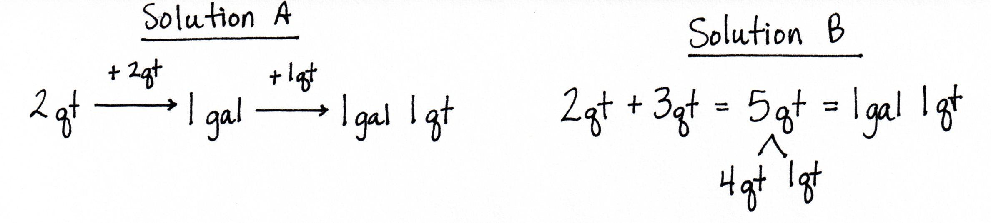

MP.7

S: Solution A makes 1 gallon first by adding on 2 quarts. Solution B adds the quarts together and then takes out 1 gallon from 5 quarts. Solution A completes a gallon just like if we were adding $\frac{2}{4}$ and $\frac{3}{4}$ and made one by adding $\frac{2}{4}$. Solution B is like adding $\frac{2}{4}$ and $\frac{3}{4}$, getting $\frac{5}{4},$and then taking out $\frac{4}{4}$ to get one and 1 fourth.

NOTES ON
MULTIPLE MEANS OF ENGAGEMENT:
Today’s lesson of partner work and discussion fosters collaboration and communication so valuable to students working below grade level as it may increase opportunities for one-on-one support and sustained engagement. Some learners may benefit from clear guidance in working effectively with others. Successful engagement comes by providing clear roles and responsibilities for partners or rubrics and norms that communicate partner work expectations.

T: Yes, we can either complete a gallon first and then add on the remaining quarts, or add to get 5 quarts and then rename to make 1 gallon and 1 quart.
Allow students to choose a method to solve and express the following sums with mixed units:
- 3 quarts + 3 quarts
- 2 cups + 3 cups
- 3 pints + 4 pints
T: Here are two different ways of adding 5 gallons 2 quarts + 3 quarts. Analyze them with a partner.
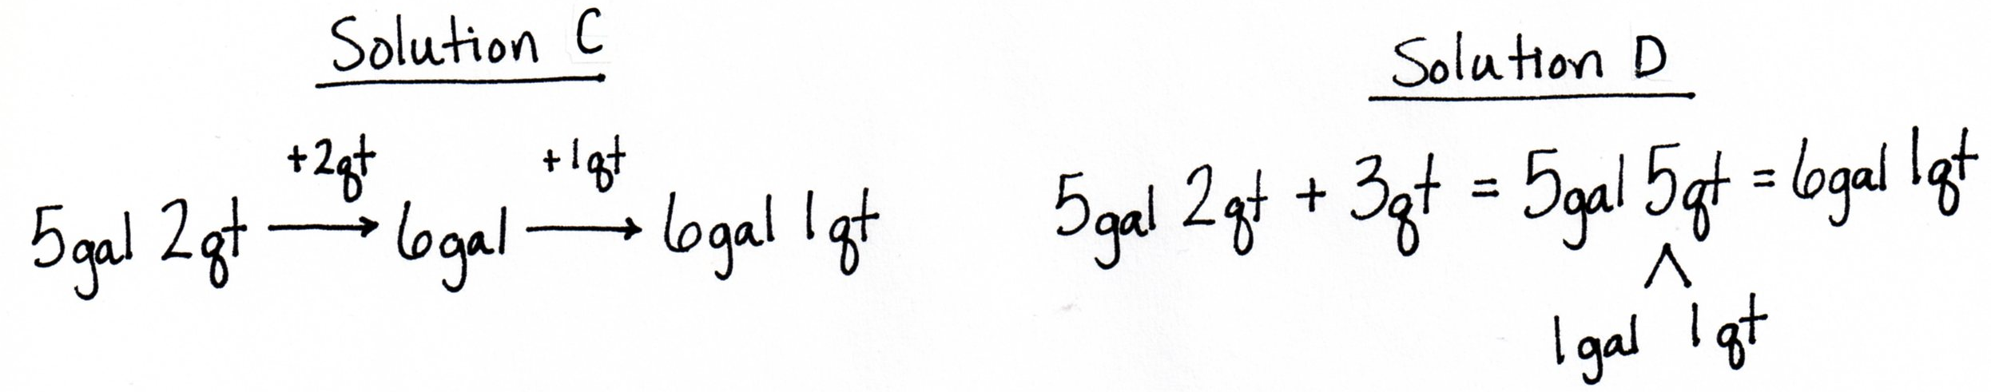

S: Solution C makes 1 gallon first by counting up 2 quarts to get 6 gallons and then adding on the extra quart. Solution D adds the quarts together to get 5 gallons 5 quarts and then takes out one gallon from 5 quarts. It’s like adding mixed numbers—we add the like units.
Allow students to choose a method to solve and express the following sums with mixed units:
- 3 gallons 1 quart + 3 quarts
- 17 quarts 3 cups + 3 cups
- 4 gallons 7 pints + 7 pints
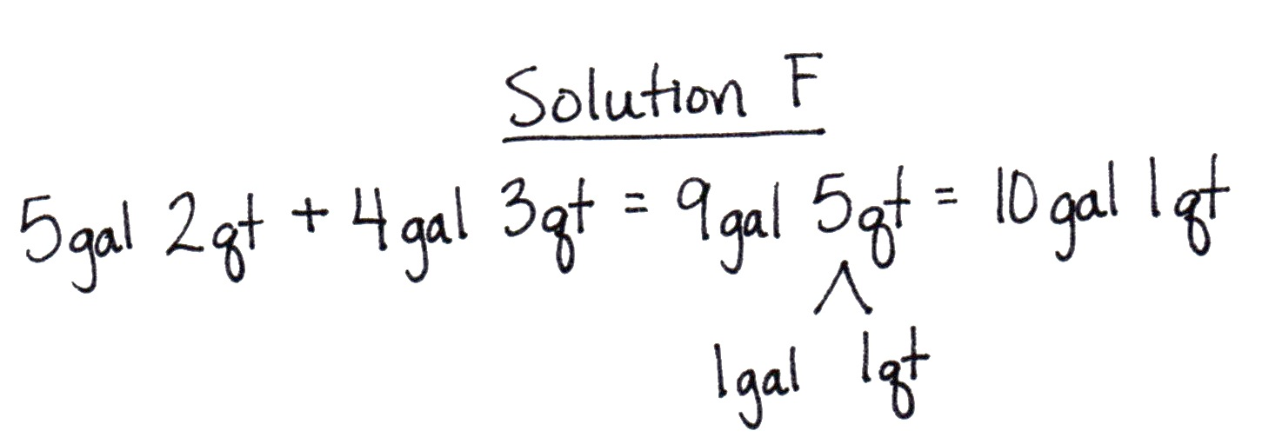
T: Here are two different ways of adding 5 gallons 2 quarts + 4 gallons 3 quarts. Analyze them with a partner.
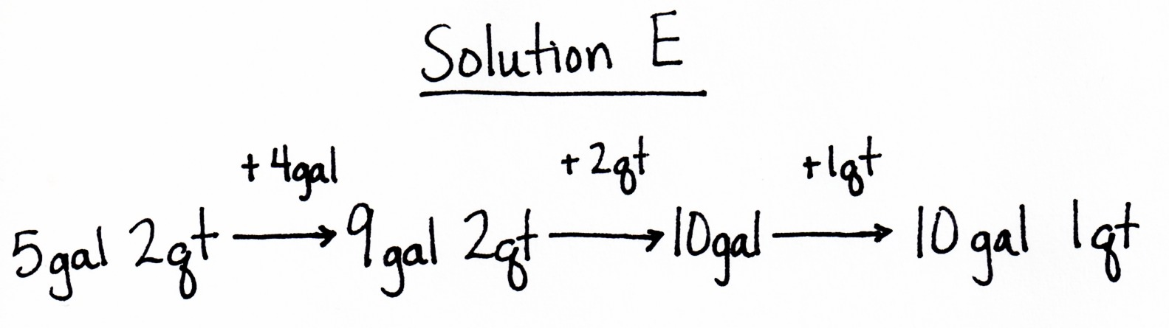

S: Solution E adds on the gallons first to get 9 gallons, then adds 2 quarts to make another gallon, and finally adds the one left over quart. Solution F adds gallons first to get 9 gallons and then makes the next gallon to get 10 gallons 1 quart. It’s just like adding mixed numbers! Add the ones and then add the smaller units. This time Solution F just added like units to get 9 gallons 5 quarts and then took out the gallon from the 5 quarts.
Allow students to choose a method to solve and express the following sums with mixed units:
- 3 gallons 1 quart + 6 gallons 3 quarts
- 17 quarts 3 cups + 2 quarts 3 cups
- 4 gallons 7 pints + 10 gallons 7 pints
Problem 2: Subtract mixed units of capacity.
T: 4 cats – 3 cats is…?
S: 1 cat.
T: 4 fourths – 3 fourths is…?
S: 1 fourth.
T: (Write $\text{1}-\frac{3}{4}$.) 1 minus 3 fourths is…?
S: 1 fourth.
T: (Directly below write 8 – $\frac{3}{4}$ .) 8 – $\frac{3}{4}$ is…?
S: $\text{7 }\frac{1}{4}.$
T: Here are two different subtraction problems. Solve them with your partner, and compare how they are similar to each other and to the problems you just solved with the fourths.
S: 1 quart – 3 cups = 1 cup. 8 quarts – 3 cups = 7 quarts 1 cup. You have to change 1 quart for 4 cups so you can subtract the cups. It’s like subtracting a fraction from a whole number, too. Actually, cups are like fourths in this problem! It takes 4 cups to make a quart just like it takes 4 fourths to make 1. So you can change 1 quart to 4 cups just like you change 1 to 4 fourths.
Have students solve the following:
- 1 gallon – 1 pint
- 8 gallons – 1 pint
- 1 quart – 2 cups
- 6 quarts – 2 cups
T: Here are two more subtraction problems. Solve them with your partner, and compare them. How are they different? How are they the same?

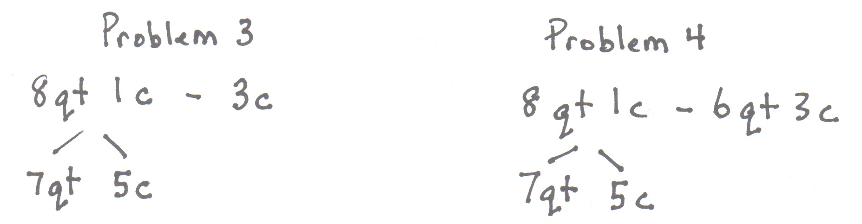
S: Problem 3 is a little trickier than Problem 2 because there is an extra cup. So, when you take 4 cups out of 8 quarts and 1 cup, you get 7 quarts and 5 cups, because 4 cups + 1 cup is 5 cups. Now, you can subtract 3 cups. In Problem 4, you have to subtract quarts, too, so just subtract like units. 7 quarts – 6 quarts is 1 quart. 5 cups – 3 cups is 2 cups. The answer is 1 quart 2 cups.
Have students solve the following:
- 9 gallons 2 quarts – 4 quarts
- 12 quarts 1 cup – 5 quarts 2 cups
- 6 gallons 3 pints – 2 gallons 7 pints
Note: Depending on how your students are doing with the addition and subtraction of mixed capacity units, introduce compensation and counting up as exemplified below in the context of solving 8 quarts 1 cup – 6 quarts 3 cups. Solution A simply adds a cup to both the subtrahend and minuend (compensation). Solution B shows counting up from the subtrahend to the minuend.
Problem Set (10 minutes)
Students should do their personal best to complete the Problem Set within the allotted 10 minutes. For some classes, it may be appropriate to modify the assignment by specifying which problems they work on first. Some problems do not specify a method for solving. Students solve these problems using the RDW approach used for Application Problems.
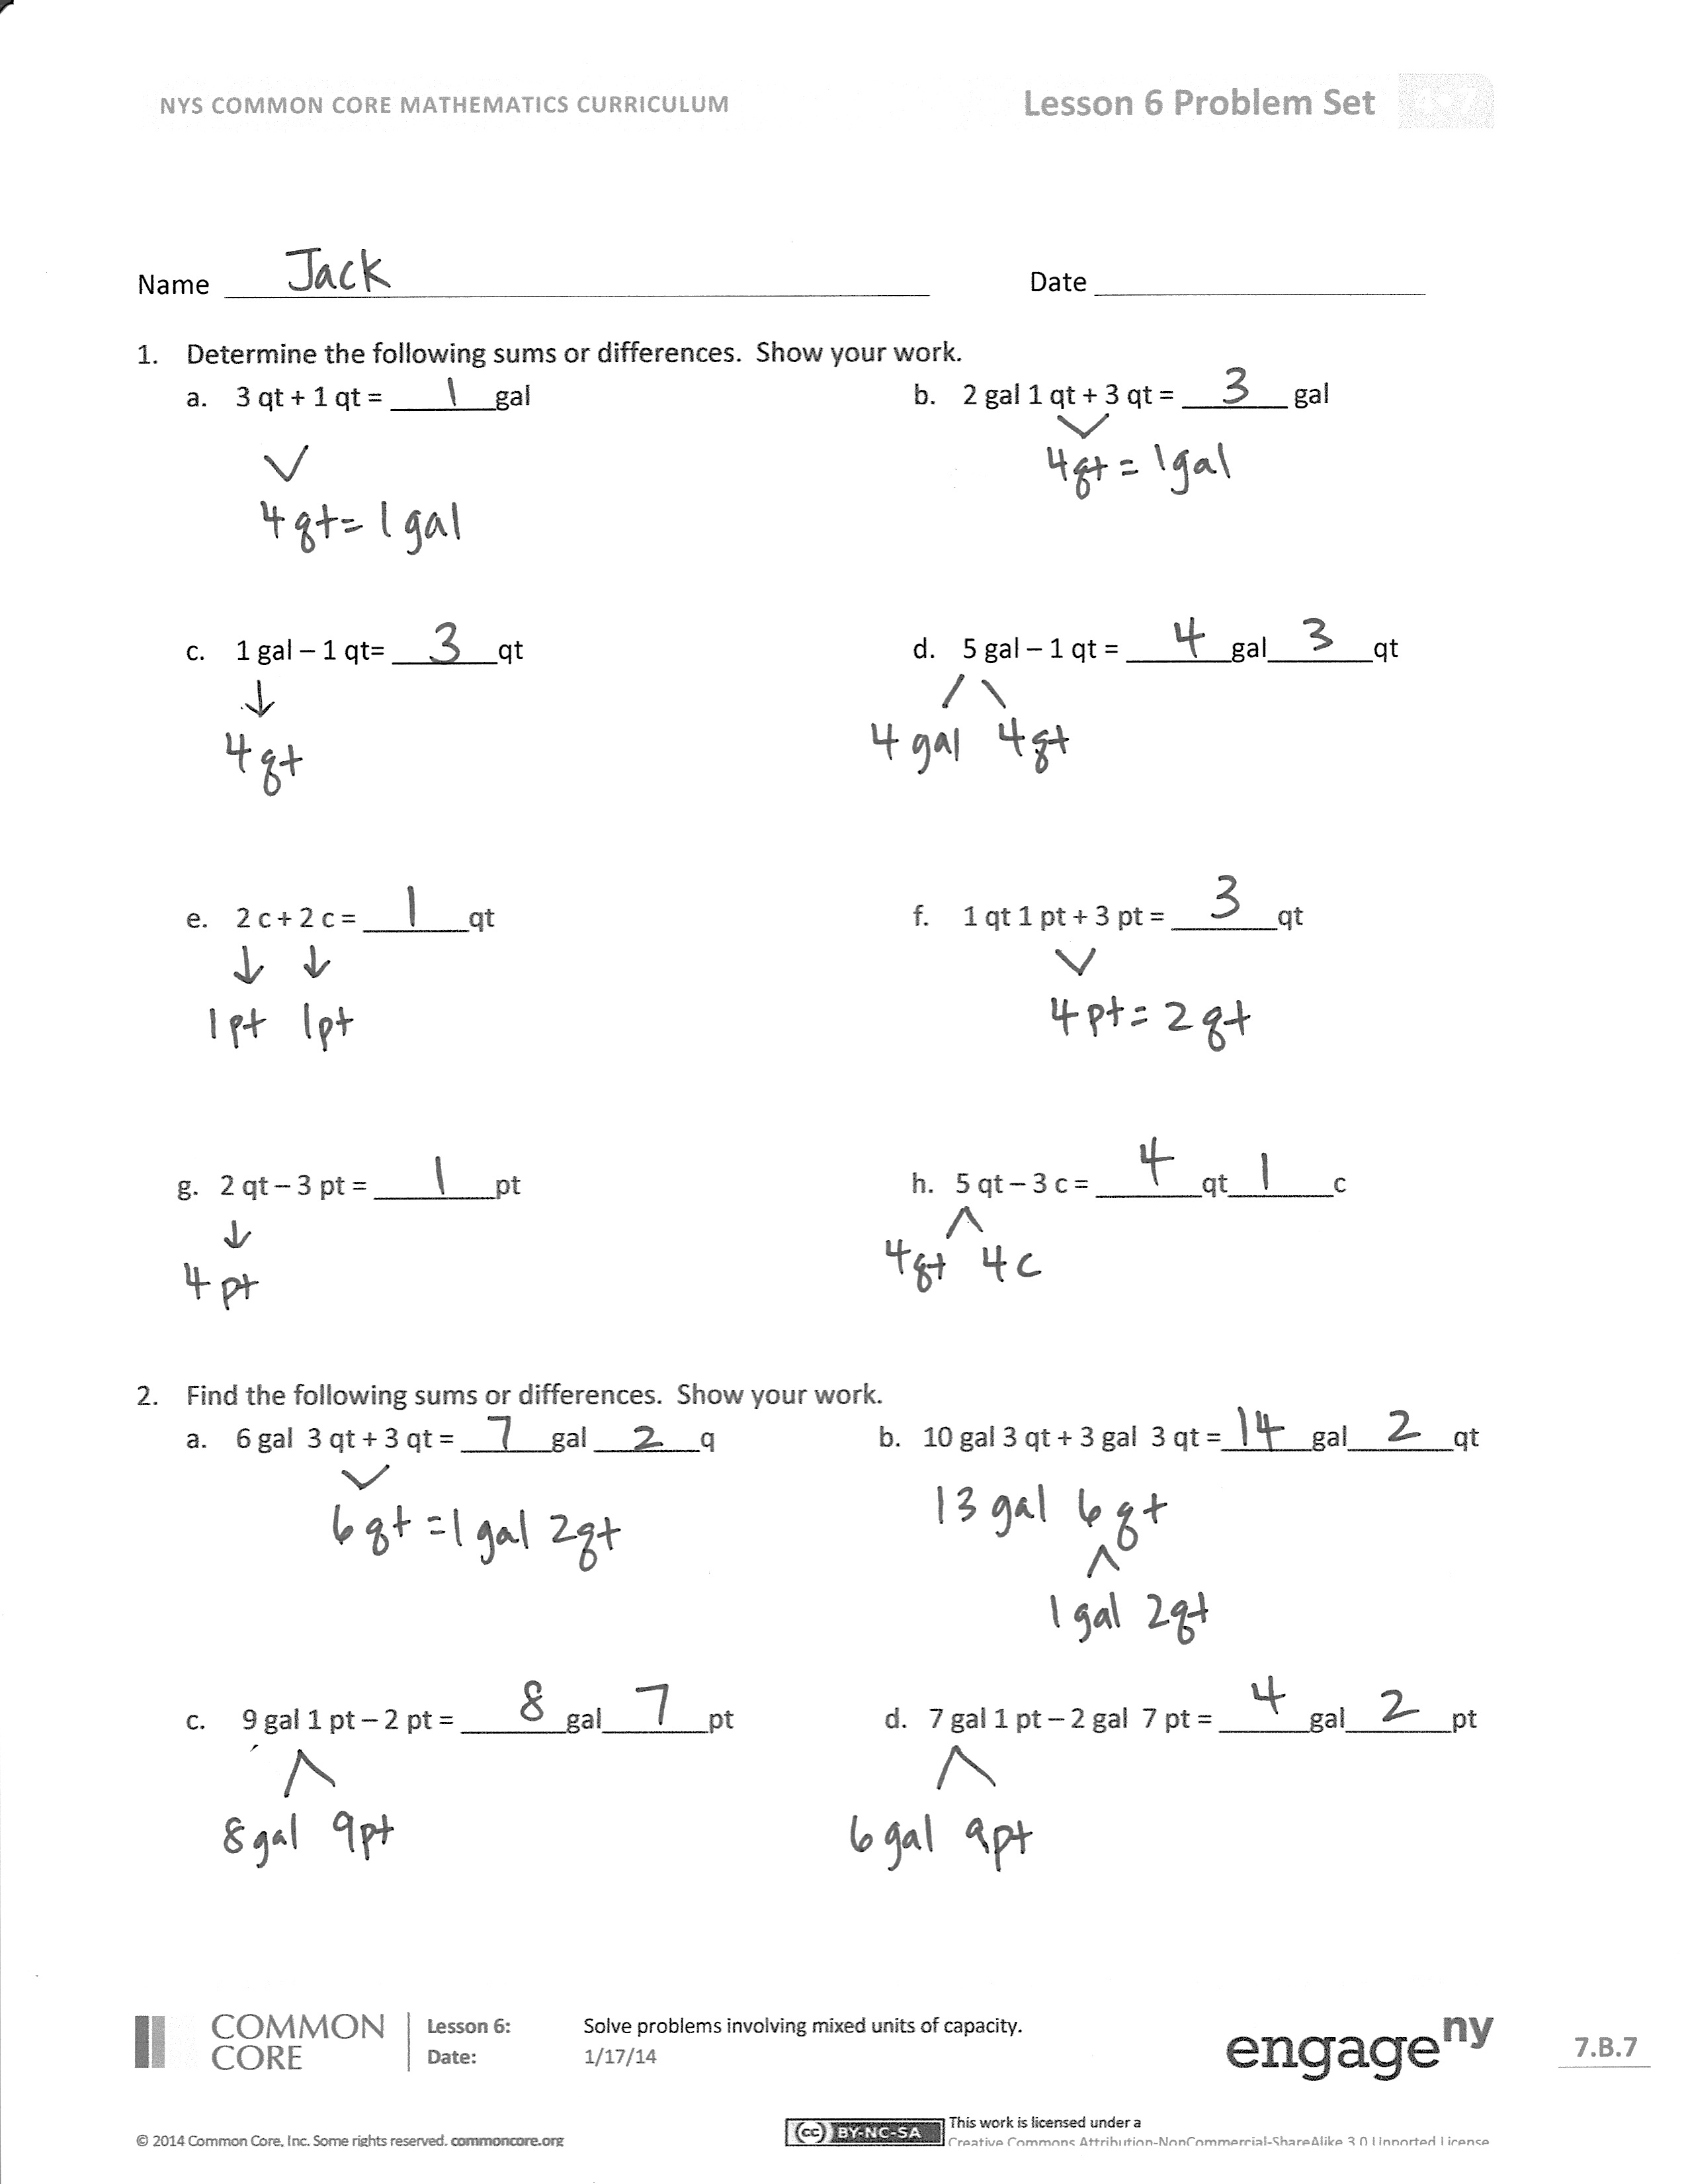
Student Debrief (12 minutes)
Lesson Objective: Solve problems involving mixed units of capacity.
The Student Debrief is intended to invite reflection and active processing of the total lesson experience.
Invite students to review their solutions for the Problem Set. They should check work by comparing answers with a partner before going over answers as a class. Look for misconceptions or misunderstandings that can be addressed in the Debrief. Guide students in a conversation to debrief the Problem Set and process the lesson.
You may choose to use any combination of the questions below to lead the discussion.
- What pattern did you notice between Problems 2(a) and 2(b)?
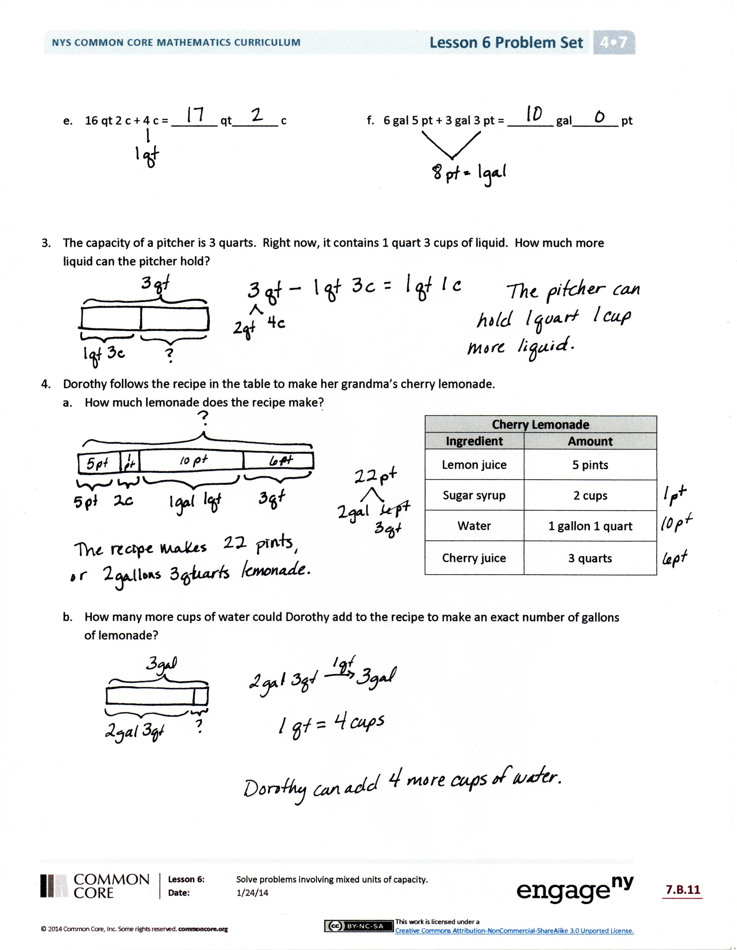
- When adding mixed units, we used two different strategies: adding like units and counting up with the arrow way. Was one strategy more effective? Did you prefer one strategy to another? Why?
- Explain to your partner how you solved Problem 4(a). Which strategy did you use for each of the ingredients?
- What was similar about working with gallons and quarts and quarts and cups?
- How is adding $\text{5}\frac{3}{4}$ + $\text{7}\frac{3}{4}$ like solving 5 gallons 3 quarts + 7 gallons 3 quarts?
- How is subtracting $\text{5}\frac{1}{8}$ – $\text{2}\frac{7}{8}$ like solving 5 gallons 1 pint – 2 gallons 7 pints?
- Compare using compensation to solve 81 – 29 or $\text{8}\frac{1}{4}$ – $\text{2}\frac{3}{4}$ to using compensation to solve 8 gallons 1 quart – 2 gallons 3 quarts.
Exit Ticket (3 minutes)
After the Student Debrief, instruct students to complete the Exit Ticket. A review of their work will help you assess the students’ understanding of the concepts that were presented in the lesson today and plan more effectively for future lessons. You may read the questions aloud to the students.

Name Date
- Determine the following sums and differences. Show your work.

- 3 qt + 1 qt = _______ gal
- 2 gal 1 qt + 3 qt = _______ gal

- 1 gal – 1 qt = _______ qt
- 5 gal – 1 qt = _______ gal_______ qt

- 2 c + 2 c = _______ qt
- 1 qt 1 pt + 3 pt = _______ qt

g. 2 qt – 3 pt = ________ pt h. 5 qt – 3 c = _______ qt_______ c

- Find the following sums and differences. Show your work.
- 6 gal 3 qt + 3 qt = ______ gal ______ qt b. 10 gal 3 qt + 3 gal 3 qt =______ gal_______ qt

- 9 gal 1 pt – 2 pt = _______ gal_______ pt d. 7 gal 1 pt – 2 gal 7 pt = ______ gal_______ pt

- 16 qt 2 c + 4 c = _______ qt_______ c f. 6 gal 5 pt + 3 gal 3 pt = _______ gal_______ pt

- The capacity of a pitcher is 3 quarts. Right now, it contains 1 quart 3 cups of liquid. How much more liquid can the pitcher hold?

- Dorothy follows the recipe in the table to make her grandma’s cherry lemonade.
- How much lemonade does the recipe make?

Cherry Lemonade
Ingredient | Amount
Lemon juice | 5 pints
Sugar syrup | 2 cups
Water | 1 gallon 1 quart
Cherry juice | 3 quarts

- How many more cups of water could Dorothy add to the recipe to make an exact number of gallons of lemonade?

Name Date
  - Find the following sums and differences. Show your work.
    - 7 gal 2 qt + 3 gal 3 qt = _______ gal_______ qt

    - 9 gal 1 qt – 5 gal 3 qt = ______ gal_______ qt

  - Jason poured 1 gallon 1 quart of water into an empty 2-gallon bucket. How much more water can be added to reach the bucket’s 2-gallon capacity?

Name Date
- Determine the following sums and differences. Show your work.
- 5 qt + 3 qt = _______ gal b. 1 gal 2 qt + 2 qt = _______ gal

- 1 gal – 3 qt = _______ qt d. 3 gal – 2 qt = _______ gal_______ qt

- 1 c + 3 c = _______ qt f. 2 qt 3 c + 5 c = _______ qt

- 1 qt – 1 pt = ________ pt h. 6 qt – 5 pt = _______ qt_______ pt

2. Find the following sums and differences. Show your work.
- 4 gal 2 qt + 3 qt = ______ gal ______ qt b. 12 gal 2 qt + 5 gal 3 qt = ______ gal_______ qt

- 7 gal 2 pt – 3 pt = _______ gal_______ pt d. 11 gal 3 pt – 4 gal 6 pt = ______ gal_______ pt

- 12 qt 5 c + 6 c = _______ qt_______ c f. 8 gal 6 pt + 5 gal 4 pt = _______ gal_______ pt

- The capacity of a bucket is 5 gallons. Right now, it contains 3 gallons 2 quarts of liquid. How much more liquid can the bucket hold?

- Grace and Joyce follow the recipe in the table to make a homemade bubble solution.
Homemade Bubble Solution
Ingredient | Amount
Water | 2 gallons 3 pints
Dish Soap | 2 quarts 1 cup
Corn Syrup | 2 cups
- How much solution does the recipe make?

- How many more cups of solution would they need to fill a 4-gallon container?

