Lesson 5
Objective: Share and critique peer strategies.

Suggested Lesson Structure
 Fluency Practice (12 minutes)
 Concept Development (38 minutes)
 Student Debrief (10 minutes)
Total Time (60 minutes)
Fluency Practice (12 minutes)
- Sprint: Convert Length Units 4.MD.1 (9 minutes)
- Convert Time Units 4.MD.2 (3 minutes)
Sprint: Convert Length Units (9 minutes)
Materials: (S) Convert Length Units Sprint
Note: This fluency activity reviews G4–M7–Lesson 1.
Convert Time Units (3 minutes)
Materials: (S) Personal white boards
Note: This fluency reviews G4–M7–Lesson 3.
T: (Write 1 hr = __ min.) How many minutes are in 1 hour?
S: 60 minutes.
Repeat the process with 2, 3, and 10 hours.
T: (Write 1 min = __ sec.) How many seconds are in 1 minute?
S: 60 seconds.
Repeat the process with 2, 3, and 10 minutes.
Concept Development (38 minutes)
Materials: (S) Problem Set, peer share and critique form
Note: In Problems 1 and 2, students create a word problem to match a tape diagram and analyze the work using the share and critique form. The Problem Set is used in Problem 3 of the Concept Development for students to write and solve problems and then to share and critique strategies with their peers using the share and critique form.
Problem 1: Create and analyze student work using the share and critique form.
Display the following:

?
5 feet
T: What information do we know by looking at this diagram?
S: One unit is 5 feet long. The other tape is twice as long. We are looking for the total value of all 3 units. The value of the second tape diagram is 2 times the length of the first. It’s 10 feet, so the value of both is 15 feet.
T: With your partner, think about a word problem that would go with this diagram. Take into consideration the units we are using when creating your word problem. Express your final answer in inches. (Answers will vary.)
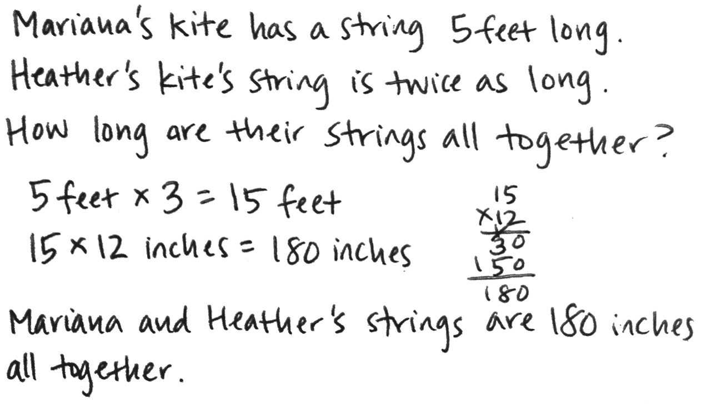
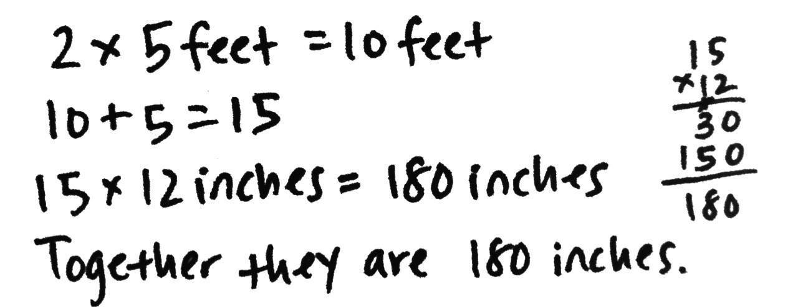
Student A
Student B
Debrief the problem using questions from the share and critique form. Ensure students notice that in Solution A, it is not realistic for Bill to be 10 feet tall. Have them generate a more realistic modification.

NOTES ON
MULTIPLE MEANS OF ACTION AND EXPRESSION:
English language learners may need scaffolds for writing word problems. Provide a word bank or sentence frames and allow students to discuss their thoughts before writing. Some possible sentence frames are given below.
- ___ had 6 gallons of ___ .
- ___ had 3 times as much.
- ___ had 2 quarts more than ___.

?
6 gallons
2 quarts
Display:

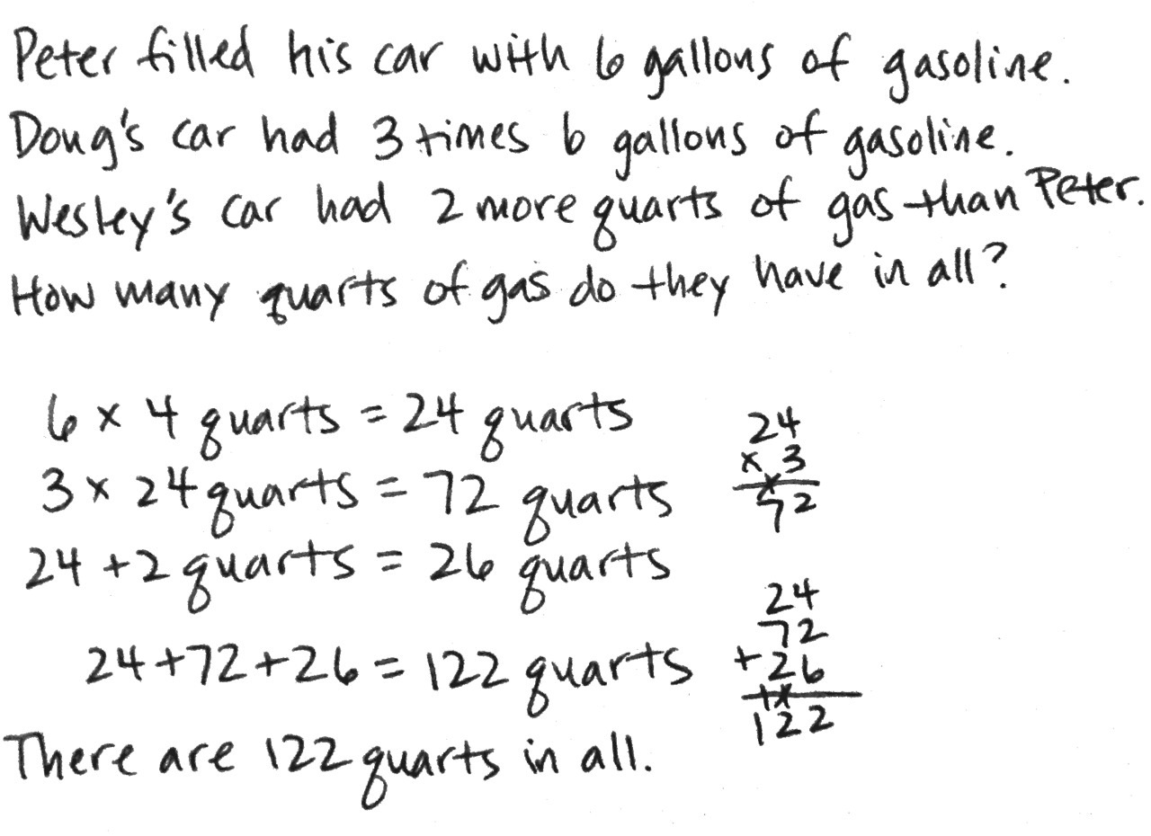
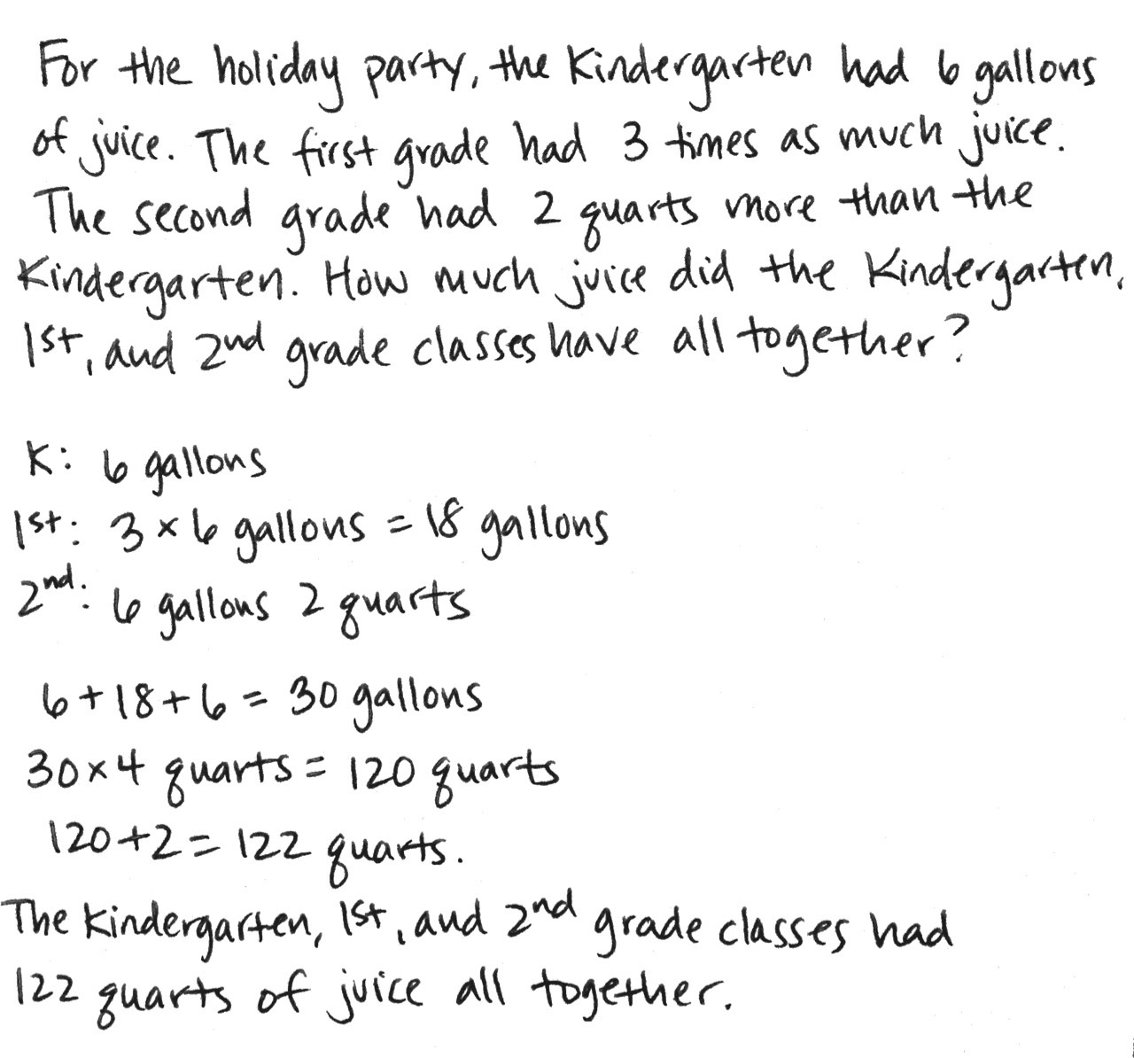
T: Turn to your partner and share what information you know from looking at this diagram. Then, create a word problem that goes with this diagram to solve for the number of quarts.
Student A
Student B

NOTES ON MULTIPLE MEANS OF ENGAGEMENT:
In the interest of cultivating a non-threatening atmosphere in which all students feel confident and comfortable sharing and receiving feedback, you may want to discuss goals, set guidelines, and model positive giving and receiving of balanced feedback.

Debrief the problem using questions from the share and critique form. Students might notice that gasoline is often measured in gallons rather than quarts. However, it is not unrealistic or wrong to state the capacity in quarts.
Problem 2: Share and critique work.
Distribute the Problem Set and share and critique form.
T: Work with a partner to complete the Problem Set. When you are finished solving and creating a word problem to go along with each diagram, turn to your partner and share. Use the peer share and critique form to take notes about your work and your partner’s work.
MP.3
Student equations and responses will vary. Circulate and assist students as necessary.
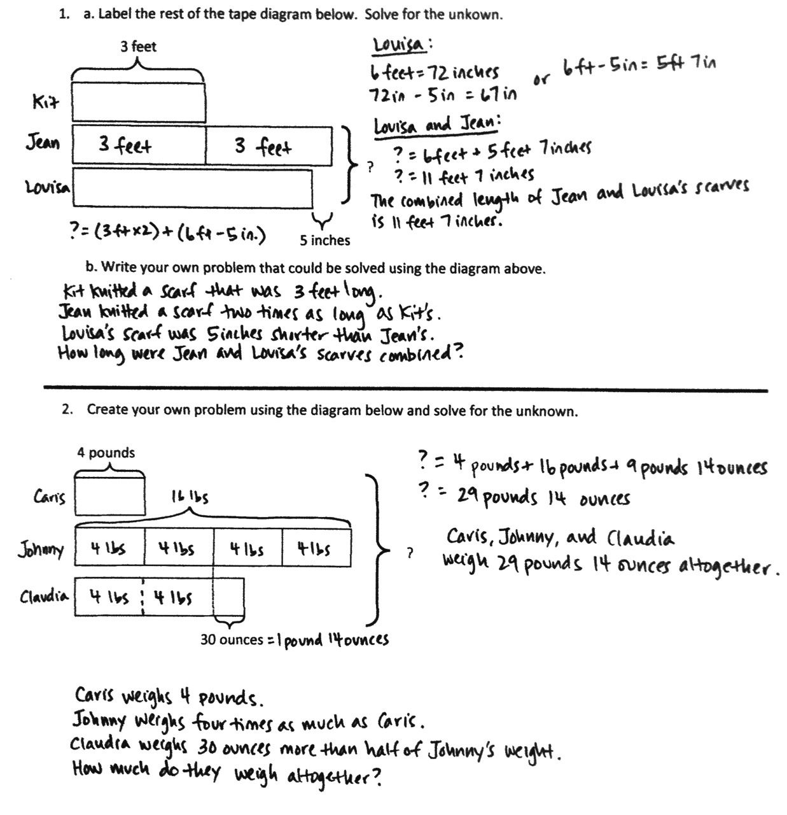

Student Debrief (10 minutes)
Lesson Objective: Share and critique peer strategies.
The Student Debrief is intended to invite reflection and active processing of the total lesson experience.
Invite students to review their solutions for the Problem Set. They should check work by comparing answers with a partner before going over answers as a class. Look for misconceptions or misunderstandings that can be addressed in the Debrief. Guide students in a conversation to debrief the Problem Set and process the lesson.
You may choose to use any combination of the questions below to lead the discussion.
- What did your partner do well in solving Problem 1? Problem 2?
- Did you and your partner use different strategies to solve Problem 1? If so, how were they different?
- How might you improve your work in solving and creating a word problem for Problem 2?
- What do we learn by analyzing different strategies for solving a problem?
Exit Ticket (3 minutes)
After the Student Debrief, instruct students to complete the Exit Ticket. A review of their work will help you assess the students’ understanding of the concepts that were presented in the lesson today and plan more effectively for future lessons. You may read the questions aloud to the students.

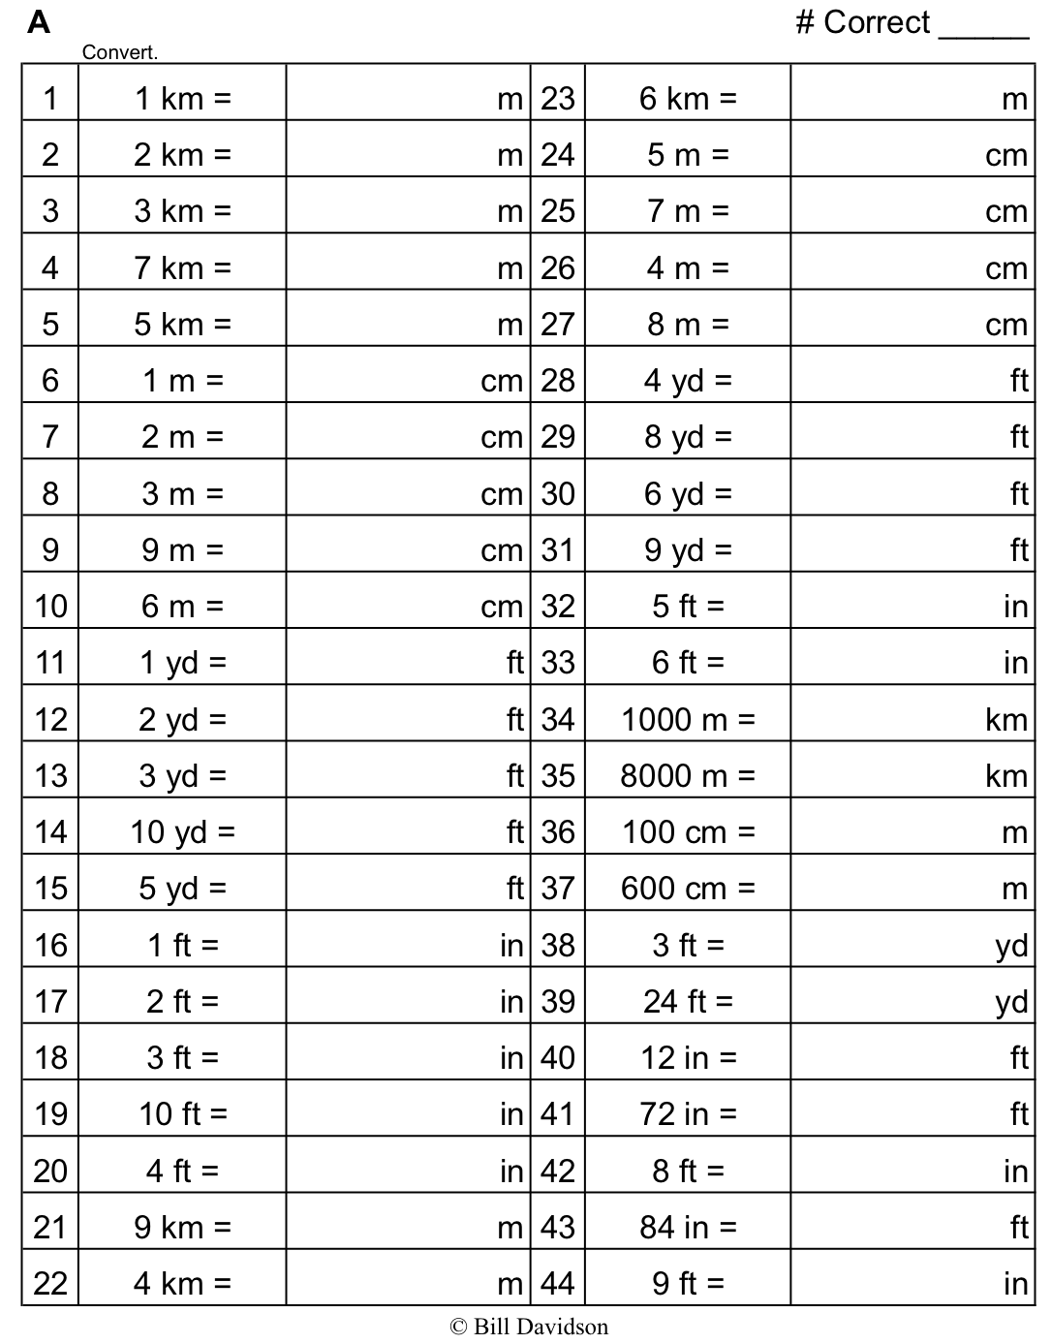
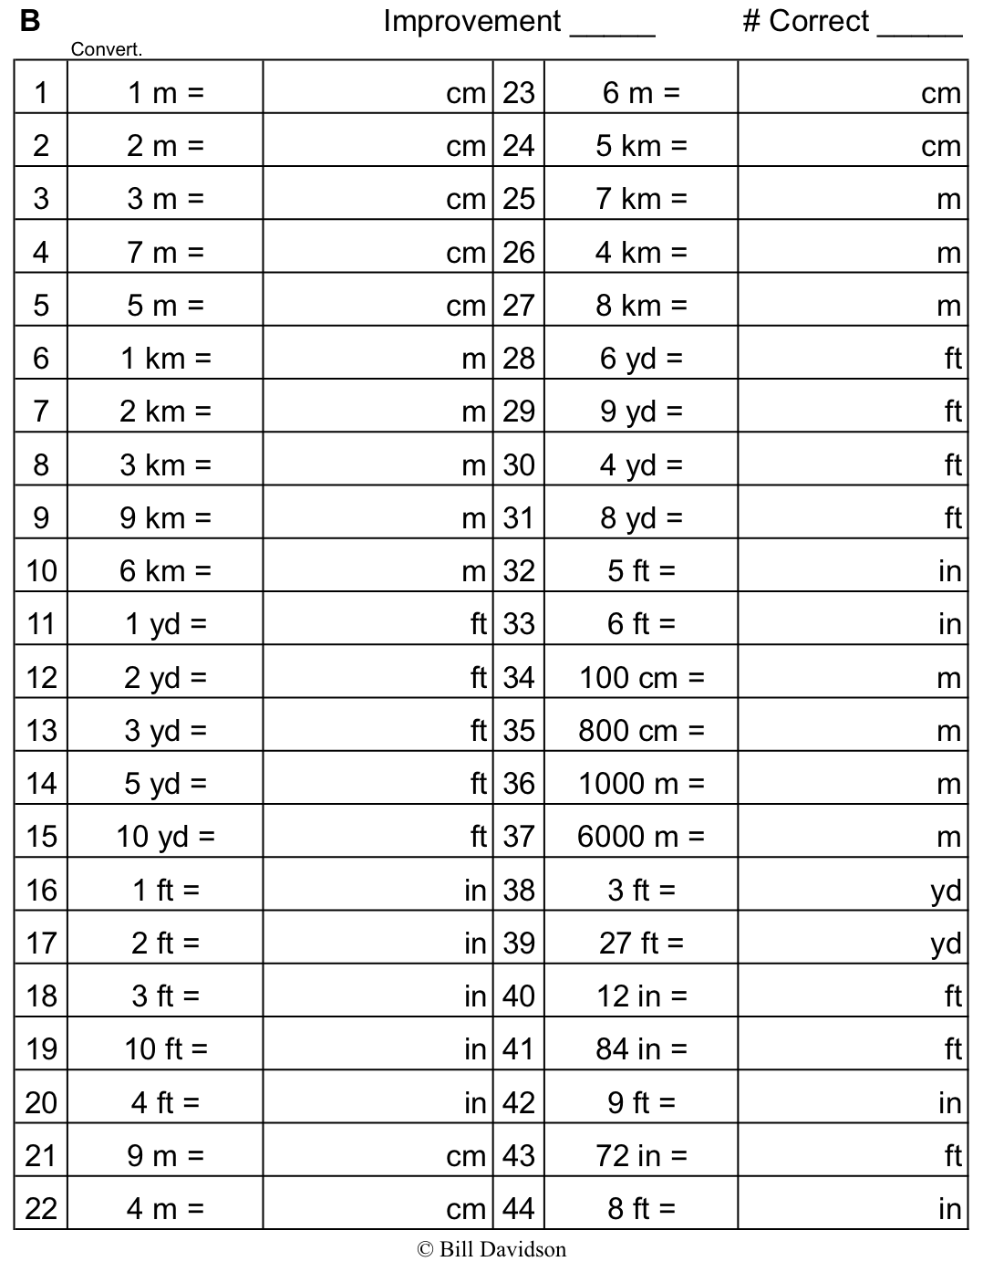

Peer Share and Critique Form
Classmate: |  | Problem Number:
Strategies my classmate used:
Things my classmate did well:
Suggestions for improvement:
Changes I would make to my work based on my classmate’s work:
Classmate: |  | Problem Number:
Strategies my classmate used:
Things my classmate did well:
Suggestions for improvement:
Changes I would make to my work based on my classmate’s work:

Name Date
- a. Label the rest of the tape diagram below. Solve for the unknown.
?
3 feet
5 inches

b. Write a problem of your own that could be solved using the diagram above.

- Create a problem of your own using the diagram below, and solve for the unknown.
4 pounds
30 ounces
?

Name Date

- Caitlin ran 1,680 feet on Monday and 2,340 feet on Tuesday. How many yards did she run in those two days?

Name Date
Draw a tape diagram to solve the following problems.
- Timmy drank 2 quarts of water yesterday. He drank twice as much water today as he drank yesterday. How many cups of water did Timmy drink in the two days?

- Lisa recorded a 2-hour television show. When she watched it, she skipped the commercials. It took her 84 minutes to watch the show. How many minutes did she save by skipping the commercials?

- Jason bought 2 pounds of cashews. Sarah ate 9 ounces. David ate 2 ounces more than Sarah. How many ounces were left in Jason’s bag of cashews?

- a. Label the rest of the tape diagram below. Solve for the unknown.
?
5 feet
10 in. inchesinchesinches

b. Write a problem of your own that could be solved using the diagram above.

- Create a problem of your own using the diagram below, and solve for the unknown.
3 pounds
8 ounces
?

