Lesson 2
Objective: Create conversion tables for length, weight, and capacity units using measurement tools, and use the tables to solve problems.

Suggested Lesson Structure
 Fluency Practice (11 minutes)
 Concept Development (39 minutes)
 Student Debrief (10 minutes)
Total Time (60 minutes)
Fluency Practice (11 minutes)
- Grade 4 Core Fluency Differentiated Practice Sets 4.NBT.4 (5 minutes)
- Convert Length Units 4.MD.1 (4 minutes)
- Convert Capacity Units 4.MD.1 (2 minutes)
Grade 4 Core Fluency Differentiated Practice Sets (5 minutes)
Materials: (S) Core Fluency Practice Sets
Note: In this lesson and throughout G4─Module 7, Fluency Practice includes an opportunity for review and mastery of the addition and subtraction algorithm by means of the Core Fluency Practice Sets. Four options are provided in this lesson:
- Practice Set A is multi-digit addition.
- Practice Set B is multi-digit subtraction.
- Practice Set C is multi-digit subtraction with zeros in the minuend.
- Practice Set D is multi-digit addition and subtraction.
All Practice Sets have a Part 1 and a Part 2. Note that Part 2 has fewer regroupings and may be used for students working below grade level. The answers to both Practice Sets are the same for ease of correction.
Students complete as many problems as possible in 120 seconds. Collect any Practice Sets that have been completed within the 120 seconds and check the answers. Students who do not finish in 120 seconds can be encouraged to use their Practice Sets for practice at home or for remedial practice in the classroom. The next time the Practice Sets are used, students who have successfully completed their set with 100% accuracy can move to the next level. Others should repeat the same level until mastery. Keep a record of student progress.
For early finishers, assign a counting pattern and start number, e.g., “Finish early? Count by sevens starting at 168 on the back of your Practice Set.” Celebrate improvement and advancement. Encourage students to compete with themselves rather than their peers. Notify caring adults of each child’s progress.
Convert Length Units (4 minutes)
Materials: (S) Personal white boards
Note: This fluency activity reviews G4–M7–Lesson 1 and metric conversions from G4–Module 2.
T: (Write 1 km = __ m.) How many meters are in 1 kilometer?
S: 1,000 m.
Repeat the process for 2 and 3 kilometers.
T: (Write 7 km = __ m.) Write the number sentence.
S: (Write 7 km = 7,000 m.)
T: (Write 1 m = __ cm.) How many centimeters are in 1 meter?
S: 100 cm.
Repeat the process for 2 and 3 meters.
T: (Write 8 m = __ cm.) Write the number sentence.
S: (Write 8 m = 800 cm.)
T: (Write 1 yd = __ ft.) How many feet are in 1 yard?
S: 3 feet.
Repeat the process for 2 and 3 yards.
T: (Write 10 yd = __ ft.) Write the number sentence.
S: (Write 10 yd = 30 ft.)
T: (Write 1 ft = __ in.) How many inches are in 1 foot?
S: 12 inches.
Repeat the process for 2 and 3 feet.
Convert Capacity Units (2 minutes)
Materials: (S) Personal white boards
Note: This fluency activity reviews metric conversions from G4–Module 2.
T: (Write 1 liter = __ mL.) How many milliliters are in 1 liter?
S: 1,000 mL.
Repeat the process for 2 and 3 liters.
T: (Write 6 liters = __ mL.) Write the number sentence.
S: (Write 6 liters = 6,000 mL.)
Concept Development (39 minutes)
Materials: (T) Gallon container, quart container, pint container, liquid measuring cup, funnel, water
(S) Gallon container (1 per group), quart container (1 per group), pint container (1 per group), liquid measuring cup (1 per group), funnel (1 per group), bucket of water (filled with 1.5 gallons of water), Practice Sheet
Note: Groups of 3 are recommended.
Problem 1: Convert gallons to quarts.
T: (Hold up a 1-gallon container and 1-quart container. Display the words gallon and quart.) This container measures 1 gallon. This container measures 1 quart of liquid. In your groups, fill the gallon with water using a 1-quart measure. How many quarts does it take to fill a gallon?
Allow enough time for all groups to have an opportunity to fill a gallon.
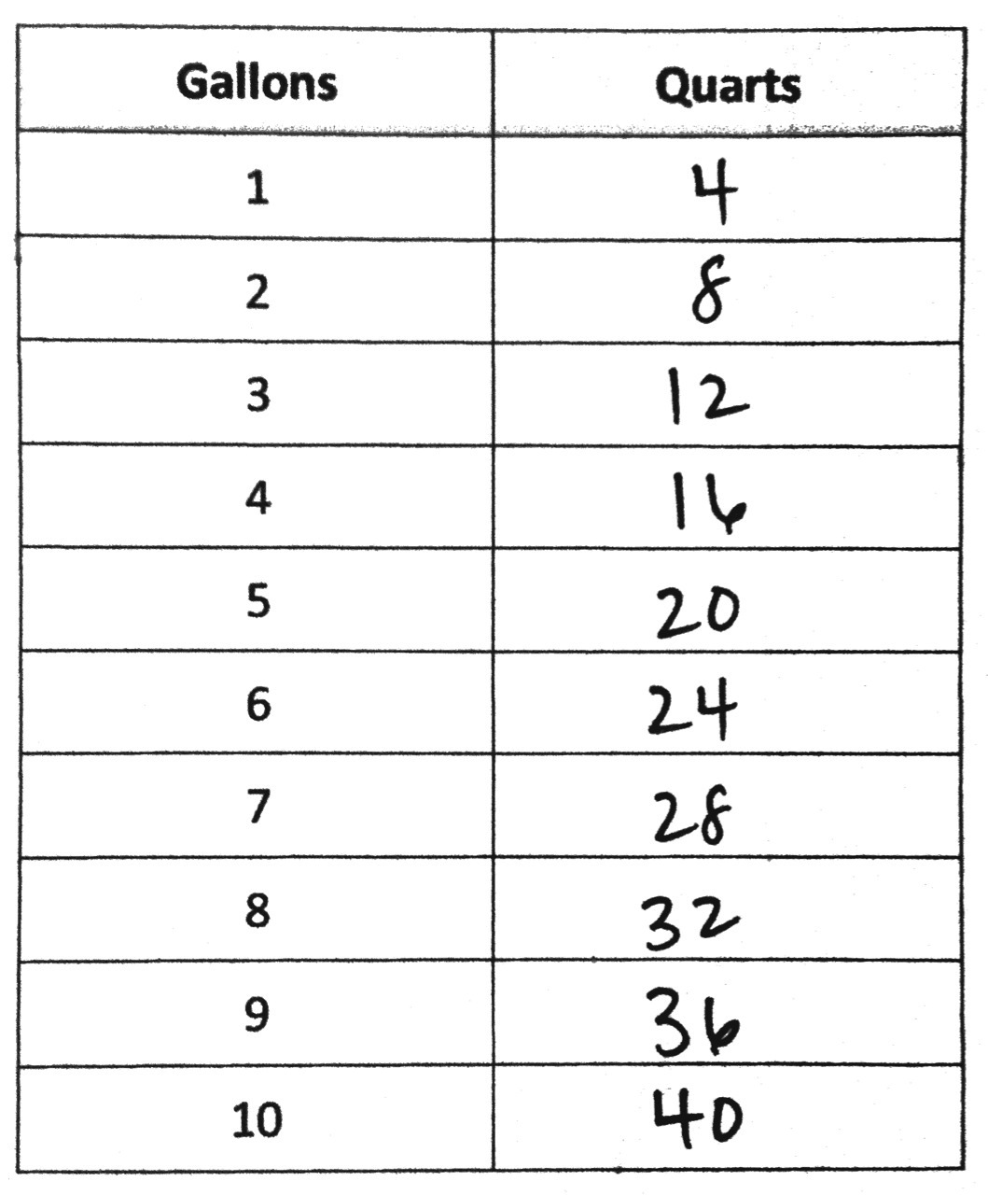
S: We used 4 quarts to fill the gallon.
T: On your Practice Sheet, fill in the first line of the Gallons to Quarts table. What is the rule for converting gallons to quarts?
S: Multiply the number of gallons by 4. A gallon holds 4 times as much as a quart.
T: How can we find the number of quarts in 13 gallons?
S: We could get 13 1-gallon containers and fill them up using the quart measure. We can use the rule and multiply the number of gallons by 4. 13 $\text{×}$ 4 = 52. 13 gallons = 52 quarts. The conversion table tells us how many quarts in 3 gallons and 10 gallons. Just add them together.
T: Just like we converted pounds to ounces, yards to feet, and feet to inches in the last lesson, we can use the conversion table as a tool to solve for the number of gallons in a given number of quarts.
T: How many quarts will there be in 18 gallons 3 quarts?
S: 75 quarts.
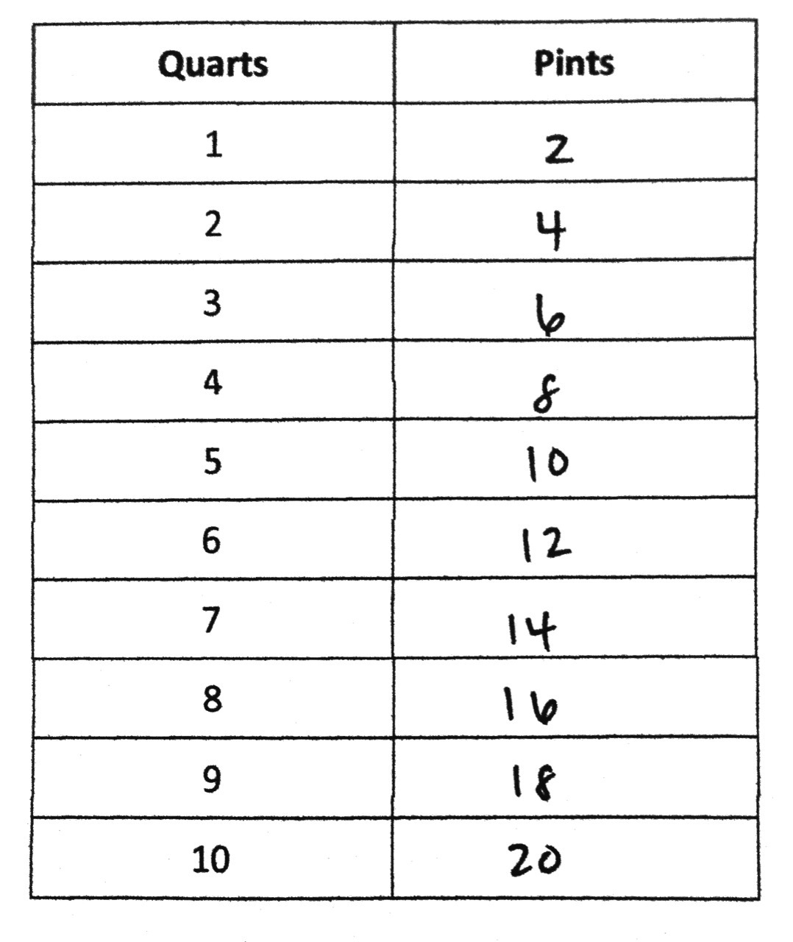
Problem 2: Convert quarts to pints. Relate pints to gallons.
T: (Hold up a 1-pint measure and display the word pint.) This is a measurement of 1 pint. Fill the quart to find out how many pints equal 1 quart.
Allow enough time for all groups to have an opportunity to fill a quart.
S: We used 2 pints to fill the quart.
T: (Display the two-column table.) We now know that 1 quart equals 2 pints. On your Practice Sheet, fill in the first line.
T: What is the rule for converting quarts to pints?
S: Multiply the number of quarts by 2. A quart holds 2 times as much as a pint.
T: Complete the table and solve for the number of pints in 13 quarts 1 pint.
T: How did you find the answer?
S: There are 26 pints in 13 quarts plus 1 pint is 27 pints. There are 20 pints in 10 quarts and 6 pints in 3 quarts so 20 pints plus 6 pints is 26 pints. Last, we have to add the 1 pint to get 27 pints in 13 quarts 1 pint.
T: (Point to the row with 4 quarts.) What do we know about the relationship of quarts and gallons?
S: 4 quarts equals 1 gallon.
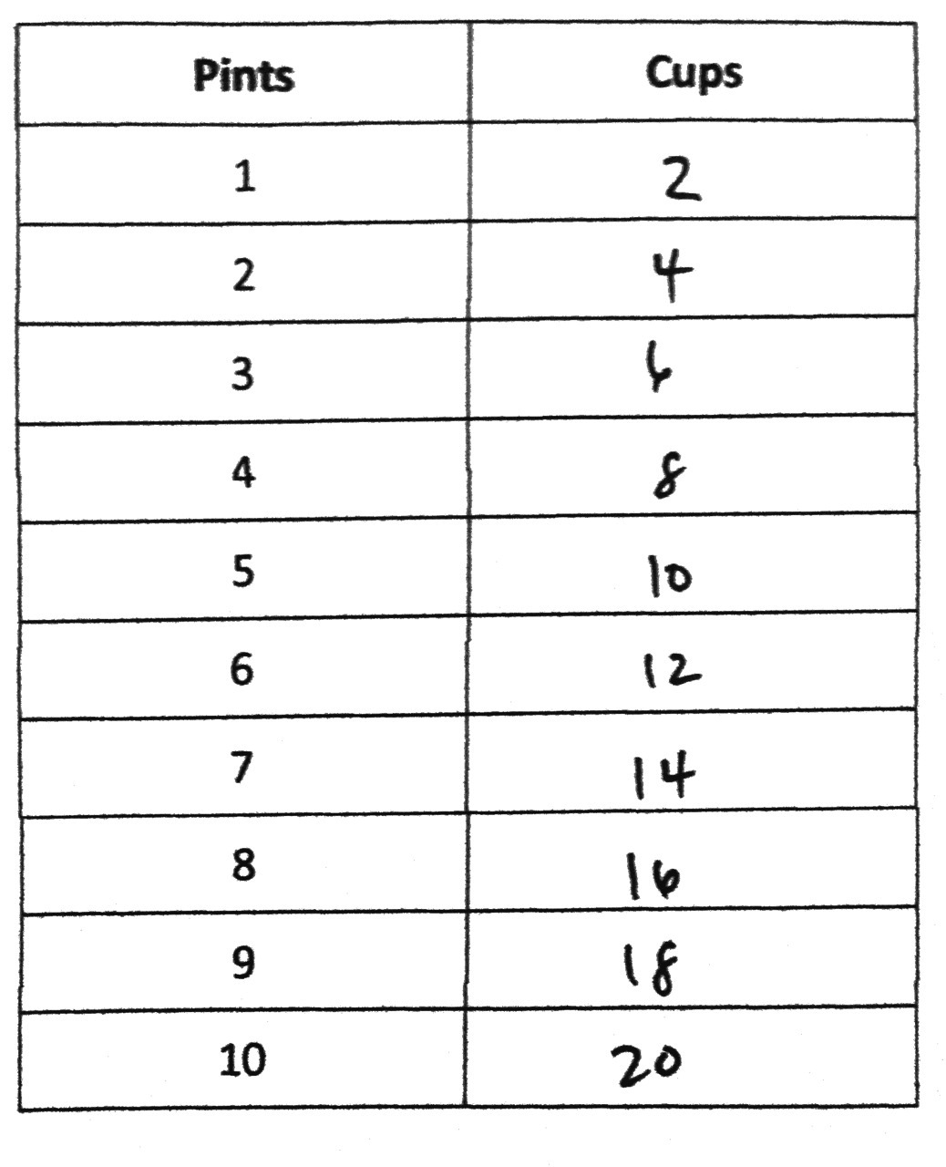
T: So how many pints equal 1 gallon?
S: 8 pints equal 1 gallon.
T: Pour 8 pints into 1 gallon to confirm.
Allow time for students to test their answer.
T: With your partner, solve for the number of pints in 2 gallons 3 quarts.
S: 2 gallons is 16 pints. 3 quarts is 6 pints. 22 pints equals 2 gallons 3 quarts.
Problem 3: Convert pints to cups. Relate cups to quarts and gallons.
T: (Hold up a 1-cup measure and display the word cup.) This is a measurement of 1 cup. Fill the pint to find out how many cups equal 1 pint.

NOTES ON
MULTIPLE MEANS OF ACTION AND
EXPRESSION:
Some learners may need scaffolds for managing information, such as conversion rules for measurement units. Provide graphic organizers and other visuals, such as the four-column table below to assist students with connecting relationships between gallons, quarts, pints, and cups.
 | Gallons |  | Quarts | Pints | Cups
 |  |  |  | 1 | 2
 |  |  | 1 | 2 | 4
 |  |  |  | 3 | 6
 | 1 |  | 4 | 8 | 16

Allow enough time for all groups to have an opportunity to fill a pint. Repeat as done in Problems 1 and 2 by finding the conversion rule, completing the table on the Practice Sheet, and solving for the number of cups in 16 pints 1 cup.
T: (Point to the row with 2 pints.) What do we know about the relationship of pints and quarts?
S: 2 pints equals 1 quart.
T: So, how many cups equal 1 quart?
S: 4 cups equal 1 quart.
T: Pour 4 cups into 1 quart to confirm. Discuss the conversion rule for quarts to cups with your partner. (Allow time for students to test their answer.)
S: Multiply the number of quarts times 4. A quart is 4 times as much as a cup.
T: With your partner solve for the number of cups in 3 quarts 1 pint.
S: 1 quart is 4 cups, so 3 quarts is 12 cups. 1 pint is 2 cups. 14 cups equals 3 quarts 1 pint.
T: With your partner, use the conversion rules to determine how many cups equal 1 gallon.
S: 1 quart equals 4 cups. 4 quarts equals 1 gallon. So, 16 cups equals 1 gallon.
T: Measure to confirm. Complete the statements comparing cups, pints, quarts, and gallons on the Practice Sheet.
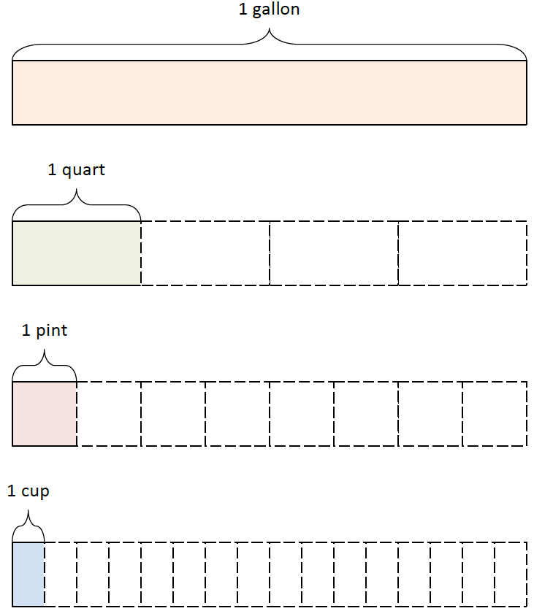
Display: 1 gal = 4 qt, 1 qt = 4 cups, 1 qt = 2 pints, 1 pt = 2 cups.
T: Discuss with your partner some of these rules we learned today. How will you be able to keep them organized? What relationships do you see between these measurements?
S: Cups, quarts, and gallons are closely related because it takes 4 cups to equal 1 quart and 4 quarts to make 1 gallon. So, the rule of times 4 makes those measurements easy to memorize and use. Quarts, pints, and cups are closely related too. 2 cups equal 1 pint. 2 pints equal 1 quart. If I use the times 2 rule with these measurements, they will be easy to convert.
Support students understanding of the connectedness of these 4 capacity measurements by displaying an image as pictured to the right or by asking students to draw tape diagrams to show the relationship if they are unable to express it in words.
Problem 4: Calculate a two-step conversion.
Brandon made 5 gallons of iced tea for his party. How many cups of iced tea can he serve?
MP.2
T: With your partner, use the RDW process to solve this problem.

In Solution A, the student starts with the whole tape representing 5 gallons, finds the number of quarts in all the iced tea and then multiplies the number of quarts by 4 to find the total number of cups. In Solution B, the student finds the number of cups in 1 gallon and then multiplies that by 5 to find the number of cups in 5 gallons. Be aware of students who know 1 gallon equals 16 cups, and multiply 16 times 5.
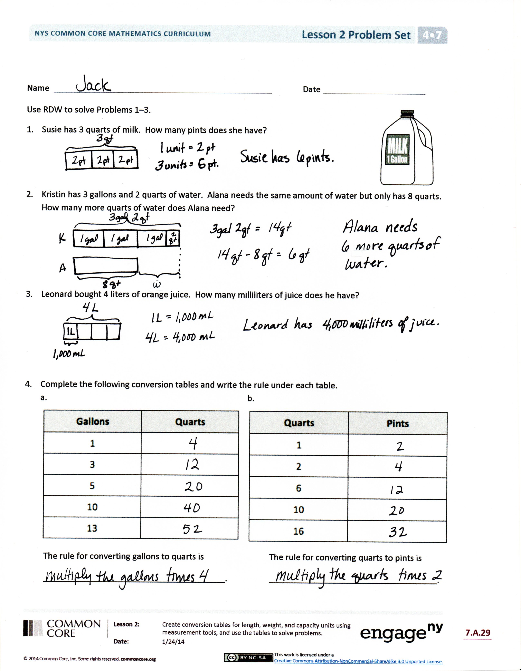
Problem Set (10 minutes)
Students should do their personal best to complete the Problem Set within the allotted 10 minutes. For some classes, it may be appropriate to modify the assignment by specifying which problems they work on first. Some problems do not specify a method for solving. Students solve these problems using the RDW approach used for Application Problems.
Student Debrief (10 minutes)
Lesson Objective: Create conversion tables for length, weight, and capacity units using measurement tools, and use the tables to solve problems.
The Student Debrief is intended to invite reflection and active processing of the total lesson experience.
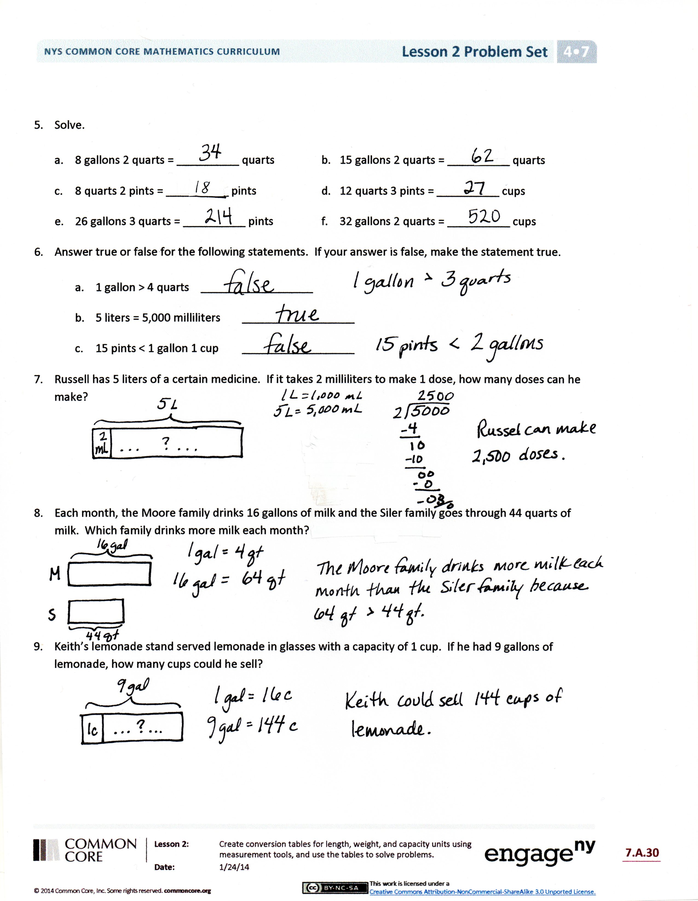
Invite students to review their solutions for the Problem Set. They should check work by comparing answers with a partner before going over answers as a class. Look for misconceptions or misunderstandings that can be addressed in the Debrief. Guide students in a conversation to debrief the Problem Set and process the lesson.
You may choose to use any combination of the questions below to lead the discussion.
- Let’s compare two different representations of Problem 2. How are these students’ solutions the same? How are they different? How did each represent the comparison? How could you solve Problem 5(c) using the conversion table? How could you solve it without a conversion table?
- Explain the strategy you used to solve Problem 8. Compare solution strategies with your small group. Whose way of solving was the most efficient?
- If someone wanted to find the number of pints or quarts in 150 gallons, would it make sense to use the conversion table to solve? Why is understanding the conversion rule important?
- When measuring liquid, such as a bottle of drinking water, which customary unit could I use? Which metric unit could I use?
- Milk is usually sold in customary units. Which customary units are used for milk? On the other hand, soda is sold in metric units. Which metric unit is used for soda?
- How many gallons of juice would our class need to serve at its next party so that each student in our class would receive 1 cup of juice? What about 2 cups of juice?
Exit Ticket (3 minutes)
After the Student Debrief, instruct students to complete the Exit Ticket. A review of their work will help you assess the students’ understanding of the concepts that were presented in the lesson today and plan more effectively for future lessons. You may read the questions aloud to the students.

Name Date
Practice Set A Part 1: Multi-Digit Addition Fluency
1. |  |  |  |  |  |  |  |  |  |  |  |  |  |  |  |  |  |  |  |  |  |  |  |  |  |  |  |  | 2. |  |  |  |  |  |  |  |  |  |  |  |  |  |  |  |  |  |  |  |  |  |  |  |  |  |  |  |  |  |  |  | 3.
 |  |  |  |  | 8, |  |  | 1 |  |  | 4 |  |  | 9 |  |  |  |  |  |  |  |  |  |  |  |  |  |  |  |  |  |  |  |  | 4 |  |  | 2, |  |  | 6 |  |  | 0 |  |  | 9 |  |  |  |  |  |  |  |  |  |  |  |  |  |  |  |  |  |  |  | 3 |  |  | 9, |  |  | 5 |  |  |  | 6 |  |  |  | 3
 |  |  | + |  | 7, |  |  | 2 |  |  | 6 |  |  | 4 |  |  |  |  |  |  |  |  |  |  |  |  |  |  |  |  |  | + |  |  |  |  |  | 8, |  |  | 6 |  |  | 8 |  |  | 5 |  |  |  |  |  |  |  |  |  |  |  |  |  |  |  |  | + |  |  | 4 |  |  | 8, |  |  | 4 |  |  |  | 3 |  |  |  | 8
4. |  |  |  |  |  |  |  |  |  |  |  |  |  |  |  |  |  |  |  |  |  |  |  |  |  |  |  |  | 5. |  |  |  |  |  |  |  |  |  |  |  |  |  |  |  |  |  |  |  |  |  |  |  |  |  |  |  |  |  |  |  | 6.
 | 6 |  | 5 |  | 8, |  |  | 1 |  |  | 9 |  |  | 9 |  |  |  |  |  |  |  |  |  |  |  |  |  |  |  |  |  | 4 |  |  | 4 |  |  | 5, |  |  | 9 |  |  | 7 |  |  | 6 |  |  |  |  |  |  |  |  |  |  |  |  |  |  |  |  | 4 |  |  | 3 |  |  | 8, |  | 6 |  |  | 1 |  |  |  | 7
+ |  |  | 2 |  | 5, |  |  | 6 |  |  | 7 |  |  | 5 |  |  |  |  |  |  |  |  |  |  |  |  |  |  | + |  |  |  |  |  | 3 |  |  | 7, |  |  | 4 |  |  | 1 |  |  | 5 |  |  |  |  |  |  |  |  |  |  |  |  |  | + |  |  | 4 |  |  | 9 |  |  | 3, |  | 8 |  |  | 5 |  |  |  | 9

Practice Set A Part 2: Multi-Digit Addition Fluency
1. |  |  |  |  |  |  |  |  |  |  |  |  |  |  |  |  |  |  |  |  |  |  |  |  |  |  |  |  |  |  |  | 2. |  |  |  |  |  |  |  |  |  |  |  |  |  |  |  |  |  |  |  |  |  |  |  |  |  |  |  |  | 3.
 |  |  |  |  |  |  |  | 9, |  |  | 2 |  |  | 0 |  |  | 2 |  |  |  |  |  |  |  |  |  |  |  |  |  |  |  |  |  |  |  |  | 4 |  |  | 2, |  |  | 7 |  |  | 7 |  |  | 4 |  |  |  |  |  |  |  |  |  |  |  |  |  |  |  |  | 5 |  |  | 3, |  |  |  |  |  | 5 |  |  |  |  | 4 |  |  |  |  | 5
 |  |  |  |  | + |  |  | 6, |  |  | 2 |  |  | 1 |  |  | 1 |  |  |  |  |  |  |  |  |  |  |  |  |  |  |  |  |  | + |  |  |  |  |  | 8, |  |  | 5 |  |  | 2 |  |  | 0 |  |  |  |  |  |  |  |  |  |  |  |  |  | + |  |  | 3 |  |  | 4, |  |  |  |  |  | 4 |  |  |  |  | 5 |  |  |  |  | 6
4. |  |  |  |  |  |  |  |  |  |  |  |  |  |  |  |  |  |  |  |  |  |  |  |  |  |  |  |  |  |  |  | 5. |  |  |  |  |  |  |  |  |  |  |  |  |  |  |  |  |  |  |  |  |  |  |  |  |  |  |  |  | 6.
 |  | 6 |  |  | 0 |  |  | 4, |  |  | 7 |  |  | 5 |  |  | 4 |  |  |  |  |  |  |  |  |  |  |  |  |  |  |  |  |  | 4 |  |  | 5 |  |  | 4, |  |  | 3 |  |  | 1 |  |  | 5 |  |  |  |  |  |  |  |  |  |  |  |  |  | 1 |  |  | 1 |  |  | 0, |  |  |  |  | 7 |  |  |  |  | 2 |  |  |  |  | 8
+ |  |  |  |  | 7 |  |  | 9, |  |  | 1 |  |  | 2 |  |  | 0 |  |  |  |  |  |  |  |  |  |  |  |  |  |  | + |  |  |  |  |  | 2 |  |  | 9, |  |  | 0 |  |  | 7 |  |  | 6 |  |  |  |  |  |  |  |  |  |  | + |  |  | 8 |  |  | 2 |  |  | 1, |  |  |  |  | 7 |  |  |  |  | 4 |  |  |  |  | 8

Name Date
Practice Set B Part 1: Multi-Digit Subtraction Fluency
 |  | 1. |  |  |  |  |  |  |  |  |  |  |  |  |  |  |  |  |  |  |  |  |  |  |  |  |  | 2.
 |  |  |  |  | 7, |  | 7 |  | 3 |  | 9 |  |  |  |  |  |  |  |  |  |  |  |  |  |  |  |  |  |  |  |  |  | 2 |  | 3, |  | 1 |  | 4 |  | 5
 |  |  |  | $$-$$ | 5, |  | 5 |  | 4 |  | 6 |  |  |  |  |  |  |  |  |  |  |  |  |  |  |  |  |  |  |  | $$-$$ |  |  |  | 5, |  | 1 |  | 2 |  | 9
 |  | 3. |  |  |  |  |  |  |  |  |  |  |  |  |  |  |  |  |  |  |  |  |  |  |  |  |  |  | 4.
 |  |  |  | 7 | 1, |  | 3 |  | 7 |  | 8 |  |  |  |  |  |  |  |  |  |  |  |  |  |  |  |  |  |  |  | 4 |  | 7 |  | 9, |  | 5 |  | 4 |  | 1
 |  |  | $$-$$ | 6 | 1, |  | 8 |  | 7 |  | 6 |  |  |  |  |  |  |  |  |  |  |  |  |  |  |  |  |  | $$-$$ |  |  |  | 7 |  | 8, |  | 8 |  | 5 |  | 6

Practice Set B Part 2: Multi-Digit Subtraction Fluency
 |  | 1. |  |  |  |  |  |  |  |  |  |  |  |  |  |  |  |  |  |  |  |  |  |  |  |  |  | 2.
 |  |  |  |  | 7, |  | 6 |  | 9 |  | 9 |  |  |  |  |  |  |  |  |  |  |  |  |  |  |  |  |  |  |  |  |  | 1 |  | 9, |  | 1 |  | 4 |  | 5
 |  |  |  | $$-$$ | 5, |  | 5 |  | 0 |  | 6 |  |  |  |  |  |  |  |  |  |  |  |  |  |  |  |  |  |  |  | $$-$$ |  |  |  | 1, |  | 1 |  | 2 |  | 9
 |  | 3. |  |  |  |  |  |  |  |  |  |  |  |  |  |  |  |  |  |  |  |  |  |  |  |  |  |  | 4.
 |  |  |  | 7 | 1, |  | 8 |  | 7 |  | 8 |  |  |  |  |  |  |  |  |  |  |  |  |  |  |  |  |  |  |  | 4 |  | 7 |  | 9, |  | 4 |  | 9 |  | 7
 |  |  | $$-$$ | 6 | 2, |  | 3 |  | 7 |  | 6 |  |  |  |  |  |  |  |  |  |  |  |  |  |  |  |  |  | $$-$$ |  |  |  | 7 |  | 8, |  | 8 |  | 1 |  | 2

Name Date
Practice Set C Part 1: Multi-Digit Subtraction with Zeros Fluency
 |  | 1. |  |  |  |  |  |  |  |  |  |  |  |  |  |  |  |  |  |  |  |  |  |  |  |  |  | 2.
 |  |  |  |  | 7, |  | 8 |  | 9 |  | 0 |  |  |  |  |  |  |  |  |  |  |  |  |  |  |  |  |  |  |  |  |  | 2 |  | 8, |  | 0 |  | 0 |  | 1
 |  |  |  | $$-$$ | 5, |  | 4 |  | 7 |  | 2 |  |  |  |  |  |  |  |  |  |  |  |  |  |  |  |  |  |  |  | $$-$$ |  |  |  | 5, |  | 8 |  | 5 |  | 3
 |  | 3. |  |  |  |  |  |  |  |  |  |  |  |  |  |  |  |  |  |  |  |  |  |  |  |  |  |  | 4.
 |  |  |  | 6 | 0, |  | 4 |  | 0 |  | 7 |  |  |  |  |  |  |  |  |  |  |  |  |  |  |  |  |  |  |  | 4 |  | 0 |  | 0, |  | 0 |  | 6 |  | 9
 |  |  | $$-$$ | 3 | 5, |  | 3 |  | 4 |  | 4 |  |  |  |  |  |  |  |  |  |  |  |  |  |  |  |  |  | $$-$$ |  |  |  | 2 |  | 4, |  | 3 |  | 6 |  | 2

Practice Set C Part 2: Multi-Digit Subtraction with Zeros Fluency
 |  | 1. |  |  |  |  |  |  |  |  |  |  |  |  |  |  |  |  |  |  |  |  |  |  |  |  |  | 2.
 |  |  |  |  | 7, |  | 8 |  | 9 |  | 0 |  |  |  |  |  |  |  |  |  |  |  |  |  |  |  |  |  |  |  |  |  | 2 |  | 8, |  | 6 |  | 0 |  | 9
 |  |  |  | $$-$$ | 5, |  | 4 |  | 7 |  | 2 |  |  |  |  |  |  |  |  |  |  |  |  |  |  |  |  |  |  |  | $$-$$ |  |  |  | 6, |  | 4 |  | 6 |  | 1
 |  | 3. |  |  |  |  |  |  |  |  |  |  |  |  |  |  |  |  |  |  |  |  |  |  |  |  |  |  | 4.
 |  |  |  | 6 | 0, |  | 4 |  | 9 |  | 7 |  |  |  |  |  |  |  |  |  |  |  |  |  |  |  |  |  |  |  | 4 |  | 0 |  | 0, |  | 8 |  | 6 |  | 9
 |  |  | $$-$$ | 3 | 5, |  | 4 |  | 3 |  | 4 |  |  |  |  |  |  |  |  |  |  |  |  |  |  |  |  |  | $$-$$ |  |  |  | 2 |  | 5, |  | 1 |  | 6 |  | 2

Name Date
Practice Set D Part 1: Multi-Digit Addition and Subtraction Fluency
1. |  |  |  |  |  |  |  |  |  |  |  |  |  |  |  |  |  |  |  |  |  |  |  |  |  |  |  |  |  |  | 2. |  |  |  |  |  |  |  |  |  |  |  |  |  |  |  |  |  |  |  |  |  |  |  |  |  |  |  |  |  |  |  | 3.
 |  |  |  |  |  |  | 9, |  |  | 3 |  |  | 2 |  |  | 7 |  |  |  |  |  |  |  |  |  |  |  |  |  |  |  |  |  |  |  |  | 3 |  |  | 9, |  |  | 4 |  |  | 6 |  |  | 3 |  |  |  |  |  |  |  |  |  |  |  |  |  |  |  |  | 7 |  |  | 5 |  |  | 8, |  |  |  |  | 1 |  |  |  | 9 |  |  |  | 4
 |  |  |  | + |  |  | 9, |  |  | 6 |  |  | 6 |  |  | 4 |  |  |  |  |  |  |  |  |  |  |  |  |  |  |  |  |  | $$-$$ |  |  | 3 |  |  | 8, |  |  | 9 |  |  | 3 |  |  | 8 |  |  |  |  |  |  |  |  |  |  |  |  |  | + |  |  |  |  |  | 3 |  |  | 5, |  |  |  |  | 4 |  |  |  | 7 |  |  |  | 8
4. |  |  |  |  |  |  |  |  |  |  |  |  |  |  |  |  |  |  |  |  |  |  |  |  |  |  |  |  |  |  | 5. |  |  |  |  |  |  |  |  |  |  |  |  |  |  |  |  |  |  |  |  |  |  |  |  |  |  |  |  |  |  |  | 6.
 | 8 |  |  | 3 |  |  | 9, |  |  | 0 |  |  | 1 |  |  | 4 |  |  |  |  |  |  |  |  |  |  |  |  |  |  |  |  |  | 4 |  |  | 3 |  |  | 8, |  |  | 6 |  |  | 1 |  |  | 5 |  |  |  |  |  |  |  |  |  |  |  |  |  |  |  |  | 9 |  |  | 6 |  |  | 0, |  |  |  | 0 |  |  |  | 4 |  |  | 3
$$-$$ |  |  |  | 2 |  |  | 7, |  |  | 0 |  |  | 7 |  |  | 5 |  |  |  |  |  |  |  |  |  |  |  |  |  |  | + |  |  | 1 |  |  | 9 |  |  | 3, |  |  | 9 |  |  | 7 |  |  | 9 |  |  |  |  |  |  |  |  |  |  |  |  |  | $$-$$ |  |  | 3 |  |  | 6 |  |  | 8, |  |  |  | 9 |  |  |  | 7 |  |  | 2

Practice Set D Part 2: Multi-Digit Addition and Subtraction Fluency
1. |  |  |  |  |  |  |  |  |  |  |  |  |  |  |  |  |  |  | 2. |  |  |  |  |  |  |  |  |  |  |  |  |  |  |  |  |  |  |  | 3.
 |  |  | 9, |  | 6 |  | 3 |  | 0 |  |  |  |  |  |  |  |  |  |  |  |  |  | 3 |  | 4, |  | 4 |  | 7 |  | 8 |  |  |  |  |  |  |  |  |  | 7 |  | 5 |  | 4, |  |  | 4 |  |  | 5 |  |  | 4
 |  | + | 9, |  | 3 |  | 6 |  | 1 |  |  |  |  |  |  |  |  |  |  |  | $$-$$ |  | 3 |  | 3, |  | 9 |  | 5 |  | 3 |  |  |  |  |  |  |  | + |  |  |  | 3 |  | 9, |  |  | 2 |  |  | 1 |  |  | 8
4. |  |  |  |  |  |  |  |  |  |  |  |  |  |  |  |  |  |  | 5. |  |  |  |  |  |  |  |  |  |  |  |  |  |  |  |  |  |  |  | 6.
 | 8 | 3 | 9, |  | 0 |  | 9 |  | 9 |  |  |  |  |  |  |  |  |  |  |  | 1 |  | 0 |  | 8, |  | 2 |  | 1 |  | 5 |  |  |  |  |  |  |  |  |  | 8 |  | 5 |  | 9, |  | 9 |  |  | 4 |  |  | 3
$$-$$ |  | 2 | 7, |  | 1 |  | 6 |  | 0 |  |  |  |  |  |  |  |  |  | + |  | 5 |  | 2 |  | 4, |  | 3 |  | 7 |  | 9 |  |  |  |  |  |  |  | $$-$$ |  | 3 |  | 6 |  | 8, |  | 8 |  |  | 7 |  |  | 2

Name Date
Gallons | Quarts |  | Quarts | Pints
1 |  |  | 1
2 |  |  | 2
3 |  |  | 3
4 |  |  | 4
5 |  |  | 5
6 |  |  | 6
7 |  |  | 7
8 |  |  | 8
9 |  |  | 9
10 |  |  | 10
The rule for converting gallons to quarts is The rule for converting quarts to pints is
_______________________________________. _______________________________________.
Pints | Cups
1
2
3
4
5
6
7
8
9
10
1 gallon = ____ pints

1 quart = ____ cups

1 gallon = ____ cups

The rule for converting pints to cups is
__________________________________.

Name Date
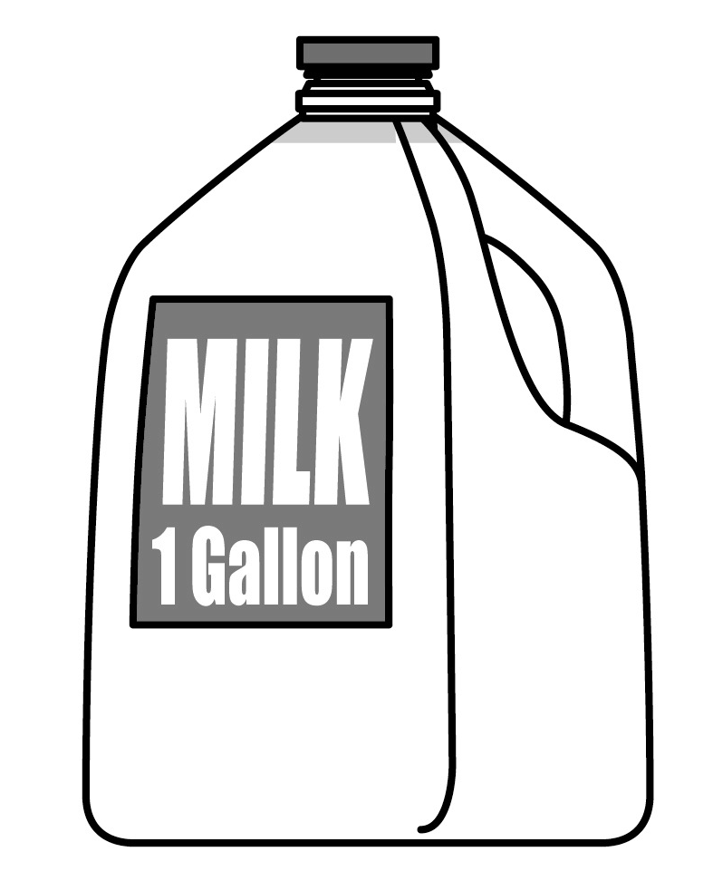
Use RDW to solve Problems 1–3.
- Susie has 3 quarts of milk. How many pints does she have?

- Kristin has 3 gallons and 2 quarts of water. Alana needs the same amount of water but only has 8 quarts. How many more quarts of water does Alana need?

- Leonard bought 4 liters of orange juice. How many milliliters of juice does he have?

- Complete the following conversion tables and write the rule under each table.
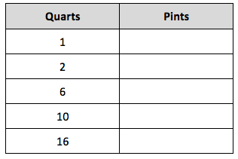
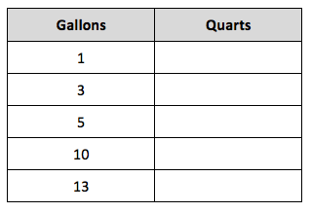
  - b.
The rule for converting gallons to quarts is The rule for converting quarts to pints is
_______________________________________. ____________________________________.
- Solve.

- 8 gallons 2 quarts = __________ quarts b. 15 gallons 2 quarts = __________ quarts
- 8 quarts 2 pints = __________ pints d. 12 quarts 3 pints = __________ cups
- 26 gallons 3 quarts = __________ pints f. 32 gallons 2 quarts = __________ cups

- Answer true or false for the following statements. If your answer is false, make the statement true.

- 1 gallon > 4 quarts __________________
- 5 liters = 5,000 milliliters __________________
- 15 pints < 1 gallon 1 cup __________________
- Russell has 5 liters of a certain medicine. If it takes 2 milliliters to make 1 dose, how many doses can he make?

- Each month, the Moore family drinks 16 gallons of milk and the Siler family goes through 44 quarts of milk. Which family drinks more milk each month?

- Keith’s lemonade stand served lemonade in glasses with a capacity of 1 cup. If he had 9 gallons of lemonade, how many cups could he sell?
Name Date
  - Complete the table.
Quarts | Cups
1
2
4

  - Bonnie’s doctor recommended she should drink 2 cups of milk per day. If she buys 3 quarts of milk, will it be enough milk to last 1 week? Explain how you know.
Name Date
Use the RDW process to solve Problems 1–3.
- Dawn needs to pour 3 gallons of water into her fish tank. She only has a 1-cup measuring cup. How many cups of water should she put in the tank?

- Julia has 4 gallons 2 quarts of water. Ally needs the same amount of water but only has 12 quarts. How much more water does Ally need?

- Sean drank 2 liters of water today, which was 280 milliliters more than he drank yesterday. How much water did he drink yesterday?

- Complete the tables.
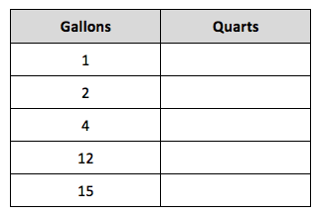
- b.

- Solve.

- 6 gallons 3 quarts = __________ quarts b. 12 gallons 2 quarts = __________ quarts
- 5 quarts 1 pint = __________ pints d. 13 quarts 3 pints = __________ cups
- 17 gallons 2 quarts = __________ pints f. 27 gallons 3 quarts = __________ cups

- Explain how you solved Problem 5(f).

- Answer “true” or “false” for the following statements. If your answer is false, make the statement true by correcting the right side of the comparison.

- 2 quarts > 10 pints __________________
- 6 liters = 6,000 milliliters __________________
- 16 cups < 4 quarts 1 cup __________________
- Joey needs to buy 3 quarts of chocolate milk. The store only sells it in pint containers. How many pints of chocolate milk should he buy? Explain how you know.

- Granny Smith made punch. She used 2 pints of ginger ale, 3 pints of fruit punch, and 1 pint of orange juice. She served the punch in glasses that had a capacity of 1 cup. How many cups can she fill?

