Lesson 1
Objective: Create conversion tables for length, weight, and capacity units using measurement tools, and use the tables to solve problems.

Suggested Lesson Structure
 Fluency Practice (12 minutes)
 Concept Development (38 minutes)
 Student Debrief (10 minutes)
Total Time (60 minutes)
Fluency Practice (12 minutes)
- Sprint: Money 4.MD.2 (9 minutes)
- Add and Subtract 4.NBT.4 (3 minutes)
Sprint: Money (9 minutes)
Materials: (S) Money Sprint
Note: This Sprint reviews G4–M6–Topic E.
Add and Subtract (3 minutes)
Materials: (S) Personal white boards

NOTES ON
MULTIPLE MEANS OF ACTION AND EXPRESSION:
Challenge students working above grade level and others to apply efficient alternative strategies learned since Grade 1 to solve the Add and Subtract fluency activity.

Note: This fluency activity reviews adding and subtracting using the standard algorithm.
T: (Write 699 thousands, 999 ones.) On your boards, write this number in standard form.
S: (Write 699,999.)
T: (Write 155 thousands, 755 ones.) Add this number to 699,999 using the standard algorithm.
S: (Write 699,999 + 155,755 = 855,754 using the standard algorithm.)
Continue the process for 456,789 + 498,765.
T: (Write 400 thousand, 1 one.) On your boards, write this number in standard form.
S: (Write 400,001.)
T: (Write 235 thousands, 165 ones.) Subtract this number from 400,001 using the standard algorithm.
S: (Write 400,001 – 235,165 = 164,836 using the standard algorithm.)
Continue the process for 708,050 – 256,089.
Concept Development (38 minutes)
Materials: (T) Balance scale, 1-pound weights, 1-ounce weights, yardstick, ruler (S) Balance scale (1 per group), 1-pound weight (1 per group), 1-ounce weights (16 per group), yardstick (1 per group), ruler (1 per group), Practice Sheet
Note: Groups of 3 students are suggested for this Concept Development.
Problem 1: Convert pounds to ounces.
Display the words pound and ounce.
T: (Hold up one 1-ounce weight.) This item weighs 1 ounce. I am going to place it on one side of the scale. (Place on scale.)
T: (Hold up one 1-pound weight.) This item weighs 1 pound. I am going to place it on the other side of the scale. (Place on scale.) What do you notice?
S: The scale moved! The pound must weigh more than the ounce because the scale went down on the pound’s side when you added that weight.
T: In your groups, use the scale and weights to determine how many ounces equal 1 pound.
Allow time for every group to reach a conclusion.
T: How many 1-ounce weights did you need to balance the scale?
S: 16 1-ounce weights. 16 ounces.
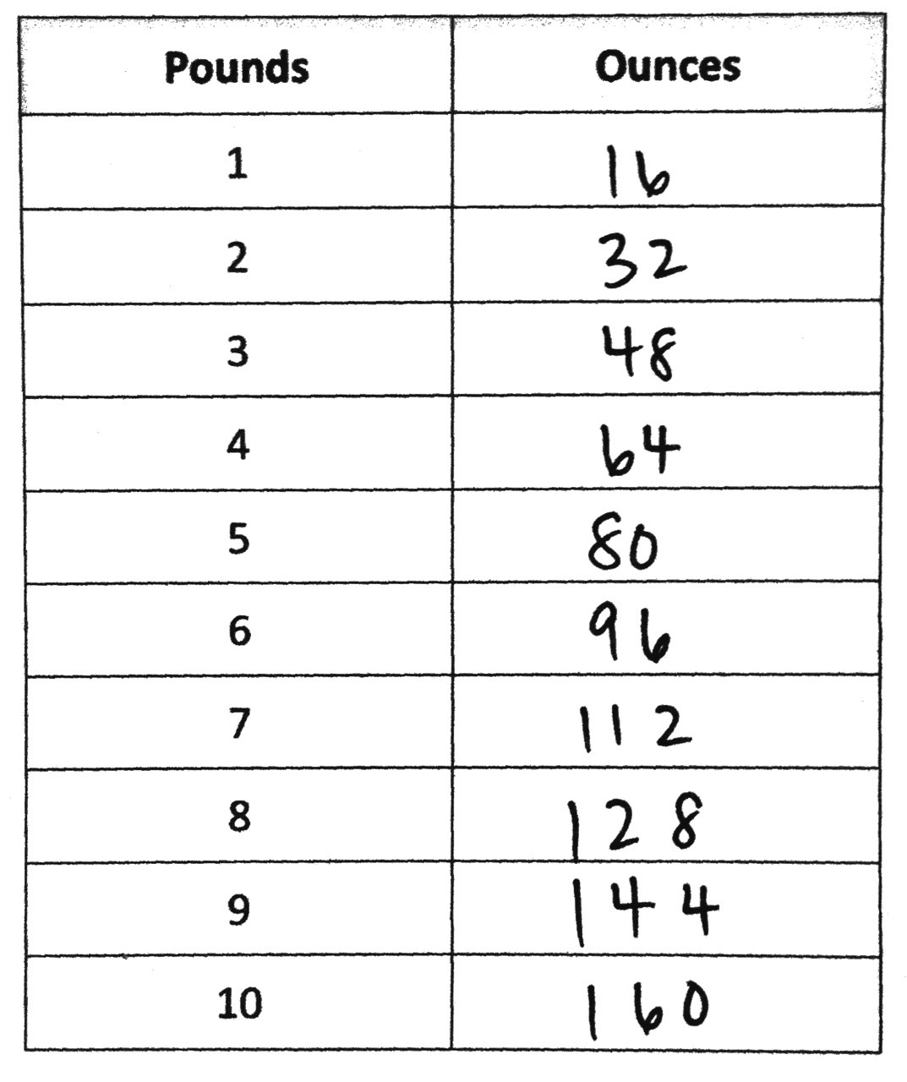
T: (Display the two-column table. Complete table together.) Now we know that 1 pound equals 16 ounces. Fill in the first line of the table.
T: How can we determine how many ounces are in 2 pounds?
S: We can add another 1-pound weight and see how many more 1-ounce weights we need to balance. We can just double 16 ounces or multiply by 2. 16 ounces times 2 is 32 ounces.
T: Fill in the rest of the conversion table for converting pounds to ounces. (Allow students time to work.)
MP.8
T: Looking at the table, what is the rule for converting pounds to ounces?
S: Keep adding 16. Take the number of pounds and multiply it by 16. 1 pound is 16 ounces.
T: How can we determine how many ounces are in 15 pounds?
S: We can make the table longer and go all the way to 15 pounds. We can multiply 15 pounds by 16. We can add the number of ounces in 10 pounds and 5 pounds together! We can multiply the number of ounces in 5 pounds by 3.

NOTES ON
MULTIPLE MEANS OF ENGAGEMENT:
Using alternative strategies to solve for ounces can engage students working below grade level. Assigning mixed-ability groups is also an option, but watch for stronger students assuming the role of calculating every product or sum. One strategy may be to solve for doubles. For example, if students find the number of ounces for 4 pounds, they can double that number to solve for 8 pounds, and so on. Give successful students working above grade level and others an opportunity to share their efficient strategies.

T: Take a moment to calculate the number of ounces in 15 pounds.
S: 15 pounds is equal to 240 ounces.
T: Convert 12 pounds 10 ounces into ounces. Discuss with your partner while working.
MP.8
S: First, we need to convert the pounds to ounces then add 10 ounces more. Let’s do 12$\text{×}$16 ounces and add 10 ounces. We can use the conversion table to add the ounces in 10 pounds and 2 pounds. Then we can add 10 ounces. 192 + 10 = 202 ounces.
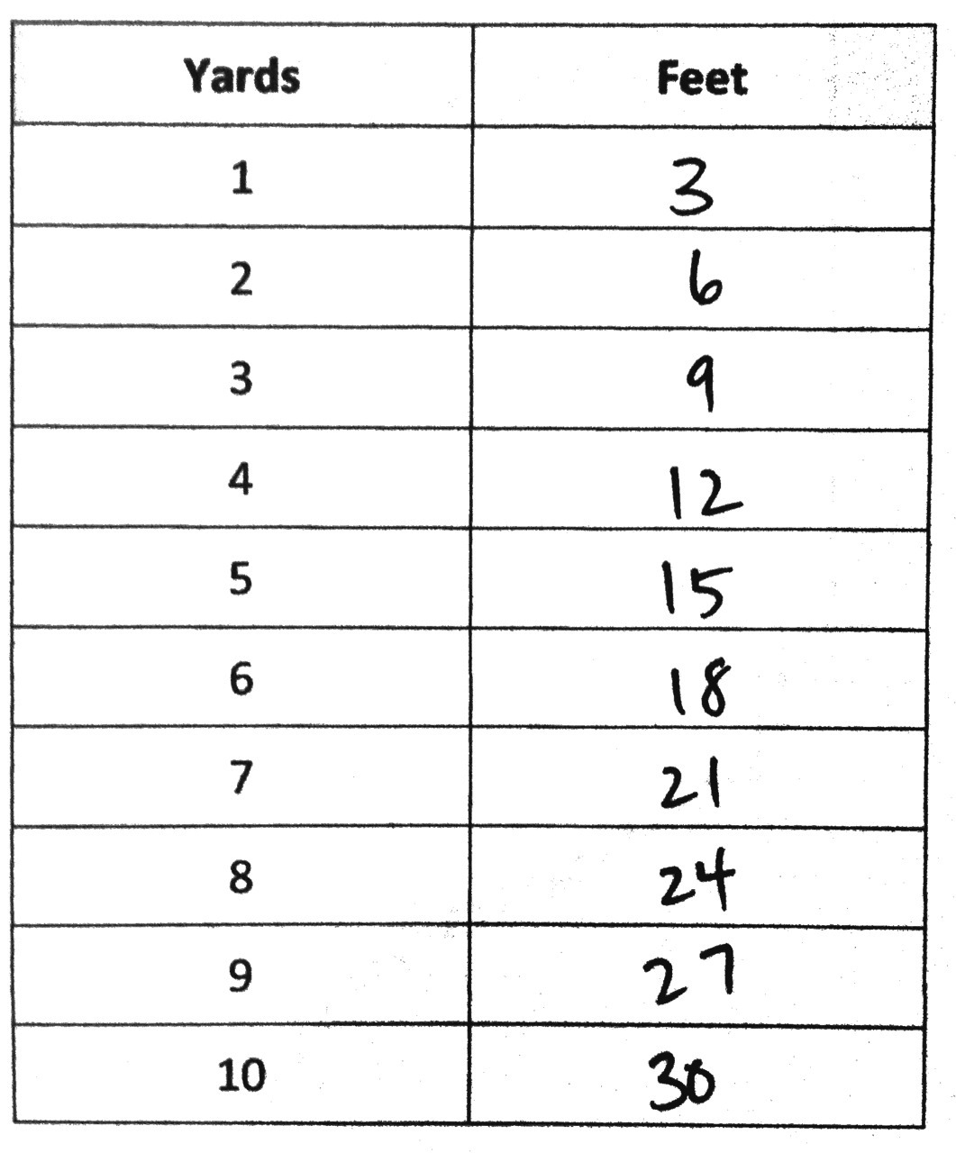
T: Pounds and ounces are part of a system called the customary system of measurement. In the United States, we’ve historically used customary units, such as pounds and ounces. In other countries, and more and more often in the U.S., the metric system of measurement is used. We studied and have used metric units this year when we solved word problems and converted kilometers to meters, kilograms to grams, and liters to milliliters.
Problem 2: Convert yards to feet.
T: In your groups, compare the yardstick to the foot ruler and share what you notice.
S: A yardstick is 36 inches where the ruler is 12 inches. It takes 3 rulers to be equal to 1 yardstick. 1 yard is 3 times as long as 1 foot.
T: (Display the two-column table. Complete table together.) On your Practice Sheet, fill in 1 yard equals 3 feet.
T: How many feet are in 2 yards?
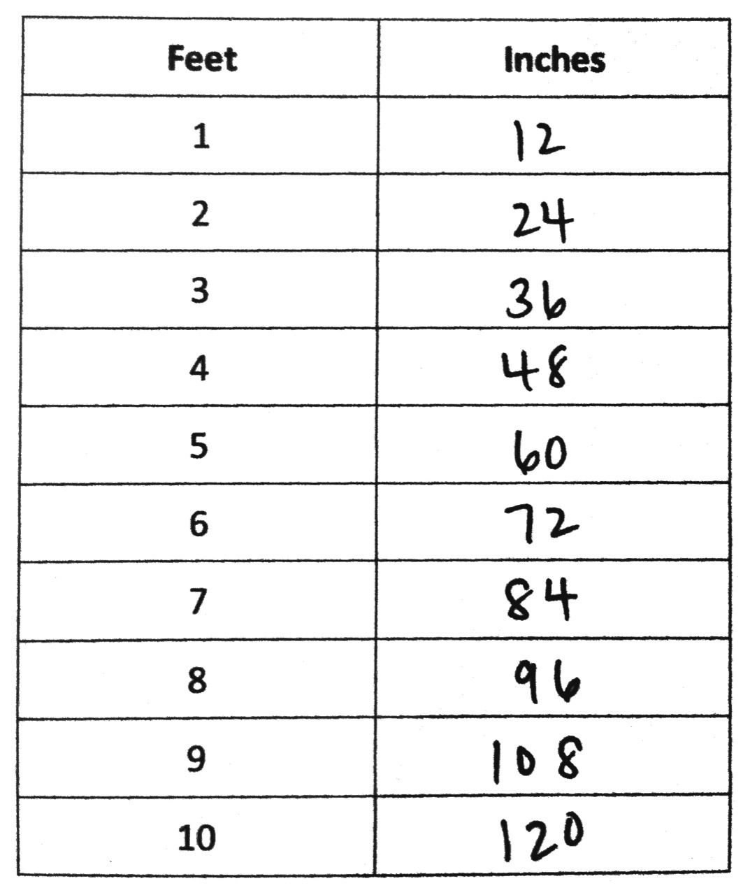
S: 6 feet!
T: Complete the table. (Allow students time to work.)
T: Now find the number of feet in 37 yards 2 feet. Work until you have found the answer and then share your strategy.
S: I multiplied 37 by 3 and added 2 feet. 111 feet + 2 feet is 113 feet. 37 yards = 30 yards + 7 yards = (3 $\text{×}$ 30 feet) + 21 feet = 111 feet. 111 feet + 2 feet = 113 feet.
Problem 3: Convert feet to inches.
T: In your groups, examine the ruler and share what you notice about the relationship between inches and feet.
S: Inches are smaller than feet. There are 12 inches in 1 foot.
T: We know that 1 foot equals 12 inches. On the table, fill in the first line.
T: Continue to fill out the table just like we did for the other units. (Allow students time to work.)
T: 1 foot is how many times the length of an inch?
S: 12 times.
T: Talk to your partner. How could you find out how many inches are in 20 feet?
S: We know that 10 feet equals 120 inches. We can just double 120 to get 240 inches in 20 feet. We could multiply 20 times 12 because there are 12 inches in 1 foot.
Follow up by having students find the number of inches in 6 feet 8 inches, 25 feet 5 inches, and 32 feet 7 inches.
Problem Set (10 minutes)
Students should do their personal best to complete the Problem Set within the allotted 10 minutes. Some problems do not specify a method for solving. This is an intentional reduction of scaffolding that invokes MP.5, Use Appropriate Tools Strategically. Students should solve these problems using the RDW approach used for Application Problems.
For some classes, it may be appropriate to modify the assignment by specifying which problems students should work on first. With this option, let the careful sequencing of the Problem Set guide your selections so that problems continue to be scaffolded. Balance word problems with other problem types to ensure a range of practice. Assign incomplete problems for homework or at another time during the day.
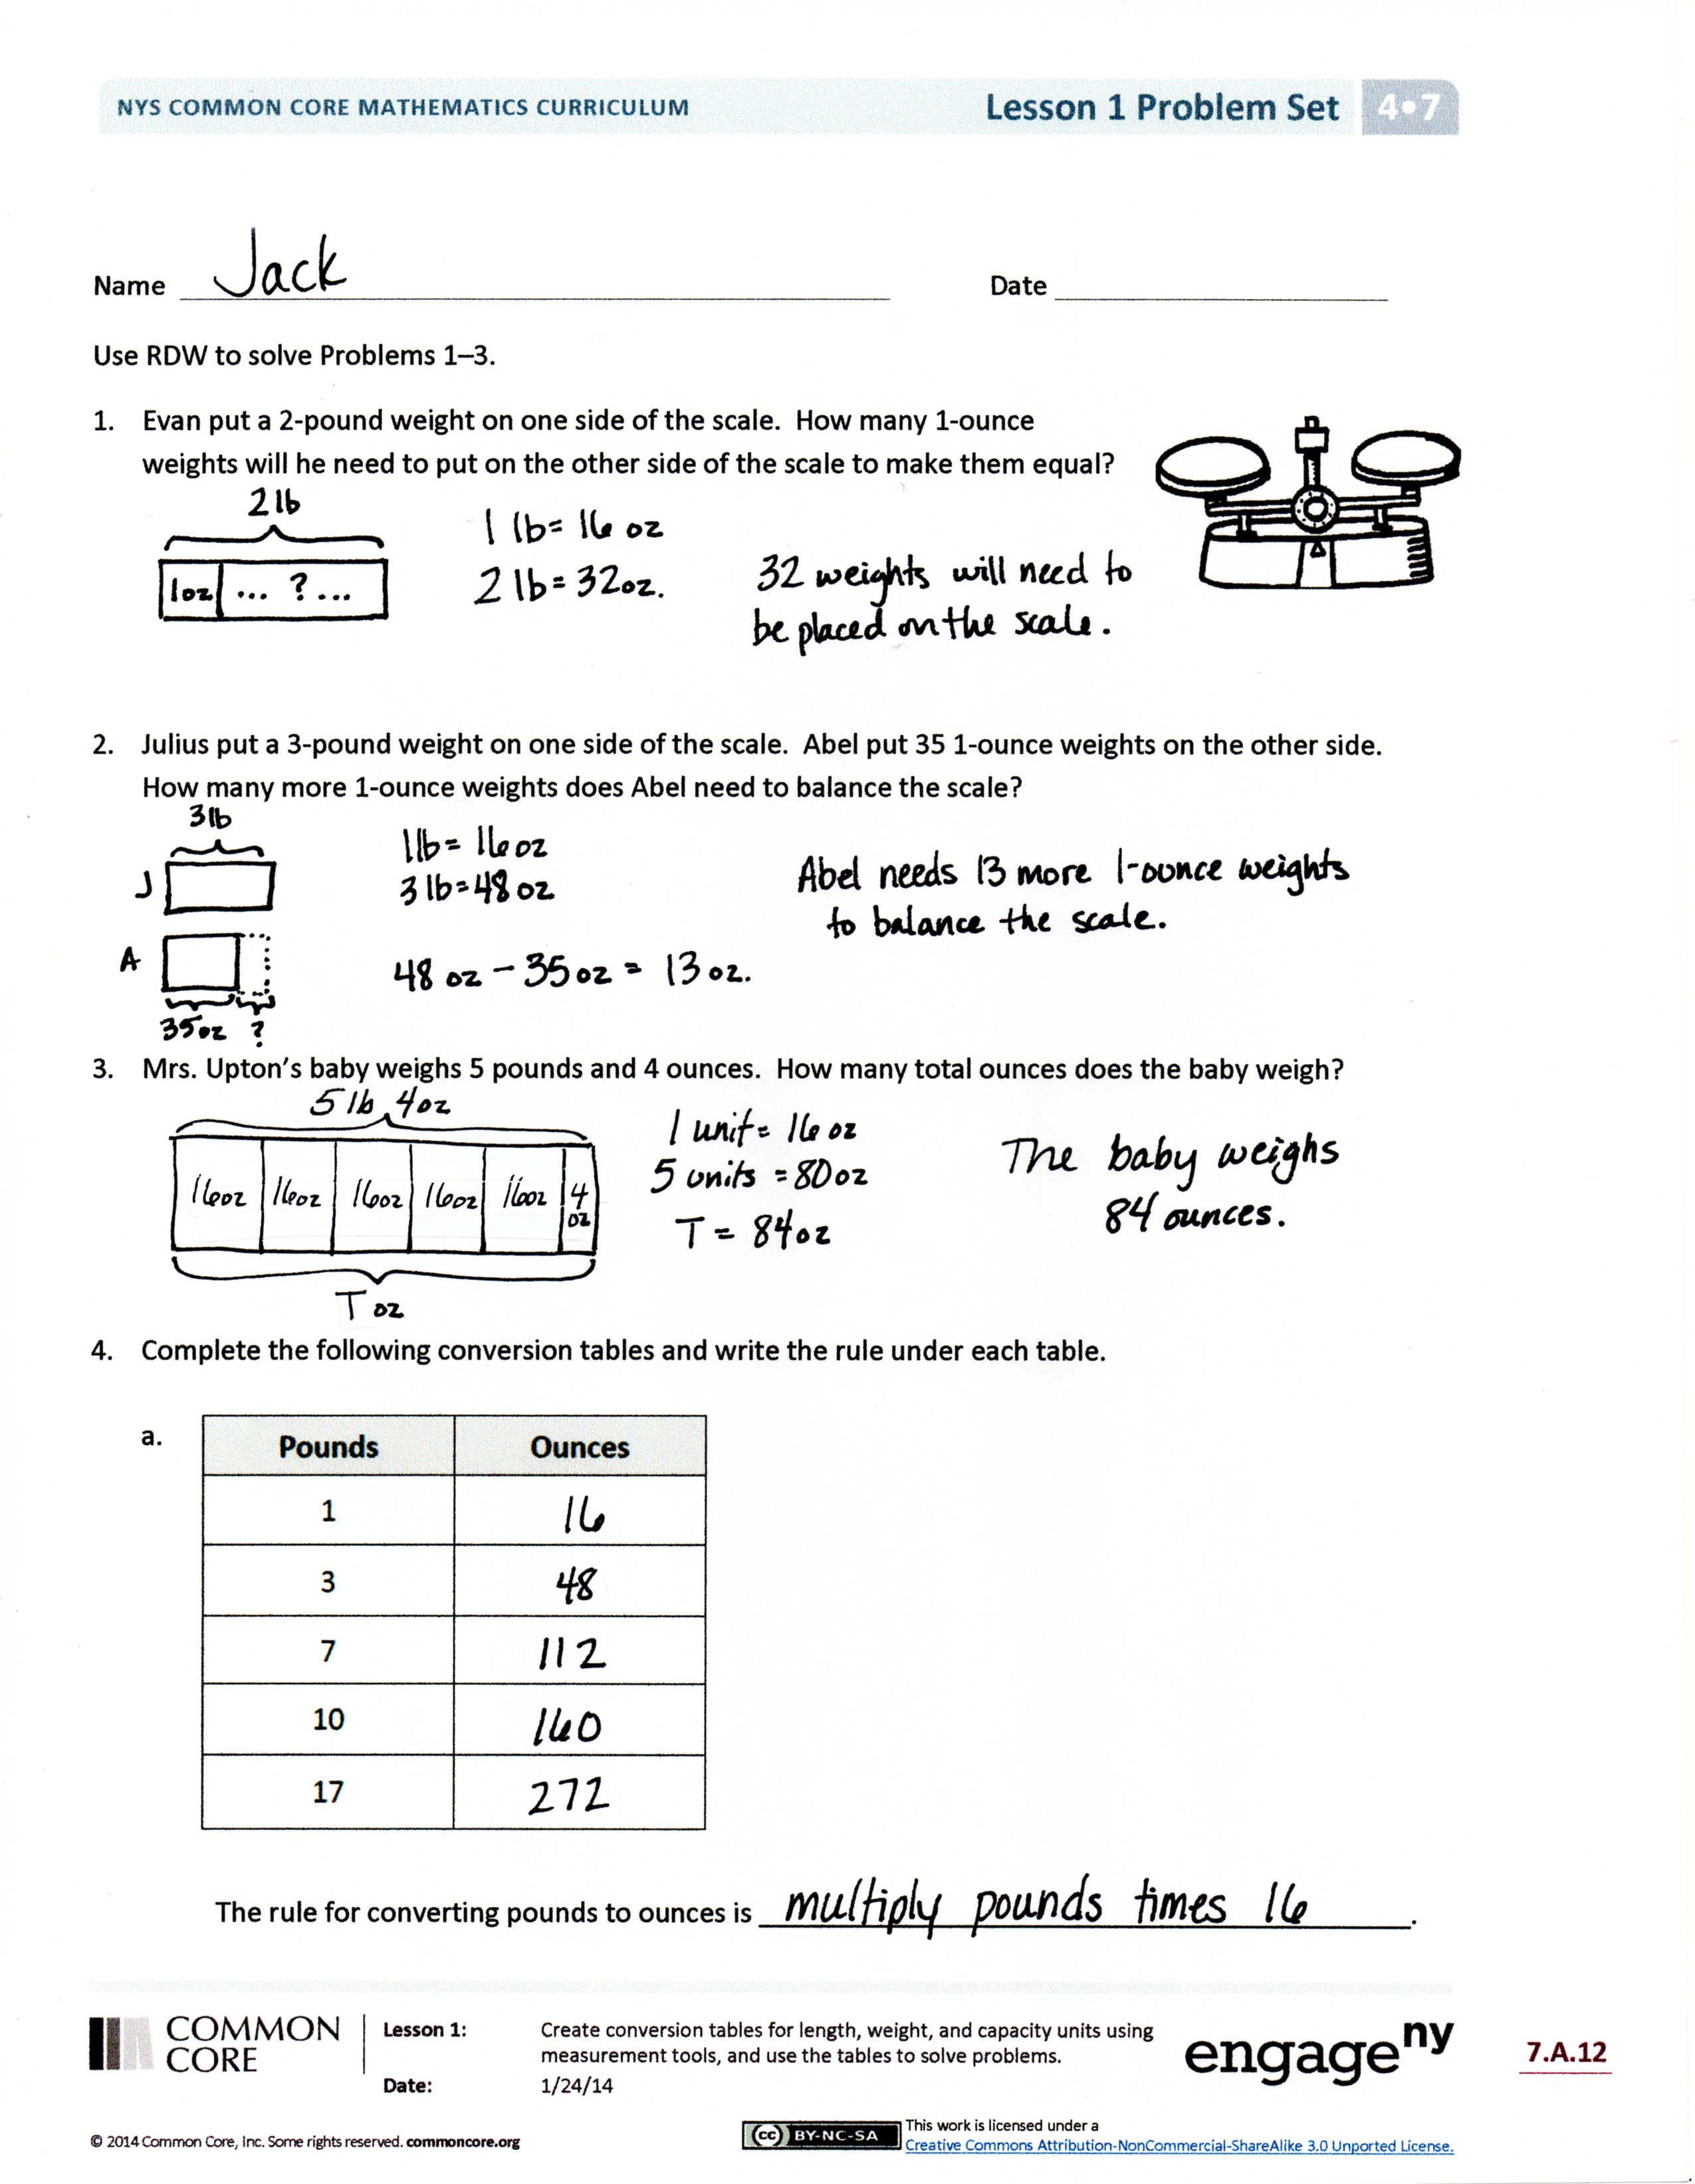
Student Debrief (10 minutes)
Lesson Objective: Create conversion tables for length, weight, and capacity units using measurement tools, and use the tables to solve problems.
The Student Debrief is intended to invite reflection and active processing of the total lesson experience.
Invite students to review their solutions for the Problem Set. They should check work by comparing answers with a partner before going over answers as a class. Look for misconceptions or misunderstandings that can be addressed in the Debrief. Guide students in a conversation to debrief the Problem Set and process the lesson.
You may choose to use any combination of the questions below to lead the discussion.
- What strategy did you use to solve Problem 2? Did you need the conversion table to help you convert pounds to ounces? If not, what rule did you use?
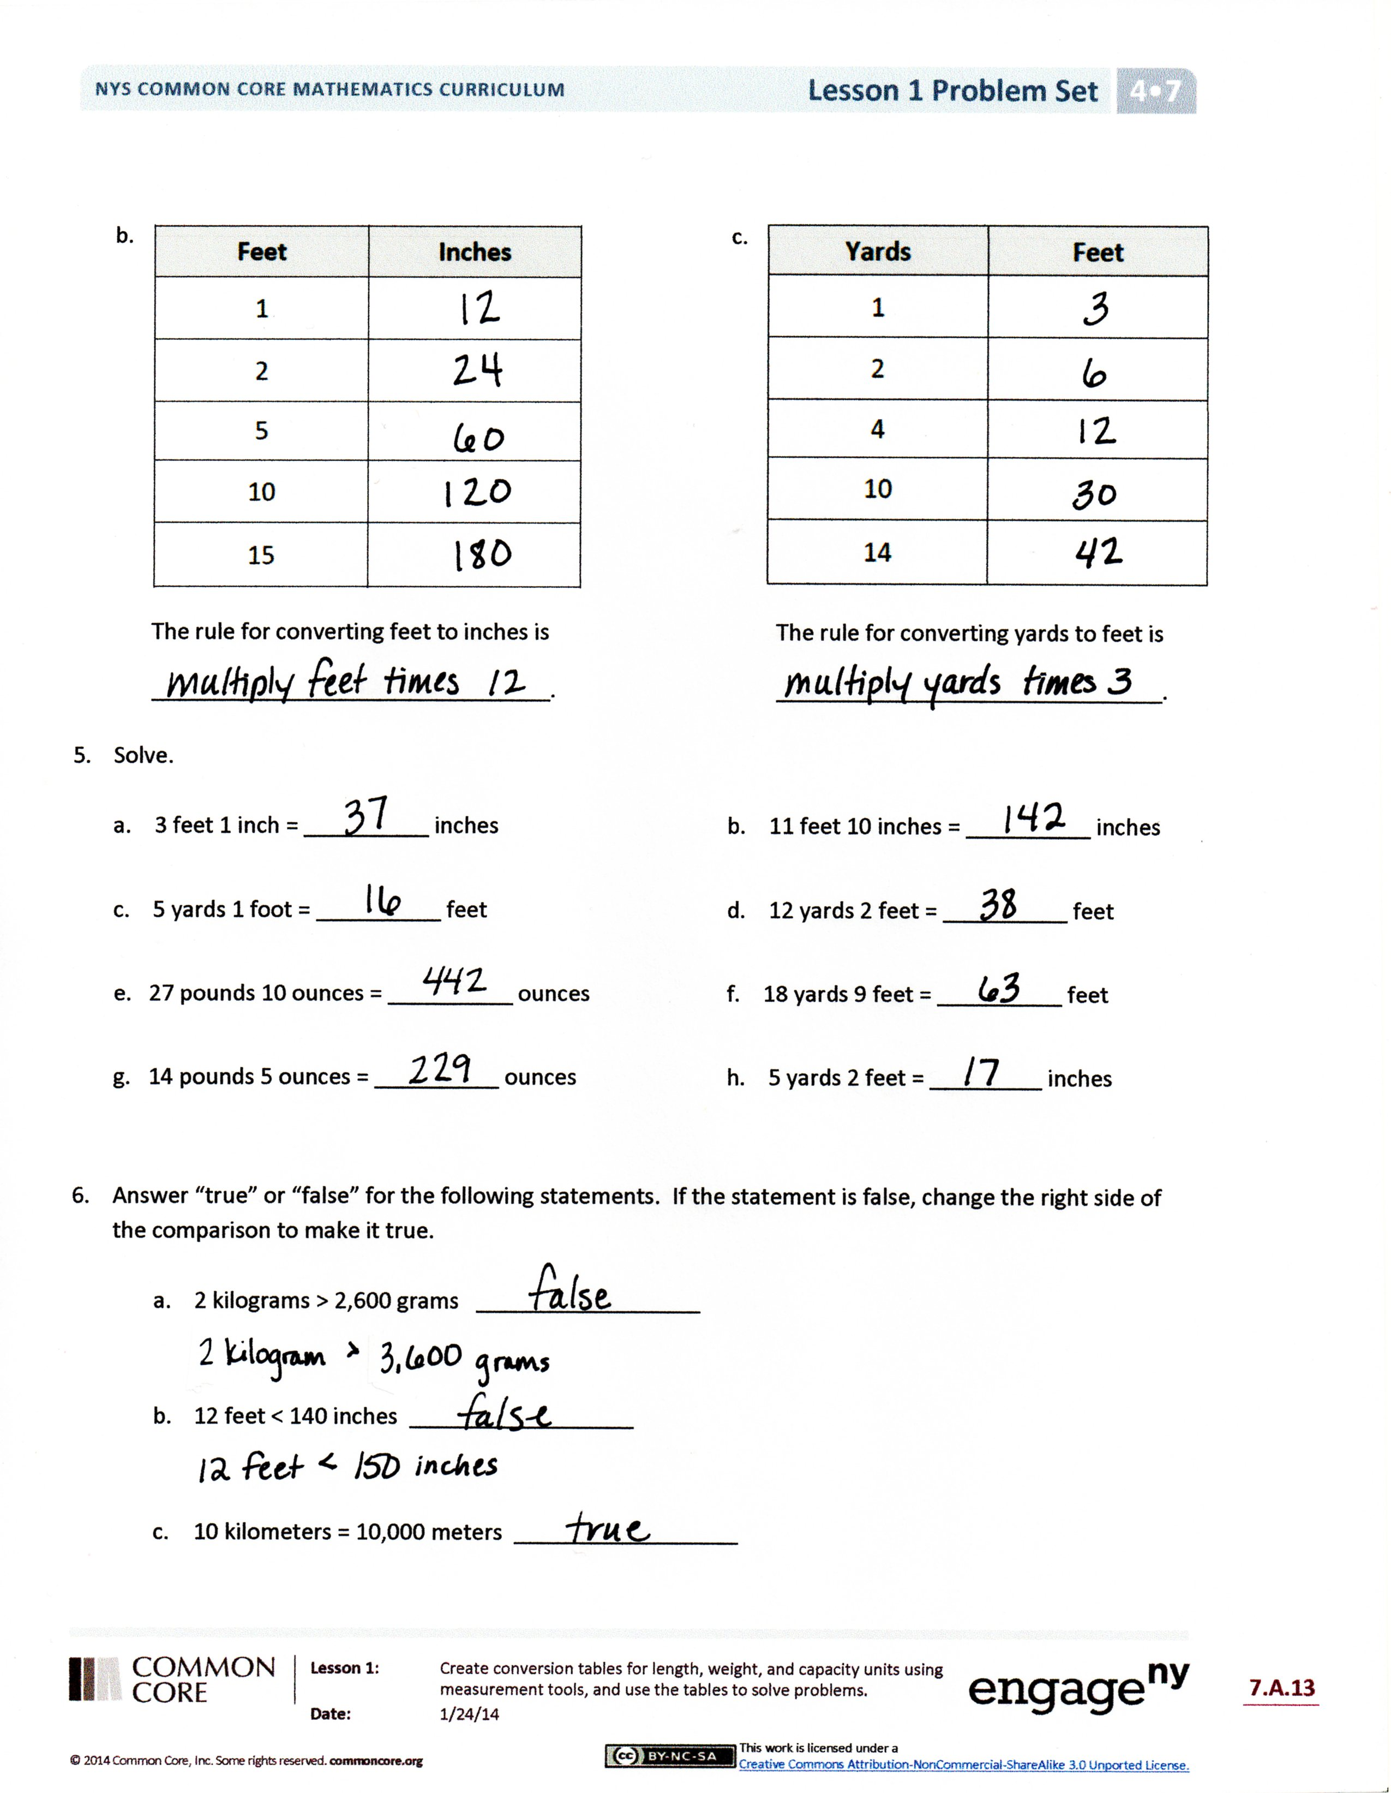
- Explain your solution for Problem 5(h) to your partner. Is there a rule for converting yards to inches?
- When might you need to compare units in real life like those in Problem 6?
- Looking at the conversion tables, what do you notice about the units that we are converting?
- Is it easier to use the conversion table or to use the rule to convert? Why?
- Name some units that are customary units. Name some units that are metric units.
- A yard and a meter are close in length, but not exactly the same. Yards are part of the customary system of measurement and meters are part of the metric system of measurement. Can you think of any other pairs that are close but not the same like this?
Exit Ticket (3 minutes)
After the Student Debrief, instruct students to complete the Exit Ticket. A review of their work will help you assess the students’ understanding of the concepts that were presented in the lesson today and plan more effectively for future lessons. You may read the questions aloud to the students.
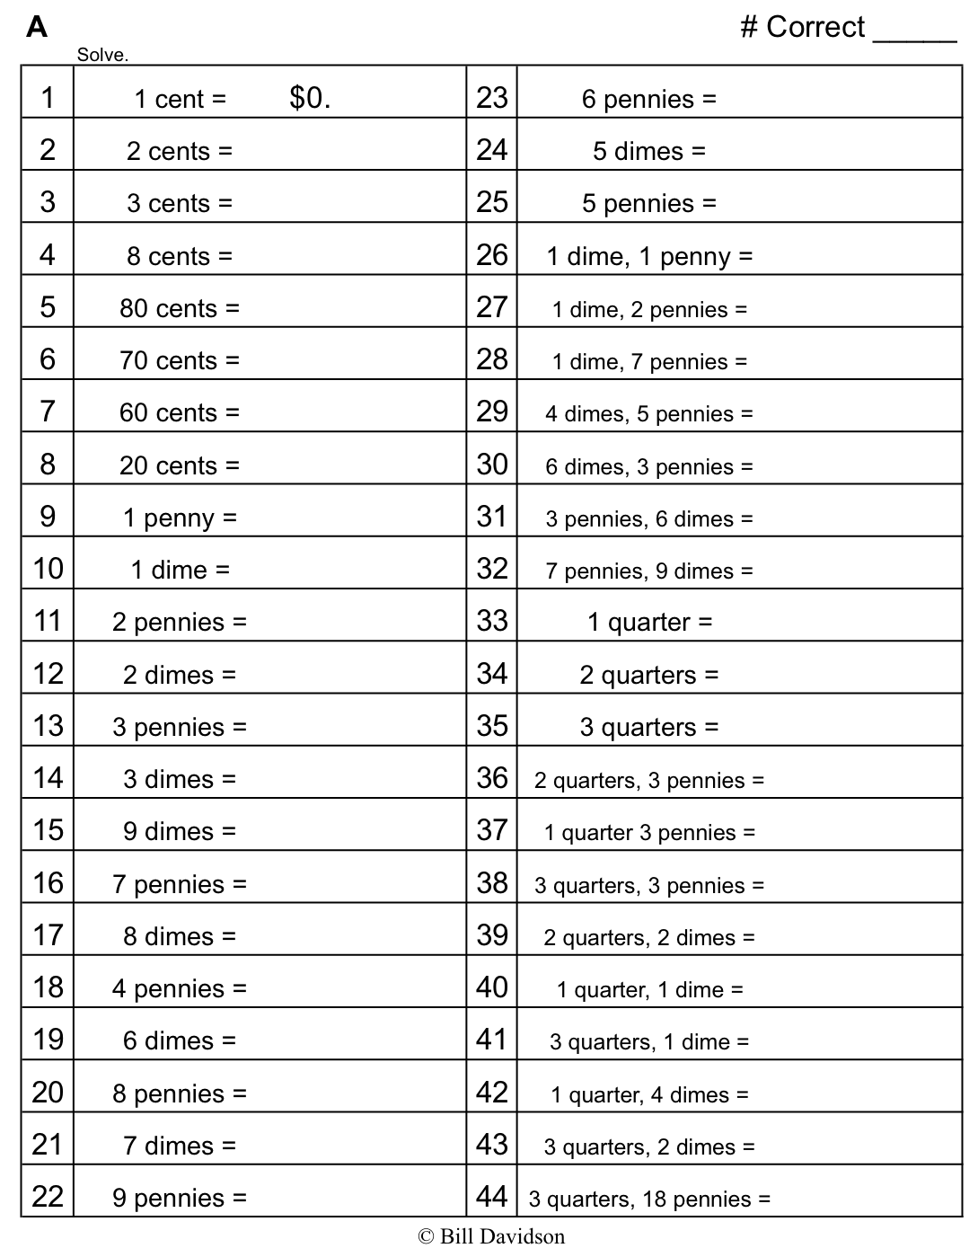
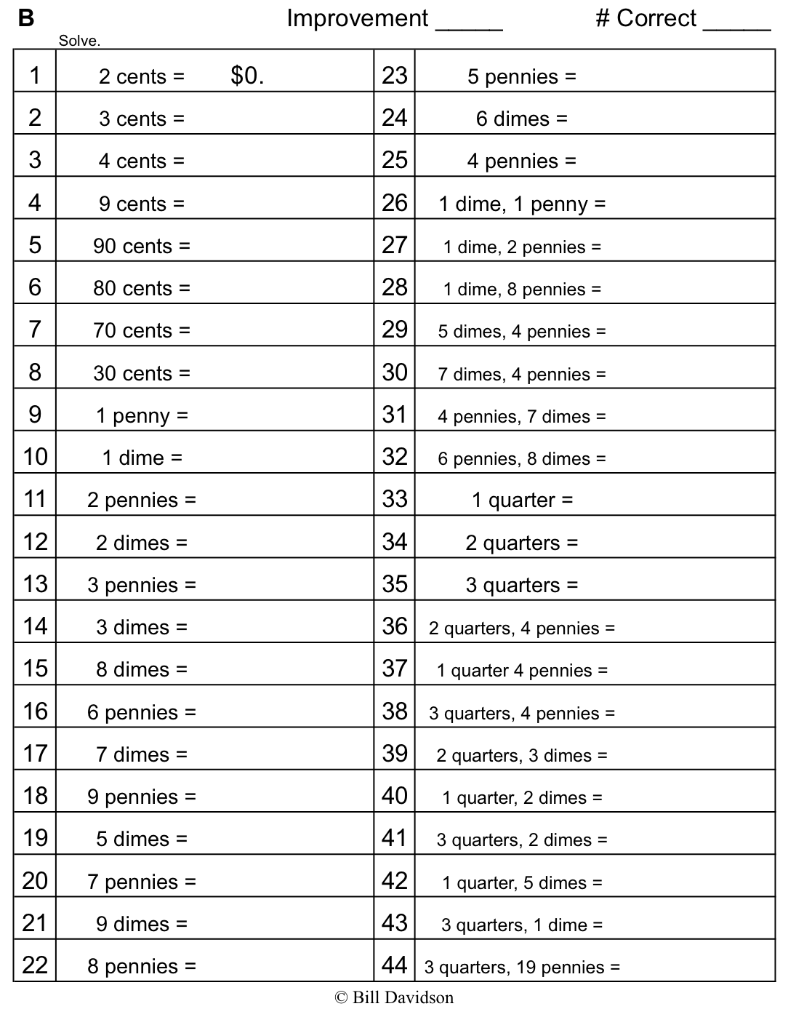

Name Date
Pounds | Ounces
1
2
3
4
5
6
7
8
9
10
The rule for converting pounds to ounces is _________________________________________.
Yards | Feet |  | Feet | Inches
1 |  |  | 1
2 |  |  | 2
3 |  |  | 3
4 |  |  | 4
5 |  |  | 5
6 |  |  | 6
7 |  |  | 7
8 |  |  | 8
9 |  |  | 9
10 |  |  | 10

The rule for converting yards to feet is The rule for converting feet to inches is
_______________________________________. _______________________________________.
Name Date
Use RDW to solve Problems 1–3.
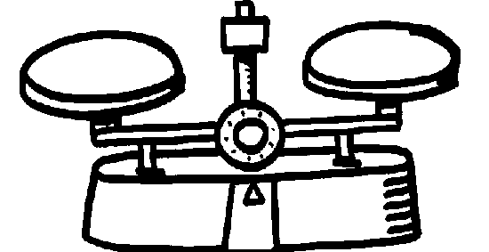
- Evan put a 2-pound weight on one side of the scale. How many 1-ounce weights will he need to put on the other side of the scale to make them equal?

- Julius put a 3-pound weight on one side of the scale. Abel put 35 1-ounce weights on the other side. How many more 1-ounce weights does Abel need to balance the scale?

- Mrs. Upton’s baby weighs 5 pounds and 4 ounces. How many total ounces does the baby weigh?

- Complete the following conversion tables and write the rule under each table.
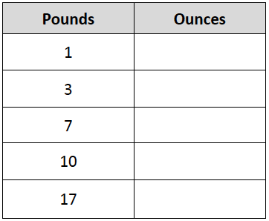
a.

The rule for converting pounds to ounces is ___________________________________________.
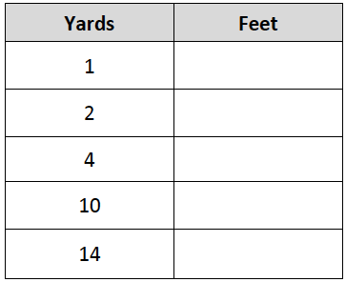
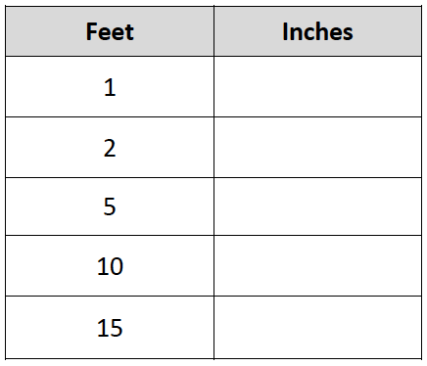
b. c.

The rule for converting yards to feet is
_______________________________.
The rule for converting feet to inches is
________________________________.

- Solve.

- 3 feet 1 inch = __________ inches b. 11 feet 10 inches = __________ inches
c. 5 yards 1 foot = __________ feet d. 12 yards 2 feet = __________ feet
e. 27 pounds 10 ounces = __________ ounces f. 18 yards 9 feet = __________ feet
g. 14 pounds 5 ounces = __________ ounces h. 5 yards 2 feet = _________ inches

- Answer “true” or “false” for the following statements. If the statement is false, change the right side of the comparison to make it true.

- 2 kilograms > 2,600 grams __________________

- 12 feet < 140 inches __________________

- 10 kilometers = 10,000 meters __________________
Name Date

- Solve.

- 8 feet = ______ inches

- 4 yards 2 feet = ______ feet

- 14 pounds 7 ounces = ______ ounces

- Answer “true” or “false” for the following statements. If the statement is false, change the right side of the comparison to make it true.

- 3 pounds > 60 ounces __________________

- 12 yards < 40 feet __________________

Name Date

- Complete the tables.
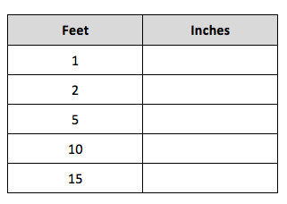
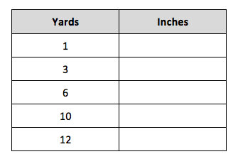
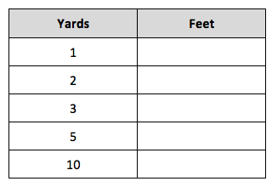

- Solve.
- 2 yards 2 inches = __________ inches b. 9 yards 10 inches = __________ inches
c. 4 yards 2 feet = __________ feet d. 13 yards 1 foot = __________ feet
e. 17 feet 2 inches = __________ inches f. 11 yards 1 foot = __________ feet
g. 15 yards 2 feet = __________ feet h. 5 yards 2 feet = __________ inches

- Ally has a piece of string that is 6 yards 2 feet long. How many inches of string does she have?

- Complete the table.
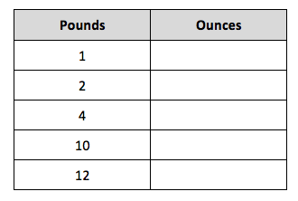

- Renee’s baby sister weighs 7 pounds 2 ounces. How many ounces does her sister weigh?

- Answer “true” or “false” for the following statements. If the statement is false, change the right side of the comparison to make it true.

- 4 kilograms < 4,100 grams __________________

- 10 yards < 360 inches __________________

- 10 liters = 100,000 milliliters __________________

