Lesson 1

Objective: Use metric measurement to model the decomposition of one whole into tenths.

Suggested Lesson Structure

 Fluency Practice (12 minutes)

 Concept Development (38 minutes)

 Student Debrief (10 minutes)

**Total Time (60 minutes)**

Fluency Practice (12 minutes)

* Divide by 10 **3.NBT.3** (4 minutes)
* Sprint: Divide by 10  **3.NBT.3** (8 minutes)

Divide by 10 (4 minutes)

Materials: (S) Personal white board

Note: This fluency activity prepares students for today’s lesson.

T: (Project a tape diagram with a value of 20 partitioned into 10 units.) Say the whole.

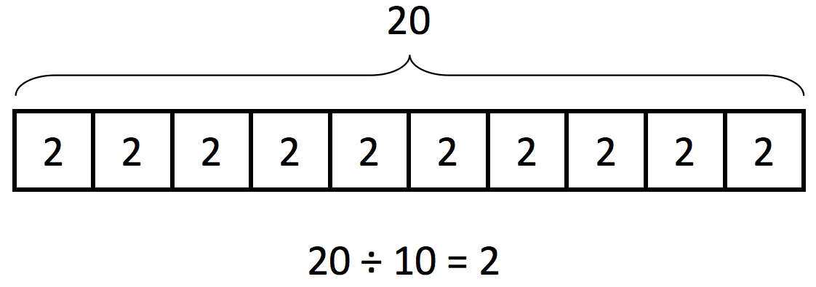S: 20.

T: How many units is 20 divided into?

S: 10.

T: Say the division sentence.

S: 20 ÷ 10 = 2.

T: (Write 2 inside each unit. Write 20 ÷ 10 = 2 beneath the diagram.)

Continue with the following possible sequence: 200 ÷ 10, 240 ÷ 10, 400 ÷ 10, 430 ÷ 10, 850 ÷ 10, 8,500 ÷ 10, 8,570 ÷ 10, and 6,280 ÷ 10.

Sprint: Divide by 10 (8 minutes)

Materials: (S) Divide by 10 Sprint

Note: This Sprint prepares students for today’s lesson.

Concept Development (38 minutes)

Materials: (T) 10 0.1-kilogram bags of rice, digital scale, 1-meter strip of paper, sticky notes, meter stick   
(S) Meter stick (per pair), blank meter strip of paper, centimeter ruler, markers or crayons, blank paper

Note: In preparing this lesson’s materials, consider the following. If a digital scale is not available, a pan balance can be used with 100-gram weights labeled as 0.1 kg. Cash register tape can be used to make meter strip papers. Use sticky notes to label each of the 10 1-meter strips of paper with one number: 0.1 m, 0.2 m, 0.3 m, …, 1.0 m.

Activity 1: Compose and decompose 1 kilogram, representing tenths in fraction form and decimal form.

T: (Place 10 bags of rice on the scale.) Here are 10 equal bags of rice. Together, all of this rice weighs  
1 kilogram.

T: Let’s draw a tape diagram to show the total amount of rice. Draw the tape as long as you can on your blank paper. What is our total amount?

S: 1 kilogram.

T: Let’s write 1 kg above the tape diagram to show that the whole tape represents 1 kilogram.

T: How can we represent the 10 equal bags on the tape diagram?

S: Make 10 equal parts.

T: Partition your tape diagram to show 10 equal parts. Each of these parts represents what fraction of the whole?

S: 1 tenth! (Divide the tape diagram into 10 equal parts.)

**MP.2**

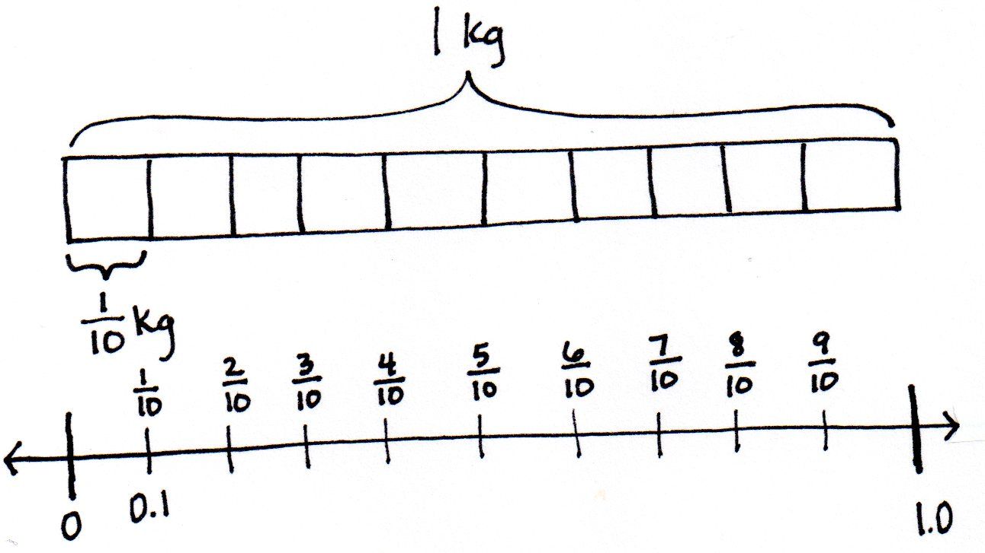

T: (Remove all bags from the scale. Hold 1 bag in front of the class.) What fractional part of 1 kilogram is 1 bag? Point to the part this 1 bag represents on your tape diagram.

S: (Point to 1 part.)

T: Let’s write the weight of this bag on your tape diagram. What is the weight of 1 bag?

S: kilogram.

T/S: (Write kg.)

T: (Place the second bag of rice in front of the class.) What is the weight of 2 bags?

S: kilogram.

Continue to count by tenths to compose 1 kilogram.

T: Let’s make a number line the same length as the tape diagram, and mark the tenths to match the parts of the tape diagram. Label the endpoints 0 and 1.

T: Let’s see what kilogram looks like on the scale. (Place 1 bag on the scale.) It says zero point one kilogram.

T: (Write 0.1 on the number line.) This is a **decimal number**. We read this decimal as 1 **tenth**, just like the fraction . The decimal form is written as zero point one. The dot in a decimal number is called a **decimal point**. (Write 1 tenth = = 0.1.) 1 tenth is written in unit form, as a **decimal fraction**, and as a decimal number. They are all equal.

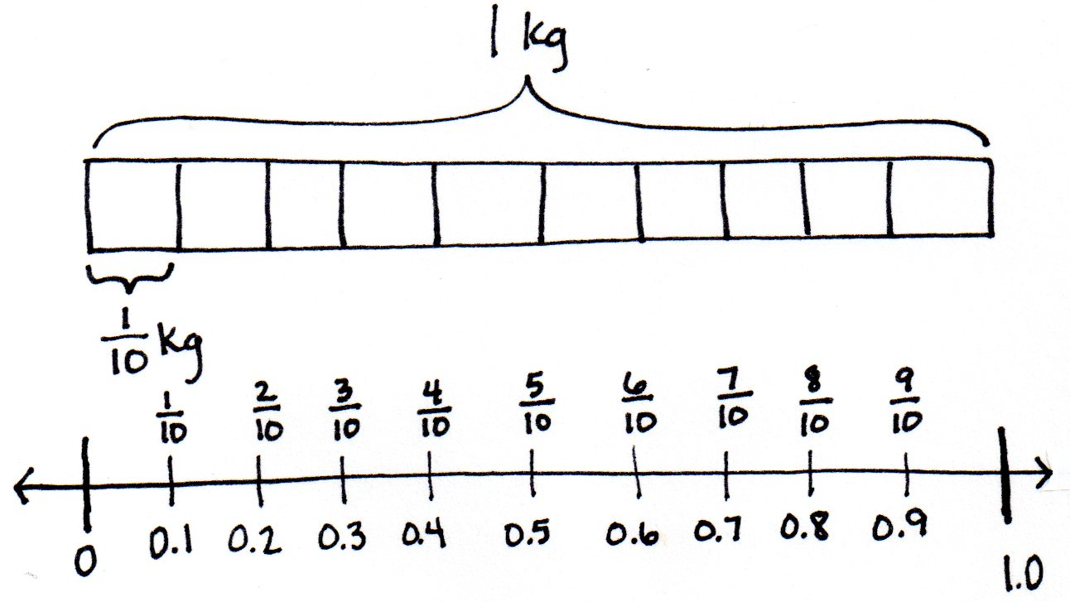T: Write 1 tenth in decimal form on your number line, just like I did.

S: (Write 0.1 on the number line.)

T: Let’s see how the number in decimal form changes as we add more bags or tenths of a kilogram.

T: We can express the weight of 1 bag two ways: zero point one kilogram, or 1 tenth kilogram. Tell me the weight of 2 bags using both ways. Start with the decimal point way.

S: Zero point two kilogram. 2 tenths kilogram.

T: (Invite a few students to the front of the room. Distribute two to three bags to each student.) As we add each bag, count and see how the scale shows the weight in decimal form, and record it on your number line.

|  |  |
| --- | --- |
|  | NOTES ON  MULTIPLE MEANS  OF ENGAGEMENT: |

Students who are not invited to place weights on the scale may enjoy shading units or placing counters in the tape diagram for each bag placed on the scale.

S/T: Zero point two kilogram, 2 tenths kilogram, zero point three kilogram, 3 tenths kilogram, …, zero point nine kilogram, 9 tenths kilogram, one point zero kilogram, 1 kilogram!

T: Notice the scale uses decimal form for 10 tenths. 10 tenths is equal to how many ones and how many tenths?

S: 1 one and 0 tenths.

T: So, we record that as 1 point 0. Revise your number line.

T: (Take off 2 bags showing 0.8 kg.) How many tenths are on the scale now?

S: 8 tenths kilogram.

T: Record the weight of 8 bags in fraction form and decimal form. Use an equal sign.

S: (Write kg = 0.8 kg.)

T: I have 2 bags in my hand. Write the weight of this amount of rice in fraction form and decimal form. Use an equal sign.

S: (Write kg = 0.2 kg.)

T: When I put together kilogram and kilogram, I have…?

S: 1 kilogram!

T: (Write 0.2 kilogram + 0.8 kilogram = 1 kilogram.) What other pairs of tenths would make 1 kilogram when put together?

S: kilogram and kilogram. 🡪 kilogram and kilogram.

As students share out pairs, write the number sentences using decimal form.

Activity 2: Decompose 1 meter, representing tenths in fraction form and decimal form.

Give each pair of students a meter stick and two to four strips of paper that are each 1 meter long. Ask them to use their meter sticks to divide each paper strip into 10 equal parts. Have them then shade with markers or crayons to show different numbers of tenths. As they work, collect strips to make an ordered set on the board, starting with   
1 meter to show 10 tenths, 9 tenths, etc. Generate and record the partner each strip needs to make 1 meter next to each strip, e.g., 0.9 meter + 0.1 meter = 1 meter. Have the students then generate two or three equivalent number sentences showing the equality of fraction form and decimal form, e.g., meter = 0.1 meter.

**Meter Stick**

**2 Examples of Shaded Paper Strips:**

4 tenths shaded

0.4 meter + 0.6 meter = 1 meter

9 tenths shaded

0.9 meter + 0.1 meter = 1 meter



Activity 3: Decompose 1 centimeter, representing tenths in fraction form and decimal form.

T: Now that we have practiced decomposing a meter into tenths, let’s use that same thinking to decompose a centimeter into tenths.

|  |  |
| --- | --- |
|  | NOTES ON  MULTIPLE MEANS  OF REPRESENTATION: |
| Students with low vision or other perceptual challenges may find drawing a 1-centimeter line and deciphering millimeters difficult. A centimeter stencil that students can easily trace may be beneficial. In addition to having students interact with a to-scale centimeter (such as a cube), it may help to project teacher modeling with an overhead projector or document camera, if available. | |

T: Take out your centimeter ruler, and draw a   
1-centimeter line on the blank paper.

S: (Draw.)

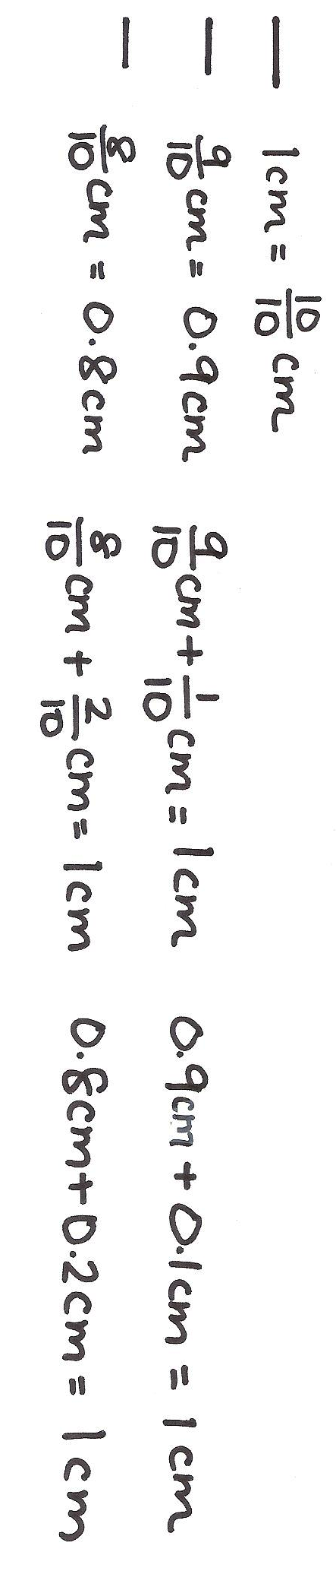T: Each centimeter has been partitioned into equal parts. How many equal parts are there from 0 to 1 centimeter?

S: 10 parts.

T: What fraction of a centimeter is one part?

S: 1 tenth.

T: How many units of 1 tenth equal 1 centimeter?

S: 10 tenths.

T: Label your line. 1 cm = cm.

T: Below your line, make a line that measures centimeter. Label your line in fraction form and decimal form.

S: (Draw a line 0.9 cm in length. Write cm = 0.9 cm.)

T: How many more tenths of a centimeter do we need to have 1 centimeter?

S: We would need 0.1 cm more.

T: (Write cm + cm = 1 cm and 0.9 cm + 0.1 cm = 1.0 cm.)

T: Now, draw a line below these lines that measures centimeter. Label this new line in fraction and decimal form. Write an addition sentence in both fraction and decimal form to show how many more tenths of a centimeter you need to get to 1 centimeter.

S: (Draw and label cm and 0.8 cm. Write cm + cm = 1 cm and 0.8 cm + 0.2 cm = 1.0 cm.)

T: Continue writing more pairs as you work, making a line that is centimeter shorter each time.

Select students to share so that the fraction form and decimal form of the number sentence are presented to the class.

Problem Set (10 minutes)

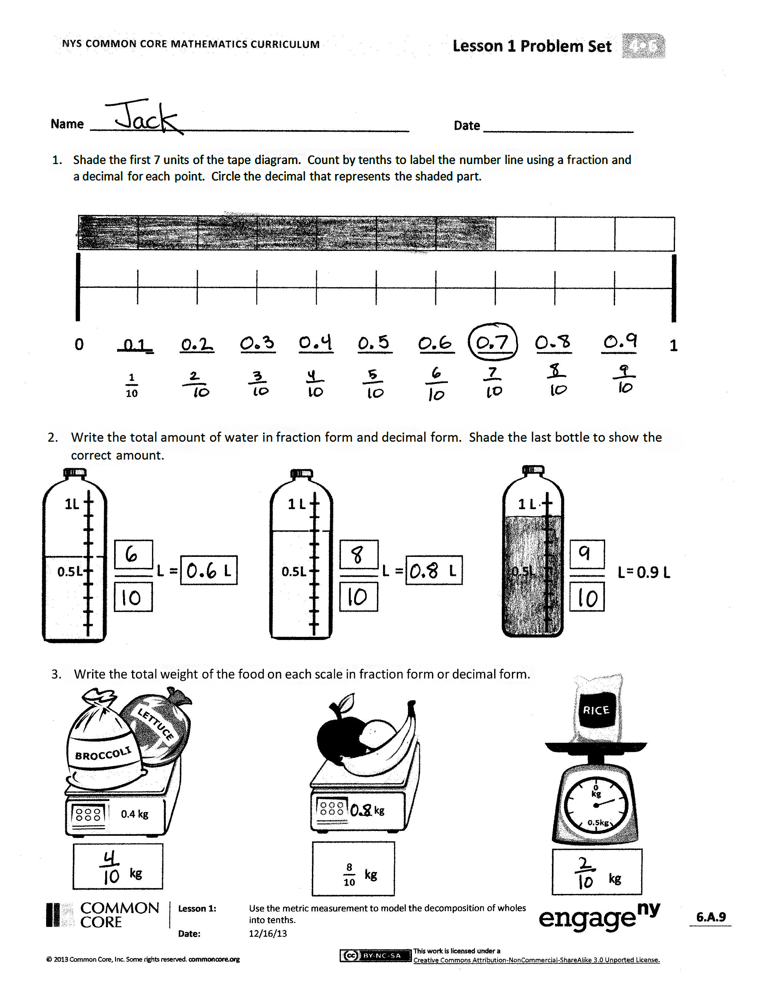Students should do their personal best to complete the Problem Set within the allotted 10 minutes. Some problems do not specify a method for solving. This is an intentional reduction of scaffolding that invokes MP.5, Use Appropriate Tools Strategically. Students should solve these problems using the RDW approach used for Application Problems.

For some classes, it may be appropriate to modify the assignment by specifying which problems students should work on first. With this option, let the purposeful sequencing of the Problem Set guide the selections so that problems continue to be scaffolded. Balance word problems with other problem types to ensure a range of practice. Consider assigning incomplete problems for homework or at another time during the day.

Student Debrief (10 minutes)

**Lesson Objective:** Use metric measurement to model the decomposition of one whole into tenths.

The Student Debrief is intended to invite reflection and active processing of the total lesson experience.

Invite students to review their solutions for the Problem Set. They should check work by comparing answers with a partner before going over answers as a class. Look for misconceptions or misunderstandings that can be addressed in the Debrief. Guide students in a conversation to debrief the Problem Set and process the lesson.

Any combination of the questions below may be used to lead the discussion.

* In Problem 2, 8 tenths liter was represented. How is that different from the 8 tenths kilogram in Problem 3? How is representing 8 tenths liter similar to representing 8 tenths kilogram?
* 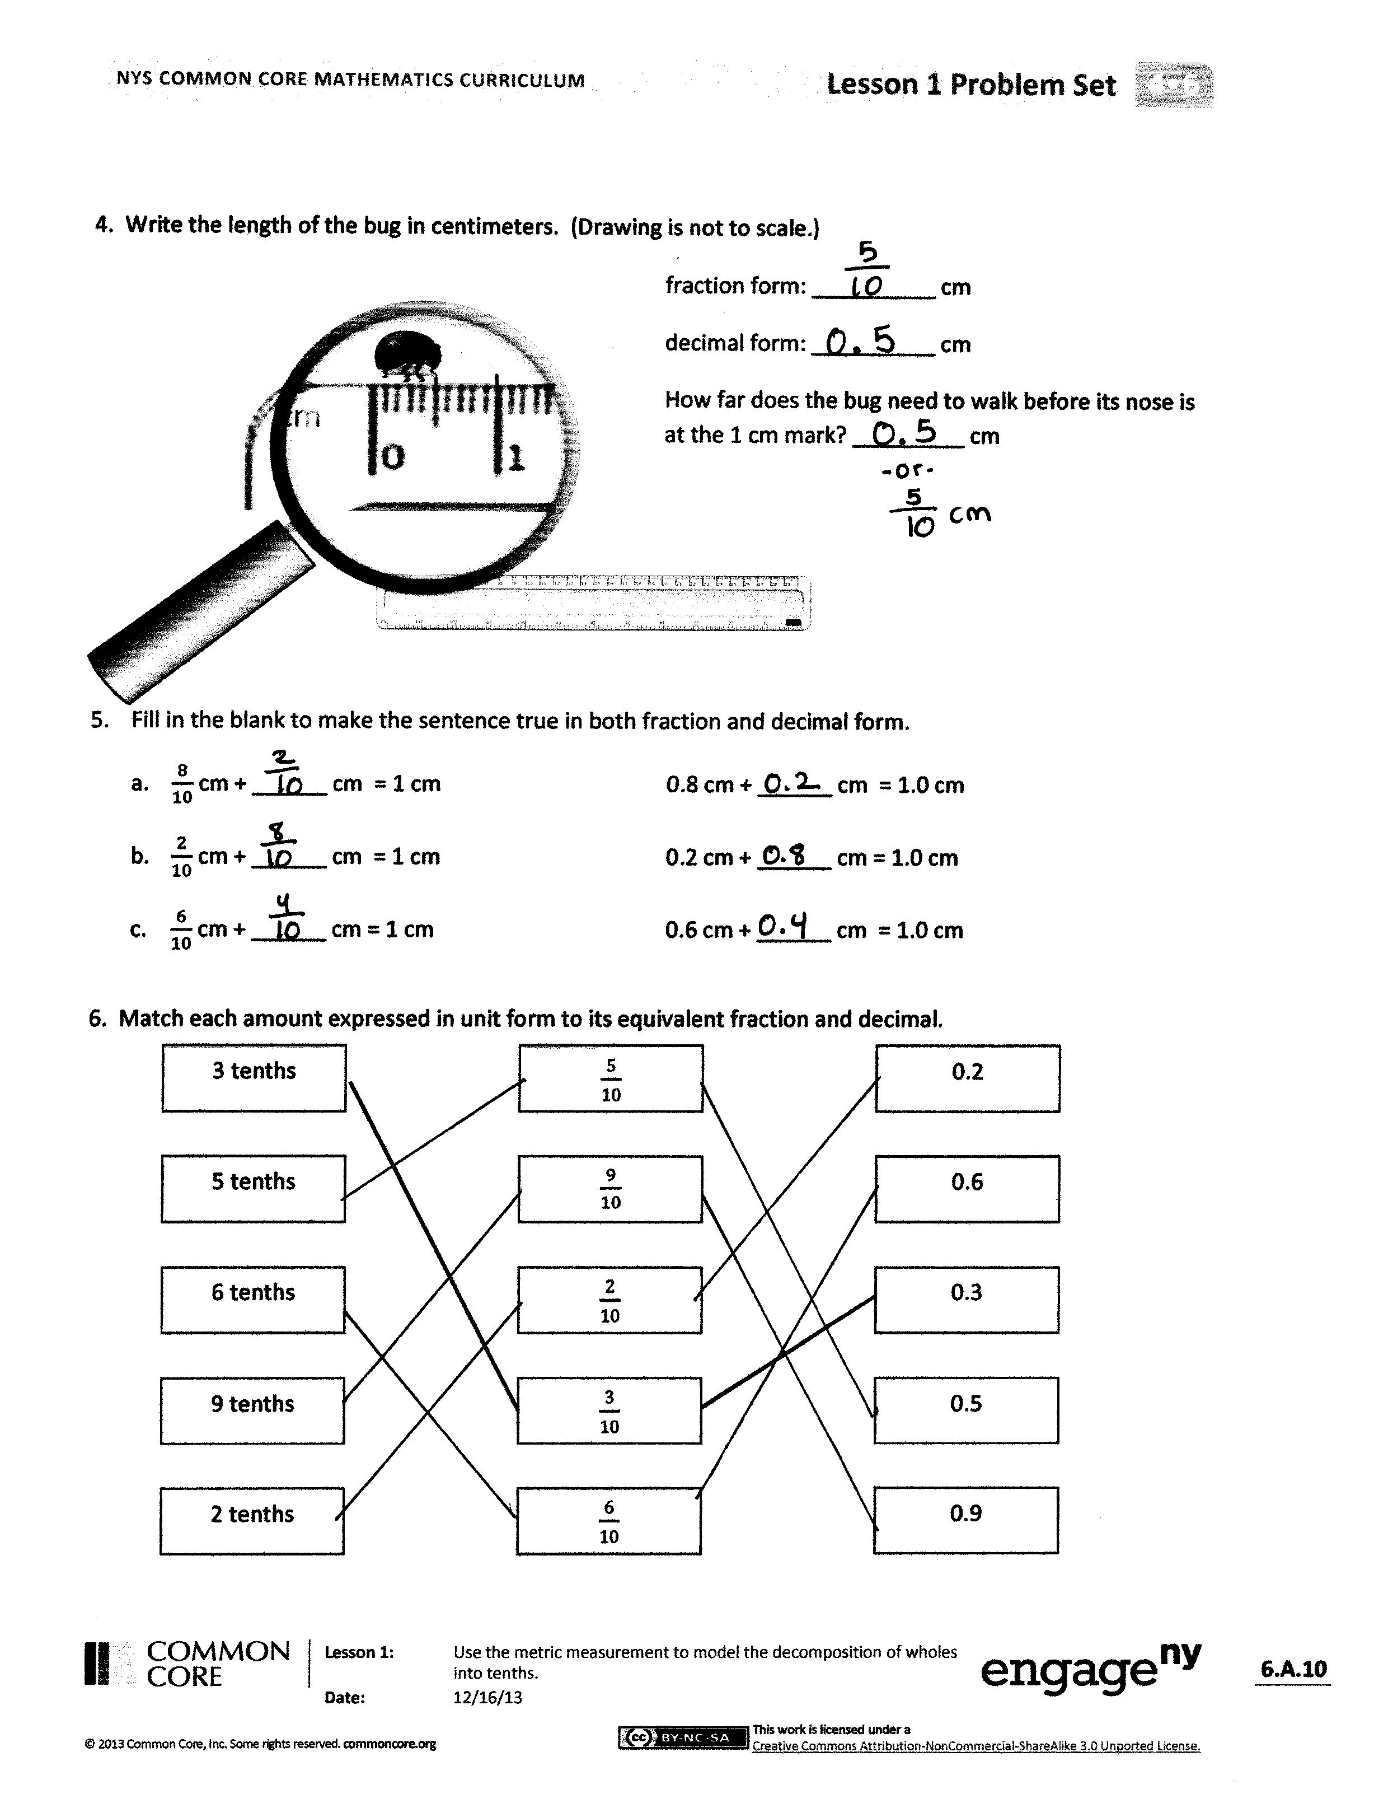In Problem 2, we measured liters of water. What other type of material might we be measuring when we measure 6 tenths of a liter? Where have you seen or used liters in your everyday life?
* Look at Problem 5. How is getting to   
  1 centimeter similar to getting to 10,as you did in earlier grades? How did getting to 10 help you in the past? How do you think getting to 1 might help you now?
* What relationship does 1 **tenth** have to 1?
* How did your work with **decimal fractions** like , , or prepare you for this lesson?
* Today, we studied **decimal** **numbers,** and we wrote them in fraction form and decimal form. How are the two forms alike? How are they different?
* What purpose does a **decimal point** serve?
* During Fluency Practice, you divided numbers by 10. How did today’s work of dividing one whole into parts relate to your fluency work? When you divide 20 by 10, what is your equal unit? When you divide 1 into 10 equal parts, what is your equal unit?

Exit Ticket (3 minutes)

After the Student Debrief, instruct students to complete the Exit Ticket. A review of their work will help with assessing students’ understanding of the concepts that were presented in today’s lesson and planning more effectively for future lessons. The questions may be read aloud to the students.

**A**

Number Correct: _______

Divide by 10

|  |  |  |  |  |  |  |
| --- | --- | --- | --- | --- | --- | --- |
|  | 20 ÷ 10 = |  |  |  | 50 ÷ 10 = |  |
|  | 30 ÷ 10 = |  |  |  | 850 ÷ 10 = |  |
|  | 40 ÷ 10 = |  |  |  | 1,850 ÷ 10 = |  |
|  | 80 ÷ 10 = |  |  |  | 70 ÷ 10 = |  |
|  | 50 ÷ 10 = |  |  |  | 270 ÷ 10 = |  |
|  | 90 ÷ 10 = |  |  |  | 4,270 ÷ 10 = |  |
|  | 70 ÷ 10 = |  |  |  | 90 ÷ 10 = |  |
|  | 60 ÷ 10 = |  |  |  | 590 ÷ 10 = |  |
|  | 10 ÷ 10 = |  |  |  | 7,590 ÷ 10 = |  |
|  | 100 ÷ 10 = |  |  |  | 120 ÷ 10 = |  |
|  | 20 ÷ 10 = |  |  |  | 1,200 ÷ 10 = |  |
|  | 120 ÷ 10 = |  |  |  | 2,000 ÷ 10 = |  |
|  | 50 ÷ 10 = |  |  |  | 240 ÷ 10 = |  |
|  | 150 ÷ 10 = |  |  |  | 2,400 ÷ 10 = |  |
|  | 80 ÷ 10 = |  |  |  | 4,000 ÷ 10 = |  |
|  | 180 ÷ 10 = |  |  |  | 690 ÷ 10 = |  |
|  | 280 ÷ 10 = |  |  |  | 6,900 ÷ 10 = |  |
|  | 380 ÷ 10 = |  |  |  | 9,000 ÷ 10 = |  |
|  | 680 ÷ 10 = |  |  |  | 940 ÷ 10 = |  |
|  | 640 ÷ 10 = |  |  |  | 5,280 ÷ 10 = |  |
|  | 870 ÷ 10 = |  |  |  | 6,700 ÷ 10 = |  |
|  | 430 ÷ 10 = |  |  |  | 7,000 ÷ 10 = |  |

**B**

**[KEY]**

Number Correct: _______

Improvement: _______

Divide by 10

|  |  |  |  |  |  |  |
| --- | --- | --- | --- | --- | --- | --- |
|  | 10 ÷ 10 = |  |  |  | 40 ÷ 10 = |  |
|  | 20 ÷ 10 = |  |  |  | 840 ÷ 10 = |  |
|  | 30 ÷ 10 = |  |  |  | 1,840 ÷ 10 = |  |
|  | 70 ÷ 10 = |  |  |  | 80 ÷ 10 = |  |
|  | 40 ÷ 10 = |  |  |  | 80 ÷ 10 = |  |
|  | 80 ÷ 10 = |  |  |  | 4,280 ÷ 10 = |  |
|  | 60 ÷ 10 = |  |  |  | 60 ÷ 10 = |  |
|  | 50 ÷ 10 = |  |  |  | 560 ÷ 10 = |  |
|  | 90 ÷ 10 = |  |  |  | 7,560 ÷ 10 = |  |
|  | 100 ÷ 10 = |  |  |  | 130 ÷ 10 = |  |
|  | 30 ÷ 10 = |  |  |  | 1,300 ÷ 10 = |  |
|  | 130 ÷ 10 = |  |  |  | 3,000 ÷ 10 = |  |
|  | 60 ÷ 10 = |  |  |  | 250 ÷ 10 = |  |
|  | 160 ÷ 10 = |  |  |  | 2,500 ÷ 10 = |  |
|  | 90 ÷ 10 = |  |  |  | 5,000 ÷ 10 = |  |
|  | 190 ÷ 10 = |  |  |  | 740 ÷ 10 = |  |
|  | 290 ÷ 10 = |  |  |  | 7,400 ÷ 10 = |  |
|  | 390 ÷ 10 = |  |  |  | 4,000 ÷ 10 = |  |
|  | 690 ÷ 10 = |  |  |  | 910 ÷ 10 = |  |
|  | 650 ÷ 10 = |  |  |  | 5,820 ÷ 10 = |  |
|  | 860 ÷ 10 = |  |  |  | 7,600 ÷ 10 = |  |
|  | 420 ÷ 10 = |  |  |  | 6,000 ÷ 10 = |  |

Name Date

1. Shade the first 7 units of the tape diagram. Count by tenths to label the number line using a fraction and a decimal for each point. Circle the decimal that represents the shaded part.

|  |  |  |  |  |  |  |  |  |  |
| --- | --- | --- | --- | --- | --- | --- | --- | --- | --- |
|  |  |  |  |  |  |  |  |  |  |

|  |  |  |  |  |  |  |  |  |  |
| --- | --- | --- | --- | --- | --- | --- | --- | --- | --- |
|  |  |  |  |  |  |  |  |  |  |
|  |  |  |  |  |  |  |  |  |  |
|  |  |  |  |  |  |  |  |  |  |
|  |  |  |  |  |  |  |  |  |  |

0

1

_____

_____

_____

_____

_____

_____

_____

0.1 ____

_____

1. 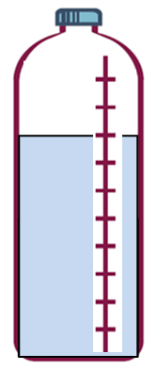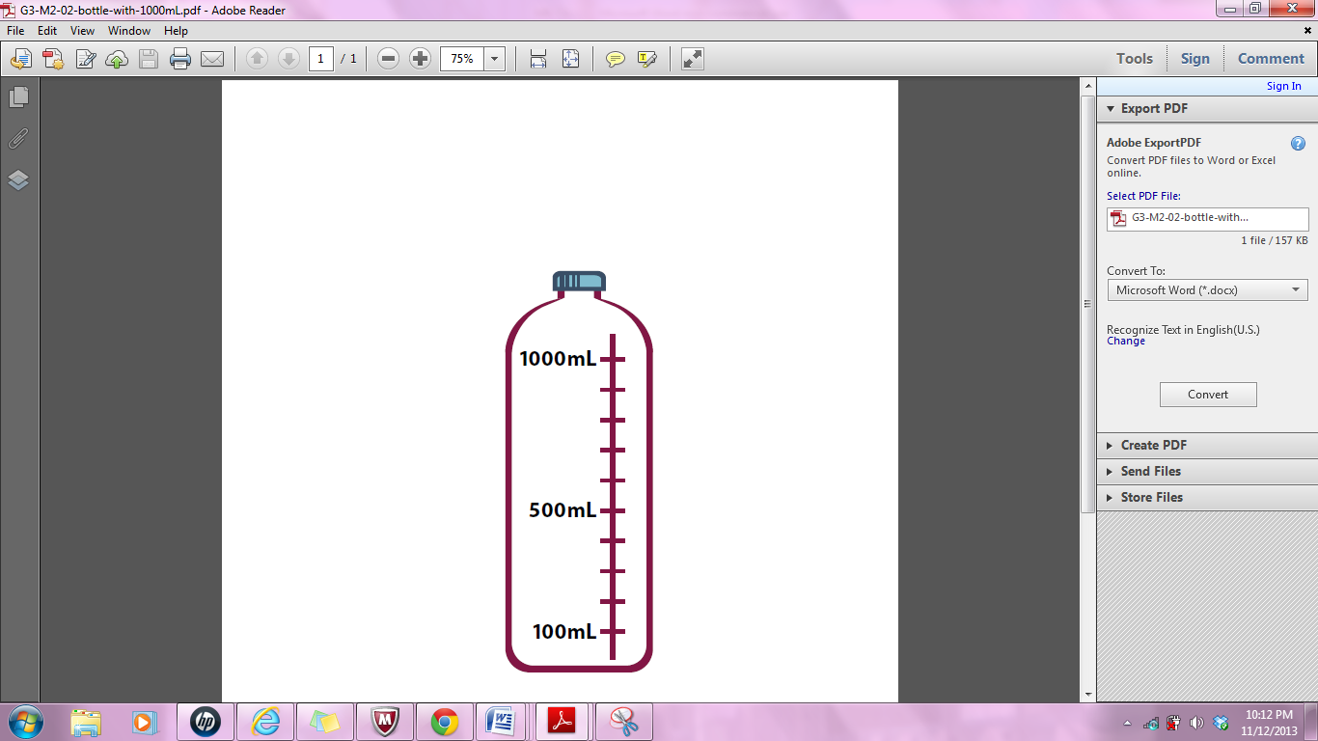Write the total amount of water in fraction form and decimal form. Shade the last bottle to show the correct amount.

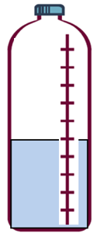

0.5



1 L

1 L

0.5

1 L

=

L

L

=

L

L

=

0.9 L

L

L

0.5

L

L

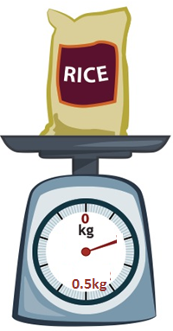

1. 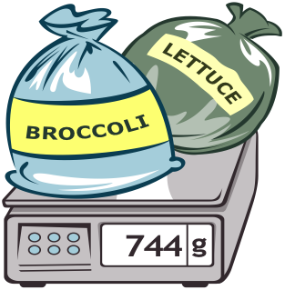Write the total weight of the food on each scale in fraction form or decimal form.

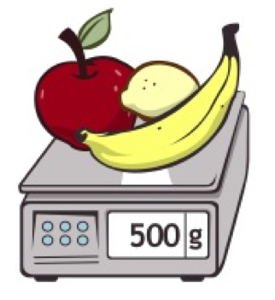

__ kg



0.4 kg

kg

kg

kg

1. Write the length of the bug in centimeters. (Drawing is not to scale.)

Fraction form: __________ cm

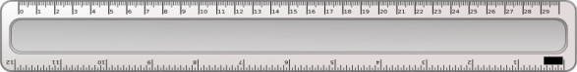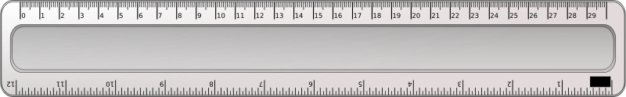

Decimal form: __________ cm

How far does the bug need to walk before its nose is at the 1 cm mark? _________ cm

cm

1. Fill in the blank to make the sentence true in both fraction form and decimal form.
2. cm + ______ cm = 1 cm 0.8 cm + ______ cm = 1.0 cm
3. cm + ______ cm = 1 cm 0.2 cm + ______ cm = 1.0 cm
4. cm + ______ cm = 1 cm 0.6 cm + ______ cm = 1.0 cm
5. Match each amount expressed in unit form to its equivalent fraction and decimal forms.

3 tenths

5 tenths

6 tenths

9 tenths

2 tenths

0.2

0.6

0.3

0.5

0.9

Name Date

* + - 1. Fill in the blank to make the sentence true in both fraction form and decimal form.

1. cm + ______ cm = 1 cm 0.9 cm + ______ cm = 1.0 cm
2. cm + ______ cm = 1 cm 0.4 cm + ______ cm = 1.0 cm
3. Match each amount expressed in unit form to its fraction form and decimal form.

3 tenths

8 tenths

0.8

0.3

0.5

5 tenths

Name Date

* + - 1. Shade the first 4 units of the tape diagram. Count by tenths to label the number line using a fraction and a decimal for each point. Circle the decimal that represents the shaded part.

|  |  |  |  |  |  |  |  |  |  |
| --- | --- | --- | --- | --- | --- | --- | --- | --- | --- |
|  |  |  |  |  |  |  |  |  |  |

|  |  |  |  |  |  |  |  |  |  |
| --- | --- | --- | --- | --- | --- | --- | --- | --- | --- |
|  |  |  |  |  |  |  |  |  |  |
|  |  |  |  |  |  |  |  |  |  |
|  |  |  |  |  |  |  |  |  |  |
|  |  |  |  |  |  |  |  |  |  |

0

1

_____

_____

_____

_____

_____

_____

_____

0.1 ____

_____

1. Write the total amount of water in fraction form and decimal form. Shade the last bottle to show the correct amount.



0.5



1 L

0.5

1 L

0.5

1 L

=

L

L

=

0.3 L

L

=

L

L

L

L

L

1. Write the total weight of the food on each scale in fraction form or decimal form.

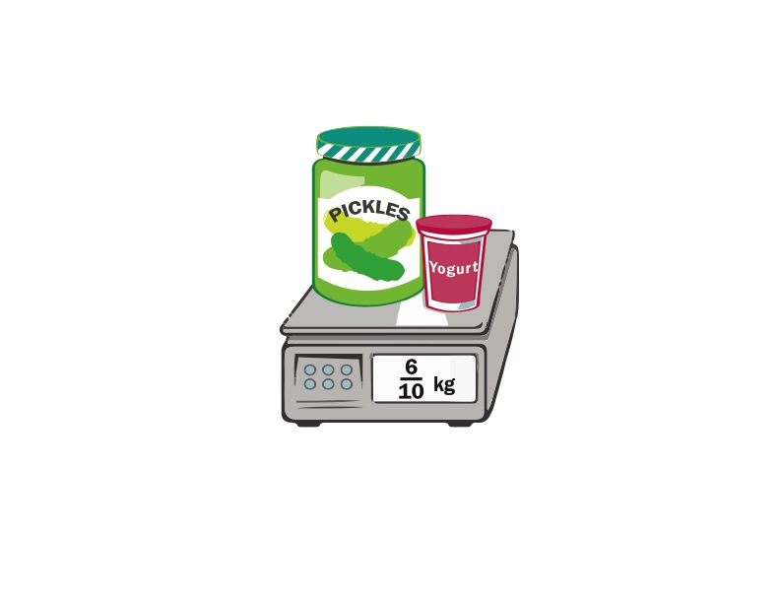

kg

kg

1. Write the length of the bug in centimeters. (Drawing is not to scale.)



Fraction form: __________ cm

Decimal form: __________ cm

If the bug walks 0.5 cm farther, where will its nose be? _________ cm

cm

1. Fill in the blank to make the sentence true in both fraction and decimal form.
2. cm + ______ cm = 1 cm 0.4 cm + ______ cm = 1.0 cm
3. cm + ______ cm = 1 cm 0.3 cm + ______ cm = 1.0 cm
4. cm + ______ cm = 1 cm 0.8 cm + ______ cm = 1.0 cm
5. Match each amount expressed in unit form to its equivalent fraction and decimal.

2 tenths

4 tenths

6 tenths

7 tenths

5 tenths

0.4

0.6

0.2

0.5

0.7