Lesson 20
Objective: Apply the commutative property to count on from a larger addend.

Suggested Lesson Structure
 Fluency Practice (15 minutes)
 Application Problems (7 minutes)
 Concept Development (28 minutes)
 Student Debrief (10 minutes)
Total Time (60 minutes)
Fluency Practice (15 minutes)
- Sparkle: Count by Tens, Starting at 5 K.CC.5 (5 minutes)
- Linking Cube Partners: 10 1.OA.6 (10 minutes)
Sparkle: Count By Tens, Starting at 5 (5 minutes)
Note: Providing students with ongoing counting practice throughout the year builds and maintains their counting skills, which are foundational for later first grade work with adding and subtracting tens.
Play two games of Sparkle, counting by tens, starting at 5. For the first game, count the regular way:
5, 15, 25, 35…. For the second game, count by tens the Say Ten way: 5, 1 ten 5, 2 tens 5, 3 tens 5….
Linking Cube Partners: 10 (10 minutes)
Materials: (S) 10 linking cubes (5 cubes one color, 5 cubes another color) per pair, personal white board
Note: This activity provides continued practice with the commutative property and prepares students for today’s objective. It also addresses the core fluency objective for Grade 1 of adding and subtracting within 10.
Show students 10 linking cubes in a stick with a color change at the 5, and then remove it from sight. Break off a part and show the part to students. Students make a number bond and two number sentences to match the part shown and the part hidden (commutative property).

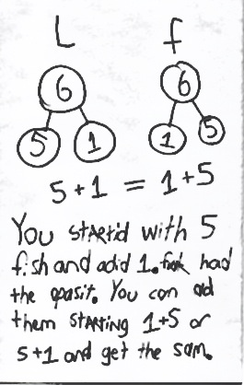
Application Problem (7 minutes)
Laura had 5 fish. Her mother gave her 1 more. Laura’s brother Frank had 1 fish. Their mother gave Frank 5 more. Laura cried, “That’s not fair! He has more fish than I do!”
Use number bonds and a number sentence to show Laura the truth. If you can, write a sentence with words that would help Laura understand.
Note: This problem is designed to support student understanding of the commutative property to enable them to apply this property for the sake of efficiency in the upcoming Concept Development.
Concept Development (28 minutes)
Materials: (S) Expression cards (Template 1), equal signs (Template 2) per pair
Note: There are enough expression cards for 34 students. Multiple copies of the equal signs sheet will be needed to accommodate the number of students in the class.
While students are still at their seats, give them expression cards, and ask each student to hold his card so the class cannot see it.
T: Find someone who has an expression card with a total equal to yours. When you find your partner, take an equal sign from the pile in front of the room, sit with your partner, and write a number sentence with your expression cards.
S: (Look for a partner, take an equal sign, sit together, and make a number sentence such as
3 + 2 = 2 + 3.)
T: Great job finding your partner. Here is one of the number sentences a partnership made.
(Write 1 + 7 = 7 + 1 on the board.)

NOTES ON
MULTIPLE MEANS
FOR ACTION AND EXPRESSION:
Some students may still be developing their ability to decide which number is bigger within a number sentence. Offer student choice to respond by first circling or coloring the bigger number. Then, have them write the number sentence using the circled or colored number first.

T: Does everyone agree that 1 plus 7 is the same amount as 7 plus 1?
S: Yes!
T: (Write the two expressions underneath each other:
1 + 7 and 7 + 1)
T: If I wanted to count on to solve this, which would be faster, starting with 1 and counting on 7 or starting with 7 and counting on 1? Talk with a partner.
S: (Discuss.)
T: Let’s try counting on with both to decide together.
S/T: Onnnnnne (gesture to first addend), 2, 3, 4, 5, 6, 7, 8. (Keep track on fingers.)

NOTES ON
MULTIPLE MEANS
OF ENGAGEMENT:
Adjust lesson structure to suit specific learning needs remembering that some students will need to keep counting all (by using objects or their 5-group cards to expose all of the dots).

T: Now, let’s try the second expression.
S/T: Seveeeennnnn (gesture to first addend), 8. (Keep track on fingers.)
Repeat the process with 3 + 5 and 5 + 3. Collect the expressions, redistribute them, and allow students to play again.
T: Which way was the faster way to count on?
S: 5 + 3.
T: Why?
S: When you start with the bigger number, you don’t have to count on as much.
T: What about when we solved 7 + 1 and 1 + 7? Discuss which was faster and why with your partner.
S: (Discuss with partner.)
Problem Set (10 minutes)
Distribute Problem Set to students, and allow them to work independently or in small groups.
Students should do their personal best to complete the Problem Set within the allotted 10 minutes. For some classes, it may be appropriate to modify the assignment by specifying which problems they work on first. Some problems do not specify a method for solving. Students solve these problems using the RDW approach used for Application Problems.
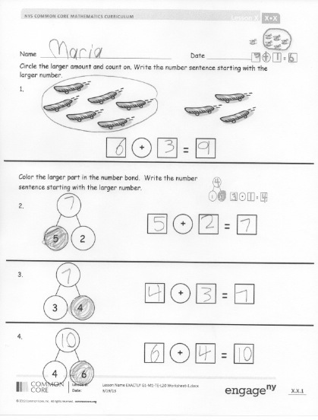
Student Debrief (10 minutes)
Lesson Objective: Apply the commutative property to count on from a larger addend.
The Student Debrief is intended to invite reflection and active processing of the total lesson experience.
Invite students to review their solutions for the Problem Set. They should check work by comparing answers with a partner before going over answers as a class. Look for misconceptions or misunderstandings that can be addressed in the Debrief. Guide students in a conversation to debrief the Problem Set and process the lesson.
You may choose to use any combination of the questions below to lead the discussion.
- Look at your Application Problem. How does it relate to today’s lesson?
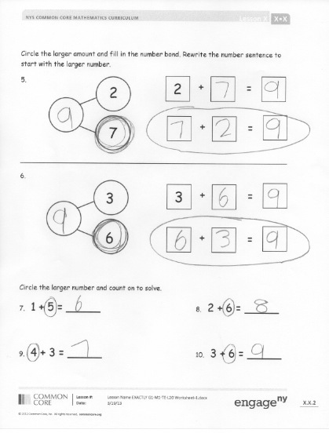
- Which problems on your Problem Set required you to rewrite the number sentence to count on from the larger number?
- When does switching the order to count on from the larger number help you the most?
- If I gave you a really challenging expression like
1 + 51, how could you use what you learned today to make it an easier expression to solve?
Exit Ticket (3 minutes)
After the Student Debrief, instruct students to complete the Exit Ticket. A review of their work will help you assess the students’ understanding of the concepts that were presented in the lesson today and plan more effectively for future lessons. You may read the questions aloud to the students.

Name Date

Circle the larger amount and count on. Write the number sentence, starting with the larger number.
1.
+

+

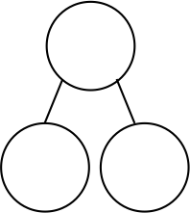
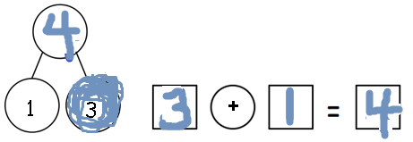
Color the larger part in the number bond. Write the number sentence, starting with the larger part.
2.
+

5
2

3
3.
+

4

4
6
4.
+

Shade in the larger part of the bond. Count on from that part to find the total. Rewrite the number sentence to start with the larger part.
5.
2
2
+

=

7

+

=

_________________________________________________________________
6.
3

=

3
6

+

Circle the larger number, and count on to solve.
7. 1 + 5 = _____ 8. 2 + 6 = _____

9. 4 + 3 = _____ 10. 3 + 6 = _____

Name Date
Circle the larger part, and complete the number bond. Write the number sentence, starting with the larger part.
b.
a.
+

3
5
2
7
+

Name Date
Color the larger part, and complete the number bond.
Write the number sentence, starting with the larger part.
2
2
+
+

1.

7+
+

2.
7

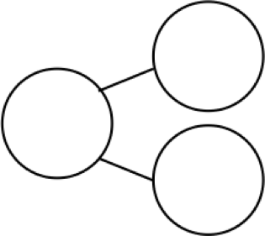
6
3.
________ + ________ = ________
1

2
4
4.

________ + ________ = ________

5
3
5.
_______ + _______ = _______

4
4

6.
_______ + _______ = _______

5
4

7.
_______ + _______ = _______

7 + 3 | 3 + 7
8 + 2 | 2 + 8
9 + 0 | 0 + 9
8 + 1 | 1 + 8
6 + 3 | 3 + 6
7 + 1 | 1 + 7

6 + 2 | 2 + 6
5 + 3 | 3 + 5
4 + 3 | 3 + 4
5 + 2 | 2 + 5
5 + 1 | 1 + 5
4 + 2 | 2 + 4

4 + 1 | 1 + 4
2 + 3 | 3 + 2
4 + 0 | 0 + 4
3 + 1 | 1 + 3
2 + 1 | 1 + 2

= | = | = | =
= | = | = | =
= | = | = | =
= | = | = | =

expression cards
expression cards
expression cards
equal signs

