Lesson 19
Objective: Represent the same story scenario with addends repositioned (the commutative property).

Suggested Lesson Structure
 Fluency Practice (13 minutes)
 Application Problem (7 minutes)
 Concept Development (25 minutes)
 Student Debrief (15 minutes)
Total Time (60 minutes)
Fluency Practice (13 minutes)
- 5-Group Addition 1.OA.3 (3 minutes)
- Sprint: +1, 2, 3 1.OA.6 (10 minutes)

NOTES ON
MULTIPLE MEANS
OF REPRESENTATION:
While using vocabulary words such as total and part is important for students’ understanding of a concept, it is essential that students understand them. This is particularly important for English language learners. When using the words, point, gesture, or label these parts of the number sentence. Encourage students to use these words when talking about number sentences, too. Using them correctly demonstrates the student’s level of understanding.

5-Group Addition (3 minutes)
Materials: (T) 5-group cards 1–5 only (Lesson 5 Template 1)
Note: This activity prepares students for working with the commutative property in today’s lessons. It also addresses the core fluency objective for Grade 1 of adding and subtracting within 10.
The teacher holds up a 5-group card, and asks students to identify the quantity. The teacher holds up a second 5-group card, and asks students to identify that quantity. The teacher holds cards side by side and asks students a series of addition questions: What is the total? What is the number sentence, starting with the bigger part? What is the number sentence, starting with the smaller part? Continue the game with various number combinations.
Sprint: +1, 2, 3 (10 minutes)
Materials: (S) +1, 2, 3 Sprint
Note: This activity addresses the core fluency objective for Grade 1 of adding and subtracting within 10.
Application Problem (7 minutes)
Dylan has 4 cats and 2 dogs at home. Sammy has 1 mama bunny and 6 baby bunnies at home. Draw a number bond showing the total number of pets of each household. Write a statement to tell if the two households have an equal number of pets.
Note: This problem serves as a bridge from the previous lesson’s focus on using the equal sign to write true number sentences.
Concept Development (25 minutes)
Materials: (S) Personal white board, bag of 7 counters (4 red, 3 white)
Invite students to sit on the carpet with their personal white boards, facing the front of the room. Choose 5 girls and 3 boys (or 3 girls and 5 boys) to stand in a row in front of the class.
T: How many girls are standing here?
S: 5 girls!
T: How many boys are standing here?
S: 3 boys!
T: Write a number sentence on your board to show 5 girls plus 3 boys.
S: (Write 5 + 3 = 8 on their boards.)
T: Starting with the boys, write the number sentence on your boards.
S: (Write 3 + 5 = 8.)
T: How many children do we have when we add 3 boys and 5 girls?

NOTES ON
MULTIPLE MEANS
FOR ACTION AND EXPRESSION:
Though some think of the commutative property as “switch arounds,” it is the addends that switch not the referents. When the placement of the materials changes when adding, the exact same four number sentences also describe the materials in different positions.

S: 8 children!
T: Is that the same total or a different total of children as we had the last time we added the boys and girls?
S: The same!
T: Take 4 red and 3 white counters out of your bag. Put them in a line starting with the red counters.
T: Tell your friend two number sentences that match your materials.
MP.7
S: 4 + 3 = 7 and 3 + 4 = 7.
T: Can you start with the whole amount
S: Yes! 7 = 4 + 3 and 7 = 3 + 4.
T: Now, switch the red and white counters, putting the white first in your line. Tell your partner four number sentences that match your new arrangement.
S: (Do so.)
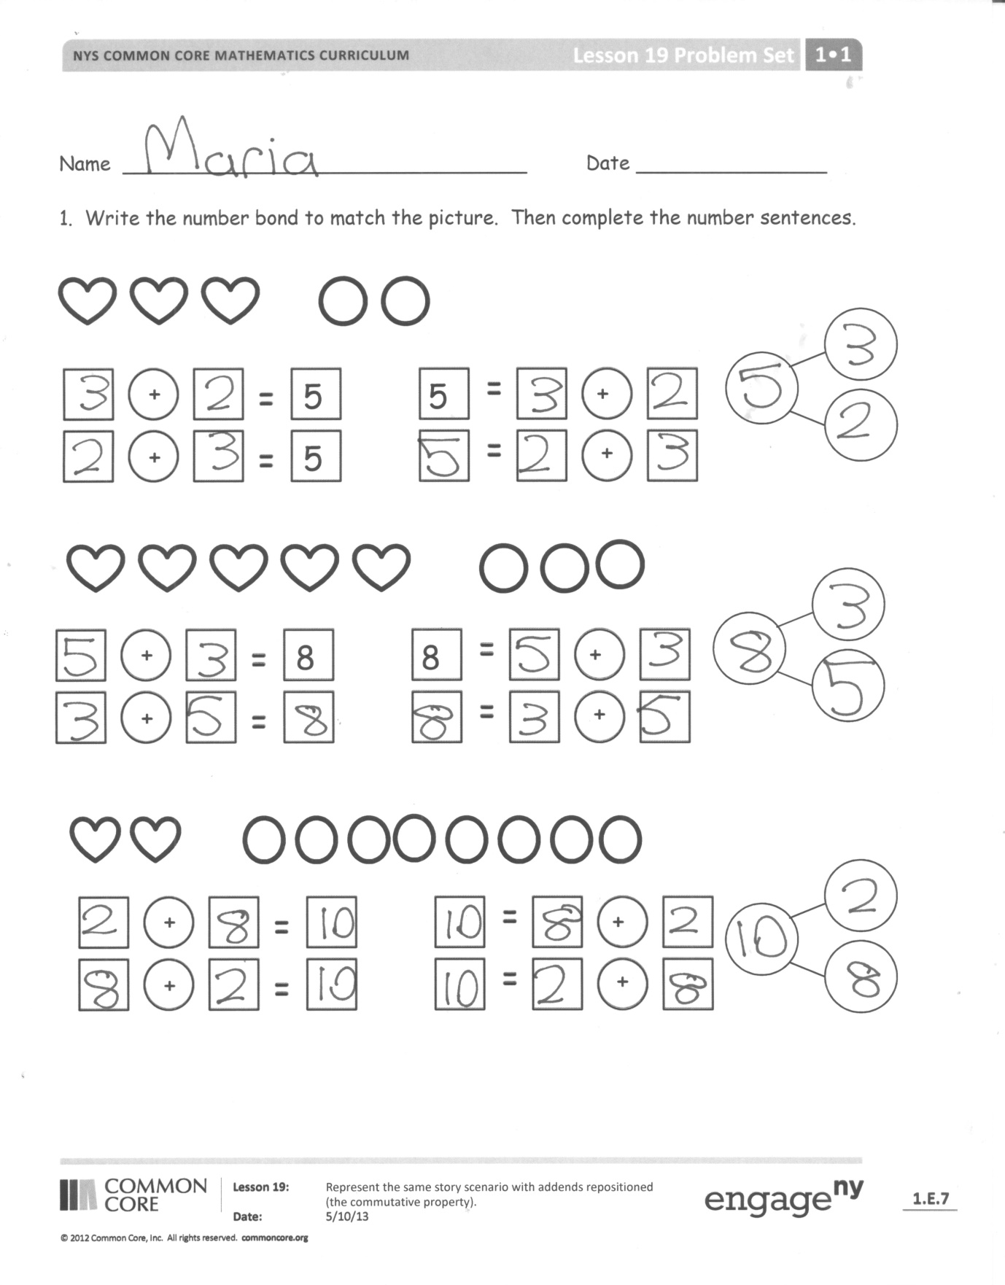
T: Is this the same set of number sentences?
S: Yes!
T: Why? Turn and talk with your partner. (Circulate and listen.)
MP.7
S: (Talk with partner.) The number of reds and whites did not change. We can add them in any order, as long as we include them all.
T: On your board, write a number sentence showing that 4 plus 3 is the same as 3 plus 4.
S: (Write 3 + 4 = 4 + 3.)
T: On your board, draw 6 circles and 3 hearts in a line. Write four number sentences to match your picture. Share your work with a partner. What are you noticing?
Problem Set (10 minutes)
Distribute the Problem Set and allow students to work independently or in small groups.
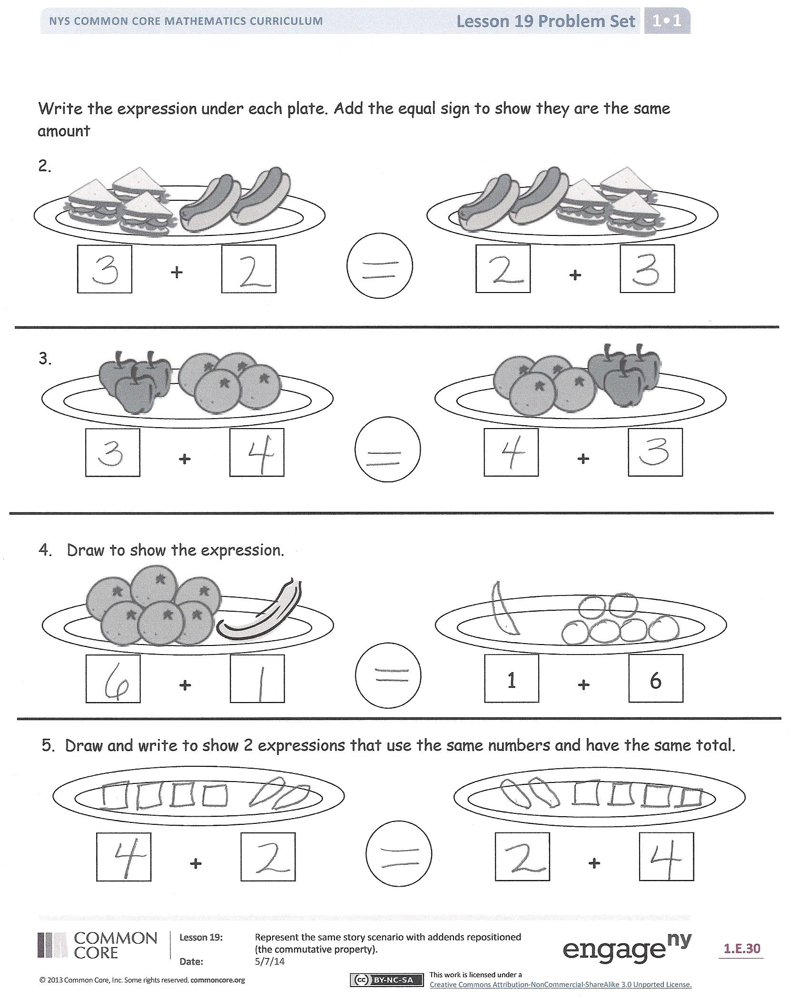
Students should do their personal best to complete the Problem Set within the allotted 10 minutes. For some classes, it may be appropriate to modify the assignment by specifying which problems they work on first. Some problems do not specify a method for solving. Students solve these problems using the RDW approach used for Application Problems.
Student Debrief (15 minutes)
Lesson Objective: Represent the same story scenario with addends repositioned (the commutative property).
The Student Debrief is intended to invite reflection and active processing of the total lesson experience.
Invite students to review their solutions for the Problem Set. They should check work by comparing answers with a partner before going over answers as a class. Look for misconceptions or misunderstandings that can be addressed in the Debrief. Guide students in a conversation to debrief the Problem Set and process the lesson.

You may choose to use any combination of the questions below to lead the discussion.
- What do you notice about the number sentences you made for Problem 1? Why do you think that happens?
- Why does the total stay the same, even though you are adding in a different order?
- Try adding two amounts in different orders. See if you get the same total each time. You can draw and use number sentences as you try it.
- Look at Problem 1(c). Which number sentence represents the easier way for you to add 2 and 8? How does choosing a certain order make adding easier?
- How will this strategy help you add more quickly next time, especially during a Number Bond Dash or a Sprint?
Exit Ticket (3 minutes)
After the Student Debrief, instruct students to complete the Exit Ticket. A review of their work will help you assess the students’ understanding of the concepts that were presented in the lesson today and plan more effectively for future lessons. You may read the questions aloud to the students.

Name Date
*Count on to add.
Number correct:
A
1 | 1 + 1 |  | 16 | 4 + 3
2 | 2 + 1 |  | 17 | 3 + 3
3 | 3 + 1 |  | 18 | 4 + 3
4 | 3 + 2 |  | 19 | 3 + 4
5 | 2 + 2 |  | 20 | 2 + 4
6 | 3 + 2 |  | 21 | 4 + 2
7 | 2 + 2 |  | 22 | 5 + 2
8 | 3 + 0 |  | 23 | 2 + 5
9 | 3 + 1 |  | 24 | 2 + 6
10 | 3 + 2 |  | 25 | 6 + 3
11 | 5 + 2 |  | 26 | 3 + 6
12 | 5 + 3 |  | 27 | 2 + 7
13 | 5 + 2 |  | 28 | 3 + 7
14 | 5 + 3 |  | 29 | 2 + 8
15 | 6 + 3 |  | 30 | 3 + 6
Name Date
Number correct:
B
*Count on to add.
1 | 2 + 1 |  | 16 | 4 + 3
2 | 1 + 1 |  | 17 | 3 + 3
3 | 2 + 1 |  | 18 | 2 + 3
4 | 2 + 2 |  | 19 | 1 + 3
5 | 3 + 2 |  | 20 | 0 + 3
6 | 2 + 2 |  | 21 | 1 + 3
7 | 3 + 2 |  | 22 | 2 + 5
8 | 3 + 1 |  | 23 | 5 + 2
9 | 5 + 1 |  | 24 | 2 + 6
10 | 6 + 1 |  | 25 | 6 + 2
11 | 6 + 2 |  | 26 | 3 + 6
12 | 5 + 2 |  | 27 | 3 + 7
13 | 6 + 2 |  | 28 | 2 + 7
14 | 6 + 3 |  | 29 | 2 + 6
15 | 5 + 3 |  | 30 | 3 + 6

Name Date

- Write the number bond to match the picture. Then, complete the number sentences.
a.
+

+

+

5
+

5
5
+

+

+

8
+

8
+

+

+

+

b.

c.

Write the expression under each plate. Add the equal sign to show they are the same amount.
2.
+
+

+

+

3.

4. Draw to show the expression.

+

1
+

6

5. Draw and write to show 2 expressions that use the same numbers and have the same total.

+
+

+

Name Date
Use the picture and write the number sentences to show the parts in a different order.

+

=

+

=

+

=

+

=

Name Date

1. Use the picture to write a number bond. Then, write the matching number sentences.

+

=

+

=

2. Write the number sentences to match the number bonds.

5

a.
+

=

+

=

8
3

b.
+

=

6
2
8
+

=

c.

8
2
+

=

+

=

7
5
+

=

+

=

d.

e.
=

+=

=

+

10
3

f.

9
3
+

=

+

=

