Lesson 18
Objective: Understand the meaning of the equal sign by pairing equivalent expressions and constructing true number sentences.

Suggested Lesson Structure
 Fluency Practice (13 minutes)
 Application Problem (7 minutes)
 Concept Development (30 minutes)
 Student Debrief (10 minutes)
Total Time (60 minutes)
Fluency Practice (13 minutes)
- Red Light/Green Light: Counting by Tens K.CC.2 (5 minutes)
- Missing Part: Make 7 1.OA.6 (3 minutes)
- Number Bond Dash: 7 1.OA.6 (5 minutes)
Red Light/Green Light: Counting by Tens (5 minutes)
Note: Providing students with ongoing practice with counting throughout the year builds and maintains their counting skills.
Begin with 0. When you say “green light,” students begin running in place and counting aloud together by tens, until they reach 100. When you say “red light,” they stop counting and freeze. Students who are still moving or counting after you say “red light” sit down until the next game. Once students reach 100, continue to play, counting back by tens until students arrive at 0. The last student (or few students) standing wins.
For the first game, start at 0 to ensure every child feels success. Then, try playing the game again beginning with 4 and 8, respectively.
Missing Part: Make 7 (3 minutes)
Materials: (S) 5-group cards (0–7 only) (Lesson 5 Template 1)
Note: This activity addresses the core fluency objective for Grade 1 of adding and subtracting within 10.
Students work with a partner, using 5-group cards. Each student puts a card to his or her forehead. The partner tells how many more to make 7. Students must guess the cards on their foreheads. Partners can play simultaneously.
Number Bond Dash: 7 (5 minutes)
Materials: (T) Stopwatch or timer (S) Number bond dash 7 (Lesson 6 Fluency Template), marker to correct work
Note: By using the same system repeatedly, students can focus on the mathematics alone. The activity addresses the core fluency objective for Grade 1 of adding and subtracting within 10.
Follow the procedure for the Number Bond Dash (Lesson 2). Remember today is the second day with making 7. Students should recall their scores from yesterday to see and celebrate improvement.
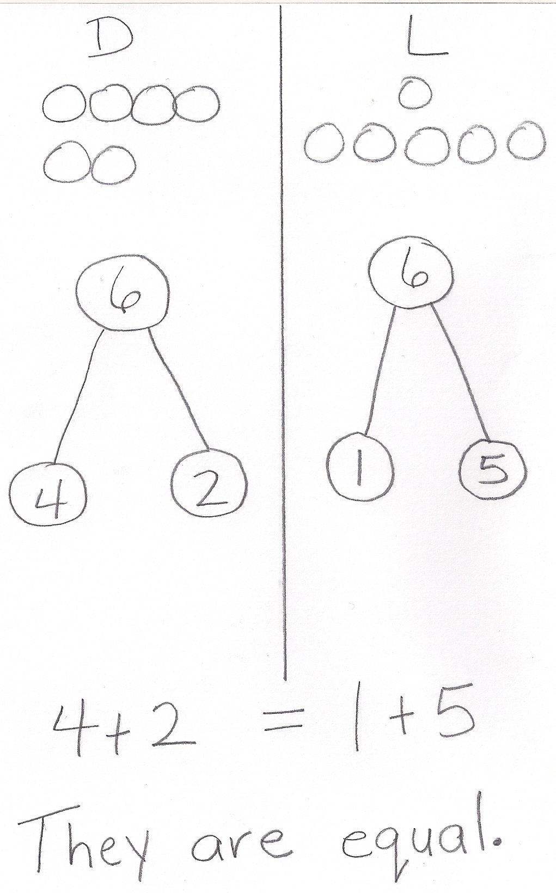
Application Problem (7 minutes)
Dylan has 4 cats and 2 dogs at home. Laura has 1 dog and 5 fish at home. Laura says she and Dylan have an equal number of pets. Dylan thinks he has more pets than Laura. Who is right? Draw a picture, write two number bonds, and use a number sentence to show if Dylan and Laura have an equal amount of pets.
Note: This problem serves as both a bridge and as a lead-up to the current lesson’s Concept Development, focusing students on using the equal sign to create true number sentences.
Concept Development (30 minutes)
Materials: (S) 5-group cards (Lesson 5 Template 1), personal white board, true and false number sentence cards (Template), red and green markers per pair
Have students sit next to their math partners in the meeting area or at their tables.
T: (Write 7 + 1 = ___ + ___. Read the number sentence aloud with students.) Talk with your partner, and use this incomplete number sentence to finish writing a true number sentence.

NOTES ON
MULTIPLE MEANS
OF REPRESENTATION:
Connect calculations to 5-group cards to encourage counting on. Students use one numeral side and one dot side and touch the dots with their fingers as they count on. Some students will be able to do the calculations in their head while others will use the 5-group cards for as long as needed.

S: (Write any combination that makes 8, for example,
6 + 2, 5 + 3, etc.)
T: Hold up your true number sentences. Look around the class. Did everyone use the same numbers to make 8 on both sides?
S: No!
T: They don’t all use the same numbers, but are all of them equal to 8?
S: Yes!
T: Yesterday, you made a lot of true number sentences. Use your 5-group cards to tell me why this number sentence is NOT true. (Project 4 + 2 = 5 + 3.)
S: (Build 4 + 2 = 5 + 3 with 5-group cards, and solve for each side.)
T: Is 4 + 2 = 5 + 3 true or false?
S: False!
T: Talk with your partner. How do you know that 4 + 2 = 5 + 3 is not equal, or false?
(As students share, circulate and listen. Then, call on one student.)
S: 4 + 2 is 6, and 5 + 3 is 8, so they are not equal because 6 is not the same as 8!
T: Talk with your partner. How can you fix this number sentence to make it equal, or true?
(As students share, circulate and listen. Then, call on a couple of students.)
S: Change 4 + 2 to 4 + 4 to make it equal 8. Change 5 + 3 to 5 + 1 to make it equal 6.

NOTES ON
MULTIPLE MEANS
FOR ENGAGEMENT:
Some students will really enjoy playing True or False Number Sentences. Provide challenging extensions
(e.g., 14 + 2 = 15 + 1) and give these students more problems to figure out and solve.

4 + 2 = 5 + 3
T: Is there more than one way to fix this number sentence to make it true?
S: Yes!
T: Today, you will be playing True or False Number Sentences, like we just did, with a partner. Here are the directions:
- Read the number sentence together.
- Use your 5-group cards to solve each side of the number sentence together.
- If the sentence is true, Partner A uses your green marker to put a check on it.
- If the sentence is false, work together to use your 5-group cards to change one number to fix the number sentence to make it equal, using your red marker.
- Then, Partner B checks it, and it becomes her turn to pick a card.
Allow students to play as you circulate and support students.
Problem Set (10 minutes)
Distribute the Problem Set and allow students to work independently or in small groups.
Students should do their personal best to complete the Problem Set within the allotted 10 minutes. For some classes, it may be appropriate to modify the assignment by specifying which problems they work on first. Some problems do not specify a method for solving. Students solve these problems using the RDW approach used for Application Problems.
Student Debrief (10 minutes)
Lesson Objective: Understand the meaning of the equal sign by pairing equivalent expressions and constructing true number sentences.
The Student Debrief is intended to invite reflection and active processing of the total lesson experience.
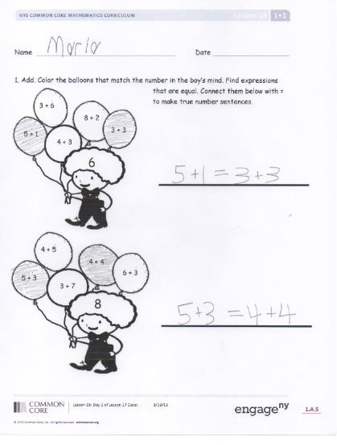
Invite students to review their solutions for the Problem Set. They should check work by comparing answers with a partner before going over answers as a class. Look for misconceptions or misunderstandings that can be addressed in the Debrief. Guide students in a conversation to debrief the Problem Set and process the lesson.
You may choose to use any combination of the questions below to lead the discussion.
- Look at Problem 2(b). How did you and your partner rewrite this to make a true number sentence? How were your number sentences the same and different?
- Look at Problem 2(f). Can we rewrite this to be 10 = 10? Why or why not? (If appropriate, ask the same about Problem 2(g) rewritten as 9 = 9.)
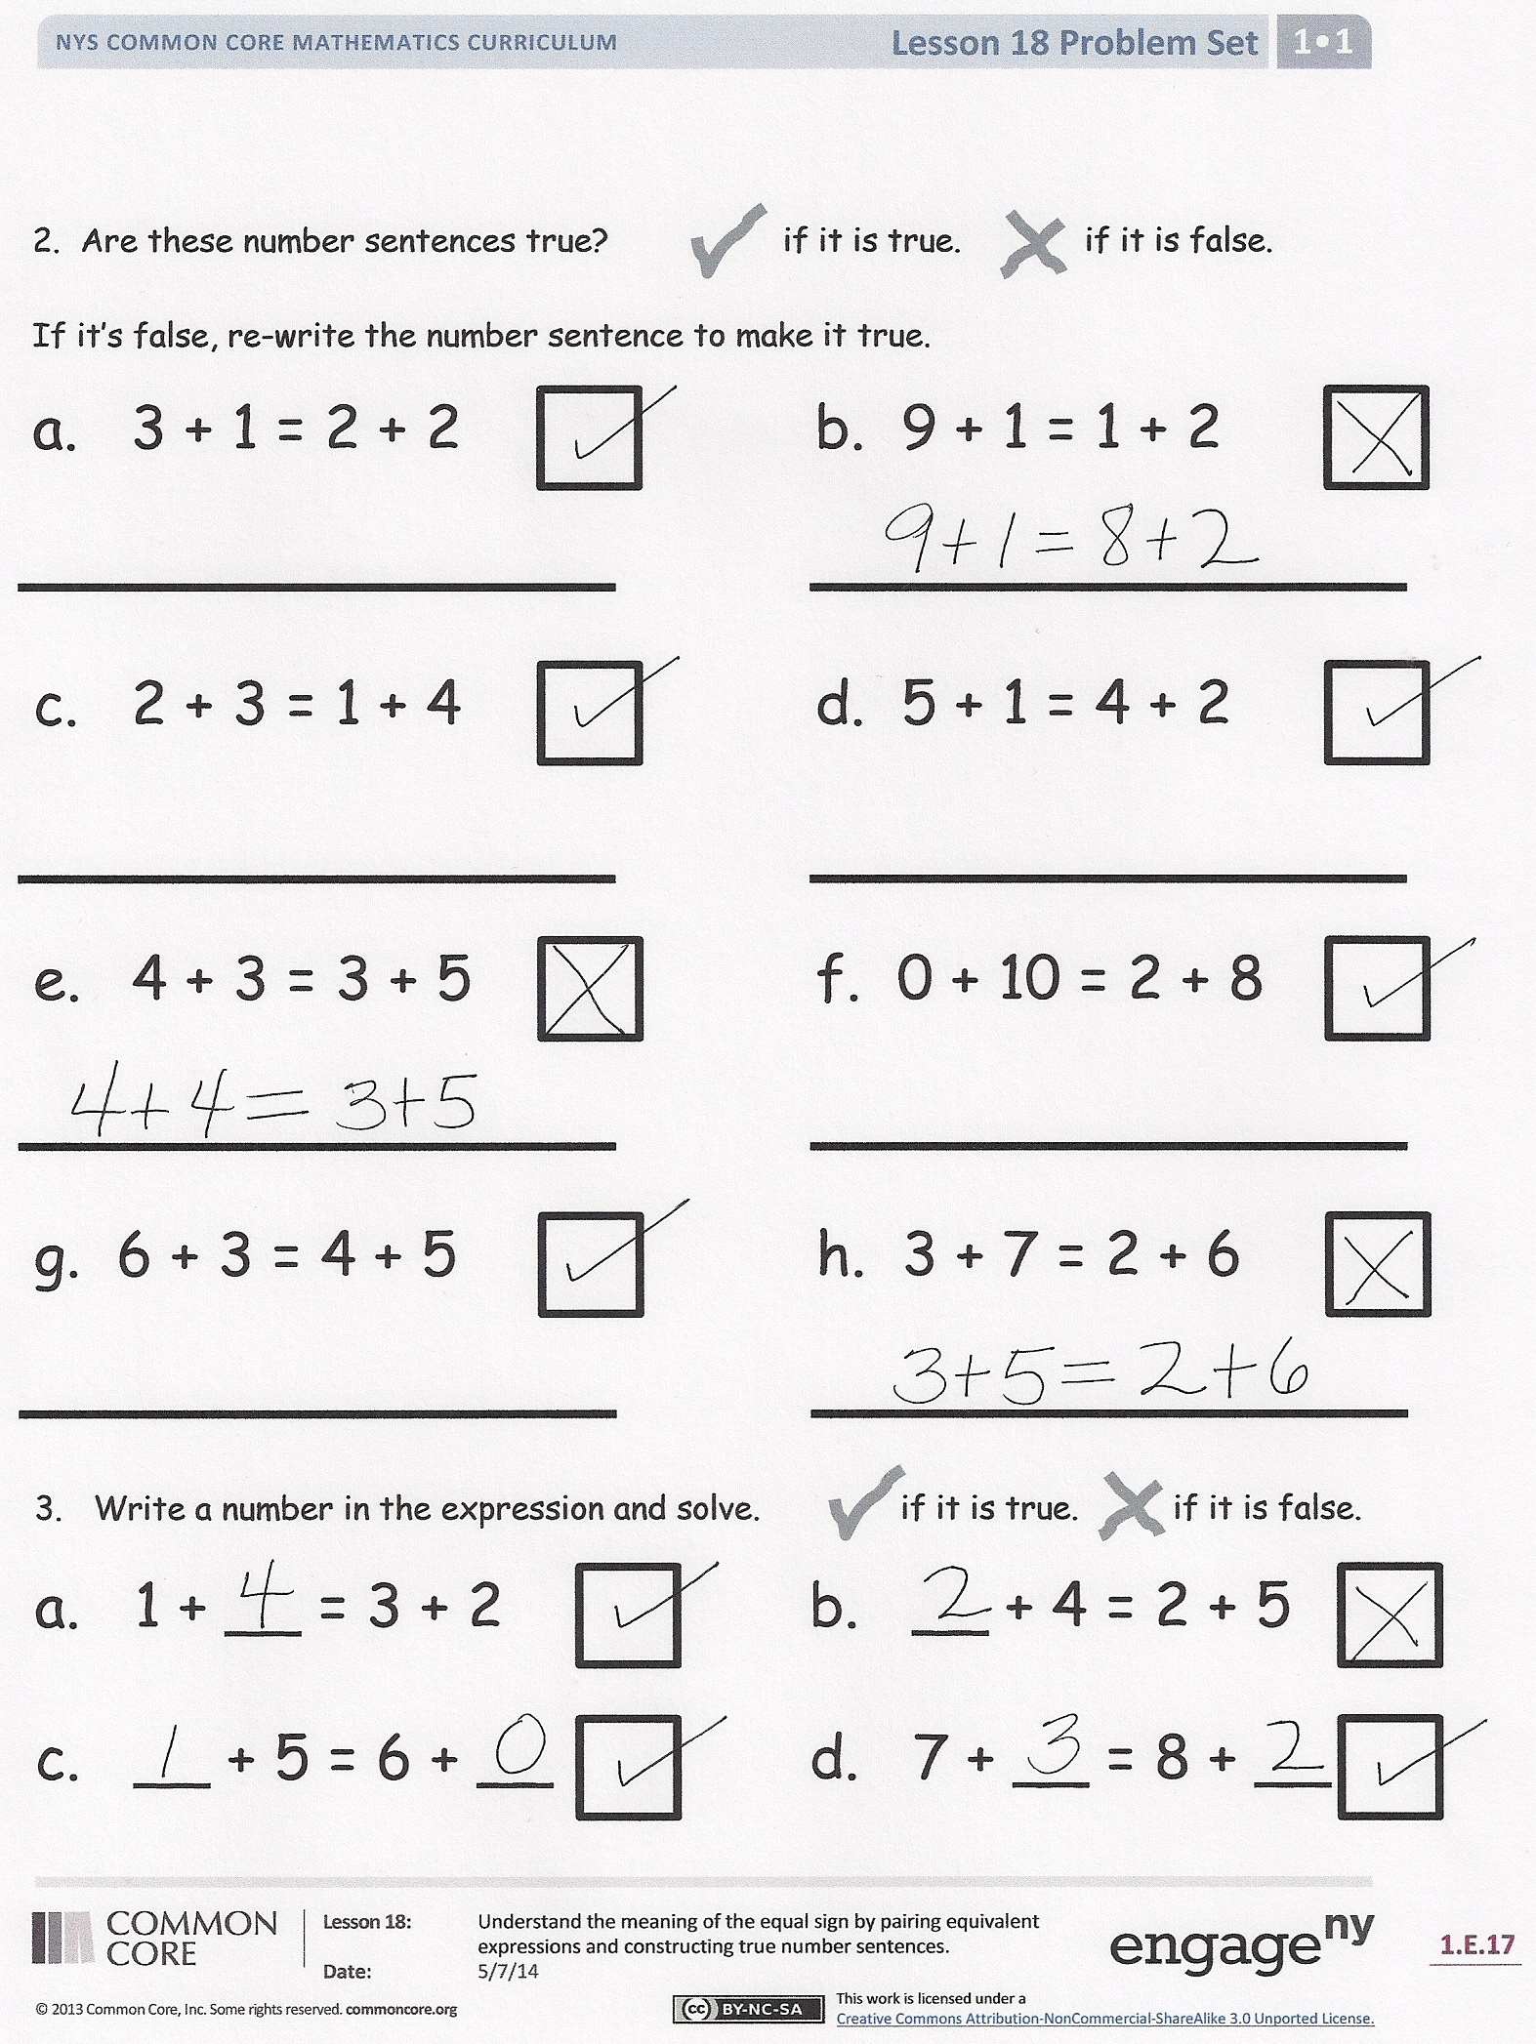
- Think about the goal of today’s lesson and the work we’ve been doing with the equal sign. Imagine an alien came down from outer space and asked you what the equal sign means. Tell your partner what you would say to that alien to describe it! Be sure to use examples.
- Look at your Application Problem. Dylan and Laura have a friend Simon who has the same number of pets they have. If Simon has 6 guinea pigs, how many other pets does he have? Show with a number sentence or number bond to prove your answer.
Exit Ticket (3 minutes)
After the Student Debrief, instruct students to complete the Exit Ticket. A review of their work will help you assess the students’ understanding of the concepts that were presented in the lesson today and plan more effectively for future lessons. You may read the questions aloud to the students.

Name Date

- Add. Color the balloons that match the number in the boy’s mind. Find expressions that are equal. Connect them below with = to make true number sentences.
a.
6
4 + 3
8 + 2
3 + 6
5 + 1
3 + 3

2. Are these number sentences true?     if it is true.   if it is false.
If it is false, rewrite the number sentence to make it true.
b.
8
3 + 7
4 + 4
4 + 5
5 + 3
6 + 3
a. 3 + 1 = 2 + 2 b. 9 + 1 = 1 + 2
c. 2 + 3 = 1 + 4 d. 5 + 1 = 4 + 2
e. 4 + 3 = 3 + 5 f. 0 + 10 = 2 + 8
g. 6 + 3 = 4 + 5 h. 3 + 7 = 2 + 6

- Write a number in the expression and solve.   if it is true.   if it is false.
a. 1 + __ = 3 + 2 b. __ + 4 = 2 + 5

c. __ + 5 = 6 + __ d. 7 + __ = 8 + __
Name Date
Find two ways to fix each number sentence to make it true.
b.
a.
7 + 3 = 6 + 2

8 + 1 = 3 + 5
7 + 3 = 6 + 4

Name Date

1. The pictures below are not equal. Make the pictures equal, and write a true number sentence.

2. Circle the true number sentences, and rewrite the false sentences to make them true.
a.
5 + 1 = 6 + 1

3 + 2 = 5 + 0

4 = 4

b.
c.

d.
3 + 3 = 6 + 2

6 + 2 = 4 + 4

9 + 0 = 7 + 2

f.
e.

4 + 3 = 2 + 4
8 = 8 + 0

6 + 3 = 5 + 4

g.
i.
h.

3. Find the missing part to make the number sentences true.
5 + 2 = 4 + ___
8 + 0 = ___ + 4
7 + 2 = 9 + ___
c.
b.
a.

e.
f.
d.
6 + ___ = 4 + 3
5 + ___ = 6 + 0
5 + 4 = ___ + 3

4 + 1 = 2 + 2 | 2 + 5 = 8 + 2
3 + 2 = 4 + 1 | 9 + 1 = 4 + 6
6 + 2 = 3 + 3 | 3 + 4 = 6 + 3
1 + 7 = 4 + 4 | 5 + 4 = 3 + 7
2 + 5 = 4 + 3 | 5 + 5 = 6 + 3
5 + 1 = 4 + 2 | 8 + 2 = 3 + 7

true and false number sentence cards

