Lesson 16
Objective: Count on to find the unknown part in missing addend equations such as 6 + __ = 9. Answer, “How many more to make 6, 7, 8, 9, and 10?”

Suggested Lesson Structure
 Fluency Practice (11 minutes)
 Application Problem (5 minutes)
 Concept Development (33 minutes)
 Student Debrief (11 minutes)
Total Time (60 minutes)
Fluency Practice (11 minutes)
- Shake Those Disks: 7 1.OA.6 (6 minutes)
- Count On Drums: 3 More 1.NBT.1 (3 minutes)
- 10 Bowling Pins 1.NBT.1 (2 minutes)
Shake Those Disks: 7 (6 minutes)
Materials: (S) 7 two-color beans (disks or pennies are also acceptable) per set of partners, personal white board, shake those disks 7 board (Fluency Template)

NOTES ON
MULTIPLE MEANS
OF ENGAGEMENT:
Encourage students who are ready to explore place value to imagine each disk has a value of 10. Adjust the recording sheet so that students can complete the number bonds as they initially identify the combinations of 70 created as they play.

Note: This activity addresses the core fluency objective for Grade 1 of adding and subtracting within 10.
Assign students partners. Give each set of partners 7 two-color beans. Instruct them to take turns as the Shaker and the Recorder. The Shaker shakes the disks and tosses them on the table. The Recorder then records the roll on the Shake Those Disks graph. (For example, if the Shaker rolls 3 red and 4 white, the Recorder puts an X on the graph above the 3 and 4 number bond.)
Count On Drums: 3 More (3 minutes)
Note: This activity supports the connection of counting on to addition and counting back to subtraction.
The teacher says a number aloud. Students repeat the number, drumming on the table to count on 3 and matching one drum tap with each consecutive number counted on. Extend the game by counting back 3.
10 Bowling Pins (2 minutes)
Note: A prepared set of bowling pins is a wonderful configuration of 10 (4 in the back, then 3, then 2, then 1). This activity supports students creating compositions of 10 in multiple ways.
Show a bird’s eye picture of the configuration. Have students look at the arrangement and discuss with a partner how many pins they see and how they know. Share different ways of knowing it is 10.
Application Problem (5 minutes)
There were 10 bowling pins standing. Finn knocked over some bowling pins and 7 were still standing. How many did he knock over? Use a simple math drawing to show what you did to solve. Write a number sentence with a box to show the mystery or unknown number.
Note: This problem prepares students for this lesson’s focus on solving for a missing addend.
Concept Development (33 minutes)
Materials: (T) 5-group cards (Lesson 5 Template 1), mystery box, enlarged blank number sentence and number bond (Lesson 6 Template 2), set of 7 beans from Shake Those Disks
(S) Personal white board, blank number sentence and number bond (Lesson 6 Template 2),
5-group cards (Lesson 5 Template 1), number sentence cards (Lesson 11 Template), sticky notes with question marks

NOTES ON
MULTIPLE MEANS
OF ENGAGEMENT:
When using words that may complicate language acquisition in English language learners, be sure to model as much as possible. Hearing teacher-talk along with math-they-can-see helps these students comprehend the skills they are learning. Teaching in multiple modalities will also help other learners in the class.

While students are putting away fluency materials, take one set of the 7 beans from Shake Those Disks and bring it to the carpet. Hide 2 of the beans under the carpet without students noticing. Gather students on the carpet with their personal white boards.
T: While we were cleaning up some of the beans fell on the carpet. I picked most of them up but I think I am still missing some. We had 7 beans in total right?
S: Right!

NOTES ON
Mathematical Practice 6, “Attend to Precision:”
All through this module, students must pay attention to the units they are counting and use precise language to convey their knowledge. Hold them accountable. 6 tens + 4 tens is 10 tens.

NOTES ON
Mathematical Practice 6, “Attend to Precision:”
All through this module, students must pay attention to the units they are counting and use precise language to convey their knowledge. Hold them accountable. 6 tens + 4 tens is 10 tens.

T: Now, I have 5 beans. (Show beans to class.)
T: How many am I missing? Talk with your partner to solve this.
MP.7
S: (Discuss.)
T: Let’s try to count on to check how many I’m missing.
S/T: Fivvvve (gesture to beans in hand), 6, 7! (Track on fingers.)
T: How many did we count on to get up to 7? (Keep fingers out to show the two that were used to track.)
S: Two!
T: So, how many beans am I missing?
S: Two beans!
T: (Lift edge of carpet to show the 2 beans.)
T: Use your 5-group cards to make the number sentence on your personal white board. Place the numeral side up. If you want to double-check your number sentence, turn cards to the dot side. Remember, try to turn over the fewest cards you can and count on. (Circulate and check for accuracy.)
S: (Create 5 + 2 = 7 on white boards with 5-group cards. Some students flip to dot side to count on and check. )
Repeat the process using the mystery box, concealing 3 of the 7 beans in the box so that students only see 4 beans. Encourage them to use their 5-group cards or track on their fingers to decide how many beans are in the mystery box. Students use the cards to make a corresponding number sentence.
T: How many beans did I place in the box?
S: 3 beans!
T: What is the number sentence you recorded?
S: 4 + 3 = 7.
T: Circle the part that was the mystery or unknown part.
T: (Write 5 + □ = 8.) Use your cards to make and solve this number sentence.
S: (Discuss and solve using cards or finger tracking to confirm.)
T: What is the mystery or unknown part of this number sentence?
S: 3!
Repeat the process with the following sequence:
- 5 + __ = 6 4 + __ = 6 3 + __ = 6
- 6 + __ = 7 5 + __ = 7 4 + __ = 7
- 7 + __ = 8 6 + __ = 8 5 + __ = 8
- 8 + __ = 9 7 + __ = 9 6 + __ = 9
- 9 + __ = 10 8 + __ = 10 7 + __ = 10
Leave the sets of number sentences on the board so that students can notice the patterns within the sequence. Explore the resulting patterns.
- What do you notice is happening?
- Imagine there is a fourth column (point to where it would be). What number sentence do you think I’ll add next in each row?
- How do the parts change from one number sentence to the next?
- What strategies did you use?
Problem Set (10 minutes)
Distribute Problem Set and allow students to work independently or in small groups.
Students should do their personal best to complete the Problem Set within the allotted 10 minutes. For some classes, it may be appropriate to modify the assignment by specifying which problems they work on first. Some problems do not specify a method for solving. Students solve these problems using the RDW approach used for Application Problems.
Student Debrief (11 minutes)
Lesson Objective: Count on to find the unknown part in missing addend equations such as 6 + __ = 9.
Answer, “How many more to make 6, 7, 8, 9, and 10?”
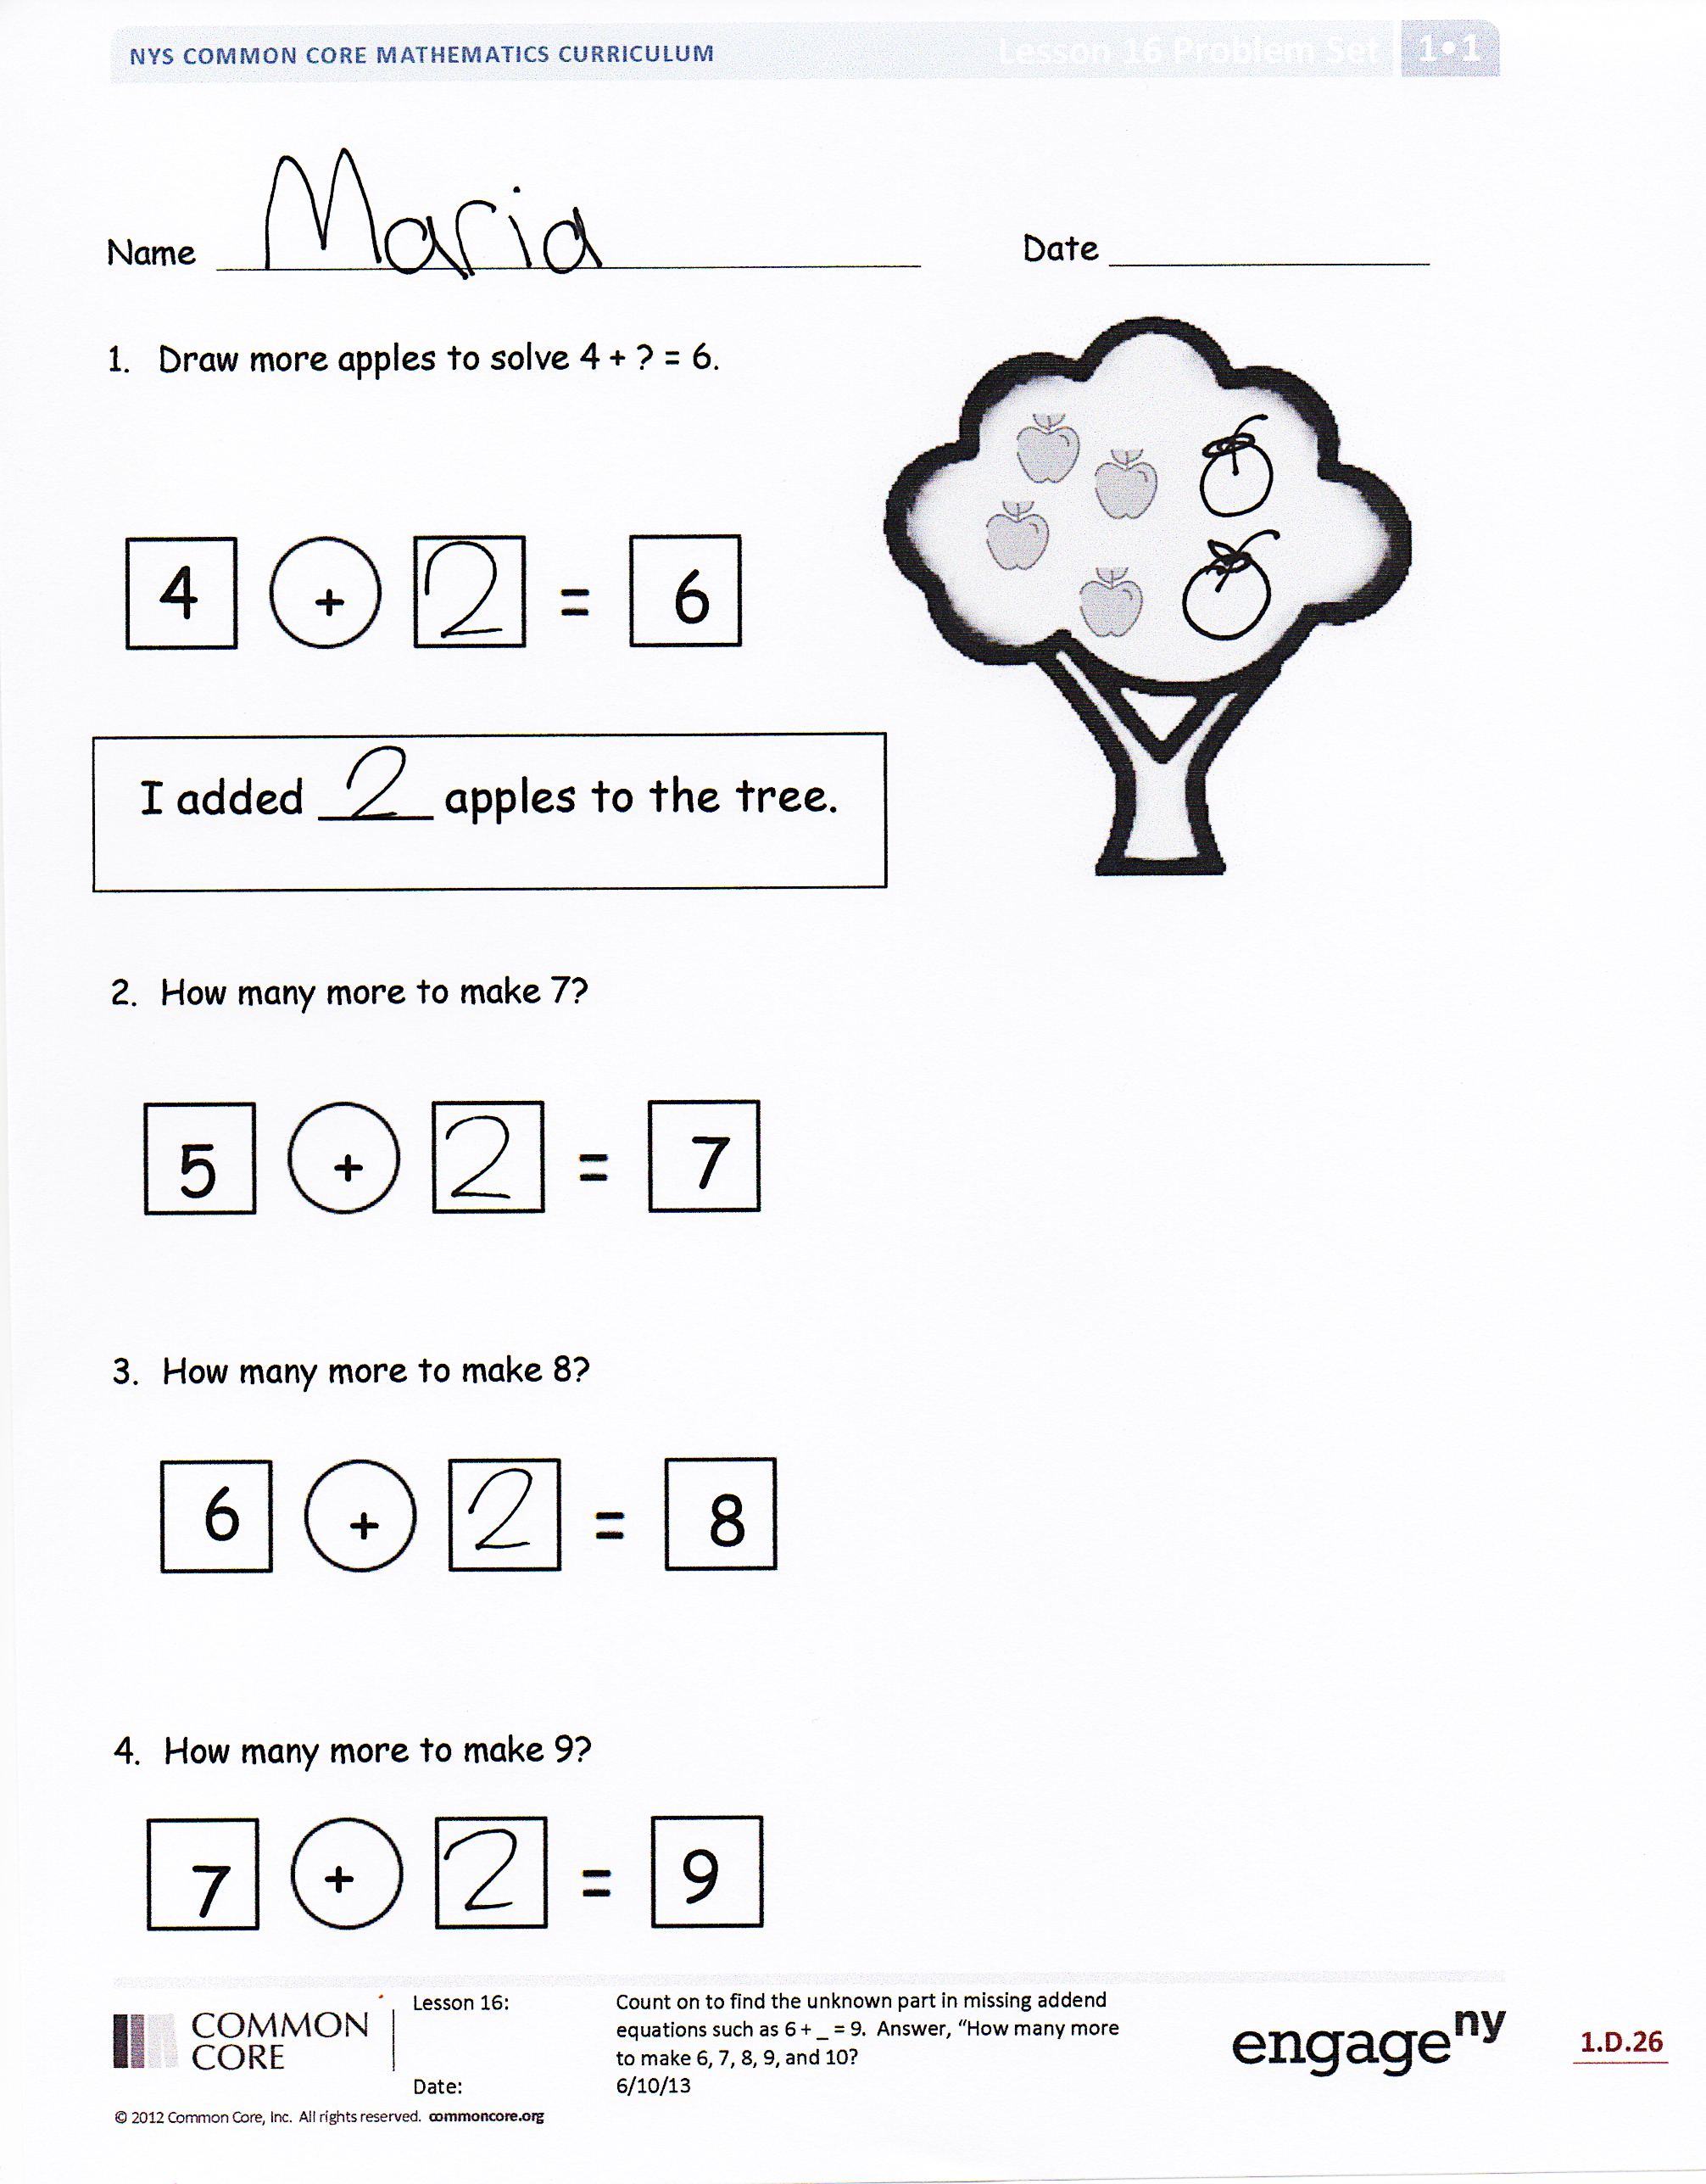
Student Debrief is intended to invite reflection and active processing of the total lesson experience.
Invite students to review their solutions for the Problem Set. They should check work by comparing answers with a partner before going over answers as a class. Look for misconceptions or misunderstandings that can be addressed in the Debrief. Guide students in a conversation to debrief the Problem Set and process the lesson.
You may choose to use any combination of the questions below to lead the discussion.
- Look at Problems 3 and 4 on the Problem Set. What do you notice is the same about these problems? What do you notice is different?
- How can it be true that all the unknown numbers, the mystery numbers, are the same on the first page?
Have students look at their work from the Application Problem with Finn’s bowling pins and the last problem on their Problem Set.
- What strategies did you use to solve these problems? How are these problems the same? How are they different? How can the parts from the bowling pin problem help you solve the last Problem Set problem?
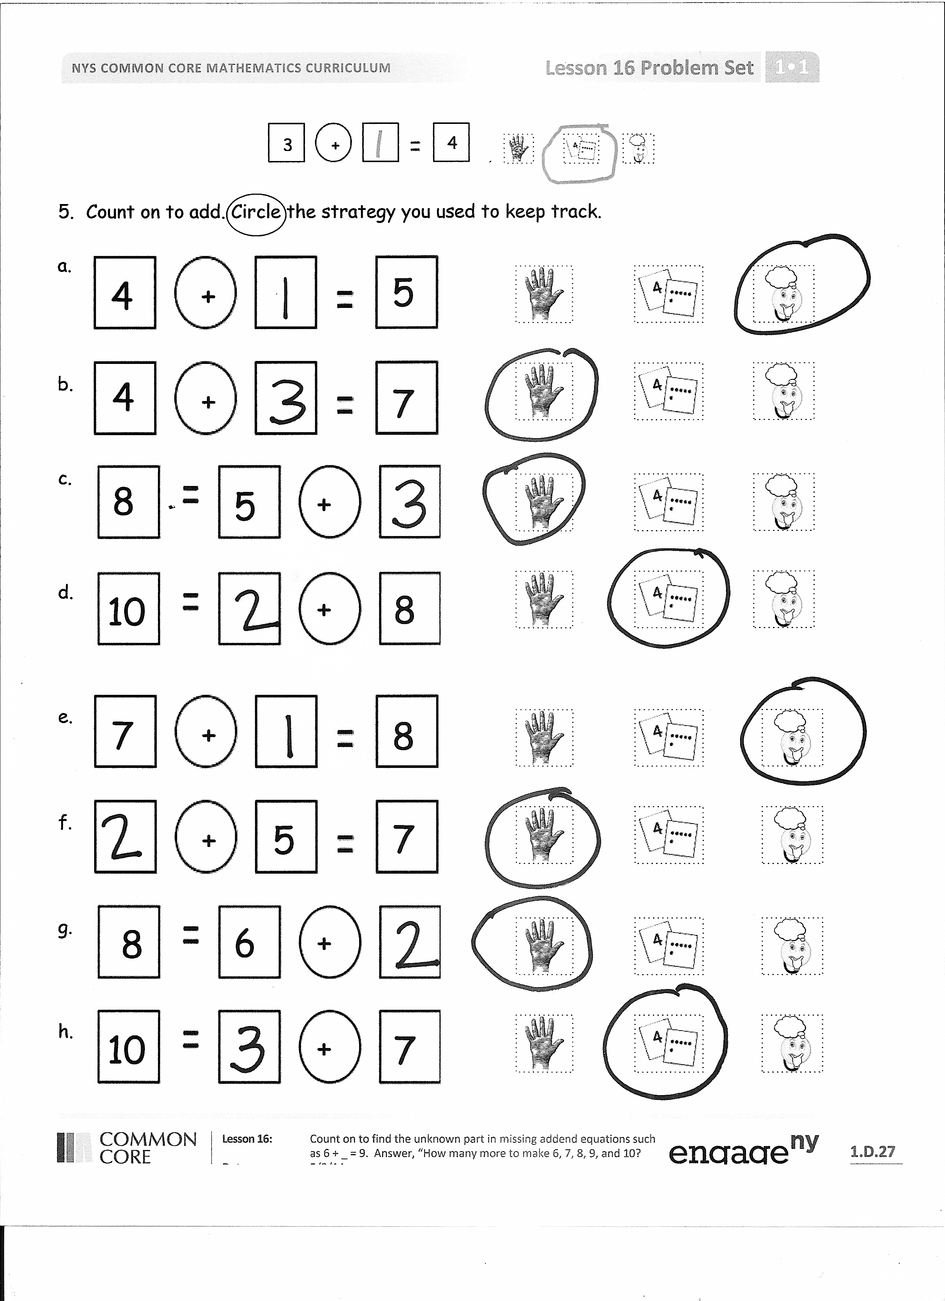
- On the Problem Set, you could pick from lots of tools or strategies. You could have kept track on your fingers, used 5-group cards, or known it in your head. Share with your partner: What do you notice about how you solved most of your problems? Why did you pick that tool or strategy the most?
Exit Ticket (3 minutes)
After the Student Debrief instruct students to complete the Exit Ticket. A quick review of their work will help you assess the students’ understanding of the concepts that were presented in the lesson today. Students have two minutes to complete the Exit Ticket. You may read the questions aloud to the students.

Name Date
- Draw more apples to solve 4 + ? = 6.

6
+
4

I added ____ apples to the tree.

- How many more to make 7?
7
+
5

- How many more to make 8?
8
+
6

- How many more to make 9?
9
+
7

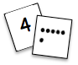
+

3
4
- Count on to add. Circle the strategy you used to keep track.
a..
+

4
5

b.
+

4
7

c.
+

5
8

d.
+

8
10

e.
+

8
7

f.
+

7
5

g.
+

8
6

h.
+

78
10

Name Date
Solve the number sentences. Circle the tool or strategy you used.
I just knew
Or
I counted on using
a.
5
+
=
7

b.
6
+
=
9
I just knew
Or
I counted on using
Name Date

- Use simple math drawings. Draw more to solve 4 + ? = 6.
=
6

4
+
=
6

2. Use your 5-group cards to solve 6 + ? = 8
6
=
8

6
+
=
8

3. Use counting on to solve 7 + ? = 10
7…

7
+
=
10

7 |  | 7 |  | 7 |  | 7
0 | 7 | 1 | 6 | 2 | 5 | 4  3

shake those disks 7 board

