Lesson 15
Objective: Count on up to 3 more using numeral and 5-group cards and fingers to track the change.

Suggested Lesson Structure
 Fluency Practice (15 minutes)
 Application Problem (5 minutes)
 Concept Development (25 minutes)
 Student Debrief (15 minutes)
Total Time (60 minutes)

Fluency Practice (15 minutes)
- Happy Counting the Say Ten Way 1.OA.5 (2 minutes)
- Sprint: Count On 1.OA.5 (13 minutes)

Happy Counting the Say Ten Way (2 minutes)
Note: Providing students with ongoing counting practice throughout the year builds and maintains their counting skills, which are foundational for later first grade work with adding and subtracting tens.
Repeat the Happy Counting activity from Lesson 3 Fluency Practice, counting by tens the Say Ten way. First, count from 0 to 50 and back. Then, count from 7 to 77 and back.

Sprint: Count On (13 minutes)

Materials: (S) Count On Sprint
Note: This activity provides continued practice relating counting to addition.

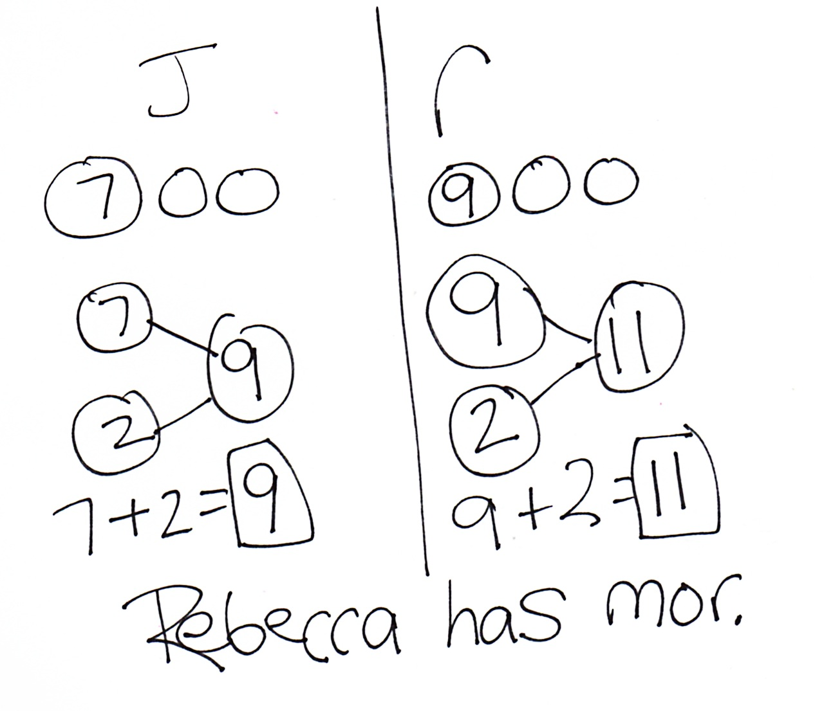
Application Problem (5 minutes)
Joshua and Rebecca were eating raisins. Joshua had 7 raisins and took 2 more from the box. Rebecca had 9 raisins and took 2 more from the box. Who had a greater number of raisins, Joshua or Rebecca? Draw math drawings and write number bonds or number sentences to show how you know.
Note: This problem provides a bridge from the previous day’s lesson to today’s as students solve problems using the Level 2 strategy of counting on.

NOTES ON
MULTIPLE MEANS
OF REPRESENTATION:
Reading aloud word problems facilitates problem solving for those students who have difficulty reading the text. Hearing the word problem also helps students who are auditory learners.

Concept Development (25 minutes)
Materials: (S) 5-group cards (Lesson 5 Template 1), number sentence cards (Lesson 11 Template) per pair with sticky note covering the total, personal white board
T: Today, let’s use our strategies for counting on to play the partner game Count On! We will need to use counting on with our fingers and counting with 5-group cards to play.
T: (Write 6 + 3 = ☐ on the board.) Show how we use counting on with our fingers to solve this.

NOTES ON
MULTIPLE MEANS
OF ENGAGEMENT:
For students who are ready, alter the number sentence cards to include more challenging numbers. For example, 23 + 2 = ? may be more appropriate for some students, as they track the change.

S: Siiiix, 7, 8, 9. (Extend fingers as they count on.)
T: Show how to use our 5-group cards to solve this.
S: Siiiix, 7, 8, 9. (Put out 5-group cards with 6 on numeral side and 3 on dot side. Touch as they count.)
T: Why did each strategy get to the same answer?
S: Both are ways to keep track of the part we are counting on.
T: This is a type of a shortcut. It is a fast or efficient strategy. Today, you will work with a partner to practice using these shortcuts, or strategies, to play Count On!
T: Here are the directions:
- Partners A and B, lay all of the number sentence cards in front of you.

NOTES ON
MULTIPLE MEANS
OF ACTION AND EXPRESSION:
When a skill is not automatic, provide support so students can practice and refine their skill. Repeated practice with 5-group cards and fingers will help students develop automaticity of their addition facts.

- Partner A, you touch the card you want to take.
- Count on or use the 5-group cards to solve for the total under the sticky note.
- When you do, your partner lifts the sticky. If you are right, your partner says, “Go ahead and take it!”
- Partner B takes a turn. Continue until all the cards are taken.
S: (Play Count On!)
T: (Circulate, listen, and observe, providing support as necessary.)
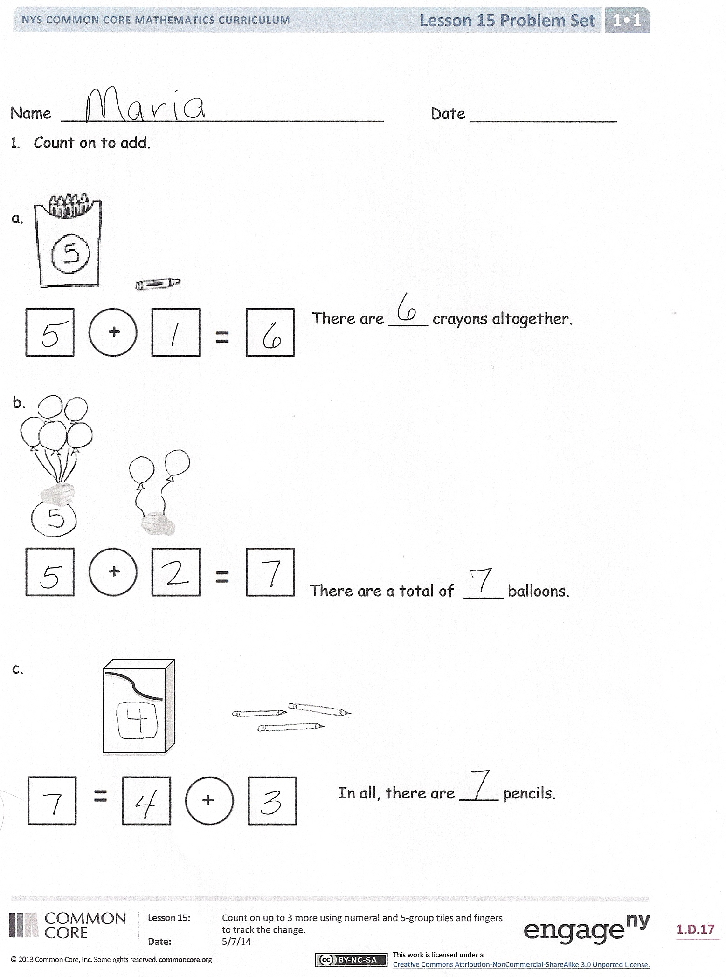
Problem Set (10 minutes)
Students should do their personal best to complete the Problem Set within the allotted 10 minutes. For some classes, it may be appropriate to modify the assignment by specifying which problems they work on first. Some problems do not specify a method for solving. Students solve these problems using the RDW approach used for Application Problems.
Review the term shortcut with students, if necessary, explaining that this is simply a fast or efficient strategy. If the second page seems overwhelming for the students, have them fold the paper in half. This way, they will only see seven number sentences at a time.

Student Debrief (15 minutes)
Lesson Objective: Count on up to 3 more using numeral and 5-group cards and fingers to track the change.
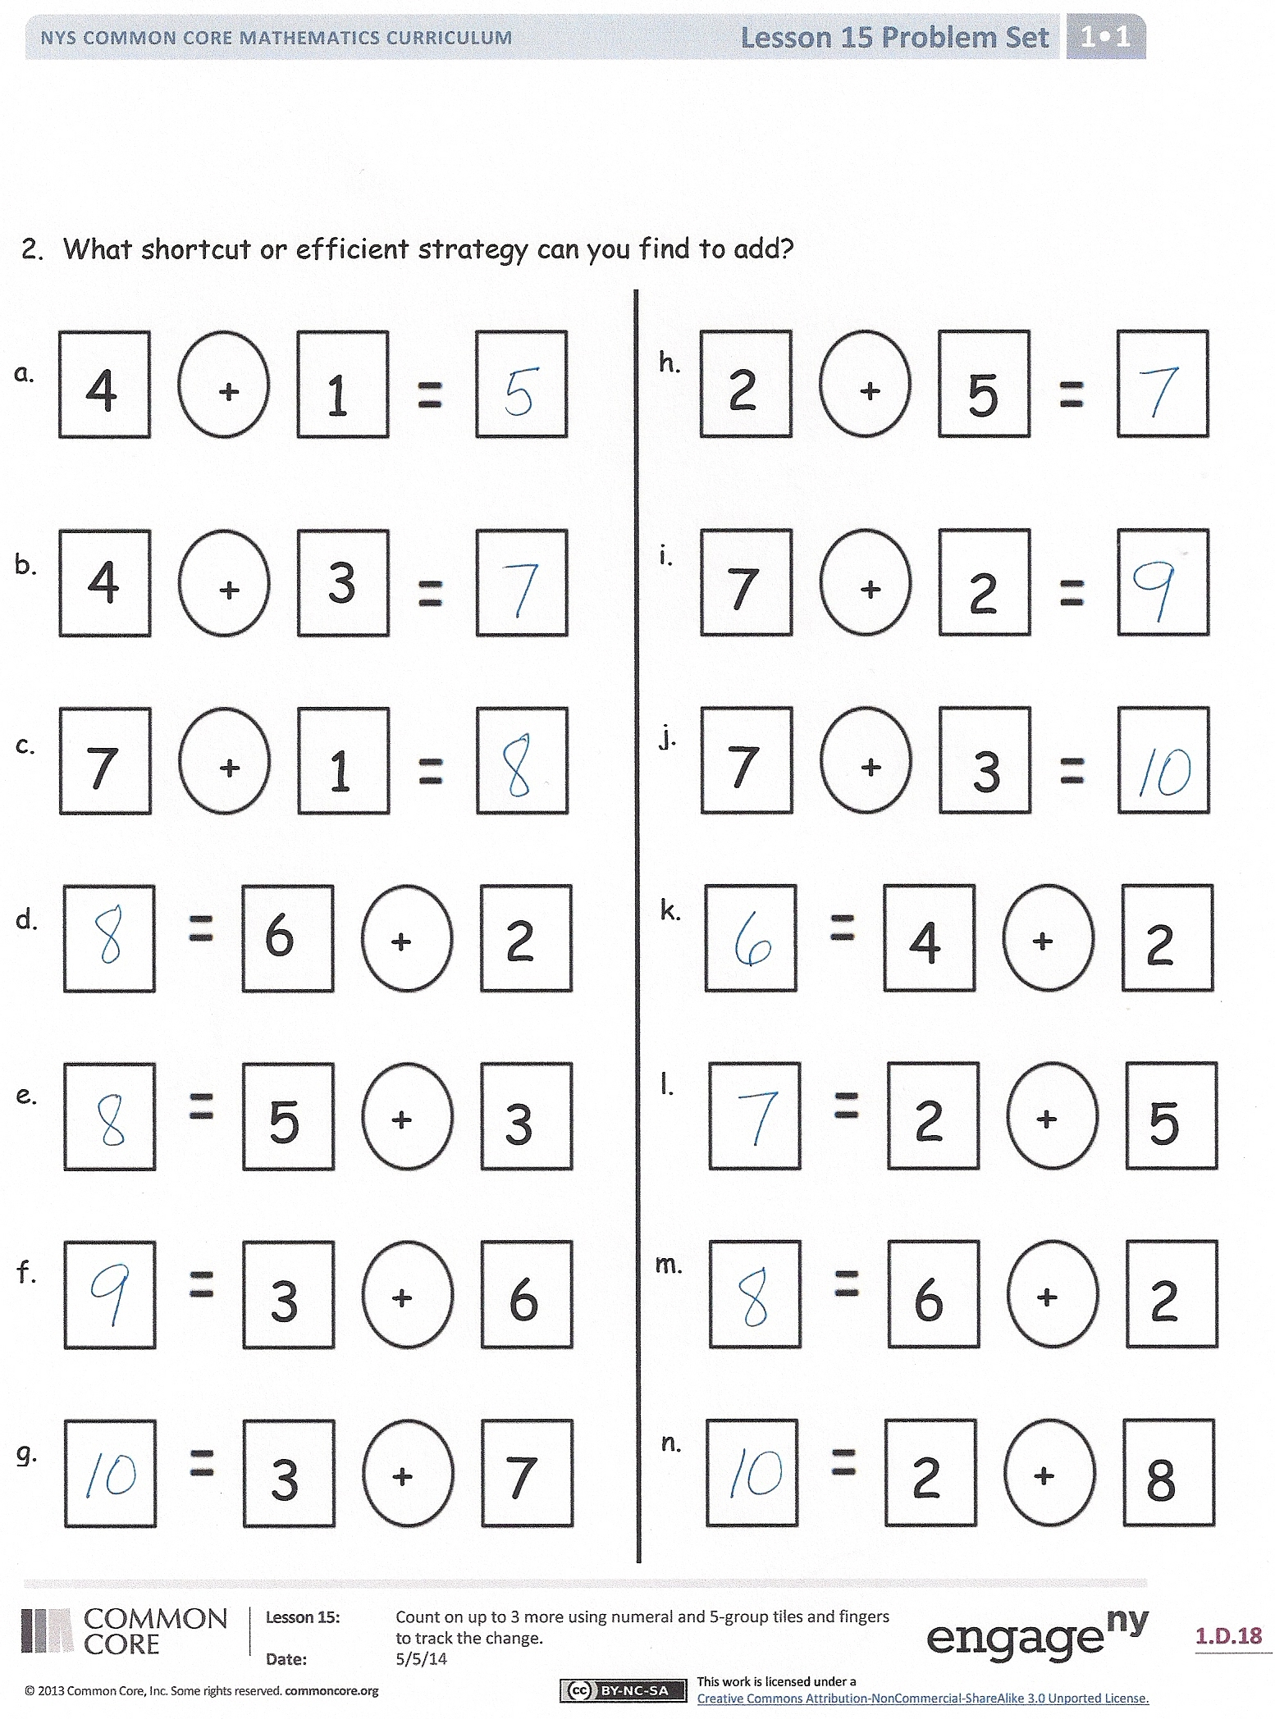
The Student Debrief is intended to invite reflection and active processing of the total lesson experience.
Invite students to review their solutions for the Problem Set. They should check work by comparing answers with a partner before going over answers as a class. Look for misconceptions or misunderstandings that can be addressed in the Debrief. Guide students in a conversation to debrief the Problem Set and process the lesson.
You may choose to use any combination of the questions below to lead the discussion.
- How are Problems 1(a) and 1(b) similar? How are they different? Can one of these help you solve the other? How?
- What shortcuts did you find to add when completing Page 2 of the Problem Set? Explain your thinking.
- How do shortcuts or strategies help us?
- Look at 7 + 1 and 6 + 2. Why is the total the same? How does counting on 1 relate to counting on 2?

- Which method do you prefer to use to keep track when you are counting on? Demonstrate what you do, using a number sentence from the Problem Set.
- Is there another way to solve these problems besides counting on? (Visualizing, knowing related facts, just knowing the fact, etc.)

Exit Ticket (3 minutes)
After the Student Debrief, instruct students to complete the Exit Ticket. A review of their work will help you assess the students’ understanding of the concepts that were presented in the lesson today and plan more effectively for future lessons. You may read the questions aloud to the students.

Name Date
Number correct:
A
*Count on to add.
1 | 1 + 1 |  | 16 | 4 + 3
2 | 2 + 1 |  | 17 | 5 + 3
3 | 3 + 1 |  | 18 | 7 + 3
4 | 3 + 2 |  | 19 | 7 + 2
5 | 1 + 2 |  | 20 | 8 + 2
6 | 2 + 2 |  | 21 | 6 + 2
7 | 2 + 3 |  | 22 | 6 + 1
8 | 2 + 1 |  | 23 | 6 + 1
9 | 2 + 2 |  | 24 | 6 + 2
10 | 3 + 2 |  | 25 | 7 + 2
11 | 5 + 2 |  | 26 | 8 + 2
12 | 8 + 2 |  | 27 | 2 + 8
13 | 8 + 1 |  | 28 | 2 + 6
14 | 7 + 1 |  | 29 | 3 + 6
15 | 9 + 1 |  | 30 | 4 + 5

Name Date
Number correct:
B
*Count and write the number.
1 | 1 + 1 |  | 16 | 4 + 2
2 | 2 + 2 |  | 17 | 3 + 2
3 | 3 + 2 |  | 18 | 5 + 2
4 | 2 + 2 |  | 19 | 7 + 2
5 | 2 + 1 |  | 20 | 7 + 3
6 | 3 + 1 |  | 21 | 6 + 3
7 | 3 + 2 |  | 22 | 6 + 2
8 | 3 + 2 |  | 23 | 6 + 2
9 | 2 + 2 |  | 24 | 5 + 2
10 | 4 + 2 |  | 25 | 7 + 2
11 | 1 + 2 |  | 26 | 6 + 2
12 | 2 + 1 |  | 27 | 2 + 6
13 | 3 + 1 |  | 28 | 2 + 7
14 | 5 + 1 |  | 29 | 3 + 7
15 | 7 + 1 |  | 30 | 4 + 7

Name Date

- Count on to add.
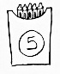
a.
+

There are ____ crayons altogether. 

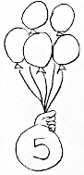
b.
+

b.

There are a total of ____ balloons.

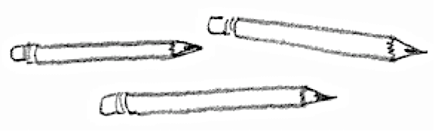
c.

+

In all, there are ____ pencils.

- What shortcut or efficient strategy can you find to add?
a.
h.
n.
i.
k.
l.
j.
+

2
51
+

23
853
+

4
1
+

4
3
+

1
7
+

5
3
+

678
32
+

26
62
+

78
32

+

74
21
b.
b.

+

78
31
c.

+

41
21
d.

e.
+

22
53523
e.

g.
f.
m.
+

6
25
Name Date

Show the shortcut you used to add.
Use the picture to add.
6

+

=

There are _________ eggs total.

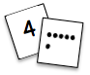
Name Date
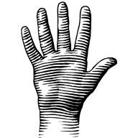

Use your 5-group cards or your fingers to count on to solve.

Show the shortcut you used to add.

+

2
6
1.
+

3
5
2.
+

2
6
+

7
3

5.
4.
6.
7
2
+

6
3
+

8
2
+

+

7
2
Show the strategy you used to add.
3.

