Lesson 11

Objective: Use the addition of adjacent angle measures to solve problems using a symbol for the unknown angle measure.

Suggested Lesson Structure

 Fluency Practice (12 minutes)

 Application Problem (8 minutes)

 Concept Development (30 minutes)

 Student Debrief (10 minutes)

**Total Time (60 minutes)**

Fluency Practice (12 minutes)

* Divide Different Units **4.NBT.1** (4 minutes)
* Break Apart 90, 180, and 360 **4.MD.7** (4 minutes)
* Find the Unknown Angle **4.MD.7** (4 minutes)

Divide Different Units (4 minutes)

Materials: (S) Personal white board

Note: This fluency activity reviews Module 3 content.

6 ÷ 2 = 3

60 ÷ 2 = 30

600 ÷ 2 = 300

6,000 ÷ 2 = 3,000

T: (Write 6 ÷ 2 = .) Say the division sentence in unit form.

S: 6 ones ÷ 2 = 3 ones.

T: (Write 6 ÷ 2 = 3. To the right, write 60 ÷ 2 = .) Say the division sentence in unit form.

S: 6 tens ÷ 2 = 3 tens.

T: (Write 60 ÷ 2 = 30. To the right, write 600 ÷ 2 = .) Say the division sentence in unit form.

S: 6 hundreds ÷ 2 = 3 hundreds.

T: (Write 600 ÷ 2 = 300. To the right, write 6,000 ÷ 2 = .) Say the division sentence in unit form.

S: 6 thousands ÷ 2 = 3 thousands.

T: (Write 6,000 ÷ 2 = 3,000.)

T: (Write 8 tens ÷ 2 = .) On your personal white boards, write the division sentence in standard form.

S: (Write 80 ÷ 2 = 40.)

Continue with the following possible sequence: 8 tens ÷ 2, 25 tens ÷ 5, 12 hundreds ÷ 4, 24 hundreds ÷ 4, 27 tens ÷ 3, 32 tens ÷ 4, 30 tens ÷ 5, and 40 hundreds ÷ 5.

Break Apart 90, 180, and 360 (4 minutes)

Materials: (S) Personal white board

Note: This fluency exercise prepares students for unknown angle problems in Lesson 11.

T: (Project a number bond with a whole of 90. Fill in 9 for one of the parts.) On your personal white boards, write the number bond, filling in the unknown part.

S: (Draw a number bond with a whole of 90 and with 9 and 81 as parts.)

Continue to break apart 90 with the following possible sequence: 55, 35, and 75.

T: (Project a number bond with a whole of 180. Fill in 142 for one of the parts.) On your boards, write the number bond, filling in the unknown part.

S: (Draw a number bond with a whole of 180 and with 142 and 38 as parts.)

Continue to break apart 180 with the following possible sequence: 47, 133, and 116.

T: (Project a number bond with a whole of 360. Fill in 58 for one of the parts.) On your boards, write the number bond, filling in the unknown part.

S: (Draw a number bond with a whole of 360 and with 58 and 302 as parts.)

Continue to break apart 360 with the following possible sequence: 93, 261, and 48.

Find the Unknown Angle (4 minutes)





Materials: (S) Personal white board

Note: This fluency activity reviews Lesson 10.

T: (Project .) Angle is a right angle. Say the given angle.

S: 80°.

T: On your personal white boards, write the measure of . If you need to, write a subtraction sentence to find the answer.

S: (Write = 10°)

Continue with right angles using the following possible sequence:  = 30° and  = 45°.

T: (Project .) is a straight angle. What’s the measurement of a straight angle?

S: 180°.

T: On your boards, write the measure of . If you need to, write a subtraction sentence to find the answer.

S: (Write 150°.)

Continue with straight angles using the following possible sequence: = 60°, = 90°, and = 135°.

Application Problem (8 minutes)

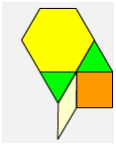

Use patterns blocks of various types to create a design in which you can see a decomposition of 360°. Which shapes did you use? Compare your representation to that of your partner. Are they the same? Write an equation to show how you composed 360°. Refer to the pattern block chart to help with the angle measures of the pattern blocks, as needed.

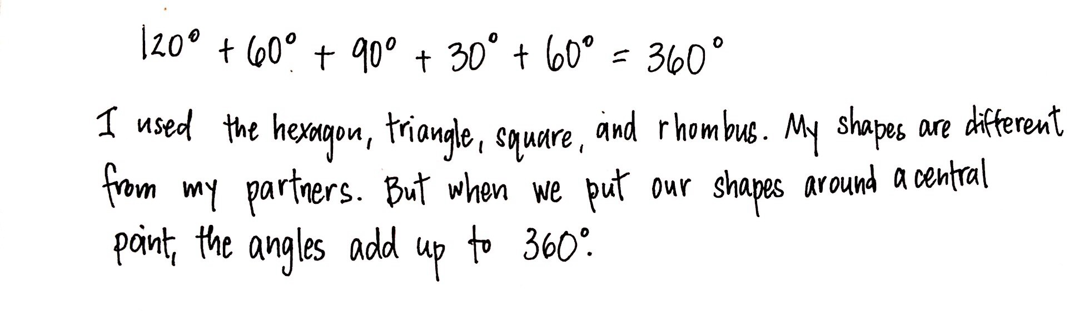

Note: This Application Problem builds from the previous lesson where students examined the relationship of the degree measure of parts of an angle to the whole and discovered that there are different ways to compose and decompose angles. This leads into today’s Concept Development where students further their discovery of the additive nature of angle measure by exploring angles that add to 360.

Concept Development (30 minutes)

Materials: (T) Blank paper, personal white board, protractor, pattern blocks, straightedge, red marker, blue marker, chart of pattern block angle measures (S) Blank paper, personal white board, protractor, pattern blocks, straightedge, red and blue pencils, markers, or crayons

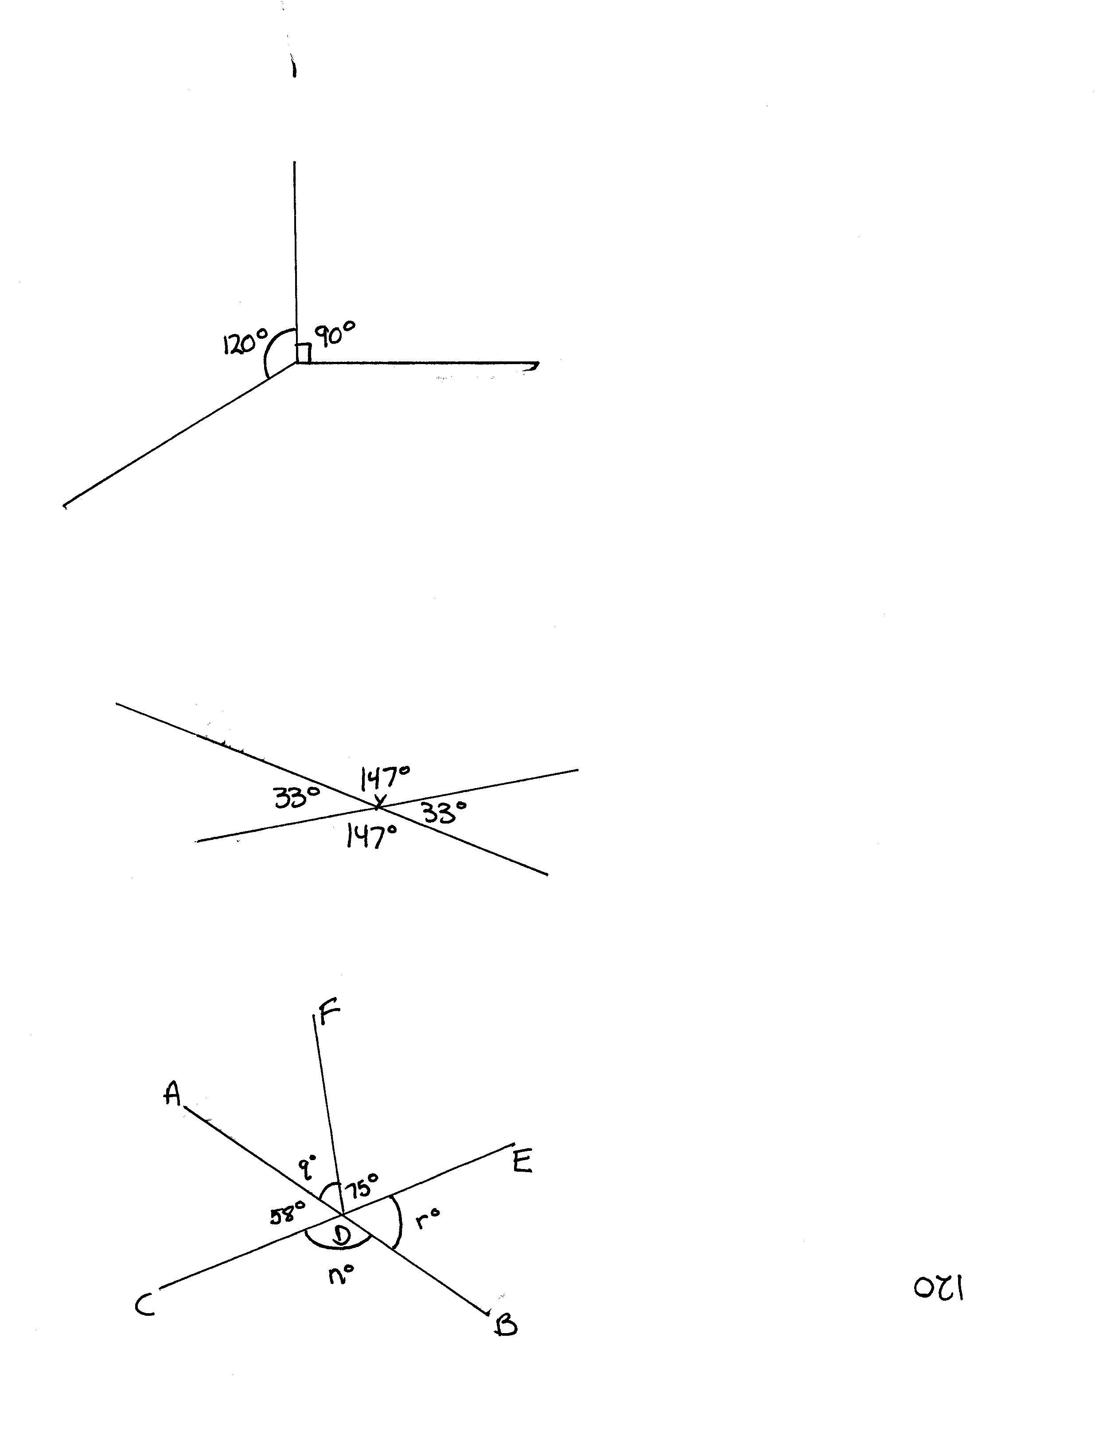

Problem 1: Decompose a 360° angle into smaller angles. Recognize that the smaller angles add up to 360°.

T: Take one of your pattern blocks away from the shape that you made in the Application Problem. Now, there is a missing piece. Write an equation to show the total using to represent the measurement of the angle of the missing piece.

S: 120 + 120 + = 360. 🡪 120 + 60 + 30 + 30 + = 360.

T: Challenge your partner to determine the unknown angle. How can we solve?

S: Add together all of the known parts, and then subtract the total from the whole, which is 360.

T: Does it matter how many parts there are?

S: The parts will always add to make the whole. 🡪 There could be as few as three parts or as many as twelve if we are using pattern blocks. 🡪 The parts will always add to 360.

T: (Project image as shown to the right.) How can we solve for the unknown angle?

S: It’s like what we just did with the pattern blocks. We know that 90 + 120 = 210. 360 – 210 = 150. The angle must be 150°.

T: Let’s use a protractor to verify.

T: Now, use your straightedge to draw two intersecting lines. Locate where they intersect, and label that point . Measure each angle that composes the angle around point . What do you notice?

S: The angles that are across from each other are the same.

T: Write a number sentence to show the total. What will the total be?

S: The total will be 360 because all of the angles surround one point. 33 + 147 + 33 + 147 = 360.

Problem 2: Given two intersecting lines and the measurement of one angle, determine the measurement of the other three angles.

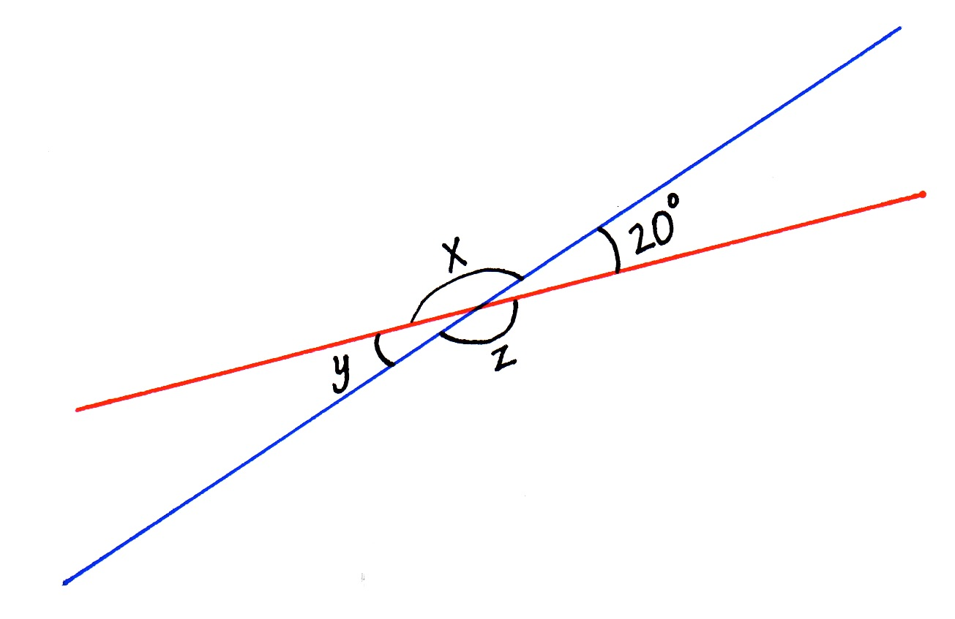Draw a line on the board using a red marker. Draw an intersecting line in blue, decomposing the straight angle into two smaller angles, one of which is 20°. Label the 20° angle, and label the unknown angles pictured to the right with variables.

T: What do you see?

S: Two intersecting lines. 🡪 Two straight angles in two parts. One angle is 20. The other angles are unknown.

T: (Point to the red line.) Determine the unknown angle, .

S: 180 – 20 = 🡪 = 160 🡪 160°.

T: Now, look at the blue line. Notice the measure of is unknown. How can we solve for it?

S: We know that is 160°. 180 – 160 = or 160 + ___ = 180. = 20.

T: (Point to the red line.) Let’s look at the red line again. How can we determine ?

S: 180 – 20 = . + 20 = 180. = 160. 🡪 Those angles are the same as the angles that we started with!

T: Let’s try another one. (Draw two intersecting lines, one red and one blue. Measure with a protractor to make one angle 110° and label the angle.) Show this on your personal white boards, and then work with a partner to determine the unknown angles.

S: The unknown angles are 70°, 110°, and 70°. Hey, the angles that are across from each other are the same!

Problem 3: Solve a practical application word problem involving unknown angles.

T: Cyndi is making a quilt square. The blue, pink, and green pieces meet at a point. At the point, the blue piece has an angle measurement of 100 degrees, and the pink has an angle measurement of 80. What is the angle measurement determined by the green piece?

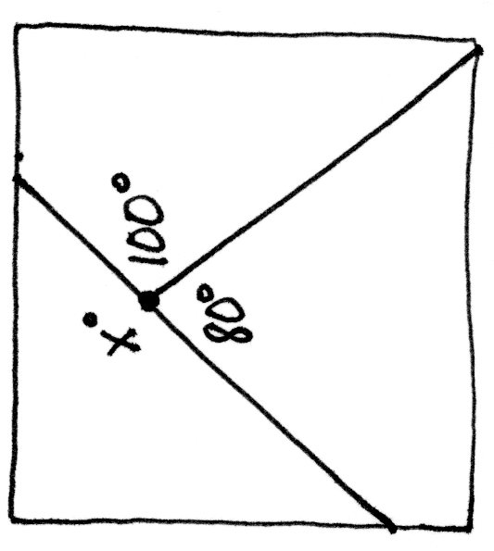T: Draw a picture to show a representation of the quilt square. Tell your partner what your picture shows. What do we want to know?

**MP.3**

S: There are three pieces of fabric sewn together. The angles are 100° and 80°. We need to know the measurement of the third angle.

T: How did you know what a 100° angle looks like without a protractor?

S: I know that 100° is slightly larger than a 90° angle. I know what a 90° angle looks like, so I can draw my angle so that it’s pretty close.

T: How about the 80°?

S: 80° is less than 90° so I can draw that pretty close too.

T: Write the equation that you will need to solve to find the measure of the last piece.

S: 100 + 80 + = 360.

T: Solve.

S: 100 + 80 = 180. 360 – 180 = 180. = 180

Problem 4: Determine the unknown angle measures surrounding a point.

T: (Project image as shown to the right.) and are intersecting segments. meets and at point , which is the intersection of and . What angles do we know?

S: is 58°, and is 75°. We can solve for 58 + 75 = 133. 🡪 180 – 133 = 47. is 47°.

T: We now know three angle measures. How can we figure out the measure of ?

S: 75 + 47 = 122 and 180 – 122 = 58. = 58. 🡪 122 + 8 is 130. 130 + 50 is 180, so is 58. 🡪 It’s 58° since the angle directly across from it is 58°.

T: Can we solve for the last angle?

S: 58 + = 180. = 122°.

T: What will the sum of the angles be?

S: 58 + 47 + 75 + 58 + 122 = 360.

Problem Set (10 minutes)

Students should do their personal best to complete the Problem Set within the allotted 10 minutes. For some classes, it may be appropriate to modify the assignment by specifying which problems they work on first. Some problems do not specify a method for solving. Students should solve these problems using the RDW approach used for Application Problems.

Student Debrief (10 minutes)

|  |  |
| --- | --- |
|  | NOTES ON  MULTIPLE MEANS  OF ENGAGEMENT: |
| Allow students working above grade level and others more choice and autonomy for the Problem Set. Extend or offer as an alternative the following opportunities:   * Invite students to precisely construct and accurately label the angles made by a pair of intersecting lines or perpendicular lines, such as in Problems 6 and 7. * Have students locate similar intersecting segments and angles within street maps, concrete or virtual, using online mapping tools pointed at familiar landmarks (for example, Times Square.) * Invite students to complete the following: Draw a pizza that is sliced for five friends to share equally. Label the angles of each slice. Use words and numbers to explain your thinking. | |

**Lesson Objective:** Use the addition of adjacent angle measures to solve problems using a symbol for the unknown angle measure.

The Student Debrief is intended to invite reflection and active processing of the total lesson experience.

Invite students to review their solutions for the Problem Set. They should check work by comparing answers with a partner before going over answers as a class. Look for misconceptions or misunderstandings that can be addressed in the Debrief. Guide students in a conversation to debrief the Problem Set and process the lesson.

You may choose to use any combination of the questions below to lead the discussion.

* What prior knowledge did you need in order to determine the two unknown angles for Problem 3?
* For Problem 4, how did knowing the angle measure of a neighboring or touching angle assist you in solving for the unknown angles? Try using the term **adjacent angle** to describe the neighboring or touching angle.
* How does your knowledge of a line assist you in solving Problem 5?
* Describe how you used the lines to solve Problem 6. Did your method for solving involve adding up angles to 180 or 360 or a combination?
* 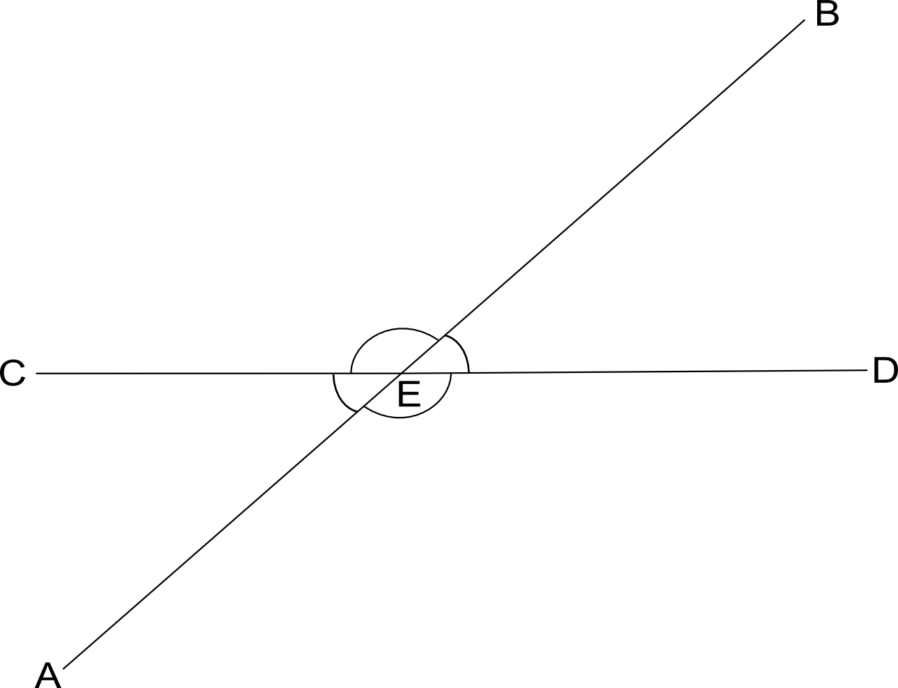In our lesson today, we used what we know to see that when two lines intersect, the vertically opposite angles are equal in measure. (Point to the angles within the figure at right.) (Write ) Why do you think they are called **vertical angles**?

:

* For the last two days, we have seen the new symbol for the plural of angles. (Allow students time to write each symbol.) On your personal white boards, show me how to write the symbols for angles add, angles at a point, angles on a line, and finally, our new one, vertical angles. Check your work with your partner, and explain, in your own words, the meaning of each symbol. You may draw to explain.
* How did the Application Problem connect to today’s lesson?

Exit Ticket (3 minutes)

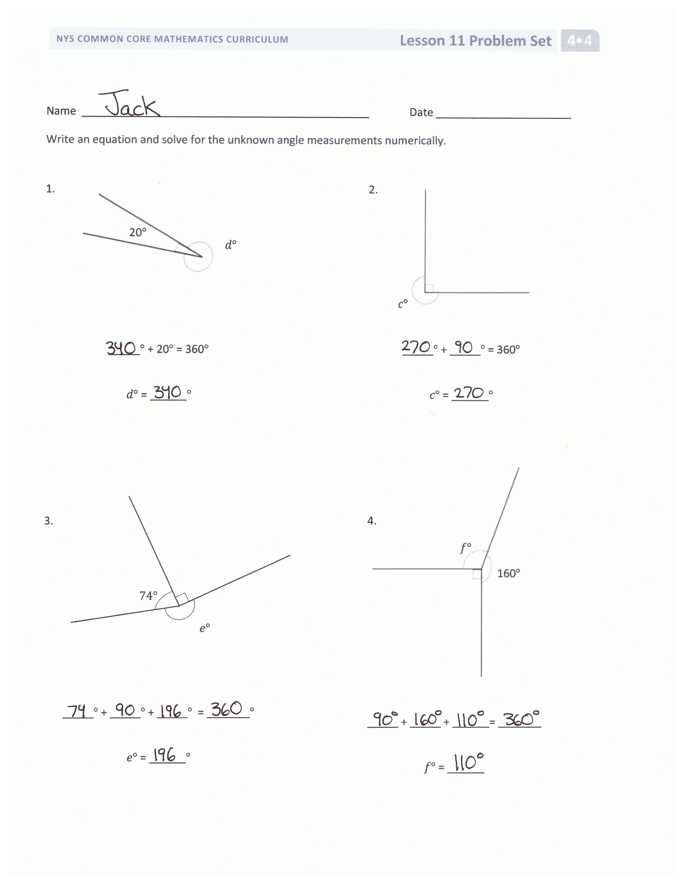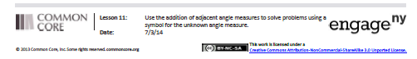

After the Student Debrief, instruct students to complete the Exit Ticket. A review of their work will help you assess the students’ understanding of the concepts that were presented in the lesson today and plan more effectively for future lessons. You may read the questions aloud to the students.

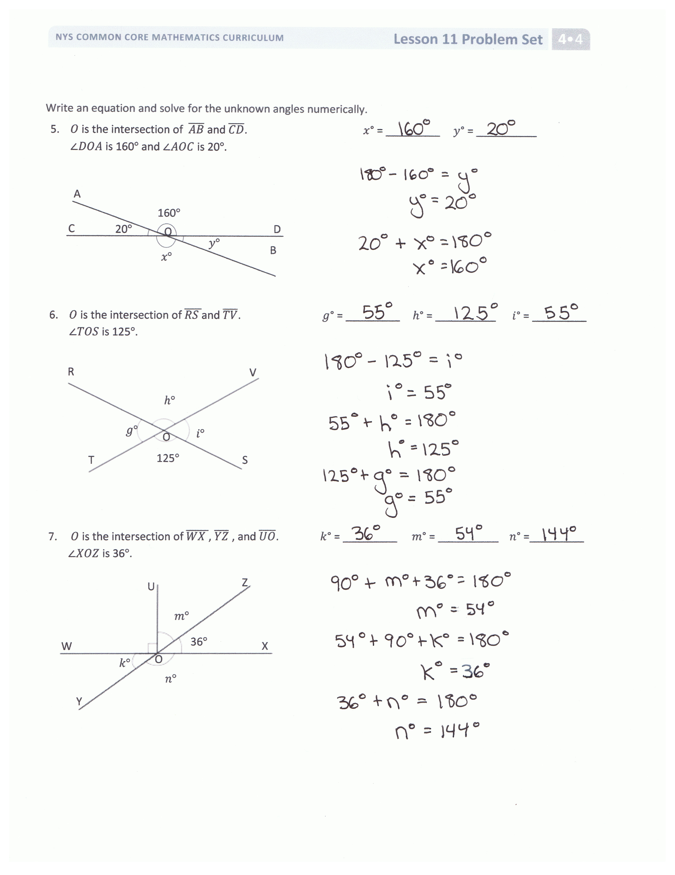

Name Date

Write an equation, and solve for the unknown angle measurements numerically.

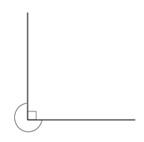

1. 2.

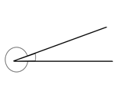

20

_____ + _____ = 360

= ______

_____ + 20 = 360

= ______

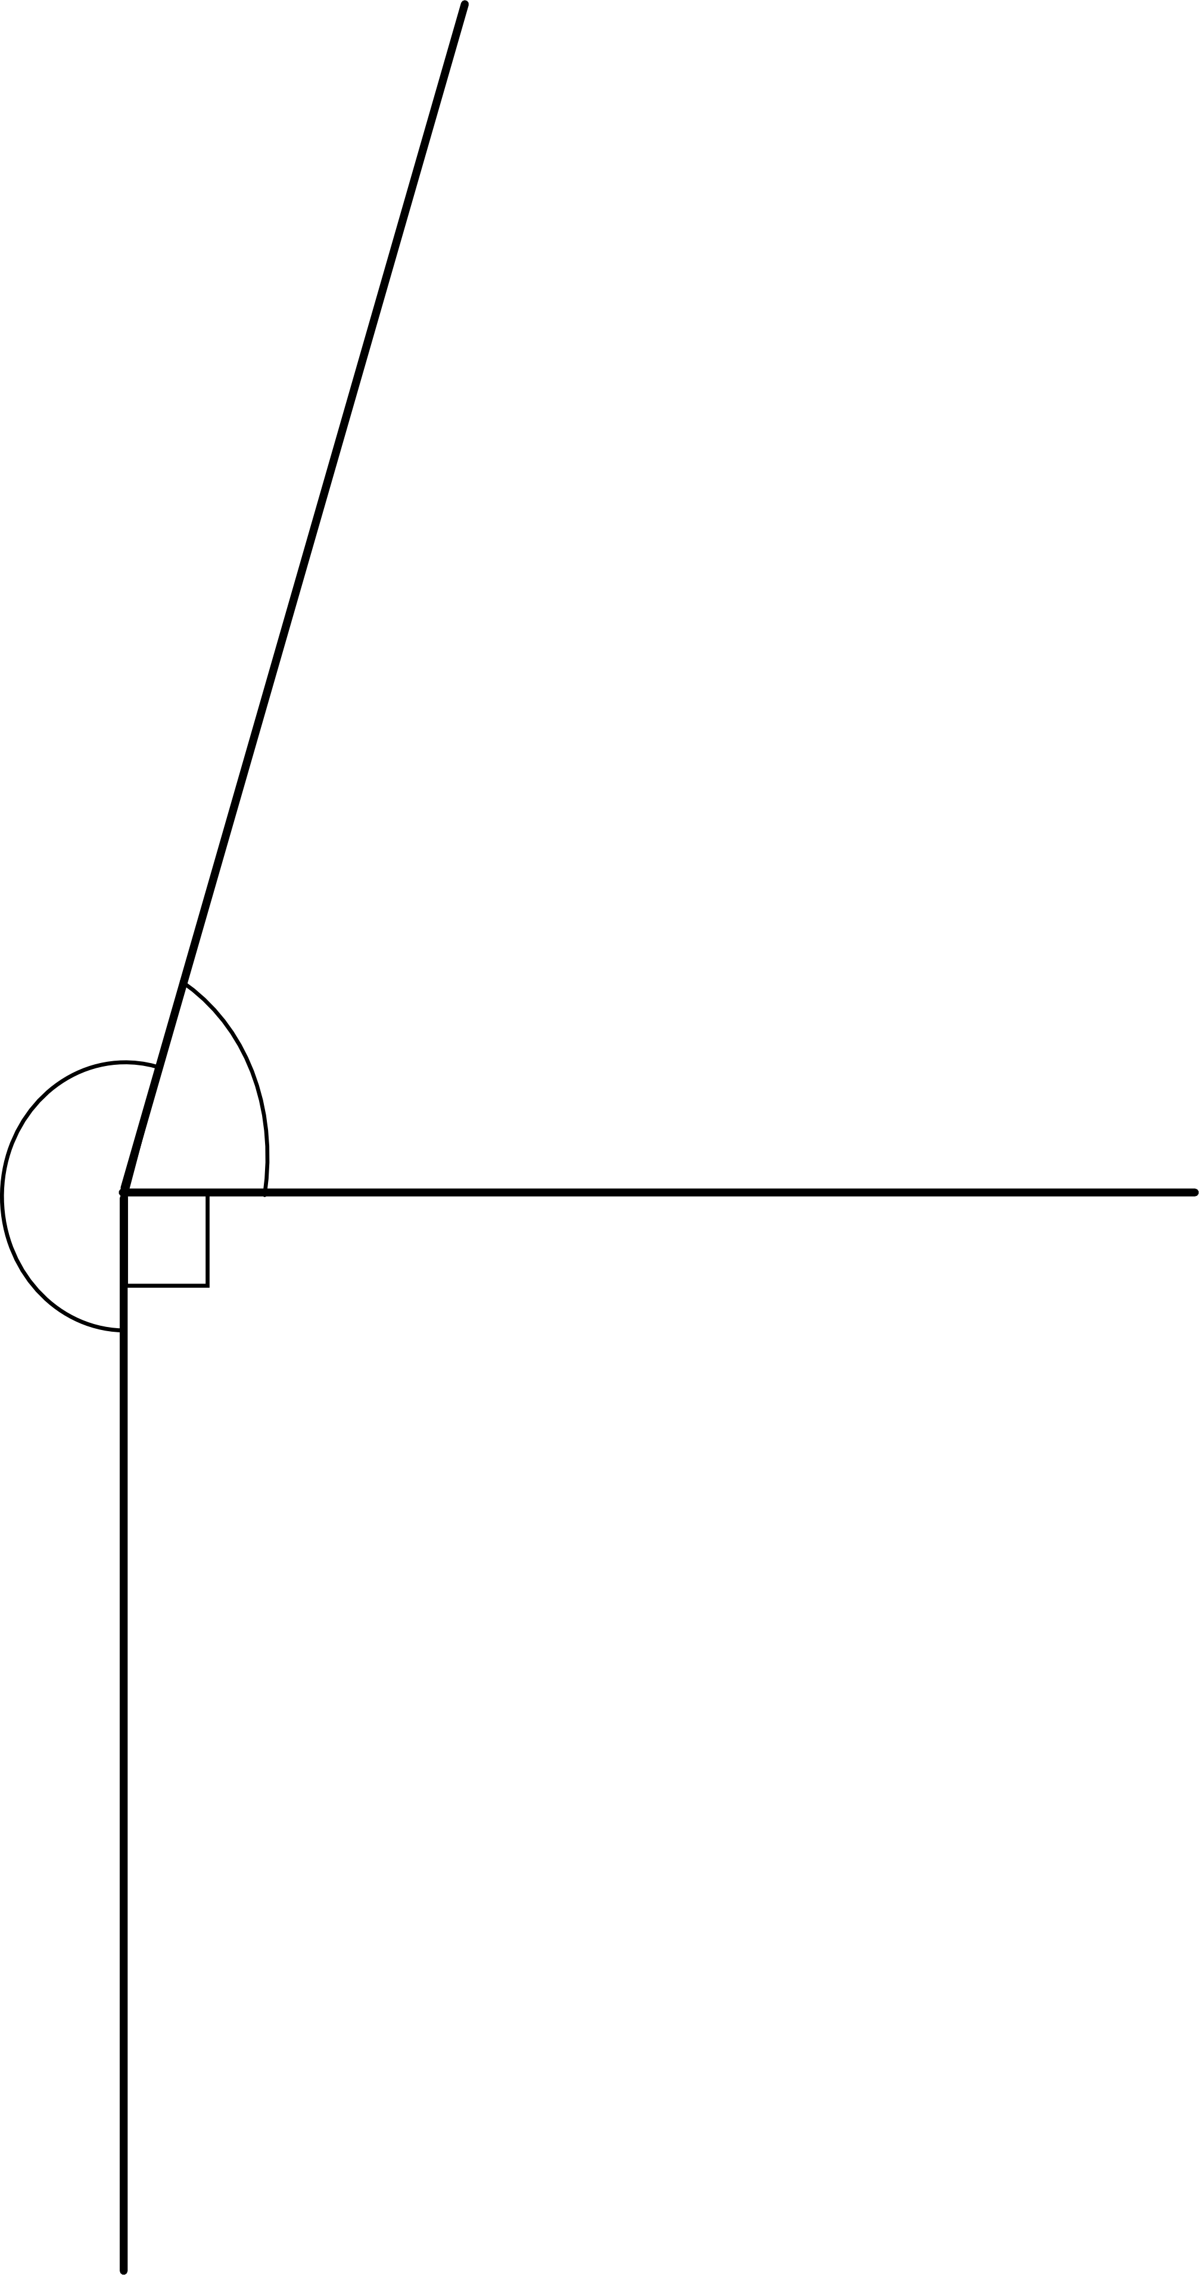

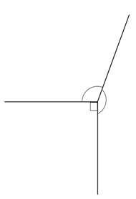

160

3. 4.

74

_____ + _____ + _____ = _______

= _____

_____ + _____ + _____ = _______

= ______

Write an equation, and solve for the unknown angles numerically.

1. is the intersection of and . = _________ = __________  
    is 160and is 20.

A

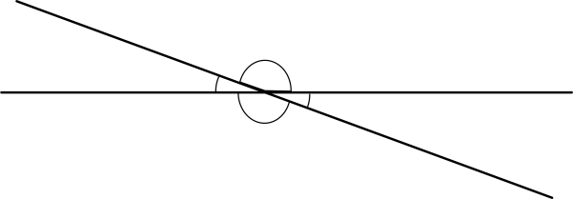

20

160

O

C

D

B

1. 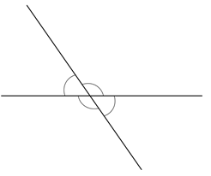 is the intersection of and . = _________ = __________ = _________  
    is 125.

R

V

O

S

T

125

1. is the intersection of , , and . = _________ = __________ =_________  
    is 36.

Z

U

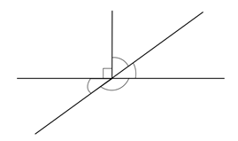

Y

W

X

O

36

Name Date

Write equations using variables to represent the unknown angle measurements. Find the unknown angle measurements numerically.

A

F

D

C

B

E

66

1. =
2. =
3. =

Name Date

Write an equation, and solve for the unknown angle measurements numerically.

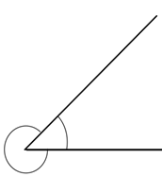

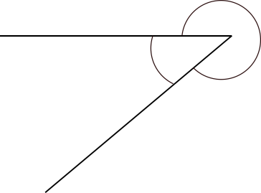1. 2.

45

320

_____ + 320 = 360

= ______

_____ + _____ = 360

= ______

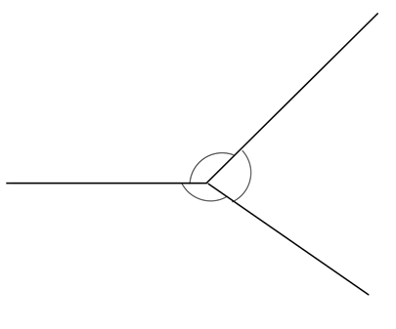

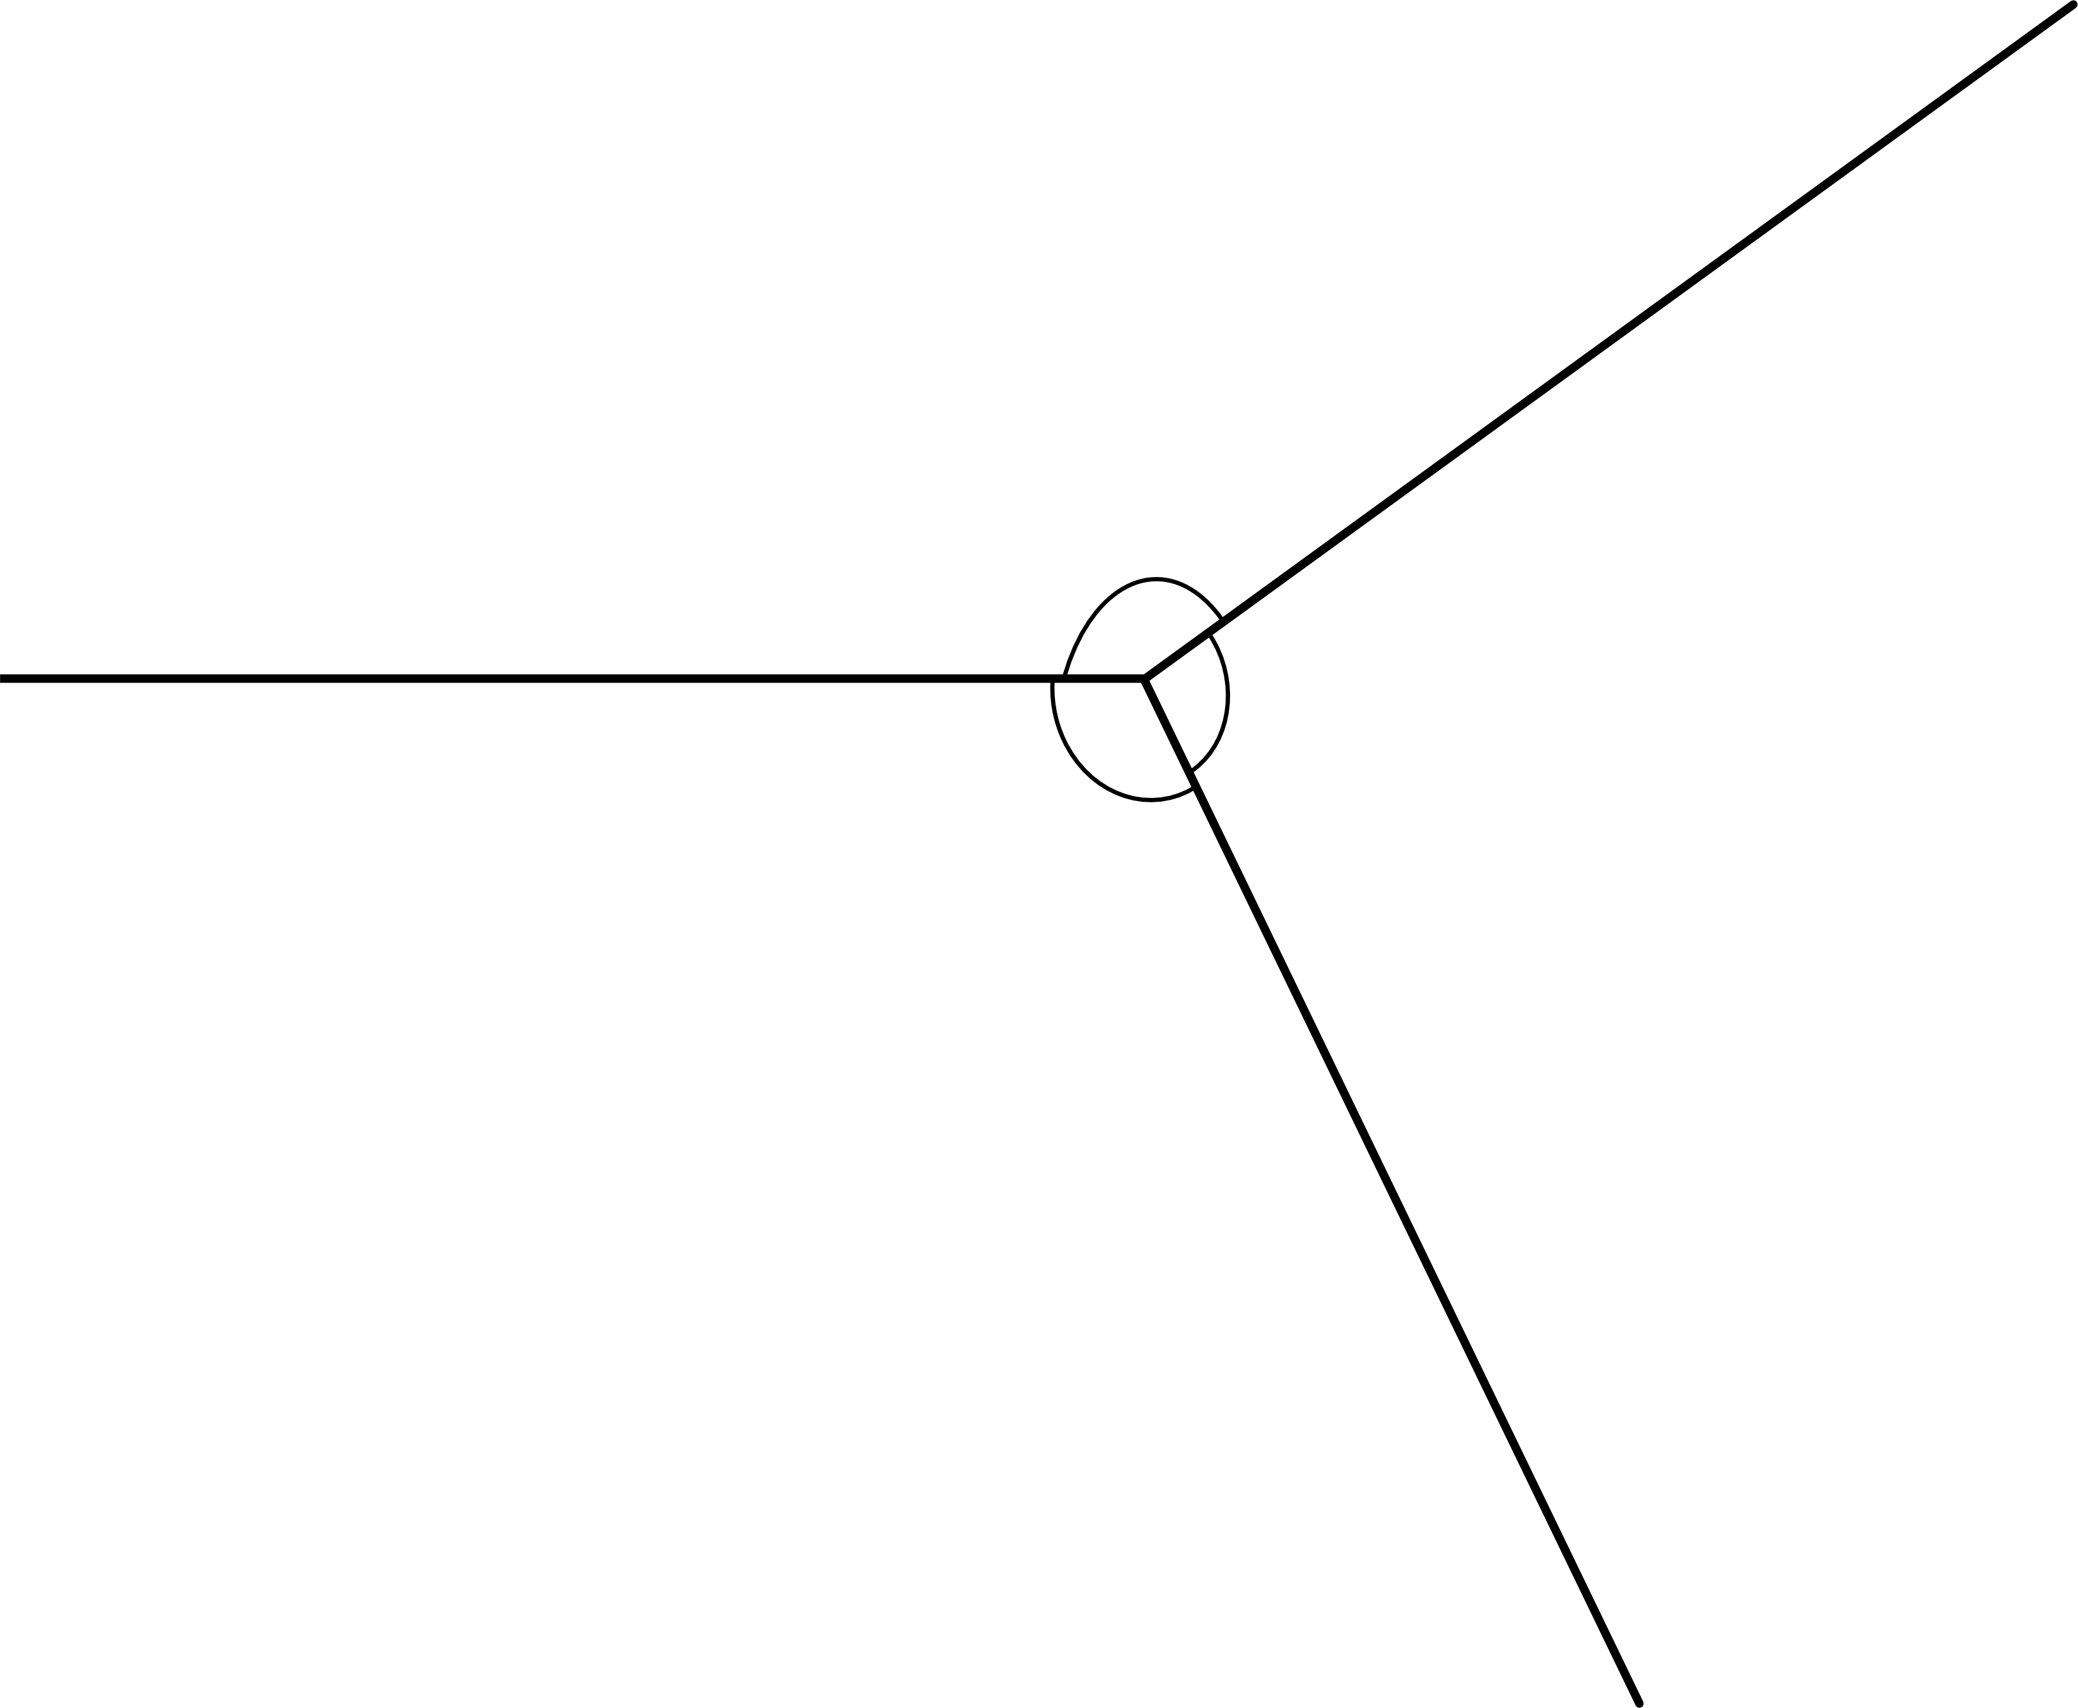3. 4.

135

145

_____ + _____ + _____° = _______

= ______

_____ + _____ + _____° = _______

= ______

Write an equation and solve for the unknown angles numerically.

1. is the intersection of and . = _________ = __________  
    is 145and is 35.

A

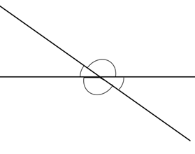

D

C

35

O

145

B

1. is the intersection of and . = _________ = __________ = _________  
    is 55.



Q

T

55

O

S

R

1. 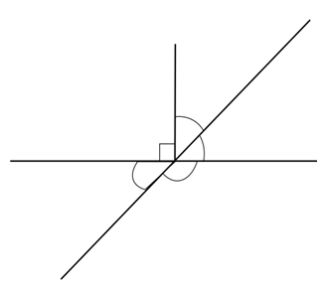 is the intersection of , , and . = _________ = __________ = ________  
    is 46.

X

Y

W

U

V

46

O