Lesson 9
Objective: Decompose angles using pattern blocks.

Suggested Lesson Structure
 Fluency Practice (12 minutes)
 Application Problem (5 minutes)
 Concept Development (33 minutes)
 Student Debrief (10 minutes)
Total Time (60 minutes)
Fluency Practice (12 minutes)
- Count by 90° 4.MD.7 (1 minute)
- Break Apart 90, 180, and 360 4.MD.7 (4 minutes)
- Sketch Angles 4.MD.6 (3 minutes)
- Physiometry 4.G.1 (4 minutes)
Count by 90° (1 minute)
Note: This fluency activity prepares students to do problem solving that involves 90° turns.
Direct students to count forward and backward, occasionally changing the direction of the count.
- Nines to 36
- 9 tens to 36 tens
- 90 to 360
- 90° to 360° (while turning)
Break Apart 90, 180, and 360 (4 minutes)
Materials: (S) Personal white board
Note: This fluency exercise prepares students for unknown angle problems in Lessons 10 and 11.
T: (Project a number bond with a whole of 90. Fill in 30 for one of the parts.) On your personal white boards, write the number bond, filling in the unknown part.
S: (Draw a number bond with a whole of 90 and with 30 and 60 as parts.)
Continue to break apart 90 with the following possible sequence: 50, 45, 25, and 65.

T: (Project a number bond with a whole of 180. Fill in 120 for one of the parts.) On your boards, write the number bond, filling in the unknown part.
S: (Draw a number bond with a whole of 180 and with 120 and 60 as parts.)
Continue to break apart 180 with the following possible sequence: 90, 75, 135, and 55.
T: (Project a number bond with a whole of 360. Fill in 40 for one of the parts.) On your boards, write the number bond, filling in the unknown part.
S: (Draw a number bond with a whole of 360 and with 40 and 320 as parts.)
Continue to break apart 360 with the following possible sequence: 160, 180, 170, 270, 120, 90, and 135.
Sketch Angles (3 minutes)
Materials: (S) Personal white board
Note: This fluency activity reviews terms from Lesson 2.
T: Sketch $∠ABC$ that measures 90°.
T: (Allow students time to sketch.) Is a 90° angle a right angle, an obtuse angle, or an acute angle?
S: Right angle.
T: Sketch $∠DEF$ that measures 100°.
T: (Allow students time to sketch.) What type of angle did you draw?
S: Obtuse.
Continue with the following possible sequence: 170°, 30°, 130°, 60°, and 135°.
Physiometry (4 minutes)
Note: Kinesthetic memory is strong memory. This fluency exercise reviews terms from Lessons 1–8.
T: (Stretch one arm straight up, pointing at the ceiling. Straighten other arm, pointing directly at a side wall.) What angle measure do you think I’m modeling with my arms?
S: 90°.
T: (Straighten both arms so that they are parallel to the floor, pointing at both side walls.) What angle measure do you think I’m modeling now?
S: 180°. Straight angle.
T: (Keep one arm pointing directly to a side wall. Point directly down with the other arm.) Now?
S: (270°.) 90°.
T: It could be 90°, but the angle I’m thinking of is larger than 180°, so that would be?
S: 270°.
Continue to 360°.
Quickly remind students that this is an illustration, and that they should not make the mistake to think that lines and points are as thick as arms. They are actually infinitely small.
T: Stand up.
S: (Stand.)
T: Model a 90° angle.
T: Model a 180° angle.
T: Model a 270° angle.
T: Model a 360° angle.
T: Point to the walls that run perpendicular to the front of the room.
S: (Point to the side walls.)
T: (Point to side wall.) Turn 90$°$ to your right.
T: Turn 90$°$ to your right.
T: Turn 90$°$to your right.
T: Turn 90$°$to your right.
T: Turn 180$°$.
T: Turn 90$°$to your left.
T: Turn 180$°$.
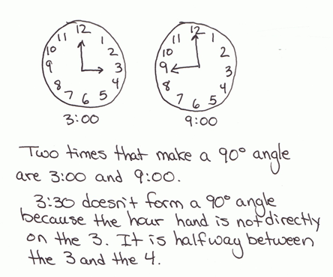
Application Problem (5 minutes)
List times on the clock in which the angle between the hour and minute hands is 90°. Use a student clock, watch, or real clock. Verify your work using a protractor.
Stay alert for this misconception: Why don’t the hands at 3:30 form a 90° angle as expected?
Note: This Application Problem reviews measuring, constructing, verifying with a protractor, and recognizing in their environment 90° angles as taught in Topic B. Students use their knowledge of 90° angles to compose and decompose angles using pattern blocks in today’s Concept Development.
Concept Development (33 minutes)
Materials: (T) Pattern blocks for the overhead projector or an interactive white board with pattern block images, straightedge, protractor (S) Pattern blocks, Problem Set, straightedge, protractor
Note: Students record discoveries with pattern blocks on the Problem Set as indicated in this Concept Development.
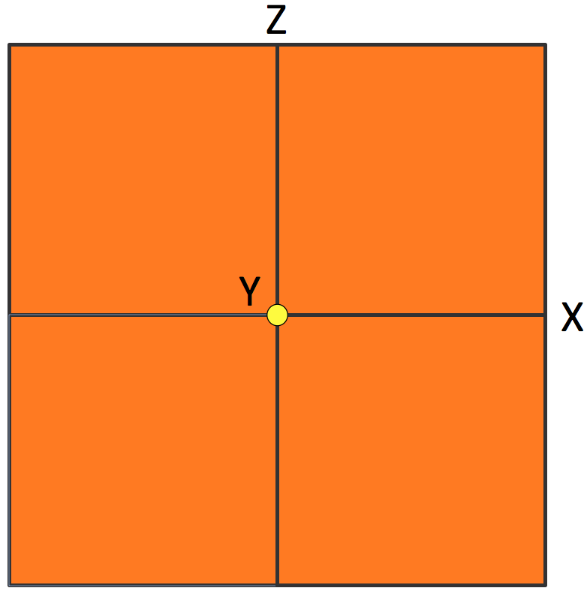
Problem 1: Derive the angle measures of an equilateral triangle.
T: Place squares around a central point. (Model.) Fit them like puzzle pieces. Point to the central point. (Model.) How many right angles meet at this central Point Y?
S: 4.
T: (Trace and highlight $∠XYZ$.) Trace $∠XYZ$. Tell your neighbor about it.
S: It’s 90°. It’s a right angle. If $\overline{XY}$ is at 0°, $∠XYZ$ is one quarter-turn counterclockwise. If this were a clock, it would be 3 o’clock.
T: How many quarter-turns are there around the central point?
S: Four quarter-turns!
T: If we didn’t know that the number of degrees in a quarter-turn is 90, how could we figure it out?
S: We could divide 360 by 4 since going all the way around in one full turn would be 360°, and there are four quarter-turns around the central point. 360 divided by 4 is 90.
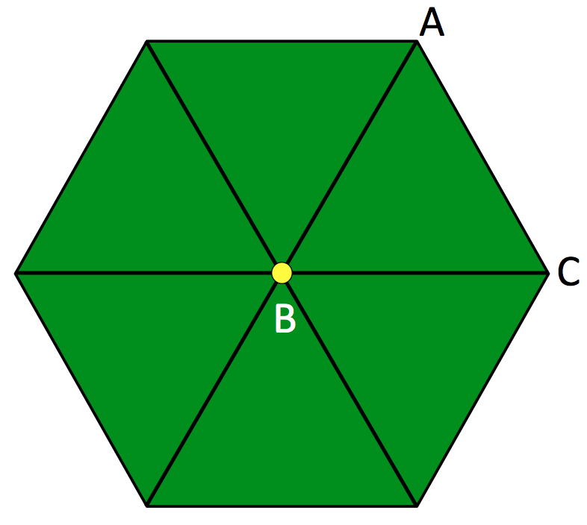
T: Tell your neighbor an addition sentence for the sum of all the right angles in degrees. Record your work on your Problem Set.
S: 90° + 90° + 90° + 90° = 360°.
T: So, the sum of the angles around a central point is…?
S: 360°.
A
T: Arrange a set of green triangles around a central point. (Model.) How many triangles did you fit around the central point?
S: 6.
T: Are all the central angles the same?
S: Yes!
T: How do you know?
S: I stacked all six triangles on top of each other. Each angle matched up with the others. I turned the angles to make sure each angle aligned.
T: What is similar about the arrangement of squares and the arrangement of triangles?
S: They all fit together perfectly at their corners. They both go all the way around a central point. Four squares added up to 360$°,$ so the six triangles must add up to 360$°$.
T: (Trace $∠ABC$.) Work with your partner to find the angle measure of $∠ABC$. On your Problem Set, write an equation to show your thinking.
NOTES ON
MULTIPLE MEANS
OF REPRESENTATION:
Check that students working below grade level and others understand that the sum of the interior—not exterior—angles around a central point is 360°. Clarify the difference between exterior and interior angles.

S: $∠ABC$ = 60°. 60° + 60° + 60° + 60° + 60° + 60° = 360°. 360$°$ ÷ 6 = 60$°$. 6 × 60$°$ = 360$°$.
T: Let’s check. Count by sixties with me. (Point to each angle as students count.) 60°, 120°, 180°, 240°, 300°, 360°.
T: What about$∠BCA$? $∠BAC$? Discuss your thoughts with your partner.
S: I don’t know. I think all the angles are the same size. 60°. If I rotate the triangle so $∠BAC$ is at $∠ABC$, all the angles at the center still add to 360$°$.
Problem 2: Verify the equilateral triangle’s angle measurements with a protractor.
T: How can we prove the angle measures in the triangle are 60°?
S: We could measure with a protractor. But the protractor is a tool for measuring lines, not pattern blocks! But, when I try to measure the angle of the triangle, the lines are not long enough to reach the markings on the protractor.
T: Use your straightedge and protractor to draw a 60° angle. (Demonstrate.) Now, using your protractor, verify that the angle you drew is indeed 60°. (Allow students time to measure the angle.) What angle measure do you read on the protractor?
S: 60°.
T: Align each angle of the triangle with this 60° angle. (Allow students time to perform the task.) What did you discover about the angles of this triangle?
S: All the angles measure 60°. When all the angles in a shape are the same, we can divide 360° by the number of angles to find the angle measures.
T: Would the angle measure change if I gave you the same triangle, just enlarged? What about a larger square pattern block?
S: No, we could still fit four squares and six triangles. The angle measure doesn’t change when the shape gets bigger or smaller. A small square or a really large square will always have 90$°$ corners. So, the angles of a smaller or larger triangle like this would always measure 60$°$. We learned a few days ago that degree measure isn’t a length measure. So, the length of the sides on the triangle or square can grow or get smaller, but their angles will always measure the same.
Problem 3: Derive the angle measure of unknown angles and verify with a protractor.
T: Turn to Page 2 of your Problem Set. In Problem 2, find the measurement of obtuse $∠ABC$. Discuss your thoughts with your partner.
NOTES ON
MULTIPLE MEANS
OF ENGAGEMENT:
Challenge students working above grade level and others to make predictions, find relationships, and use mental math when finding unknown angles in pattern blocks. Ask, “Is there a relationship between equal angles and equal segments in a polygon?” Ask students to make predictions for unknown angle measures, and then to justify their predictions in words. Challenge them to visualize to solve mentally before using paper and pencil.

S: I see two angles, 90° and 60°. Together, that makes 150°. 90 + 60 is 150. This angle measures 150°.
T: The six angles of the hexagon are the same. Use your pattern blocks to find the angle measure of one angle.
S: I can place the six triangles on top of the hexagon. Two 60° angles fit in one angle of the hexagon. 60° + 60° is 120°. 2 × 60 = 120. One of the hexagon’s angles measures 120°.
T: In the margin of your Problem Set, record your observations about the relationship between the angles of the hexagon and the triangle. (Allow students time to record.) Then, write an equation to solve for the obtuse angle measure of the hexagon. Verify your answer by measuring with a protractor.
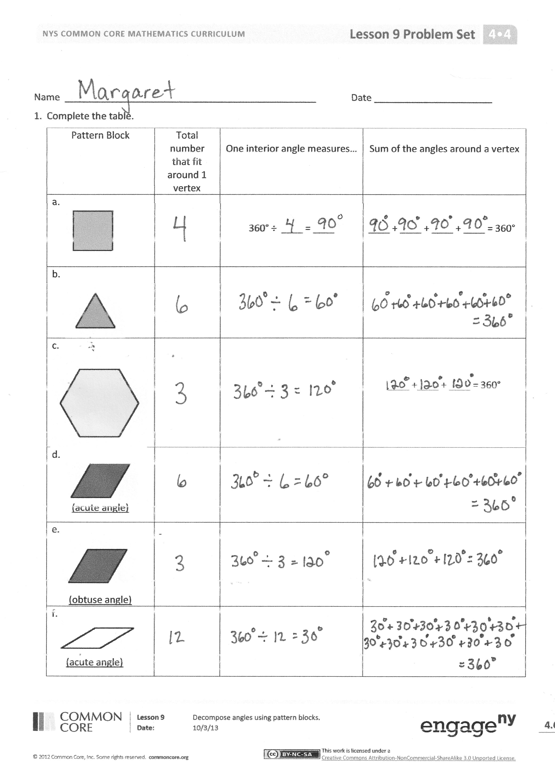
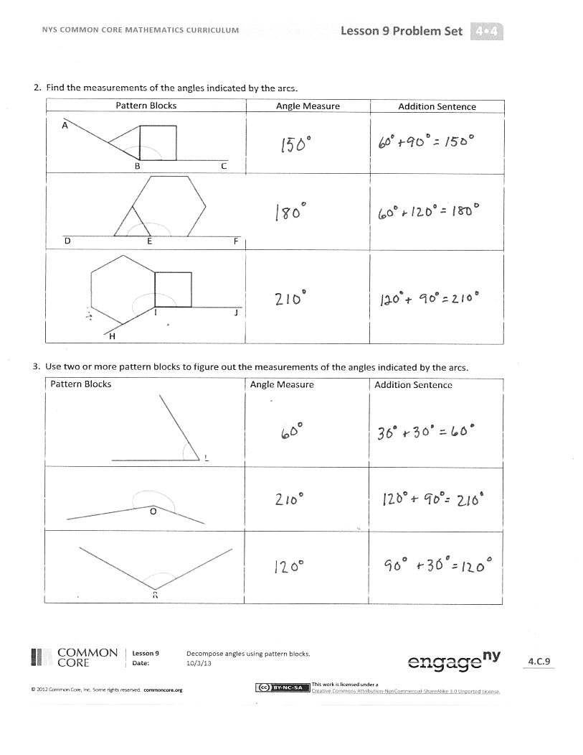
T: Look on your Problem Set. What angle do you form when you combine the triangle and the hexagon?
S: A straight angle!
T: Record the measurement of $∠DEF$as an addition sentence on the Problem Set.
T: Use your pattern blocks to find the angle measure for the obtuse and acute angles in the blue rhombus. Discuss and share your equations with your neighbor. Record your work in Rows (d) and (e) of Problem 1 of the Problem Set.
S: I fit two triangles onto the blue rhombus. The acute angle of the rhombus is the same as the angles of the triangle. It is 60°. The three obtuse angles can fit around the central point of a circle. We know the sum is 360°. 360 ÷ 3 = 120. The obtuse angle measures 120°. I see two 60° angles make the obtuse angle when I align two triangles on one rhombus. 60° + 60° = 120°. 120° + 120° + 120° = 360°.
MP.6
T: How can you use what you’ve learned?
S: I can use what I know about the angle measurements in known shapes to find the angle measurements I don’t know. I can use the angles I know like this 60° angle to measure other angles. I can add angle measurements to find the measurement of a larger angle.
T: Work with your partner to find the measurement of the unknown angles of the tan rhombus. Then, use your pattern blocks to find the measurements of the unknown angles in Tables 2 and 3 on the Problem Set. Use words, equations, and pictures to explain your thinking.
Problem Set (10 minutes)
Students should do their personal best to complete the Problem Set within the allotted 10 minutes. For some classes, it may be appropriate to modify the assignment by specifying which problems they work on first. Some problems do not specify a method for solving. Students solve these problems using the RDW approach used for Application Problems.
Student Debrief (10 minutes)
Lesson Objective: Decompose angles using pattern blocks.
The Student Debrief is intended to invite reflection and active processing of the total lesson experience.
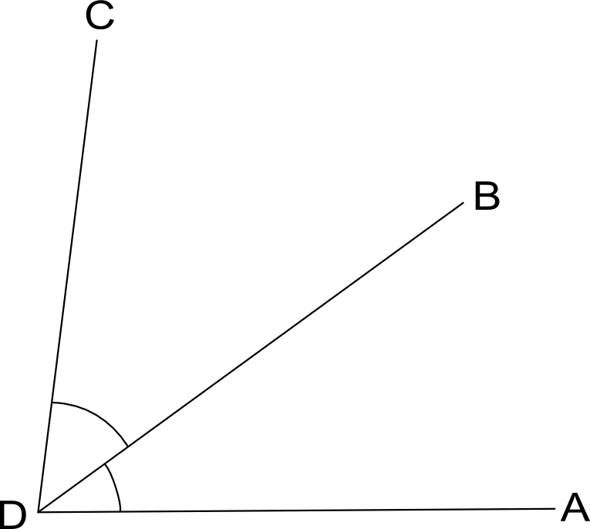
Invite students to review their solutions for the Problem Set. They should check work by comparing answers with a partner before going over answers as a class. Look for misconceptions or misunderstandings that can be addressed in the Debrief. Guide students in a conversation to debrief the Problem Set and process the lesson.
$$∠s add:$$
$$∠ADB+∠BDC=∠ADC$$
You may choose to use any combination of the questions below to lead the discussion.
- What are the measures for the acute and obtuse angles of the cream rhombus? What did you discover when you fit the acute angles around a vertex?
- How are the different angles in the pattern blocks related?
- What was the measure of $∠HIJ$? $∠L$? $∠O$? $∠R$? How did you find the angle measures? What combination of blocks did you use? How did your method compare with your neighbor’s?
- What did you learn about adding angles?
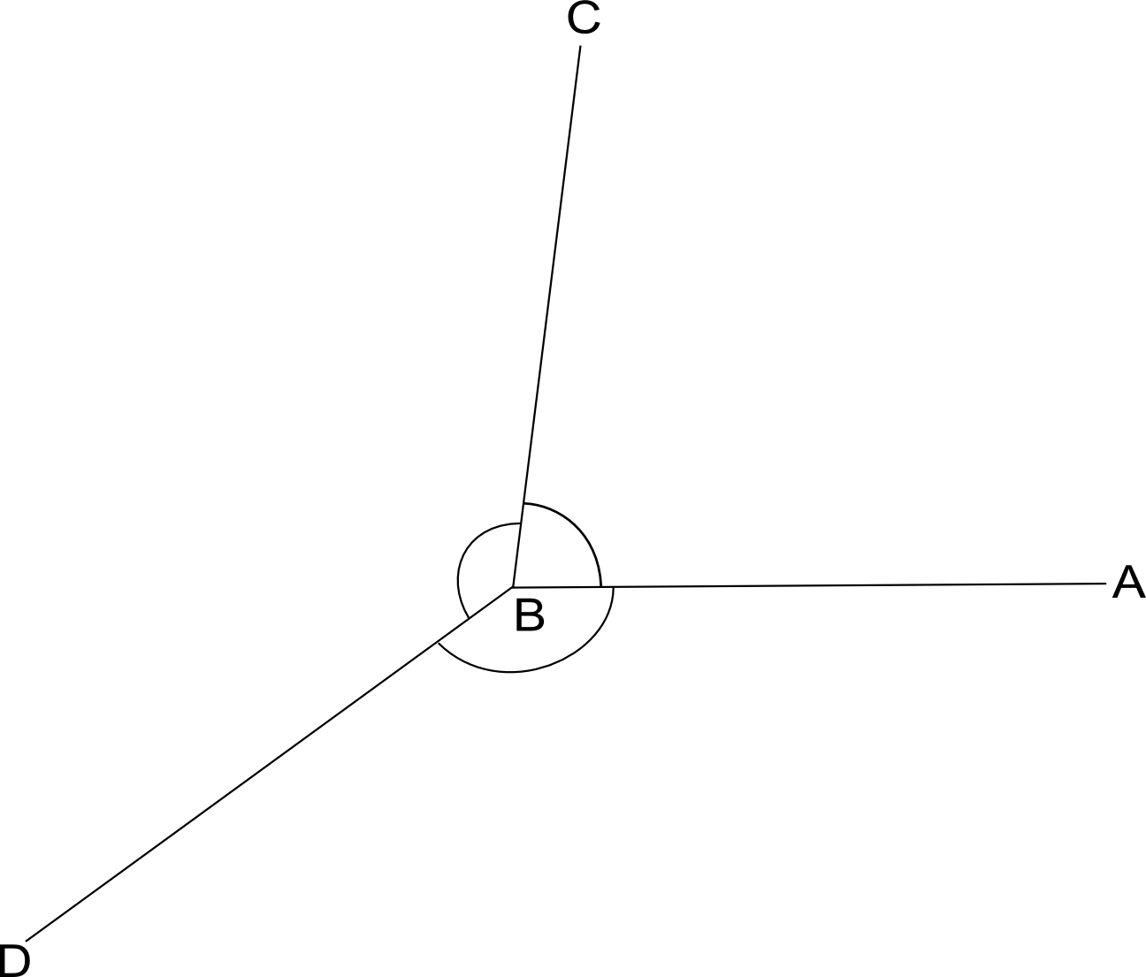
- (Write $∠s add.$) The angle symbol with an s just means angles. It’s the plural of angle. “∠s add” translates as “we are adding these angles that share a side.” (Write ∠ADB + ∠BDC = ∠ADC.) What are different methods for finding the sum of the pictured angles?
$$∠s at a pt:$$
$$∠ABC+∠CBD+∠DBA=360°$$
- (Write $∠s at a pt$.) In our problems today we also made use of the fact that when angles meet at a point, they add up to $360°.$ “∠s at a pt” simply translates as “we have angles centered around a point,” which means their sum would be 360°. (Write ∠ABC + ∠CBD + ∠DBA = 360°.) Restate this in your own words to your partner.
- How can you verify an angle’s measure?
Exit Ticket (3 minutes)
After the Student Debrief, instruct students to complete the Exit Ticket. A review of their work will help you assess the students’ understanding of the concepts that were presented in the lesson today and plan more effectively for future lessons. You may read the questions aloud to the students.
Name Date
- Complete the table.
Pattern block | Total number that fit around 1 vertex | One interior angle measures… | Sum of the angles around a vertex
a. |  | 360° ÷ ____ = ____ | ____ + ____ + ____ + ____ = 360°
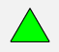
b.
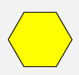  c. |  |  | ____ +____ + ____ = 360°
d.
(Acute angle)
e.
(Obtuse angle)
f.
(Acute angle)

- Find the measurements of the angles indicated by the arcs.
Pattern blocks | Angle measure | Addition sentence
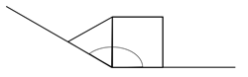
A

C
B
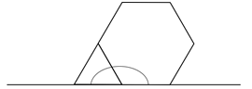

D
E
F
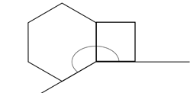

J
I

H

- Use two or more pattern blocks to figure out the measurements of the angles indicated by the arcs.
Pattern blocks | Angle measure | Addition sentence
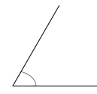

L

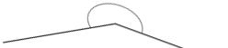
O

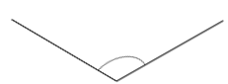

R

Name Date
1. Describe and sketch two combinations of the blue rhombus pattern block that create a straight angle.

2. Describe and sketch two combinations of the green triangle and yellow hexagon pattern block that create a straight angle.

Name Date
Sketch two different ways to compose the given angles using two or more pattern blocks.
Write an addition sentence to show how you composed the given angle.
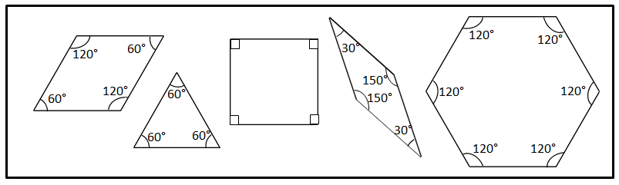

- Points $A, B,$ and $C$form a straight line.

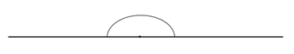

A
B
C
C
B
A

180° = __________________________________ 180° = __________________________________

- $∠DEF$ = 90°
D
D

F
E
F
E

90° = __________________________________ 90° = __________________________________

- $∠GHI$ = 120°
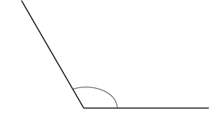
G
H
I
G
H
I
120° = __________________________________ 120° = __________________________________
J
L
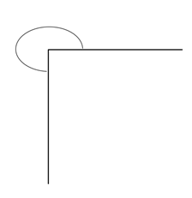
L

- $x°=270°$
J
K
K
$$x°$$
$$x°$$

270° = __________________________________ 270° = __________________________________

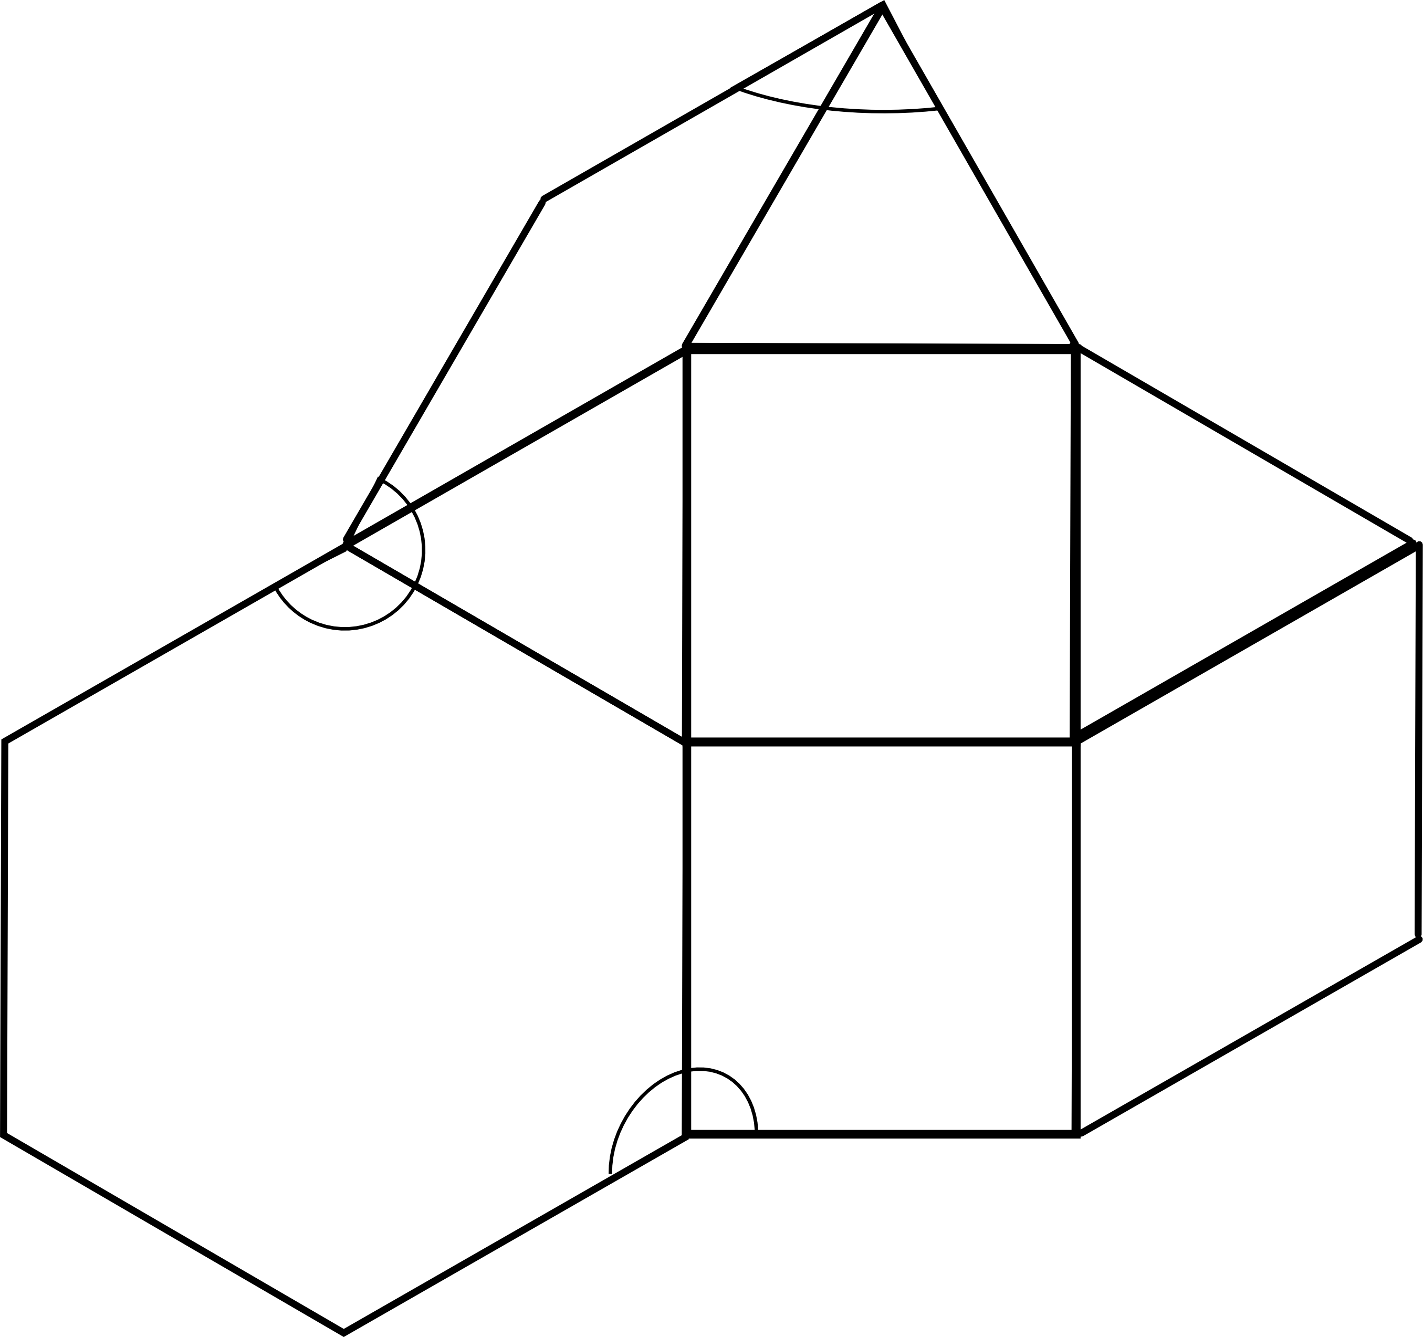
- Micah built the following shape with his pattern blocks. Write an addition sentence for each angle indicated by an arc and solve. The first one is done for you.
A
B
C
D
E
F
H
I
J
K
$$x°$$
$$y°$$
G
$$z°$$
b. $z°=$______________________
$z°=$__________
c. $x°=$______________________
$x°=$__________
a. $y°= 120°+90°$
$$y°= 210°$$

