Lesson 14
Objective: Count on up to 3 more using numeral and 5-group cards and fingers to track the change.

Suggested Lesson Structure
 Fluency Practice (11 minutes)
 Application Problem (4 minutes)
 Concept Development (30 minutes)
 Student Debrief (15 minutes)
Total Time (60 minutes)
Fluency Practice (11 minutes)
- Skip-Counting Squats: Forward and Back to 20 1.OA.5 (2 minutes)
- Count On Cheers: 2 More 1.OA.5 (3 minutes)
- Missing Part: Make 10 1.OA.6 (6 minutes)
Skip-Counting Squats: Forward and Back to 20 (2 minutes)
Note: This activity supports the connection of counting on by 2 to adding 2 and counting back by 2 to subtracting 2.
Have students count from 0 to 20 and back two times, squatting down and touching the floor on odd numbers and standing up for even numbers.
- For the first count, instruct students to whisper when they squat and talk normally when they stand.
- On the second count, encourage students to try to think of the numbers in their heads when they squat and whisper when they stand.
Count On Cheers: 2 More (3 minutes)
Note: This activity supports the connection of counting on by 2 and adding 2 with counting back by 2 and subtracting 2.
fiiiive
six
seven
The teacher says number aloud. Students repeat the number, touching their heads and counting on as they put their fists in the air, one at a time. Alternately, students can count on with boxing punches. Extend the game by counting back 2.
Missing Part: Make 10 (6 minutes)
Materials: (S) 5-group cards (Lesson 5 Template 1)
Note: This activity addresses the core fluency objective for Grade 1 of adding and subtracting within 10.
Students work with a partner, using 5-group cards. Each student puts a card on his or her forehead. The partner tells how many more to make 10. Students must guess the cards on their foreheads. Partners can play simultaneously, each putting a card on his or her forehead. If appropriate, remind students that they may use their fingers to help.
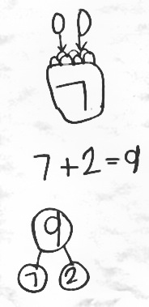
Application Problem (4 minutes)
Beth went apple picking. She picked 7 apples and put them in her basket. Two more apples fell out of the tree right into her basket! How many apples does she have in her basket now? Draw a math picture and write a number bond and number sentence to match the story.
Note: This serves as a bridge from the change unknown stories of the previous topic into the Concept Development of this lesson, which focuses on strategies for counting on.
Concept Development (30 minutes)
Materials: (T) Pictures of crayons and hot dogs (Template) (S) 5-group cards (Lesson 5 Template 1), personal white board
T: Today, let’s try some of those same great strategies to help us solve missing numbers in math sentences. What are some of the ways we figured out the mystery number in our bear stories? Turn and talk with a partner.
T: (Give time for partner sharing. Then, call on students to share strategies such as counting on, using 5-group cards, and drawing.)

NOTES ON
MULTIPLE MEANS
OF REPRESENTATION:
As the class is counting, support those students who may need visual or auditory help. Using physical cues such as body movements (pointing, nodding the head, eye blinking, or foot tapping) will help students who need visual help. Using auditory cues such as a snap, clap, or stomp will help those students who need auditory support.

T: Let’s use those strategies with this situation. (Project a picture of a box of crayons labeled 4 on the outside and 2 more crayons.) Look at this picture. How many crayons are outside of the box?
S: 2!
T: Let’s use our fingers to keep track of these. As I point, put out your fingers to follow along.
S/T: (Touch crayons on projection.) Oooneeee (put out one finger), 2 (put out another finger).
T: How many fingers do you have out?
S: 2!
T: Those 2 fingers match these 2 crayons.
T: Let’s count on to find out how many crayons are in the picture. We’ll start with the box first. Use your fingers and count with me.
S/T: Fourrrrr (gesture to box), 5, 6. (Put out fingers while counting.)
T: How many crayons are there altogether?
S: 6 crayons!
T: Take out your 5-group cards and build the number sentence using the numeral side.
S: (Share number sentences, such 4 + 2 = 6, 2 + 4 = 6, 6 = 4 + 2, or 6 = 2 + 4.)
T: Turn over your 2 to show the dot side. We will use the 5-group cards to check our solution.

NOTES ON
MULTIPLE MEANS
OF ACTION AND EXPRESSION:
When students are having difficulty counting on with fingers or 5-group cards, continue with more examples together. Some students need to move forward in small steps. Regular opportunities to practice what they are learning will eventually get them to abstract level thinking.

S/T: Fourrrr (touch 4), 5, 6. (Touch dots while counting.)
T: What is the total when we use the cards?
S: 6!
MP.7
T: What is the total when we counted the crayons with our fingers?
S: 6 crayons!
T: Great job! Let’s try another. (Repeat the process with a picture of a package of 6 hot dogs and 2 more hot dogs.)
T: Turn and talk with your partner about the two strategies we just used. How are they similar?
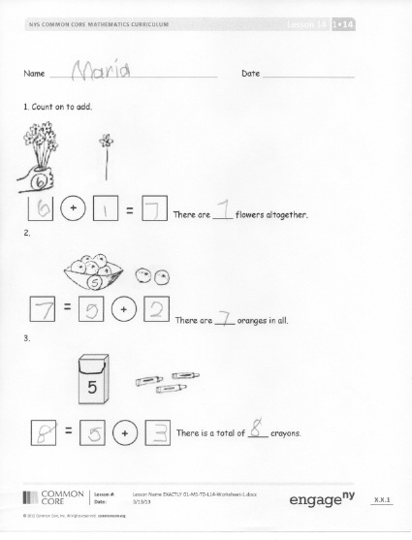
S: When we count on using our fingers, it’s just like when we touch the dots. Each finger is like a dot.
T: (Project number sentence on the board:
4 + 3 = ☐.) Let’s try to solve one more with a partner. Talk quietly with your partner to decide what number belongs in the box. Remember that you can count on using your fingers or your 5-group cards to help you.
Problem Set (10 minutes)
Students should do their personal best to complete the Problem Set within the allotted 10 minutes. For some classes, it may be appropriate to modify the assignment by specifying which problems they work on first. Some problems do not specify a method for solving. Students solve these problems using the RDW approach used for Application Problems.
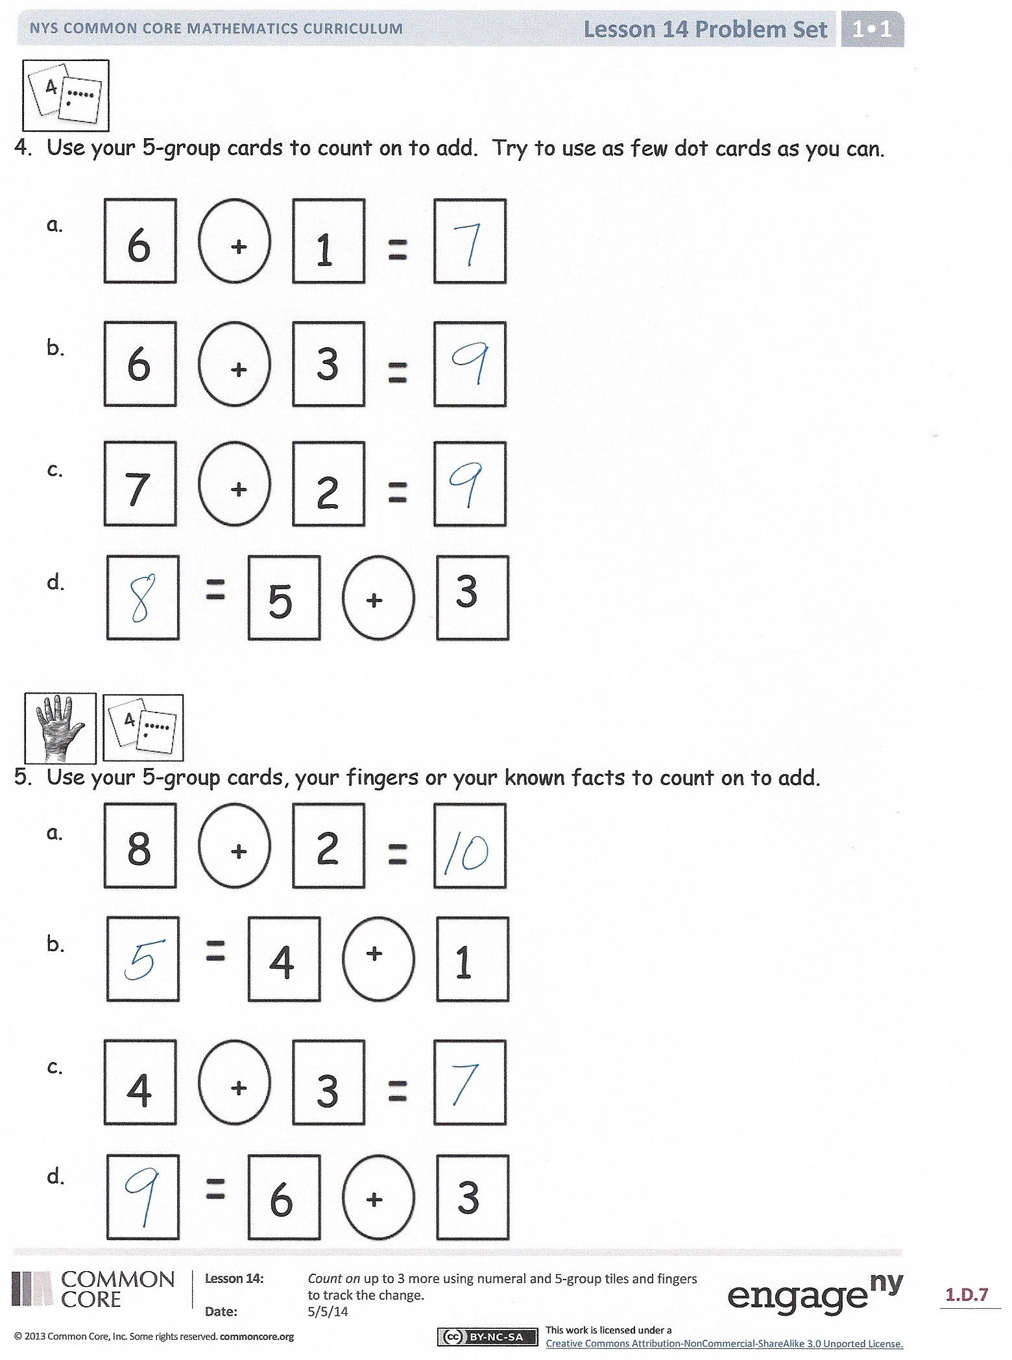
Student Debrief (15 minutes)
Lesson Objective: Count on up to 3 more using numeral and 5-group cards and fingers to track the change.
The Student Debrief is intended to invite reflection and active processing of the total lesson experience.
Invite students to review their solutions for the Problem Set. They should check work by comparing answers with a partner before going over answers as a class. Look for misconceptions or misunderstandings that can be addressed in the Debrief. Guide students in a conversation to debrief the Problem Set and process the lesson.
You may choose to use any combination of the questions below to lead the discussion.
- For which problems did you need to add 1? Let’s list those number sentences.
- What do you notice about these problems? Is there a pattern you can find?
- Look at the first three problems. What do you notice about what we are adding each time? Why might we be only counting on 1, 2, or 3 more with our fingers?
- Are there any problems that have the same total? Let’s list those number sentences.
- How can the totals be the same if we counted on different amounts?
Exit Ticket (3 minutes)
After the Student Debrief, instruct students to complete the Exit Ticket. A review of their work will help you assess the students’ understanding of the concepts that were presented in the lesson today and plan more effectively for future lessons. You may read the questions aloud to the students.

Name Date

- Count on to add.
+

There are ____ flowers altogether.

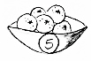
2.
+

There are ____ oranges in all.

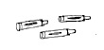
5
3.

+

There is a total of ____ crayons.
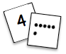
- Use your 5-group cards to count on to add. Try to use as few dot cards as you can.
a.
+

8
2
+

7
2
+

5
3
+

6
1
+

6
3
+

4
3
+

6
3
+

1
4

b.

c.

d.

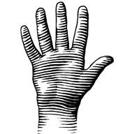

- Use your 5-group cards, your fingers, or your known facts to count on to add.
a.

b.

c.

d.

Name Date
1.
+

2
=

6

6
Count on to solve the number sentences.
b.
+

2
=

8

+

3
=

7

a.
2.
I counted _______ hats in all.

Now there are ______ hats.

Name Date
5, 6
+

5
2
+

7
21
+

7

+

6
3
Write what you say when you count on.
a.
Count on to add.
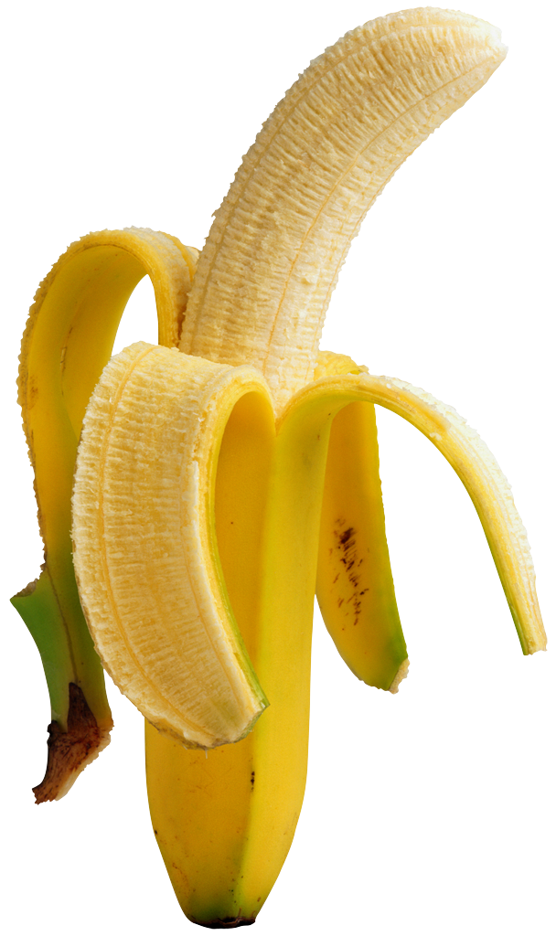
b.
+

5
1
5

d.
c.

e.
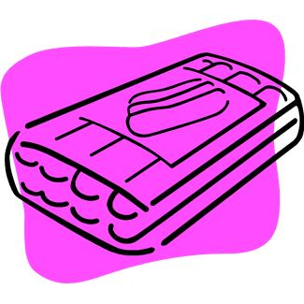
6
4

pictures of crayons and hot dogs

