Lesson 7
Objective: Measure and draw angles. Sketch given angle measures, and verify with a protractor.

Suggested Lesson Structure
 Fluency Practice (12 minutes)
 Application Problem (5 minutes)
 Concept Development (33 minutes)
 Student Debrief (10 minutes)
Total Time (60 minutes)
Fluency Practice (12 minutes)
- Break Apart 90, 180, and 360 4.MD.7 (4 minutes)
- Physiometry 4.G.1 (4 minutes)
- Identify Angle Measures 4.MD.6 (4 minutes)
Break Apart 90, 180, and 360 (4 minutes)
Materials: (S) Personal white board
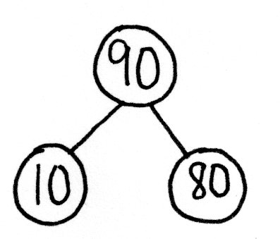
Note: This fluency activity prepares students for unknown angle problems in Lessons 10─11.
T: (Project a number bond with a whole of 90. Fill in 10 for one of the parts.) On your personal white boards, write the number bond, filling in the unknown part.
S: (Draw a number bond with a whole of 90 and with 10 and 80 as parts.)
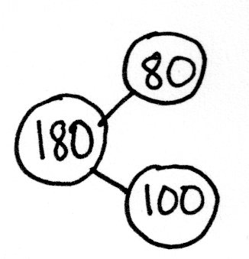
Continue breaking apart 90 with the following possible sequence: 50, 40, and 45.
T: (Project a number bond with a whole of 180. Fill in 80 for one of the parts.) On your boards, write the number bond, filling in the unknown part.
S: (Draw a number bond with a whole of 180 and with 80 and 100 as parts.)
Continue breaking apart 180 with the following possible sequence: 90, 120, 140, and 35.
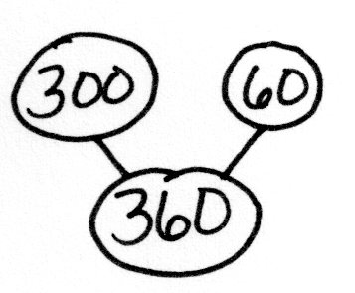
T: (Project a number bond with a whole of 360. Fill in 300 for one of the parts.) On your boards, write the number bond, filling in the unknown part.
S: (Draw a number bond with a whole of 360 and with 300 and 60 as parts.)
Continue breaking apart 360 with the following possible sequence: 100, 90, 180, 120, and 45.
Physiometry (4 minutes)
Note: Kinesthetic memory is strong memory. This fluency activity reviews terms from Lessons 1–5.
T: Stand up.
S: (Stand up.)
T: Show me an acute angle.
S: (Make an acute angle with arms.)
T: Show me an obtuse angle.
S: (Make an obtuse angle with arms.)
T: Show me a right angle.
S: (Make a right angle with arms.)
T: Show me an angle that measures approximately 80°.
S: (Move arms closer together, lessening the space between their arms, so that it’s approximately 80°.)
T: Show me an angle that measures approximately 10°.
S: (Close arms more to approximately 10°.)
Continue with the following possible sequence: 90°, 100°, 170°, 150°, 60°, 140°, 70°, and 180°.
T: What is the term for a 180° angle?
S: A straight angle.
T: Show me a line segment.
S: (Close fists.)
T: Show me a ray.
S: (Open one hand while keeping the other hand clenched.)
T: Partner up with a classmate next to you. Decide who is Partner A and who is Partner B.
S: (Pair up with a partner. Decide who is Partner A and who is Partner B.)
T: Partner A, point at a side wall.
S: (Point at a side wall.)
T: Partner B, point at the walls that are perpendicular to the wall Partner A is pointing to.
S: (Point at front and back walls.)
T: Partner B, point to any wall in the room.
S: (Point at a wall.)
T: Partner A, point at the wall that is parallel to the wall Partner B is pointing to.
S: (Point at wall parallel to the wall Partner B is pointing to.)
Identify Angle Measures (4 minutes)
Materials: (S) Personal white board
Note: This fluency activity reviews Lesson 5.
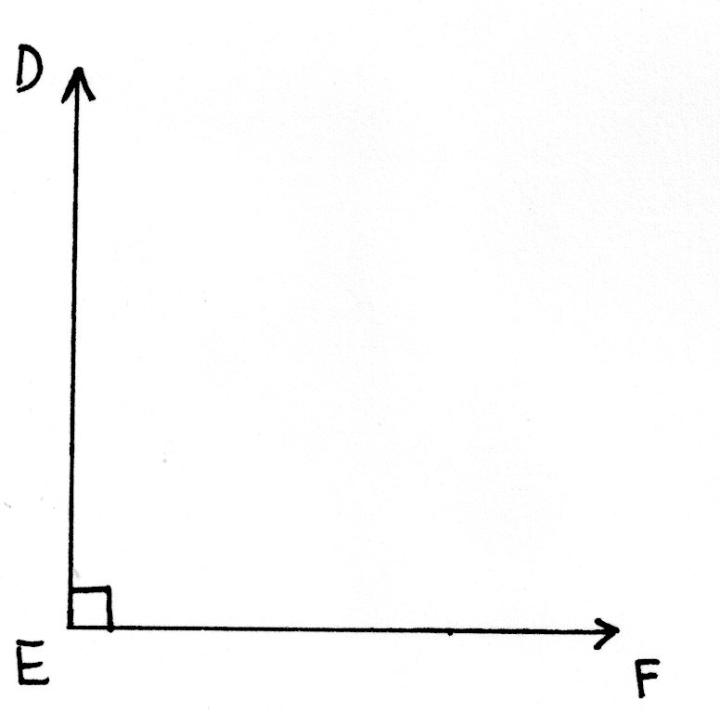
T: How many degrees are in a right angle?
S: 90°.
T: (Project a right $∠DEF$.) Name the angle.
S: $∠DEF$.
T: What type of angle is it?
S: A right angle.
T: What’s the relationship of $\overset{⃑}{ED}$ and $\overset{⃑}{EF}$?
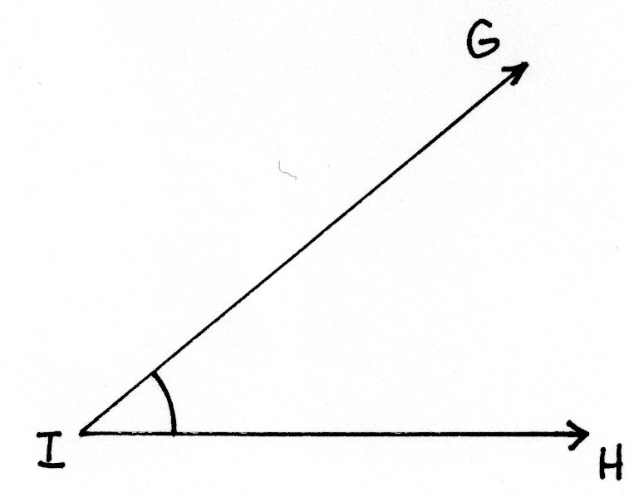
S: They’re perpendicular.
T: How many degrees are in $∠DEF$?
S: 90°.
T: (Project an acute $∠GIH$.) Name the angle.
S: $∠GIH$.
T: (Beneath $∠GIH$, write 40° or 140°.) Estimate. Is the measure of $∠GIH$ 40° or 140°?
S: 40°.
T: How do you know?
S: Acute angles are less than 90°.
Continue with the following possible sequence: obtuse angle measuring 130° or 50°, acute angle measuring 75° or 105°, and obtuse angle measuring 92° or 88°.
Application Problem (5 minutes)
Predict the measure of $∠XYZ$ using your right angle template. Then, find the actual measure of $∠XYZ$ using a circular protractor and 180° protractor. Compare with your partner when you are finished.

NOTES ON
MULTIPLE MEANS
OF ACTION AND EXPRESSION:
Provide protractor alternatives for students, if necessary. Some students may work more efficiently with large-print protractors that include a clear, moveable wand. Others may find using an angle ruler easier.
For students with poor vision and other restrictions, outline angles and shapes to be measured with pipe cleaners to make the activity tactile.
Note: This Application Problem reviews the practice of measuring angles from Lesson 6 and transitions into the Concept Development of today’s lesson, where students measure and draw angles. This figure can be found on the Practice Sheet (Figure 1).
X
Y
Z
W

Concept Development (33 minutes)
Materials: (T/S) Circular protractor, 180° protractor, Practice Sheet
Problem 1: Measure angles less than 180° using a circular and 180° protractor.
T: In completing the Application Problem, what was your prediction for the measure of $∠XYZ$?
S: I predicted $∠XYZ$ to be about 100°. I know that $∠XYZ$ is an obtuse angle because it is greater than a right angle, so I predicted it to be about 110°.
T: How did you use the circular and 180° protractor to find the measure of $∠XYZ$?
S: I lined up one side of the angle with the base line on the circular protractor. Then, I saw where the other side of the angle touched on the arc. First, I put the center hole of the 180° protractor at the vertex Y. Next, I lined up $\overset{⃑}{YZ}$ with the zero line on the protractor. Then, I read where $\overset{⃑}{YX}$ measured on the protractor.
A
B
C
T: Aligning the protractor correctly is very important. Let’s practice measuring $∠CAB$ using the circular protractor. Measure $∠CAB$ (Practice Sheet, Figure 2).
T: Now, with your partner, take the 180° protractor and measure the same angle.
T: What do you notice?
S: Both protractors say 45$°$. The angle measure is the same no matter which protractor we use.
T: Look at Figure 3 on your Practice Sheet. Using either protractor, find the measure of $∠DEF$.

NOTES ON
MULTIPLE MEANS
OF ENGAGEMENT:
As they measure $∠CAB$, guide students working below grade level to adjust the paper rather than the protractor.
Challenge students working above grade level to predict the measure of $∠CAB$ before measuring. Invite students to explain their reasoning. Also, extend the task as time permits by having students measure $∠CAB$ using each side of the angle as a base. Ask, “What do you notice?”
S: With the circular protractor, $∠DEF$ measures 120°.
With the 180° protractor, $∠DEF$ measures 120°.
Problem 2: Measure an angle greater than 180° by subtracting from 360°.
T: Look at Figure 4 on your Practice Sheet. Use either protractor to measure $∠QRS$. Which protractor will you use?
S: I am going to use the circular protractor because the 180° protractor doesn’t fit right. $∠QRS$ measures 230°. I want to use a 180° protractor, but I am not sure how. It isn’t big enough to measure the angle.
T: Let’s figure out how to use the 180° protractor. The arc close to the vertex symbolizes the angle we want to measure.

T: What happens if we extend the drawing of the arc? Show me.
S: (Extend arc.) We have a circle with point R in the middle.
T: There are two angles represented. Talk to your partner about them.
S: One angle is shown by the arc that was already there. The other angle is shown by the arc that we just drew. The two angles go together to represent a whole turn.
T: Which angle is easier to measure with the 180° protractor?
S: The smaller angle.
T: What is the measure of that angle? (Pause.)
MP.2
S: 130°.
T: What is the total angle measure around point R?
S: 360°.
T: If there are 360° in the whole, and 130° in one of the parts, figure out the measure of the other part. Talk to your partner about your strategy.
S: We could subtract. We know that the whole minus a part equals the other part.
360$°$ – 130$°$ = 230$°$. I counted up 2 hundreds from 130 to 330, and then added 30 more.
$∠QRS$ is 230°. That’s the same as when we measured with the circular protractor!
Problem 3: Measure an angle greater than 180° by adding on to 180°.
T: Let’s explore another way to find the measure of $∠QRS$. Erase the arc that you just drew. Now, use your straightedge to extend $\overset{⃑}{QR}$ to the right.
S: (Extend $\overset{⃑}{QR}$ to the right.)
T: What happened to $∠QRS$, indicated by the arc?
S: Now, it’s chopped into two smaller angles.
T: What is the angle measure of this straight line?
S: 180°.
T: Measure the new acute angle. (Pause.)
S: It’s 50°.
T: Label each angle with its measure. What do you notice?
S: When I add the two angles together, I get the measure of the whole thing. 180° + 50° = 230°. Hey, it’s the same!
Problem 4: Draw an angle less than 180° using a 180° protractor.
T: Now, let’s practice drawing angles. Draw a ray that we can align to our 0° line.
T: Watch as I draw my ray and label my endpoint with the letter $A$. Now, you draw. (See Step 1 on the next page.)
T: The next ray’s endpoint should also be point $A$ so that you can form an angle.
T: Watch as I align my protractor, placing the center over the endpoint, $A$, and making sure my ray aligns with the 0° line. Now, it’s your turn.

NOTES ON
USING A
PROTRACTOR:
Help students measure accurately using a protractor with the following tips:
- Place the center notch of the protractor on the vertex.
- Put the pencil point through the notch and move the straightedge into alignment.
- When measuring angles, it is sometimes necessary to extend the sides of the angle so that they intersect with the protractor’s scale.
T: Next, I look to see where 80° is on the protractor. Everyone, find 80° on your protractor, and place a small point directly above 80°. (See Step 2.)
T: Use the straightedge of the protractor to draw the next ray. I create a ray beginning at point $A$, along my straightedge, toward the mark I made above 80°. Note that I am not going to extend my ray all the way to the point where I marked 80°. (See Steps 3 and 4.)
T: Now that the angle has been made, verify the measure with the protractor. Extend the ray to measure the angle. (See Step 5.)

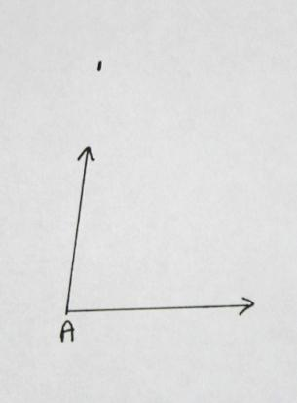
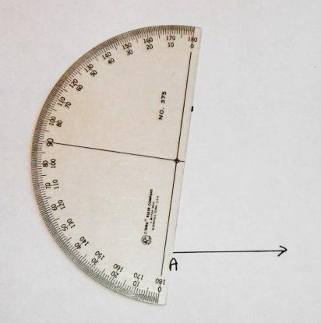
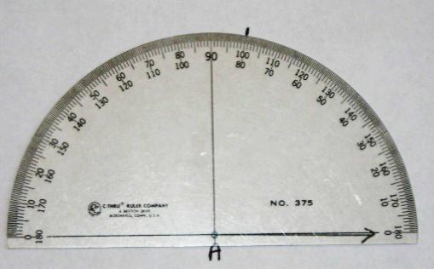
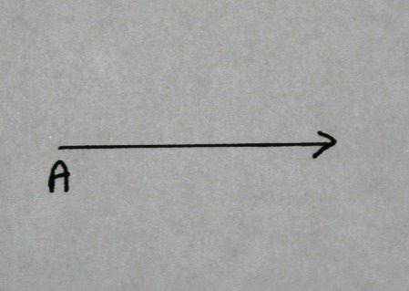
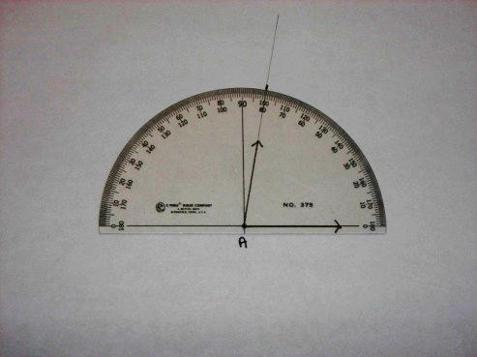
Step 4
Step 3
Step 2
Step 1
Step 5

T: Let’s draw another angle. Let’s use our straightedge and a protractor to construct a 133° angle.
T: What’s the first step?
S: We draw a ray and label the endpoint. Let’s label it with a B this time.
T: What do we do next?
S: We put our protractor on the ray so that the notch is directly aligned with point B and the ray is lined up with the 0° line on the protractor.
T: Next?
S: We find 133° on the protractor. Hey! It’s not there!
T: Look at the numbers that are there. Between which two numbers would you find 133?
S: Between 130 and 140.
T: Find the number 130. Let’s start at 130 and count the tick marks up to 140 just like we would if we were counting on a number line.
S: 131, 132, 133, 134, 135, 136, 137, 138, 139, 140.
T: Point to the tick mark that represents 133°.
T: Make a small mark on your paper directly above the 133° mark on your protractor. Take your protractor off of your paper. What do we do next?
S: We need to draw the other ray. We line the straightedge up with point B and the mark that we just made.
T: Place your straightedge on your paper. Be sure that point B and the tick mark are touching the edge. Draw a ray from point B beyond the tick mark.
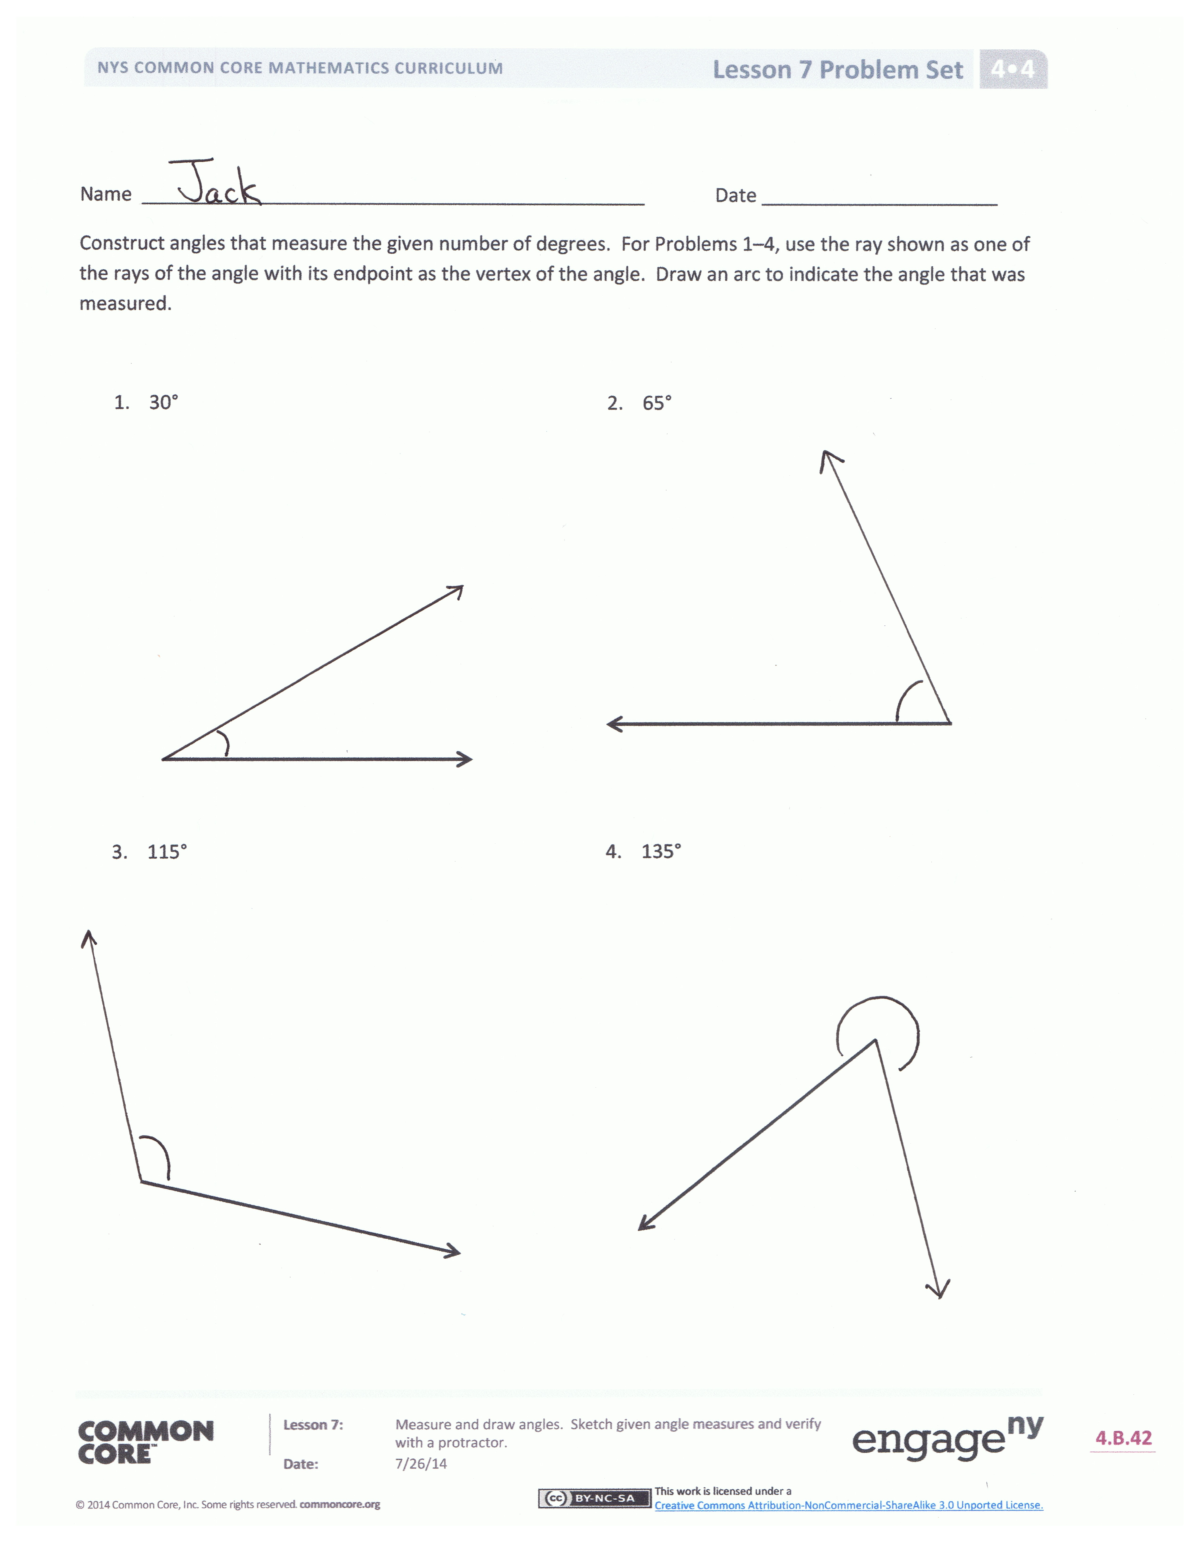
S: We have drawn the angle! Let’s verify it!
T: Remember that it is very important to place your protractor properly.
Problem Set (10 minutes)
Students should do their personal best to complete the Problem Set within the allotted 10 minutes. For some classes, it may be appropriate to modify the assignment by specifying which problems they work on first. Some problems do not specify a method for solving. Students should solve these problems using the RDW approach used for Application Problems.
Student Debrief (10 minutes)
Lesson Objective: Measure and draw angles. Sketch given angle measures, and verify with a protractor.
The Student Debrief is intended to invite reflection and active processing of the total lesson experience.
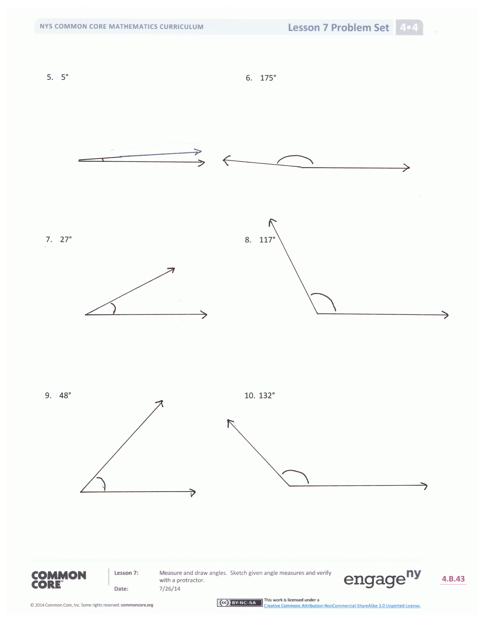
Invite students to review their solutions for the Problem Set. They should check work by comparing answers with a partner before going over answers as a class. Look for misconceptions or misunderstandings that can be addressed in the Debrief. Guide students in a conversation to debrief the Problem Set and process the lesson.
You may choose to use any combination of the questions below to lead the discussion.
- In Problem 1, how did you draw the angles with a 180° protractor?
- In Problem 1, which were the most challenging angles to draw? Explain.
- Why is it important to be precise when drawing angles? Tell your partner how you can be precise when drawing angles.
- Why do we verify our sketches with a protractor?
- It is important to learn to use the 180° protractor because it is the one you will see everywhere. Explain to your partner how to measure an angle greater than 180° with a 180° protractor.
Exit Ticket (3 minutes)
After the Student Debrief, instruct students to complete the Exit Ticket. A review of their work will help you assess the students’ understanding of the concepts that were presented in the lesson today and plan more effectively for future lessons. You may read the questions aloud to the students.

Name Date
Figure 2
Figure 1
A
B
C

X
Y
Z
W

Figure 3

Figure 4

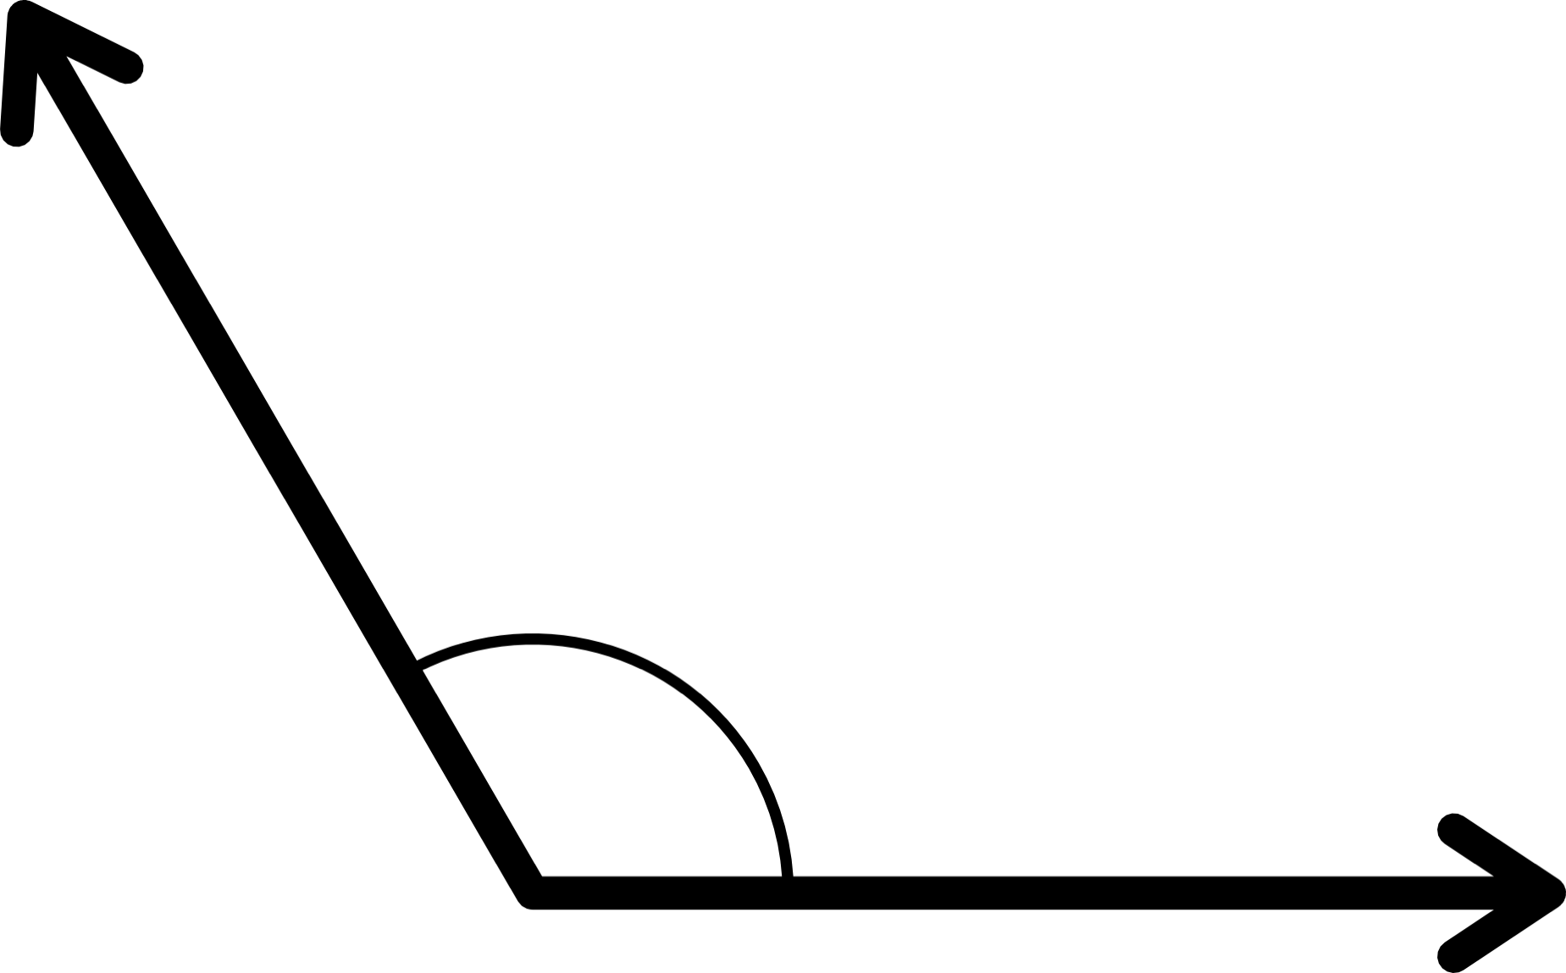
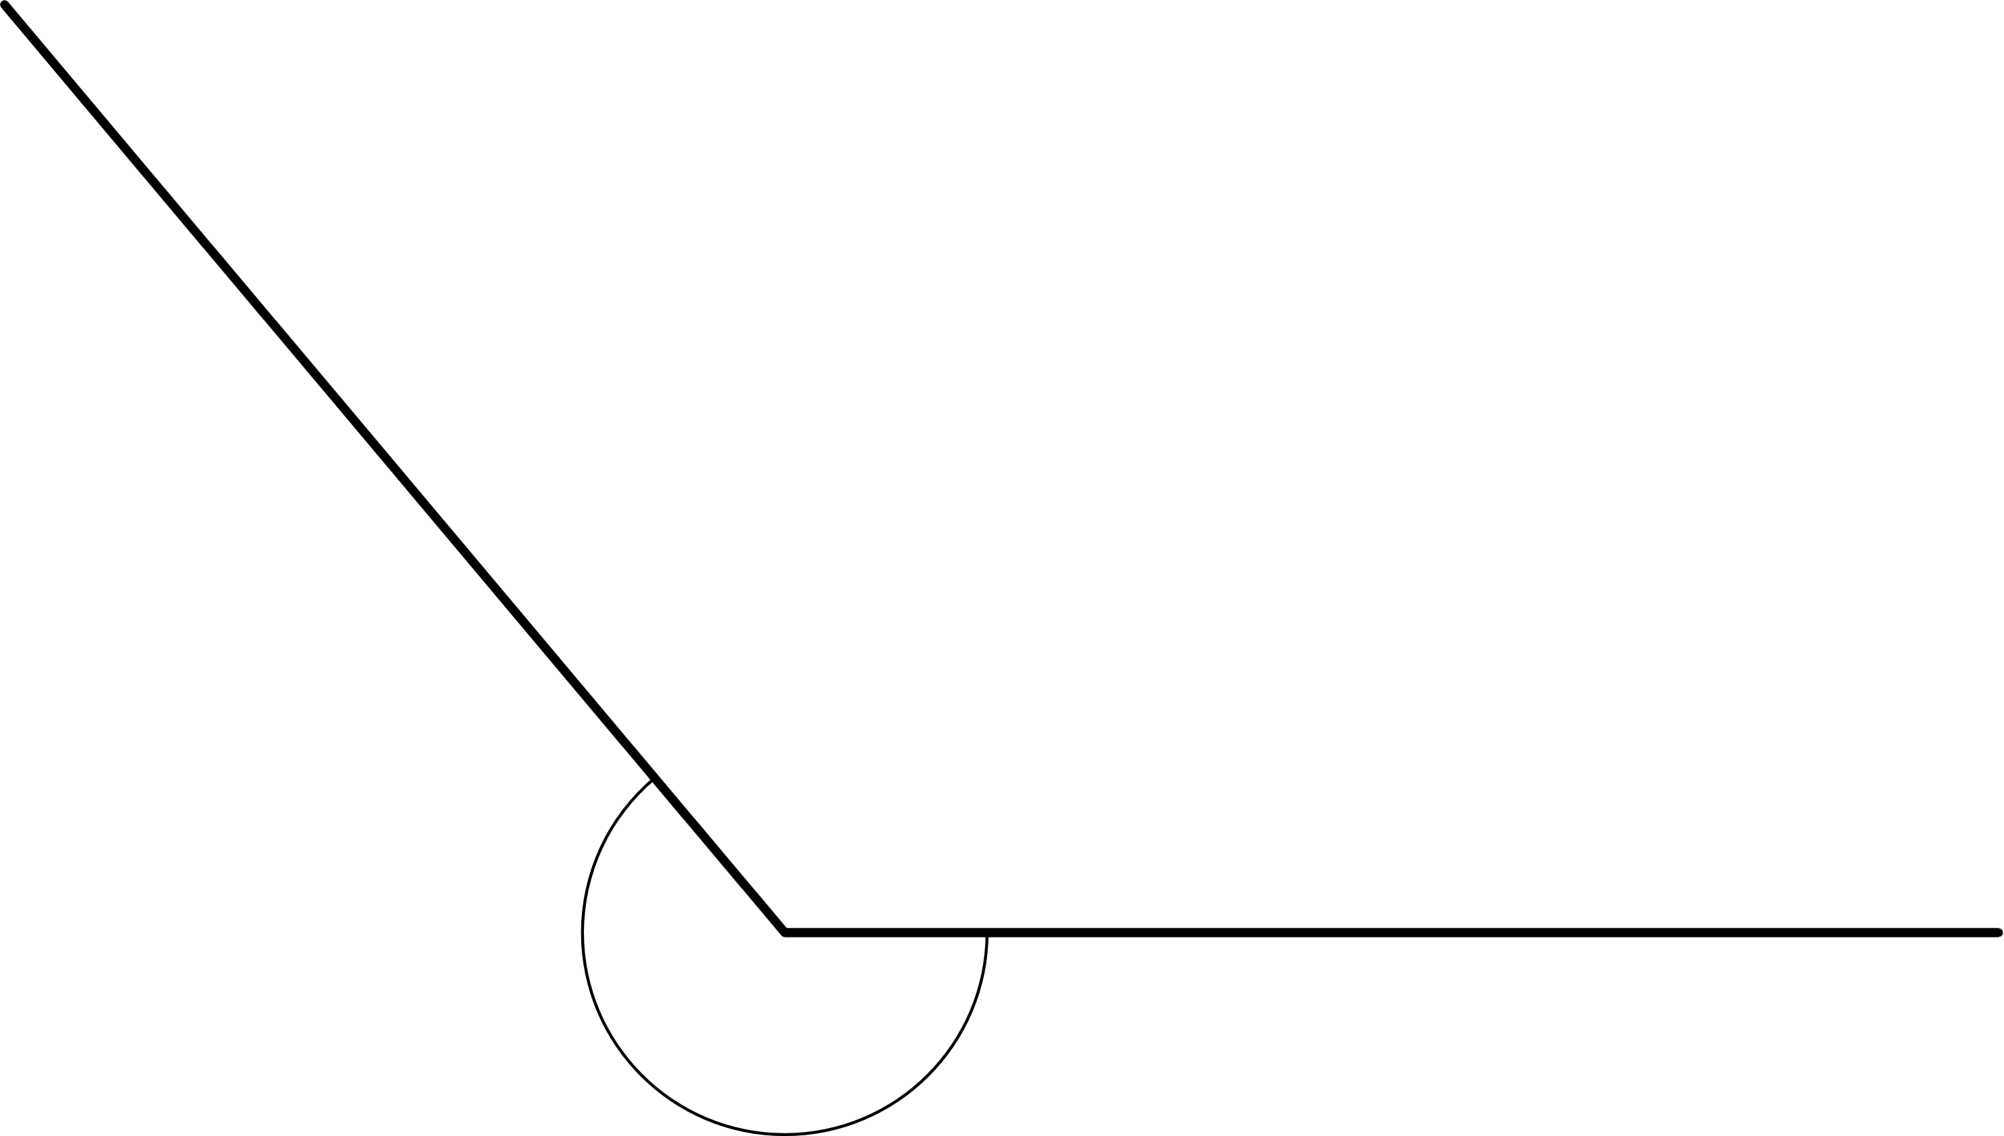
D
E
F
S
Q
R

Name Date
Construct angles that measure the given number of degrees. For Problems 1–4, use the ray shown as one of the rays of the angle with its endpoint as the vertex of the angle. Draw an arc to indicate the angle that was measured.

- 30° | - 65°
- 115° | - 135°
- 5° | - 175°
- 27° | - 117°
- 48° | - 132°

Name Date
Construct angles that measure the given number of degrees. Draw an arc to indicate the angle that was measured.
- 75° | - 105°
- 81° | - 99°

Name Date
Construct angles that measure the given number of degrees. For Problems 1–4, use the ray shown as one of the rays of the angle with its endpoint as the vertex of the angle. Draw an arc to indicate the angle that was measured.

- 25° | - 85°
- 140° | - 83°
- 108° | - 72°
- 25° | - 155°
- 45° | - 135°

