Lesson 13
Objective: Tell put together with result unknown, add to with result unknown, and add to with change unknown stories from equations.

Suggested Lesson Structure
 Fluency Practice (20 minutes)
 Application Problem (5 minutes)
 Concept Development (27 minutes)
 Student Debrief (8 minutes)
Total Time (60 minutes)
Fluency Practice (20 minutes)
- Count by Tens 1.NBT.2 (5 minutes)
- Ten and Tuck 1.OA.6, 1.OA.3 (5 minutes)
- Memory: Partners to 10 1.OA.6 (10 minutes)
Count by Tens (5 minutes)
Materials: (T) 5-group cards (Lesson 5 Template 1)
Note: Providing students with ongoing counting practice throughout the year builds and maintains their counting skills, which are foundational for later Grade 1 work with adding and subtracting tens.
Use the tens from your 5-group cards as a visual while students count by tens, first the regular way and then the Say Ten way.
Next, show students a 3 card and add 10 cards to count on by tens the Say Ten way, starting at three (three, ten 3, 2 tens 3, 3 tens 3…).
Repeat, starting at various numbers between 1 and 9.
Ten and Tuck (5 minutes)
Note: This activity addresses the core fluency objective for Grade 1.
Tell students to show 10 fingers. Instruct them to tuck 3 (students put down the pinky, ring finger, and middle finger on their right hands). Ask them how many fingers are up (7), and how many are tucked (3). Then, ask them to say the number sentence aloud, beginning with the larger part (7 + 3 = 10), beginning with the smaller part (3 + 7 = 10), and beginning with the whole (10 = 3 + 7 or 10 = 7 + 3).
Memory: Partners to 10 (10 minutes)
Materials: (S) Per group: 1 set of single-sided 5-group cards, 1 set single-sided numeral cards (Lesson 5 Template 1, single-sided)
Note: This activity addresses the core fluency objective for Grade 1 of adding and subtracting within 10.
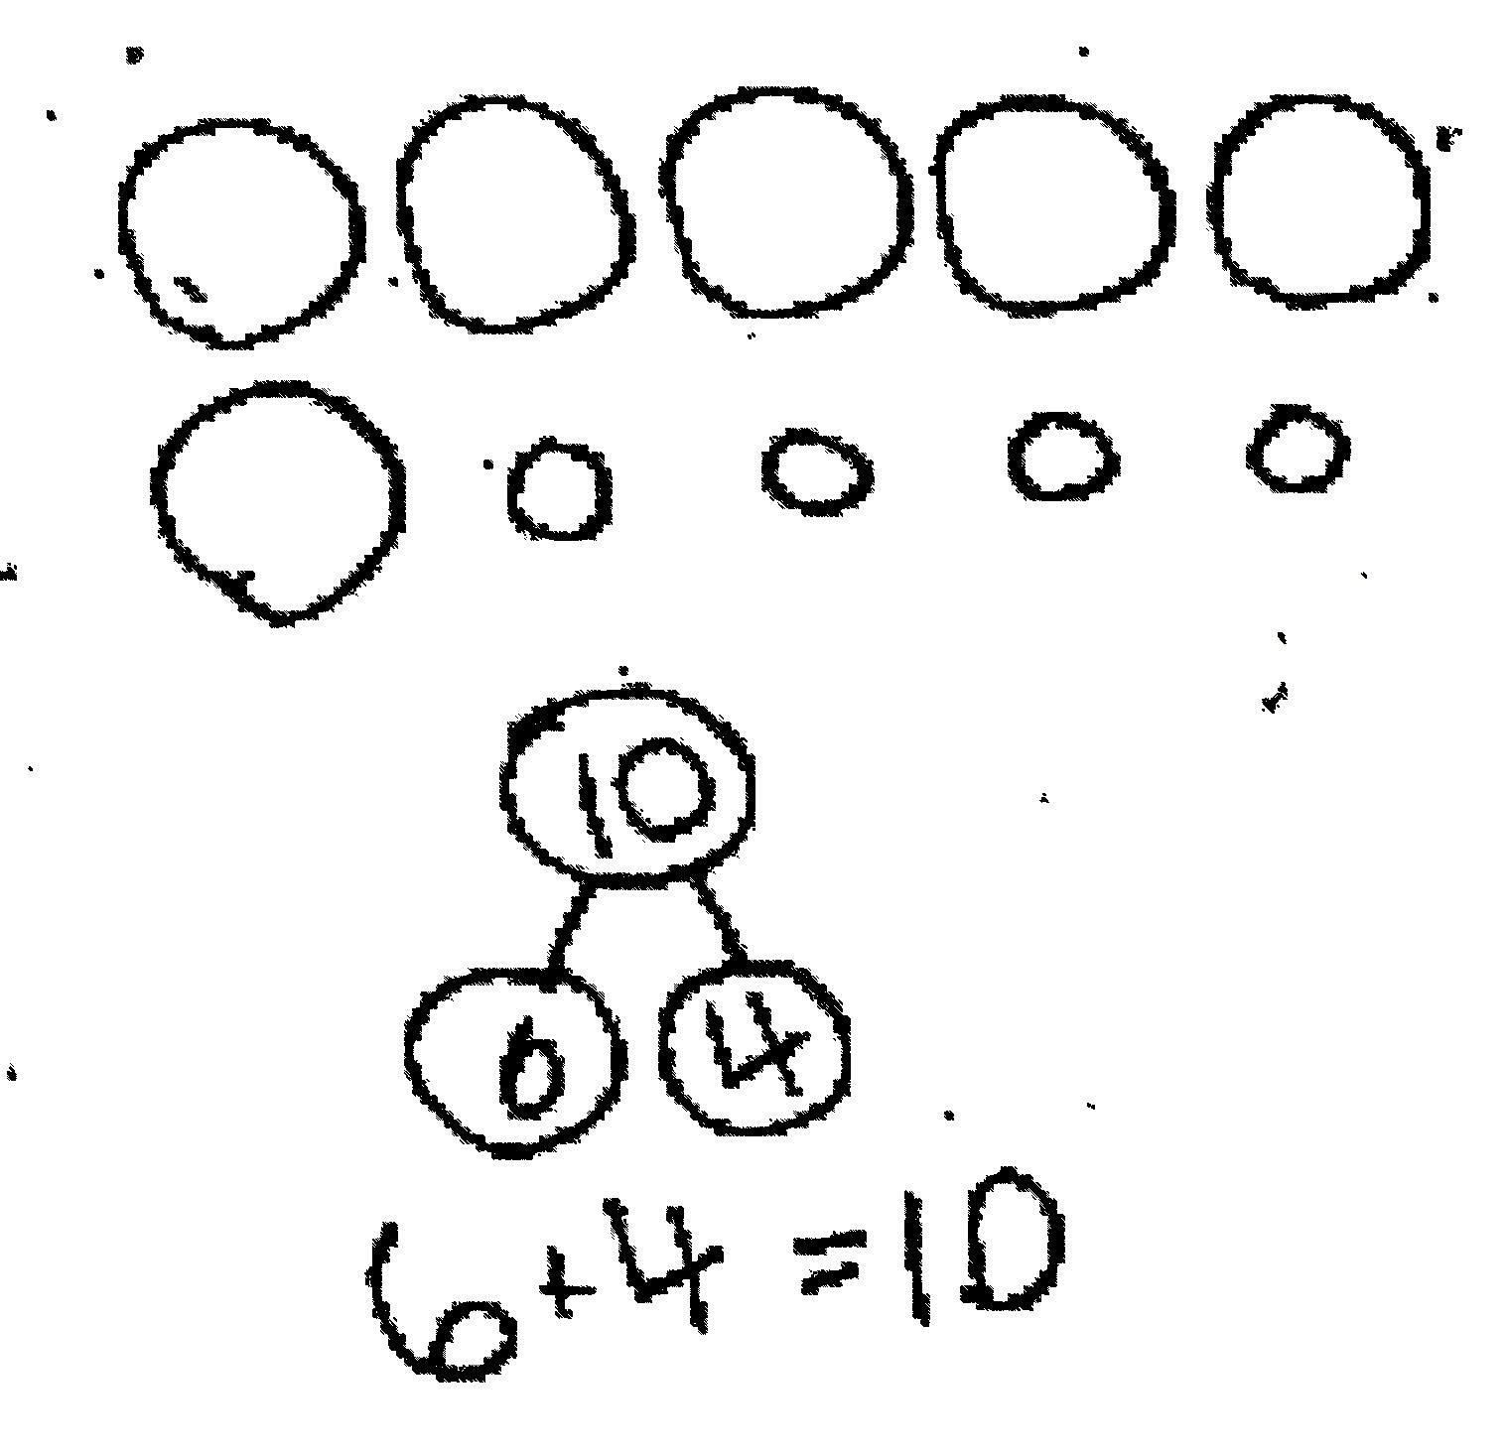
Give Partner A a set of single-sided 5-group cards and Partner B a set of single-sided numeral cards. Tell students to sit facing each other and line up their cards in front of them, face down. Instruct students to take turns flipping over one of their cards and one of their partner’s cards to try to make a ten. When they make a ten, they place the cards in a separate pile and keep them until the end of the game. The player with the most cards at the end of the game wins.
Application Problem (5 minutes)
Sammi had 6 bunnies. One of them had babies. Now, she has 10 bunnies. How many babies were born? Draw a picture to show how you know. Write a number bond and a number sentence to match your picture.
Note: This problem is designed both as a bridge and a lead-up, in that it focuses students on solving a change unknown problem.

NOTES ON
MULTIPLE MEANS
OF REPRESENTATION:
When asking students to draw an object, check for understanding that they know what it is. If needed, provide a picture of the object for English language learners. At the same time, remind your students they are always to do math drawings and not spend time on their illustrations.

Concept Development (27 minutes)
Materials: (S) Number sentence cards (Lesson 11 Template) with sticky notes labeled with a question mark per pair, personal white board, blank number sentence and number bond (Lesson 6 Template 2)
T: (Project 5 + 1 = 6 number sentence card with the 6 covered with a sticky note.) What do we need to find in this number sentence?

NOTES ON
MULTIPLE MEANS
OF REPRESENTATION:
Never underestimate the use of manipulatives when students are learning a new skill. Students should use their 5-group cards or other manipulatives, such as counting bears, when they need extra support. Allow students to use the extra support as long as they need it.

S: The total!
T: With your partner, make up a math story using this number sentence. As you make up the story, draw a picture to help you solve for the number that hides under the question mark.
S: (Make up math stories and illustrate.)
T: (Choose two or three pairs to share their stories. After each pair tells the story, invite the class to say the answer and the number sentence. Emphasize the importance of naming the unit: 5 lions + 1 lion = 6 lions.)
T: (Project 6 + 2 = 8 number sentence card with the 2 covered with a sticky note.) What do we need to find in this number sentence?
S: The missing part! It’s like finding what’s in the mystery box.
Repeat the earlier sequence to allow students to share and solve their change unknown story problems.
Distribute a set of number sentence cards to each pair of students and assign each student to be A or B.
T: You and your partner will take turns being math storytellers. Partners will each pick their own number sentence card and make it special by placing a sticky note either on the total or on the second part of the number sentence. (Model the two different types as they are being presented.) Then, come up with a story that matches your number sentence creation. Tell your partner your story as you show your number sentence. The partner will have to draw a math picture to show what is happening in the story and to solve the problem.
MP.6
S: (Participate in creating their own math story problems, and take turns solving the partner’s problem by drawing a picture.)
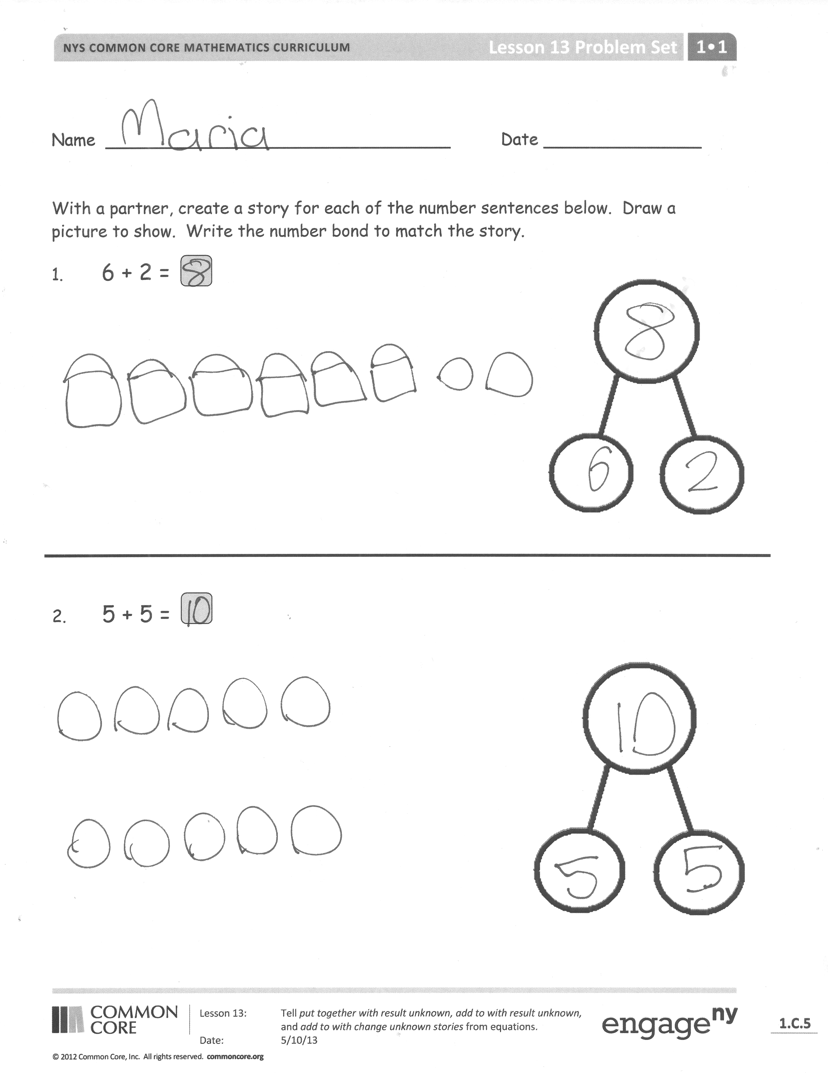
Problem Set (12 minutes)
Distribute the Problem Set and allow students to work independently or in small groups. While students are working, the teacher circulates and listens. Some students may need encouragement to vary between add to and put together stories.
Students should do their personal best to complete the Problem Set within the allotted 12 minutes. For some classes, it may be appropriate to modify the assignment by specifying which problems they work on first. Some problems do not specify a method for solving. Students solve these problems using the RDW approach used for Application Problems.
Student Debrief (8 minutes)
Lesson Objective: Tell put together with result unknown, add to with result unknown, and add to with change unknown stories from equations.
The Student Debrief is intended to invite reflection and active processing of the total lesson experience.
Invite students to review their solutions for the Problem Set. They should check work by comparing answers with a partner before going over answers as a class. Look for misconceptions or misunderstandings that can be addressed in the Debrief. Guide students in a conversation to debrief the Problem Set and process the lesson.

You may choose to use any combination of the questions below to lead the discussion.
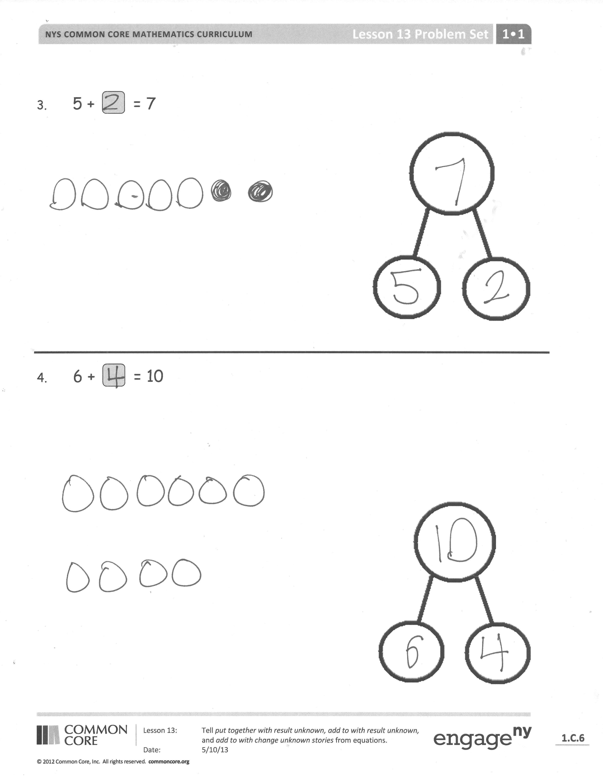
- Which two problems from your Problem Set did you think were similar? Why?
- Which two problems from your Problem Set did you think were different? Why?
- Which of your stories was the most difficult for you to make? Which story was the easiest for you? Why?
- (Project a sample of a student Application Problem on the board.) Which problem was our Application Problem similar to? In what way(s) are they similar?
Exit Ticket (3 minutes)
After the Student Debrief, instruct students to complete the Exit Ticket. A review of their work will help you assess the students’ understanding of the concepts that were presented in the lesson today and plan more effectively for future lessons. You may read the questions aloud to the students.

Name Date

With a partner, create a story for each of the number sentences below. Draw a picture to show. Write the number bond to match the story.
1. 6 + 2 =

2. 5 + 5 =

3. 5 + = 7

4. 6 + = 10

Name Date

Tell a math story for each number sentence by drawing a picture.

- 5 + 1 = 6 2. 3 + ? = 8

Name Date

Use the number sentences to draw a picture, and fill in the number bond to tell a math story.
1. 5 + 2 = 7
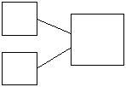

2. 3 + 6 = 9

3. 7 + ? = 9

