Lesson 6
Objective: Use varied protractors to distinguish angle measure from length measurement.

Suggested Lesson Structure
 Fluency Practice (12 minutes)
 Application Problem (5 minutes)
 Concept Development (37 minutes)
 Student Debrief (6 minutes)
Total Time (60 minutes)
Fluency Practice (12 minutes)
- Divide Using the Area Model 4.NBT.6 (4 minutes)
- Draw and Identify Two-Dimensional Figures 4.G.1 (4 minutes)
- Physiometry 4.G.1 (4 minutes)
Divide Using the Area Model (4 minutes)
Materials: (S) Personal white board
Note: This fluency activity reviews G4–M3–Lesson 20 content.
T: (Project area model that shows 68 ÷ 2.) Write a division expression for this area model.
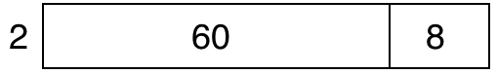
S: (Write 68 ÷ 2.)
T: Label the length of each rectangle in the area model.
S: (Write 30 above the 60 and 4 above the 8.)
T: Solve using the standard algorithm.
S: (Solve.)
Continue with the following possible sequence: 69 ÷ 3, 78 ÷ 3, and 76 ÷ 4.
Draw and Identify Two-Dimensional Figures (4 minutes)
Materials: (S) Personal white board, straightedge
Note: This fluency activity reviews terms introduced in Lessons 1─5.
T: (Project $\overline{AB}$. Point to $A$.) Say the term for what I’m pointing to.
S: Point $A$.
T: (Point to $B$.) Say the term.
S: Point $B$.
T: (Point to $\overline{AB}$.) Say the term.
S: Line segment $AB$.
T: Use your straightedge to construct $\overline{CD}$on your personal white boards.
S: (Draw $\overline{CD}$.)
T: Beneath $\overline{CD}$, draw $\overset{⃡}{EF}$ that is parallel to $\overline{CD}$.
S: (Beneath $\overline{CD}$, draw $\overset{⃡}{EF}$ that is parallel to$\overline{CD}$.)
T: Draw $\overset{⃑}{GH}$ that begins on $\overset{⃡}{EF}$ and runs perpendicular through $\overline{CD}$.
S: (Draw $\overset{⃑}{GH}$ that begins on $\overset{⃡}{EF}$ and runs perpendicular through $\overline{CD}$.)
T: What’s the relationship between $\overset{⃑}{GH}$ and $\overline{CD}$?
S: $\overset{⃑}{GH}$ is perpendicular to $\overline{CD}$.
T: Draw $\overline{IJ}$ that is perpendicular to $\overline{KL}$.
S: (Draw $\overline{IJ}$. Draw $\overline{KL}$ that is perpendicular to $\overline{IJ}$.)
T: Draw $\overline{MN}$ that is perpendicular to $\overline{IJ}$ and parallel to $\overline{KL}$.
S: (Draw $\overline{MN}$ that is perpendicular to $\overline{IJ}$ and parallel to $\overline{KL}$.)
T: (Project a right $∠ACB$.) Name the angle.
S: $∠ACB$.
T: What type of angle is it?
S: Right angle.
T: What’s the relationship of $\overset{⃑}{CA}$ and $\overset{⃑}{CB}$?
S: They’re perpendicular.
T: How many degrees are in $∠ACB$?
S: 90$°$.
T: (Project an acute $∠DFE$.) Name the angle.
S: $∠DFE$.
T: (Beneath $∠DFE$, write 30° or 150°.) Estimate. Is the measure of $∠DFE$ 30° or 150°?
S: 30°.
T: How do you know?
S: Acute angles are less than 90°.
Continue with the other given angles.

Physiometry (4 minutes)
Note: Kinesthetic memory is strong memory. This fluency activity reviews terms from Lessons 1─5.
T: Stand up.
S: (Stand up.)
T: Show me a right angle.
S: (Stretch one arm up directly at the ceiling. Stretch another arm directly toward a wall, parallel to the floor.)
T: Show me a different right angle.
S: (Stretch the arm pointing toward a wall directly up toward the ceiling. Move the arm pointing toward the ceiling so that it points directly toward the opposite wall.)
T: Show me an obtuse angle.
S: (Make an obtuse angle with arms.)
T: Show me an acute angle.
S: (Make an acute angle with arms.)
T: Show me a right angle.
S: (Make a right angle with arms.)
T: Show me an angle that measures approximately 30°.
S: (Move arms closer together, lessening the space between their arms, so that it is approximately 30°.)
T: Show me an angle that measures approximately 60°.
S: (Open arms further apart to approximately 60°.)
Continue with the following possible sequence: 90°, 120°, 150°, 50°, 170°, 70°, and 180°.
T: What is the term for a 180$°$angle?
S: A line.
T: Show me a line segment.
S: (Close fists.)
T: (Point at the classroom’s back wall.) Point to the walls that run perpendicular to the wall I’m pointing to.
S: (Point to the side walls.)
T: (Point to the front wall.)
S: (Point to the side walls.)
Continue pointing to one side wall, the back wall, the other side wall, and the front wall.
T: (Point to the back wall.) Point to the wall that runs parallel to the wall I’m pointing to.
S: (Point to the front wall.)
Continue pointing to one side wall, the front wall, and the other side wall.
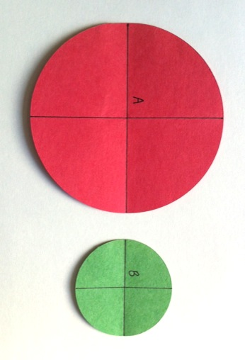
Application Problem (5 minutes)
Materials: (S) 2 circles of different sizes (different colors, if possible)
Fold Circle A and Circle B as you would to make a right angle template. Trace the folded perpendicular lines. How many right angles do you see at the center of each circle? Did the size of the circle matter?
Note: This Application Problem connects to Lesson 5, in which students found four right angles within a circle. As an introduction to arc length measure having no effect on angle measurement, students find the number of right angles around the center point of different size circles.
Concept Development (37 minutes)
Materials: (T) 2 circle cutouts from Application Problem, 2 pieces of wire the same length as the circumference of each circle cutout, Practice Sheet, dark marker, straightedge, an assortment of protractors including at least one circular protractor and one 180° protractor (S) 2 circle cutouts from Application Problem, Practice Sheet, dark marker, straightedge, an assortment of protractors including at least one circular protractor and one 180° protractor
Note: Providing a variety of protractors allows students to distinguish angle measure from length measure. Students may share protractors during this activity. It is not necessary for every student to have two or three varied protractors of their own.

NOTES ON
MULTIPLE MEANS
OF REPRESENTATION:
Check that English language learners and others understand the meaning of the new math term arc. If necessary and possible, offer explanations in students’ first language. Link arc to more familiar words or phrases such as the Gateway Arch in St. Louis.
Problem 1: Explore the effect of angle size on arc length. Distinguish between angle and length measurement.
T: How many degrees are in a right angle?
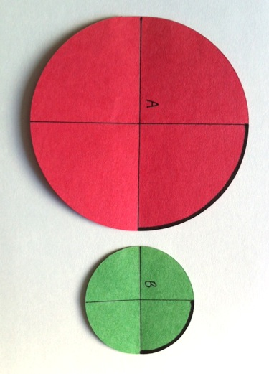
S: 90$°$.
T: Use a marker to draw an arc on Circle A and Circle B (as pictured to the right).
T: Trace your finger along each arc. Which circle has a longer arc?
S Circle A!
T: But don’t both arcs measure 90$°$? Why are the arcs different lengths?
S: I don’t know. Circle A is bigger, so maybe it needs a bigger arc.
T: How many total degrees in this circle? (Point to Circle A.)
S: 360$°$.
T: How many total degrees in this circle? (Point to Circle B.)
S: 360$°$.
T: So, if I divide Circle A into 360$°$, each arc length will be a little longer than the arc lengths in Circle B. I’m still measuring a quarter turn in each circle, and each arc is one fourth of the total distance around the circle.
T: Think of it as taking the length of an arc from each circle and stretching them out into a line. (Model two wires that wrap the circumference of each circle stretched out in a line.) I can chop each wire into 360 equal-size pieces. Which arc will have smaller pieces?
S: The arc from Circle B.
T: Right! 90$°$ is one quarter of 360$°$. (Cut each wire into four equal parts. Show that one part from each wire is the same length as the arc of each circle.) Which arc is longer?
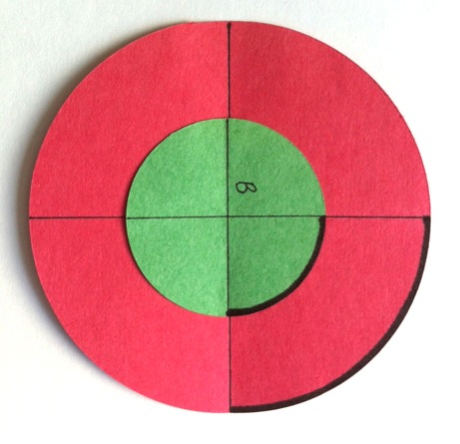
S: Circle A has a longer arc.
T: So, does the length of an arc determine the measure of a given angle? Discuss this with your partner.
S: No! The arcs might be longer or shorter, but they could be measuring the same size angle. No matter where the arc is, I just have to remember that that arc is part of 360$°$. Right, because I could have a super tiny circle or a really big circle, but still, the right angles measure 90$°$.
T: Place Circle B on top of Circle A to show that the length of an arc does not determine the degree measure.
Problem 2: Use a 180° protractor to verify angle measure.
T: (Project $∠C$ and $∠D$ from the Practice Sheet.) What type of angle do you see?
S: Acute!
T: Discuss what you notice about the arc length in each angle.
S The arc length in $∠C$ is longer than the one in $∠D$. The arcs are different lengths, but the angles look like they might be the same. It looks like $∠C$ came from a larger circle than $∠D$ did.
T: Let’s measure to find out if the angles turn the same number of degrees.
T: (Distribute and display a 180° protractor.) What do you notice about this protractor?
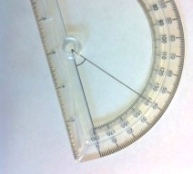
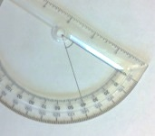
S: It’s half a protractor. It’s only a piece of a circular protractor. It’s got a straight edge.
T: Just like you measured angles with a circular protractor, you can measure angles with this 180° protractor. Protractors sometimes have two sets of numbers. We determine which number to read based off of the side of the angle that touches zero. (Show a 40$°$ angle as pictured to the right, aligning both sides to zero and discussing which set of numbers to read.)
T: (Model. Place the middle notch on the vertex of the angle. Align a side with the zero or base line on the protractor. Read the number the second side length touches.)
T: With your partner, measure $∠C$.
S: 60$°$. No. Wait, 120$°$. It can’t measure 120$°$. It’s an acute angle. 60$°$. Remember, we count up from the side of the angle at zero. So, we are using the outside numbers for this angle.
T: Measure $∠D$.
S: 60$°$.
T: What did you discover? Discuss it with your partner.
S: The arc lengths are different, but the degrees are the same. Both angles are 60$°$, but $∠D$ looks different because the sides of the angle are shorter.
T: What would happen if we placed the angles on top of each other? Turn and talk. (Allow time for a brief discussion.) Let’s try! (Model.)
S: They match up! The angles are the same size!
T: Imagine a circle drawn with the vertex of $∠D$ as its center point, the end of one segment being the length to the arc and another circle drawn in the same way around $∠C$.
T: What could you say about the two circles?
S: The circles would be different sizes. The lengths of the sides of $∠C$ would make a larger circle than the sides of $∠D$. The arcs and sides of the angles will be different lengths, but the angle will measure the same because each angle represents a fraction of 360$°$.
Problem 3: Use multiple protractors to measure the same angle.
T: Look at the different protractors in front of you. What do you notice about them?
S: Some are 360° protractors, and some are 180° protractors. Some have only one set of numbers; others have two sets. They are all different sizes. The base line of this one is on the bottom of the protractor, but the base line of this one is above the plastic.
T: Align your protractors using the center point, just like we did with our two circles at the beginning of the lesson. Do you see how these different protractors have different arcs?
S: Yes, some are small, and some are big.
T: Yes, but they all measure 360$°$of a circle.
S: But some only measure 180$°$.
T: That’s because it is representing half a circle. Notice the tick marks on all of the different protractors.
S: Some are really close together!
T: Why is that?
S: It’s on the smallest protractor, so that means the arc lengths are shorter than those of the other protractors.
T: Let’s use at least three different protractors to measure $∠E$.
Allow time for students to measure individually, with partners, or in small groups, depending on the variety of protractors available in the classroom.

NOTES ON
MULTIPLE MEANS
OF ACTION AND EXPRESSION:
Students who experience frustration with manipulating and reading a protractor may find success with virtual protractors, such as those found at the following website: http://www.teacherled.com/resources/anglemeasure/angleteach.swf
Virtual protractors may be a viable option for classrooms that do not have a wide range or large number of protractors.

S: All three protractors showed that this is a 130° angle!
T: What does that tell you about the side lengths of an angle?
S: The side lengths can be any length. No matter where you measure on the circle, the number of degrees will always be the same. We aren’t measuring the sides of angles. The different sizes of protractors pick a different point on each segment where a circle could be and measures that.
T: Let’s look at Problem 1(a) of the Problem Set together. Measure the angle that is shown.
S: I can’t measure that angle. The image is too small!
I know what to do! We can make the segments of the angle longer. We just found out that the angle measure stays the same no matter what the side length is.
T: Use your straightedge to extend the sides of the angle until they are long enough for you to use the protractor to measure the angle. (Model.)
S: Now, I can measure the angle!
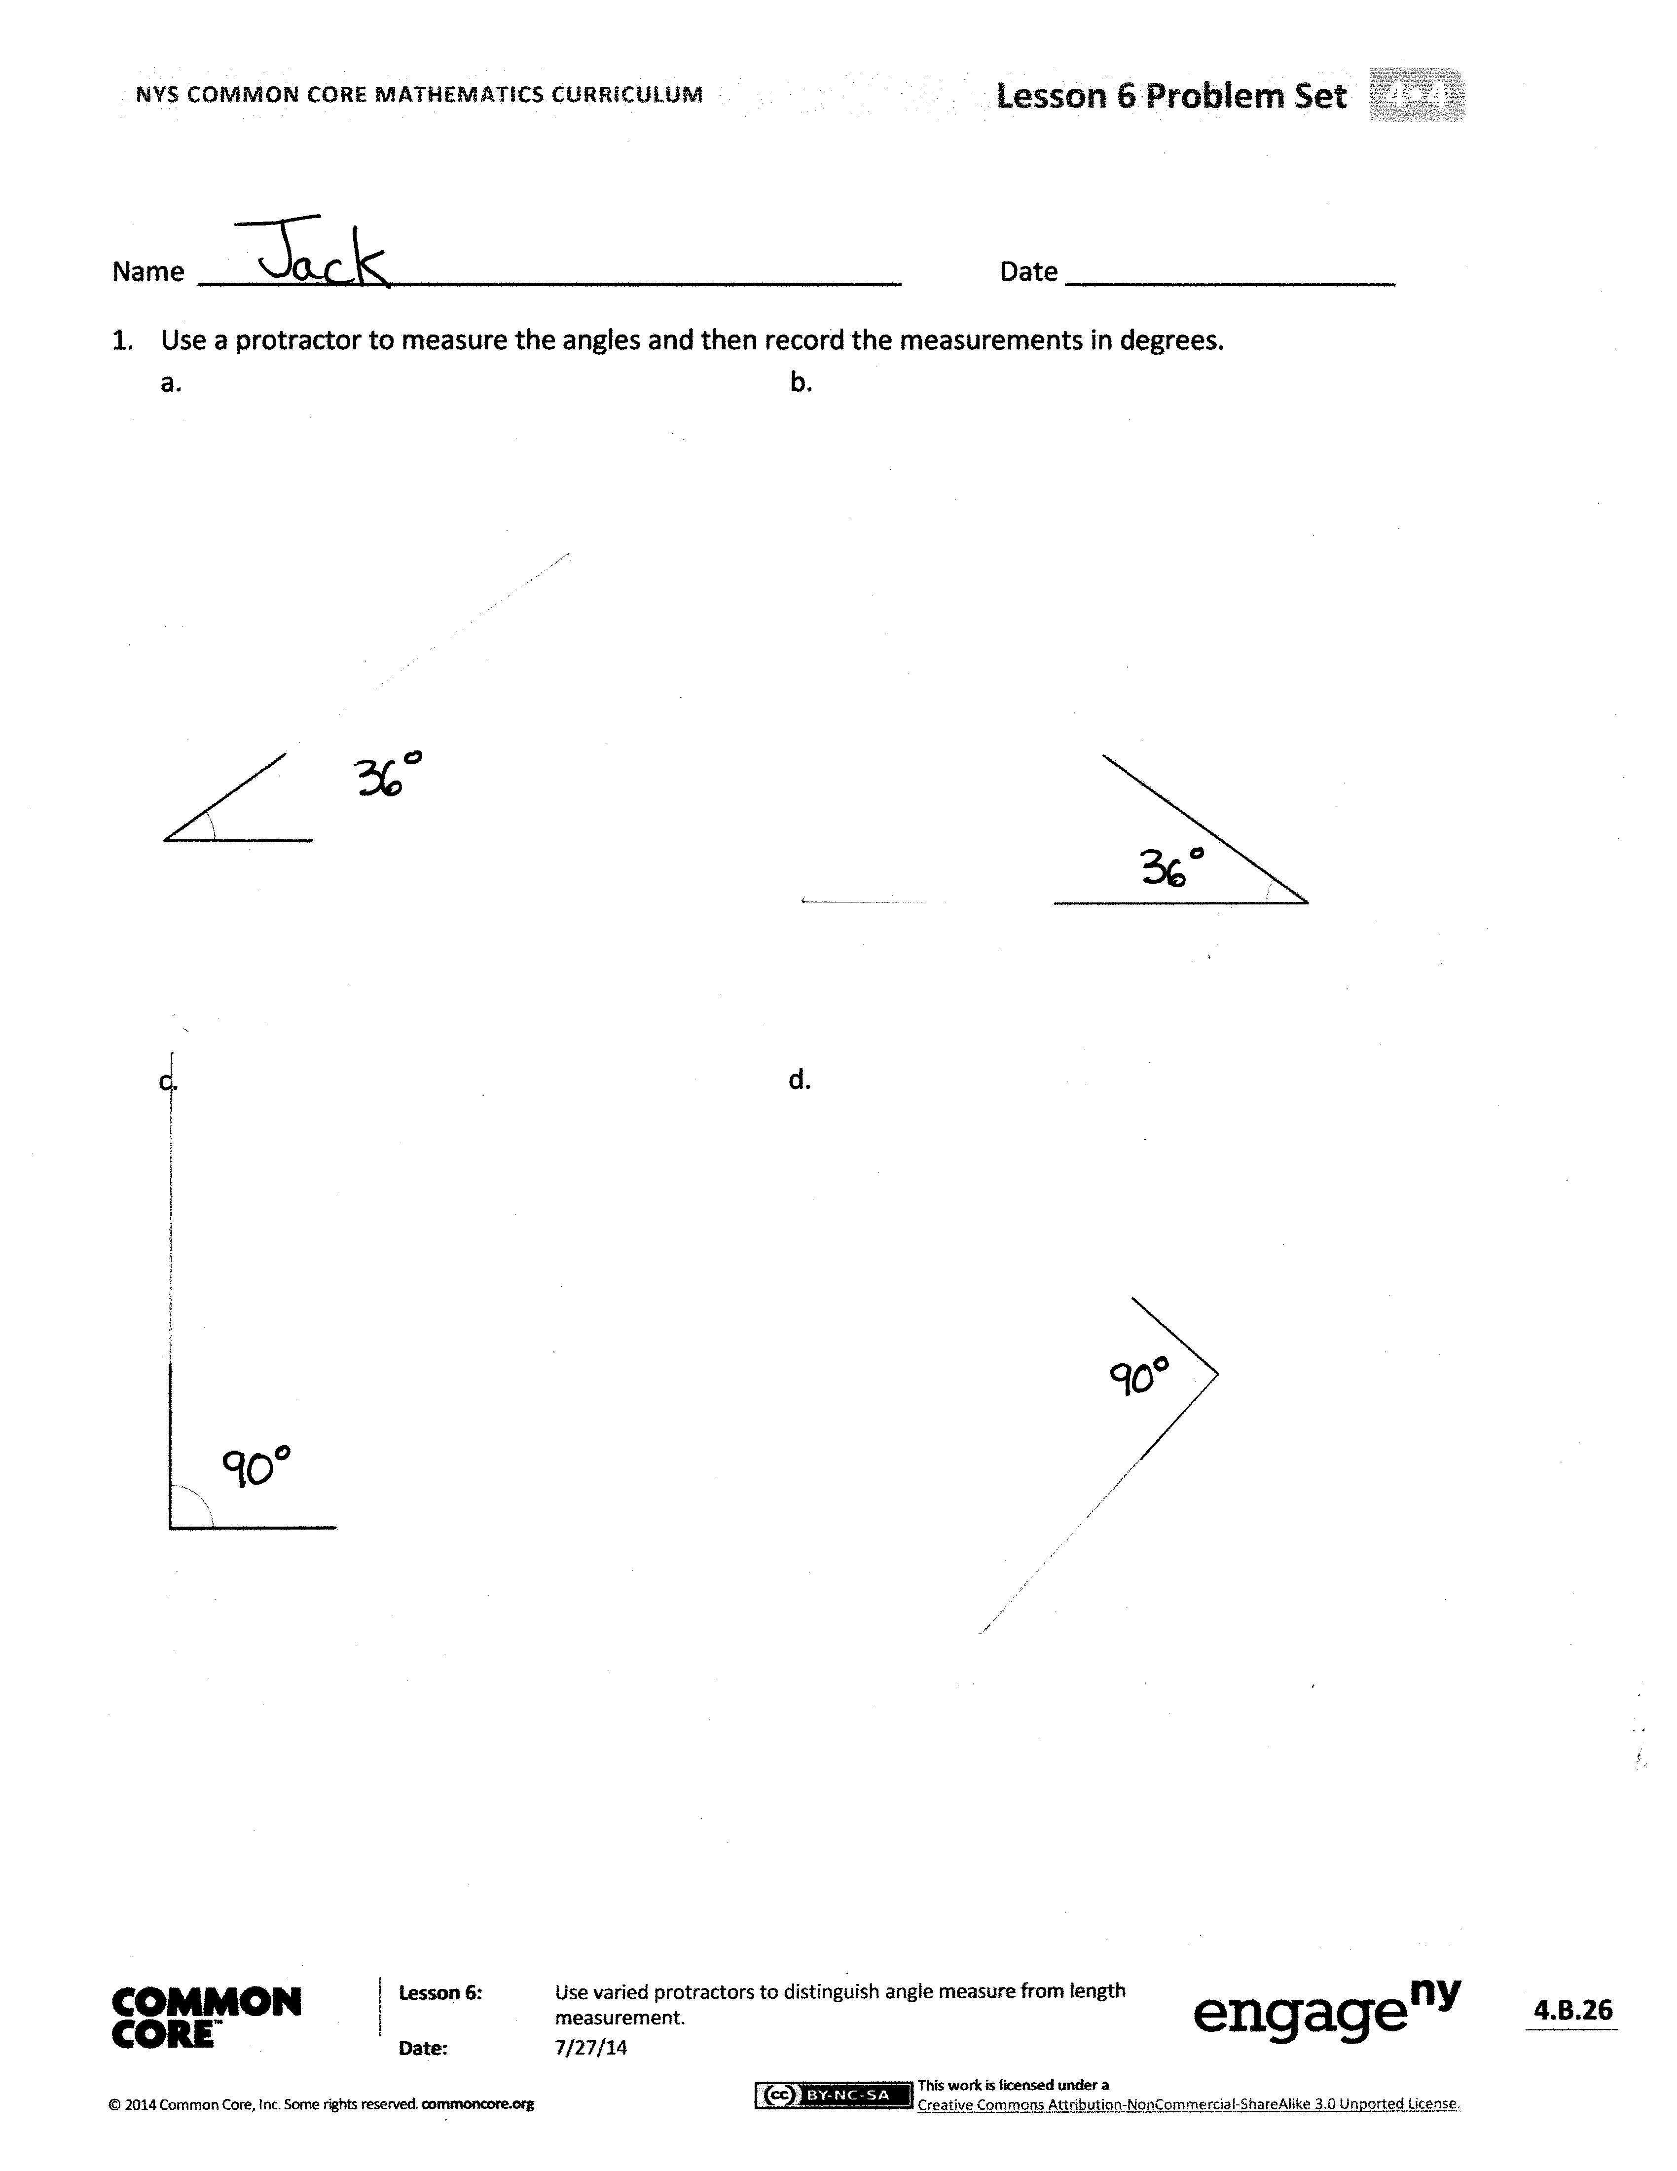
Problem Set (10 minutes)
Students should do their personal best to complete the Problem Set within the allotted time frame. For some classes, it may be appropriate to modify the assignment by specifying which problems they should work on first.
Student Debrief (6 minutes)
Lesson Objective: Use varied protractors to distinguish angle measure from length measurement.
The Student Debrief is intended to invite reflection and active processing of the total lesson experience.
Invite students to review their solutions for the Problem Set. They should check work by comparing answers with a partner before going over answers as a class. Look for misconceptions or misunderstandings that can be addressed in the Debrief. Guide students in a conversation to debrief the Problem Set and process the lesson.
You may choose to use any combination of the questions below to lead the discussion.
- In Problem 1, which angle had the same measure as $∠G$? $∠I$?
- In Problem 1, which angles had the same angle measure but different side length measures?
- For Problem 2, discuss your experience of measuring with different protractors. Describe how the length of an arc on each protractor did or did not affect the measure of the given angle.
- How many degrees did the angles in Problem 3 measure? What type of angle is the angle in Part (a)? We know a straight angle forms a straight line. Points A, B, and C create $∠ABC$ and $\overline{ABC}$. When three or more points are found on a line, we call them collinear points. Are points D, E, and F collinear? Why not?
- Take a look at your 180° protractor. Find pairs of numbers that label the two scales, such as 150° and 30°. Name other pairs of numbers. What do you notice about the pairs of numbers?
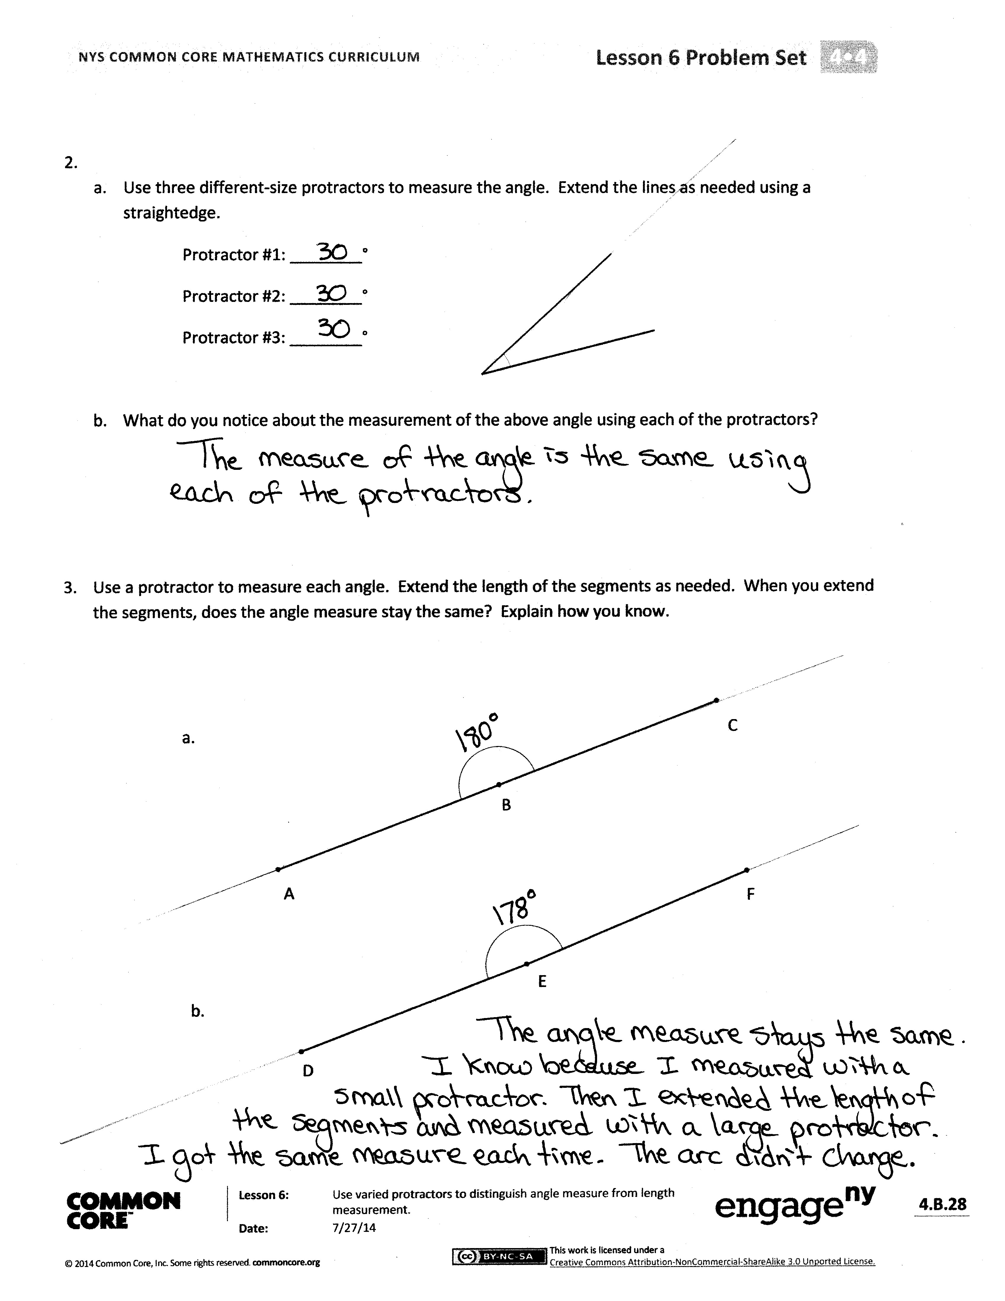
- How did the Application Problem help you understand that an angle measure remains constant and is not a length measure?
Exit Ticket (3 minutes)
After the Student Debrief, instruct students to complete the Exit Ticket. A review of their work will help you assess the students’ understanding of the concepts that were presented in the lesson today and plan more effectively for future lessons. You may read the questions aloud to the students.

Name Date

C
D

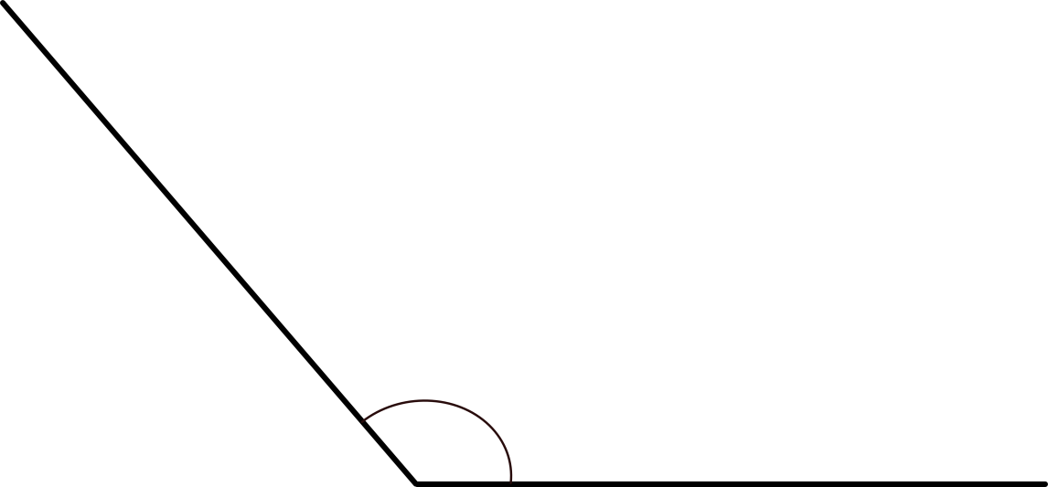
E
E
Name Date
- Use a protractor to measure the angles, and then record the measurements in degrees.
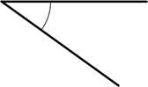
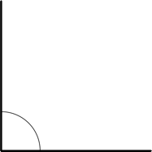
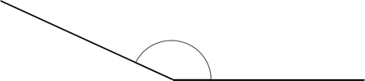
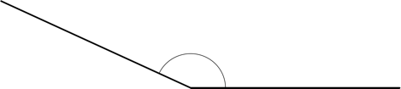
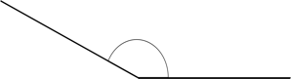
- a. Use three different-size protractors to measure the angle. Extend the lines as needed using a straightedge.
Protractor #1: ________ °
Protractor #2: ________ °
Protractor #3: ________ °

- What do you notice about the measurement of the above angle using each of the protractors?

- Use a protractor to measure each angle. Extend the length of the segments as needed. When you extend the segments, does the angle measure stay the same? Explain how you know.

C
B

A
F
E
D

Name Date
Use any protractor to measure the angles, and then record the measurements in degrees.

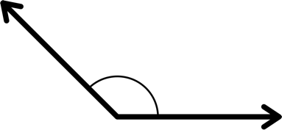 | 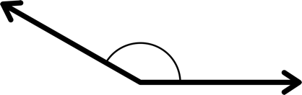
3. | 4.

Name Date
- Use a protractor to measure the angles, and then record the measurements in degrees.

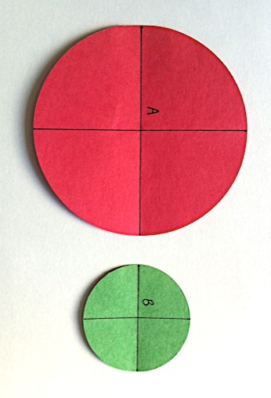
- Using the green and red circle cutouts from today’s lesson, explain to someone at home how the cutouts can be used to show that the angle measures are the same even though the circles are different sizes. Write words to explain what you told him or her.

- Use a protractor to measure each angle. Extend the length of the segments as needed. When you extend the segments, does the angle measure stay the same? Explain how you know.

B
A
C

E
D
F

