Lesson 12
Objective: Solve add to with change unknown math stories using 5-group cards.

Suggested Lesson Structure
 Fluency Practice (15 minutes)
 Application Problem (5 minutes)
 Concept Development (30 minutes)
 Student Debrief (10 minutes)
Total Time (60 minutes)
Fluency Practice (15 minutes)
- Slam: Partners to 6 1.OA.6 (10 minutes)
- Number Bond Dash: 6 (Day 2) 1.OA.6 (5 minutes)
Slam: Partners to 6 (10 minutes)

NOTES ON
MULTIPLE MEANS
FOR ACTION AND EXPRESSION:
When playing games, provide a variety of ways for students to respond. Oral fluency games should be adjusted for students who are deaf or students with hearing impairments. This can be done in many ways, including showing the answer with fingers, using student boards to write answers, or using a visual signal or vibration.

Materials: (T/S) 5-group cards (Lesson 5 Template 1)
Note: This activity addresses the core fluency objective for Grade 1 of adding and subtracting within 10. In this engaging context, be sure to help students focus on the mathematics of this activity.
Tell students to order cards 0–6 on their desks, beginning with 0. Flash a 5-group card, and instruct students to “slam” the card with the partner to 6 (students carefully slap the card on the table). Tell students to say the partners they found when you snap, beginning with the card they just slammed (5 and 1 make 6). Then, tell them to say it again, beginning with the card you flashed (1 and 5 make 6). Continue playing until students have found all possible partners to 6. Then, give them time to play the game with partners.
Number Bond Dash: 6 (5 minutes)
Materials: (T) Stopwatch or timer (S) Number bond dash 6 (Lesson 5 Fluency Template 2), marker to correct work
Note: By using the same system repeatedly, students can focus on the mathematics alone. The activity addresses the core fluency objective for Grade 1 of adding and subtracting within 10.
Follow the procedure for the Number Bond Dash from Lesson 5 Fluency Practice. Remember that today is the second day with making 6. Students should recall their scores from the previous lesson to celebrate improvement.
Application Problem (5 minutes)
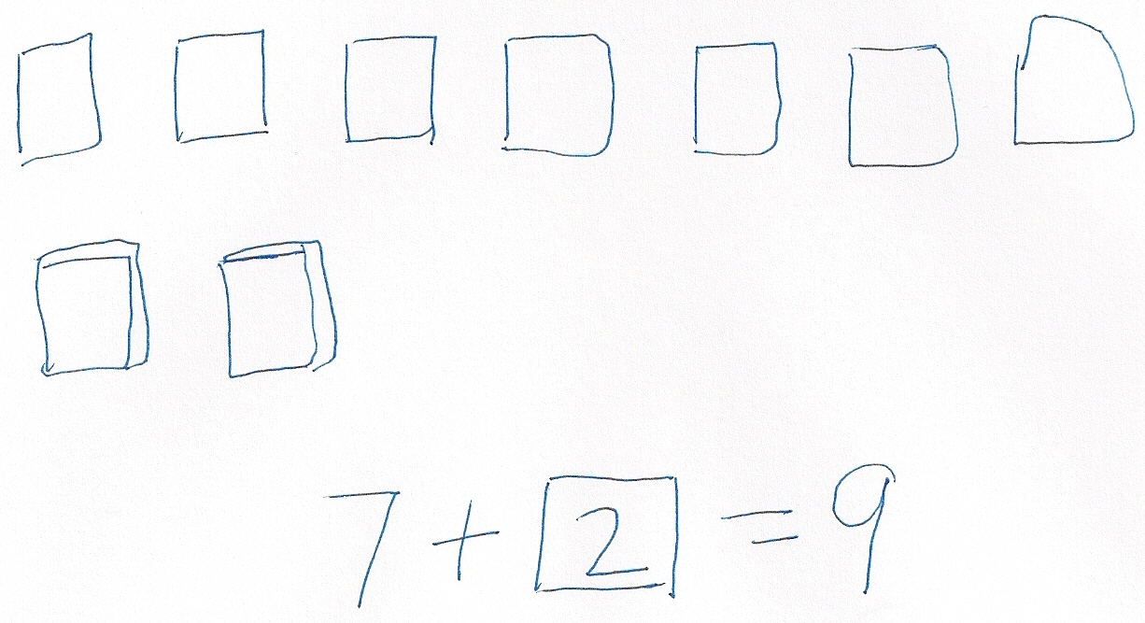
Tanya has 7 books on her shelf. She borrowed some books from the library, and now there are 9 books on her shelf. How many books did she get at the library? Explain your thinking in pictures, words, or with a number sentence. Draw a box around the mystery number in your number sentence.
Note: This problem is designed both as a bridge and a lead-up in that it focuses students on solving a change unknown problem. Students come back to the problem in the Debrief, applying the use of 5-group cards as another resource for problem solving as they count on to solve.
Concept Development (30 minutes)
Materials: (T) Mystery box (Lesson 11), counting bears (or another engaging classroom material that allows you to tell stories), enlarged blank number sentence and number bond (Lesson 6 Template 2)
(S) Personal white board, blank number sentence and number bond (Lesson 6 Template 2),
5-group cards including blank (Lesson 5 Template 1), number sentence cards (Lesson 11 Template) with sticky notes labeled with question marks per pair
Before the lesson, privately place 3 counting bears in the mystery box. Have students sit in a semi-circle with their 5-group cards and number sentence template.
T: Use the number side of your 5-group cards to help me solve a story. Once upon a time, 5 little bears came out of hibernation. (Place 5 bear counters above the first addend space on the teacher number sentence template.)
S: (Place the numeral 5 card on number sentence.)
T: Then, some more bears came out of hibernation. (Bring out mystery box.)
T: What should we do in our number sentence here? Turn and talk to your partner, and show it on your number sentence.
S: (Discuss. Acceptable responses are leaving the second square blank or inserting a question mark.)
T: Here’s a blank card for everyone. (Distribute a blank card.) Place it in your number sentence to show that this part is a mystery.
T: At the end, there were 8 little bears out of hibernation. Where should we show that number of bears in our number sentence? (Give students time to discuss and place the 8 card in the final box. Then, place the numeral 8 in the teacher equation template.)
T: How can we use the 5-group cards to figure out how many more bears came out of hibernation? With your partner, use your cards to show how many bears are in the box. (Circulate.)
S: (Discuss and solve. For example, students may turn the 8 over to the dot side, gesture to the five and count on, “Fiiiive, 6, 7, 8.”)
T: How many bears joined the group?
S: (Share ideas.)
T: How did you use your 5-group cards to figure this out? (Ask students with cards dot side up to demonstrate. Some students may use the cards to check their solution by creating the number sentence 5 + 3 = 8 with the numeral cards and then flipping the 3 to the dot side to count on.)
T: Let’s count on as we point to each dot.
S/T: Fiiiiive, 6, 7, 8!
T: How many more bears came out of hibernation?
S: 3 bears!
T: Let’s open the box and see how many more bears came out of hibernation! Write the number sentence using the 5-group cards in front of you to help.
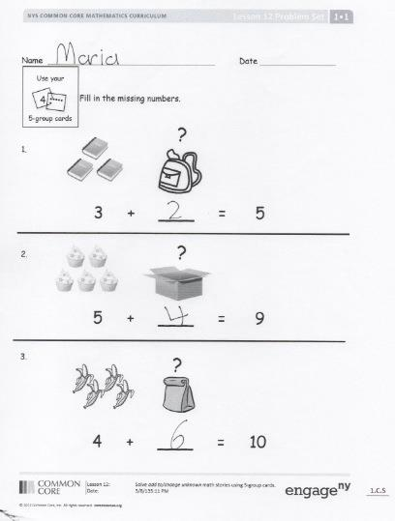
Explain to the students that this type of a story problem is a “mystery change” problem since the change that results in the total is a mystery (the unknown).
T: (Show 4 + ? = 7.) This time, I want you to think of a mystery change story with your partner. Try to solve the mystery using your 5-group cards.
Choose a number sentence card with a sticky note covering the second addend, such as 9 = 5 + ?. Have the students create a mystery change story to go with the number sentence. When the students are ready to work more independently, give partners two or three number sentence cards with sticky notes already covering the second addend to continue telling stories and solving.
Problem Set (10 minutes)
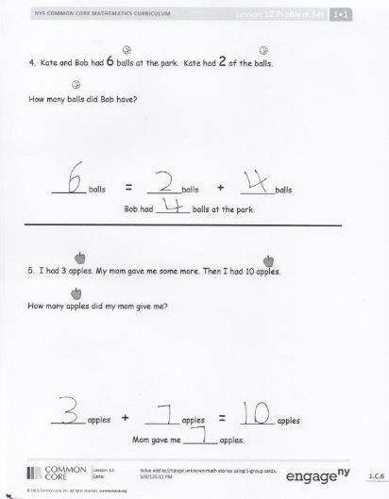
Students should do their personal best to complete the Problem Set within the allotted 10 minutes. For some classes, it may be appropriate to modify the assignment by specifying which problems they work on first. Some problems do not specify a method for solving. Students solve these problems using the RDW approach used for Application Problems.
Student Debrief (10 minutes)
Lesson Objective: Solve add to with change unknown math stories using 5-group cards.
The Student Debrief is intended to invite reflection and active processing of the total lesson experience.
Invite students to review their solutions for the Problem Set. They should check work by comparing answers with a partner before going over answers as a class. Look for misconceptions or misunderstandings that can be addressed in the Debrief. Guide students in a conversation to debrief the Problem Set and process the lesson.
You may choose to use any combination of the questions below to lead the discussion.
- How did the 5-group cards help you with today’s work?
- Were some problems faster to solve than others? Why? Share an example.
- Compare the different strategies we used yesterday and today. Which strategy was easier for you, and why?
- How are Problem 3 and Problem 5 different? How are they the same?
- Look at your Application Problem. How can you use 5-group cards to solve this problem?
- Share with your partner an “I can…” statement, based on something you can now do on your own. For example, “I can make up mystery change problems and write number sentences with sticky notes,” or “I can use 5-group cards to help me solve mystery change problems.”
Exit Ticket (3 minutes)
After the Student Debrief, instruct students to complete the Exit Ticket. A review of their work will help you assess the students’ understanding of the concepts that were presented in the lesson today and plan more effectively for future lessons. You may read the questions aloud to the students.

Name Date
4
Use your

5-group cards

Fill in the missing numbers.
?
1.

3 + ___ = 5
?
2.

5 + ___ = 9
?
3.

4 + ___ = 10
- Kate and Bob had 6 balls at the park. Kate had 2 of the balls.
How many balls did Bob have?

_______ balls = _______ balls + _______ balls
Bob had _______ balls at the park.

- I had 3 apples. My mom gave me some more. Then, I had 10 apples.
How many apples did my mom give me?

_______ apples + _______ apples = _______ apples

Mom gave me _______ apples.
Name Date

Draw a picture and count on to solve the math story.
Bob caught 5 fish. John caught some more fish. They had 7 fish in all. How many fish
did John catch?
Write a number sentence to match your picture.
=
+

John caught _________ fish.

Name Date
4
Use your 5-group cards to count on to find the missing number in the number sentences.
?

5
5
+
=

?
7
=

1.
The mystery number is

2
6
6
+

?
9
=

2
+

?
8
=

2.
The mystery number is

3.
Use your 5-group cards to count on and solve the math stories. Use the boxes to show your 5-group cards.
The mystery number is
4

- Jack reads 4 books on Monday. He reads some more on Tuesday. He reads 7 books total. How many books does Jack read on Tuesday?

Jack reads ______ books on Tuesday.

+

=

- Kate has 1 sister and some brothers. She has 7 brothers and sisters in all. How many brothers does Kate have?

Kate has ______ brothers.

+

=

- There are 6 dogs in the park and some cats. There are 9 dogs and cats in the park altogether. How many cats are in the park?

There are ______ cats total.

+

=

