Lesson 11
Objective: Solve add to with change unknown math stories as a context for counting on by drawing, writing equations, and making statements of the solution.

Suggested Lesson Structure
 Fluency Practice (8 minutes)
 Application Problem (5 minutes)
 Concept Development (30 minutes)
 Student Debrief (17 minutes)
Total Time (60 minutes)
Fluency Practice (8 minutes)
- Count On Cheers: 2 More 1.OA.5 (3 minutes)
- Number Bond Dash: 6 1.OA.5 (5 minutes)
Count On Cheers: 2 More (3 minutes)
Note: This activity supports the connection of counting on by 2 to adding 2.
fiiiive
six
seven
The teacher says the number aloud. Students repeat the number, touching their heads and counting on as they put their fists in the air, one at a time. Alternately, students can count on with boxing punches.
Number Bond Dash: 6 (5 minutes)
Materials: (T) Stopwatch or timer (S) Number bond dash 6 (Lesson 5 Fluency Template 2), marker to correct work
Note: By using the same system repeatedly, students can focus on the mathematics alone. The activity addresses the core fluency objective for Grade 1 of adding and subtracting within 10.
Follow the procedures for the Number Bond Dash from Lesson 5 Fluency Practice. Tell students to remember how many problems they get correct so they can try to improve their scores tomorrow.
Application Problem (5 minutes)
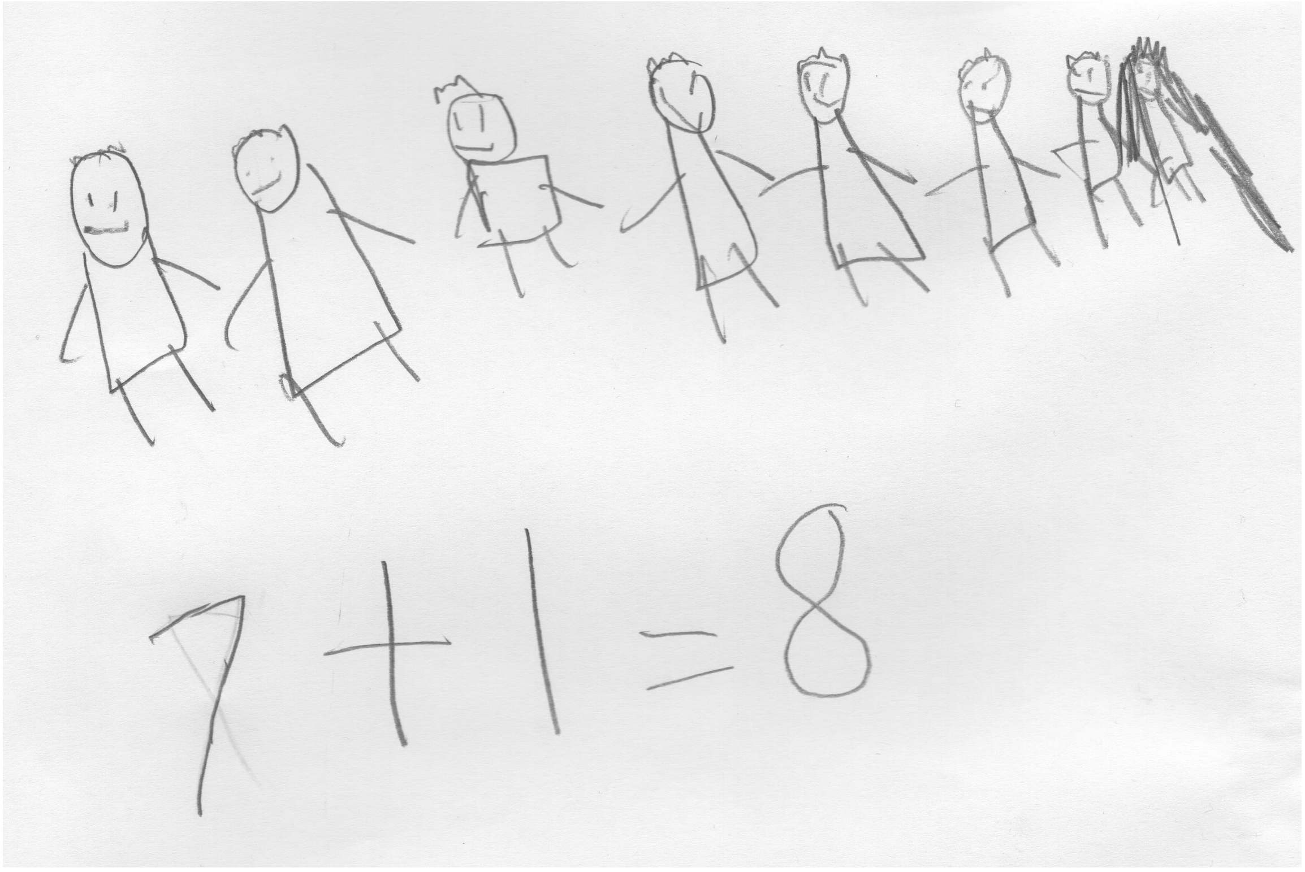
There are 8 children in the afterschool cooking club. How many boys and how many girls might be in the class? Draw a picture and write a number sentence to explain your thinking.
Extension: How many other combinations of boys and girls could be made? Write a number bond for each combination you can think of.
Note: This problem serves as a bridge from the previous lesson’s focus on solving put together stories. It serves as a context for counting on during the Debrief.
Concept Development (30 minutes)
Materials: (T) Mystery box (shoe box or other box with a question mark on it), counting bears (or another engaging classroom material that allows you to tell stories), enlarged blank number sentence and number bond (Lesson 6 Template 2), number sentence cards (Template) and 2" × 2" sticky notes labeled with question mark (S) Personal white board; blank number sentence and number bond (Lesson 6 Template 2); yellow colored pencil or a crayon; set of bear counters, paper bag labeled with question marks on the front per pair
Before the lesson, privately place 2 counting bears in a mystery box. Set the box out of sight. Have students bring their personal white boards and sit in a semi-circle. Display 3 counting bears in front of the enlarged number sentence template.
T: Once upon a time, 3 little bears went to play tag in the forest. (Place 3 bear counters on the template on the floor.) Then, some more bears came over. (Place the box with the question mark next to the bears.) In the end, there were 5 little bears playing tag in the woods altogether.
T: How many bears do you think came to play (point to the box)? Turn and talk to a partner. (Circulate and listen to student discussions.)
S: (Discuss.)
T: How many bears joined the group to play tag? (Have students share ideas.) What strategy did you use to decide? (Ask a few students to share varying ideas.) Let’s use counting on to test our ideas.
MP.2
S/T: (Gesture over the 3.) Threeeee, (tap the box while drawing dots below the box for each count) 4, 5!
5
3
T: How many more bears came to play?
S: 2 bears!
T: Let’s find out if we were right. (Open up the box and reveal 2 bears.) You were right! There were 2 more bears that came to play tag. (Close the box and place the 2 bears on top of the box.)
T: Write the number sentence and number bond for the story. (Circulate.)
S: (Write the number sentence and number bond.)
T: Let’s replace our bears with numbers to see our number sentence. (Replace the 3 bears with the number 3 and the 2 bears with the number 2. Add the number 5 after the equal sign as the total.)
Analyze the referents for each number, ensuring that students understand what each number represents in the story. Emphasize the unknown in the number sentence and number bond as being the change.

NOTES ON
MULTIPLE MEANS
OF ENGAGEMENT:
The mystery number game that was played in class today would be a good game to send to parents to play at home. This game provides a challenging extension for students to practice counting on to find the missing addend. Let those students who are able to work with larger numbers count on from a two-digit number.

Repeat this process with a decomposition number sentence such as 9 = 6 + ?. Nine bears were playing tag. At first, there were 6 bears playing. How many more bears joined in?
Provide sets of bears and a paper bag to each pair. Then, distribute one to two number sentence cards with a question mark sticky note covering the second addend. Have students use the bears and the paper bag to tell a story that matches their number sentence card and figure out the mystery number. Circulate and listen to students sharing strategies, solutions, and writing the corresponding number sentence on their templates. Encourage students to talk about what’s happening in each story so that they can contextualize the numbers in the action of the story.
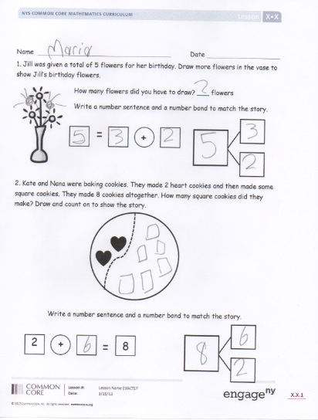
Problem Set (10 minutes)
Students should do their personal best to complete the problem set within the allotted 10 minutes. For some classes, it may be appropriate to modify the assignment by specifying which problems they work on first. Some problems do not specify a method for solving. Students solve these problems using the RDW approach used for Application Problems.
Student Debrief (17 minutes)
Lesson Objective: Solve add to with change unknown math stories as a context for counting on by drawing, writing equations, and making statements of the solution.
The Student Debrief is intended to invite reflection and active processing of the total lesson experience.
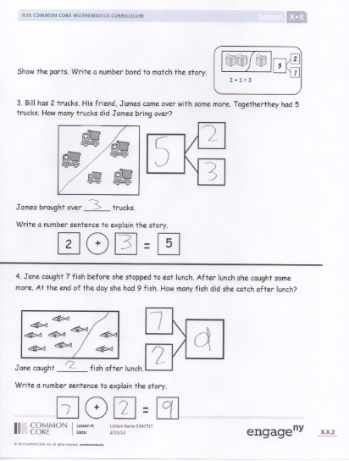
Invite students to review their solutions for the Problem Set. They should check work by comparing answers with a partner before going over answers as a class. Look for misconceptions or misunderstandings that can be addressed in the Debrief. Guide students in a conversation to debrief the Problem Set and process the lesson.
You may choose to use any combination of the questions below to lead the discussion. Have students bring their Problem Sets with a yellow colored pencil or crayon to the meeting area.
- Look at Problem 1. Where was the mystery number in your number sentence? (Have students color in the box with a yellow crayon.) Repeat the process for the rest of the Problem Set.
- What other strategy did you use to solve these problems?
- Look at Problem 3. How can you show the starting part and the mystery part in the picture?
- How are Problem 1 and Problem 3 different and similar?
- How are these number stories different from other number stories we’ve solved?
- (Select student Application Problem samples that represent all decompositions of 8.) There are so many different answers. Are these all correct? How can we figure out if we came up with all of the ways to make 8 boys and girls?
- There were 8 boys and girls in our Application Problem, 2 more boys join the cooking club. How can we count on to find out how many students are in the club now? How would you change your number sentence?
- What if there were still 8 students in the afterschool cooking club, and we knew that there were 5 boys, but we didn’t know how many girls? How can you write that as a new number sentence?
Exit Ticket (3 minutes)
After the Student Debrief, instruct students to complete the Exit Ticket. A review of their work will help you assess the students’ understanding of the concepts that were presented in the lesson today and plan more effectively for future lessons. You may read the questions aloud to the students.
Name Date

- Jill was given a total of 5 flowers for her birthday. Draw more flowers in the vase to show Jill’s birthday flowers.
How many flowers did you have to draw? ___ flowers
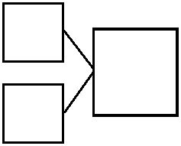
Write a number sentence and a number bond to match the story.
+

- Kate and Nana were baking cookies. They made 2 heart cookies and then made some square cookies. They made 8 cookies altogether. How many square cookies did they make? Draw and count on to show the story.

Write a number sentence and a number bond to match the story.
+

8

2

Show the parts. Write a number bond to match the story.
2 + 1 = 3
3
23
1

- Bill has 2 trucks. His friend, James, came over with some more. Together, they had 5 trucks. How many trucks did James bring over?

James brought over ______ trucks.
Write a number sentence to explain the story.
+

5

2

- Jane caught 7 fish before she stopped to eat lunch. After lunch, she caught some more. At the end of the day, she had 9 fish. How many fish did she catch after lunch?

Jane caught _______ fish after lunch.
Write a number sentence to explain the story.
+

Name Date

Draw more bears to show that Jen has 8 bears total.

I added _____ more bears.
+

Write a number sentence to show how many bears you drew.
+

=

bears

Name Date

- Use the 5-group cards to count on to find the missing number in the number sentences.

2
+

=
7
8
=
5
+

9
=

+
9
9
=
7
+

a.

b.

c.

d.

2. Match the number sentence to the math story. Draw a picture or use your 5-group cards to solve.
- Scott has 3 cookies. His mom gives him some more. Now, he has 8 cookies. How many cookies did his mom give him?

Scott's mom gave him ________ cookies.

6
+

?

9
=

3
+

?
8
=

b. Kim sees 6 birds in the tree.
Some more birds fly in.
Kim sees 9 birds in the tree. How many birds flew to the tree?

______ birds flew to the tree.

4
+

?

8
=

3 + 2 = 5
7 + 1 = 8
6 + 1 = 7
4 + 2 = 6
6 = 5 + 1
10 = 7 + 3
8 = 6 + 2
7 = 5 + 2

number sentence cards

