Lesson 9

Objective: Solve add to with result unknown and put together with result unknown math stories by drawing, writing equations, and making statements of the solution.

Suggested Lesson Structure

 Fluency Practice (20 minutes)

 Application Problem (5 minutes)

 Concept Development (25 minutes)

 Student Debrief (10 minutes)

**Total Time (60 minutes)**

Fluency Practice (20 minutes)

* Sparkle: The Say Ten Way **1.NBT.2** (5 minutes)
* 5-Group Flash: Partners to 10 **1.OA.6** (5 minutes)
* X-Ray Vision: Partners to 10 **1.OA.6** (5 minutes)
* Number Bond Dash: 10 **1.OA.6** (5 minutes)

Sparkle: The Say Ten Way (5 minutes)

Note: Providing students with ongoing practice with counting throughout the year builds and maintains their counting skills, which are foundational for later Grade 1 work using the Level 3 strategies of making ten and taking from ten when adding and subtracting.

See Lesson 7 for activity instructions.

5-Group Flash: Partners to 10 (5 minutes)

Materials: (T/S) 5-group cards (Lesson 5 Template 1)

Note: This activity addresses the core fluency objective for Grade 1 of adding and subtracting within 10.

Flash 5-group cards for 2–3 seconds, and then instructs students to say the number at the snap. On the second snap, ask students to identify the partner to 10. Remind students they can use their fingers to help. Flash higher numbers first to facilitate finding the partner to 10 so that all students can feel successful.

Next, assign students partners, and instruct them to take turns flashing their 5-group cards with each other.

X-Ray Vision: Partners to 10 (5 minutes)

Materials: (T) 10 counters, container

Note: This activity addresses the core fluency objective for Grade 1 of adding and subtracting within 10.

1. Tell students you heard a rumor that some of the children in your class are superheroes, and you are wondering if any of them have x-ray vision. Place 10 counters on the floor next to a container.
2. Tell the students to close their eyes.
3. Put 1 of the items into the container
4. Tell students to open their eyes and identify how many counters you put inside it.
5. When a student figures it out, deem her a superhero with x-ray vision!
6. Continue the game, eliciting all partners to 10.

Number Bond Dash: 10 (5 minutes)

Materials: (T) Stopwatch or timer (S) Number bond dash 10 (Fluency Template), marker to correct work

Note:  By using the same system repeatedly, students can focus on the mathematics alone. The activity addresses the core fluency objective for Grade 1 of adding and subtracting within 10.

Follow the procedure for the Number Bond Dash (see Lesson 5 Fluency Practice).

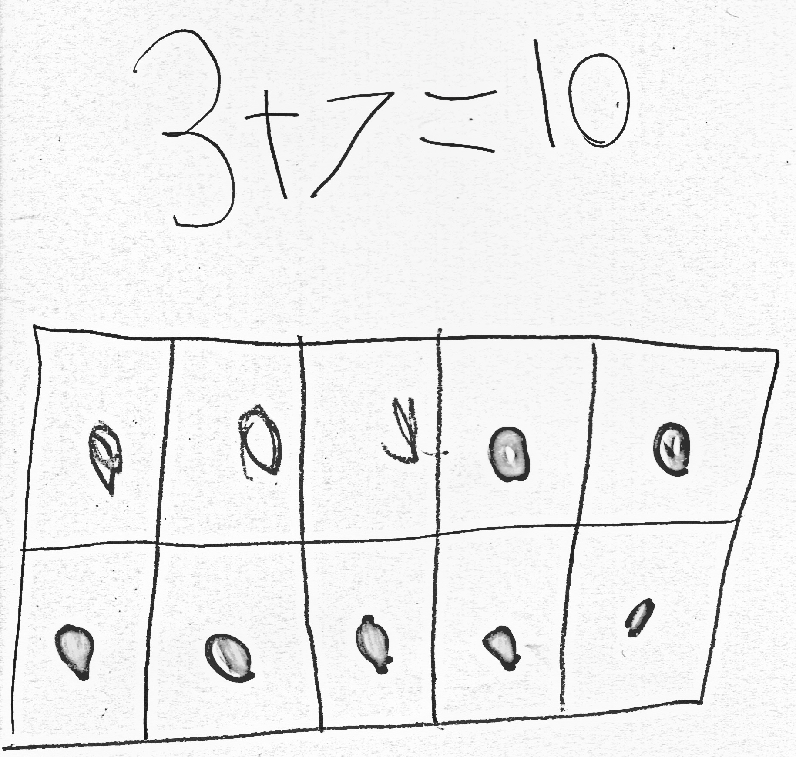Application Problem (5 minutes)

Kira was making a number bracelet with a total of 10 beads on it. She has put on 3 red beads so far. How many more beads does she need to add to the bracelet? Explain your thinking in a picture and number sentence.

Extension: If Kira wants to use 5 red beads and 5 yellow beads for her bracelet, how many red beads and how many yellow beads does she need to add?

Note: This problem is designed to serve as a bridge from the previous lesson’s focus on decompositions of 10.

Concept Development (25 minutes)

Materials: (S) Personal white board, number bond and two blank equations (Template)

Have students sit in a large semi-circle facing the front. Use students to act out the math stories. Draw a number bond on the board. Begin the lesson with *add to* story problems.

|  |  |
| --- | --- |
|  | NOTES ON  MULTIPLE MEANS  FOR ACTION AND EXPRESSION: |
| When choosing numbers to use in a story, start at a simple level, and after students have solved it with easy numbers, change to harder numbers. Here is a suggested sequence starting from simple to more complex:  Add within 5 (e.g., 4 + 1 = 5).  Add adding 1 (e.g., 8 + 1 = 9).  Add using 5 (e.g., 5 + 2 = 7).  Add with the smaller addend first  (e.g., 3 + 5 = 8).  Add to 9 and 10 (e.g., 7 + 3 = 10).  Add to 9 and 10 with smaller addend first (e.g., 3 + 7 = 10) Add including 0 (e.g., 0 + 8 = 8 or 8 + 0 = 8). | |

T: Good morning, boys and girls. Welcome to Math Stories Theater! You will be watching some math stories and have a hand at solving them. First, close your eyes. When I tap you on the shoulder, quietly come up to the front.

S: (Close eyes.)

T: (Tap 5 students to come up. Have 1 of the students hide behind the bookcase.)

T: Open your eyes. How many students do you see?

S: 4 students.

T: There are 4 students dancing at a party. After a little while, along came their dancing friend, [name of the hiding student]. How many students are dancing at the dance party now?

S: 5 students.

T: This is the total number of students at the party. Let’s show the total in the number bond. (Write 5 in the total portion of the number bond.)

T: How many students were dancing at first?

S: 4 students.

T: (Record on the number bond.) How many more students came over to dance?

|  |  |
| --- | --- |
|  | NOTES ON  MULTIPLE MEANS  FOR ACTION AND EXPRESSION: |
| Ask those students who have moved into abstract thinking to solve the subsequent problems without drawing. Ensure that they are still making sense of the problems by having them write or talk about how they solved each one. | |

S: 1 more student.

T: (Record on the number bond.) Think about the math story you just watched. Turn and tell your partner the number sentence that tells how many students were dancing in all.

S: (Turn and talk.)

T: Say the number sentence.

S: 4 + 1 = 5.

T: (Write on the board below the completed number bond.) What is the total?

S: 5.

T: What does 5 equal? What are the two parts that make 5?

S: 4 and 1.

T: Say the number sentence starting with *5 equals*. (Write number sentence on the board.)

S: 5 = 4 + 1.

Analyze the referents for each number, ensuring that students understand what each number represents in the story. Possibly continue with 8 + 1 = 9, but without writing in the number bond on the board.

Choose a group of new actors to act out *put together* math stories (e.g., 5 students sitting, 2 students standing: 5 + 2 = 7; 3 students facing sideways, 5 students facing forward: 3 + 5 = 8).

T: We will now make math drawings. (Distribute personal white boards.)

T: I will tell you a story and you draw. There are 4 inchworms on a giant leaf.

S: (Draw 4 worms on a leaf.)

T: Three more inchworms crawled onto the leaf.

S: (Draw 3 more worms.)

T: Does your drawing show the two parts of our story clearly? (Have students share how to make their drawings match the story by drawing two distinct groups.)

T: Write a number sentence to show what happened in your picture and find the total.

S: (Write 4 + 3 = 7.)

**MP.2**

T: Turn and talk to your partner about what each number tells about the story.

S: (Share with their partners.)

T: Write the rest of the number sentences that go with your story.

Possibly continue with the following suggested sequence: 7 + 3 = 10, 3 + 6 = 9, and 0 + 2 = 2.

T: This time, I will only write the number sentence on the board. Your job is to draw a picture with math drawings to match the number sentence. (Write 5 + 2 = 7.)

S: (Draw 5 circles with one color and 2 circles with another color and write 5 + 2 = 7.)

Repeat the process for 6 + 4 = 10, 2 + 7 = 9, and 4 + 0 = 4.

Problem Set (10 minutes)

Students should do their personal best to complete the Problem Set within the allotted 10 minutes. For some classes, it may be appropriate to modify the assignment by specifying which problems they work on first. Some problems do not specify a method for solving. Students solve these problems using the RDW approach used for Application Problems.

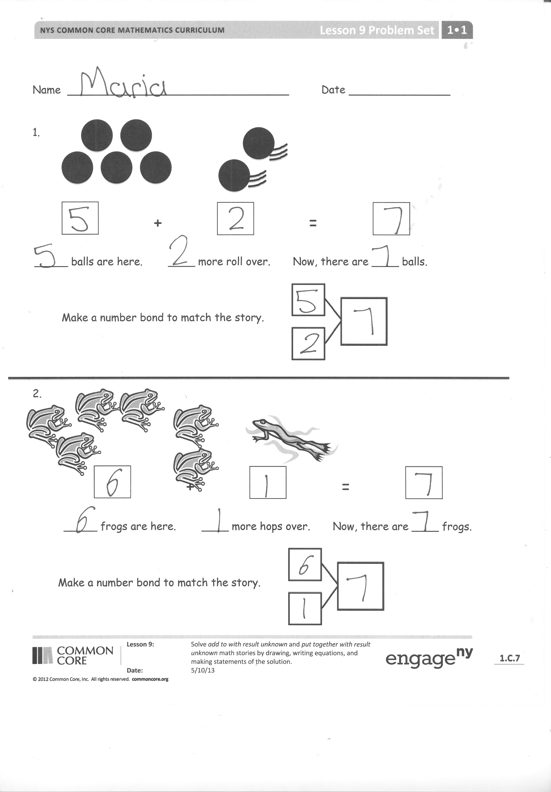Student Debrief (10 minutes)

**Lesson Objective**: Solve *add to with result unknown* and *put together with result unknown* math stories by drawing, writing equations, and making statements of the solution.

The Student Debrief is intended to invite reflection and active processing of the total lesson experience.

Invite students to review their solutions for the Problem Set. They should check work by comparing answers with a partner before going over answers as a class. Look for misconceptions or misunderstandings that can be addressed in the Debrief. Guide students in a conversation to debrief the Problem Set and process the lesson.

You may choose to use any combination of the questions below to lead the discussion.

* How are the Problem Set stories the same? What did we do to solve them? How are the ball and frog problems different from the flag and flower problems?
* 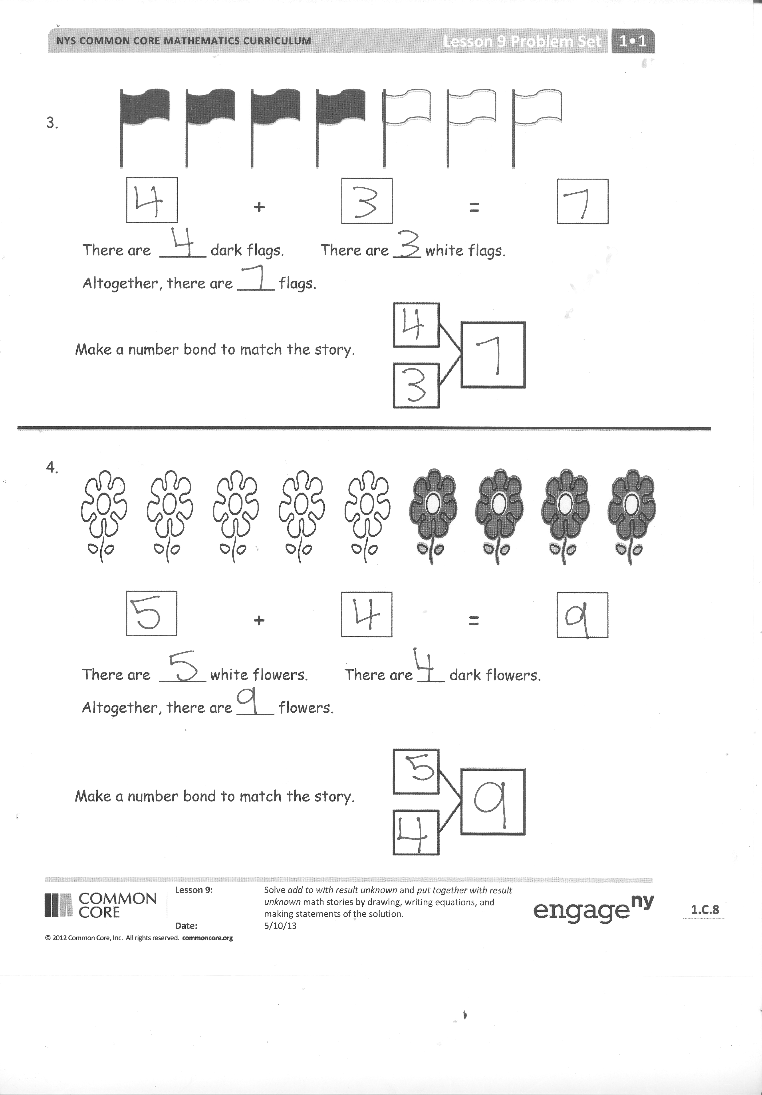Which of our Math Story Theatersituations was like the ball and frog problem? Which situations were like the flag and flower problem?
* Use your picture from your personal white board or think of your own story for us to act out for Math Stories Theater!
* How was today’s lesson related to our lesson on ways to make 9? (You may also cite the lessons on ways to make 6, 7, 8, or 10.)

Exit Ticket (3 minutes)

After the Student Debrief, instruct students to complete the Exit Ticket. A review of their work will help you assess the students’ understanding of the concepts that were presented in the lesson today and plan more effectively for future lessons. You may read the questions aloud to the students.

Name Date

Do as many as you can in 90 seconds. Write the number of bonds you finished here:

1. 2. 3. 4. 5.

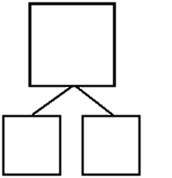

10

10



10

10



10

9



10

8



10

9

[1]

6. 7. 8. 9. 10.



10

7



10

8



10

7



10

8



10

9

11. 12. 13. 14. 15.



10

4



10

5



10

6



10

7



10

6

16. 17. 18. 19. 20.



10

3



10

4



10

36



10

4



10

6

21. 22. 23. 24. 25.



10

2



10

4



10

2



10

1



10

0

Name Date

1.

+

=

_____ balls are here. ____ more roll over. Now, there are ____ balls.



Write a number bond to match the story.

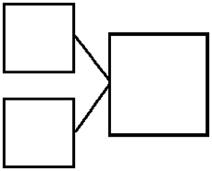

Make a number bond to match the story.

2.



+

=

_____ frogs are here. ____ more hops over. Now, there are ____ frogs.

3.



Make a number bond to match the story.

+

=

There are _____ dark flags. There are ___ white flags.

Altogether, there are ____ flags.



Make a number bond to match the story.

Write a number bond to match the story.

4.



+

=

There are _____ white flowers. There are ___ dark flowers.

Altogether, there are ____ flowers.



Make a number bond to match the story.

Name Date

Draw a picture and write a number sentence to match the story.



Ben has 3 red balls and gets 5 green balls. How many balls does he have now?

Ben has _______ balls.

+

=

Name Date

1. Use the picture to tell a math story.

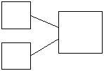

Write a number bond to match your story.



Write a number sentence to tell the story.

There are _______ sharks.

+

=

_________________________________________________________________________________________

2. Use the picture to tell a math story.

Write a number bond to match your story.





There are _______ students.

Write a number sentence to tell the story.

+

=

Draw a picture to match the story.

1. Jim has 4 big dogs and 3 small dogs. How many dogs does Jim have?

+

=

Jim has ________ dogs.

1. Liv plays at the park. She plays with 3 girls and 6 boys. How many kids does she play with at the park?

+

=

Liv plays with _______ kids.

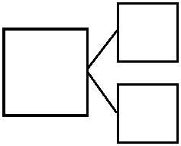



+



+

[2]

1. number bond dash 10
2. number bond and two blank equations