Lesson 4
Objective: Represent put together situations with number bonds. Count on from one embedded number or part to totals of 6 and 7, and generate all addition expressions for each total.

Suggested Lesson Structure
 Fluency Practice (12 minutes)
 Application Problem (6 minutes)
 Concept Development (30 minutes)
 Student Debrief (12 minutes)
Total Time (60 minutes)
Fluency Practice (12 minutes)
- Sprint: 1 More with Dots and Numerals 1.OA.6 (10 minutes)
- Happy Counting by Ones, 10–20 1.NBT.1 (K.CC.1, K.CC.2) (2 minutes)
Sprint: 1 More with Dots and Numerals (10 minutes)
Materials: (S) Sprint: 1 More with Dots and Numerals
Note: This activity addresses the core fluency objective for Grade 1 of adding and subtracting within 10.
Happy Counting by Ones, 10–20 (2 minutes)
Materials: (S) Rekenrek
Note: Counting forward and backward by ones affords students review with the counting sequence.
Play Happy Counting (see Lesson 3) from 10 through 20 and back, first the regular way, then the Say Ten way, as shown below.
Regular way: 8, 9, 10, 11, 12, 13, 14….
Say Ten way: 8, 9, ten 1, ten 2, ten 3, ten 4….
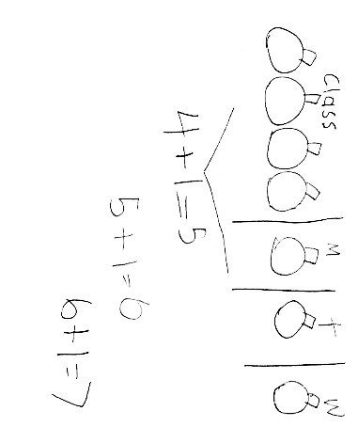
Application Problem (6 minutes)
Our class had 4 pumpkins. On Monday, Marta brought 1 more pumpkin. How many pumpkins did our class have on Monday?
On Tuesday, Beto brought 1 more pumpkin. How many pumpkins did our class have on Tuesday?
Then, on Wednesday, Shea brought 1 more pumpkin. How many pumpkins did our class have on Wednesday? Draw a picture and write a number sentence to show your thinking. What do you notice about what happened each day?
Extension: If this pattern continues, how many pumpkins will our class have on Friday?
Note: This problem is designed as a bridge from the previous lesson, which focused on 1 more. As students represent decompositions with drawings, they are preparing for today’s Concept Development.
Concept Development (30 minutes)
Materials: (T) Chart to record decompositions of 6 (S) Bag of 10 two-color beans (painted white on one side and red on the other), 6 apples picture card (Template)
Choose a group of students who have different attributes to represent decompositions of 6 (e.g., 4 boys, 2 girls; 5 with shoelaces, 1 without; 3 with short sleeves, 3 with long sleeves). Be sure to encourage the actors themselves to participate in the mathematics of the lesson.
T: How many students do you see?
S: 6!
T: How many boys are there?
S: 4!
T: How many girls are there?
S: 2!
T: Talk to your partner about what would be a good strategy to see how many students there are altogether. (Circulate and listen to student discussion.)
S: We can count on from 4.
T: Point with me to keep track as we count on from 4. (Gesture around the group of 4, and then touch the 2 students on the head as you count on with the class.)
S: Fouuuur, 5, 6!
T: What parts did we put together to make 6?
MP.7
S: 4 and 2!
T: Let’s write those parts in a number sentence. (Call on students to help you write the equation
6 = 4 + 2 on the board.)
T: (Ask the 2 girls to move to the left, and the 4 boys to move to the right.) What would our number sentence look like if we started with the girls first? Talk to your partner about what the number sentence would be.
T: (Circulate and listen to student discussion. Call on students to help you write the equation 6 = 2 + 4 on the board.)
T: Now, look at the shoes on these students. I notice shoes that have…
S: (Answers may vary.) Shoelaces!
Repeat the earlier process with decomposing according to having shoelaces and not, and again with short sleeves and not, in order to complete decomposing 6.

NOTES ON
MULTIPLE MEANS
OF ENGAGEMENT:
For students who still need to count all of the objects, scaffold their learning and allow them to count all. After they have mastered counting all, be sure to model counting on so that they have an example of how they should be thinking when counting.

Bring up the topic of zero and the total as a possible decomposition:
T: How many students do you see up here?
S: 6!
T: How many tigers do you see up here?
S: 0!
T: How many living things do you see up here?
S: 6!
T: How can we write that story in a number sentence?
S: 6 + 0 = 6!
T: Think of a different story that shows 6 + 0 = 6. (If necessary ask, “Think of what we can make the zero represent.”) Call on students to share.
T: When we add zero, we add nothing to the other part. And, this is another way we can make 6! Six and zero makes 6!
Problem Set (10 minutes)
Distribute the picture card for 6, the Problem Set, and a bag of 10 two-color beans to each student.
T: Let’s look at the picture of 6 apples, and use our beans to find different ways to make 6.

NOTES ON
MULTIPLE MEANS
OF REPRESENTATION:
Look for ways to connect real life experiences in math. Use apples during this lesson as a connection to science curriculum. Cut the apples to explore the parts of the apple connecting to total and part vocabulary.

T: How many apples do you see?
S: 6.
T: Let’s see how many apples with stems are there. Put a red bean on each apple as we count.
S: 1, 2, 3, 4.
T: How many apples do not have stems? Let’s put a white bean on each stem-less apple and count.
S: 1, 2.
T: Let’s see how many apples there are by counting on from the red beans. As you count, touch each bean.
S: Foooour, 5, 6.
T: (Have students write the expressions to match these parts.) When we just write 4 + 2, without writing the full number sentence, we call it an expression. (Point to 4 +2.) See, it doesn't have an equal sign!
Repeat this process to explore the rest of the apple combinations in the picture and to complete the remainder of the problem set. Help students set up a portfolio to save their work with decompositions of 6.
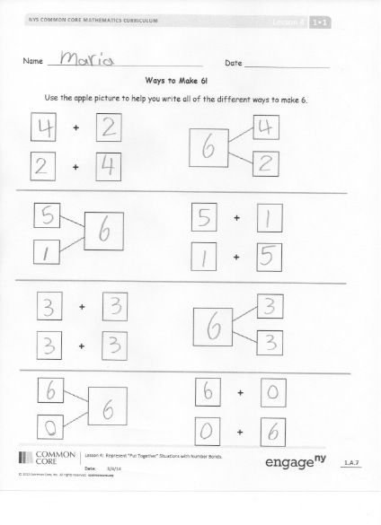
In the upcoming lessons, they will save decompositions of 7, 8, 9, and 10. You do not need to focus on the commutative property in this lesson.
Student Debrief (12 minutes)
Lesson Objective: Represent put together situations with number bonds. Count on from one embedded number or part to totals of 6 and 7, and generate all addition expressions for each total.
The Student Debrief is intended to invite reflection and active processing of the total lesson experience.
Invite students to review their solutions for the Problem Set. They should check work by comparing answers with a partner before going over answers as a class. Look for misconceptions or misunderstandings that can be addressed in the Debrief. Guide students in a conversation to debrief the Problem Set and process the lesson.
You may choose to use any combination of the questions below to lead the discussion.

NOTES ON
MULTIPLE MEANS
OF ACTION AND EXPRESSION:
Display charts with the number bonds for 6 so students can refer to it if needed. Creating a place in the classroom for students to access this information will help those students who are visual learners or students who have trouble committing things to memory.

T: Why did we keep track of the apples as we counted?
S: So we wouldn’t count any twice or miss any!
T: Talk with your partner about all of the different ways you made 6!
S: (Work together to check their work and the numbers’ referents in the picture.)
T: We will write number bonds to show all the different ways you made 6. What was the biggest part you found in your number bond, and what was its partner?
S: 6! And 0!
T: (Record this number bond on a chart, and call on students to help you write the expressions.)
Repeat this process in order to record all of the decompositions of 6 (5 + 1, 4 + 2, 3 + 3). Ask the following questions to close the lesson:
- What do you notice about the two parts in the expressions that make 6 as we look at them in order from left to right?
- What is different about this (point to 4 + 2), the expression, and this (point to 4 + 2 = 6), the number sentence?
- Turn to your partner and talk about what we learned about in today’s lesson. What did you get really good at today?
Exit Ticket (3 minutes)
After the Student Debrief, instruct students to complete the Exit Ticket. A review of their work will help you assess the students’ understanding of the concepts that were presented in the lesson today and plan more effectively for future lessons. You may read the questions aloud to the students.

Name Date
*Write the number that is 1 more.
Number correct:
A
1 |  |  | 16
2 |  |  | 17 | 9
3 |  |  | 18 | 7
4 |  |  | 19
5 |  |  | 20 | 8
6 |  |  | 21 | 7
7 |  |  | 22
8 | 5 |  | 23
9 |  |  | 24 | 10
10 | 6 |  | 25
11 |  |  | 26
12 | 7 |  | 27
13 |  |  | 28 | 9
14 |  |  | 29
15 | 8 |  | 30
Name Date
*Write the number that is 1 more.
Number correct:
B
1 |  |  | 16
2 |  |  | 17 | 8
3 |  |  | 18 | 9
4 |  |  | 19
5 |  |  | 20
6 |  |  | 21 | 10
7 |  |  | 22
8 | 4 |  | 23
9 |  |  | 24 | 10
10 | 5 |  | 25
11 |  |  | 26
12 | 7 |  | 27
13 |  |  | 28 | 8
14 |  |  | 29
15 | 6 |  | 30

Name Date
Ways to Make 6!
Use the apple picture to help you write all of the different ways to make 6.
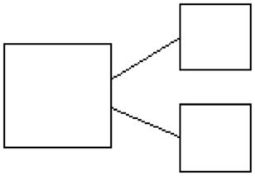

+

+

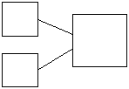

+

+

+

+

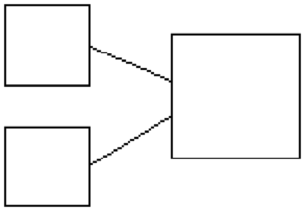

+

+

Name Date

Show different ways to make 6. In each set, shade some circles and leave the others blank.

Write a number sentence to match this picture.
Write a number bond to match this picture.

+

=

Name Date

Today, we learned the different combinations that make 6! For homework, cut out the flashcards below, and write the number sentences that you learned today on the back. Keep these flashcards in the place where you do your homework to practice ways to make 6 until you know them really well! As we continue to learn different ways to make 7, 8, 9, and 10 in the upcoming days, continue to make new flashcards.
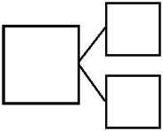*Note to families: Be sure students make each of the combinations that make 6. The flashcards can look something like this:
2 + 4 = 6
6
2
4

Front of Card Back of Card
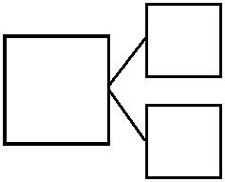

6 apples picture card

