Lesson 3

Objective: See and describe numbers of objects using 1 more within   
5-group configurations.

Suggested Lesson Structure

 Fluency Practice (12 minutes)

 Application Problem (7 minutes)

 Concept Development (35 minutes)

 Student Debrief (6 minutes)

**Total Time (60 minutes)**

Fluency Practice (12 minutes)

* Happy Counting by Ones Within 10 **K.CC.1, K.CC.2** (4 minutes)
* 5-Group Flash **K.OA.4, 1.OA.5**  (3 minutes)
* Number Bond Dash: 5 **K.OA.3, K.OA.5** (5 minutes)

Happy Counting by Ones Within 10 (4 minutes)

Materials: (T) Rekenrek

Note: Counting forward and backward by ones affords students a review of this strategy as it relates to addition and subtraction. It also directly relates to the current lesson objective. This game may be challenging for students at first. A Rekenrek helps students visualize numbers and makes it easier for them to change direction as they count. Rekenreks can be made simply and inexpensively with cardboard, elastic, and beads. If this is not available to you, there are also interactive Rekenreks online.

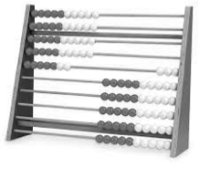

*Rekenrek*

Move the beads on the Rekenrek to model counting forward and backward by ones within ten. Students count along with the beads (e.g., 1, 2, 3, 2, 3, 4 ,5, 6, 5, etc.). When students are ready, put the Rekenrek away.

T: Let’s play Happy Counting! We’re going to count by ones. When I hold my hand like this (point thumb and motion up), I want you to count up. If I put my hand like this (point thumb and motion down), I want you to count down. If I do this (thumb to the side) that means stop, but try hard to remember the last number you said. (See illustration on the next page.)

T:          

T/S: 1 2 3 (pause) 2 1 (pause) 2 3 4

5-Group Flash (3 minutes)

Materials: (T) 5-group cards (the dot cards from the 1 More game in this lesson may be used, as long as they have been enlarged on the copier)

Note: This activity relates to the core fluency objective of Grade 1 of adding and subtracting within 10.

Teacher flashes 5-group cardsfor 2–3 seconds, and instructs students to say the number when teacher snaps. After flashing all the numbers from 0 to 10 (in a random order), flash the cards again and count on from the number flashed, up to 10.

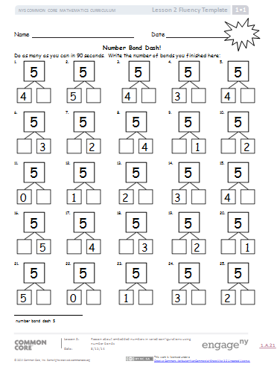Number Bond Dash: 5 (5 Minutes)

Materials: (T) Stopwatch or timer (S) Number bond dash 5 (Lesson 2 Fluency Template), marker to correct work

Note:  Reviewing number bonds allows students to build and maintain fluency with addition and subtraction facts within 10 and gets them ready for the upcoming lesson.

Distribute Dash face down to students. Instruct students to flip their papers when you say, “Go!” and complete as many number bonds as they can in 90 seconds. Assure them that it is okay if they run out of time before they finish. Tell them that if they finish before time, they can practice counting backwards from 20 on the back of their papers.

T: Take a second to remember the score you got on yesterday’s Number Bond Dash so you can try to do even better today.

T: (Set the timer for 90 seconds.) On your mark, get set, GO! (Press start.)

T: (When the timer goes off, tell students to put down their pencils and grab a marker to correct their work.)

T: When you get an answer correct, put a check mark on the problem number. If you make a mix-up, fix it with your marker.

Read the number bonds aloud, starting with Problem 1. When you are finished checking all the problems, tell students to write the number they got correct in the star-like shape on the top and show you a big smile if they improved their score from yesterday.

Application Problem (7 minutes)

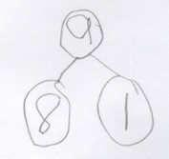Alex had 9 marbles in his hand. He hid his hands behind his back and put some in one hand and some in the other. How many marbles might be in each hand? Use pictures or numbers to draw a number bond to show your idea.

Note: This problem is designed as a bridge from the previous lesson, which focused on reasoning about embedded numbers and finding various decompositions.

Concept Development (35 minutes)

Materials: (T) Sentence frame 1 more (Template 1) (S) 5-group mat (Template 2), bag with 9 linking cubes of the same color, 1 linking cube of another color, personal white board, 1 More game cards (Template 3)

T: Show me 5 fingers on one hand the Math Way.

|  |  |
| --- | --- |
|  | NOTES ON  MULTIPLE MEANS  OF ENGAGEMENT: |

Cultivate excitement by connecting   
on-level math with higher-math.   
For example:

* You know 1 more than 6 is 7. What is 1 more than 16?
* If 1 more than 18 is 19, then what is 1 more than 28?
* See how far you can extend presenting numbers to 100.

S: (Hold up their left hand, showing 5 fingers.)

T: Show me 4 fingers inside your 5.

T: Show me your 5.

T: Show me your 4.

T: How much does 4 need to make 5?

S: 1!

T: Show me 7 fingers the Math Way.

T: Show me 6.

T: Show me 7.

T: Show me 6.

T: How much does 6 need to make 7?

S: 1.

T: Put 5 cubes that are the same color onto your 5-group mat. How many cubes do you have?

S: 5.

T: Use a different color cube and put 1 more on your mat. Now, how many do you have?

S: 6.

T: How did you know that so quickly?

S: I counted on from 5. 🡪 It was just 1 more. 🡪 I saw 5 and 1. 🡪 I just knew it. 🡪 I counted on from 5. It was just 1 more.

T: What is 1 more than 5?

S: 6.

T: Let’s say that in a full sentence. (Point to the sentence frame as students speak. 1 more than *___*_ is *____*.)

T/S: 1 more than 5 is 6.

T: Let’s try saying this in a different way. What was the first part we saw?

|  |  |
| --- | --- |
|  | NOTES ON  MULTIPLE MEANS  OF EXPRESSION: |

For students who may need additional support with the language of *1 more than ___ is ____* and *____ is 1 more than ___*, insert a sentence frame into their personal white boards, and allow them to write the numbers into the blanks. Pointing to each word and reading the number can provide a bridge between the concrete and the abstract.

S: 5.

T: How many more did 5 need to make 6?

S: 1.

T: So, we can say 6 is 1 more than.... (Invite student responses.)

S: 5.

T: Say it as a whole sentence. (Point to the sentence frame as students speak. *____* is 1 more than *____*.)

S: 6 is 1 more than 5.

T: Help me write our parts and total in a number sentence, or equation. (As you ask each question, write the components of the number sentence.) What did we start with?

S: 5.

T: How many cubes did we add?

S: 1.

T: How many cubes do we have altogether?

S: 6.

T: Let’s read our number sentence together.

T/S: 5 + 1 = 6.

Have students clear their mats, and continue this process with 7, 8, and 9. Have students say both “8 is 1 more than 7,” and “1 more than 7 is 8.” When writing the number sentence, be sure to have the equal sign on either side of the equation (i.e., 7 + 1 = 8 and 8 = 7 + 1).

T: Now, you’ll get to work with a partner to play the 1 More game! The goal is to match a dot card with the card that has 1 more. Here are the directions:

1. Put all of your cards face down, with dot cards on one side and sentence cards on the other.
2. 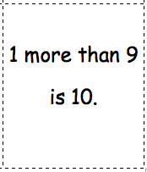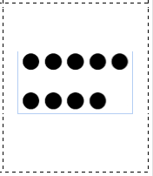Flip over a dot card.
3. Flip over a sentence card.
4. Keep the pair if the sentence card is one more than the dot card.
5. Turn both cards back over if they do not match.
6. When you and your partner have made all the pairs, write a number sentence for each pair.

Model how to play this with students. Practice the language *1 more than ____ is ____* and *____ is 1 more than ____.*

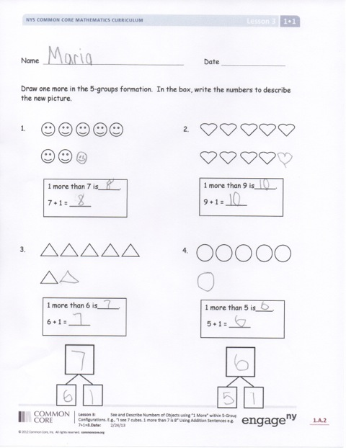Problem Set (10 minutes)

Students should do their personal best to complete the Problem Set within the allotted 10 minutes. For some classes, it may be appropriate to modify the assignment by specifying which problems they work on first. Some problems do not specify a method for solving. Students solve these problems using the RDW approach used for Application Problems.

Student Debrief (6 minutes)

Lesson Objective: See and describe numbers of objects using *1* *more* within 5-group configurations.

The Student Debrief is intended to invite reflection and active processing of the total lesson experience.

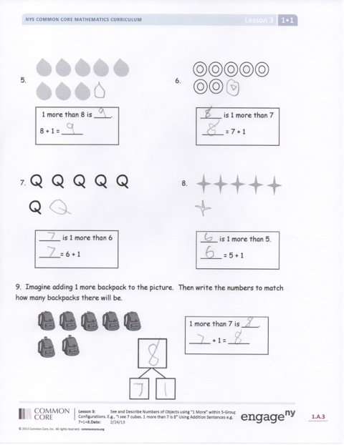Invite students to review their solutions for the Problem Set. They should check work by comparing answers with a partner before going over answers as a class. Look for misconceptions or misunderstandings that can be addressed in the Debrief. Guide students in a conversation to debrief the Problem Set and process the lesson.

You may choose to use any combination of the questions below to lead the discussion.

* What is the same and different about Problem 4 and Problem 8?
* Look at Problems 8, 7, 6, and 5. What do you notice about how these are changing?
* If we had to find 2 more, how would today’s lesson help us?
* What did you notice about the number sentences in Problems 5 and 6?
* Using what you learned today, what is 1 more than 13? How do you know?
* Turn and talk to your partner about what we did today. What were we learning about, understanding, and getting good at?

Exit Ticket (3 minutes)

After the Student Debrief, instruct students to complete the Exit Ticket. A review of their work will help you assess the students’ understanding of the concepts that were presented in the lesson today and plan more effectively for future lessons. You may read the questions aloud to the students.

Name Date

Draw one more in the 5-group. In the box, write the numbers to describe the new picture.

1. 2.

1 more than 9 is _____.

9 + 1 = _____

1 more than 7 is ____.

7 + 1 = _____

1. 4.

1 more than 6 is _____.

6 + 1 = _____

1 more than 5 is ____.

5 + 1 = _____

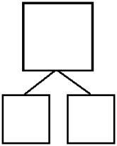

5. 6.

1 more than 8 is ­­­­­____.

8 + 1 = _____

_____ is 1 more than 7

_____ = 7 + 1

7. Q Q Q Q Q 8.

Q

_____ is 1 more than 6

_____ = 6 + 1

____ is 1 more than 5.

_____ = 5 + 1

9. Imagine adding 1 more backpack to the picture. Then, write the numbers to match how many backpacks there will be.



1 more than 7 is ____.

_____ + 1 = _____



Name Date

How many objects do you see? Draw one more. How many objects are there now?

1. 2.

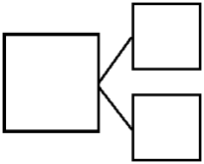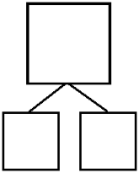

1 more than 6 is _____.

_____ + 1 = _____

_____ is 1 more than 9.

9 + 1 = _____

Name Date

How many objects do you see? Draw one more. How many objects are there now?

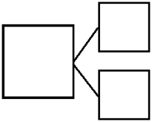

1 more than 9 is ____.

9 + 1 = _____

____ is 1 more than 7.

_____ = 7 + 1

____ is 1 more than 5.

_____ = 5 + 1

1 more than 8 is ____.

_____ + 1 = _____

1.



2.



3.



4.

5. Imagine adding 1 more pencil to the picture.   
Then, write the numbers to match how many pencils there will be.





1 more than 5 is _____.

5 + 1 = _____

6. Imagine adding 1 more flower to the picture.   
Then, write the numbers to match how many flowers there will be.



____ is 1 more than 8.

_____ + 1 = _____

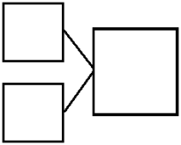

[1]

___ is 1 more than ____.

1 more than ____ is ____.

[2]

|  |  |  |
| --- | --- | --- |
| Description: small 1.bmp | Description: small 2.bmp | Description: small 3.bmp |
| Description: small 4.bmp | Description: small 5.bmp | Description: small 6.bmp |
| Description: small 7.bmp[3] | Description: small 8.bmp | Description: small 9.bmp |
| 2 is 1 more than 1. | 3 is 1 more than 2. | 4 is 1 more than 3.[4] |
| 1 more than 4 is 5. | 1 more than 5 is 6. | 1 more than 6 is 7. |
| 8 is 1 more than 7. | 1 more than 8 is 9. | 1 more than 9 is 10. |

1. sentence frame 1 more
2. 5-group mat
3. 1 more game cards
4. 1 more game cards